COURSE CODE: DCIT 208
D2: Software Requirements Specification (SRS)
PROJECT TITLE: ScentHub
TEAM NAME: InnovateX
CLIENT: Yussif Kangre Abdulai
GitHub Classroom Team Repository URL: https://github.com/selasi07/ScentHub
Relevant Commit Hash:
DATE: 3RD July 2026

TABLE OF CONTENT
Contents
1. Requirement Overview 3
1.1 Purpose 3
1.2 Scope 3
1.3 System Boundary 3
1.4 Stakeholders 4
1.5 User Roles 4
1.6 Functional Requirements Summary 4
1.7 Assumptions 4
1.8 Constraints 4
1.9 Dependencies 5
2. Use Case Model 5
2.1 Introduction 5
2.2 Identify the Actors 5
2.3 Identify the uses cases 5
2.4 Use Case Diagram 6
3. User Stories 6
3.1 Introduction 6
3.2 User Stories 6
3.3 User Story Prioritisation 7
4.Non-Functional Requirements 7
4.1 Introduction 7
4.2 Non- Functional Requirements 7
4.3 Importance of the Non-Functional Requirements 8
5.Data and External Interface Requirements 8
5.1 introduction 8
5.2 Data requirements 8
5.3 External Interface Requirement 8
5.4 Data Validation 9
5.5 Data Relationship 9
6. Glossary and Client Validation 9
6.1 Glossary 9
6.2 Client Validation 9
6.3 Conclusion 10

Requirement Overview
This section introduces the software requirements by explaining the purpose, scope, stakeholders, and overall requirements of ScentHub.

Purpose
The purpose of this Software Requirements Specification (SRS) is to define the functional and non-functional requirements for ScentHub, a web-based inventory and sales management system for perfume businesses. This document serves as a shared reference for the client, stakeholders, and development team by describing what the system is expected to do and the constraints under which it will operate. The SRS will guide the design, development, testing, and validation of the system while ensuring that the delivered solution meets the client's business needs.

Scope
ScentHub is a web-based application designed to help perfume businesses manage inventory, sales, customers, and business reporting more efficiently. The system provides secure user authentication, product and inventory management, sales recording, customer management, dashboard analytics, and report generation. These features replace manual record-keeping with a centralized digital solution that improves operational efficiency and reduces errors.
The first version of the system does not include online payment processing, mobile applications, delivery management, supplier management, or support for multiple business branches. These features may be considered in future releases.

System Boundary
Inside the System | Outside the System
User authentication | Banks and payment gateways
Product management | Delivery companies
Inventory management | Suppliers
Sales recording | Mobile Money services
Customer management | Customers purchasing physically
Dashboard and reports | Third-party business systems

Stakeholders
Stakeholder | Interest in the System
Business Owner | Manages products, inventory, sales, and reports
Sales Attendant | Records customer sales and updates inventory
Customers | Purchase products and receive improved service
Development Team | Designs, develops, tests, and maintains the system

User Roles
Stakeholder | Interest in the System
Business Owner | Manages products, inventory, sales, and reports
Sales Attendant | Records customer sales and updates inventory
Customers | Purchase products and receive improved service
Development Team | Designs, develops, tests, and maintains the system

Functional Requirements Summary
• Authenticate authorized users.
• Manage perfume products.
• Manage inventory levels.
• Record customer sales.
• Manage customer records.
• Generate sales and inventory reports.
• Display business performance through a dashboard.
• Maintain accurate stock levels after every sale.

Assumptions
• Users have basic computer literacy.
• A stable internet connection is available while using the system.
• Products are entered into the inventory before sales are recorded.
• Authorized users have valid login credentials.
• The database is available whenever the system is in operation.

Constraints
• The system will be developed as a web application.
• Development must follow the DCIT 208 project timeline.
• The first version excludes online payment integration.
• Development resources are limited to the assigned project team.
• The system must comply with the approved project scope.

Dependencies
• Internet connectivity.
• Web browser compatibility.
• Database management system.
• Authentication module.
• Client feedback and approval throughout development.

Use Case Model

Introduction
The use case model shows how different users interact with the ScentHub system. It identifies the main users of the system and the tasks they can perform. This helps both the client and the development team understand the system's expected behavior before development begins.

Identify the Actors
Actor | Description
Business Owner | Has full access to manage products, inventory, customers, sales, reports and user accounts.
Sales Attendant | Records sales, views products, updates customer information and performs other daily sales activities based on the permissions given by the Business Owner.

Identify the uses cases
ID | Use Case | Primary Actor
UC1 | Log In | Business Owner, Sales Attendant
UC2 | Manage Products | Business Owner
UC3 | Manage Inventory | Business Owner
UC4 | Record Sale | Business Owner, Sales Attendant
UC5 | Manage Customers | Business Owner, Sales Attendant
UC6 | View Dashboard | Business Owner
UC7 | Generate Reports | Business Owner
UC8 | Log Out | Business Owner, Sales Attendant

Use Case Diagram
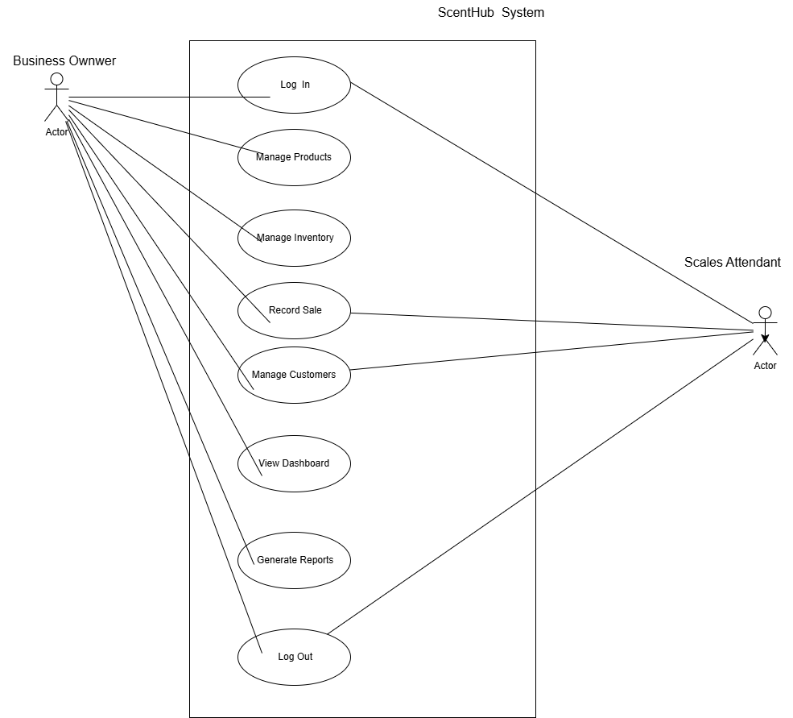

User Stories

Introduction
User stories describe the system from the users' point of view. They explain what each user wants to achieve with the system and why the feature is important. These stories were developed from the client's requirements gathered during the discovery process and help guide the development of ScentHub.

User Stories
ID | User Story | Priority
US1 | As a Business Owner, I want to log into the system securely so that only authorized users can access business information. | High
US2 | As a Business Owner, I want to add, edit and remove perfume products so that the product catalogue remains up to date. | High
US3 | As a Business Owner, I want to manage inventory so that stock levels are always accurate. | High
US4 | As a Sales Attendant, I want to record customer purchases so that every sale is stored correctly. | High
US5 | As a Sales Attendant, I want to update customer details so that customer records remain accurate. | Medium
US6 | As a Business Owner, I want to view sales reports so that I can monitor business performance and make informed decisions. | High
US7 | As a Business Owner, I want to view a dashboard that summarizes sales and inventory information so that I can quickly understand how the business is performing. | Medium
US8 | As a Business Owner, I want to log out of the system securely so that my account remains protected after use. | High

User Story Prioritization
The user stories were prioritized based on the client's business needs. Features that are essential for the daily operation of the business, such as user authentication, inventory management and sales recording, were given a high priority. Features that improve convenience and decision-making, such as dashboards and customer record updates, were assigned a medium priority because the system can still function without them during the initial release.

4.Non-Functional Requirements

4.1 Introduction
Non-functional requirements describe the qualities and standards that the ScentHub system should meet. Unlike functional requirements, they do not describe specific tasks the system performs. Instead, they focus on how well the system should perform, how secure it should be, and how easy it should be to use and maintain.

4.2 Non- Functional Requirements
Category | Requirement

Performance | The system should load most pages within three seconds under normal operating conditions.

Security | Only authorized users should be able to access the system using valid login credentials.

Reliability | The system should save sales and inventory information accurately without losing data during normal operation.

Usability | The interface should be simple and easy to understand so that staff can use it with little training.

Availability | The system should be available whenever the business is operating, except during scheduled maintenance.

Scalability | The system should support the addition of more products and customer records as the business grows.

Maintainability | The system should be organized so that future updates and bug fixes can be made without affecting existing features.

Compatibility | The system should work properly on modern web browsers such as Google Chrome, Microsoft Edge and Mozilla Firefox.

4.3 Importance of the Non-Functional Requirements
These requirements help ensure that ScentHub is not only functional but also dependable and easy to use. Meeting these requirements will improve the user experience, protect business information, and support the system as the business grows over time

5.Data and External Interface Requirements

5.1 introduction
This section describes the main data used by the ScentHub system and the external interfaces that allow users to interact with it. Defining these requirements helps ensure that information is stored correctly and that users can access the system easily and efficiently.

5.2 Data requirements
Data Item | Description
User | Stores information about authorized users, including their username, password and role.
Product | Stores details about each perfume, including its name, brand, category, selling price and available quantity.
Customer | Stores customer information such as name and contact details.
Sale | Stores information about each completed sale, including the product sold, quantity, date, total amount and the staff member who recorded the sale.
Inventory | Stores the current stock level of each product and updates automatically after every sale.

5.3 External Interface Requirement
Interface | Requirement
User Interface | The system should provide a clean and easy-to-use web interface that allows users to perform their tasks with minimal training.
Hardware Interface | The system should run on standard desktop or laptop computers with internet access.
Software Interface | The system should use a database to store application data and should operate through modern web browsers.
Communication Interface | The system should communicate over a secure internet connection to protect user information during use.

5.4 Data Validation
To maintain accurate records, the system should validate information before it is saved. Required fields should not be left empty, prices and quantities should contain valid numeric values, duplicate usernames should not be allowed, and only authorized users should be able to perform restricted actions.

5.5 Data Relationship
The different types of data in ScentHub are connected to support the daily operations of the business. A user records sales, each sale is linked to a customer and one or more products, and every completed sale automatically updates the inventory. These relationships help keep business records accurate and consistent throughout the system.

6. Glossary and Client Validation

6.1 Glossary
Term | Meaning
SRS | Software Requirements Specification, a document that describes what the system should do and the requirements it must meet.
User Story | A short description of a system feature from the user's point of view.
Functional Requirement | A feature or function that the system must perform.
Non-Functional Requirement | A quality or standard that describes how the system should perform.
Inventory | The collection of perfume products available for sale.
Dashboard | A screen that provides a summary of important business information, such as sales and stock levels.
Business Owner | The person responsible for managing the perfume business using the system.
Sales Attendant | A staff member who records sales and assists customers using the system.

6.2 Client Validation
The requirements presented in this document were developed from the information gathered during the client interview and the subsequent requirement validation process. Feedback from the client was used to clarify business needs, confirm the required system features, and ensure that the documented requirements accurately reflect the expected behavior of the ScentHub system. The validated requirements provide a solid foundation for the design and development stages of the project.

6.3 Conclusion
This Software Requirements Specification defines the requirements for the ScentHub system based on the client's needs and the project's objectives. It provides a clear understanding of the system's expected features, quality requirements, and data requirements. The document will serve as a guide for the design, implementation, testing, and evaluation of the system during the remaining phases of the project.

