2.2 What is the advantage of a relocatable assembler compared to an absolute
assembler?
A relocatable assembler allows you to develop application software in modules that are
linked together to create the program to go into the ROM.

2.3 What is a microcontroller memory map?
A memory map shows the organization of addresses for each type of memory.

2.12 Why must a three-state gate be used to interface an input device to the data bus?
The input device sends a high impedance signal to the data bus when not in use so that a non-active signal is not misinterpreted.

2.17 Design an instruction decoder as shown in Figure 2-13 using AND. OR. and inverter
gates to decode the 3-bit opcodes and produce a control signal asserted by each of the
operations given in Table 2-5.

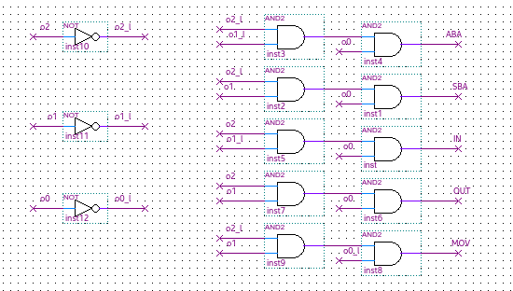

3.2. What are the three basic elements of structured programming?
Simple structures that minimize the number of programming element interactions
Minimizing program segment sizes
Hierarchical organization of the solution.

3.3. Write the pseudocode and draw the flowchan symbol to represent the decislon [f A l-'
TRUE THE B ELSE C.
IF A is TRUE
THEN B
ELSE C

3.7. Use structured flowcharts or pseudocode to \Hite 3 de ign thaI wtillmplemenl the ~ \-
lowi ng problem description:

DO
IF BUF is NULL
THEN
prompt user for keyboard input
save input in BUF
ENDIF (BUF is NULL)
IF BUF is alphabetic
THEN
change case of BUF
ENDIF (BUF is alphabetic)
IF BUF is alphanumeric
THEN
print BUF
clear BUF
ELSE
beep bell
clear BUF
ENDIF (BUF is alphanumeric)
WHILE ESC not pressed

4.5 What is the meaning of sign bit = 1 when unsigned binary coded numbers are added?
It is treated like a normal positive binary digit.

4.6 What is the meaning of sign bit = 1 when two's-complement binary coded numbers are added?
The result is negative.

4.7 What is the meaning of carry bit = 1 when unsigned binary coded numbers are added?
The result is larger than what can be expressed with the number of digits (overflow)

4.11 What is the meaning of two's-complement overflow bit = 1 when unsigned binary coded numbers are added?
A carry was required for the operation.

4.12 What is the meaning of two's-complement overflow bit = 1 when two's-complement binary coded numbers are added?
It means that a carry or a borrow was required for the operation, depending on whether subtraction or addition was performed.

5.1 List the addressing modes available in the CPU you are studying.
5.2 Briefly explain the following terms: physical address, effective address, memory map.
Physical Address - Actual memory location.
Effective Address - Memory location computed by the processor.
Memory Map - Organization of addresses for each type of memory.

5.9 To increase the memory address space in a computer system. one must (a) increase
the number of data lines. (b) increase the number of read and write control bits going
to the memory, (c) increase the number of address lines.
C

5.10 A pointer is (a) an area in memory used for address storage. (b) a memory address
held in a register, (c) a subroutine address held in the stack pointer
B

5.11 A register indirect address instruction (a) has the address of the operand in the
instruction. (b) has the address of the operand in a register. (c) uses the program
counter to calculate the offset address of the operand.
B

