**Project 4 – Report**

Reflection environment map result (two views):

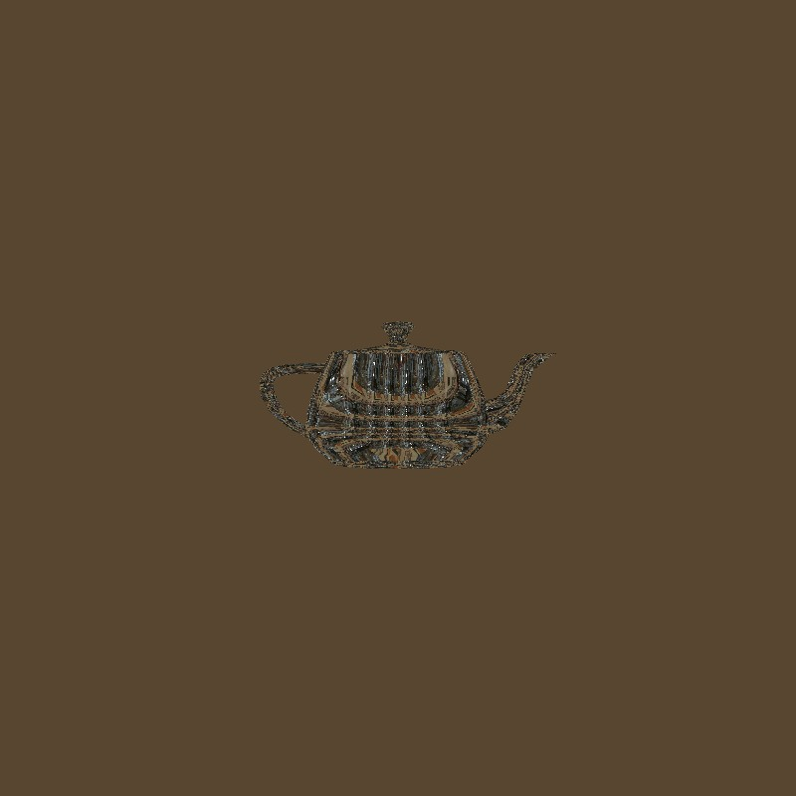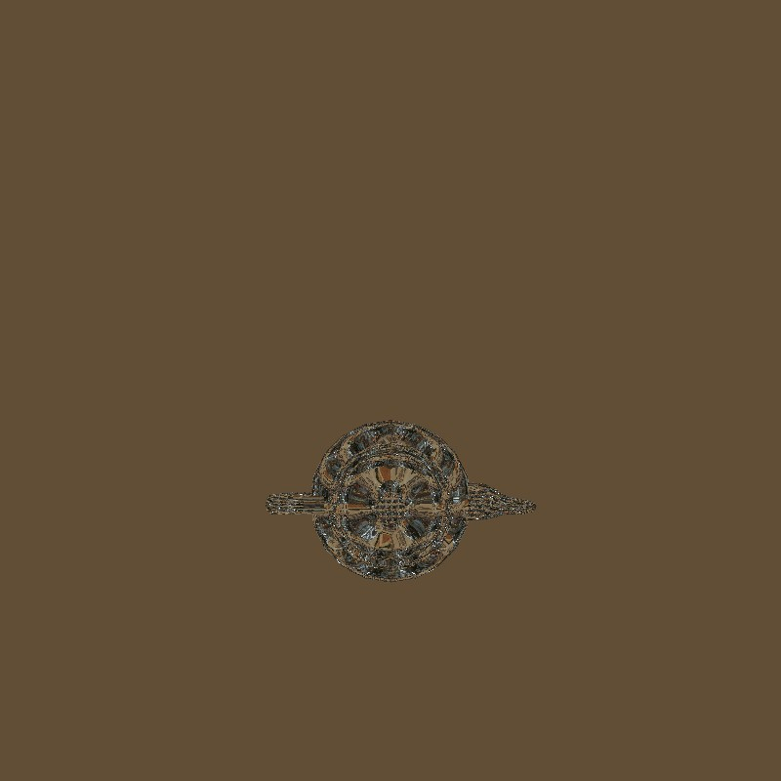

Implementation:

We began this project by following the to-do’s in the order that they came in. We followed the tutorial link provided closely in order to make sure we were using OpenGL correctly. We tried to keep running our code to test if any changes were made after doing a few of the methods and drawing the skybox. However, it was only after we devised a working shader pipeline that we were able to see results.

How to run code, bugs, difficulties:

We did not have any special instructions to run the code. A bug we have is that the skybox does not get textured appropriately, even though it interpolated the average color. The teapot gets textured with the images of StPeters. We had a hard time knowing what to implement into the main methods of the shader classes. We were also not sure if we did the correct binding and unbinding order. A few days into implementation, Khari’s backpack was stolen, which had his laptop in it. We worked diligently from the CISE computer labs to finish despite this setback.

Original reflection environment map result from shader:

