Creating a Noctis USB Bootable USB Drive

- Run HBUSBFW.EXE from the DriveKey folder.
- Choose your drive, format as FAT, and choose to create a DOS startup disk using the system files at NoctdiskII\FDOS\BIN.
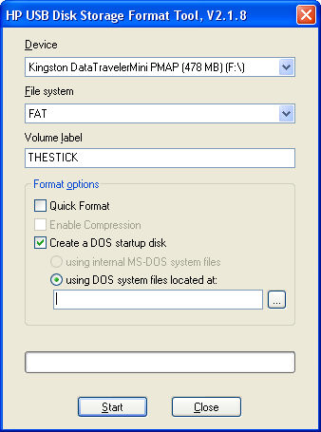
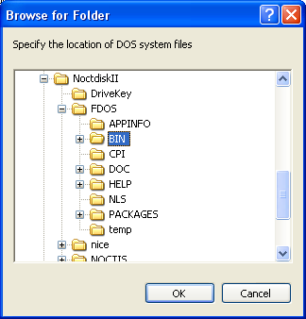
- Copy everything from the NoctdiskII folder to the drive. That is, copy its contents, not the folder itself.
- Shut down your computer, then boot to the USB device. You should be able to press a key such as F9 or F12 at the BIOS screen to choose to boot to the device, or you may have to change the boot order in your BIOS to give precedence to USB devices.

Troubleshooting

- My BIOS doesn't have a USB boot option: Two possibilities exist. Your BIOS may be so old that it actually doesn't support USB booting; if it's that old, you probably can't run an OS that won't run Noctis natively. The more likely scenario is that your BIOS treats the USB drive as a hard drive, or simply calls it by something useless like its model. Pay careful attention to the devices available in your boot device selection screen.
- I'm having trouble formatting the drive: You are probably using too large a USB drive.

