Network based multifactorial modelling microRNA-target interaction.

Selcen Ari[1]

Alper Yilmaz[2]

22 Ağustos 2019

## Abstract

Competing endogenous RNA (ceRNA) regulations and crosstalk between various types of non-coding RNA in human is remarkable in means of miRNA regulation. Many studies have pointed out that an alteration in miRNA:target interaction can result in unexpected changes due to indirect and complex interactions. In this paper, we defined a new network-based model that handles miRNA:ceRNA interactions with expression values. Our model is able to handle miRNA interaction factors such as seed type, binding energy, if provided. Our approach is able to reveal that a perturbation in an element of network affects whole competing elements differently and cooperative efficiencies of miRNAs on common targets could be calculated. Our findings emphasized importance of miRNA:target ratios being crucial, as reported by previous studies. We have showed that the competing elements which have the same or close expression values may not be affected equally from the perturbation because of repression functionality depended on interaction factors of miRNA target pairs (answer: Hocam etkileşim faktörlerinden dolayı ekspresyonları yakın olsa bile baskılanma aktitesinin aynı sergilenmeyeceğini ifade etmeye çalıştım. Bu şekilde anlaşılıyor mu?). We applied the model to real sample consisting of breast cancer gene and miRNA expression dataset and experimental miRNA:target interaction dataset all generated via high throughput sequencing methods. A gene over-expressed in tumor tissue, namely *ABCC1*, is used as perturbing element. We have observed that change in expression level of single gene in miRNA:target network is sufficient to perturb regulations in whole network, due to unforeseen and unpredicted regulation which are only visible when considered in network context. Therefore, this model helps unveiling the crosstalk between elements in miRNA:target network where abundance of target and sponge effect are taken into account. The model is scalable and can be plugged in with emerging miRNA effectors such as circRNAs. The model is available as R package [ceRNAnetsim](https://github.com/selcenari/ceRNAnetsim).

## Introduction

MicroRNAs (miRNAs) are a family of short non-coding RNAs which are key regulator of gene expression through various post-transcriptional mechanisms. Although the mechanisms by which miRNA represses are not fully understood, miRNAs predominantly repress their targets. Repressive activities of miRNAs vary depending on many factors that are significant to microRNA:target interactions. These factors include microRNA:target binding energy, binding location in target sequence, base pairing types between miRNA and target, abundance of miRNAs and targets (Grimson et al. 2007). Binding energies of miRNA:target complexes vary based on nucleotide context and determine folding stability of complex (Cao and Chen 2012). It has been demonstrated that the binding energy between miRNA and target indicates stability or affinity of complex (Helwak et al. 2013) and does not directly determine repressive activity of miRNA (Cao and Chen 2012). Early studies have argued that 2-8 nt sequence, seed, located in miRNA 5’end bind to specific sequence located in 3’UTR of its target (Bartel 2004; Lewis, Burge, and Bartel 2005). In recent studies, it has been shown that miRNAs can interact with targets via sequences located in regions such as 5’UTR or CDS (Hausser et al. 2013; Helwak et al. 2013; Moore et al. 2015). These studies also showed that binding location could indicate functionality of miRNA:target interaction or be effective on abundance of targets(TOFIX abundance etkisi derken, bazen azaltabilir, bazen arttırabilir, manasında mı? answer: evet hocam anlaşılmıyorsa değiştirebilirim). It has been shown that miRNAs exhibit repressive activity via, 6-8 nt long sequence that is perfectly complementary with targets, seed region at the 5’ end of miRNAs (Bartel 2009; Grimson et al. 2007). On the other hand, some researchers have reported that seed sequence of miRNA can have mismatches or bulged/wobble nucleotides and may locate in region other than 5’end of miRNAs (Hafner et al. 2010; Helwak et al. 2013). On top of all these factors, abundance of miRNAs and targets and miRNA:target ratio in cells predominantly affect efficiency of miRNA:target interaction (Arvey et al. 2010; Bosson, Zamudio, and Sharp 2014; Denzler et al. 2014).

As it is possible for miRNAs to suppress multiple targets, an individual mRNA molecule can also be targeted by multiple miRNAs. In that case, the targeted mRNAs exhibit competitor behavior, that is hypothesized as competing endogenous RNAs (ceRNAs) (Ala et al. 2013; Cesana and Daley 2013), against their miRNAs. Briefly, Ala et al. have explained the ceRNA hypothesis as disturbance of the other target when one of the targets on a steady-state system that included one miRNA and two target was perturbed with expression change (Ala et al. 2013). Regarding interaction between miRNAs and their target in a cell, explaining and predicting results of an individual perturbation is difficult due to complexity of interactions. Various computational and experimental studies have tackled the problem of unraveling ceRNA:miRNA interactions. It has been observed that when abundance of one of the targets of miR-122 was increased, the other target expression also slightly increased as a result of decreasing repressive activity of miR-122 on them (Denzler et al. 2014). Bosson et al. have developed a mathematical model for changes on total target pool concentration after grouping targets according to affinity and demonstrated that miRNA activity correlated with affinity between miRNA and target (Bosson, Zamudio, and Sharp 2014). Cooperative efficiency of miRNAs as well as competitor behaviors of targets were also studied and it has been demonstrated to be crucial for regulating available mRNA levels of targets (Denzler et al. 2016). MiRNA:target interactions have been modeled as stoichiometric and catalytic mechanisms and Figliuzzi et al. have recommended handling models in network context (Figliuzzi, Marinari, and De Martino 2013). The model that can explain miRNA target interaction through topological features has been applied at bipartite network by Nitzan et al. (Nitzan et al. 2014). Robinson and Henderson applied the model that handles miRNA:target direct and indirect interactions via common miRNA of gene and target of miRNA, at bipartite network. It has been demonstrated that all miRNAs and targets in the network can interact with each other through common miRNAs and genes, without interaction between the same type of nodes (Robinson and Henderson 2018).Associated genes that are targets of the same miRNAs have been found with help of correlation of gene expression changes in recent algorithm (Markus List 2017). List et al. have specified that their approach can be useful for ceRNA studies and published their approach as an R package.

## Methods

### Construction of miRNA:target network

miRNA and target pairs per line should be provided as edge list to construct the network. At each line minimum required information is expression levels of miRNA and the target. If available, additional data about factors effecting binding or efficiency of miRNA can be provided as separate columns. After construction of the network, amount of miRNA per target is calculated and kept as edge data. Simply, a target will sequester miRNA proportional to its ratio amount among other targets. If additional criteria effecting the binding of miRNA to its target is provided, distribution of miRNA will be calculated accordingly. Target can be mRNA or any other ceRNA (circRNA, ncRNA, etc.) thus, throughout the manuscript terms target, gene and ceRNA are used interchangeably.

### Triggering perturbation and subsequent calculations

Initially, the network is assumed in steady-state (a) condition and needs a trigger for initiating calculations. The trigger can be a change in expression level of one or more genes (b). After a trigger, the network undergoes iterative cycle of calculations at each of which distribution of miRNA in local neighborhood is recalculated (c). Based on new miRNA distribution, expression level of each node (i.e. ceRNA) is updated. Due to nodes which are targeted by multiple miRNAs, the change in one neighborhood spreads to other neighborhoods (d), consequently have potential to effect whole network due to “ripple effect”.

Buraya daha detaylı yazabilirsin.

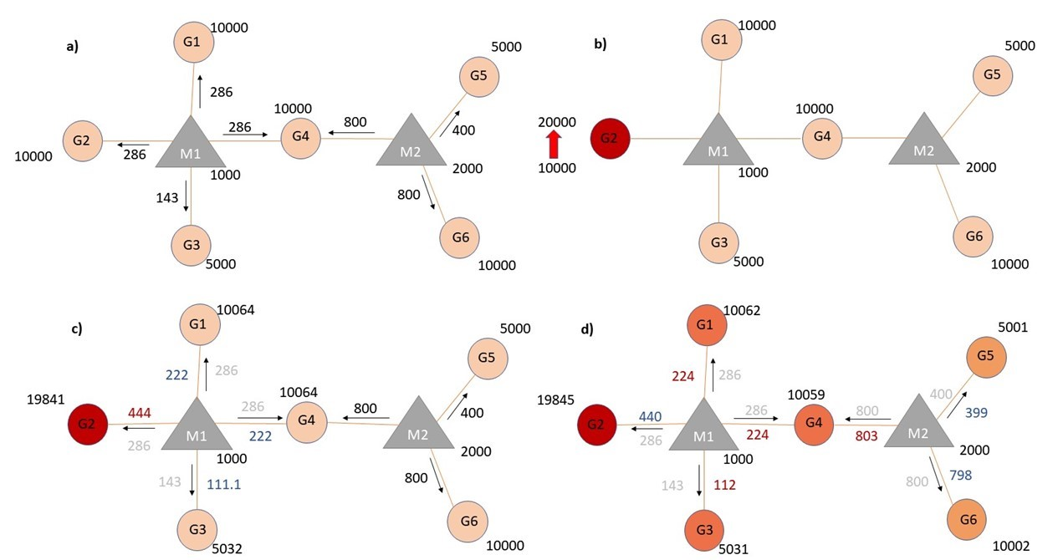

Schematic presentation of mechanism of network based model. a) In steady state, miRNAs (M: gray triangle) repress targets (G: circle coconut) according to proportion of their targets’ expression. b) Two fold increase in transcript level of Gene2 (G2) acts as a trigger (shown with red in figure). c) Distribution of miRNA1 (M1) changes. d) The change at expression (shown with light red because minor changes are occured on their expression values.) of common target effects changes of proportional distribution of miRNA2 (M2). Expression values are rounded to integers for simplicity

During calculations, following assumptions were adopted; 1) Transcription and degradation rates of miRNAs are steady and equal. 2) All available miRNAs are recycled as in miRNA:ceRNA binding, target is degraded and miRNA is unaffected. 3) ceRNA targets also have stable transcription and degradation rates and these rates are equal.

The repression efficiency of a miRNA on the individual target ($Eff_{gi}$) is calculated according to equation ; where miRNA expression ($C_{m}$) in local neighborhood is distributed among targets using individual gene expression levels ($C_{gi}$) (#FIX isn’t $C_{g}$ gene expressions in the group is equal to total of $C_{gi}$ in group? answer: its my false. now its corect.). For the genes targeted by multiple miRNAs, cooperative activity of miRNAs on a target gene, $R$, is calculated by summing repression activity of each miRNA (Equation ).

### Multifactorial calculations in miRNA:target network

Interactions between miRNAs and their targets can be affected from various factors. So, our model integrates multiple factors when calculating overall miRNA activity. We classified factors into two categories. Factors effecting binding determine interaction between miRNA and target and they alter amount of miRNA sequestered to target. Degradation efficiency factors assign amount of degradated target amount in miRNA:target pairs.(#FIX fix this sentence: answer:). In other words, binding factors exert their influence before or during binding, efficiency factors exert their influence after binding. In the literature, binding free energy (Cao and Chen 2012 ; Helwak et al. 2013) and seed type (Werfel et al. 2017) in miRNA:target interactions are described as factors effecting binding affinity. Efficiency factors determine how many of miRNA:target complexes will result in inhibition and binding region on target drastically effect miRNA degradation efficiency (Hausser et al. 2013; Helwak et al. 2013). Both binding and efficiency factors are normalized to their maximum values and scaled to [0,1] interval. The normalized values of factors take into account to determine binding activity and miRNA efficiency on targets (). Binding affinities (activity, $Eff$) of miRNAs on each individual gene are calculated as shown in equation ; $C_{m}$, miRNA expression in the group; $C_{gi}$, individual gene expression; gi, individual gene (c).

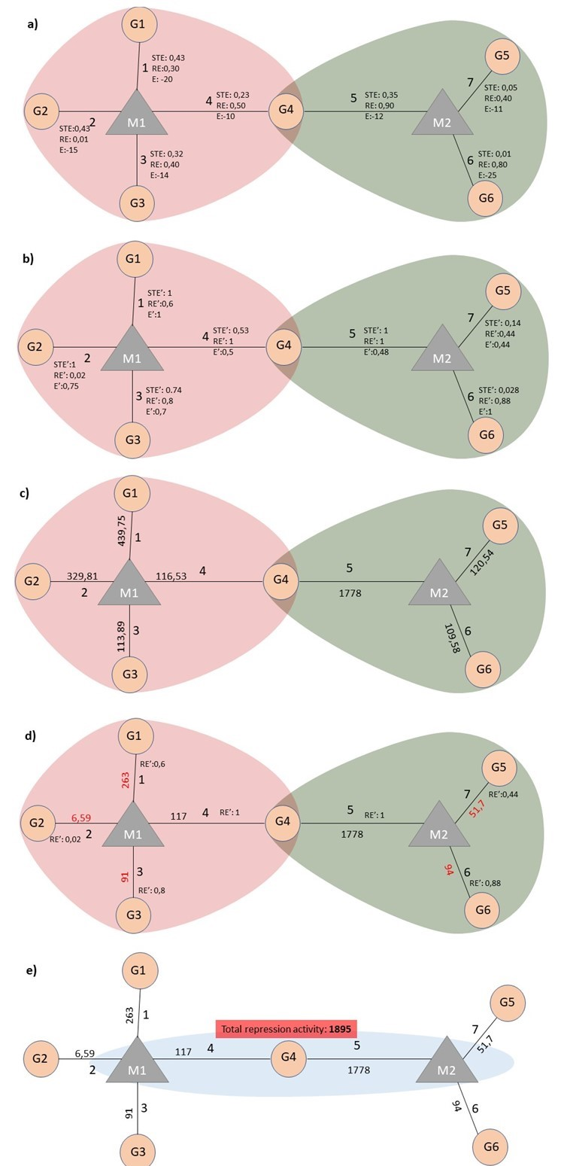

Calculations to determine of miRNA binding and repression efficiency. $G$, Gene; $M$, miRNA; $STE$, seed type effect; $RE$, Region Effect; $E$, Energy; $STE^{'}$, normalized values of seed type efficiency coefficient; $RE^{'}$, normalized values of region efficiency coefficient; $E^{'}$, normalized values of energy coefficient.

%% (#TODO the equation is not considering binding factors, right?. We should explain the calculation made in simulate function here, in simple sentences. the function looks like this: %% input_graph%>% %% tidygraph::activate(edges)%>% %% group_by(to)%>% %% mutate(mirna_count_per_comp = mirna_count_current*comp_count_current*afff_factor/sum(comp_count_current*afff_factor), mirna_count_per_comp = ifelse(is.na(mirna_count_per_comp), 0, mirna_count_per_comp))%>% %% ungroup()%>% %% mutate(effect_pre = effect_current, effect_current = mirna_count_per_comp*degg_factor)%>% %% group_by(from)%>% %% mutate(comp_count_pre = ifelse(comp_count_current< 0, 1, comp_count_current), comp_count_current = comp_count_pre - (sum(effect_current)-sum(effect_pre)), comp_count_current = ifelse(comp_count_current< 0, 1, comp_count_current))%>% %% ungroup()%>% %% mutate(comp_count_list = pmap(list(comp_count_list, comp_count_current), c), effect_list = pmap(list(effect_list, effect_current), c), mirna_count_list = pmap(list(mirna_count_list, mirna_count_current), c)) %% )

I shown in figure and explained at following. I didn’t fully understand whether it is enough or not.

After miRNA binds to its target, but might not repress to bound target. The functionality of bound miRNA on target depends on efficiency factors like region that is binding sequence of miRNA on its target. Exact repression efficiency of miRNA is calculated according to equation (d); $RE_{gi}^{'}$, normalized values of region efficiency coefficient between miRNA and gene. The cooperative repression activity of miRNAs to their common targets is figured out as shown in e.

### Breast cancer patient dataset

We have applied our model in a real dataset for which experimental measurements of various factors were available. Expression levels of miRNA and genes in tumor and normal tissue of single patient are retrieved from [TCGA](https://www.cancer.gov/about-nci/organization/ccg/research/structural-genomics/tcga)(#TODO). High-throughput experimental datasets which are provided miRNA:gene target pairs with interaction factors (Helwak et al. 2013; Moore et al. 2015). We have combined miRNA and gene expression datasets via miRNA:target gene dataset retrieved from … (#FIX name of database and its citation) answer->suplementary datasets of (Helwak et al. 2013; Moore et al. 2015). Detailed description of network construction and its code is available in Supplementary data (#TODO burada link nasıl olacak, word dosyası veya PDF dosyası ismi mi vermemiz mi gerekiyor, yoksa sadece Sup Data denilmesi yeterli mi? ilgili dosya: TCGA_E9-A1N5_article.Rmd). ABCC1 gene, over-expressed in tumor tissue, was selected as trigger for simulation of integrated dataset. After simulation of network, we have compared simulation results and tumor tissue expression levels.

## Results and Conclusions

### Networks with single factor

We have developed a network-based approach to assess effects of expression level changes in competitive ceRNA regulation. The basic mode of miRNA repression activity has been based on miRNA and target abundance in various researches(Arvey et al. 2010; Denzler et al. 2014). Our approach can effortlessly calculate effects of expression changes when abundance levels of miRNAs and targets is only available factor. In sample network given in Figure (), after an increase in expression level of a gene (G2), expression values of other genes also changed due to redistribution of miRNA among its targets. Previous studies have shown that if a gene abundance increases in ceRNA system, expression levels of genes targeted by shared miRNA are also affected (Lai, Wolkenhauer, and Vera 2016; Salmena et al. 2011; Tay, Rinn, and Pandolfi 2014). It was observed that expression levels of primary neighborhoods which do not interact with another miRNA of the trigger gene change in relation to their expression. However, expression level change of common target (G4) in network has been observed different from G1 that has the same expression value with G4 target at initial conditions because more than one miRNA repress this target (d) (#FIX last sentence needs some clarification, after “but cooperative…”).

Genes targeted by multiple miRNAs act as a trigger for adjacent local neighborhood of targeting miRNAs, causing changes in expression levels of genes outside the local neighborhood of original trigger gene. Therefore, primary expression level change in gene (G2) causes changes in other group of genes (G5 and G6) even though original trigger gene (G2) and genes in other group are not targeted by common miRNA. In addition, as shown by ceRNA hypothesis model of Ala et al., after the increase of gene expression level of G2, the miRNA that is found in the same group (M1) tended to be less repressive on its remaining targets (G1, G3 and G4). It’s important to note that the changes in gene expression levels will have more pronounced effect if miRNA:target ratio is high, i.e., more miRNA available per target, which was reported in previous findings (Arvey et al. 2010; Bosson, Zamudio, and Sharp 2014; Denzler et al. 2014).

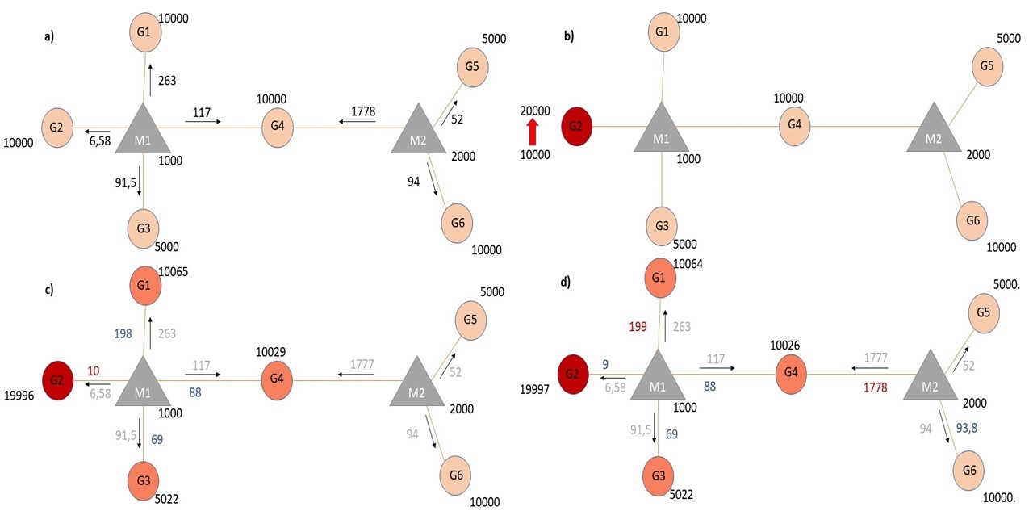

Target regulations with interaction parameters. a) In the steady-state the repression activity of miRNAs on the targets after binding and repression efficiency. b) The changes the repression activities after increasing of G2 expression. c) Perturbation of primary neighborhoods of M1 miRNA (M1 miRNA group). d) Regulation of gene expression of other gene group via triggering target (common target between M1 and M2).

### Competing Endogenous RNA:Target networks based on interaction factors

#FIX: <> “title should be more informative”-> answer.

Earlier studies reported that miRNA regulatory interactions are affected by different parameters. For example, Xu et al. have investigated the importance of seed pairing type between miRNAs and their targets and target site location by using proteomics dataset (Xu, Wang, and Liu 2014). They have proposed that the features of binding between miRNA and target can be critical for miRNA efficiency. In addition, binding energy between miRNA and targets is a significant determinant for miRNA efficiency and it has been reported that strength of miRNA:target interactions is depended on binding energy of complexes (Breda et al. 2015). Similarly, another study revealed that affinity is correlated with seed pairing of miRNA:target pairs and suggested that affinity is correlated with number of canonical seed base pairing (Bosson, Zamudio, and Sharp 2014). Therefore, we have integrated aforementioned interaction parameters that could be useful for predicting miRNA repression activity more accurately. The sample dataset used in is recalculated with additional factors in effect with same trigger, two fold increase in Gene2 (). When the factors were taken into account in the system, miRNA efficiencies varied as shown in a. Although the miRNA:target expression ratios in steady-state were same in comparison with the sample dataset without factors, efficiency of binding and repression have changed.

It is considered that entire miRNAs in the system affect targets according to target:total target ratio a, when interaction factors did not take into account. However, in presence of interaction factors in miRNA:target interaction network (shown in ), miRNAs are distributed according to target:total target ratio and affinity factors in first like shown in c. After affinity mediated propotional distribution of miRNA expression, degradation factor is considered to specify count of repressive miRNA in pairs because entire bound miRNA target pairs might not be resulted with degradation (It is figured out shown in d). For this reason, miRNA1 (M1) has more weak repressive effect (shown as edge variables) on target Gene2 a in comparison with miRNA1 (M1):Gene2 (G2) interaction in a. On the other hand, it is possible that taking into accont of these interaction factors could cause increasing miRNA repression activity like in miRNA2:Gene4 interaction a. When expression of Gene2 (G2) increased, expression values of all genes also changed differentially because of contribution of efficiency factors ( b,c,d). We have considered that in our approach energy and seed type of pairs is significant for binding and targeted region is important for repression.

In regulation of miRNA target sample system (), miRNA (M1) repressive efficiency on the primary triggering gene (G2) is low in steady-state. So it has been observed that the regulatory activities of miRNA efficiencies on the targets are weak after the increase of miRNA target G2. When model is triggered with two fold increase in expression level of common target (G4), the changes of other gene expressions have observed more prominent . Furthermore, change in expression level of target gene that has strong miRNA repression efficiency resulted in evident perturbation in network. On the other hand, it was observed that Gene2 was weakly affected from change of Gene4 expression because of its weak interaction factors. Since perturbation efficiency of each gene is different, we have developed a function which screens each gene in the network for their perturbation efficiencies. **(see details in Supplementary File(fig1_2app.Rmd)**. On the other hand, when we applied the method on the minimal dataset, Gene4 has been found to be the most efficient element in terms of number of perturbed elements and miRNA2 (M2) has been found to be causing the highest mean in expression changes. [][#TODO2]

We used our model to simulate a real dataset which contains thousands of genes and hundreds of miRNAs. Our model can successfully simulate perturbations in such large network despite complex behaviors and struggle to reach steady-state **(see details in Supplementary File(TCGA_E9-A1N5_article.Rmd)**. Simulations show that change in expression level of single gene has potential to effect whole network, perturbing almost all nodes. These observations are in accordance with competing endogenous RNA hypothesis where genes targeted with many common miRNAs subsequently transmit perturbation to neighboring groups.

Network based approaches for analyzing miRNA:target interactions have been developed in earlier studies. An initial attempt demonstrated the ceRNA crosstalk in a network-like minimal interaction structure with concentrations of ceRNA and miRNAs (Figliuzzi, Marinari, and De Martino 2013). Next, a network based kinetic model integrating miRNA and target rates of transcription, degradation, binding and unbinding was developed (Nitzan et al. 2014) using high throughput experimental dataset about miR-92a depletion (Helwak et al. 2013). In this study, it was demonstrated that distant ceRNAs can interact with each other via indirect links, and the interactions are effected depending on distance between ceRNAs or topological features of network (Nitzan et al. 2014). More recently, an approach to detect ceRNA interaction by using the miRNA expression, gene expression and common miRNAs between gene targets was developed (Markus List 2017) which was effective in analyzing genes through miRNAs. Based on the observations that a miRNA can exhibit strong functionality to a target but may not against an other, the authors have concluded that common miRNA based approach may not be suitable for understanding regulations of ceRNA interactions.

In our approach, we have not taken into account transcription, degradation or binding rates of elements in network. Because, although it is known as the miRNAs are highly stable, the transcription and degradation rates of miRNAs change depending on cellular conditions (Rüegger and Großhans 2012). However, due to lack of datasets including degradation and transcription rates of miRNAs at specific cellular conditions, such factors are neglected in our model. Additionally, other regulation parameters such as gene-gene interactions and transcription factors are ignored but the network structure is flexible and can integrate additional regulation elements as they become available. In the future, with developments in experimental techniques about miRNAs:target interaction dynamica, more accurate results can be obtained from our model resulting in better understanding and predictions of abnormal regulations and pathways underlying diseases or conditions.

## References

Ala, U., F. A. Karreth, C. Bosia, A. Pagnani, R. Taulli, V. Leopold, Y. Tay, P. Provero, R. Zecchina, and P. P. Pandolfi. 2013. “Integrated Transcriptional and Competitive Endogenous RNA Networks Are Cross-Regulated in Permissive Molecular Environments.” *Proceedings of the National Academy of Sciences* 110 (18): 7154–9. <https://doi.org/10.1073/pnas.1222509110>.

Arvey, Aaron, Erik Larsson, Chris Sander, Christina S Leslie, and Debora S Marks. 2010. “Target mRNA Abundance Dilutes microRNA and siRNA Activity.” *Molecular Systems Biology* 6 (April). <https://doi.org/10.1038/msb.2010.24>.

Bartel, David P. 2004. “MicroRNAs.” *Cell* 116 (2): 281–97. <https://doi.org/10.1016/S0092-8674(04)00045-5>.

Bartel, David P. 2009. “MicroRNAs: Target Recognition and Regulatory Functions.” *Cell* 136 (2): 215–33. <https://doi.org/10.1016/j.cell.2009.01.002>.

Bosson, Andrew D., Jesse R. Zamudio, and Phillip A. Sharp. 2014. “Endogenous miRNA and Target Concentrations Determine Susceptibility to Potential ceRNA Competition.” *Molecular Cell* 56 (3): 347–59. <https://doi.org/10.1016/j.molcel.2014.09.018>.

Breda, Jeremie, Andrzej J. Rzepiela, Rafal Gumienny, Erik van Nimwegen, and Mihaela Zavolan. 2015. “Quantifying the Strength of miRNA–Target Interactions.” *Methods* 85 (September): 90–99. <https://doi.org/10.1016/j.ymeth.2015.04.012>.

Cao, Song, and Shi-Jie Chen. 2012. “Predicting Kissing Interactions in microRNA–Target Complex and Assessment of microRNA Activity.” *Nucleic Acids Research* 40 (10): 4681–90. <https://doi.org/10.1093/nar/gks052>.

Cesana, Marcella, and George Q. Daley. 2013. “Deciphering the Rules of ceRNA Networks.” *Proceedings of the National Academy of Sciences of the United States of America* 110 (18): 7112–3. <https://doi.org/10.1073/pnas.1305322110>.

Denzler, Rémy, Vikram Agarwal, Joanna Stefano, David P. Bartel, and Markus Stoffel. 2014. “Assessing the ceRNA Hypothesis with Quantitative Measurements of miRNA and Target Abundance.” *Molecular Cell* 54 (5): 766–76. <https://doi.org/10.1016/j.molcel.2014.03.045>.

Denzler, Rémy, Sean E. McGeary, Alexandra C. Title, Vikram Agarwal, David P. Bartel, and Markus Stoffel. 2016. “Impact of MicroRNA Levels, Target-Site Complementarity, and Cooperativity on Competing Endogenous RNA-Regulated Gene Expression.” *Molecular Cell* 64 (3): 565–79. <https://doi.org/10.1016/j.molcel.2016.09.027>.

Figliuzzi, Matteo, Enzo Marinari, and Andrea De Martino. 2013. “MicroRNAs as a Selective Channel of Communication Between Competing RNAs: A Steady-State Theory.” *Biophysical Journal* 104 (5): 1203–13. <https://doi.org/10.1016/j.bpj.2013.01.012>.

Grimson, Andrew, Kyle Kai-How Farh, Wendy K. Johnston, Philip Garrett-Engele, Lee P. Lim, and David P. Bartel. 2007. “MicroRNA Targeting Specificity in Mammals: Determinants Beyond Seed Pairing.” *Molecular Cell* 27 (1): 91–105. <https://doi.org/10.1016/j.molcel.2007.06.017>.

Hafner, Markus, Markus Landthaler, Lukas Burger, Mohsen Khorshid, Jean Hausser, Philipp Berninger, Andrea Rothballer, et al. 2010. “Transcriptome-Wide Identification of RNA-Binding Protein and MicroRNA Target Sites by PAR-CLIP.” *Cell* 141 (1): 129–41. <https://doi.org/10.1016/j.cell.2010.03.009>.

Hausser, J., A. P. Syed, B. Bilen, and M. Zavolan. 2013. “Analysis of CDS-Located miRNA Target Sites Suggests That They Can Effectively Inhibit Translation.” *Genome Research* 23 (4): 604–15. <https://doi.org/10.1101/gr.139758.112>.

Helwak, Aleksandra, Grzegorz Kudla, Tatiana Dudnakova, and David Tollervey. 2013. “Mapping the Human miRNA Interactome by CLASH Reveals Frequent Noncanonical Binding.” *Cell* 153 (3): 654–65. <https://doi.org/10.1016/j.cell.2013.03.043>.

Lai, Xin, Olaf Wolkenhauer, and Julio Vera. 2016. “Understanding microRNA-Mediated Gene Regulatory Networks Through Mathematical Modelling.” *Nucleic Acids Research* 44 (13): 6019–35. <https://doi.org/10.1093/nar/gkw550>.

Lewis, Benjamin P., Christopher B. Burge, and David P. Bartel. 2005. “Conserved Seed Pairing, Often Flanked by Adenosines, Indicates That Thousands of Human Genes Are MicroRNA Targets.” *Cell* 120 (1): 15–20. <https://doi.org/10.1016/j.cell.2004.12.035>.

Markus List, Marcel Schulz. 2017. “SPONGE.” Bioconductor. <https://doi.org/10.18129/B9.bioc.SPONGE>.

Moore, Michael J., Troels K. H. Scheel, Joseph M. Luna, Christopher Y. Park, John J. Fak, Eiko Nishiuchi, Charles M. Rice, and Robert B. Darnell. 2015. “miRNA-Target Chimeras Reveal miRNA 3’-End Pairing as a Major Determinant of Argonaute Target Specificity.” *Nature Communications* 6 (November): 8864. <https://doi.org/10.1038/ncomms9864>.

Nitzan, Mor, Avital Steiman-Shimony, Yael Altuvia, Ofer Biham, and Hanah Margalit. 2014. “Interactions Between Distant ceRNAs in Regulatory Networks.” *Biophysical Journal* 106 (10): 2254–66. <https://doi.org/10.1016/j.bpj.2014.03.040>.

Robinson, J. M., and W. A. Henderson. 2018. “Modelling the Structure of a ceRNA-Theoretical, Bipartite microRNA-mRNA Interaction Network Regulating Intestinal Epithelial Cellular Pathways Using R Programming.” *BMC Research Notes* 11 (1): 19. <https://doi.org/10.1186/s13104-018-3126-y>.

Rüegger, Stefan, and Helge Großhans. 2012. “MicroRNA Turnover: When, How, and Why.” *Trends in Biochemical Sciences* 37 (10): 436–46. <https://doi.org/10.1016/j.tibs.2012.07.002>.

Salmena, Leonardo, Laura Poliseno, Yvonne Tay, Lev Kats, and Pier Paolo Pandolfi. 2011. “A ceRNA Hypothesis: The Rosetta Stone of a Hidden RNA Language?” *Cell* 146 (3): 353–58. <https://doi.org/10.1016/j.cell.2011.07.014>.

Tay, Yvonne, John Rinn, and Pier Paolo Pandolfi. 2014. “The Multilayered Complexity of ceRNA Crosstalk and Competition.” *Nature* 505 (7483): 344–52. <https://doi.org/10.1038/nature12986>.

Werfel, Stanislas, Simon Leierseder, Benjamin Ruprecht, Bernhard Kuster, and Stefan Engelhardt. 2017. “Preferential microRNA Targeting Revealed by in Vivo Competitive Binding and Differential Argonaute Immunoprecipitation.” *Nucleic Acids Research* 45 (17): 10218–28. <https://doi.org/10.1093/nar/gkx640>.

Xu, Wenlong, Zixing Wang, and Yin Liu. 2014. “The Characterization of microRNA-Mediated Gene Regulation as Impacted by Both Target Site Location and Seed Match Type.” Edited by Thomas Preiss. *PLoS ONE* 9 (9): e108260. <https://doi.org/10.1371/journal.pone.0108260>.

1. Department of Bioengineering, Yildiz Technical University, Istanbul, Turkey
2. Department of Bioengineering, Yildiz Technical University, Istanbul, Turkey