1. Implementation of Stop and Wait Protocol and Sliding Window Protocol.

STOP-WAIT PROTOCOL :

SERVER SIDE:

Acknowledgement received.

CLIENT SIDE:

Data is received

SLIDING-WINDOW PROTOCOL :

SERVER SIDE:

Acknowledgement received.

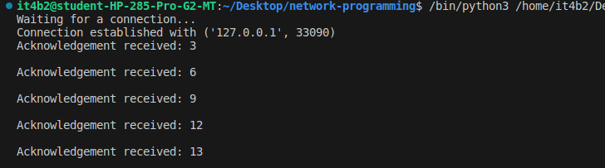
CLIENT SIDE:

Data is received
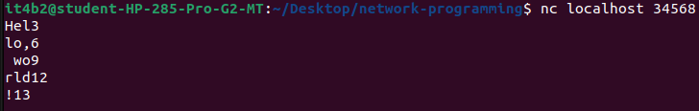
.

2. Study of Socket Programming and Client – Server model

SERVER SIDE :

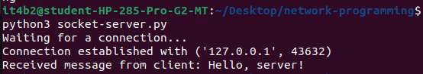
.
RECEIVER SIDE :

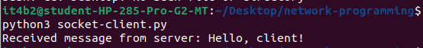
3. Write a code simulating ARP /RARP protocols.

