**Teknolojiler**

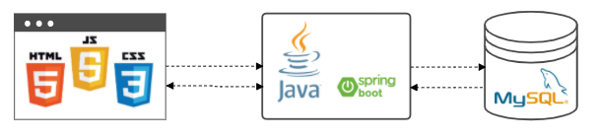

***Ekran(HTML+JS+CSS) → Uygulama(Java+Spring Boot) → Veritabanı(MySQL)***

**Ekranlar ve Kodlar**

***Kullanıcı Giriş Ekranı***

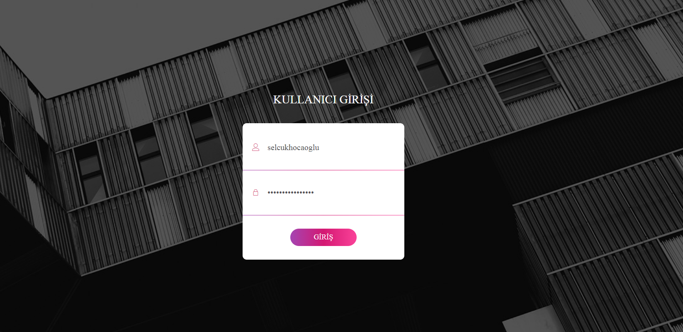

**HTML**

<!DOCTYPE html>

<html lang="tr">

<head>

<title>Proje Yönetim Sistemi</title>

<meta charset="UTF-8">

<meta name="viewport" content="width=device-width, initial-scale=1">

<link rel="icon" type="image/png" href="images/icons/favicon.ico" />

<link rel="stylesheet" type="text/css" href="vendor/bootstrap/css/bootstrap.min.css">

<link rel="stylesheet" type="text/css" href="fonts/font-awesome-4.7.0/css/font-awesome.min.css">

<link rel="stylesheet" type="text/css" href="fonts/Linearicons-Free-v1.0.0/icon-font.min.css">

<link rel="stylesheet" type="text/css" href="vendor/animate/animate.css">

<link rel="stylesheet" type="text/css" href="vendor/css-hamburgers/hamburgers.min.css">

<link rel="stylesheet" type="text/css" href="vendor/animsition/css/animsition.min.css">

<link rel="stylesheet" type="text/css" href="vendor/select2/select2.min.css">

<link rel="stylesheet" type="text/css" href="vendor/daterangepicker/daterangepicker.css">

<link rel="stylesheet" type="text/css" href="css/util.css">

<link rel="stylesheet" type="text/css" href="css/main.css">

</head>

<body>

<div class="limiter">

<div class="container-login100" style="background-image: url('images/bg-01.jpg');">

<div class="wrap-login100 p-t-30 p-b-50">

<span class="login100-form-title p-b-41">

Kullanıcı Girişi

</span>

<form class="login100-form validate-form p-b-33 p-t-5">

<div class="wrap-input100 validate-input" data-validate="Enter username">

<input class="input100" type="text" name="username" placeholder="Kullanıcı Adı">

<span class="focus-input100" data-placeholder="&#xe82a;"></span>

</div>

<div class="wrap-input100 validate-input" data-validate="Enter password">

<input class="input100" type="password" name="pass" placeholder="Şifre">

<span class="focus-input100" data-placeholder="&#xe80f;"></span>

</div>

<div class="container-login100-form-btn m-t-32">

<button class="login100-form-btn">

Giriş

</button>

</div>

</form>

</div>

</div>

</div>

<div id="dropDownSelect1"></div>

<script src="vendor/jquery/jquery-3.2.1.min.js"></script>

<script src="vendor/animsition/js/animsition.min.js"></script>

<script src="vendor/bootstrap/js/popper.js"></script>

<script src="vendor/bootstrap/js/bootstrap.min.js"></script>

<script src="vendor/select2/select2.min.js"></script>

<script src="vendor/daterangepicker/moment.min.js"></script>

<script src="vendor/daterangepicker/daterangepicker.js"></script>

<script src="vendor/countdowntime/countdowntime.js"></script>

<script src="https://unpkg.com/axios/dist/axios.min.js"></script>

<script src="js/main.js"></script>

<script async src="https://www.googletagmanager.com/gtag/js?id=UA-23581568-13"></script>

<script>

window.dataLayer = window.dataLayer || [];

function *gtag*() {

dataLayer.push(arguments);

}

*gtag*('js', new Date());

*gtag*('config', 'UA-23581568-13');

</script>

</body>

</html>

**JS**

(function($) {

"use strict";

$('.input100').each(function() {

$(this).on('blur', function() {

if ($(this).val().trim() != "") {

$(this).addClass('has-val');

} else {

$(this).removeClass('has-val');

}

})

})

var input = $('.validate-input .input100');

$('.validate-form').on('submit', function() {

var check = true;

var response;

for (var i = 0; i < input.length; i++) {

if (validate(input[i]) == false) {

showValidate(input[i]);

check = false;

}

}

if(check==true) {

var kullaniciAdi = $(input[0]).val(); *// kullanici adi*

var sifre = $(input[1]).val(); *// sifre*

const endPoint = "http://localhost:8081/projeyonetim/kullanici";

window.location.href = 'proje_tablo/user_page.html?kullaniciAdi='+kullaniciAdi;

*/*axios({*

*method: "post",*

*url: endPoint,*

*data: {*

*kullaniciAdi: kullaniciAdi,*

*sifre: sifre*

*}*

*})*

*.then(data => alert(data.data.kullanici.sifre))*

*.catch(err => console.log(err))*

*\*/*

}

return check;

});

$('.validate-form .input100').each(function() {

$(this).focus(function() {

hideValidate(this);

});

});

function validate(input) {

if ($(input).attr('type') == 'email' || $(input).attr('name') == 'email') {

if ($(input).val().trim().match(/^([a-zA-Z0-9_\-\.]+)@((\[[0-9]{1,3}\.[0-9]{1,3}\.[0-9]{1,3}\.)|(([a-zA-Z0-9\-]+\.)+))([a-zA-Z]{1,5}|[0-9]{1,3})(\]?)$/) == null) {

return false;

}

} else {

if ($(input).val().trim() == '') {

return false;

}

}

}

function showValidate(input) {

var thisAlert = $(input).parent();

$(thisAlert).addClass('alert-validate');

}

function hideValidate(input) {

var thisAlert = $(input).parent();

$(thisAlert).removeClass('alert-validate');

}

var showPass = 0;

$('.btn-show-pass').on('click', function() {

if (showPass == 0) {

$(this).next('input').attr('type', 'text');

$(this).addClass('active');

showPass = 1;

} else {

$(this).next('input').attr('type', 'password');

$(this).removeClass('active');

showPass = 0;

}

});

})(jQuery);

***Öğrenci Kullanıcı Ekranı***

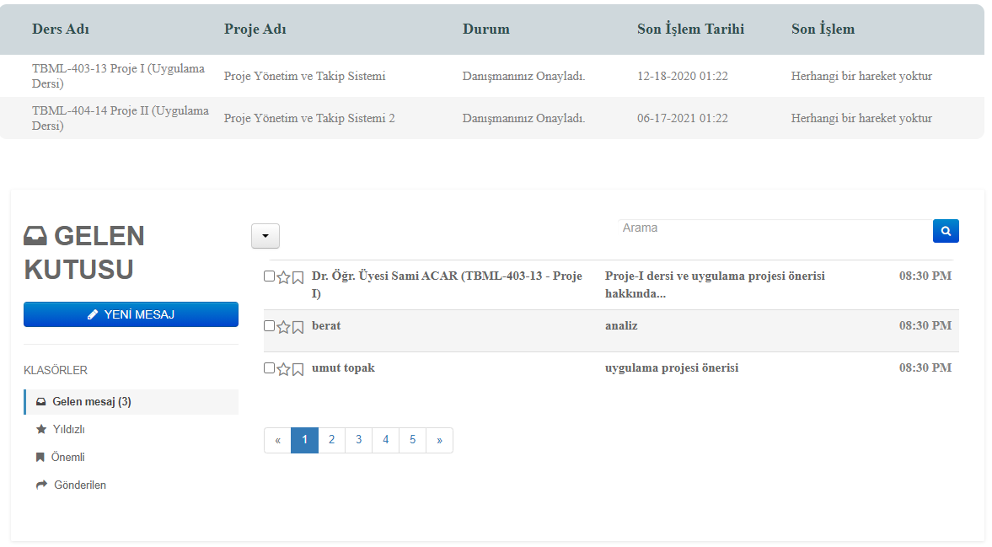

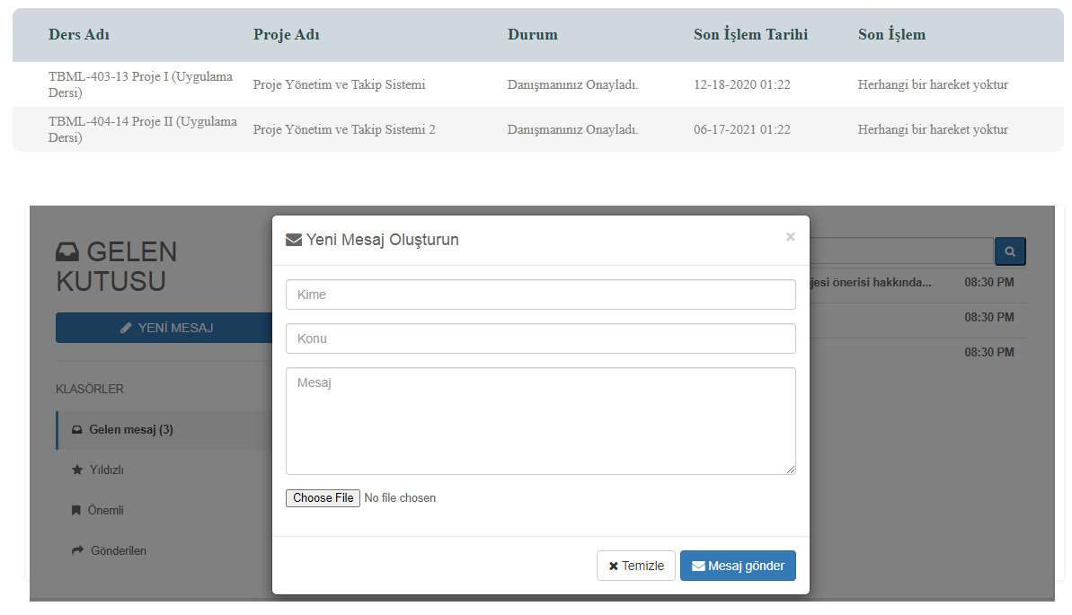

**Kod Link :**

<https://github.com/selcuk0188/proje-yonetim-2/tree/master/proje_tablo>

***Danışman Öğretmen Kullanıcı Ekranı***

**Onay ve Listeleme Ekranı**

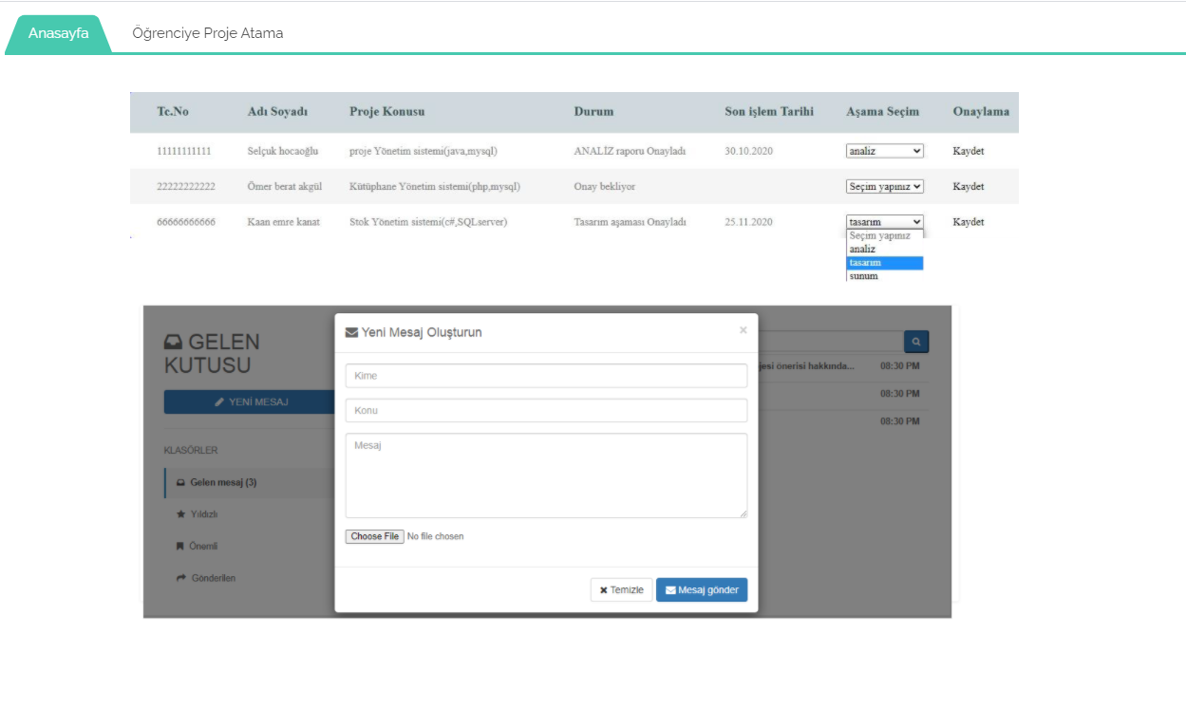

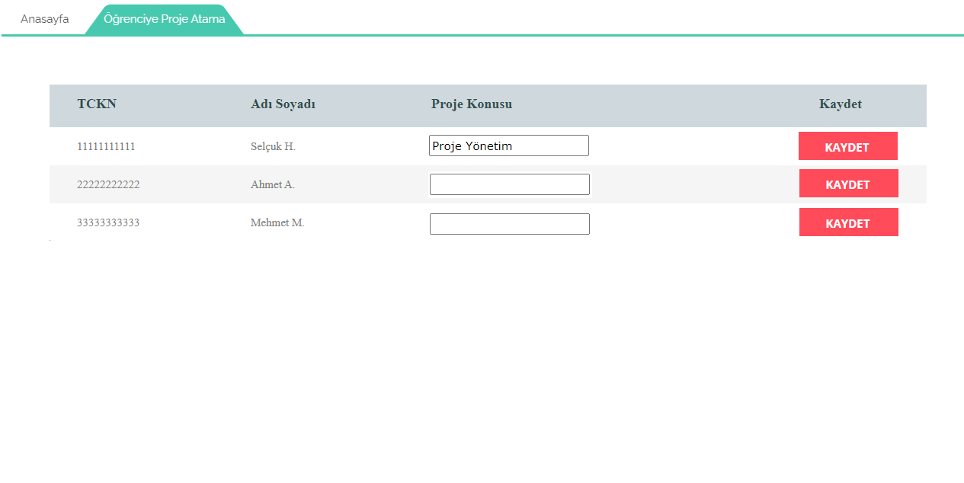

***Sistem Yönetici Kullanıcı Ekranı***

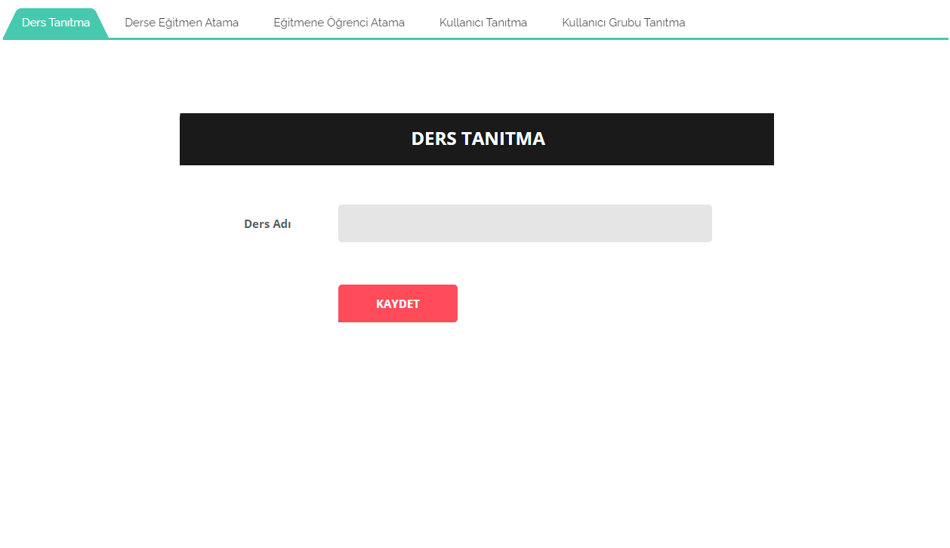

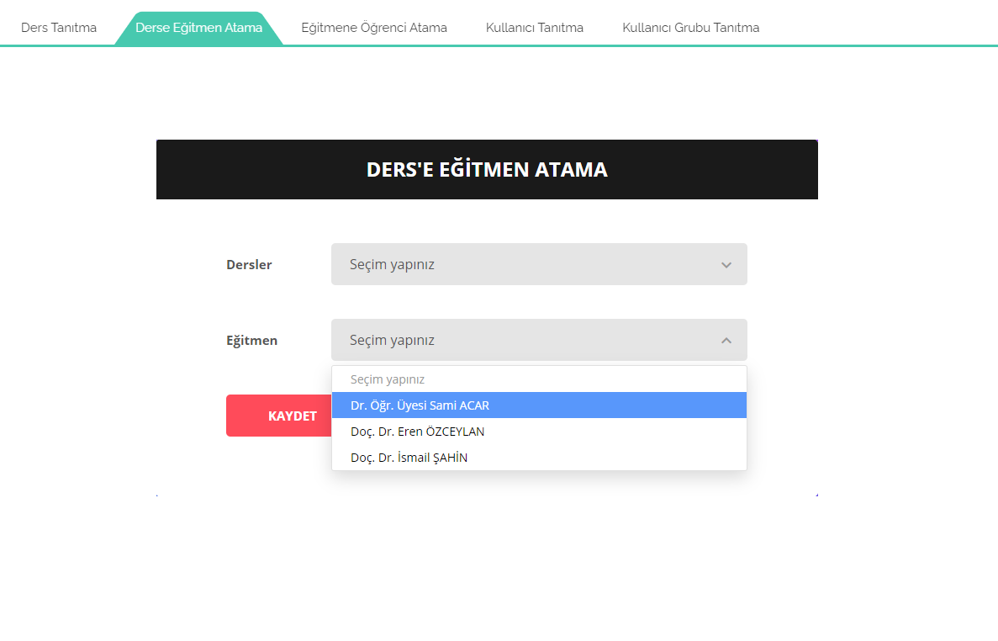

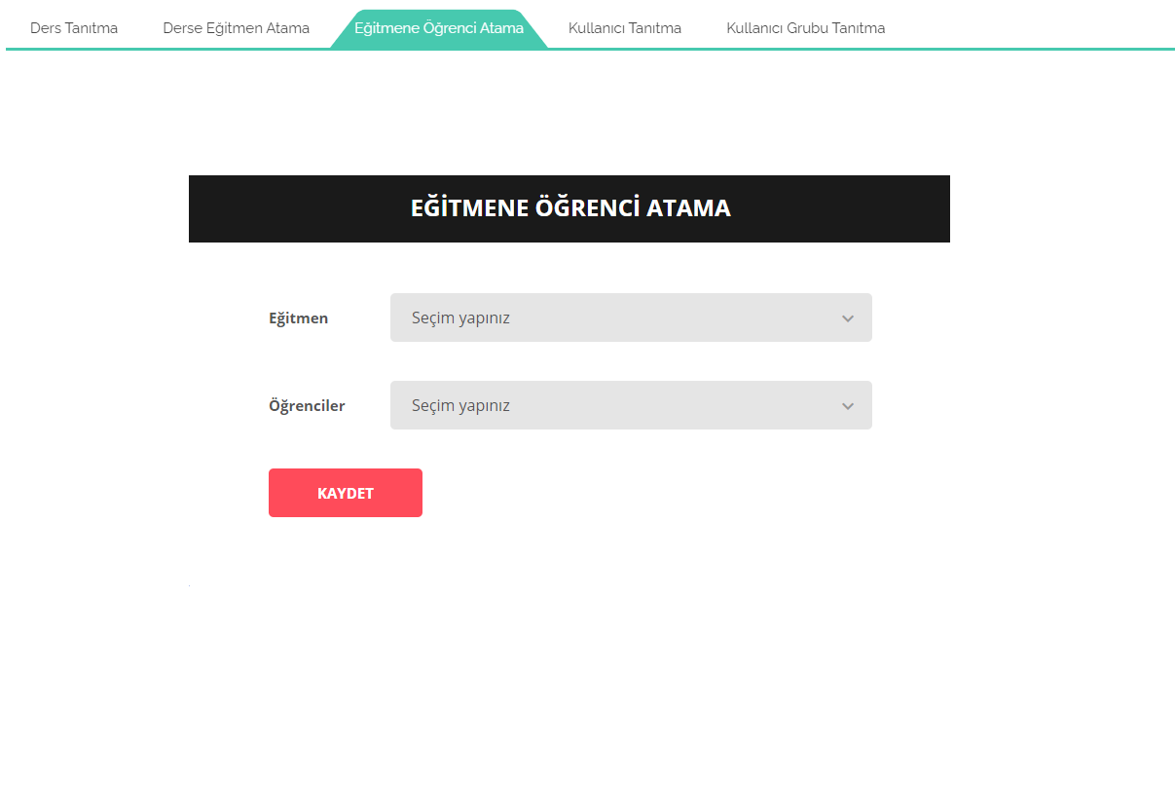

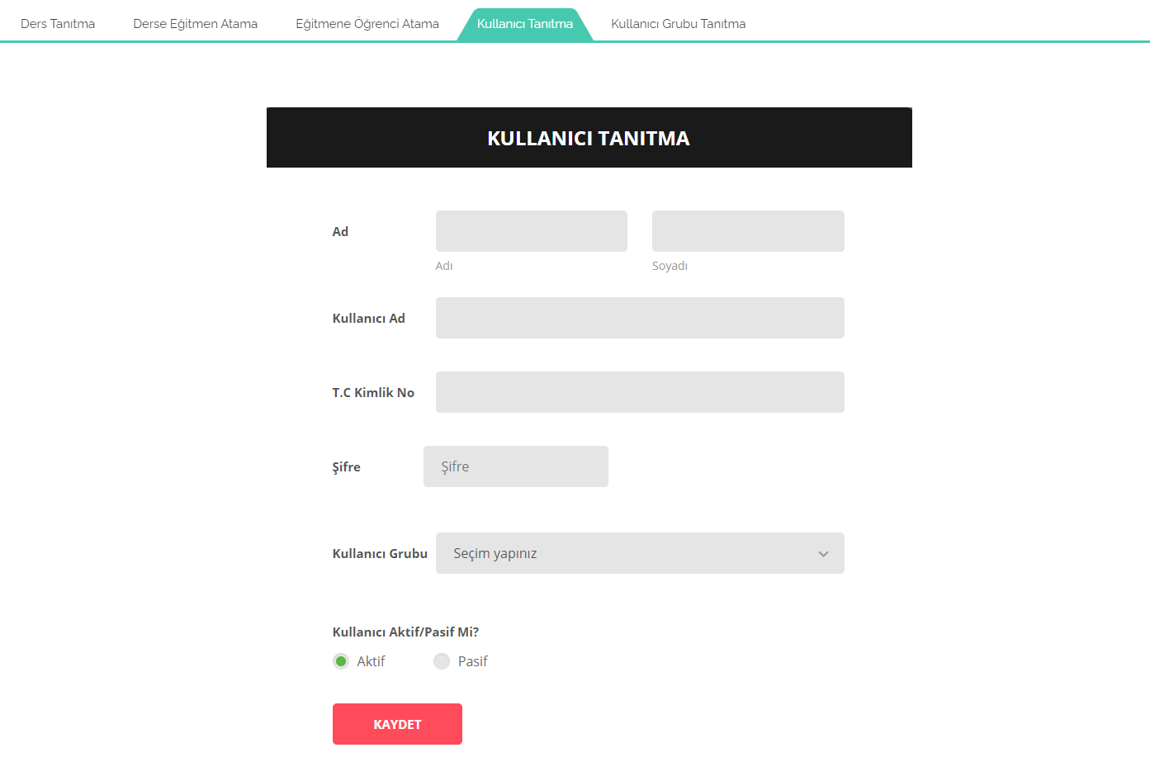

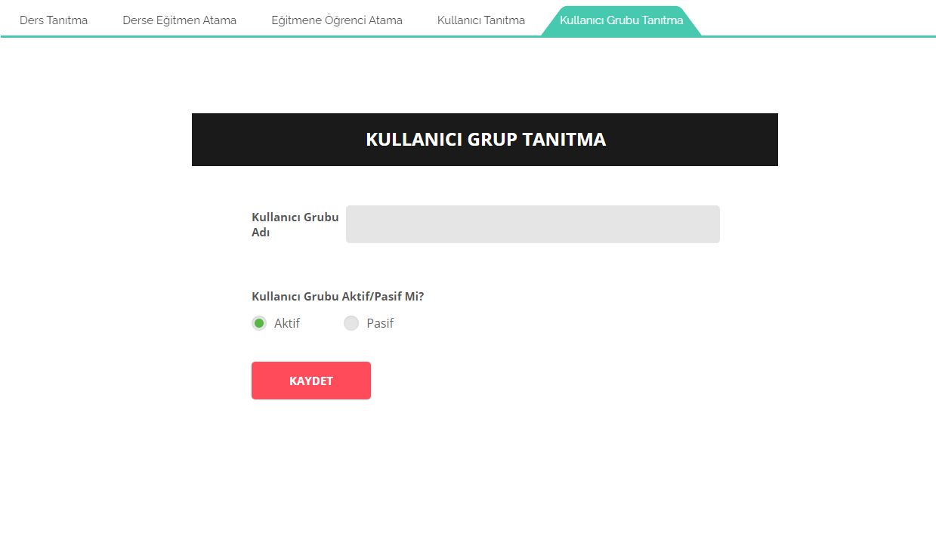

**Uygulama Proje Yapısı**

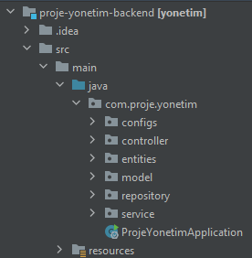

Ekran → **Controller → Service → Repository** → Veritabanı

**Uygulama Kodları**

**Link:** <https://github.com/selcuk0188/proje-yonetim-backend>

***Entity***

**Ders**

@Entity

@Table(name = **"ders"**)

**public class** Ders {

@Id

**private** Integer **id**;

@Column(name = **"ders_adi"**)

**private** String **dersadi**;

}

**Kullanıcı**

@Entity

@Table(name = **"kullanici"**)

**public class** Kullanici {

@Id

**private** Integer **id**;

@Column(name = **"ad_soyad"**)

**private** String **adSoyad**;

@Column(name = **"kullanici_adi"**)

**private** String **kullaniciAdi**;

@Column(name = **"sifre"**)

**private** String **sifre**;

@Column(name = **"durum"**)

**private** String **durum**;

@Column(name = **"tc_no"**)

**private** String **tcNo**;

@OneToOne(cascade = CascadeType.***ALL***)

@JoinColumn(name = **"rol_id"**, referencedColumnName = **"id"**)

**private** Rol **rol**;

}

**Rol**

@Entity

@Table(name = "rol")

public class Rol {

@Id

private Integer id;

@Column(name = "rol_adi")

private String roladi;

@Column(name = "rol_yetki")

private String rolyetki;

@Column(name = "rol_tanim")

private String roltanim;

}

**Mesaj**

@Entity

@Table(name = "mesaj")

public class Mesaj {

@Id

private Integer id;

@Column(name = "mesaj_basligi")

private String mesajbasligi;

@Column(name = "mesaj_konusu")

private String mesajkonusu;

@Column(name = "mesaj_icerigi")

private String mesajicerigi;

@Column(name = "yeni_mesaj_mi")

private String yenimesajmi;

@Column(name = "dosya_eki_var_mi")

private String dosyaekivarmi;

@Column(name = "dosya_icerigi")

private String dosyaicerigi;

@Column(name = "gonderen_kullanici_id")

private Integer gonderenkullaniciid;

@Column(name = "gonderilen_kullanici_id")

private Integer gönderilenkullaniciid;

@Column(name = "okuyan_sayisi")

private Integer okuyansayisi;

@Column(name = "okumayan_sayisi")

private Integer okumayansayisi;

@Column(name = "durum")

private String durum;

@Column(name = "kullanici_id")

private Integer kullaniciId;

@Column(name = "tarih")

private Date tarih;

}

**Proje**

@Entity

@Table(name = "proje")

public class Proje {

@Id

private Integer id;

@Column(name = "proje_adi")

private String projeAdi;

@Column(name = "son_islem")

private Date sonIslem;

@Column(name = "son_islem_tarihi")

private String sonIslemTarihi;

@Column(name = "kullanici_id")

private Integer kullaniciId;

@OneToOne

@JoinColumn(name = "ders_id", referencedColumnName = "id")

private Ders dersid;

@OneToOne

@JoinColumn(name = "id", referencedColumnName = "proje_id")

private ProjeOnay projeOnay;

}

**ProjeOnay**

@Entity

@Table(name = "proje_onay")

public class ProjeOnay {

@Id

private Integer id;

@Column(name = "proje_id")

private Integer projeId;

@Column(name = "durum")

private String durum;

}

***Repository***

**Ders**

**public interface** DersRepository **extends** JpaRepository<Ders, Integer> {

}

**Kullanici**

**public interface** KullaniciRepository **extends** JpaRepository<Kullanici, Integer> {

Kullanici findByKullaniciAdiAndSifre(String kullaniciAdi, String sifre);

}

**Mesaj**

**public interface** MesajRepository **extends** JpaRepository<Mesaj, Integer> {

List<Mesaj> findBykullaniciId(Integer kullaniciId);

}

**Proje**

**public interface** ProjeRepository **extends** JpaRepository<Proje, Integer> {

List<Proje> findBykullaniciId(Integer kullaniciId);

}

**ProjeOnay**

**public interface** ProjeOnayRepository **extends** JpaRepository<ProjeOnay, Integer> {

ProjeOnay findByProjeId(Integer projeId);

}

**Rol**

**public interface** RolRepository **extends** JpaRepository<Rol, Integer> {

}

***Controller***

**Ders**

@RestController

public class DersController {

@Autowired

private DersService dersService;

@RequestMapping(value = "/dersListele", method = RequestMethod.*POST*)

public DersResponse dersListele() {

return dersService.getDers();

}

@RequestMapping(value = "/dersKaydet", method = RequestMethod.*POST*)

public DersKayitResponse dersKaydet(@RequestBody Ders ders) {

return dersService.saveDers(ders);

}

}

**Kullanici**

@RestController

public class KullaniciController {

@Autowired

private KullaniciService kullaniciService;

*//@CrossOrigin(origins = "http://localhost:63342")*

@RequestMapping(value = "/kullaniciListele", method = RequestMethod.*POST*)

public KullaniciResponse kullaniciListele(@RequestBody KullaniciRequest request) {

return kullaniciService.getKullaniciList(request);

}

@RequestMapping(value = "/kullaniciLogin", method = RequestMethod.*POST*)

public LoginKullaniciResponse kullaniciLogin(@RequestParam("kullaniciAdi") String kullaniciAdi, @RequestParam("sifre") String sifre) {

return kullaniciService.getKullanici(kullaniciAdi, sifre);

}

@RequestMapping(value = "/kullaniciKayit", method = RequestMethod.*POST*)

public KullaniciKayitResponse kullaniciKayit(@RequestBody Kullanici kullanici) {

return kullaniciService.saveKullanici(kullanici);

}

@RequestMapping(value = "/kullaniciGuncelle", method = RequestMethod.*POST*)

public KullaniciGuncelleResponse kullaniciGuncelle(@RequestBody Kullanici kullanici) {

return kullaniciService.updateKullanici(kullanici);

}

@RequestMapping(value = "/kullaniciSil", method = RequestMethod.*POST*)

public KullaniciSilResponse kullaniciSil(@RequestParam("kullaniciId") Integer kullaniciId) {

return kullaniciService.deleteKullanici(kullaniciId);

}

}

**Mesaj**

@RestController

**public class** MesajController {

@Autowired

**private** MesajService **mesajService**;

@RequestMapping(value = **"/mesajListele"**, method = RequestMethod.***POST***)

**public** MesajResponse mesajListele() {

**return mesajService**.getMesajList();

}

@RequestMapping(value = **"/mesajByKullaniciId"**, method = RequestMethod.***POST***)

**public** MesajResponse mesajByKullaniciId(@RequestParam(**"kullaniciId"**) Integer kullaniciId) {

**return mesajService**.getMesajBykullaniciId(kullaniciId);

}

@RequestMapping(value = **"/mesajKayit"**, method = RequestMethod.***POST***)

**public** MesajKayitResponse mesajKayit(@RequestBody Mesaj mesaj) { **return mesajService**.mesajKayit(mesaj);

}

}

**Proje**

@RestController

**public class** ProjeController {

@Autowired

**private** ProjeService **projeService**;

@RequestMapping(value = **"/projeListele"**, method = RequestMethod.***POST***)

**public** ProjeListResponse projeListele() {

**return projeService**.getProjeList();

}

@RequestMapping(value = **"/projeBykullaniciId"**, method = RequestMethod.***POST***)

**public** ProjeListResponse projeBykullaniciId(@RequestParam(**"kullaniciId"**) Integer kullaniciId) {

**return projeService**.getProjeBykullaniciId(kullaniciId);

}

@RequestMapping(value = **"/projeKaydet"**, method = RequestMethod.***POST***)

**public** ProjeKayitResponse projeKaydet(@RequestBody Proje proje) {

**return projeService**.saveProje(proje);

}

@RequestMapping(value = **"/projeAta"**, method = RequestMethod.***POST***)

**public** ProjeKayitResponse projeAta(@RequestParam(**"projeId"**) Integer projeId, @RequestParam(**"kullaniciId"**) Integer kullaniciId) {

**return projeService**.assignProje(projeId, kullaniciId);

}

}

**ProjeOnay**

@RestController

**public class** ProjeOnayController {

@Autowired

**private** ProjeOnayService **projeOnayService**;

@RequestMapping(value = **"/projeOnayListele"**, method = RequestMethod.***POST***)

**public** ProjeOnayResponse projeOnayListele() {

**return projeOnayService**.getProjeOnay();

}

@RequestMapping(value = **"/projeOnayGuncelle"**, method = RequestMethod.***POST***)

**public** ProjeOnayGuncelleResponse projeOnayGuncelle(@RequestBody ProjeOnay projeOnay) {

**return projeOnayService**.updateProjeOnay(projeOnay);

}

}

**Rol**

@RestController

**public class** RolController {

@Autowired

**private** RolService **rolService**;

@RequestMapping(value = **"/rolListele"**, method = RequestMethod.***POST***)

**public** Role Response rolListele() {

**return rolService**.getRol();

}

}

***Service***

[**https://github.com/selcuk0188/proje-yonetim-backend/tree/master/src/main/java/com/proje/yonetim/service**](https://github.com/selcuk0188/proje-yonetim-backend/tree/master/src/main/java/com/proje/yonetim/service)