LangChain lab sheet
Nov 3, 2026

How to work
Write each answer in the lab/ folder of the applied-llm-langchain repository (some questions give you a starter file), and run it from the applied-llm-langchain folder, as with the examples:
uv run python lab/q1_token_chatbot.py
Use "ollama:llama3.2:1b" as the model unless a question says otherwise.
How to answer: write or paste into the empty box under each grey header. Paste code and terminal output as text; add screenshots as pictures, with your prompt (user name) and the command visible.
Your details · name, student ID, date, and the output of ollama --version
Selçuk Aloba
20221701075
3.11.26
ollama version is 0.40.2
ollama3.2:3b was not installed on my machine, so per my instructor's approval, I used llama3.2:1b for all Q2 tasks.

Q1 · A chatbot that counts its tokens
Open lab/q1_token_chatbot.py and fill in the YOUR TURN part: a chatbot that runs in an infinite loop and, after every assistant reply, shows how many tokens the conversation has used so far.
Requirements
- The loop never stops on its own: it keeps asking You: until the user types quit.
- The bot remembers the conversation. Ask "What is my name?" after telling it your name to check.
- After every reply, print the tokens of that turn (input and output) and the cumulative totals since the start: input, output and both together.
Example run (your replies and numbers will differ)
You: Hi, my name is Ada.
Assistant: Hello Ada, how can I assist you today?
[this turn: 41 in, 11 out | total: 41 in, 11 out, 52 tokens]
You: What is a credit card late fee?
Assistant: A credit card late fee is a charge imposed by a credit card issuer ...
[this turn: 69 in, 68 out | total: 110 in, 79 out, 189 tokens]
You: What is my name?
Assistant: Your name is Ada.
[this turn: 151 in, 6 out | total: 261 in, 85 out, 346 tokens]
You: quit
Hints
- Start from examples/02_chat_loop.py (slide 7). It stops after 10 turns; yours must not.
- Every reply has a usage_metadata field (slide 8); examples/05_cost.py (slide 10) adds it up.
Think about
- The third question is the shortest, so why does it have the most input tokens?
- If the chat goes on for 50 turns, what happens to the input tokens of each turn, and to the total?
Your answers to Q1
Your code · paste the lines you wrote in the YOUR TURN part
"""Lab - Q1 - A chatbot that counts its tokens ..."""

from langchain.chat_models import init_chat_model

model = init_chat_model("ollama:llama3.2:1b")

messages = [{"role": "system", "content": "You are a helpful assistant. Be brief."}]
total_in = total_out = 0

while True:
user = input("You: ").strip()
if user.lower() == "quit":
break

messages.append({"role": "user", "content": user})
reply = model.invoke(messages)
messages.append({"role": "assistant", "content": reply.content})

usage = reply.usage_metadata or {}
turn_in = usage.get("input_tokens", 0)
turn_out = usage.get("output_tokens", 0)
total_in += turn_in
total_out += turn_out

print(f"Assistant: {reply.content}")
print(
f" [this turn: {turn_in} in, {turn_out} out | "
f"total: {total_in} in, {total_out} out, {total_in + total_out} tokens]"
)

Terminal output · paste the whole run as text. Use your own name instead of Ada, and ask at least the three questions of the example
C:\Users\aloba\applied-llm-langchain>uv run python lab\q1_token_chatbot.py
You: hi my name is selcuk
Assistant: Hello Selcuk. How can I assist you today?
[this turn: 41 in, 13 out | total: 41 in, 13 out, 54 tokens]
You: What is a credit card late fee?
Assistant: A credit card late fee is a charge imposed by a credit card issuer if you're late with a payment. It's usually a percentage of the outstanding balance, ranging from 1% to 5% per month, and can be waived if you pay the fee before the due date.
[this turn: 71 in, 59 out | total: 112 in, 72 out, 184 tokens]
You: how can i avoid it
Assistant: To avoid or reduce credit card late fees:

1. **Pay on time**: Set up automatic payments or reminders to ensure you pay on time.
2. **Keep your account in good standing**: Pay your balance in full each month to avoid late fees.
3. **Contact your issuer**: If you're having trouble making payments, communicate with your credit card issuer to discuss possible hardship programs or temporary payment extensions.
4. **Check your balance regularly**: Monitor your account regularly to ensure you're not overextending yourself.
5. **Consider a payment plan**: If you're experiencing financial difficulties, ask your issuer about payment plan options or temporary reduced payments.
6. **Use a credit card with no foreign transaction fees**: If you travel abroad, choose a credit card with no foreign transaction fees to avoid additional charges.

By following these tips, you can avoid or minimize credit card late fees.
[this turn: 144 in, 179 out | total: 256 in, 251 out, 507 tokens]
You: what is my name
Assistant: Your name is Selcuk.
[this turn: 336 in, 8 out | total: 592 in, 259 out, 851 tokens]
You: quit

C:\Users\aloba\applied-llm-langchain>

Screenshot · the terminal with the command and the run
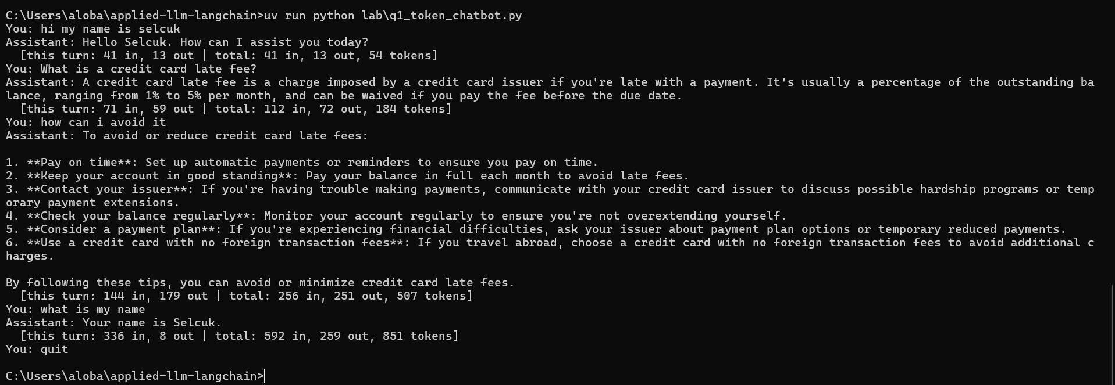

Think about 1 · why does the shortest question have the most input tokens? (2–3 sentences)
Even if the last question is very short, it uses more input tokens because the chatbot sends the whole conversation history with every new question. As the conversation gets longer, the number of input tokens increases, and the total token usage can grow very quickly. This can eventually exceed the model's context limit.

Bonus · switch to a smaller model when the chat gets long
Copy your Q1 answer to lab/q1_bonus_switch_model.py. Start with "ollama:llama3.2:1b". When the cumulative total passes a threshold (say 300 tokens), switch to the smaller "ollama:qwen2.5:0.5b" for the rest of the chat. Tell the user when the switch happens, and show which model answered on every token line. Keep the conversation history: the new model gets the same messages list.
First, download the model once:
ollama pull qwen2.5:0.5b
Example run:
You: Hi, my name is Ada.
Assistant: Hello Ada, how can I help you today?
[ollama:llama3.2:1b | this turn: 41 in, 11 out | total: 41 in, 11 out, 52 tokens]
You: What is a credit card late fee?
Assistant: A credit card late fee is a charge imposed by some credit card issuers ...
[ollama:llama3.2:1b | this turn: 69 in, 64 out | total: 110 in, 75 out, 185 tokens]
You: How can I avoid it?
Assistant: To avoid late fees, make sure to: ...
[ollama:llama3.2:1b | this turn: 148 in, 107 out | total: 258 in, 182 out, 440 tokens]
>>> 440 tokens used, over the limit of 300: switching to ollama:qwen2.5:0.5b. The conversation so far is kept.
You: What is my name?
Assistant: Your name is Ada.
[ollama:qwen2.5:0.5b | this turn: 259 in, 6 out | total: 517 in, 188 out, 705 tokens]
You: quit
Think about: does the smaller model still know your name? Why can you swap the model in the middle of a conversation at all?
Your answers to the Q1 bonus
Your code · paste the lines that check the total and switch the model
if current_model_name == BIG_MODEL and total > THRESHOLD:
print(
f" >>> {total} tokens used, over the limit of {THRESHOLD}: "
f"switching to {SMALL_MODEL}. The conversation so far is kept."
)
current_model_name = SMALL_MODEL
model = init_chat_model(SMALL_MODEL)

Terminal output · paste the whole run as text; it must include the line where the model switches
C:\Users\aloba\applied-llm-langchain>uv run python lab\q1_bonus_switch_model.py
You: hi my name is selcuk
Assistant: Hello Selcuk, how can I assist you today?
[ollama:llama3.2:1b | this turn: 41 in, 13 out | total: 41 in, 13 out, 54 tokens]
You: What is a credit card late fee?
Assistant: A credit card late fee is a small charge imposed by most credit card issuers when a customer is late with their monthly payment. The amount of the fee varies by credit card issuer, but it's typically a percentage of the outstanding balance, such as $5 to $25.

For example, if you have a credit card with a $1,000 balance and a 2% late fee, you'll be charged $20 per month if you're 30 days late with your payment.
[ollama:llama3.2:1b | this turn: 71 in, 100 out | total: 112 in, 113 out, 225 tokens]
You: How can I avoid it?
Assistant: To avoid a credit card late fee, make sure to pay your balance on time. Here are some tips:

1. Set up automatic payments: Arrange for your payment to be automatically deducted from your bank account on the due date.
2. Keep your account balance low: Try to keep your balance below 30% of your credit limit to minimize the risk of being charged a late fee.
3. Check your statements regularly: Monitor your account statements to ensure you're not missing any payments.
4. Pay the minimum payment: If you can't pay the full balance, try to pay the minimum payment to avoid being charged a late fee.
5. Consider a payment plan: If you're having trouble making a payment, ask your credit card issuer if they can offer a payment plan or temporary hardship program.

By following these tips, you can help avoid a late fee and maintain a healthy credit score.
[ollama:llama3.2:1b | this turn: 186 in, 181 out | total: 298 in, 294 out, 592 tokens]
>>> 592 tokens used, over the limit of 300: switching to ollama:qwen2.5:0.5b. The conversation so far is kept.
You: What is my name?
Assistant: Hello Selcuk, thank you for asking! My name is "Selcuk". How can I assist you today?
[ollama:qwen2.5:0.5b | this turn: 375 in, 26 out | total: 673 in, 320 out, 993 tokens]
You: quit

Screenshot · the terminal with the switch message visible
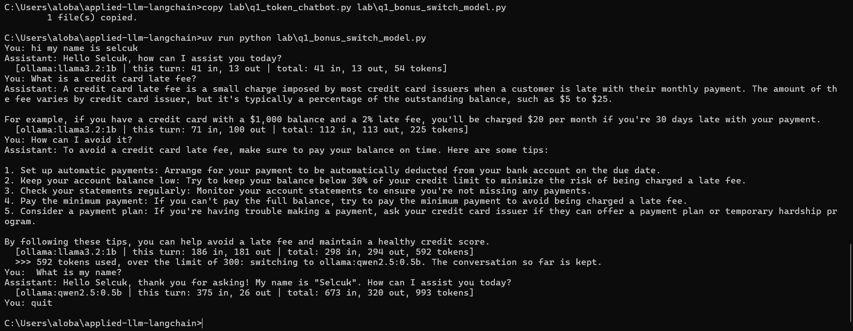

Think about · did the smaller model still know your name? Why can you swap the model mid-conversation?
The smaller model, qwen2.5:0.5b could still see the full conversation history.So, it knew the name Selcuk. However, it mixed up the roles and said My name is Selcuk instead of Your name is Selcuk. In LangChain, the model does not store memory by itself. The conversation history is kept in the messages list, so we can change the model and continue using the same messages.

Q2 · Counting complaints by urgency, three ways
data/complaints.md holds 18 customer complaints, separated by lines with only ---. The bank wants to know how many complaints there are for each urgency, using this scale:
Urgency | Meaning
5 | Money is being lost or is at risk right now (fraud, a stolen card, an unknown payment)
4 | The customer can't get to money they need soon
3 | A wrong charge or a mistake that needs fixing, but no harm yet
2 | A service problem or an inconvenience
1 | Feedback or a suggestion, no money involved
Read through the file first. Some complaints are tricky on purpose: an angry customer with a small problem, a polite one with a serious problem, and numbers in the text that aren't urgencies.
There is one file per method, and they all look alike: the loop reads the complaints, counts the urgencies and prints the totals. You only fill in the lines marked YOUR TURN, which set urgency to an int, or to "invalid" when the answer can't be used. Every answer outside 1–5 is counted as invalid. Q2 uses ollama:llama3.2:3b, and each file takes about 20 seconds to run.
(i) Prompting: lab/q2a_prompting.py. Ask the model to rate the complaint from 1 to 5 and to answer with the number only. Turn reply.content into an int yourself; if that fails, use "invalid".
(ii) A simple schema: lab/q2b_simple_schema.py. Write a pydantic class with just product: str and urgency: int, as on slide 14 (examples/07_structured_output.py). Send only the complaint text and take the urgency field.
(iii) A schema with proper fields and definitions: lab/q2c_detailed_schema.py. As on slides 15–18 (examples/08_structured_output_fields.py):
- make product a Literal of the allowed products;
- limit urgency to 1–5 with Field(ge=..., le=...) and give it a description;
- send the scale (SCALE in the file) in a system prompt, and tell the model to judge by the risk to the money, not by the customer's tone.
In (ii) and (iii), invoke raises an exception when the reply doesn't fit the schema: catch it and use "invalid".
Expected counts
Urgency | 1 | 2 | 3 | 4 | 5 | invalid
Complaints | 4 | 3 | 4 | 3 | 4 | 0
Your numbers won't match these exactly; the point is to compare the three methods.
Hints
- model.with_structured_output(Complaint) returns a version of the model whose invoke returns a Complaint object.
- A system prompt goes in a messages list: [{"role": "system", ...}, {"role": "user", ...}].
Think about
- What does (i) do with an answer like "Urgency: 4"? What does (ii) return that isn't a valid urgency?
- Look at the line printed for each complaint. Which complaints does each method get wrong?
- (ii) and (iii) both return an int. Why does (iii) give so much better answers?
- Structured output guarantees the format of the answer. Does it guarantee the answer is right?
Your answers to Q2
(i) Your code · paste the lines you wrote in q2a_prompting.py
reply = model.invoke(
f"Rate the urgency of this customer complaint on a scale from 1 (low) "
f"to 5 (critical). Answer with the number only, no other text.\n\n"
f"Complaint:\n{complaint.strip()}"
)
try:
urgency = int(str(reply.content).strip())
except ValueError:
urgency = "invalid"

if urgency not in [1, 2, 3, 4, 5]:
urgency = "invalid"

(i) Terminal output · paste the whole run: the line per complaint and the counts
C:\Users\aloba\applied-llm-langchain>ollama list
NAME ID SIZE MODIFIED
nomic-embed-text:latest 0a109f422b47 274 MB 58 minutes ago
qwen2.5:0.5b a8b0c5157701 397 MB About an hour ago
llama3.2:1b baf6a787fdff 1.3 GB 4 weeks ago

C:\Users\aloba\applied-llm-langchain>uv run python lab\q2a_prompting.py
1 | Someone I don't know used my card to buy a TV online this mo
1 | Hello. I am writing to let you know that I think someone may
1 | I got a text asking me to confirm a payment of 2,400 to an a
2 | My wallet was stolen on the train an hour ago with my debit
2 | My salary was paid in three days ago but it still doesn't sh
2 | My card was blocked after I travelled abroad and now I can't
1 | I've called 4 times this week. My loan payment was taken twi
1 | I was charged a 35.00 late fee even though I paid on the due
1 | The interest on my last statement looks higher than the rate
2 | A shop refunded 89.99 to my card two weeks ago and I still d
2 | I asked to close my old savings account in March and it is s
2 | The mobile app logs me out every few minutes, so I have to t
2 | I waited 45 minutes on the phone before anyone answered. Thi
2 | My new card arrived but the PIN letter didn't. I can still p
1 | THIS IS UNACCEPTABLE!!! YOUR LETTER SPELLED MY STREET NAME W
1 | Could you add a dark mode to the app? The white screen is ve
2 | The new branch opening hours are inconvenient for people who
1 | I'd give your app 5 stars if it showed my spending by catego

urgency 1: 9
urgency 2: 9
urgency 3: 0
urgency 4: 0
urgency 5: 0
urgency invalid: 0

(i) Screenshot · the terminal with the command and the counts
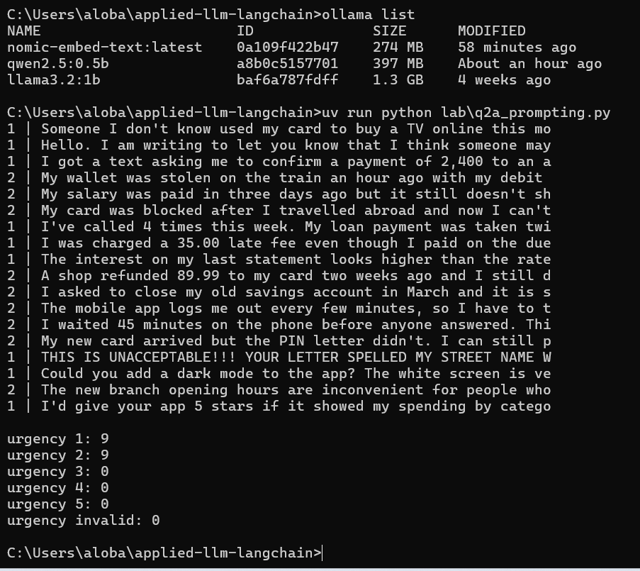

(ii) Your code · paste your class, the structured model and the lines in the loop
class Complaint(BaseModel):
product: str
urgency: int
structured_model = model.with_structured_output(Complaint)

try:
result = structured_model.invoke(complaint)
urgency = result.urgency
except Exception:
urgency = "invalid"

if urgency not in [1, 2, 3, 4, 5]:
urgency = "invalid"

(ii) Terminal output · paste the whole run: the line per complaint and the counts
C:\Users\aloba\applied-llm-langchain>uv run python lab\q2b_simple_schema.py
invalid | Someone I don't know used my card to buy a TV online this mo
invalid | Hello. I am writing to let you know that I think someone may
invalid | I got a text asking me to confirm a payment of 2,400 to an a
invalid | My wallet was stolen on the train an hour ago with my debit
invalid | My salary was paid in three days ago but it still doesn't sh
3 | My card was blocked after I travelled abroad and now I can't
invalid | I've called 4 times this week. My loan payment was taken twi
3 | I was charged a 35.00 late fee even though I paid on the due
invalid | The interest on my last statement looks higher than the rate
2 | A shop refunded 89.99 to my card two weeks ago and I still d
5 | I asked to close my old savings account in March and it is s
invalid | The mobile app logs me out every few minutes, so I have to t
3 | I waited 45 minutes on the phone before anyone answered. Thi
invalid | My new card arrived but the PIN letter didn't. I can still p
invalid | THIS IS UNACCEPTABLE!!! YOUR LETTER SPELLED MY STREET NAME W
invalid | Could you add a dark mode to the app? The white screen is ve
invalid | The new branch opening hours are inconvenient for people who
2 | I'd give your app 5 stars if it showed my spending by catego

urgency 1: 0
urgency 2: 2
urgency 3: 3
urgency 4: 0
urgency 5: 1
urgency invalid: 12

C:\Users\aloba\applied-llm-langchain>

(ii) Screenshot · the terminal with the command and the counts
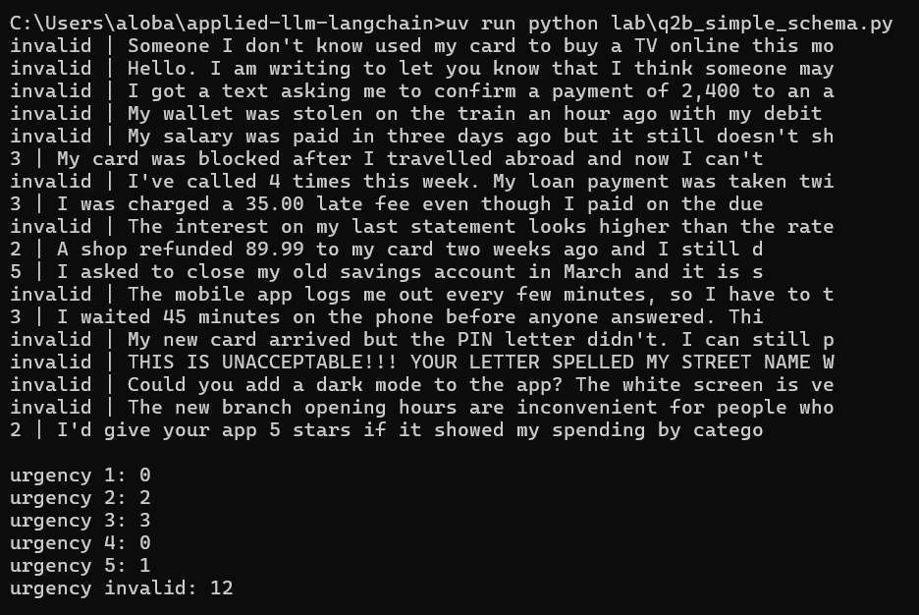

(iii) Your code · paste your class, the structured model, the system message and the lines in the loop
class Complaint(BaseModel):
product: Literal["credit_card", "debit_card", "loan", "savings_account", "mobile_app", "other"] = Field(
description="The product the complaint is about"
)
urgency: int = Field(
ge=1, le=5,
description="Urgency from 1 to 5 based ONLY on the risk to the customer's money"
)

structured_model = model.with_structured_output(Complaint)

SYSTEM_PROMPT = (
"You are a bank assistant. Rate the urgency of the customer complaint.\n\n"
f"{SCALE}\n\n"
"IMPORTANT: Judge by the risk to the customer's money, not by how angry or polite the customer sounds."
)

# ... (loop içinde)
messages = [
{"role": "system", "content": SYSTEM_PROMPT},
{"role": "user", "content": text}
]
try:
result = structured_model.invoke(messages)
urgency = result.urgency
except Exception:
urgency = "invalid"

(iii) Terminal output · paste the whole run: the line per complaint and the counts
C:\Users\aloba\applied-llm-langchain>uv run python lab\q2c_detailed_schema.py
4 | Someone I don't know used my card to buy a TV online this mo
1 | Hello. I am writing to let you know that I think someone may
4 | I got a text asking me to confirm a payment of 2,400 to an a
5 | My wallet was stolen on the train an hour ago with my debit
4 | My salary was paid in three days ago but it still doesn't sh
4 | My card was blocked after I travelled abroad and now I can't
4 | I've called 4 times this week. My loan payment was taken twi
1 | I was charged a 35.00 late fee even though I paid on the due
3 | The interest on my last statement looks higher than the rate
4 | A shop refunded 89.99 to my card two weeks ago and I still d
4 | I asked to close my old savings account in March and it is s
4 | The mobile app logs me out every few minutes, so I have to t
4 | I waited 45 minutes on the phone before anyone answered. Thi
2 | My new card arrived but the PIN letter didn't. I can still p
1 | THIS IS UNACCEPTABLE!!! YOUR LETTER SPELLED MY STREET NAME W
4 | Could you add a dark mode to the app? The white screen is ve
4 | The new branch opening hours are inconvenient for people who
1 | I'd give your app 5 stars if it showed my spending by catego

urgency 1: 4
urgency 2: 1
urgency 3: 1
urgency 4: 11
urgency 5: 1
urgency invalid: 0

C:\Users\aloba\applied-llm-langchain>

(iii) Screenshot · the terminal with the command and the counts
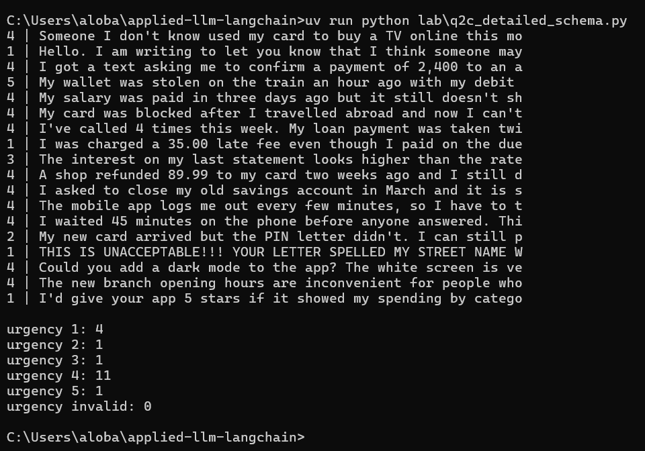

Counts · for urgency 1–5 and invalid, write expected / (i) / (ii) / (iii), e.g. 4: 3 / 7 / 0 / 0
1: | 4 | 9 | 0 | 4
2: | 3 | 9 | 2 | 1
3: | 4 | 0 | 3 | 1
4: | 3 | 0 | 0 | 11
5: | 4 | 0 | 0 | 1
invalid | 0 | 0 | 12 | 0

Wrong answers · for each method, list the complaint numbers it got wrong and one reason why
I: Failed on emergencies, such as 1, 2, 3 by rating them too low. because it relied only on the prompt and gave 0 invalid, but couldn't grasp the scale.
II: Failed by throwing 12 exceptions
III: Fixed the formatting but the 1b model still overestimates urgency for trivial things because smaller models struggle with logical distinction.

Bonus for (i) · does the system prompt make a difference?
Copy lab/q2a_prompting.py to lab/q2a_bonus_prompts.py and run method (i) with several system prompts. Try at least these three, and add your own ideas (for example, two or three example complaints with their correct urgency):
- bare: your prompt from (i), with only "from 1 (low) to 5 (critical)";
- scale: the same prompt plus the urgency scale (copy SCALE from lab/q2c_detailed_schema.py);
- scale + tone: the scale plus "judge by the risk to the customer's money, not by how angry or polite the customer sounds".
Print the counts of every prompt side by side, next to the expected ones. Example output:
urgency expected bare scale scale+tone
1 4 0 1 1
2 3 5 5 3
3 4 3 6 8
4 3 7 1 1
5 4 3 5 5
invalid 0 0 0 0
Think about: which complaints change urgency when you change the prompt? Compare your best prompt with (iii): how much of (iii)'s improvement came from the schema, and how much from the prompt?
Your answers to the bonus for (i)
Your prompts · write out every system prompt you tried, with its name (bare, scale, scale + tone, your own)
bare: "Rate the urgency of this customer complaint on a scale from 1 (low) to 5 (critical). Answer with the number only."
scale: Same as bare + the full urgency scale (5 = money at risk, 4 = can't access money soon, 3 = wrong charge, 2 = service problem, 1 = feedback).
scale + tone: Same as scale + "Judge by the risk to the customer's money, not by how angry or polite the customer sounds."

Terminal output · paste the side-by-side counts table from your run
C:\Users\aloba\applied-llm-langchain>uv run python lab\q2a_bonus_prompts.py
--- Running prompt: bare ---
--- Running prompt: scale ---
--- Running prompt: scale+tone ---

urgency expected bare scale scale+tone
1 4 14 18 18
2 3 4 0 0
3 4 0 0 0
4 3 0 0 0
5 4 0 0 0
invalid 0 0 0 0

C:\Users\aloba\applied-llm-langchain>

Screenshot · the terminal with the command and the counts table
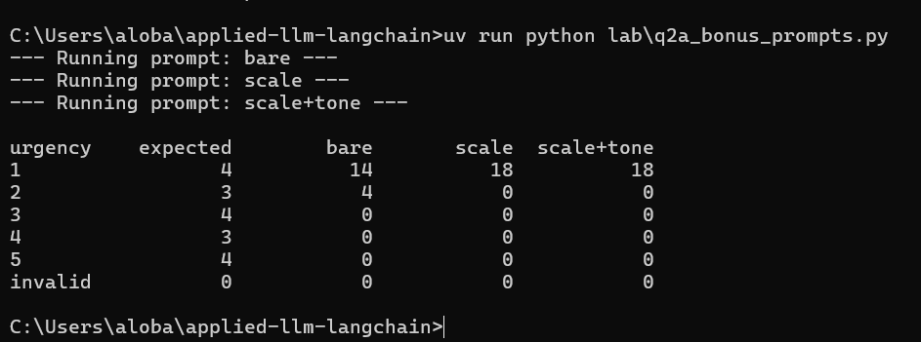

Think about · which complaints changed with the prompt? How much of (iii)'s gain came from the prompt?
With the 1b model, changing the prompt did not make any complaints more urgent. Instead, it gave a score of 1 to all 18 complaints, while the basic prompt gave four complaints a score of 2. In the third version, most of the improvement came from the schema. It forced the model to return valid numbers and stopped it from giving invalid answers. The prompt added more context, but the 1b model still struggled with its reasoning. A larger 3b model would probably benefit more from the improved prompt.

