Named Entity Recognition of Clinical Concepts in Safety Reports using Large Language Models and BERT

Wenjuan Zhang^{1, $}, Mengjie Lu^{2, $}, Brandon Penny^{1, $}, Joshua Xu¹, Oanh Dang^{2*}, Leihong Wu^{1*}
$Contributed equally to this study

¹Divsion of Bioinformatics and Biostatistics, National Center for Toxicological Research, U.S. FDA, 3900 NCTR Rd, Jefferson, AR, USA, 72079
²Office of Surveillance and Epidemiology, Center for Drug Evaluation and Research, U.S. FDA, 10903 New Hampshire Avenue, Silver Spring, MD, USA, 20993

*Corresponding author: Oanh Dang (oanh.dang@fda.hhs.gov), Leihong Wu (Leihong.wu@fda.hhs.gov)

Abstract
Introduction: Post-marketing safety surveillance relies heavily on free-text narratives in the Individual Case Safety Reports (ICSRs), but large-scale extraction of clinical concepts (i.e., key safety information) remains challenging. The lack of an extensive benchmarking dataset is a prominent obstacle.
Methods: Using an annotation tool built in-house, we compiled expert reference annotations for 829 FDA Adverse Event Reporting System (FAERS) ICSR narratives covering 17 clinical entity types. We then used this corpus to compare three automated annotation strategies: a previously established rule-based system (ETHER), instruction-tuned large language models (LLM), and a fine-tuned BERT named entity recognition model.
Results: The LLM substantially outperformed ETHER and provided broader concept coverage. On FAERS narratives, BERT achieved higher overall F1 than the LLM. The LLM was comparable to BERT for common categories such as adverse events and drugs, whereas BERT showed clear gains in accuracy for context-dependent concepts including laboratory findings, diagnostic entities, and status. A similar pattern was observed on an existing Vaccine Adverse Events Reporting System (VAERS) benchmark corpus, where BERT again outperformed the LLM in overall F1.
Conclusion: These results highlight the value of fine-tuning BERT models on curated corpora for specific pharmacovigilance NLP tasks and establish the FAERS annotations as an expert-curated reference resource for development and methodological evaluation of clinical concept extraction from safety narratives.

Key points:
• We developed an expert-curated FAERS reference corpus for clinical concept extraction from safety report narratives, and characterized its scale, clinical composition, and annotation diversity.
• Large language models substantially outperformed a traditional rule-based system, demonstrating the promise of modern AI approaches for safety report analysis.
• Fine-tuned BERT models are evaluated using repeated random-seed training and cross-validation to quantify robustness and reduce dependence on a single experiment run.

1. Introduction
Post-marketing safety surveillance is essential for ensuring the continued safety of drugs and vaccines after they enter the market. In the United States, the FDA relies heavily on Adverse Event Monitoring Systems (AEMS) including the FDA Adverse Event Reporting System (FAERS)[1] and the Vaccine Adverse Event Reporting System (VAERS)[2], which together receive millions of individual case safety reports (ICSRs) annually. These reports contain structured information, such as patient demographics and drug-related information, but more detailed clinical information is embedded from in the narrative text, where reporters describe symptoms, medical history, treatments, timing of events, and overall clinical context[3, 4]. Extracting this information is crucial for accurate signal detection and ICSR assessment[5, 6], as narrative details often provide a more holistic view of the adverse drug experience by complementing the data that are in structured fields of the ICSR.
However, manually reviewing ICSR narratives is increasingly impractical. FAERS and VAERS reporting volumes continue to grow, and each narrative requires careful review to identify and interpret clinical concepts such as adverse events, suspect and concomitant drugs, laboratory findings, and patient outcomes. This manual process is time-consuming, labor-intensive, and vulnerable to inconsistency across reviewers[7]. Moreover, ICSR narratives are unstructured, highly variable, and can contain nonstandard terminology, abbreviations, and reporter-specific phrasing. These characteristics present substantial challenges for computational systems aiming to extract information robustly at scale.
Named Entity Recognition (NER) provides a structured means for converting unstructured narrative text into analyzable clinical concepts, supporting pharmacovigilance tasks such as duplicate ICSR detection, case definition classification, causality assessment, safety signal detection, and automated case summarization. With recent advances in natural language processing (NLP), the performance of automated methods on specialized regulatory safety data such as FAERS and VAERS can be compared and characterized. Existing rule-based systems generally lack flexibility and cannot recognize all entity types important for pharmacovigilance. For example, ETHER, a rule-based system developed for FDA’s adverse event reports[8], is constructed on handcrafted expert rules and thus has limited capacity to adapt to the linguistic variability present in real-world reports.
Recent models based on transformers, such as BERT, BioBERT, and ClinicalBERT, have shown strong performance on several clinical NER tasks by learning contextual representations rather than relying on fixed rules[9]. However, these models require substantial quantities of high-quality annotated data for training, which remain scarce for pharmacovigilance applications. Large language models (LLMs) have attracted significant attention [10] for their ability to perform zero-shot or few-shot extraction using prompts, but their performance on biomedical NER is inconsistent. LLMs may struggle with fine-grained entity boundaries, confuse closely related clinical concepts, and lack familiarity with domain-specific phrasing common in FAERS and VAERS. Their outputs can vary across prompts and entity types, and they may omit or hallucinate entities. These limitations can present risks for regulatory use cases requiring high precision, reproducibility, and interpretability. Additionally, the computational cost of applying LLMs to millions of narratives poses scalability challenges.
A major barrier to progress is the absence of comprehensive, multi-entity annotated datasets tailored to pharmacovigilance. Most existing corpora focus on a narrow set of concepts and do not represent the full complexity of FAERS and VAERS narratives. To fill this gap, we compiled a large, high-quality, human-annotated dataset covering broadly 17 clinical entity types. Annotations were produced by a research fellow with clinical nursing experience, using an in-house annotation platform.
Using both annotated FAERS and VAERS datasets, we systematically evaluate three types of automated annotation approaches: a legacy rule-based system (ETHER)[8], a zero-shot, instruction-tuned LLM, and a fine-tuned BERT NER model trained on our human-annotated corpora. Particularly, we randomly selected 80% of the annotated data to train the BERT NER model. Our aim is to determine the performance of these AI-based approaches for various clinical entity types and to characterize their strengths, limitations, and suitability for real-world pharmacovigilance workflows.

2. Materials and Methods

2.1 Datasets
Two adverse event (AE) annotation datasets were involved in this study, one for FAERS and one for VAERS. The FAERS dataset was manually annotated during this study, while the VAERS dataset was obtained from a previous publication. Together, the two corpora comprise 1,829 clinical narrative reports, 854,257 tokens, and 39,809 sentences. Table 1 summarizes the key corpus statistics, including document length, annotation volume, and lexical surface-form diversity.

Table 1. Descriptive statistics of the annotated corpora.
Statistic | FAERS D1 | VAERS
#Reports | 829 | 1,000
Total tokens | 414,576 | 439,681
Total sentences | 17,766 | 22,043
Avg tokens per report | 500.1 ± 254.6 | 439.7 ± 143.0
Median tokens per report | 476 | 395
SME annotations | 36,425 | 40,711
Unique AE terms | 3,991 | 13,819
Unique Drug/Vaccine terms | 2,085 | 863

The FAERS dataset consisted of 829 ICSRs which was a convenient subset of a dataset that has been previously used in other pharmacovigilance studies [11]. These 829 ICSRs involved four drug–adverse event pairs: Azacitidine–QT prolongation, Tramadol–hypoglycemia, Baricitinib–hypersensitivity, and Erenumab–stroke. All reports contained detailed narratives describing adverse drug experiences. We manually annotated this dataset in this study (see 2.2). Across the FAERS corpus, the expert reference set contained 36,425 annotations, including 3,991 unique AE/symptom terms and 2,085 unique drug terms under exact string matching.
The VAERS dataset comprised 1,000 randomly selected reports drawn from the public VAERS, which was previously created as a gold standard annotated reference to support the development and evaluation of NLP systems, including the ETHER text-mining algorithm[12]. Each report has been annotated for clinical features, temporal features, and clinical–temporal associations using a multi-phase annotation methodology. The annotations were produced using the ETHER Annotator[8] with expert-defined guidelines and quality-controlled through adjudicator review. The corpus contains 40,711 reference annotations, with 2085 unique Drug/Vaccine terms and 13,819 unique AE/symptom terms under exact string matching.

2.2 Human Annotation Protocol
To begin human annotation, we first developed a comprehensive annotation guideline, with input from pharmacovigilance experts and adapted from prior VAERS work. The guideline defines 17 clinical entity types, including drug-related categories (e.g., suspect, concomitant, and other drugs, as well as dose and treatment), clinical outcomes (adverse events and their manifestations or sequelae), diagnostic and laboratory information, medical and family history, indications, and patient status, along with demographic attributes such as age and sex. Full definitions of the guideline are provided in Supplementary Table S1.
Annotations were performed by a research fellow who received task-specific training and followed the predefined annotation guidelines throughout the process. The annotator was also involved in the development and iterative refinement of these guidelines, ensuring consistent interpretation of entity definitions. All annotations were stored in a structured format capturing span boundaries and entity labels, enabling reproducibility and facilitating downstream validation and analysis. To avoid potential bias, the annotation process was conducted entirely manually without assistance from AI-based tools, and the resulting human annotations were used as the benchmark for evaluating automated systems including LLM, BERT, and rule-based tools such as ETHER.
To facilitate consistent and efficient annotation, we developed an in-house annotation platform tailored for ICSR narrative labeling. The tool enables annotators to highlight text spans and assign entity types based on a predefined controlled vocabulary, directly reflecting the annotation guidelines. It also provides functionalities for case management and annotation review, supporting systematic data organization and quality control throughout the process. Importantly, the platform incorporates version control to track changes across annotation iterations, allowing transparent comparison of updates and ensuring reproducibility. In addition, adjudication functionalities are built in to support review and resolution of ambiguous or uncertain annotations, enabling refinement of guideline interpretation and improving overall annotation consistency. These features collectively enhance data reliability and facilitate future validation and extension of the dataset. The user interface of the platform is illustrated in Figure 1, and the source code is publicly available at https://github.com/seldas/LLM4AE.

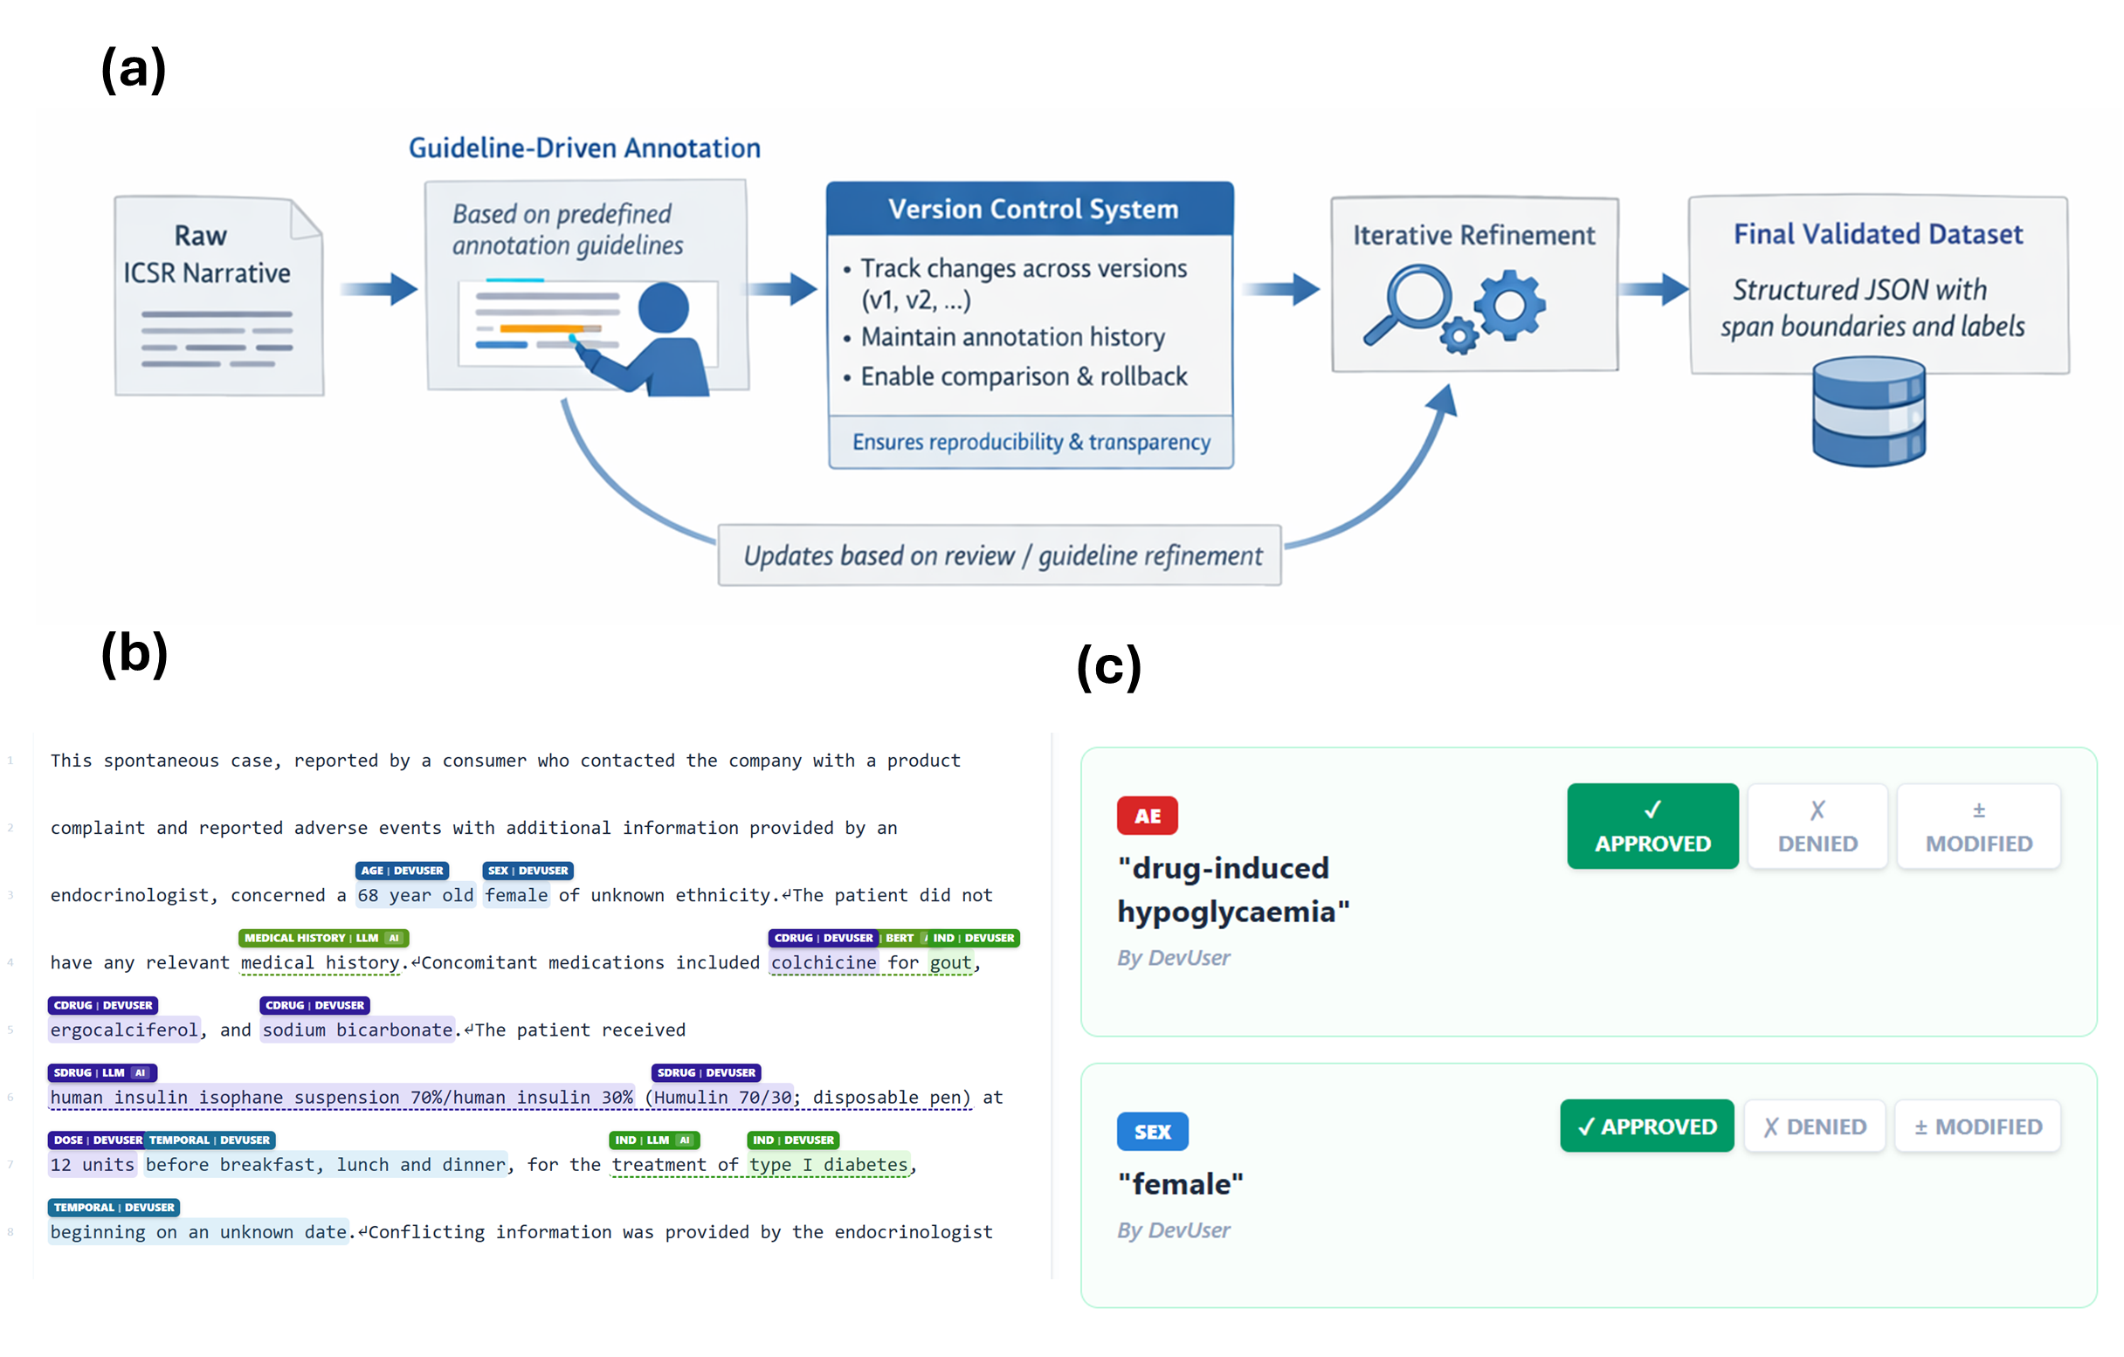
Figure 1. In-house annotation platform and workflow. (a) Annotation workflow illustrating guideline-driven labeling and version-controlled updates for reproducibility. (b) Annotation interface for span labeling using predefined clinical entity types. (c) Adjudication and quality control process for resolving ambiguous cases and refining annotation consistency.

2.3 Automated Annotation Approaches
In this study, we applied three annotation approaches: rule-based tool (e.g., ETHER); Large Language Model (LLM); and BERT-based Named Entity Recognition (NER) model. ETHER is a previously deployed rule-based system used to extract clinical concepts from ICSR narratives[8]. It relies on handcrafted rules, dictionaries, and pattern-matching heuristics. Because ETHER recognizes only a limited set of entity types and has difficulty handling linguistic variability, it serves as a baseline in this study.
Second, we used an instruction-tuned LLM (Llama-4-Maverick-17B-128E-Instruct-FP8, https://huggingface.co/collections/meta-llama/llama-4) to annotate narratives using an in-text XML tagging strategy (Figure 2). The LLM was prompted to insert tags around identified entities without altering the surrounding text ("Apart from the inserted annotation tags, every character of the original narrative must remain unchanged."). After annotation, we compute a character-level mapping between the LLM's tag-stripped output and the original page text, using the SequenceMatcher function from the difflib Python library (https://docs.python.org/3/library/difflib.html) to extract accurate character offsets. Besides filtering out unsuccessfully tagged items (e.g., mismatched closing tags, unescaped angle brackets, or tags did not match pre-defined categories), using in-text annotation plus back mapping as a strategy helped ensure the original narratives were not altered during the annotation process. Unsuccessful tagging and text alterations have both been observed during preliminary studies, particularly where some LLMs were intended to correct typos from narratives. The full prompt used for LLM annotation is provided in Supplementary File 1.

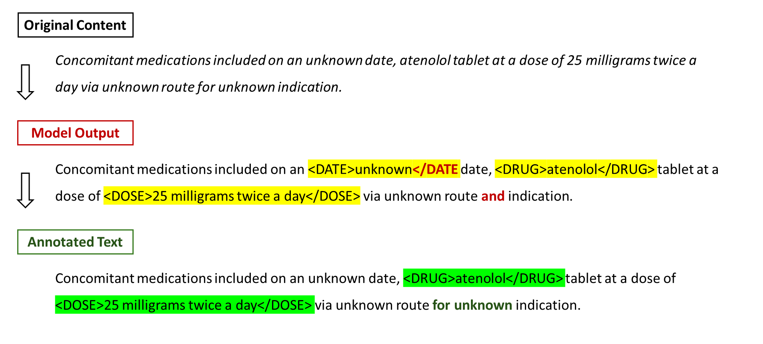
Figure 2. Example of LLM in-text annotation. The Original Content was processed by LLM and the model output In-text annotated texts. In case there are some misplaced tags like incomplete ones or altered texts (Highlighted in Red), they will be discarded after mapping back to the original text, where only valid tagged annotation remained (in green).

Third, BERT-based NER models were implemented using the spaCy transformer pipeline (TransformerModel.v3) for FAERS and VAERS datasets. Narratives were tokenized and aligned with span annotations. Entities were converted to the BIO tagging scheme for model input. All preprocessing steps were standardized to ensure reproducibility.
To address variability associated with neural-network initialization, all BERT evaluations were repeated using five independent random seeds (42, 123, 456, 789, and 1011). For FAERS, the four predefined drug–adverse-event case series enabled a four-fold leave-one-drug–event-pair-out evaluation: each case series served once as the held-out test domain, and each fold was independently trained under all five seeds (20 training runs). For VAERS, which lacks an analogous predefined drug–event grouping, we use report-level 10-fold cross-validation with fixed folds; each fold is repeated under the same five seeds (50 training runs). The final overall estimates are calculated from pooled out-of-fold predictions for each seed and summarized as mean ± standard deviation across the five seeds. Hyperparameters included a learning rate of 0.0001, batch size of 32, and up to 20,000 training steps. Sentences exceeding the 512-token limit were segmented before transformer processing.
To determine the best base BERT model, we conducted an ablation experiment comparing BERT[13], BioBERT[14], ClinicalBERT[15], and Bio_ClinicalBERT[16] using the VAERS data. BioBERT demonstrated superior precision and recall across key biomedical categories (Table S2) and was selected as the base model in this study.

2.4 Evaluation Metrics
Model performance was evaluated using mention-level matching adapted from ADE-Eval[17]. System predictions were categorized as Match (M), Conflation (C), Spurious (S), and Null (N). Match denotes an exact span and label match; Conflation denotes an overlapping span with inexact boundaries under the same label, or a mis-label annotation; Spurious denotes a predicted entity without a corresponding reference match; and Null denotes a reference entity that was not identified.
For example, an automated prediction of “hypoglycemia” as AE that exactly matches the reference span and label is classified as a Match (M). A prediction is classified as Conflation (C) when it identifies the same underlying text region but does not exactly reproduce the reference annotation. Conflation includes both boundary inexactness, for example predicting “severe hypoglycemia” when the reference span is “hypoglycemia”, and category misclassification, for example identifying “hypoglycemia” but labeling it as DX rather than AE. A Spurious (S) prediction is a predicted entity with no character overlap with any reference entity, whereas Null (N) represents a reference entity for which no overlapping prediction is produced, such as failing to identify “somnolence”.
We evaluated model performance using two complementary evaluation schemes. The primary scheme was a strict exact-match NER evaluation, in which a prediction was counted as correct only when both its span boundaries and entity label exactly matched the reference annotation. Under this scheme, precision and recall were calculated as below:
$$P_{1}=M/(M+C+S)$$
$$R_{1}=M/(M+C+N)$$

The secondary scheme was an adapted ADE-Eval weighted evaluation. In this scheme, an exact Match receives full credit, while a Conflation receives 0.5 partial credit. Spurious predictions are assigned a 0.25 penalty weight, whereas completely missed reference entities (N) retain their full penalty. Weighted precision and recall were therefore calculated as below:
$$P_{2}=(M+0.5C)/(M+C+0.25S)$$
$$R_{2}=(M+0.5C)/(M+C+N)$$

F1 was calculated as the harmonic means of precision and recall under each scheme, all P/R/F1 were measured in Micro-Level; per-category metrics were reported separately.

3. Results

3.1 Annotation Statistics
Human annotators labeled entities according to 17 clinical concept categories, as summarized in Table 2. The annotations from ETHER and LLM approaches were also included.
Table 2. FAERS annotations, categorized by Human, ETHER and LLM
Category | Human | ETHER | LLM
SDrug | 3,501 | 17164† | 2,181
CDrug | 2,928 |  | 2,491
Odrug | 245 |  | 1,310
Dose | 1,621 | n/a | 2,057
Indication | 162 | n/a | 1,368
Treatment | 1,479 | n/a | 1,472
AE | 9,080 | 25,031† | 6,311
mAE | 112 |  | 1,015
Dx | 1783 | 4,344 | 941
Lab | 3,480 | n/a | 2,362
Status | 1,796 | n/a | 2,275
R/O | 9 | 33 | 83
CoD | 3 | 125 | 220
MHx | 2,304 | 755 | 2,830
FHx | 105 | 22 | 24
Age | 787 | n/a | 811
Sex | 768 | n/a | 768
† ETHER does not distinguish drug roles or AE types — all drug and AE mentions are output under a single DRUG tag (17,164) and AE tag (25,031).

3.2 LLM performs significantly better than ETHER
First, we compared two machine annotation methods, LLM and ETHER, against human annotations as the gold standards on FAERS case series dataset. For LLM, both Llama-4 and Claude 4.6 Sonnet were evaluated. The goal was to assess which method more accurately replicates human-level annotation performance across common annotation types.
As shown in Figure 3a, Llama-4 and Claude 4.6 Sonnet showed similar performance, and in overall the few-shots LLM demonstrated robust generalization capabilities, outperformed ETHER in all categories that are available for comparisons (Figure 3b). Moreover, LLMs offer broader coverage of safety concepts such as age, sex, and lab values, some of which were challenging to extract using ETHER rule-based systems.

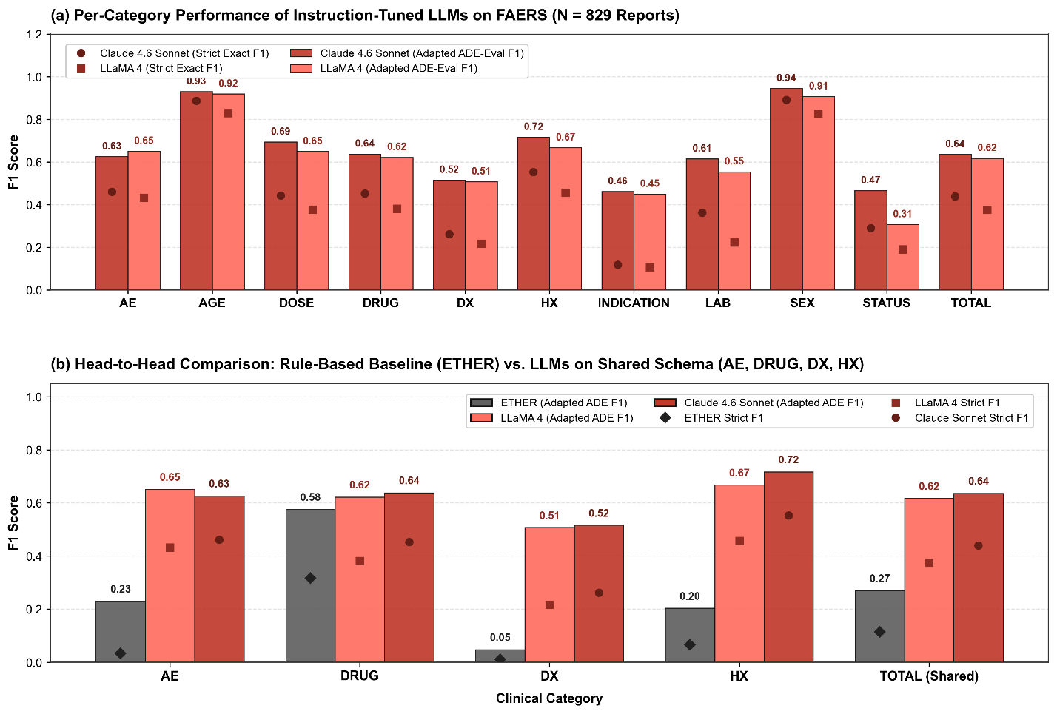
Figure 3. Overall Performance Comparison Across Three Evaluation Schemes on FAERS Narratives (N = 829). Grouped bar chart comparing the rule-based baseline ETHER (Gray), fine-tuned BioBERT (Blue), open-weight LLaMA 4 (Pink-Coral), and proprietary Claude 4.6 Sonnet (Crimson Red) across Scheme 1 (Relaxed Boundary Match), Scheme 2 (Adapted ADE-Eval Clinical Weighted Metric), and Scheme 3 (Strict Exact-Match NER). Numerical F1 scores are labeled above each bar.

3.3 BERT-based NER model performance
We then trained a BERT-based named entity recognition (NER) model using the FAERS case series training set. Specifically, BioBERT was selected following an initial ablation study comparing multiple transformer architectures, where it achieved the strongest performance across biomedical entity categories (Table S2), motivating its use as the backbone of our final NER model.

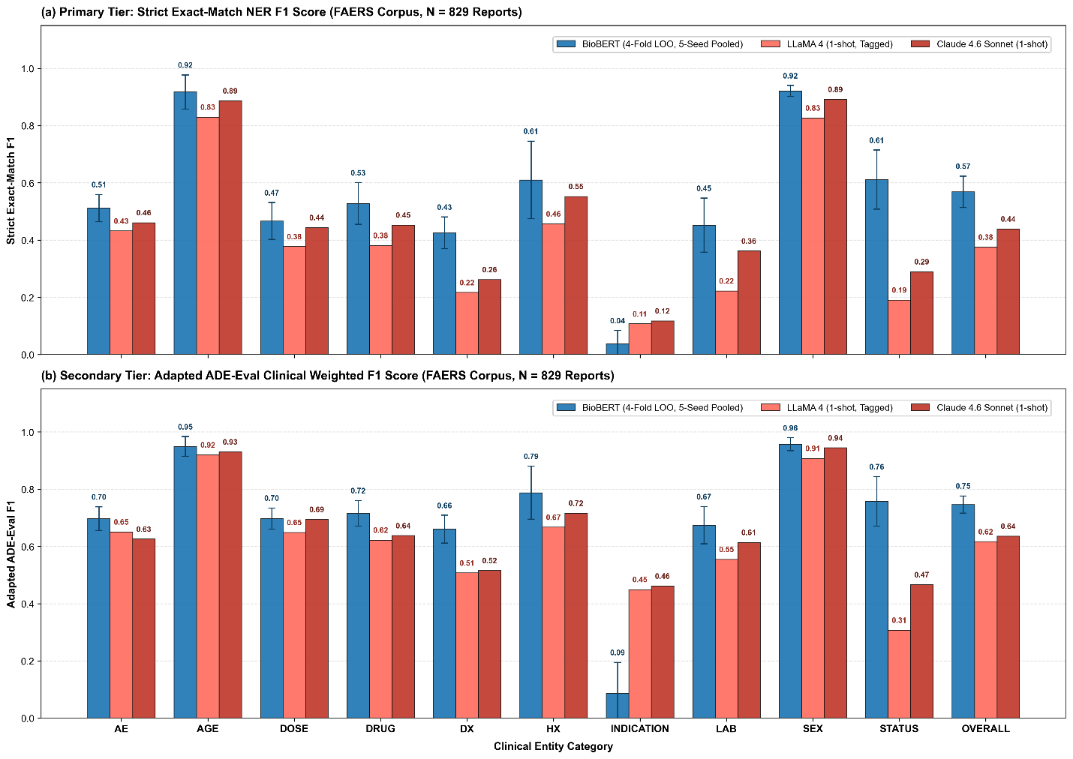
Figure 4. comparative study between BERT and LLMs (Llama-4 and Sonnet 4.6). (a) strict exact-Match F1; (b) Adapted ADE-Eval F1, with weighted Conflation and Spurious Predictions. The Adapted ADE-Eval F1 reflects the real-world impact of wrongly or missing annotated terms in PV study.

3.4 Error analysis
Next, we conducted a detailed error analysis to characterize how the BERT model and the zero-shot LLM differ in their failure modes. Using character-level span alignment between model outputs and human annotations, each predicted span was categorized as an exact match (M), boundary and label error (C), overlapping a reference span but with mismatched start and/or end positions, or with a different label), or hallucination (S, no overlap with any reference entity). Reference entities with no overlapping prediction were counted as misses (N).
Figure 5a shows that BERT produces more exact matches and fewer boundary and hallucination errors than the LLM. For BERT, 46.1% of spans are exact matches (3845), compared with 35.4% (3379) for the LLM. The LLM, in contrast, has more coverage errors (25.5% vs 20.3%; 2434 vs 1698 spans), where a predicted span overlaps the reference span but has the wrong boundaries or label. It also produces more spurious spans (24.4% vs 15.8%; 2326 vs 1319), reflecting hallucinated (or potentially human missed) entities with no corresponding human annotations. Missed spans (N) show the opposite pattern: BERT has a slightly higher proportion of misses than the LLM (17.8% vs 14.7%; 1487 vs 1405). This difference is modest and is consistent with the recall gap between the two models in Figure 4, while the much larger excess of coverage and spurious errors for the LLM reflects its tendency to over-segment or hallucinate entities rather than leaving spans unannotated.
The top confusion pairs for both systems (Figure 5b and 5c) show that mistakes cluster in closely related label types rather than being spread out randomly. For BERT, the most common error is diagnostics predicted as medical history (i.e., DX→MHX), followed by AE→MHX and AE→LAB, which often occurs when chronic conditions and new symptoms are described next to each other in the text. Smaller but still notable errors include diagnostics predicted as drugs and vice versa (i.e., DX↔DRUG) and LAB↔AE, usually when disease names or lab results are written in a symptom-like way. The LLM shows a similar but more diffuse pattern. Its largest errors are DX→DRUG, DX→MHX, and DX→AE, along with frequent LAB→AE and AE↔LAB/MHX confusions. Overall, both models have the most trouble where clinical categories are conceptually similar, but the LLM spreads its mistakes across more label pairs, while BERT’s errors are concentrated in a smaller set of related pairs.
We observed a low performance in annotating DX in both algorithms, particularly in the LLM approach. We applied word-cloud visualizations on two LLM misclassification categories (DX→DRUG and DX→MHX) to further clarify these patterns at the term level. For DX spans that misclassified as DRUG (Figure 5d), the most prominent tokens were medication names such as isoniazid, while this drug name appeared inside a complex phrase (e.g., “isoniazid-induced hepatitis”), the LLM often annotated them separately as a drug entity (i.e., isoniazid) and diagnostics (i.e., hepatitis), which resulted as error C (boundary and label error). In contrast, DX spans that misclassified as MHX (Figure 5e) were dominated by common chronic conditions and comorbidities including migraine, hypertension, rheumatoid arthritis, osteoporosis, depression, and hematologic malignancies. This appears to suggest a systematic LLM bias to treat frequently encountered disease terms as background medical history rather than current diagnoses.
Overall, the LLM’s zero-shot annotations are prone to hallucinated spans, boundary drift, and broader label confusion, which lowers precision and complicates direct use without additional filtering. BERT, while more schema-consistent and conservative in its predictions, still struggles with fine-grained segmentation of status expressions, leading primarily to partial matches and missed entities.

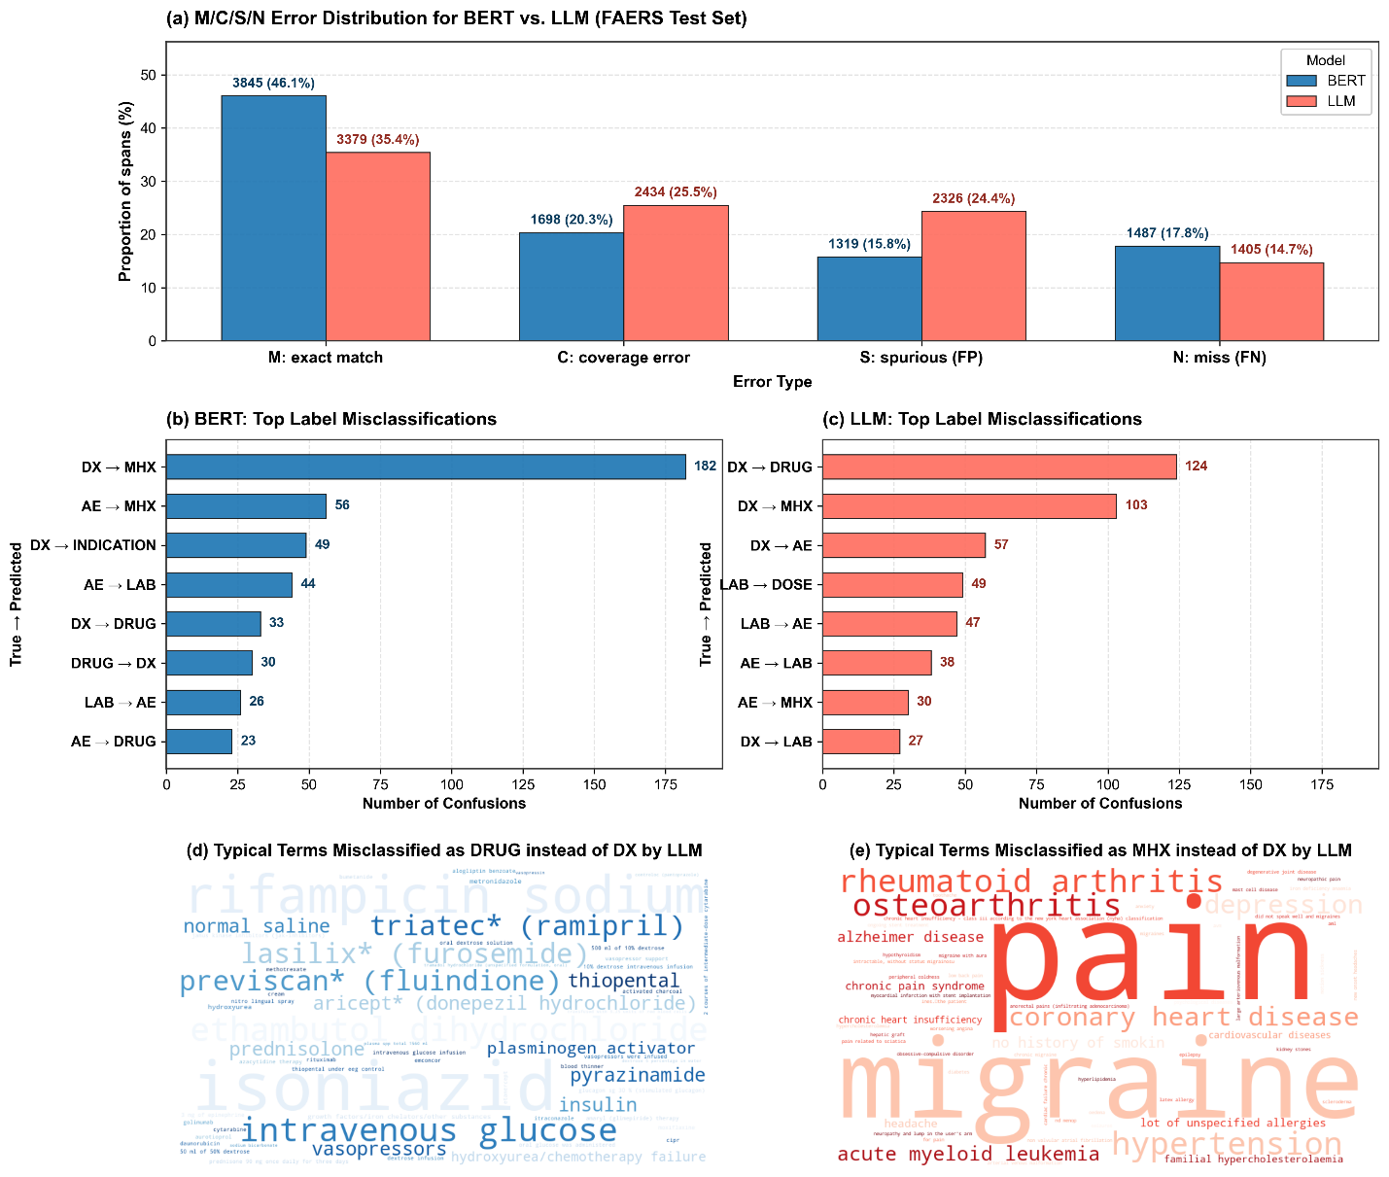
Figure 5. Error Analysis on FAERS annotations. (a) annotation errors break down by four categories. (b) top misclassifications for BERT; (c) top misclassifications for LLM (Llama-4); (d) typical terms that were misclassified as DRUG instead of DX by LLM; (e) typical terms that were misclassified as MHX instead of DX.

3.5 VAERS Evaluation
To examine whether the observed patterns extend beyond drug-related FAERS narratives, we repeated our analysis on the VAERS vaccine corpus. As in the FAERS setting, we trained the BERT-based model on 80% of the human-annotated narratives and compared it against LLM-generated annotations on the same held-out 20% test set. As shown in Figure 6, the BERT-based model achieved a substantially higher overall F1-score than the LLM baseline. This difference reflects consistent gains across both precision and recall, resulting in an absolute F1 improvement of approximately 0.22, and highlighting the advantages of supervised, domain-specific training for vaccine safety narratives.

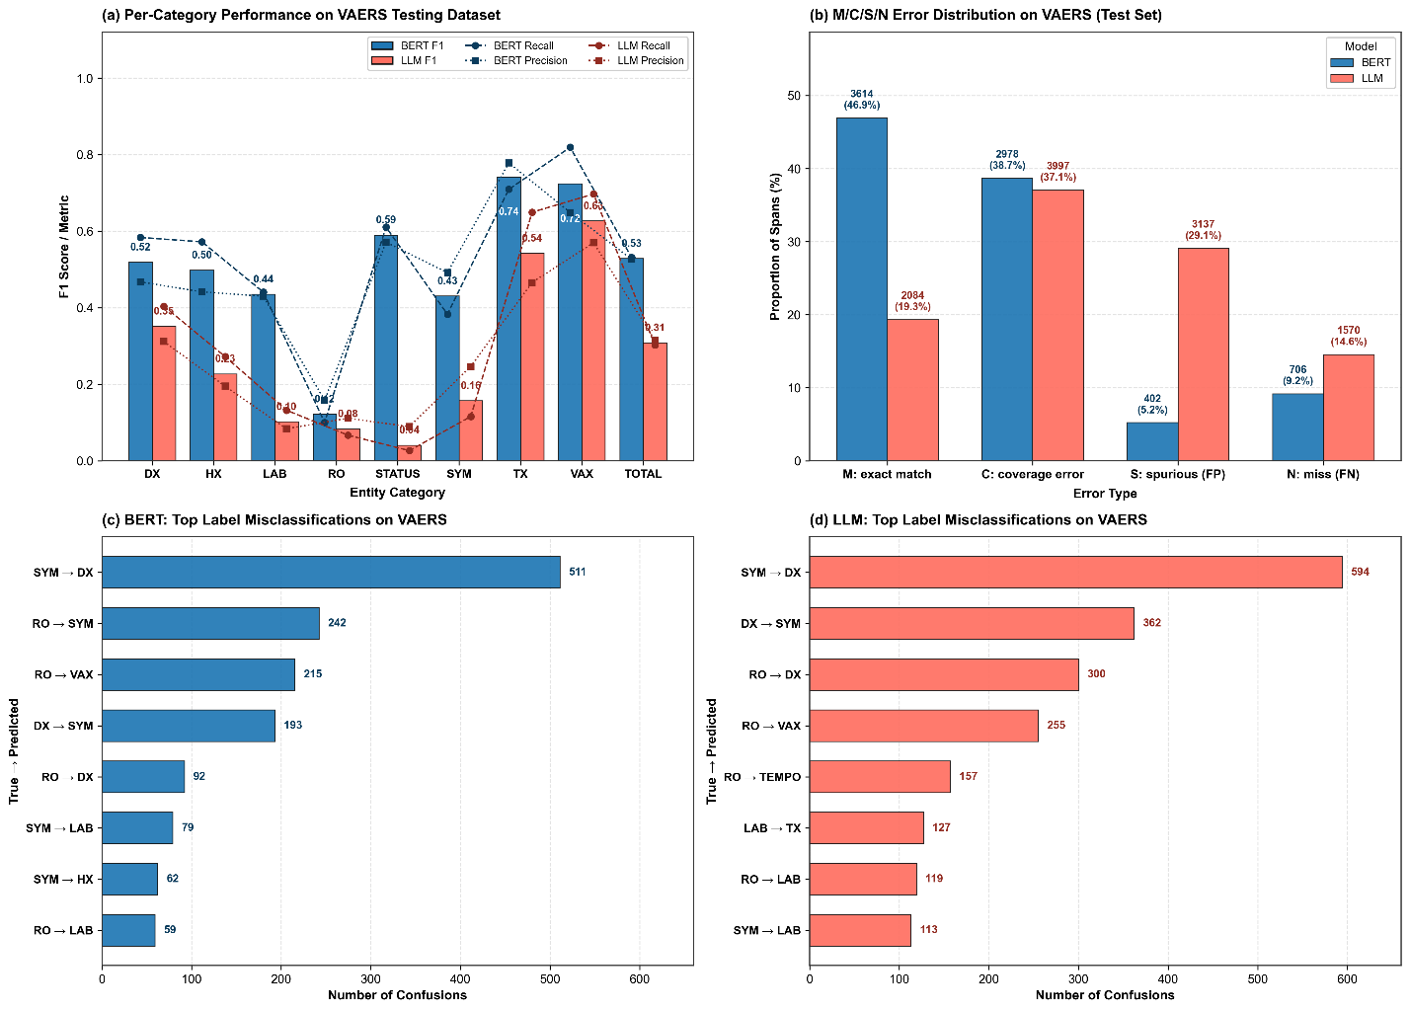
Figure 6. Error Analysis on VAERS annotations. (a) BERT and LLM annotation performance. (b) annotation errors break down by four categories. (c) top misclassifications for BERT; (d) top misclassifications for LLM (Llama-4).

3.6 Ablation Studies

Leave-One-Drug-Event-Pair-Out in BERT
We applied a repeated Leave-One-Drug-Event-Pair-Out approach in FAERS data analysis. For each of 4 reported drug-event pairs, they would be considered as validation set and excluded from the training process. The experiment therefore consisted of 4 folds to cover all cases the be included in the validation set once.
Mean strict exact-match F1 across the five seeds was 0.6280 ± 0.0097 for azacitidine–QT prolongation, 0.6563 ± 0.0178 for baricitinib–hypersensitivity, 0.5602 ± 0.0091 for tramadol–hypoglycemia, and 0.5274 ± 0.0105 for erenumab–stroke. The between-series spread was larger than the within-fold seed variation, indicating that case-series difficulty contributed more variation than stochastic initialization in these runs.

Random seed in BERT Training
For Both FAERs and VAERS BERT model training, we repeated the training process 5 times with different random seeds (42, 123, 456, 789,1011).

LLM Output Format Impact
We investigated whether the output format designed in LLM prompt will affect the final performance. We compared in-text tagging (which we used in the main study) and json output.

4. Discussion
This work provides a systematic comparison of automated systems for extracting clinical concepts from regulatory safety narratives, grounded in newly developed FAERS annotations and an established VAERS benchmark. The annotated dataset captures the complexity of real-world pharmacovigilance narratives and can serve as benchmarks for future NER and related regulatory tasks.
In this study, we observed that a zero-shot, instruction-tuned LLM markedly outperforms a legacy rule-based system (ETHER). This highlights the utility of LLMs as a flexible baseline when annotated data or rule development is limited. On the other hand, a supervised BERT model trained on high-quality annotations achieved consistently higher overall performance across both FAERS and VAERS datasets, with especially large gains for context-dependent categories such as STATUS, HX, and laboratory and diagnostic entities. These findings reinforce the value of domain-specific supervised models for structured extraction tasks.
Taken together with the FAERS results, these VAERS findings demonstrate that BERT-based models trained on high-quality human annotations provide more robust and reliable performance across heterogeneous pharmacovigilance datasets. While LLM-derived annotations offer a convenient low-resource alternative, their direct use leads to substantially lower accuracy, particularly in semantically complex categories such as STATUS, LAB, and HX. These results underscore the continued importance of curated human-labeled data for medical NER and highlight the effectiveness of supervised transformer models for large-scale safety narrative processing in real-world biomedical applications.
The reported performance should be interpreted in the context of a multi-class classification task with a stringent evaluation framework. Because the metric requires exact agreement in both span boundaries and fine-grained labels, it penalizes minor boundary differences and ambiguities between closely related categories (e.g., AE vs. diagnosis vs. medical history). As a result, the observed F1-scores likely underestimate the models’ ability to identify clinically relevant concepts, and should be understood as reflecting task complexity and strict evaluation criteria rather than limited practical utility.
Error analysis provides additional context for the observed performance under this strict evaluation framework. BERT produces more exact matches and fewer hallucinated spans, reflecting stronger adherence to annotation boundaries and label definitions, but tends to miss entities in more ambiguous contexts. In contrast, the LLM shows broader coverage but introduces more boundary inconsistencies and label confusion, particularly among closely related categories (e.g., diagnosis vs. medical history). These patterns suggest that a substantial portion of “errors” arise from boundary mismatch or label ambiguity rather than complete failure to identify relevant clinical concepts, contributing to the relatively low F1-scores under exact-match evaluation.
From a practical perspective, these differences highlight complementary roles of the two approaches. BERT serves as a stable and efficient “workhorse” for large-scale deployment, offering consistent, schema-adherent outputs, while LLMs provide flexibility for tasks such as initial annotation, candidate identification, and guideline refinement. This complementary design supports a hybrid workflow in which structured models ensure reliability and scalability, and LLMs facilitate iterative improvement through human-in-the-loop processes.
Beyond model comparison, the annotated datasets themselves provide a valuable resource for future research. By spanning both drug and vaccine safety narratives and incorporating harmonized entity definitions, they enable studies on cross-domain generalization, transfer learning, and multi-task modeling. The detailed error characterizations also highlight areas where additional training data, refined guidelines, or specialized modeling approaches may further improve performance.
This study has several limitations. The annotated datasets, while carefully constructed, represent a subset of possible reporting scenarios and may not fully generalize across all products and adverse events. The current annotation workflow was designed as a linear process, starting with a single annotator, with future work planned to incorporate cross-annotator review and adjudication for additional validation and robustness. In addition, this work focuses on span-level NER and does not address downstream tasks such as relation extraction or causality assessment, which are critical for regulatory applications. Finally, due to data sensitivity constraints, we were unable to evaluate certain commercial LLMs, and future advances in model capabilities may shift the relative performance observed here.
In summary, BERT-based NER models demonstrate strong and reliable performance for pharmacovigilance concept extraction when trained on curated datasets. Rather than replacing such models, LLMs complement them by providing flexibility and supporting annotation and analysis workflows. Together, these approaches highlight the continued importance of high-quality annotated data in enabling accurate and scalable NLP solutions for regulatory safety applications.

Acknowledgement
Karen Long and Joseph Cusimano provided feedback on drafts of the clinical concept categories and definitions for the annotation guidelines. WZ and ML are grateful for the support by an appointment to the Research Participation Program of the U.S. FDA through the Oak Ridge Institute for Science and Education (ORISE).
Disclaimer: This manuscript reflects the views of the authors and does not necessarily reflect those of the Food and Drug Administration. Any mention of commercial products is for clarification only and is not intended as approval, endorsement, or recommendation.
This manuscript was created with the assistance of FDA’s Generative AI tool, Elsa. Elsa was used to help identify relevant references and improve clarity and grammar of text that was initially written by one of the authors. Authors have reviewed, verified, and edited the content for the final manuscript.

Declarations

Funding
This work was funded by the U.S. Food and Drug Administration.

Conflicts of interest
The authors declare that the research was conducted in the absence of any commercial or financial relationships that could be construed as potential conflicts of interest.

Ethics approval
Not Applicable

Consent to participate
Not Applicable.

Consent for publication
Not Applicable.

Availability of data and materials
The FAERS reports analyzed in this study were obtained from the U.S. Food and Drug Administration Adverse Event Reporting System (FAERS). The expert annotations generated for this study are not publicly available because they constitute a research dataset developed by the authors and are subject to institutional and regulatory restrictions. The VAERS benchmark dataset used in this study is available from its original publication. Additional information regarding the datasets may be available from the corresponding authors upon reasonable request and subject to applicable restrictions.

Code availability
The annotation prompt and source code for the annotation platform are available at: https://github.com/seldas/LLM4AE.

Author contributions
LW, OD, JX conceptualized the study, ML did the data curation and annotation and OD oversaw the annotation process to provide guidance and address inquiries as needed. WZ, ML, LW did the modeling and data analyses. LW, JX, OD wrote the manuscript. All authors agreed with the final version.

Reference
1. FDA. FDA's Adverse Event Reporting System (FAERS). 2025 [cited 2025 11/24]; Available from: https://www.fda.gov/drugs/surveillance/fdas-adverse-event-reporting-system-faers.
2. HHS, the Vaccine Adverse Event Reporting System. 2025.
3. Fu, S., et al., Clinical concept extraction: a methodology review. Journal of biomedical informatics, 2020. 109: p. 103526.
4. Peng, C., et al., Clinical concept and relation extraction using prompt-based machine reading comprehension. Journal of the American Medical Informatics Association, 2023. 30(9): p. 1486-1493.
5. Norén, G.N., The power of the case narrative-can it be brought to bear on duplicate detection? Drug Safety, 2017. 40(7): p. 543-546.
6. Kreimeyer, K., et al., Using probabilistic record linkage of structured and unstructured data to identify duplicate cases in spontaneous adverse event reporting systems. Drug Safety, 2017. 40(7): p. 571-582.
7. Pilipiec, P., M. Liwicki, and A. Bota, Using Machine Learning for Pharmacovigilance: A Systematic Review. Pharmaceutics, 2022. 14(2).
8. Pandey, A., et al., Adverse event extraction from structured product labels using the event-based text-mining of health electronic records (ETHER) system. Health informatics journal, 2019. 25(4): p. 1232-1243.
9. Bergman, E., et al., BERT based natural language processing for triage of adverse drug reaction reports shows close to human-level performance. PLOS Digital Health, 2023. 2(12): p. e0000409.
10. Ball, R. and G. Dal Pan, “Artificial intelligence” for pharmacovigilance: ready for prime time? Drug safety, 2022. 45(5): p. 429-438.
11. Kreimeyer, K., et al., Increased confidence in deduplication of drug safety reports with natural language processing of narratives at the us food and drug administration. Frontiers in Drug Safety and Regulation, 2022. 2: p. 918897.
12. Foster, M., et al., Generation of an annotated reference standard for vaccine adverse event reports. Vaccine, 2018. 36(29): p. 4325-4330.
13. Devlin, J., et al. Bert: Pre-training of deep bidirectional transformers for language understanding. in Proceedings of the 2019 conference of the North American chapter of the association for computational linguistics: human language technologies, volume 1 (long and short papers). 2019.
14. Lee, J., et al., BioBERT: a pre-trained biomedical language representation model for biomedical text mining. Bioinformatics, 2020. 36(4): p. 1234-1240.
15. Huang, K., J. Altosaar, and R. Ranganath, Clinicalbert: Modeling clinical notes and predicting hospital readmission. arXiv preprint arXiv:1904.05342, 2019.
16. Lee, S.A., A. Wu, and J.N. Chiang, Clinical modernbert: An efficient and long context encoder for biomedical text. arXiv preprint arXiv:2504.03964, 2025.
17. Bayer, S., et al., ADE Eval: An Evaluation of Text Processing Systems for Adverse Event Extraction from Drug Labels for Pharmacovigilance. Drug Saf, 2021. 44(1): p. 83-94.

Supplementary File 1. LLM Prompt for Narrative Annotation
**You are an expert medical annotator tasked with identifying and tagging key clinical and contextual attributes in a FAERS (FDA Adverse Event Reporting System) case report narrative. Follow these instructions meticulously:**

### ✳️ Annotation Format and Rules
1. Perform **in-text annotation** by enclosing the relevant text with appropriate XML-style tags.
2. **Do not alter the original text in any way**. Your task is solely to insert annotation tags.
3. Use capitalized tags in this format: `<TAG>relevant text</TAG>`.
4. Ensure all tags are properly opened and closed. For example: `<SDRUG>atenolol</SDRUG>`.
5. Be precise in your tag placement. Include only the specific words that correspond to the entity being tagged.

### Tag Types
Include a list of all possible tags here, such as SDRUG, CDRUG, AE, DATE, DOSE, etc., with a brief description of each.

### Annotation Example
Original text:
Concomitant medications included on an unknown date, atenolol tablet at a dose of 25 milligrams twice a day via unknown route for unknown indication.

Correctly annotated text:
Concomitant medications included on an unknown date, atenolol tablet at a dose of 25 milligramstwice a day via unknown route for unknown indication.

### Common Mistakes to Avoid
1. Incomplete tags (e.g., `<SDRUG>atenolol` without a closing tag)
2. Altering the original text content
3. Inconsistent capitalization of tags
4. Overlapping or nested tags

Your task is to apply these annotation principles to the provided FAERS case report narrative. Maintain accuracy and consistency throughout your annotations.
---

### Annotation Types and Their Descriptions
Use the following table as your reference to annotate the provided text:
/* Annotation Guidance */

> *Note:* Adverse Events should be tagged as `<AE>...</AE>` only when clearly distinguishable from general diagnoses.

---

### Output Instructions
- Begin your output with:
The annotated text is shown as below:
- Follow this with the full narrative, inserting only the annotation tags where appropriate.
- Ensure **the original text structure and punctuation remain unchanged** aside from the added tags.

Table S1. Annotation Categories and Definitions
Clinical Concept | Definitions
sDrug: Suspect Drug Products | A drug or biological product believed to have caused, contributed to, or been associated with the adverse event. Often discontinued, changed, or adjusted after the AE. May have explicit causal language linking it to the AE.
cDrug: Concomitant Drug Products | Drugs that were concurrently administered with other drugs (e.g., suspect drugs), as part of the patient’s ongoing or routine regimen. May include chronic medications, maintenance therapy, or background treatments. Some may have a potential or implicit causal relationship with the AE, as per applicant report.
oDrug: Other Drug Products | Drugs mentioned but not clearly linked to current adverse event, concomitant drugs or therapy, or explicit treatment purpose.  Illicit substances (e.g. Methamphetamine in its non-medical form) should also be included, as they may act as important confounding factors or be relevant to future drug approvals involving such substances (e.g. psychedelics).  Typically include historical drug use or drug references without any specified clinical context.
Dose: Dose Administered | Explicitly stated dosage information of any drugs.
IND: indication | The reason or intended medical purpose for which a drug, treatment, or procedure is used. This includes explicit statements like "used for fever" or "given for infection." Also includes cases where the indication is unknown or unspecified but clearly referenced.
Treatment: Drug used for treatment | Capture only drug products/ drug administration explicitly described as treatments addressing disease, adverse events or symptoms.
AE: Adverse Event | Any negative health outcome, condition, or symptom that could represent an adverse event, regardless of their relation to the drug or baseline status. This category includes all clinically relevant events, including baseline symptoms, new diagnoses, and patient-reported symptoms. An adverse event may be a formally diagnosed condition or a subjective symptom reported by the patient, indicating a potential impact on the patient’s health.
mAE: AE Manifestations/Sequelae | mAE-Manifestations: immediate signs, symptoms that appear as part of the adverse event. Observable or measurable effects associated with the AE. May include physiological changes or specific clinical findings. Documented at or near the time of the AE onset.  mAE-Sequelae: consequences or complications resulting from the adverse event. Persistent or secondary effects occurring after the acute phase of the AE. May develop days, weeks, or even years after the AE.
Dx: diagnostic test results | Captured only the names of diagnostic procedures performed to evaluate or confirm a medical condition or diagnosis.
Lab: Laboratory Finding | Results (test named and specific results) specifically from laboratory tests indicating quantitative measurements or biochemical markers, such as blood tests, enzyme levels, height, weight and other routine or other clinical parameters. Regardless of whether the results are normal, abnormal, positive, or negative. Laboratory findings provide objective data about the patient’s health status and can support the assessment of adverse events when combined with symptoms or diagnoses. This category captures information related to specific measurements, test outcomes, and diagnostic indicators but doesn’t imply an adverse event on its own.
Status: patient status | captures statements about the progression or outcome of either the patient’s overall clinical condition or the adverse event status after a treatment, or intervention. This category captures many references to how the patient’s condition has progressed over time, whether they recover, worsened, remained stable, or experienced long-term effects. Outcome data helps to understand the impacts and severity of adverse events and provide insight into the efficacy of treatments.
R/O: Rule-out diagnosis | Conditions considered but ultimately ruled out as causes of symptoms or adverse events.
CoD: Cause of Death | Specific cause or reason for patient death that may be related to the drug.
MHx: Medical History | Symptoms, conditions, or medical findings that pre-existed before the adverse event and are not caused by it. This includes the patient's past or chronic conditions, prior diagnoses, pre-existing diseases, or stable ongoing symptoms. Helps differentiate between background health status and AE-related events.
FHx: Family History | Patient’s family medical history, often related to genetic predispositions.
Age: Age | The age of the patient when the AE occurred or during the described event.
Sex: sex | The biological sex of the patient, as described in the clinical narrative.

Table S2. Performance comparison between Bert models on VAERS Dataset (Regular Metrics).
 | Precision |  |  |  | Recall
Model | (Overall) | (VAX) | (sDX) | (SYM) | (Overall) | (VAX) | (sDX) | (SYM)
BioBERT | 0.485 | 0.598 | 0.462 | 0.422 | 0.655 | 0.858 | 0.561 | 0.577
ClinicalBERT | 0.509 | 0.610 | 0.474 | 0.450 | 0.610 | 0.840 | 0.533 | 0.507
BERT | 0.483 | 0.596 | 0.503 | 0.409 | 0.636 | 0.832 | 0.482 | 0.592
Bio_ClinicalBERT | 0.481 | 0.601 | 0.451 | 0.414 | 0.641 | 0.864 | 0.546 | 0.552

