Named Entity Recognition of Clinical Concepts in Safety Reports using Large Language Models and BERT

Wenjuan Zhang^{1, $}, Mengjie Lu^{2, $}, Brandon Penny^{1, $}, Joshua Xu¹, Oanh Dang^{2*}, Leihong Wu^{1*}
$Contributed equally to this study

¹Divsion of Bioinformatics and Biostatistics, National Center for Toxicological Research, U.S. FDA, 3900 NCTR Rd, Jefferson, AR, USA, 72079
²Office of Surveillance and Epidemiology, Center for Drug Evaluation and Research, U.S. FDA, 10903 New Hampshire Avenue, Silver Spring, MD, USA, 20993

*Corresponding author: Oanh Dang (oanh.dang@fda.hhs.gov), Leihong Wu (Leihong.wu@fda.hhs.gov)

Abstract
Introduction: Post-marketing safety surveillance relies heavily on free-text narratives in the Individual Case Safety Reports (ICSRs), but large-scale extraction of clinical concepts (i.e., key safety information) remains challenging. The lack of an extensive benchmarking dataset is a prominent obstacle.
Methods: Using an annotation tool built in-house, we compiled expert reference annotations for 829 FDA Adverse Event Reporting System (FAERS) ICSR narratives covering 17 clinical entity types. We then used this corpus to compare three automated annotation strategies: a previously established rule-based system (ETHER), instruction-tuned large language models (LLM), and a fine-tuned BERT named entity recognition model.
Results: The LLM substantially outperformed ETHER and provided broader concept coverage. On FAERS narratives, BERT achieved higher overall F1 than the LLM. The LLM was comparable to BERT for common categories such as adverse events and drugs, whereas BERT showed clear gains in accuracy for context-dependent concepts including laboratory findings, diagnostic entities, and status. A similar pattern was observed on an existing Vaccine Adverse Events Reporting System (VAERS) benchmark corpus, where BERT again outperformed the LLM in overall F1.
Conclusion: These results highlight the value of fine-tuning BERT models on curated corpora for specific pharmacovigilance NLP tasks and establish the FAERS annotations as an expert-curated reference resource for development and methodological evaluation of clinical concept extraction from safety narratives.

Key points:
• We developed an expert-curated FAERS reference corpus for clinical concept extraction from safety report narratives, and characterized its scale, clinical composition, and annotation diversity.
• Large language models substantially outperformed a traditional rule-based system, demonstrating the promise of modern AI approaches for safety report analysis.
• Fine-tuned BERT models are evaluated using repeated random-seed training and cross-validation to quantify robustness and reduce dependence on a single experiment run.

1. Introduction
Post-marketing safety surveillance is essential for ensuring the continued safety of drugs and vaccines after they enter the market. In the United States, the FDA relies heavily on Adverse Event Monitoring Systems (AEMS) including the FDA Adverse Event Reporting System (FAERS)[1] and the Vaccine Adverse Event Reporting System (VAERS)[2], which together receive millions of individual case safety reports (ICSRs) annually. These reports contain structured information, such as patient demographics and drug-related information, but more detailed clinical information is embedded from in the narrative text, where reporters describe symptoms, medical history, treatments, timing of events, and overall clinical context[3, 4]. Extracting this information is crucial for accurate signal detection and ICSR assessment[5, 6], as narrative details often provide a more holistic view of the adverse drug experience by complementing the data that are in structured fields of the ICSR.
However, manually reviewing ICSR narratives is increasingly impractical. FAERS and VAERS reporting volumes continue to grow, and each narrative requires careful review to identify and interpret clinical concepts such as adverse events, suspect and concomitant drugs, laboratory findings, and patient outcomes. This manual process is time-consuming, labor-intensive, and vulnerable to inconsistency across reviewers[7]. Moreover, ICSR narratives are unstructured, highly variable, and can contain nonstandard terminology, abbreviations, and reporter-specific phrasing. These characteristics present substantial challenges for computational systems aiming to extract information robustly at scale.
Named Entity Recognition (NER) provides a structured means for converting unstructured narrative text into analyzable clinical concepts, supporting pharmacovigilance tasks such as duplicate ICSR detection, case definition classification, causality assessment, safety signal detection, and automated case summarization. With recent advances in natural language processing (NLP), the performance of automated methods on specialized regulatory safety data such as FAERS and VAERS can be compared and characterized. Existing rule-based systems generally lack flexibility and cannot recognize all entity types important for pharmacovigilance. For example, ETHER, a rule-based system developed for FDA’s adverse event reports[8], is constructed on handcrafted expert rules and thus has limited capacity to adapt to the linguistic variability present in real-world reports.
Recent models based on transformers, such as BERT[13], BioBERT[14], ClinicalBERT[15], etc., have shown strong performance on several clinical NER tasks by learning contextual representations rather than relying on fixed rules[9]. However, these models require substantial quantities of high-quality annotated data for training, which remain scarce for pharmacovigilance applications. Large language models (LLMs) have attracted significant attention [10] for their ability to perform zero-shot or few-shot extraction using prompts, but their performance on biomedical NER is inconsistent. LLMs may struggle with fine-grained entity boundaries, confuse closely related clinical concepts, and lack familiarity with domain-specific phrasing common in FAERS and VAERS. Their outputs can vary across prompts and entity types, and they may omit or hallucinate entities. These limitations can present risks for regulatory use cases requiring high precision, reproducibility, and interpretability. Additionally, the computational cost of applying LLMs to millions of narratives poses scalability challenges.
A major barrier to progress is the absence of comprehensive, multi-entity annotated datasets tailored to pharmacovigilance. Most existing corpora focus on a narrow set of concepts and do not represent the full complexity of FAERS and VAERS narratives. To fill this gap, we compiled a large, high-quality, human-annotated dataset covering broadly 17 clinical entity types. Annotations were produced by a research fellow with clinical nursing experience, using an in-house annotation platform.
Using both annotated FAERS and VAERS datasets, we systematically evaluate three types of automated annotation approaches: a legacy rule-based system (ETHER)[8], a few-shot, instruction-tuned LLM, and a fine-tuned BERT NER model trained on human-annotated corpora. For FAERS and VAERS datasets, we performed Leave-One-Group-Out or Leave-Many-Out cross validation, to train and evaluate the BERT NER model. Our aim is to determine the performance of these AI-based approaches for various clinical entity types and to characterize their strengths, limitations, and suitability for real-world pharmacovigilance workflows.

2. Materials and Methods

2.1 Datasets
Two adverse event (AE) annotation datasets were involved in this study, one for FAERS and one for VAERS. The FAERS dataset was manually annotated during this study, while the VAERS dataset was obtained from a previous publication. Together, the two corpora comprise 1,829 clinical narrative reports, 854,257 tokens, and 39,809 sentences. Table 1 summarizes the key corpus statistics, including document length, annotation volume, and lexical surface-form diversity.

Table 1. Descriptive statistics of the annotated corpora.
Statistic | FAERS D1 | VAERS
#Reports | 829 | 1,000
Total tokens | 414,576 | 439,681
Total sentences | 17,766 | 22,043
Avg tokens per report | 500.1 ± 254.6 | 439.7 ± 143.0
Median tokens per report | 476 | 395
SME annotations | 30,163 | 40,711
Unique AE terms | 3,991 | 13,819
Unique Drug/Vaccine terms | 2,085 | 863

The FAERS dataset consisted of 829 ICSRs which was a convenient subset of a dataset that has been previously used in other pharmacovigilance studies [11]. These 829 ICSRs involved four drug–adverse event pairs: Azacitidine–QT prolongation, Tramadol–hypoglycemia, Baricitinib–hypersensitivity, and Erenumab–stroke. All reports contained detailed narratives describing adverse drug experiences. We manually annotated this dataset in this study (see Section 2.2). Across the FAERS corpus, the expert reference set contained 30,163 annotations, including 3,991 unique AE/symptom terms and 2,085 unique drug terms under exact string matching.
The VAERS dataset comprised 1,000 randomly selected reports drawn from the public VAERS, which was previously created as a gold standard annotated reference to support the development and evaluation of NLP systems, including the ETHER text-mining algorithm[12]. Each report has been annotated for clinical features, temporal features, and clinical–temporal associations using a multi-phase annotation methodology. The annotations were produced using the ETHER Annotator[8] with expert-defined guidelines and quality-controlled through adjudicator review. The corpus contains 40,711 reference annotations, with 863 unique Drug/Vaccine terms and 13,819 unique AE/symptom terms under exact string matching.

2.2 Human Annotation Protocol
To begin human annotation, we first developed a comprehensive annotation guideline, with input from pharmacovigilance experts and adapted from prior VAERS work. The guideline defines 17 clinical entity types, including drug-related categories (e.g., suspect, concomitant, and other drugs, as well as dose and treatment), clinical outcomes (adverse events and their manifestations or sequelae), diagnostic and laboratory information, medical and family history, indications, and patient status, along with demographic attributes such as age and sex. Full definitions of the annotation guideline are provided in Supplementary File S2. For VAERS data annotation, we followed the guidelines in previous publication and rewrote it into Supplementary File S3. The VAERS annotation guideline is only used for LLM prompting.
Annotations were performed by a research fellow who received task-specific training and followed the predefined annotation guidelines throughout the process. The annotator was also involved in the development and iterative refinement of these guidelines, ensuring consistent interpretation of entity definitions. All annotations were stored in a structured format capturing span boundaries and entity labels, enabling reproducibility and facilitating downstream validation and analysis. To avoid potential bias, the annotation process was conducted entirely manually without assistance from AI-based tools, and the resulting human annotations were used as the benchmark for evaluating automated systems including LLM, BERT, and rule-based tools such as ETHER.
To facilitate consistent and efficient annotation, we developed an in-house annotation platform tailored for ICSR narrative labeling. The tool enables annotators to highlight text spans and assign entity types based on a predefined controlled vocabulary, directly reflecting the annotation guidelines. It also provides functionalities for case management and annotation review, supporting systematic data organization and quality control throughout the process. Importantly, the platform incorporates version control to track changes across annotation iterations, allowing transparent comparison of updates and ensuring reproducibility. In addition, adjudication functionalities are built in to support review and resolution of ambiguous or uncertain annotations, enabling refinement of guideline interpretation and improving overall annotation consistency. These features collectively enhance data reliability and facilitate future validation and extension of the dataset. The user interface of the platform is illustrated in Figure 1, and the source code is publicly available at https://github.com/seldas/LLM4AE.

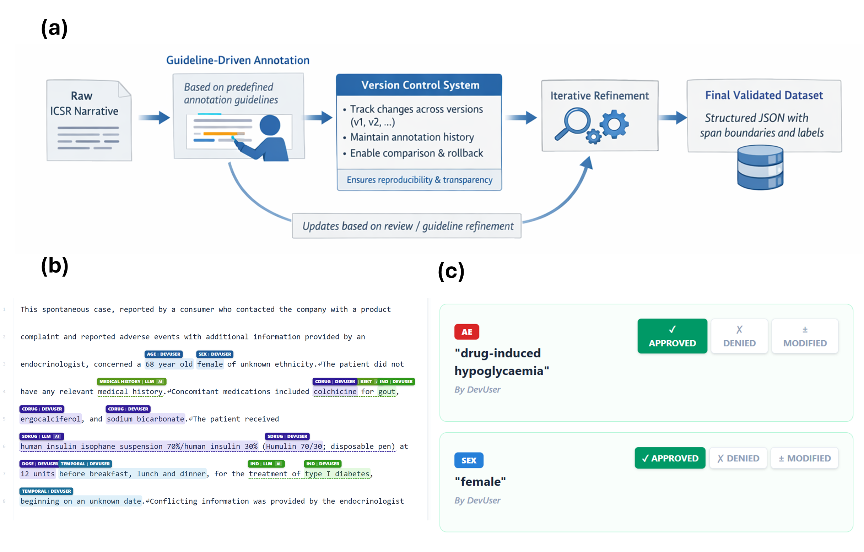
Figure 1. In-house annotation platform and workflow. (a) Annotation workflow illustrating guideline-driven labeling and version-controlled updates for reproducibility. (b) Annotation interface for span labeling using predefined clinical entity types. (c) Adjudication and quality control process for resolving ambiguous cases and refining annotation consistency.

2.3 Automated Annotation Approaches
In this study, we applied three annotation approaches: rule-based tool (e.g., ETHER); Large Language Model (LLM); and BERT-based Named Entity Recognition (NER) model. ETHER is a previously deployed rule-based system used to extract clinical concepts from ICSR narratives[8]. It relies on handcrafted rules, dictionaries, and pattern-matching heuristics. Because ETHER recognizes only a limited set of entity types and has difficulty handling linguistic variability, it serves as a baseline in this study.
Second, we used an instruction-tuned LLM to annotate narratives using an in-text XML tagging strategy (Figure 2). In this study, two LLMs were applied with the same prompts. LLaMA-4 (LLaMA-4-Maverick-17B-128E-Instruct-FP8, https://huggingface.co/collections/meta-Llama/LLaMA-4) and Claude 4.6 Sonnet (via FDA Elsa API). The LLM was prompted to insert tags around identified entities without altering the surrounding text (see Supplementary File S1). After annotation, we compute a character-level mapping between the LLM's tag-stripped output and the original page text, using the SequenceMatcher function from the difflib Python library (https://docs.python.org/3/library/difflib.html) to extract accurate character offsets. All tags are normalized to standard categories by insensitive case mapping. Besides filtering out unsuccessfully tagged items (e.g., mismatched closing tags, unescaped angle brackets, or tags did not match pre-defined categories),using in-text annotation plus back mapping as a strategy helped ensure the original narratives were not altered during the annotation process. Unsuccessful tagging and text alterations have both been observed during preliminary studies, particularly where some LLMs were intended to correct typos from narratives. Full prompt used for LLM annotation is provided in Supplementary File S1. The annotation guidance used in the prompt are provided in Supplementary File 2 and 3, for FAERS and VAERS dataset, respectively.

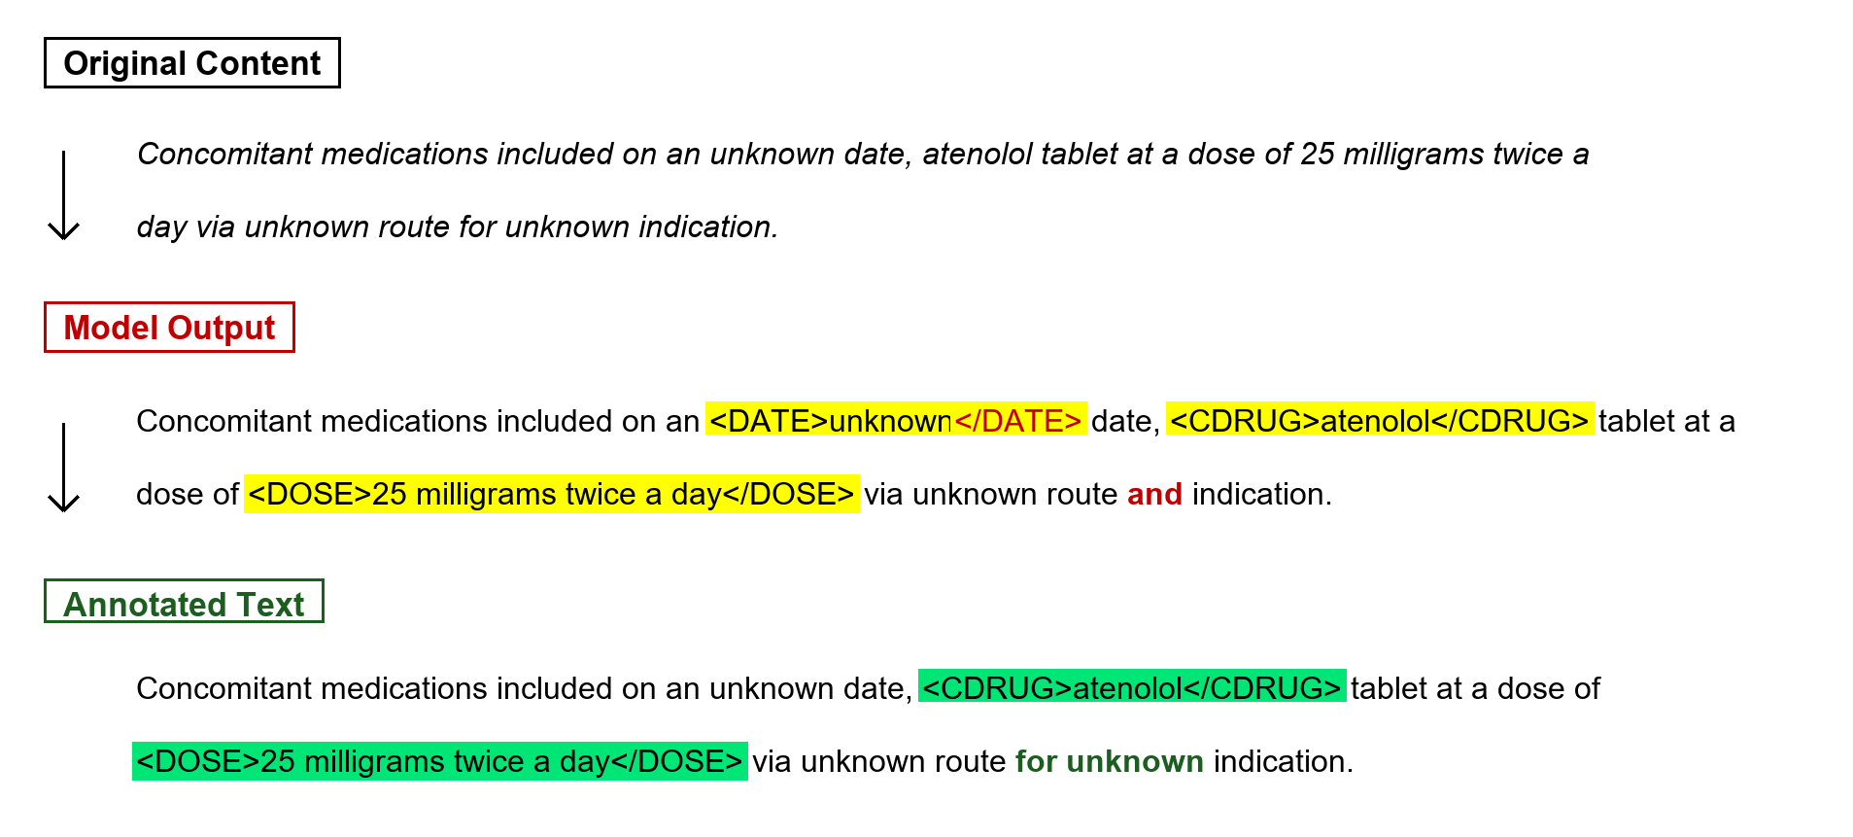
Figure 2. Overview of the In-Text XML Tagging Annotation Framework (P2_TAG). The raw clinical narrative is processed using an instruction-tuned prompt with in-text XML tags (e.g., <DRUG>, <AE>, <DX>). Strict boundary alignment is verified against the original narrative text via character offset matching to ensure zero loss or corruption of narrative context.

Third, BERT-based NER models were implemented using the spaCy-transformer pipeline (TransformerModel.v3) for FAERS and VAERS datasets. Narratives were tokenized and aligned with span annotations. Entities were converted to the BIO tagging scheme for model input. All preprocessing steps were standardized to ensure reproducibility.
For the primary BERT evaluation, we used a prespecified random seed (seed 42). For FAERS, BERT was evaluated using four-fold leave-one-drug-event-pair-out cross-validation, with each of the four drug–event case series serving once as the held-out test cohort. For VAERS, BERT was evaluated using report-level 10-fold cross-validation with fixed folds. Primary performance estimates were calculated from the out-of-fold predictions generated under this prespecified seed. To assess sensitivity to stochastic model initialization, the complete cross-validation procedures were subsequently repeated using four additional random seeds (123, 456, 789, and 1011); these results are reported separately in Section 3.6.
Since the cross-runs variance is small (see section 3.6), for both FAERS and VAERS experiments, the final overall estimates are calculated from pooled out-of-fold predictions from one seed (42). Hyperparameters included a learning rate of 0.0001, batch size of 32, and up to 20,000 training steps. Sentences exceeding the 512-token limit were segmented before transformer processing.
To determine the best base BERT model, we conducted an ablation experiment comparing BERT[13], BioBERT[14], ClinicalBERT[15], and Bio_ClinicalBERT[16] using the VAERS data. BioBERT demonstrated superior precision and recall across key biomedical categories and was used as the BERT model in this study. Any unspecified BERT model used in this study were based on BioBERT.

2.4 Evaluation Metrics
Model performance was evaluated using mention-level matching adapted from ADE-Eval[17]. System predictions were categorized as Match (M), Conflation (C), Spurious (S), and Null (N). Match denotes an exact span and label match; Conflation denotes an overlapping span with inexact boundaries under the same label, or a mis-label annotation; Spurious denotes a predicted entity without a corresponding reference match; and Null denotes a reference entity that was not identified.
For example, an automated prediction of “hypoglycemia” as AE that exactly matches the reference span and label is classified as a Match (M). A prediction is classified as Conflation (C) when it identifies the same underlying text region but does not exactly reproduce the reference annotation. Conflation includes both boundary inexactness, for example predicting “severe hypoglycemia” when the reference span is “hypoglycemia”, and category misclassification, for example identifying “hypoglycemia” but labeling it as DX rather than AE. A Spurious (S) prediction is a predicted entity with no character overlap with any reference entity, whereas Null (N) represents a reference entity for which no overlapping prediction is produced, such as failing to identify “somnolence”.
We evaluated model performance using two complementary evaluation schemes. The primary scheme was a strict exact-match NER evaluation, in which a prediction was counted as correct only when both its span boundaries and entity label exactly matched the reference annotation. Under this scheme, precision and recall were calculated as below:
$$P_{1}=M/(M+C+S)$$
$$R_{1}=M/(M+C+N)$$

The secondary scheme was an adapted ADE-Eval weighted evaluation. In this scheme, an exact Match receives full credit, while a Conflation receives 0.5 partial credit. Spurious predictions are assigned a 0.25 penalty weight, whereas completely missed reference entities (N) retain their full penalty. Weighted precision and recall were therefore calculated as below:
$$P_{2}=(M+0.5C)/(M+C+0.25S)$$
$$R_{2}=(M+0.5C)/(M+C+N)$$

F1 was calculated as the harmonic means of precision and recall under each scheme. All precision, recall, and F1 measures were calculated using mention-level micro-averaging. For cross-validation analyses, predictions from all held-out folds were pooled to generate a complete set of out-of-fold predictions, and performance metrics were calculated from the pooled mention-level counts.

3. Results

3.1 Annotation Statistics
Human annotators labeled entities according to 17 clinical concept categories, as summarized in Table 2. The annotations from ETHER and LLM approaches were also included for comparison.

Table 2. FAERS annotations, categorized by Human, ETHER and LLM
Category | Human | ETHER | LLM (LLaMA-4) | LLM (Sonnet 4.6)
SDrug | 3,501 | 17,164* | 5,907 | 4,041
CDrug | 2,928 |  | 3,514 | 2,656
ODrug | 245 |  | 511 | 344
Dose | 1,621 | n/a | 2,013 | 1,799
Indication | 162 | n/a | 1,415 | 1,346
Treatment | 1,479 | n/a | 1,720 | 1,266
AE | 9,080 | 25,031* | 12,398 | 8,580
mAE | 112 |  | 605 | 379
Dx | 1,783 | 4,344 | 813 | 578
Lab | 3,480 | n/a | 4,348 | 3,415
Status | 1,796 | n/a | 1,038 | 1,378
R/O | 9 | 33 | 175 | 274
CoD | 3 | 125 | 234 | 230
MHx | 2,304 | 755 | 3,241 | 2,760
FHx | 105 | 22 | 25 | 21
Age | 787 | n/a | 885 | 774
Sex | 768 | n/a | 837 | 819
*ETHER does not distinguish drug roles or AE types – all drug and AE mentions are output under a single DRUG tag (17,164) and AE tag (25,031).

3.2 LLM performs significantly better than ETHER
First, we compared two machine annotation methods, LLM and ETHER, against human annotations as the gold standards on FAERS case series dataset. For LLM, both LLaMA-4 and Claude 4.6 Sonnet were evaluated. The goal was to assess which method more accurately replicates human-level annotation performance across common annotation types.
As shown in Figure 3a, LLaMA-4 and Claude 4.6 Sonnet showed similar performance, and overall, the few-shot LLM demonstrated robust generalization capabilities, outperformed ETHER in all categories that are available for comparisons (Figure 3b). Moreover, LLMs offer broader coverage of safety concepts such as age, sex, and lab values, some of which were challenging to extract using ETHER rule-based systems. We observed a slightly decreased performance of Dx in LLMs, which we will discuss more in later section about Error Analysis.
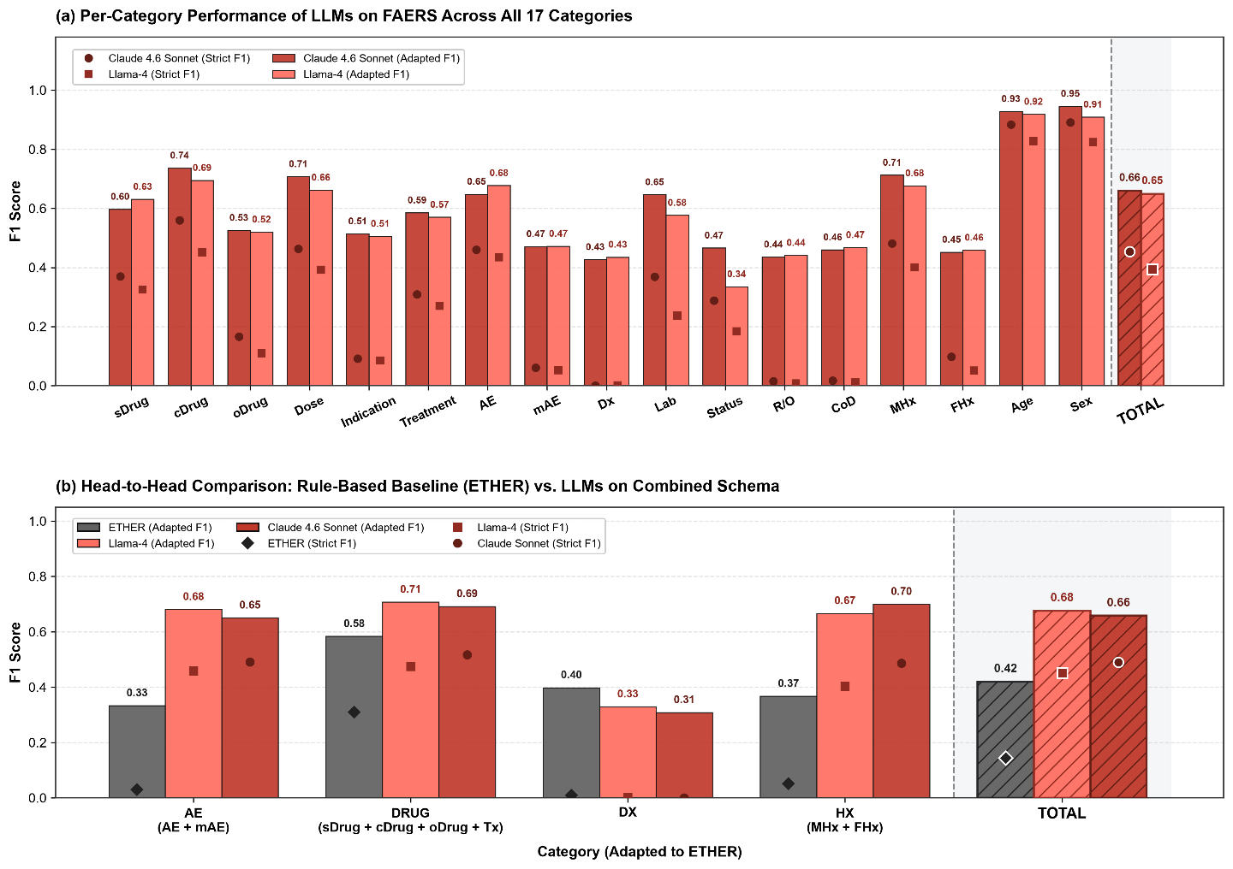
Figure 3. Overall Performance Comparison on FAERS dataset, for rule-based baseline ETHER (Gray), Claude 4.6 Sonnet (Red), and LLaMA-4 (Pink). Both adapted ADE-Eval F1 and Strict Exact-Match F1 are shown. (a) Per-category analysis between LLaMA-4 and Sonnet 4.6; (b) comparative result between ETHER and LLMs; to comply with ETHER’s labeling groups, some categories in LLMs are combined.

3.3 BERT-based NER model performance
We trained and evaluated the BERT NER model using a 4-fold Leave-One-Drug-Event-Pair-Out cross-validation design on the 829 FAERS narratives across all 17 clinical concept categories. Table 3 summarizes the overall benchmark comparison across model families, input paradigms, and evaluation tiers. BERT achieved a strict exact-match F1 of 0.5685 and an adapted ADE-Eval F1 of 0.7463, which substantially outperformed few-shot LLaMA-4 (0.4043 Strict, 0.6249 Adapted), Claude 4.6 Sonnet (0.4667 Strict, 0.6443 Adapted), and baseline ETHER system (0.1147 Strict, 0.2447 Adapted).

Table 3. Performance Benchmark on the FAERS Dataset (N = 829 Reports).
Model | Strict Exact F1 | Adapted ADE-Eval F1
BERT | 0.5685 ± 0.0080 | 0.7463 ± 0.0076
LLaMA-4 | 0.4043 | 0.6249
Claude 4.6 Sonnet | 0.4667 | 0.6443
ETHER | 0.1147 | 0.2447

Figure 4 showed the category-level performance breakdown across 17 clinical concept categories. Particularly, some categories (oDrug, mAE, Dx, R/O, CoD) have close-to-zero strict F1 across all situations, indicating accurately tagging these categories are challenging regardless of the selected model. Interestingly, some of them showed higher (nearly 0.5) F1 under adapted ADE-Eval F1 in LLM models (LLaMA-4 and Sonnet 4.6), implying these terms were found however with inaccurate boundaries or mislabeled to a different category (i.e., Conflation). On the other side, BERT kept the nearly-zero performance for 4 of 5 categories (oDrug, mAE, R/O, CoD), implying its weakness on these challenging annotation categories.
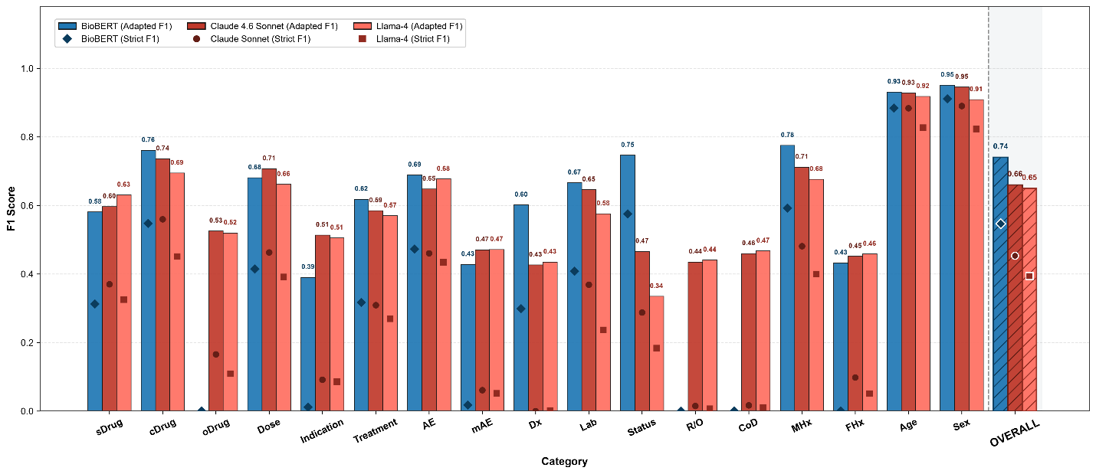
Figure 4. Comparative Performance Across 17 Categories on the FAERS dataset, for BERT (Blue), Claude 4.6 Sonnet (Red), and LLaMA-4 (Pink).

3.4 Error analysis
Next, we conducted an error analysis on the FAERS dataset to characterize whether BERT and LLM (LLaMA-4) differed in their failure modes. Figure 5a shows that BERT produces more exact matches, fewer Conflation and Spurious outcomes than LLaMA-4. BERT produced 17,864 exact matches, compared with 13,770 for LLaMA-4. BERT also had fewer Conflation outcomes (including boundary errors and class confusions: 7,146 vs 10,119) and fewer Spurious predictions (9,861 vs 15,790). Null/Misses were comparable: 5,436 for BERT and 6,259 for LLaMA-4.
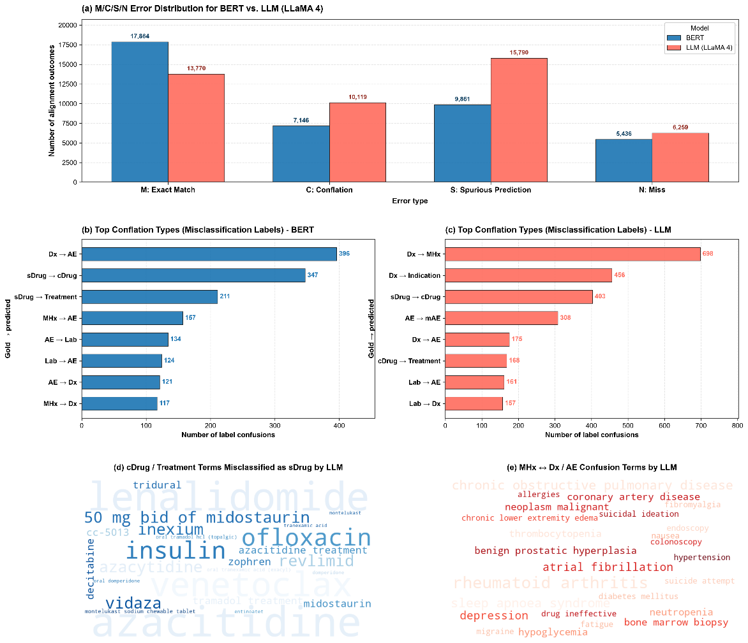
Figure 5. Error analysis on the FAERS dataset. (a) Overall M/C/S/N error distribution (M: exact match; C: Conflation error, including boundary errors and class confusions; S: spurious prediction; N: miss). (b) Top Conflation types for BERT. (c) Top Conflation types for LLaMA-4. (d) Example of concomitant drug and treatment terms misclassified as suspect drug (sDrug) by LLaMA-4. (e) Example of medical history (MHx) to diagnosis (Dx) / adverse event (AE) confusions by LLaMA-4.

The top confusion pairs for both systems (Figure 5b and 5c) demonstrate that errors cluster within clinically related concept types rather than dispersing randomly. For BERT (Figure 5b), the largest confusions were Dx labeled as adverse events (Dx to AE: 396), suspect drugs labeled as concomitant drugs (sDrug to cDrug: 347), and suspect drugs labeled as treatment interventions (sDrug to Treatment: 211). Other frequent errors involved medical history labeled as AE (MHx to AE: 157), AE labeled as laboratory findings (AE to Lab: 134), and laboratory findings labeled as AE (Lab to AE: 124), AE labeled as Dx (AE to Dx: 121), and medical history labeled as Dx (MHx to Dx: 117).
For LLaMA-4 (Figure 5c), the most frequent confusion was Dx labeled as medical history (Dx to MHx: 698), followed by Dx labeled as indication (Dx to Indication: 456). Other prominent errors included suspect drugs labeled as concomitant drugs (sDrug to cDrug: 403), AE labeled as mAE (AE to mAE: 308), Dx labeled as AE (Dx to AE: 175), concomitant drugs labeled as treatment (cDrug to Treatment: 168), and laboratory findings labeled as AE (Lab to AE: 161) or Dx (Lab to Dx: 157).
We further applied word-cloud visualizations to the primary LLaMA-4 misclassification categories to clarify these failure modes. For concomitant and treatment spans misclassified as suspect drug (sDrug) by LLaMA-4 (Figure 5d), prominent terms included azacitidine, lenalidomide, venetoclax, insulin, and ofloxacin. In contrast, clinical spans exhibiting medical history and diagnosis/AE confusions (Figure 5e) were dominated by chronic conditions and comorbidities, including rheumatoid arthritis, chronic obstructive pulmonary disease, sleep apnoea syndrome, atrial fibrillation, and depression.
Overall, compared with BERT, LLaMA-4 annotations show fewer exact matches and more Conflation and Spurious predictions. Nevertheless, as shown in Figure 4, partial boundary and label matches can still receive partial credit under the adapted ADE-Eval metric, which is particularly relevant for uncommon categories such as oDrug, mAE, R/O, and CoD.

3.5 VAERS Evaluation
To evaluate cross-domain generalization beyond the FAERS dataset, we further analyzed the annotation performance over VAERS dataset. Since VAERS dataset did not provide ETHER result, we only compared SME with LLM annotations. As the result, BERT fine-tuned via 10-fold cross-validation achieved a strict exact-match F1 of 0.7015 ± 0.0174 (0.8370 ± 0.0095 for Adapted F1). In contrast, the 1-shot LLaMA-4 baseline evaluated under the official 11-category annotation guidance achieved a strict F1 of 0.3383 and an adapted ADE-Eval F1 of 0.6400 (with 0.6691 Precision and 0.6134 Recall).
Table 4. VAERS annotations across 11 categories.
Category | Human | LLM (LLaMA-4)
pDx | 1,244 | 1,243
sDx | 8,265 | 2,784
R/O | 171 | 498
SYM | 14,581 | 11,656
CoD | 46 | 45
Lab | 3,849 | 4,858
FHx | 195 | 198
MHx | 1,183 | 2,006
STATUS | 1,747 | 2,898
TX | 3,607 | 3,955
VAX | 5,823 | 5,429
TOTAL | 40,711 | 35,570

Category-level analysis (Figure 6a) across all 11 clinical concept categories confirmed strong supervised encoder advantages across vaccines (VAX: 0.93 vs 0.85), treatments (TX: 0.92 vs 0.76), secondary diagnoses (sDx: 0.87 vs 0.62), medical history (MHx: 0.85 vs 0.58), patient clinical status (STATUS: 0.83 vs 0.61), primary diagnoses (pDx: 0.83 vs 0.70), adverse-event symptoms (SYM: 0.78 vs 0.57), laboratory findings (Lab: 0.76 vs 0.56), and family history (FHx: 0.65 vs 0.51). Notably, few-shot LLaMA-4 successfully extracted specialized categories unmodeled by the encoder, including cause of death (CoD: 0.70 F1; P = 0.67, R = 0.73) and rule-out diagnoses (RO: 0.53 F1), while overall micro-average performance reached 0.84 for BERT versus 0.64 for LLaMA-4. Error anatomy (Figure 6b) on the VAERS dataset revealed that BERT achieved 64.5% exact matches (15,068 spans) and 19.3% coverage errors (4,506 spans), with only 8.9% spurious spans (2,081) and 7.3% misses (1,711). In contrast, LLaMA-4 produced 30.4% exact matches (12,015 spans) and 49.3% coverage errors (19,476 spans), while spurious hallucinations (10.3%; 4,079 spans) and true unpredicted omissions (10.0%; 3,972 spans). Confusion breakdowns (Figure 6c & 6d) demonstrated that the predominant error mode for LLaMA-4 was subsuming secondary diagnoses under adverse symptoms (sDx to SYM: 4,452), accompanied by reciprocal symptom-to-diagnosis misclassifications (SYM to sDx: 1,093), symptom conflation with medical history (SYM to MHx: 758), and symptom labeling of laboratory results (SYM to Lab: 745). For BERT, confusions similarly peaked at sDx to SYM (782) and SYM to sDx (350), but at markedly lower absolute frequencies.

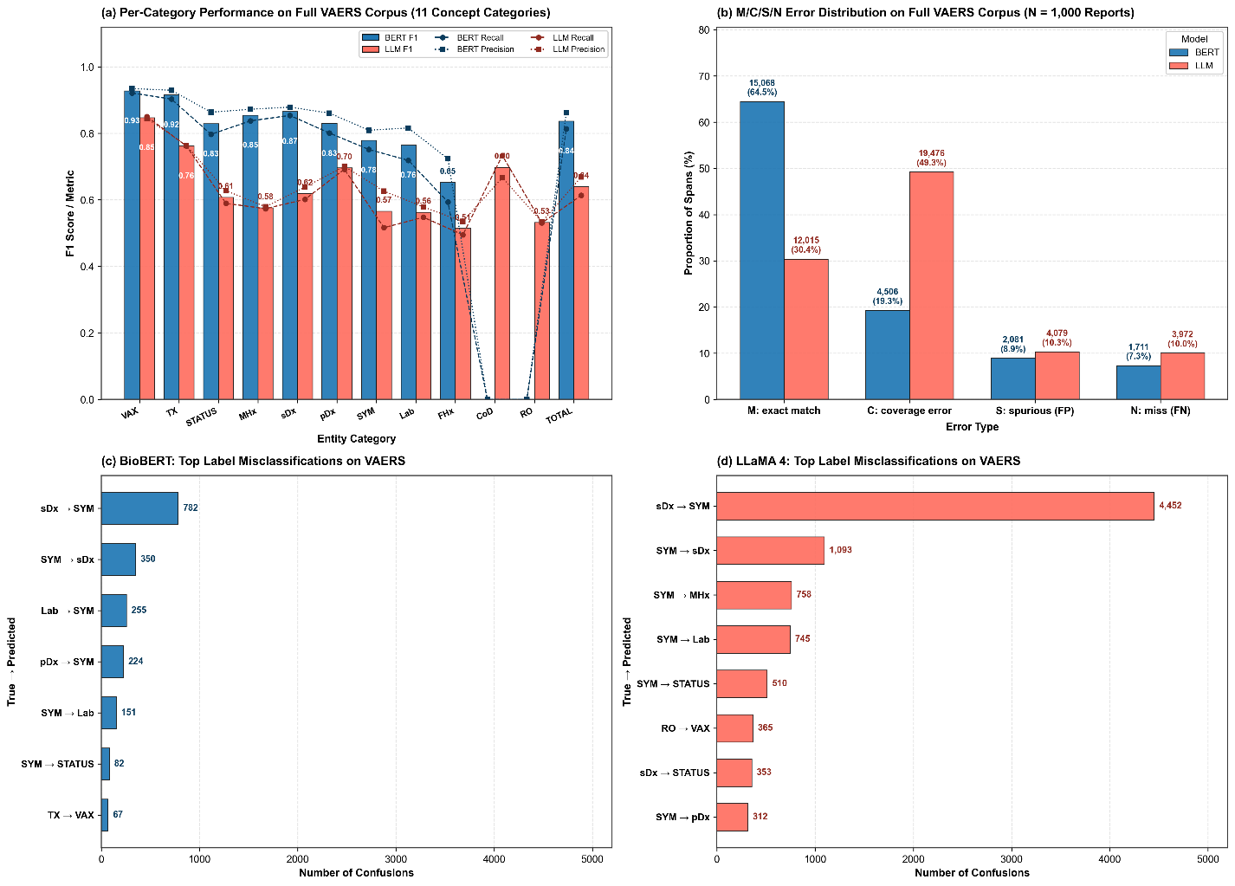
Figure 6. Annotation performance and error analysis on the VAERS dataset. (a) Per-category performance across all 11 clinical concept categories for BERT (Blue) vs. LLaMA-4 (Pink). (b) M/C/S/N error distribution for BERT vs. LLaMA-4 (M: exact match; C: conflation error; S: spurious prediction; N: miss). (c) BERT top label misclassifications. (d) LLaMA-4 top label misclassifications.

3.6 Ablation Studies

Leave-One-Drug-Event-Pair-Out in BERT
We applied a repeated Leave-One-Drug-Event-Pair-Out cross-validation protocol on the FAERS corpus to evaluate model generalization across distinct therapeutic contexts on all 17 clinical concept categories. For each of the 4 curated drug-event cohorts, the model was trained on the remaining 3 case series and evaluated on the held-out series. As shown in Table 5, strict exact-match F1 was 0.6002 ± 0.0113 for azacitidine–QT prolongation (N = 200), 0.6367 ± 0.0201 for baricitinib–hypersensitivity (N = 200), 0.5289 ± 0.0093 for tramadol–hypoglycemia (N = 229), and 0.5084 ± 0.0122 for erenumab–stroke (N = 200), yielding an aggregated micro-average F1 of 0.5564 ± 0.0069 across the full corpus (0.7420 ± 0.0061 Adapted ADE F1). The between-series performance variance exceeded within-fold variation, demonstrating that narrative complexity and therapeutic vocabulary differences contribute more variation than stochastic model initialization.
Table 5. Leave-One-Drug-Event-Pair-Out Cross-Validation Performance on FAERS dataset
Drug–Event Case Series | Validation Cohort Size | Strict Exact F1 | Adapted ADE-Eval F1
Azacitidine – QT Prolongation | 200 | 0.6002 ± 0.0113 | 0.7733 ± 0.0092
Baricitinib – Hypersensitivity | 200 | 0.6367 ± 0.0201 | 0.7751 ± 0.0128
Tramadol – Hypoglycemia | 229 | 0.5289 ± 0.0093 | 0.7242 ± 0.0036
Erenumab – Stroke | 200 | 0.5084 ± 0.0122 | 0.7126 ± 0.0077
Total (Micro-Average) | 829 | 0.5564 ± 0.0069 | 0.7420 ± 0.0061

Random seed in BERT Training
To rigorously verify neural network optimization stability, we conducted 5 independent training runs using random initialization seeds (42, 123, 456, 789, 1011) across both FAERS and VAERS. As summarized in Table 6, cross-runs variance was exceptionally low across both datasets. On FAERS, strict F1 averaged 0.5685 ± 0.0080 (0.7463 ± 0.0076 Adapted) across the 5 seeds. On VAERS, strict F1 averaged 0.7009 ± 0.0016 (0.8397 ± 0.0018 Adapted) across the 5 seeds. These findings confirm that BERT convergence is robust to weight initialization.
Table 6. BERT Stability Performance Across Five Runs in FAERS
Dataset | Random Seed | Strict Exact F1 | Adapted ADE-Eval F1
FAERS (4-Fold LOO) | Seed 42 | 0.5582 ± 0.0649 | 0.7431 ± 0.0295
FAERS (4-Fold LOO) | Seed 123 | 0.5652 ± 0.0509 | 0.7402 ± 0.0293
FAERS (4-Fold LOO) | Seed 456 | 0.5783 ± 0.0697 | 0.7586 ± 0.0355
FAERS (4-Fold LOO) | Seed 789 | 0.5662 ± 0.0476 | 0.7413 ± 0.0324
FAERS (4-Fold LOO) | Seed 1011 | 0.5748 ± 0.0694 | 0.7484 ± 0.0371
FAERS (Pooled) | Mean ± SD (5 Seeds) | 0.5685 ± 0.0080 | 0.7463 ± 0.0076
VAERS (10-Fold CV) | Seed 42 | 0.7015 ± 0.0174 | 0.8370 ± 0.0095
VAERS (10-Fold CV) | Seed 123 | 0.7013 ± 0.0156 | 0.8405 ± 0.0070
VAERS (10-Fold CV) | Seed 456 | 0.7008 ± 0.0202 | 0.8400 ± 0.0113
VAERS (10-Fold CV) | Seed 789 | 0.7026 ± 0.0152 | 0.8419 ± 0.0082
VAERS (10-Fold CV) | Seed 1011 | 0.6983 ± 0.0159 | 0.8389 ± 0.0091
VAERS (Pooled) | Mean ± SD (5 Seeds) | 0.7009 ± 0.0016 | 0.8397 ± 0.0018

LLM Output Format Impact
We investigated whether the output representation paradigm impacts generative LLM extraction fidelity. We benchmarked two structured output paradigms on FAERS (Table 7): (1) Inline Tagged XML, where the LLM embeds XML tags directly into the narrative text, versus (2) JSON, where the LLM produces a structured JSON array of extracted entity spans and character offsets across the 17 clinical concept categories. The inline XML tagging approach achieved higher adapted ADE F1 (0.6249 vs. 0.5995) but slightly lower Strict Exact-Match F1 (0.4043 v.s 0.4071). Overall, output format had minimal impact on strict exact-match F1 but a more noticeable effect on adapted ADE-Eval F1.

Table 7. Impact of LLM Output Format Paradigm
Model | Output Paradigm | Strict Exact-Match F1 | Adapted ADE-Eval F1
LLaMA-4 | Inline Tagged | 0.4043 | 0.6249
LLaMA-4 | JSON | 0.4071 | 0.5995
Claude 4.6 Sonnet | Inline Tagged | 0.4667 | 0.6443

Pretrained Transformer Encoder Architecture Ablation
To investigate the impact of underlying pretraining corpora on pharmacovigilance concept extraction, we conducted an ablation study comparing four transformer encoder architectures (BERT-Base, BioBERT, Bio_ClinicalBERT, and ClinicalBERT) on the VAERS dataset across 5 independent random initialization seeds (Table 8). BioBERT achieved the highest validation F1 (0.8471 ± 0.0058, Precision = 0.8666, Recall = 0.8285), confirming its selection as the primary encoder architecture. All four models demonstrated close performance with minimal variance across seeds (SD < 0.009).

Table 8. BERT model comparison the VAERS Dataset
BERT Model | Validation F1 (Mean ± SD) | Validation Precision | Validation Recall | Clinical Score
BioBERT v1.1 | 0.8471 ± 0.0058 | 0.8666 ± 0.0048 | 0.8285 ± 0.0089 | 0.8500 ± 0.0071
Bio_ClinicalBERT | 0.8433 ± 0.0070 | 0.8610 ± 0.0078 | 0.8264 ± 0.0104 | 0.8440 ± 0.0055
BERT-Base | 0.8382 ± 0.0047 | 0.8596 ± 0.0055 | 0.8179 ± 0.0061 | 0.8420 ± 0.0045
ClinicalBERT | 0.8369 ± 0.0086 | 0.8615 ± 0.0106 | 0.8140 ± 0.0167 | 0.8400 ± 0.0071

4. Discussion
This work provides a systematic comparison of automated systems for extracting clinical concepts from regulatory safety narratives, grounded in newly developed FAERS annotations and an established VAERS benchmark. The annotated dataset captures the complexity of real-world pharmacovigilance narratives and can serve as benchmarks for future NER and related regulatory tasks.
In this study, we observed that a few-shot, instruction-tuned LLM markedly outperforms a legacy rule-based system (ETHER). This highlights the utility of LLMs as a flexible baseline when annotated data or rule development is limited. On the other hand, a supervised BERT model trained on high-quality annotations achieved consistently higher overall performance across both FAERS and VAERS datasets, with especially large gains for context-dependent categories such as STATUS, HX, and laboratory and diagnostic entities. These findings reinforce the value of domain-specific supervised models for structured extraction tasks.
Taken together with the FAERS results, these VAERS findings demonstrate that BERT-based models trained on high-quality human annotations provide more robust and reliable performance across heterogeneous pharmacovigilance datasets. While LLM-derived annotations offer a convenient low-resource alternative, their direct use leads to substantially lower accuracy, particularly in semantically complex categories such as STATUS, LAB, and HX. These results underscore the continued importance of curated human-labeled data for medical NER and highlight the effectiveness of supervised transformer models for large-scale safety narrative processing in real-world biomedical applications.
The reported performance should be interpreted in the context of a multi-class classification task with a stringent evaluation framework. Because the metric requires exact agreement in both span boundaries and fine-grained labels, it penalizes minor boundary differences and ambiguities between closely related categories (e.g., AE vs. diagnosis vs. medical history). As a result, the observed F1-scores likely underestimate the models’ ability to identify clinically relevant concepts, and should be understood as reflecting task complexity and strict evaluation criteria rather than limited practical utility.
Error analysis provides additional context for the observed performance under this strict evaluation framework. BERT produces more exact matches and fewer hallucinated spans, reflecting stronger adherence to annotation boundaries and label definitions, but tends to miss entities in more ambiguous contexts. In contrast, the LLM shows broader coverage but introduces more boundary inconsistencies and label confusion, particularly among closely related categories (e.g., diagnosis vs. medical history). These patterns suggest that a substantial portion of “errors” arise from boundary mismatch or label ambiguity rather than complete failure to identify relevant clinical concepts, contributing to the relatively low F1-scores under exact-match evaluation.
From a practical perspective, these differences highlight complementary roles of the two approaches. BERT serves as a stable and efficient “workhorse” for large-scale deployment, offering consistent, schema-adherent outputs, while LLMs provide flexibility for tasks such as initial annotation, candidate identification, and guideline refinement. This complementary design supports a hybrid workflow in which structured models ensure reliability and scalability, and LLMs facilitate iterative improvement through human-in-the-loop processes.
Beyond model comparison, the annotated datasets themselves provide a valuable resource for future research. By spanning both drug and vaccine safety narratives and incorporating harmonized entity definitions, they enable studies on cross-domain generalization, transfer learning, and multi-task modeling. The detailed error characterizations also highlight areas where additional training data, refined guidelines, or specialized modeling approaches may further improve performance.
This study has several limitations. The annotated datasets, while carefully constructed, represent a subset of possible reporting scenarios and may not fully generalize across all products and adverse events. The current annotation workflow was designed as a linear process, starting with a single annotator, with future work planned to incorporate cross-annotator review and adjudication for additional validation and robustness. In addition, this work focuses on span-level NER and does not address downstream tasks such as relation extraction or causality assessment, which are critical for regulatory applications. Finally, due to data sensitivity constraints, we were unable to evaluate certain commercial LLMs, and future advances in model capabilities may shift the relative performance observed here.
In summary, BERT-based NER models demonstrate strong and reliable performance for pharmacovigilance concept extraction when trained on curated datasets. Rather than replacing such models, LLMs complement them by providing flexibility and supporting annotation and analysis workflows. Together, these approaches highlight the continued importance of high-quality annotated data in enabling accurate and scalable NLP solutions for regulatory safety applications.

Acknowledgement
Karen Long and Joseph Cusimano provided feedback on drafts of the clinical concept categories and definitions for the annotation guidelines. WZ and ML are grateful for the support by an appointment to the Research Participation Program of the U.S. FDA through the Oak Ridge Institute for Science and Education (ORISE).
Disclaimer: This manuscript reflects the views of the authors and does not necessarily reflect those of the Food and Drug Administration. Any mention of commercial products is for clarification only and is not intended as approval, endorsement, or recommendation.

Declarations

Funding
This work was funded by the U.S. Food and Drug Administration.

Conflicts of interest
The authors declare that the research was conducted in the absence of any commercial or financial relationships that could be construed as potential conflicts of interest.

Ethics approval
Not Applicable

Consent to participate
Not Applicable.

Consent for publication
Not Applicable.

Availability of data and materials
The FAERS reports analyzed in this study were obtained from the U.S. Food and Drug Administration Adverse Event Reporting System (FAERS). The expert annotations generated for this study are not publicly available because they constitute a research dataset developed by the authors and are subject to institutional and regulatory restrictions. The VAERS benchmark dataset used in this study is available from its original publication. Additional information regarding the datasets may be available from the corresponding authors upon reasonable request and subject to applicable restrictions.

Code availability
The annotation prompt and source code for the annotation platform are available at: https://github.com/seldas/LLM4AE.

Author contributions
LW, OD, JX conceptualized the study, ML did the data curation and annotation and OD oversaw the annotation process to provide guidance and address inquiries as needed. WZ, ML, LW did the modeling and data analyses. LW, JX, OD wrote the manuscript. All authors agreed with the final version.

AI Usage
This manuscript was created with the assistance of FDA’s Generative AI tool, Elsa. Elsa was used to help identify relevant references and improve clarity and grammar of text that was initially written by one of the authors. Authors have reviewed, verified, and edited the content for the final manuscript.

Reference
1. FDA. FDA's Adverse Event Reporting System (FAERS). 2025 [cited 2025 11/24]; Available from: https://www.fda.gov/drugs/surveillance/fdas-adverse-event-reporting-system-faers.
2. HHS, the Vaccine Adverse Event Reporting System. 2025.
3. Fu, S., et al., Clinical concept extraction: a methodology review. Journal of biomedical informatics, 2020. 109: p. 103526.
4. Peng, C., et al., Clinical concept and relation extraction using prompt-based machine reading comprehension. Journal of the American Medical Informatics Association, 2023. 30(9): p. 1486-1493.
5. Norén, G.N., The power of the case narrative-can it be brought to bear on duplicate detection? Drug Safety, 2017. 40(7): p. 543-546.
6. Kreimeyer, K., et al., Using probabilistic record linkage of structured and unstructured data to identify duplicate cases in spontaneous adverse event reporting systems. Drug Safety, 2017. 40(7): p. 571-582.
7. Pilipiec, P., M. Liwicki, and A. Bota, Using Machine Learning for Pharmacovigilance: A Systematic Review. Pharmaceutics, 2022. 14(2).
8. Pandey, A., et al., Adverse event extraction from structured product labels using the event-based text-mining of health electronic records (ETHER) system. Health informatics journal, 2019. 25(4): p. 1232-1243.
9. Bergman, E., et al., BERT based natural language processing for triage of adverse drug reaction reports shows close to human-level performance. PLOS Digital Health, 2023. 2(12): p. e0000409.
10. Ball, R. and G. Dal Pan, “Artificial intelligence” for pharmacovigilance: ready for prime time? Drug safety, 2022. 45(5): p. 429-438.
11. Kreimeyer, K., et al., Increased confidence in deduplication of drug safety reports with natural language processing of narratives at the us food and drug administration. Frontiers in Drug Safety and Regulation, 2022. 2: p. 918897.
12. Foster, M., et al., Generation of an annotated reference standard for vaccine adverse event reports. Vaccine, 2018. 36(29): p. 4325-4330.
13. Devlin, J., et al. Bert: Pre-training of deep bidirectional transformers for language understanding. in Proceedings of the 2019 conference of the North American chapter of the association for computational linguistics: human language technologies, volume 1 (long and short papers). 2019.
14. Lee, J., et al., BioBERT: a pre-trained biomedical language representation model for biomedical text mining. Bioinformatics, 2020. 36(4): p. 1234-1240.
15. Huang, K., J. Altosaar, and R. Ranganath, Clinicalbert: Modeling clinical notes and predicting hospital readmission. arXiv preprint arXiv:1904.05342, 2019.
16. Lee, S.A., A. Wu, and J.N. Chiang, Clinical modernbert: An efficient and long context encoder for biomedical text. arXiv preprint arXiv:2504.03964, 2025.
17. Bayer, S., et al., ADE Eval: An Evaluation of Text Processing Systems for Adverse Event Extraction from Drug Labels for Pharmacovigilance. Drug Saf, 2021. 44(1): p. 83-94.

