Guten Tag. I brought pictures.

The relations inspector is an editor window that displays a graph of relations, like this:
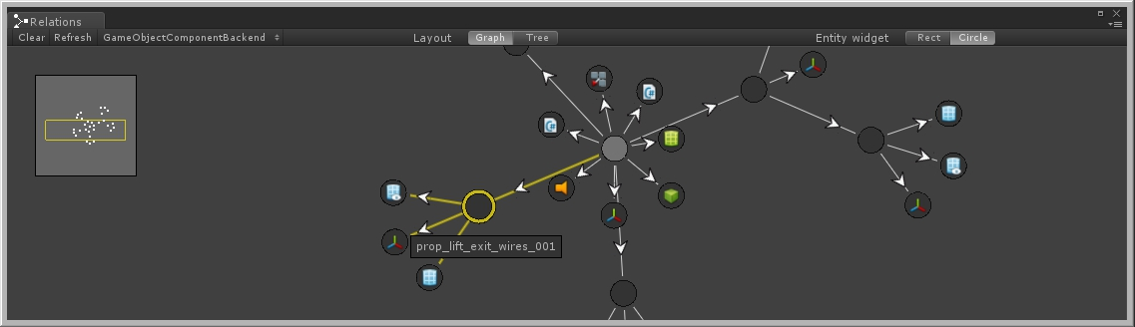
image: gameObjectGraph.jpg
caption: Unity Stealth project. Inspecting the exit lift, showing its nested objects and their components.

In this case it displays ownership-relations between GameObjects and components. Here it shows the feelings between people:
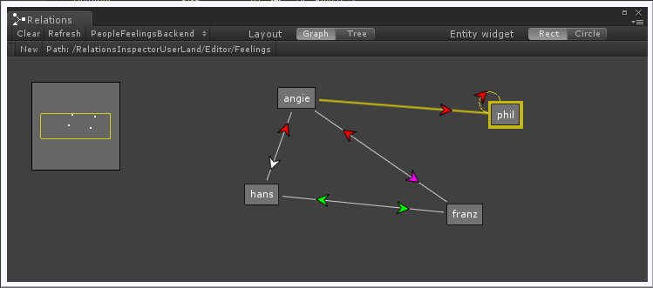
image: feelings.jpg
caption: hans and franz have a thing for angie, but despise each other. angie likes phil, who only likes himself.

Just like the inspector, it allows the user to view and modify data. However, instead of focusing on properties of one object, it‘s concerned with relations between objects. Many existing graph editors serve the same purpose, usually for a specific domain like animation states, behaviour trees, tech trees or dialog graphs. The relations inspector is another such tool, except its domain specific code is supplied by you, similar to writing a custom inspector.

Here is such a backend class for the feelings between people domain:

<code>

It tells the tool which object relations to display, and which editing operations are allowed. The tool then takes care of building the graph, layout, navigation and editing. It is not restricted to GameObjects or Unity Objects, you can also feed it with xml entities, data from other editor windows or even runtime data in playmode.

Here is a demo package: <link>
It‘s not restricted in functionality, but it‘s very sleepy and requires many a naptime.

There is no documentation yet, so please ask all the questions you run into, and let me know of any bugs and API change requests.

I hope you like.

