***Message From The Head Of The Bureau***

***Dear gusts! Ladies and gentlemen! I warmly well come you to Amhara Culture, Tourism and Parks Development Bureau website!***

***The Amhara  region is a multinational state of the Amhara, Agew, Himra,Oromo and Argoba people who live together in common,with mutualrespect and solidarity for long to the present . The people and nations of the Amhara region, Like the rest of the Ethiopian society elsewhere in the country, are known for their unique and exceptional character of cheerful hamblity and hospitality; but this not without due of an addition of a farvour of national pride and sense of indignity in the rich cultural goods and heritage of the the people.***

***The Regional State has rich and diverse sites of tourism and tourist attraction places in which some of them are among the record wonders of world heritages.  Among the nine World record heritage sites of Ethiopia, threeof them are for instance found in Amhara National Regional State. Those which includes, the Lalibela rock hewn churches of the 11thcentury   with its architectural elegance and religious value, the 16 century Gondar Castles and the Semin Mountains National Park.***

***In addition to those already existingtourist attraction centers ,the regional government in collaboration with the people and other stake holders is exerting concerted effort of exploring and developing the sector for greater degree and expanding horizon.So far and in the recent time several new tourism destination and attraction areas are being explored and identified from out of the richpotentials of the region and its people.***

***It is there for my message of invitation and welcoming of our guests here that the Amhara region governement  and its friendly people are ready to make available of your needs and interests served and satisfied in the  growing tourism industry.Your valuable comment is our source of strength for sustainable improvement.***

**Visit Amhara! Amhara National Region, Home of wonders!**

**The following some standard Lists of hotels at tourist**   
**Destination sites**

|  |  |  |  |
| --- | --- | --- | --- |
| No | **Name of hotels** | **Destination** | **Telephone** |
| 1 | **Roha Hotel** | **Lalibela** | **0333360009** |
| 2 | **Eyerusalem Guest house** | **”   ”** | **0333360047** |
| 3 | **heven guesthouse** | **”   ”** | **0333360075** |
| 4 | **Asheton Hotel** | **’’   ’’** | **0333360030** |
| 5 | **Alef paradise** | **”   ”** | **0333360205** |
| 6 | **Lale Hotel** | **”   ”** | **0333600844** |
| 7 | **Lalibela  Hotle** | **”   ”** | **0333360036** |
| 8 | **Yimiriha Hotle** | **”   ”** | **0333360865** |
| 9 | **Tikule Hotel** | **”   ”** | **0333360564** |
| 10 | **Sevene Olibes** | **”   ”** | **0333360020** |
| 11 | **Bluelale Hotel** | **”   ”** | **0333360387** |
| 12 | **Helen  Hotel** | **”   ”** | **0333360053** |
| 13 | **Aman  Hotel** | **”   ”** | **0333360086** |
| 14 | **Sevat Wayra  Hotel** | **”   ”** | **0333360020** |
| 15 | **Bete Abriham  Hotel** | **”   ”** | **0333361065** |
| 16 | **Maunt View  Hotel** | **”   ”** | 0333360804 |
|  |  |  |  |
| 01 | **Tana Hotel** | **Bahir Dar** | **0582200554** |
| 02 | **Ghion** | **”       ”** | **0582200303** |
| 03 | **Kuriftu Resort&Sposek Tana Lodge** | **”       ”** | **0582264868** |
| 04 | **Abay minchi Lodge** | **”       ”** | **0582181039** |
| 05 | **Dib Anbesa** | **”       ”** | **0582201436** |
| 06 | **Papyrus** | **”       ”** | **0582205100** |
| 07 | **Ethio star** | **”       ”** | **0582202026** |
| 08 | **SemerLand** | **”       ”** | **0582206566** |
| 09 | **Blue Nile** | **”       ”** | **0582206566** |
| 10 | **Azwa** | **”       ”** | **0582202028** |
| 11 | **Bahir Dar** | **”       ”** | **0582203820** |
| 12 | **Enkutatash No2** | **”       ”** | **0582204435** |
| 13 | **Hadas** | **”       ”** | **0582200309** |
| 14 | **Fikireselam** | **”      ”** | **0582200350** |
| 15 | **Girum Gaynit** | **”      ”** | **0582200832** |
| 16 | **Axum** | **”      ”** | **0582204849** |
| 17 | **Hadas** | **”      ”** | **0582200309** |
| 18 | **Nile** | **”      ”** | **0582203429** |
| 19 | **Goha Hotel** | **Gondar** | **0581110634** |
| 20 | **Quara** | **”     ”** | **0581110040** |
| 21 | **Land mark International** | **”     ”** | **0581122929** |
| 22 | **Atse Bekafa** | **”     ”** | **0581117711** |
| 23 | **Walia Kapra** | **”     ”** | **0581120314** |
| 24 | **Fogera** | **”     ”** | **0581110405** |
| 25 | **Semien Park** | **”     ”** | **0581110309** |
| 26 | **Serkle** | **”     ”** | **0581111991** |
| 27 | **Mekuriaw  Alemayehu** | **”     ”** | **0581116677** |
| 28 | **Nile hotel** | **”     ”** | **0581111600** |
| 29 | **Hibret Hotel** | **”     ”** | **0581120400** |
| 30 | **Lamerger Hotel** | **”     ”** | **0918772487** |
| 31 | **Embassy** | **”     ”** | **0581140868** |
| 32 | **ambaras** | **”     ”** | **0581111181** |
| 33 | **Red Fox** | **”     ”** | **0581140581** |
| 34 | **Universal Guest house** | **”     ”** | **0581121435** |
| 35 | **Kwin Hotel** | **”     ”** | **0581141297** |
| 36 | **GaintLobilia** | **Debark** | **0581170560** |
| 37 | **MetGogo** | **”     ”** | **0918773110** |
| 38 | **Semien park** | **”     ”** | **0581170055** |
| 39 | **Semien Lodge** | **Semien park** | **0582310741** |
| 40 | **Awash green land** | **Dessie** | **0331124608** |
| 41 | **Tosa** | **”     ”** | **0331119225** |
| 42 | **Ambaras** | **”     ”** | **0331119118** |
| 43 | **Qualeber** | **Dessie** | **0331111548** |
| 44 | **Gihon** | **Dessie** | **0331111115** |
| 45 | **Lalibela** | **”     ”** | **0331116908** |
| 46 | **Ethiopia** | **”     ”** | **0331117056** |
| http://www.amharatours.org.et/images/index_bahirdar.jpg | | | | | |
| the city of Bahirdar | | | | | |
| http://www.amharatours.org.et/images/att_clip_image022.gif | | | | | |
| Gonder Fasil Castel world heritage site (UNESCO) | | | | | |
|  | | | | | |
|  | | | | | |
| http://www.amharatours.org.et/images/aerial%20view,Lalibela%20comp.jpg | | | | | |
| Lalibela world heritage site (UNESCO) | | | | | |
| http://www.amharatours.org.et/images/agond_clip_image012.jpg  Seimen mountain National Park (UNESCO)    http://www.amharatours.org.et/images/alebel.jpg  Messages From The Head Of The Bureau | | | | | |

Ethiopian giant inland water body, Lake Tana, is glooming. The African largest river, Blue Nile emerging from this lake and sweeping along, the lined tall palm trees and jacarandas along the main streets and the papyrus reed boats having been sailing since the Egyptian pyramid age on the lake are that ever adorn this Ethiopian highland town. That is why it has become a major destination and gate off for both domestic and international tourists.

BAHIRDAR

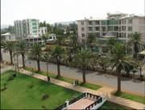Bahir Dar is also a convenient jump off for the Ethiopian famous 'Historic Route' passing through Gonder, Lalibela and Axum. Consequently, Bahir Dar has been launching economically, socially and politically. And now it is the capital of the Amhara National  
Regional State.  
The town's v Year of foundation: in 1930.  
v Distance - from Addis Ababa -Via Debre Marcos, 565  
kilometres. -Via Mota, 485 kilometres.  
- from Gonder, 180 kilometres and  
- from Axum, 540 Kilometres  
v Altitude: 1790 metres above sea level  
v Average Temperature: 18.30c which is the most  
favourable weather condition throughout the year.  
v Language: It is Amharic that is the official language  
of the Country, comprehensively spoken though

*Bezawit Hill Top and the Emperors' Palace*  
Five kilometres east of the town, the split-level Bezawit palace of the former Ethiopian Emperor Haile Sillassie perches alone upon a hilltop with elegant views over the Nile River and Lake Tana. This most s p e c t a c u l a r s c e n e r y , Bezawit palace was used only twice by the Emperor when he would stay an overnight on his periodic tour These endemic fish species constitute 14 large barbs, one small barb and two gara species. These noteworthy Lake Tana large barbs species are varied because of the morphologically distinct forms they exhibit. Some of these large barbs reach a body length of 85cm and a weight of 12kg. Of the commercial catch in the southern shore of Lake Tana, the large barbs comprise 35%.

*Island and Peninsular Monasteries*

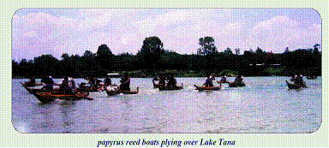  
It is the 37 islands that make Lake Tana the most breathtaking site.These islands shelter some 21 monasteries surviving remnants of a very old meditative tradition. Most of the monasteries with some exceptions which dated back even to the 14th century AD were established in the medieval period by the monks locally referred as The Seven Stars. The dedicated monastic spiritual life of the monks Despite the fact that every island monastery deserves a visit, the most commonly visiting ones, taking Bahir Dar as springboard are the following.  
*Kibran Gabriel (about 9 kilometres)*  
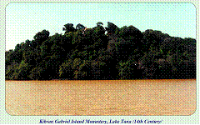  
Kibran Gabriel founded in the 14th century and rebuilt during the reign of Emperor Iyasu /1682-1706/ is the closest monastery to Bahir Dar. The museum of this monastery, which was built during the construction of the Gonderine palaces displays collections of  
priceless treasures. Because of religious reasons, this monastery is not indulged for ladies to enter.  
***Zegie Peninsula (about 12 kilometres)***  
***Wura Kidane Mihiret***  
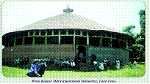  
The peninsular monastery of Zegie, Wura Kidane Mihiret permitting ***Tana***women to enter is the other plebeian adduction of Lake Tana. The church's design is similar to that of kibran Gebriel

***Kibran Gabriel Island Monastery, Lake Tana /14th Century/***  
***Wura Kidane Mihiret peninsula Monastery, Lake***. As noted by many visitors, Wura has a more decorated building with colourful frescoes depicting scene from biblical lore and the history of the Ethiopian Orthodox Tewahido Church. The frescoes dating back to the early 17th century are incredible to have been painted by human being. Besides, in the enclosure like the other monasteries, there is a museum having priceless treasures such as illuminated manuscripts of more than 1040 years old, crowns, dresses of Empresses and so on. In this peninsula, along with Wura Kidanemihiret monastery, Mehal Zegie Giyorgis, Abune Betre Mariam and Azwa Mariam monasteries are also worthy of visiting. The grass roofed and elegantly built monastery, Azwa Mariam is renowned for its remarkable frescoes as Wura. Where as Mehal zegie Giyorgis and Abune Betre Mariam  
monastries jointly possess a splendid museum having collections of crowns, crosses, vestments, illuminating manuscripts and others. As Ura, these monasteries let ladies enter.  
***Daga Estifanos (about 40 kilometre)***  
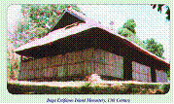  
Daga is the other principal magnetism and most visited monastery though it is far from Bahir Dar. As that of Kibran, it is closed to women. This monastery is erected on a steepy hilltop and needs to climb up walking through a winding path. The treasure house found here is different from other monasteries in that it hosts piles of brightly coloured ceremonial cloaks and mummified coffins containing remains of the former Ethiopian Emperors; that is, Emperor Dawit /Late 14thc/, Emperor Zere Yakob  (15th c), Emperor Suseniyos (early 17th c) and Emperor Fasiledes(17th c).

***Tana Kirkos (about 50 kilometre)***  
Projecting on the eastern shore of LakeTana and on a  remarkably beautiful s e t t i n g, Tana kirkos monastery had been used as one of the four places of ancient Judaic worship where sacrificial stones are still found. It is in this monastery that the Ark of the Covenant had been kept for 800 years before it was taken to Axum (the ancient Ethiopian capital) in the 4th century AD.

***Daga Estifanos Island Monastery, 13th Century***  
***Judiac Sacrificial stone - Tana Kirkos Monastery***  
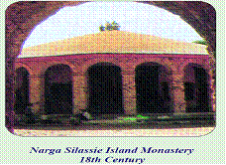  
The founder of the Ethiopian church music, St. Yared has written his first book of song called Degua at this monastery. The museum of the monastery has collections of several valuable and unique treasures, which inspire visitors. It is closed to ladies.

***Narga Silassie (about 37 kilometres)***

Located on the shore of Deq islands, particularly at a small woody semi-island, Narga Silassie monastery is quite different from other Tana monasteries architecturally; that is, it is similar to the palaces of Gonder. Narga Silassie was unusually built by Empress Mintiwab (1730-1755) with domes and turrets of the three gates. It is open for ladies.

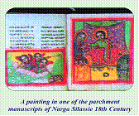

***Narga Silassie Island Monastery***  
***18th Century***  
***A painting in one of the parchment***  
***manuscripts of Narga Silassie 18th Century***

***The Blue Nile Falls***  
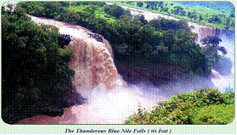

Blue Nile, the Grand River in Africa is one of the natural wonders ofEthiopia especially for its breathtaking falls. The Blue Nile Falls near  
***The Thunderous Blue Nile Falls ( tis Isat )***  
Tis Abay town, 35 Kilometres South East of Bahir Dar has been drawing the attention of tourists from different corners of the world. That is why thousands of visitors are seen streaming to this most spectacular scene.  
The Blue Nile Falls locally known as ''Tis Isat'' or ''Smoke of Fire'' that the water stretched on 400 metres wide surface and plunging dramatically 45 metres deep creates drizzly plethora that in turn produces brilliant rainbows across the gorges of the river. The misty deluges drive the onlookers up to a kilometres away. The curtains of the spray enthrall any visitor and will not ever vanish from memory. Specially, a morning visit rewards tourists with the astounding rainbows. Environ of these falls is endowed with marvelous landscapes, natural forests and multicoloured birds. On the way to Tis Abay Falls, Andasa Mineral Water is found in a small island formed by the Blue Nile River. Furthermore, to the West of Tis Abay Town, some 7 kilometres off the road in the extended escarpment of Yagume ridge, surrounded by stunning natural scenery, there is an impressive rock hewn church called Dengay Debelo which is said to have been hewed by St. Lalibela before his coronation. To reach the falls, there are two alternative ways. One is the route through 1.5kilometres road Eastern out skirt of the town to the parking lot, which lies on the edge of the Blue Nile gorge. Then after walking for about 20 minutes crossing the 17thc footbridge locally called Alata Bridge that had a historical value built by Portuguese, a  
38  
crescent shaped gorge appears with a thunderous noise; that is, the Blue Nile Falls. The other alternative is the route through the North East of the main road where the local people cross the river with papyrus reed boats. For the guests, motorboats are hired to cross the waters. After plying across the waters, a 30-40 minutes walking along the bank of the river is required to reach the bottom of the falls. But using the former route gives chance to visit the historic footbridge, the spectacular sceneries, and also it provides a chance to watch birds in the forest and in the gorge. Or else both ways can be used, one to go to falls and the other to turn back from the falls. 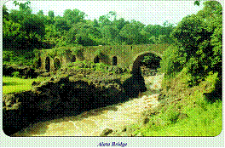  
***Alata Bridge***

***Wanzaye - The curative hot spring***  
How nature is generous, wonderful, merciful, mysterious and beautiful is witnessed at Wanzaye, a highland spa and hot spring. The en route attraction located 49kilometres from Bahir Dar East of the main road to Gonder before reaching Wereta town, having dressed in greenish vegetations, Sheltering numerous and beautiful birds in its compound, Wanzaye is really a place most breathtaking. Having got situated encircled with superintendent standing hills and the big river Gumara, Wanzaye becomes still brilliant and extra ordinary. The holy hot spring of wanzaye is av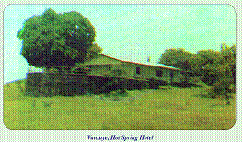ailable in the form of shower in different rooms having different temperature /38oc, 40oc and 42oc /. Many domestic tourists especially desperate patients flock to Wanzaye and in turn Wanzaye's holy hot spring dries the tears of such patients. Here lies the mercy of nature. Washing and drinking with the holy hot spring treat certain diseases like scabies, skin infections, intestinal parasites, rheumatism and others.  
Wanzaye, Hot Spring Hotel  
Visitors moreover, enjoy much watching the colourful birds and the leaping apes, and observing the riverside evergreen natural vegetations and the beautiful garden. A guest does not need to worry where to stay, Wanzaye Hot Spring Hotel is handy and welcomes any tourist. There are bar and restaurant services that can meet the needs of the tourist. The bedrooms (10 twin and ten double) the camping sites are ready to accommodate their guests. The beautiful compound and the satellite TV are also entertaining the tourist.

**GONDER**  
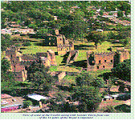The glorious, historical and graceful city, Gonder that has been called the 'African Camelot', is known for its astonishing castles of the medieval emperors. This land of monuments founded during the reign of Emperor Fasiledes /Fasil/ in the 17th century was the principal city of Ethiopia for about 250 years. Lying at an altitude of 2300 metre, skirted by two mountains, Gonder has spectacular views over the beautiful landscapes of the fertile agricultural land and the gleaming waters of Lake Tana, 60 kilometers to the southwest. The renowned castles of Gonder have got the status of world heritage site. It is because of these monuments that Gonder has become one of the destinations of the famous 'Historic Route'. Great many tourists of the world flock regularly to Gonder to praise and enjoy these old age Ethiopian heritage and religious ceremonies.   
The town's v Year of foundation : 1632EC  
v Distance from - Addis Ababa, 750 kilometre  
- Bahir Dar, 180 kilometre  
- Axum, 360kilometre  
v Average Temperature: 19.70c  
v Visiting season: Through out the year, even  
though January is the best time to enjoy the  
colourful celebrations of Epiphany.  
v Language: Amharic, the official language of  
Ethiopia

***Medieval Castles of Gonder***  
***The Royal Enclosure***  
Stretched in the area of 76,000m2 in the heart of the town and containing six castles plugging in complex tunnels and raised walkways, the Royal Enclosure is the authentic beauty of Gonder. The oldest and the most impressive one is the Castle of Emperor Fasil standing two storeys high that was constructed around 1640. It is made of roughly hewn basalt stones and has a crenellated p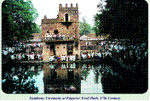arapet

and four domed towers.   
***Epiphany Ceremony at Emperor Fasil Bath, 17th Century***  
***Emperor Fasil Bath***  
Emperor Fasil, due to his keen interest in architecture, along with the seven churches and a number of bridges, has built a three storey stone pavilion positioned next to a large sunken bathing place-even today it is filled with water from the near by Keha river during the ''Timket'' or Epiphany ceremony. It is about 2 kilometre from the centre of the town along the G o n d e r-Bahir 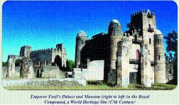Dar

road. Epiphany ceremony at this  
***Emperor Fasil's Palace and Museum (right to left/ in the Royal***  
***Compound, a World Heritage Site /17th Century/***  
***Empress Mintwab Banquet Hall, 18th Century***  
***Mikael Sehule Palace***  
Situated outside the Royal Enclosure, Mikael Sehule's palace is also an important site worthy of visiting.

***Debre Birhan Silassie***  
The original church, which was not destroyed by the Mahadist war bath, which great many tourists u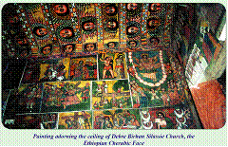sed to attend enthusiastically, is the most colourful celebration.

***Debre Birhan Silassie Church, 17th Centur y***

***Kuskuam Complex***  
Perched on the hills, northwest of the town about 3_ Kilometre, there s a royal compound known as Kuskuam. It was built in the second half of the 18th century by Empress Mintiwab. The enclosure, though not well preserved as the royal one has a series of buildings including a three-storey castle and ruined palaces. when the Dervish  of Sudan attacked Gonder in the end of the 19th century, is Debre Birhan Silassie-'Trinity at the mount of light.' This is one of the most beautiful churches in Ethiopia. Debre Birhan is renowned for its magnificent ceiling, amusingly decorated with a marvelous painting of the winged heads of the 80 Ethiopian Cherubic Faces- all have slightly different expressions. Drawn by the same artist, Haile Meskel, the walls are also adorned with frescoes that manifest briefly the Ethiopian Saints, martyrs and biblical lore. East of this church, there is a traditional church school with magnificent collection of small Gojjos/huts.It deserves a visit too.

***Wolleka-Felasha Village***  
The former 'Bete Israels' or the Ethiopian Jews' or Felashas' village situated about 3 kilometres north of the town is the other popular visiting place especially for the magnificent souvenirs, pottery and the Jews temple, which has no laity now a day. For not accepting Christianity, the 'Bete Israels' were confiscated their land. C o n s e q u e n t l y, their economy get shifted to pottery, blacksmithing and wavering. Despite the mass evacuation of the Felashas to Israel in 1991, the craft of making pots has been adopted by the residents of that village (non-Felashas).   
***Candle Stick Made of Clay, Welleka***  
There are machine products of pots besides the intricate hand made red and black pots that are not to be missed by any visitor.

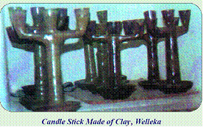

***Angereb Bridge***  
Located about 5 kilometres Southeast of the town, having built on the Angereb River in the early 17th century by Emperor Fasil with the still existing four arches, Angerb Foot Bridge is an impressive relic of the period.  
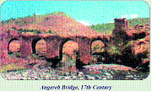

***Angereb Bridge, 17th Century***

***Kossoye Hill***  
Kossoye ensconced on the lofty hill, north of Gonder town about 30 kilometres along the road to Axum is a wonderful magnetic site. The tower of Kossoye offers views to any direction to the maximum, even to a section of the North Western border of the country. Because of its astounding scenery, Queen Elizabeth of England and the former Ethiopian Emperor Haile Silassie once camped here. Topographically, it is similar to the Simen Mountains National Park.

***Gorgora Port***   
Situated at 64 kilometres from Gonder and about 95 kilometres from Bahir Dar, on the northern shore of Lake Tana, Gorgora is a town of affinity; that is, the most rewarding site especially for birdwatchers. This is one of the many medieval towns of Ethiopia that served as a  
temporary capital. The most inspiring visiting site is the near by ancient round Church Debre Sina Maryam, built in 1334, which is remarkably adorned with the very old frescoes. It is also possible to visit ruins of Susneyos palace, the island churches and monasteries such as Birgida Mariam and Man Inde Aba Medihane Alem and the likes.  
Gorgora can be reached either by minibus from Gonder or from Bahir Dar by speedy ferries. To 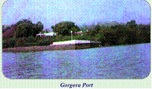stay at Gorgora, there is Gorgora Hotel, which is run by the maritime Authority.

***The Simien Mountains National Park /SMNP/***  
The marvelous landscape of all Abyssinian lands, the SMNP is one of the Ethiopian World Heritage Sites. What make this park unique are its scenic beauty and rich b i o d I v e r s i t y. Its altitude ranges 1900 metres to 4620 metres (Ras Dejen) the highest peak in Ethiopia and the fourth African summit. The scenic splendors of the Rocky Mountains and the ragged chain of e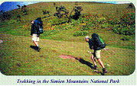scarpments, the massifs, the deep gorges are some of the  
***Trekking in the Simien Mountains National Park***  
where every arrangement is made. For instance, arranging visiting programmes, assigning guides, scouts, mules and muleteers are done here by the park office.  
Debarq is a small town 101 kilometres north of Gonder and is reached by the regular running buses from Gonder or by the tour operators' vehicles. There are about two hotels that can deserve tourists well, Simien Park Hotel and Simien Hotel.  
***Walia Ibex Gelada Baboon Red Fox (Simien Fox)***  
breathtaking views of the park. Owing to the extended elevation, varied fauna and flora are sheltered among which many are endemic species. Walia Ibex-even endemic to the park, Gelada Baboon, Simien Fox and Minilik Bush Duck are endemic mammals. Golden Backed Wood some of the endemic bird species to be worth mentioned.

***World Wonder Rock hewn Churches of Lalibela***  
The perplexing ***Rock Hewn Churches of Lalibela*** and its vicinity inspire their guests. Great many tourists stream to Lalibela town to applaud the rock-hewn churches of King Lalibela dated back about 800years. What unique antiques that have been carved and still erected for that many centuries! The impossible has become possible; the incredible has become credible here on the rock-hewn churches. How could man hew these unusually complicated and each architecturally unique church masterly with pristine tools without the advent of modern engineering techniques to Ethiopia! The construction of these churches is said to have been done by King Lalibela himself and it is said that he had finished the work in 24 years of time. After paying a call on these churches, many visitors worry a lot to talk and to write on what they have visited. As a case in point to Alvarez, the first European to visit Lalibela in 1520 wrote, ***''I swear by God, in*** ***his power I am, that all that is written is the trust and there is much***  
***more than I have already written, and I have left it that they may***  
***not tax me with its being falsehood,''*** such a worry occurs because these types of churches are not found elsewhere in the world. For their amazing intricacy, even Ethiopians get overwhelmed at a great extent as the foreigners though there are more than 400 rock hewn churches built before and after Lalibela specially in the northern part  
of the country. In the carving of the 11 rock hewn churches, as the Deeds of St. Lalibela and the taught of the church advocate, some supper natural force have helped him. Otherwise, who would manage the bulk of burdens to make the dream come true? There was no slave labor as the Egyptians pyramid construction. There were no such skilled crafts men. So, who did help him all that constructing activity? If we assume that foreigners might helped him, why did not they whittled for their own country and why rulers of other nations did not employ  
these skilled crafts men for their country to have such wonderful monuments? Series of questions can be raised but their answers are not as such easy. In the churches, every thing has biblical implications. What is found here in Lalibela symbolically is found there in the holy city, Jerusalem. To visit the Lalibela Rock Hewn churches, they are grouped in to three basing the river called Jordan. The first group north of Jordan River comprises six churches; Bete Medihane Alem, Bete Maryam, Bete Meskel, Bete Denagil, Bete Debre Sina and Bete Golgota. This group of churches symbolizes the Earthly Jerusalem.

 Bete Medihane Alem (The House of the Redeemer of the World)  
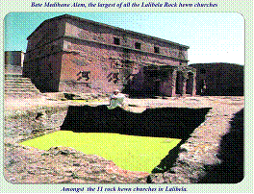

is the largest church of all the Lalibela churches amazingly having 72 giant pillars. It is a freely standing monolithic church resting alone in its courtyard. Inside this church, among other interesting things to see, three striking empty graves symbolically dug for the three biblical

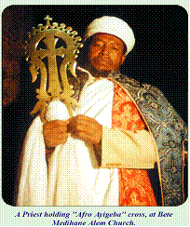  
***A Priest holding ''Afro Ayigeba'' cross, at Bete***  
***Medihane Alem Church.***  
patriarchs Abraham, Isaac and Jacob are visited. Moreover, there is ''Afro Ayigeba'' the renowned cross for its healing power that is shown on Sundays and on some holidays. Recently, this cross has been stolen and sold out to foreigners and brought back to its original place by a tremendous combined effort of a great many people Ethiopians and foreigners alike.  
In the churches, every thing has biblical implications. What is found  
here in Lalibela symbolically is found there in the holy city,  
Jerusalem. Crossing the short tunnel south of Bete Medihane Alem comes Bete Mariam courtyard, which also comprises Bete Meskel and Bete Denagil.

***Bete Mariam (The House of Mary)***  
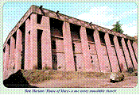 is the other freely erecting one storey monolithic church, which was built first. It is the most beloved church by the pilgrims. Even King Lalibela favoured this church in which he used to attend the daily masses. The most colourful holiday celebrations like Christmas and Epiphany are carried out here even today. Here the visitors experience an atmosphere of serenity. In this courtyard, there is a pool, which is believed that washing in it can cure woman sterility.

***Christmas -at Bete Mariam***  
What make Bete Mariam still more contemplative are its frescoes bearing biblical lore.  
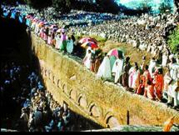In the northern and Southern corners of this courtyard, Bete Meskel and Bete Denagil are posted which are not as large as the other Churches. South west of the courtyard, after crossing the trench appear the most inscrutable complex of twin churches, Bete Debre Sina and Bete Golgotha in which the Silassie (the Trinity) Chapel, the symbol of Tomb of Adam and even the grave of King Lalibela are sheltered. Sheltered under the same roof with Bete Golgotha, Bete Debre Sina (The House of Mount Sinai) is the immediate chapel from the entrance. Saint Lalibela built this church to symbolize Mount Siena where Moses received the Ark of the Covenant. Bete Golgota (The House of Golgotha) church is interchangeably called Bete Mikael. This is the most complex chapel where Golgotha, Bethlehem, and Keranio are built        symbolically. From the tomb of

Bete Abba Libanos

Saint Lalibela inside this church, holysoil-'Imnet' is taken by which people get treated from certain 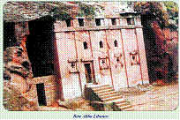diseases because of their adherent belief. On the wall of the church,   
 there are relief sculptures of 7 apostles. Moreover, a decorated cross and a wooden praying stick of Saint Lalibela are shown. The second group of churches symbolizing the heavenly Jerusalem, located East of Jordan River comprises east to West Bete Amanuel, Bete Merkorios, Bete Abba Libanos and Bete Gebriel-Rufael.

**Bete Amanuel** (The House of Emanuel) is architecturally most outstanding and freely erecting monolithic church. Even art historians appreciate more its architecture. It has an upper storey and most striking blind windows. The church is linked with the neighbouring one, Bete Merkorios with a 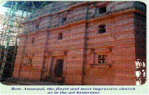dark, long subterranean tunnel.

Bete Merkorios (The House of Merkorios) is dedicated to Saint Merkorios. The church has wooden bound parchment manuscripts, brass and gold crosses, and cotton fabric paintings that particularly portray the crucification of Christ.

Bete Abba Libanos (The House of Libannos), a church dedicated to the Ethiopian Saint Abba Libanos, constitutes the southern boarder of the second group of churches. The roof of this church is attached to the living rock.  
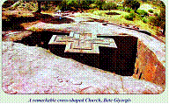  
A remarkable cross-shaped Church, Bete Giyorgis

Bete Gebrael - Rufael (The House of Gabrael and Rufael) is architecturally complex and twin church like Bete Debre Sina and Bete Golgotha. It can be entered from two directions. The two chapels are sharing the same roof and entrance. In the immediate chapel, Bete Gebrael, an impressive and a very big parchment manuscript having 332 pages and different crosses are displayed. It is this chapel usually open for visitors. What makes this church complex is that it has underground rooms. Constituting the third group and setting lonely, Bete Giyorgis is architecturally an elegant, sophisticated and most striking church. This freely standing monolithic church symbolizes Noah's ark. Owing to these sorts, Bete Giyorgis is getting the standard of national 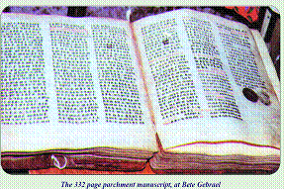symbol.   
The church is entered through a tunnel that again leads to a trench. In the courtyard, there is a holy water where it flows from is not easily demarcated. In the grave holes around the detached walls in the courtyard, there are mummies that are easily seen by visitors. In side the church along with big parchment manuscripts and crosses, there is a large wooden box, which was unusually locked by wooden nuts in which saint Lalibela used to put the pristine carving tools. The presence of this box here signifies that Bete Giyorgis is the lastly built church.  
To visit all these rock-hewn churches meaningfully, a couple of days are required.  
*Other Rockhewn and Cave Churches around Lalibela*

In the vicinity of Lalibela, there are several rock-hewn and cave churches, which can be reached either by walking or riding mules. Following two are examples.

*Asheten Mariam,*

alighting on the glamorous mountain, 4000m above sea level, is indeed the most captivating site, which offers a commanding view of Lalibela Town and its environs. King NeAkuto Le Ab, the 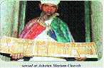nephew and successor of king Lalibela, built this church. The church is partially detached from the living rock. ***sensul at Asheten Mariam Church***

This church has alluring leather paintings particularly depicting the crucification of Christ, elegantly decorated parchment manuscripts and crosses. This church is reached either by two hours gentle walking or by riding mule. Stationed on the hill foot, ***Ne Akuto Le Ab*** is a marvelous cave church. The cave in which the church is positioned, by its nature is breathtaking. From the roof of this church, a curative holy water drips constantly throughout the year. This holy water is said to have a healing power to many ailments.  
At the treasure house of Ne Akuto Le Ab, priests show visitors strange metallic drums, crowns and crosses. The church is reached after driving 7 Kilometre on the road to the Airport and walking for 15 minutes to the east. The other elegant cave and rock hewn churches around Lalibela are

*Yimrihane Kirstos* (cave church), ***Arbaitu Insisa, Bilbila Giyorgis,***  
***Bilbila Kirkos, Genete Maryam, Emkina Lideta Maryam, Emkina***  
***Medihane Alem and Kenkenit Mikael.***  
The other sight seeing for the tourist in Lalibela town is the ***open-air market*** that is visited on Saturdays. In this marvelous open-air marketthe most attractive traditional dresses and sashes are not to bemissed souvenirs to be purchased. Besides, observing the bargainingsystem of the peasants is really enjoyable.

**( Meqdela amba )**

**The trek from Debrtabor (gafat) to Maqdela is a wonderful challenge for the adventurous trekker it takes   you to our final                   (Gafat)                    campsite, top of Maqdala Amba, which is over 3000 meters, The trek begins  Gafat is a place which is located about 4.4 kilometers to the northeast of the town of the Debretabor . The name Gafat was probably taked from the gafat people. At present Gafat is better known for its nineteenth century canon foundry Established by Emperor Tewdros, The gafat people are assumed to have been mainly craftsmen and craftswomen. Initially the gafat canon production**   
***(Emperor Tewodros)***  
**site was started with eightEuropean artisans assisted by Ethiopian craftsmen. He asked the artisans whether they could produce him cannons; he was desperate for the weapons for the protection of his country from the Egyptians who had controlled the Sudan and Massawa.**   
**(Sevastopol Cannon)**  
**Emperor Tewodros persuaded or ordered  the artisans to produce him the desired weapons  at new site near the stream where he established a canon foundry, It is obvious that Tewodros was successful in producing a few of the anticipated canons among which the Sevastopol was the largest.**

**Tewodros’s Journey to meqdela and the transporting of the cannons made at gafat in 1867/8 started from kulualikue or Janhoy mieda in debretabor from delanta he followed traditional route passing through the villages of shofa (kahinate seamy) senbelett, yewetet(yatila), yedereq,and Robbit(Aroge). It was at kessie in Aroge where the actual battle took place and where Fitawrari Gebriye fell while fighting bravely.**

**Finally Tewodros was observing the approaching enemy from selamgie silassie, an extension of the Meqdela Mountain putting the Sevastopol cannon at the lower escarpment pointing towards the advancing enemy. When emperor Tewodros’s realized the death of his brave general Gebriye “he lamented saying”**

**“ Gebriye  Gebriye  Eniem Emettalehu Tinish Qoyet biye”**

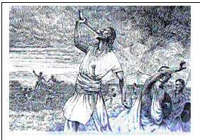**His words marked the culmination of tewodros’s mega dream about the transformation of Ethiopia. He finally went to the Meqdela Mountain   where he bravery committed suicide in the hall near the main palace immediately above the qoqit entrana, The Sevastopol cannon is still there just below the trinity church of selamgie, west of meqidela, where Tewodros Left it. The Cannon burst at the initial trial because the artisan who made is did not cast it properly. There was also one of the small cannons put at the saddle between selamgie and meqdela near the site where Ethiopian prisoners were kept. The small canon had rolled down the cliff and it had rested halfway down where it still lays.**

**Our trek begins Debrtabor to meqdela enable travelers to experience and enjoy the truly varied topography and landscape. At Meqdela besides its beautiful Scenery (one) can visit the Sebastopol cannon, Emperor Tewodros graveyard, the ruin of Tewodros’s Meqdela palace with its big storage houses, The ruin of the ancient  medhaneAlem church, The Aroge Battle Field is the best  enjoying place.**   
***It is accessibly by small***   
***foot***

***(Emperor TewodrosII graveyard place)***

***track corridors. How ever, the peak of the Mekdela  Amba is not accessible by car. To safeguard the history and natural beauty of the site it is advisable for visitors to walk or use pack animal to reach the site.***

***The Meqdela site has the following in its compound***:

The site where Emperior Tewodros commited Suicide Magnificent scenery site Emperor Tewodros palace and store The foundation of the 1868 Burnt Medhanelaem church The Burial place of Emperor Tewodros The historical and old Mekdela mariam Church (about980 years old) Sebastopol Canyon and others

**Abut as**

**CLIMATE**

There are two major seasons: the dry season prevails from October through May; the wet seasons from June to September. January and February are hotter and much driver. The landscape is likely to be more aired than November, which can still be quite lush after the rains. In the highlands (most of the historic route) the day time is temperature is moderate not exceeding, 300c even at the hottest time of the year and nights are generally moderate to cold in all months of the year.

**LANGUAGE**

A variety of language is spoken in the multi-ethnic state of the Ethiopia. The official language of the region is Amharic. English also widely spoken in all tourist destination sites of Amhara Region.

**TIME**

Ethiopia is the GMT+3 hour’s time zone. The day is calculated in a manner similar to many equatorial countries, where day and nights have the same length. Counting starts when the sun rises, at1:00 o’clock when it is 7: AM for Europeans and stops when the sunsets at 12:00 o’clock when it is 6:00 PM for Europeans.

**CALANDER**

Ethiopia follows the Julian calendar, which consists of 12 months of 30 days each and a thirteen month of five or six days (in every four year).

**EXCHANGE RATE**  
In main tourists destination sites there are government & Private Banks.  
For current exchange rate see:     http://coinmill.com/ETB-GBP.html

**Souvenir**

Most of the arts and artifacts along the historic route-Lalibela,Gondar,BahirDar  and Dessie  reflect the Orthodox Christian: Silver crosses ,icons, painting on animal skin, and woven garments-items with a Christian motif.

**Travel**

**TRANSPORTAION OPTIONS**

Getting to northern Ethiopia:

The easiest and quickest way to get to Northern Ethiopia from Addis Ababa is to fly, **Ethiopian air lines** currently are the only scheduled air line operating these routes. Their daily service connects Addis Ababa with Bahir Dar, Gonder, Lalibela. That is the order of their flight service that leaves Addis early in the morning &afternoon For Further details check: http://www.ethiopianairlines.com/

**Buses:**  
Those with more time and who want to see more of the surrounding countryside may chose to do all some parts of their journey by road. The roads are improving being asphalted. But this will take time and result in delays. Local buses ply all major roads in amhara region.  Reasonably good buses leave Bahirdar, Gondar Weldiya and dessie passing through Gashena.

**Water Transport**

Boats can be hired from the Marine Transport in Bahirdar to visit Lake tana and monasteries.

Code of Conduct

Respect towards the resident population, their traditional values and their lifestyle is required. This implies that retain restraint may occur when taking photos, so asking for permissions before taking the photos is advisable.

A high degree of respect towards religious and holy places is required. Shoes should be removed before entering churches.To stop the progressive negative impacts from radiant light, photographing mural paintings is prohibited in most cases.Please be aware that buying antiquities or removing them from their original places is contrary to law. Such illegal act may cause penalization to a religious offence.Please be aware of the possible long- term consequence of handing out gifts: sweets, medicines, and even a pen to the local population. This may encourage begging and also cause children to drop school.

Tips

It is highly recommended to hire an authorized local guide. Local guides are officially recruited from the very locality, and are therefore perfectly familiar with the environment. Not only do they know about the attraction sites; they are also kept informed of the latest regulations about each site. Their competence in English enables the visitor to get in touch with the local population.

As a 'translator' of socio-cultural information, the guide will be able   to point out many details that are otherwise overlooked. An appropriate itinerary and means of transportation can be chosen with help of the guide in order to work   out a tour that best meets the visitor's expectations and wishes. The guide will also organize additional   assistance by helping the visitor in identifying hotels and recreation activity and shopping. Please be aware that young people who did not get the necessary authorization   to give a guide service may contact visitors to offer some assistance. Yet since such people have no ethical qualities and the necessary skills, it is not advisable to deal with them. Therefore, it is important to make sure that the guide you contact is issued with a badge that is stamped with the seal of Amhara National Regional State Tourism Commission. Possible long-term negative consequences of using children as a guide should also be noted.

Though the environment of the country is generally safe with regard to crimes, it is advisable to keep luggage and belongings within sight when in bus stations and public gatherings.

For additional information contact

* ANRS Culture and Tourism Bureau/ Tel 058 220 11 32/
* Gondar tourist information center / Tel 058  111 00 22/
* Lalibela tourist information center/ 0333-36 01 67 /
* Blue Nile tourist information center /0582370054/
* Bahir Dartourist information center /058 220 1686 /
* Siemen mountain national Park / 058 1170789 /

Have a Nice Visit

**Links**

* [Amhara capacity building](http://www.amhcbb.gov.et)
* [ANRS Parks and Protection Authority](http://www.padpa.org)
* [Amhara Region Information Bureau](http://www.amharainfo.gov.et)
* [TESFA (Tourism in Ethiopia for Sustainable Future Alternatives)](http://www.community-tourism-ethiopia.com)
* [Ethiopian Airlines Flight](http://www.ethiopianairlines.com)
* [Amhara Mass Media Agency](http://www.amma.gov.et)

Our Vision

We envisage sustainable culture and tourism development that contributes fast and continued economic growth in the Amhara region.

Our Mission

Conserving and developing outstanding cultural and natural heritages to ensure the prevalence of susrainable tourisim in amhara region.

**Attraction Sites**

**Gondar**   
**World Heritage Site**   
Ethiopia, one of the most beautiful countries in the world with oldest civilizations and unique geographical features, is situated to the Horn of Africa. Recent studies witnessed that ancestor of the modern man used to live in Ethiopia three million years ago. Hence the nation has been a cross roods of civilizations and peoples for thousands of years.

Through this long process of civilization and history, quite a number of towns and cities had flourished. Of these, Gondar is a medieval royal city which was ascribed by UNESCO as the" World Heritage Site" in 1978.

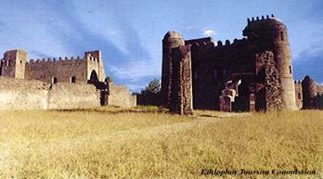

Gondar is positioned in Northwestern Ethiopia, at about 740 and 175 kilometers away from Addis Ababa and Bahir-Dar respectively. Its altitude is 2200 meters above sea level.

Founded by emperor Fasiladas in 1636, the city of Gondar had been the seat of the Ethiopian state for about 250 years. The foundation of this Imperial city witnessed a period of optimism and renaissance of the golden days of Aksum and Lalibela. Architecture, literature, education, music, painting commerce that had been perished after the fall of ancient Aksum, rose to prominence.

It was also a center of commerce for Africa, South Arabia and the Mediterranean world. This medieval royal city has many things to offer for visitors: the imperial enclosure, the ancient monasteries, the Felasha village, the Fasil bridge, the rich daily market, and the culture of the people. The Simien Mountains National Park and Lake Tana's northern shore /Gorgora/ are also found with a short distance.

The Royal Compound

Lying within 70,000 m.sq, the Royal Compound encompasses six lofty castles and many different purposed buildings like the royal archive, house of the musicians, the lion cage, the horse zoo, the sauna bath, house of the spinners etc. The earliest and grandest of all edifices is that of Emperor Fasiladas, which is 32 meters high and with battlemented square tower.

To the North of this castle stands the chancery of Emperor Yohannis I ( r/1667-1682) and a splendid palace of Iyasu I ( r/1682-1770). The palace of Iyasu was astonishingly embellished with ivory, gold, precious stone etc. To the North West, lies Dawit III's music hall, Emperor Bakafa's banquet house and empress Mintwab's palace. A huge circular wall with 12 gates forms the enclosure.  
West of Emperor Fasil's archive, there is the church of Gimjabet Mariam, /the treasury of St. Mary/ and the tomb of W.C Plowden, British consul to Ethiopia in the 19th c.

The Bath of Emperor Fasiladas

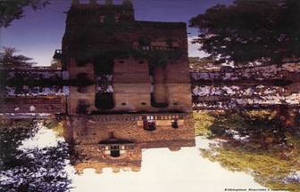

It is a kilometer away to the west of the city. We are told that during the heyday of Gondar the bath had been used for sports and religious rites on the day of epiphany. But now it is employed only for the annual celebration of baptism. Near by lies the tomb of Emperor Fasiladas' great horse, Zobil.

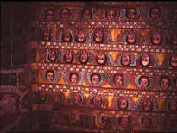

The Monastery of Debre-Birhan Silassie

The monastery of Debre-Birhan Sillassie, built during the reign of Iyasu I, is famous especially for its fine frescoes. The ceiling and the beams are painted with rows of winged angels and the wall with impressive biblical events that reflect the life of Christ, Mary, the Saints and martyrs.  
The church's compound is also a botanical garden rich with giant junipers and old olive trees on which birds of different species nest. At the back of the enclosure is a traditional school where famous clerics of the nation learn church music, writing and binding of parchments.

**The Qusquam complex**   
Founded by Empress Mintwab, the monastery of Qusquam and the ruined palace are situated to the west of the town at about three kilometers from the city center.

Qusquam was the last flower of Gondar before glory of the city wilted due to court intrigues and destructive civil wars. Here visitors can see the old church ruined palace of the Empress, fine old manuscripts, skeletal remains of the Empress, her son Iyasu II and grand son Iyoas.

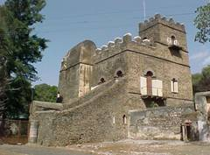Ras Gimb

North of Gondar tourist information center is a majestic two storeyed square plan palace; the Ras Gimb also called Sehul Michael building. The palace has remarkable history. It was used as residence for the powerful Seoul Michael, provincial palace for Emperor Haile Silassie I, a house for Italian Generals during W.W II and a torture house during the Derg regime. The castle houses many historical items.

**The Felasha Village**  
Situated three kilometers to the north from the city center, the small village of Weleqa was once   inhabited by the Felasha community (Ethiopian Jews). For its history and center of craftsmanship like earthen pots, Woleqa is one of the attractions frequented by tourists especially for earthen pots.

**Gorgora and Its Environs**  
  The old town of Gorgora that lies on the Northern Shore of Lake Tana was the seat of Emperor Susenyos, father of Emperor Fasildas in the early 17thc. Near Gorgora are impressive monasteries of the 14thc of which Debre Sina Mariam is the most important. The living style of the monastic communities in the Mendaba monastery, the palace of Susenyos and the monument of Mussolini are other wonders. The palace is very shining and astonishingly ornamented; perhaps it was only here that the Portuguese masons invested their art of building.

Standing on a commanding hill, the monument of Mussolini offers an excellent look at Lake Tana and the fertile plains of Dembya. It is believed that it was built as a beacon for motorboats from the Lake. In addition to its cultural richness, Gorgora also allows a crazy birds view for bird watchers.

Guzara

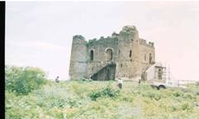  
Empereor Tsarsa-Dingle, founder of the Gondarine dynasty in the late 16thc,   had built a    fortified square plan castle on the Guzara hill. It is excellently positioned near the town of Enfranz at the side of Gondar- Bahir Dar highway overlooking the sandy beach of Lake Tana.

**Kossoye-Queens Village**   
Found 30 kilometers from Gondar on the way to Aksum, Kosoye is known for its scenic beauty and usage as a camp when Queen Elisabeth of England visited Ethiopia in 1965. Standing to the west of the village enables to watch the most stunning and gentile escarpment that slops down to the Sudan.

Simien Mountains National Park:-World Natural Heritage Site

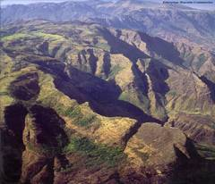

The Simien Mountains National Park is found 132 and 30 kilometers away from Gondar and the park gate town, Debark. Its altitude ranges from 1900-4620 meters above sea level.  Ras Dashen, the highest peak in Ethiopia and the fourth largest mountain in Africa, is part of the National Park. The temperature in the Simien National park varies from 15oc   to -5oc.  
The area was designed to be a National Park in 1969 so as to preserve its spectacular scenery and scarce bio-diversity. In 1978, UNESCO ascribed the park as world natural heritage site.   
The Dramatic topography of the Simien National park has resulted from the volcanic activity that occurred during the Oligocene period (C.40-25 million years ago). The lava flow of this period ended up with a creation of gigantic cliffs, towering battlements of flat-toped *Ambas*, dog tooth hills and great escarpments. In its scenic beauty, the Simien National park is very akin to the Grand Canyon of America. Mighty water falls gushed out from these overhanging cliffs. Dijnabr fall near Sankaber, for example, throws itself from 800 meters cliff.

The Simien park is also graced by exceptional botanical phenomena that are so unique, abundant and rare some of which are olives, cedar, Abyssinian rose, junipers, giant heather, giant lobelia, erica and hundreds of species of flowers and shrubs.

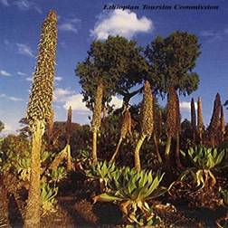  
The Simien National park is also a zoo of wild life that are found no where in our planet. Walia Ibex, Red fox, and Chilada Baboons are few to site. Over fifty species of birds have been also identified in the Simien Mountains National Park, which vary from minute to unusually huge creations. A typical example of the huge birds is the Lammergeyer. This magnificent bird has three meters wing and its feeding habit is amusing. It takes a larger bone into the sky and then throws it down on a huge rock and breaks into pieces. Then it enjoys the tasty bone marrow.  
 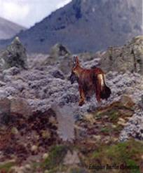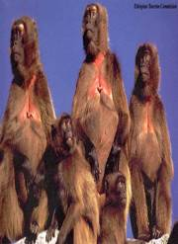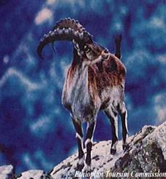

Attending the indigenous culture of the local people is another interest for tourists.  
It is possible to buy egg, hen, sheep, and fire- wood potato etc from the local people.

Epiphany

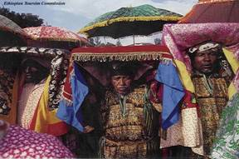  
The festival occurs on Jan 19every year. On the eve at about 3 p.m. congregations of ecclesiastics carrying a *Tabot* /*Ark*/ and being accompanied by the faithful march to the baptismal bath of Fasiladas.   
Through out the night the services will continue and on the morrow comes the brilliant scene of the festival. The bishop / Abun/ and his clerics appear to the edge of the baptismal pool and attendants of the rite will gather round waiting for spraying of the blessed water. The *Abun* blesses the water with processional cross and splashes it over the crowd who are waiting eagerly redemption of their sins.

Then comes the colorful return occasion during which the feast attains its zenith. Every body feels full of life and sprits. The hymns from reverend clerics, the chanting and dancing of gay and beautiful girls, the heroic parade of handsome boys and of great men resonated through out the streets of Gondar. At about 2 p.m. the processions will arrive at their respective churches and the feast will come to its end.

The foundation of the holy cross on September 27 and the Ethiopian New Year are also interesting events.

**LALIBELA**  
**W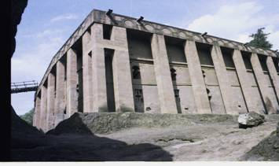ORLD HERITAGE SITE**"By Vast Expense and hideous pain, The Rock a Church became",   
( New History of Ethiopia; Ludolf, H, 1684 ).**LALIBELA**Lalibela, the second capital of the ancient Ethiopian empire in the north (next to Axum) and graced with the most beautiful setting on the mountains of Lasta, has a distinctively African atmosphere. Days can be spent exploring the mysterious rock hewn churches carved from solid rock by one of the last kings of the Zagwe dynasty, Lalibela. Previously known as Roha, Lalibela is named after the king.  
     
Here the antiques housed in 11 churches and chapels; namely Bete Medhane Alem, Bete Mariam, Bete Meskal, Bete Denagil, Bete Golgotha & Bete Debresina, Bete Amanuel, Bete Merkorios, Bete Aba-libanos, Bete Gebreal Rufael, and Bete Giorgis safe from the prying eyes and plundering hands of hostile interlopers for some 900 years are of particular interest. Lalibela has been a center of pilgrimage since the fall of the 12th c. and became favorite tourist destination starting from the 16th century.  Still it is a perfect place to discover ancient architecture & culture. *The chapels in Lalibela are of three groups.*   
First Group (symbolize Earthly Jerusalem);

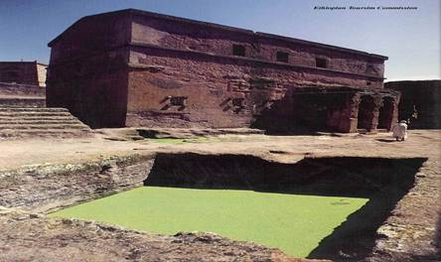**1. Bete Medhane Alem** /House of the Holly Savior/ Measuring 37.7m in length, 23.7m in width and 11.5m in height, Bette Medhane Alem     (House of Redeemer of the world) is the largest rock- hewn monolithic church in the world with 72 giant pillars. Explore the 800 year old Lalibela cross that was stolen in 1997 and returned from Belgium to its home in 1999 and many other invaluable antiques inside; including the striking empty graves symbolically chiseled for Abraham, Isaac and Jacobs in the courtyard.

**2. Bete Mariam** /House of Marry/  
Standing on a plinth in a trapezoid excavation without porches, Bete Mariam (House   
Of Marry) is a one storey monolithic church that measures 13x9.2x9.1m. The most colorful holiday celebration Christmas has been carried out in this firstly built church. Visit the baptismal containing holly water (which is believed that a bath in it can cure woman sterility), bas-relief of two riders fighting a dragon, variety forms of crosses and impressive ancient paintings in the same courtyard. Bete Mariam is the most internally ornamented and painted church in Lalibela. The paintings represent biblical stories.

**3. Bete Meskel** / House of the cross/The chapel of Bete Meskel that measures 11m in length and 3.4m width has been excavated in a bulge in the northern wall of Bete Maryam courtyard. Here, the ancient wooden *menber* (container of the *tabote* or ark), the cross carved in relief beneath stylized foliage on one of spandrels of the arches and the hermits that inhabit the large caves in the courtyard are also worth a visit.Nearby are the little chapel of Bete Deneghel and the 20thc.  Memorial to Ras Kassa Darge who was the governor of central and northwestern Ethiopia prior to the Italian occupation

.**4. Bete Denagil** /house of virgins/Bete -Denagil is a semi-monolithic rock hewn church carved in the south façade of Bete- mariam courtyard. It is partly projecting (outside) and partly grotto (in a cave). It has two doors from the out side view, one in the inside and a false window to the north.    
It is believed to have been dedicated to the 36 saint women who were among the 120 family members of Jesus Christ.

**5. Bete Golgota & Bete Debre-sina** /twin churches/Golgotha is the most mysterious church housing its holiest shrine the *silassie* (trinity) chapel, symbol of tomb of Adam and tomb of king Lalibela. Here, you can see remarkable pieces of early Christian Ethiopian art: figurative relief's that are rare else where in Ethiopia. The bas-relief figures of the 12 apostles; Lalibela's age old hand cross and his rod (praying wooden stick). *Bete Golgotha is closed for women*. Near by are the buildings of Bete Mikael, Bethlehem, and Keranio.

**Second Group (symbolize Heavenly Jerusalem)**

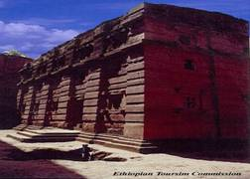**6. Bete Amanuel** / House of Emmanuel / Carefully sculptured from a block unit of 18x12x12m, Bete Amanuel is the only true monolithic structure of this group. Art historians consider Bete Amanuel to be the most impressive and finest church in Lalibela. It is a home for remains of sacred bees that prophesied Kingship to Lalibela   and graves of monks and pilgrims who wanted to be buried here.                                                                             
From the interior Bete Amanuel is a true Basilica plan which contains five bays, a mighty vaulted nave and two isles and a doomed sanctuary.

**7. Bete-Merkorios** /House of Merkorios/Bete merkorios is the most seriously damaged cave like rock hewn church in Lalibela. It had partially collapsed and became irregular in shape. The church is dedicated to a martyr of Rome, St. Merkorios which recalls the contacts of early Christian Ethiopia with the Roman Empire.

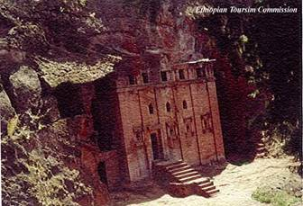**8. Bete Aba Libanos** /House of father LibanosBete Aba- Libanos is a good example of a cave church. The roof is not separated from the rock, but the other three sides are detached by a tunnel. Here priests will tell you that there is a little light in the middle of the altar wall shining day and night by its power. Nearby is monastery village of Lalibela, where many monks and nuns live in tiny caves (4mx3m) hewn out of the rock.

**9. Bete Gabriel- Rufael** /house of St. Gabreal-Rufael/Bete Gabriel is a two storey building with unusual windows. The monumental northern part facing Bete Gebriel is the most impressive feature. It is ornamented with ogival niches whose top shape is similar to the top part of the Axumite Stella.  
The ancient parchment manuscript (800 years-old) and two crosses are treasures that attract a visitor's attention. A Pass through the dark and narrow ridge of rock chiseled to symbolize the "path to heaven".

**The third group symbolize Noah’s Ark.**

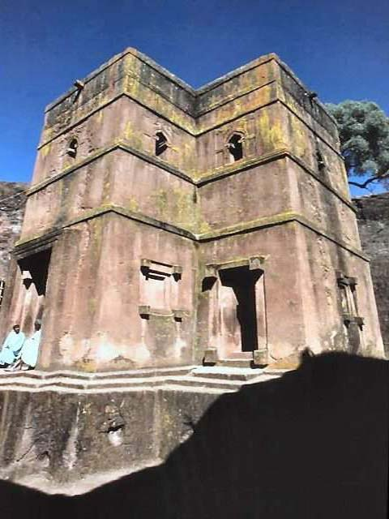**10. Bete Giorgis** **/**House of St. George**/**  
The monolithic Bete Giorgis, which constitutes the 3rd group and architecturally sophisticated, symbolizes Noh's Ark. Its sophistication is revealed in its cruciform floor plan, relief of three equilateral crosses on the roof and straight relief cross in the eastern arm of the church. Two crosses of the Lalibela period and a wooden box in which Saint Lalibela used to put his pristine carving tools, and usually locked by wooden nuts are worth visiting. The presence of this box here signifies that Bete Giorgis is the lastly hewn church.

**CHURCHES OUTSIDE TOWN**

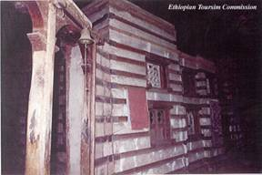Yemrehane kristosLying 42 kms northwest of Lalibela, Yemrehane Kristos is undoubtedly the finest church outside the town. Unusually, the church is built rather than excavated with in a cave. The whole church rests on a foundation of carefully laid olivewood panels, which float it perfectly above the marshy ground below.Lookout the bones of countless pilgrims who chose to be buried here, and tombs that include remains of Yemrehane Kristos at the back of the church. Near by are the churches of Arbatu Ensesa, Bilbila Chirkos and Bilbila Giorgis. Bilibila Giorgis resembles Bete Abba Libanos in design.

**Asheten Maryam**The church of Asheten Maryam sits atop a mountain that rises above Lalibela to an altitude of nearly 400m.  There are commanding views in all directions. The monastery was started during King Lalibela's reign but finished under king Na' akuto La'ab.  
The journey takes you through a lovely countryside. Listen out for the witchlike cackle of the francolins resounding around the valley.

**Na'akuto La'ab**Lying 6km, from Lalibela, the monastery of Na’akuto La'ab was built by   king Lalibela's nephew and successor Na'akuto La 'ab. It is an attractive little church built around a cave. Some very old stone receptacles collect the precious holly water as it drips from the cave roof. Visit the various treasures belonged to its founder including crosses crowns, an illuminated bible, and a metallic drum.

**GENETE MARIAM**It is purely monolithic rock hewn church found some 22 kms south east of Lalibela. It’s form of excavation is more or less similar to that of Bete Medihane Alem church in Lalibela..



**EVENTS** Gena / Christmas (every 7th of January), Timket /Epiphany (Every 20th of January) and Fasika/ Easter and Kidus Yohanes/ Ethiopian New Year (every 11th of September) are colorful celebrations of Lalibela. Many people around the globe and pilgrims all over Ethiopia have been attending the special ceremony of Christmas since long ago.

|  |
| --- |
|  |
|  |
|  |
|  |
|  |
|  |
|  |
|  |
|  |

**BAHIR DAR**  
**and**  
**LAKE  TANA**

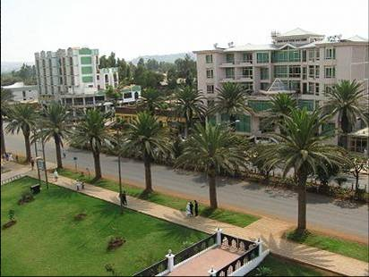

#### 

#### Bahir Dar

Founded during the first decades of the 20thc. at the Southern tip of Lake Tana and   along sides of the Blue Nile, Bahir Dar has gone on to become the foremost tourist destination of North Western Ethiopia. The city has an altitude of 1830 meters above sea   
level and a tropical climate with an average temperature of 190c.  
At Bahir Dar days can be spent by strolling through palm-lined avenues, lake side vistas, and exploring the Nile, and the negede Woito (clan of Woitos’) village, viewing spectacular sun set and riding a bicycle. St George church and the 16thc one storied Portuguese building in the same compound are also worth visiting.  
Festivals like the New Year on Sept. 10 or 11, the finding of the true cross on Sept. 27, Christmas on Jan. 7, Timkat or Epiphany on Jan. 19, are also colorfully celebrated at Bahir Dar.

**The Bazawit Hill Top**

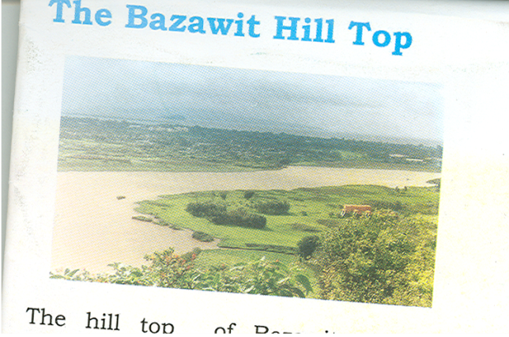

 The hill top of Bezawit offers a spectacular view of the surrounding, the city, the islands   of Lake Tana and Blue Nile leaving the lake. With some luck hippopotamus colonies can be seen at the bottom. There is the palace of Emperor Hailesillasie built in the 1960s. However, it is not yet open to the public. You can hire a taxi or ride a bicycle to Bezawit.

**The open Air Market**  
  One of the largest markets in Northern Ethiopia is found in Bahir Dar. And if you want to feel your trip complete and have a remainder where you have been, discover this unique market and purchase handicrafts like jewelries, woven and embroidered garments, ox-horn cups, grass baskets/ Agelgil/  for which Bahir Dar is known. Look at also the hair, clothing and market exchange styles and other indigenous culture of the local community.

Church Schools

The Ethiopian Orthodox Church is a pioneer to modern education in the country. Still today there are famous traditional schools in Bahir Dar where prospective   clergies learn Geez, and hymn, writing on parchment. The system of education and the living styles of students in their small huts are amazing. Hence, get them closely attached to the different churches of the town.

**Blue Nile Falls**

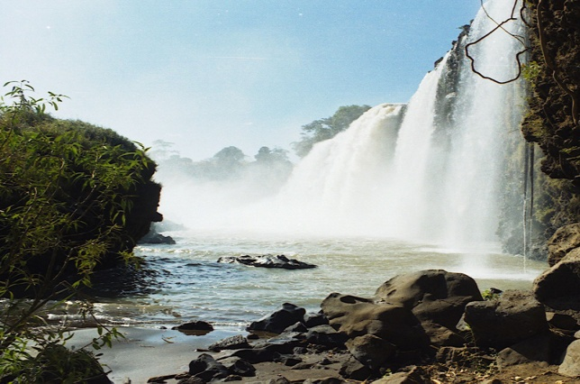  
Thirty kilometers south of Bahir Dar, there is a spectacular basalt cliff where the Nile forms an incredible falls of 45 meters high, known as the Blue Nile falls. The noise, the force and the smoke created by this fall is really worth discovering. The Blue Nile Falls is locally called Tis Abay, literally meaning water that smokes.  
Recently a dam has been built for hydropower; hence, the volume of the falls decrease during the dry season.  
Down to the power plant there is a historic bridge across the Nile River built in the 17thc. Standing on the bridge, it is amazing to look at how the massive water is collected and flow through a very narrow but deep gorge.  
The fall is accessed either by crossing the bridge or by a ferry above the power plant. Before a trip to the fall, remember to get a ticket at Tis Abay tourist information center.

Lake Tana

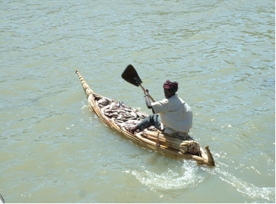

Tana, Ethiopia's largest lake is a principal reservoir of the Nile and home to unique monasteries and spectacular bird’s life. It had been serving as a link between Ethiopia and the ancient world .Tana was known by the ancient Greeks as "copper tinted Lake" or "the Jewel of Ethiopia".  
At the Southern tip of the lake and the Northern outskirts of the town, the Nile leaves Lake Tana and launches its long journey to the Mediterranean Sea. This spot is accessed by boats from the city. Here one could enjoy exploring church of St. Marry (monastery of Debra- Maryam), Hippos and the exact site where the famous Blue Nile River pours out of the lake

.**Kibran Gebriel**

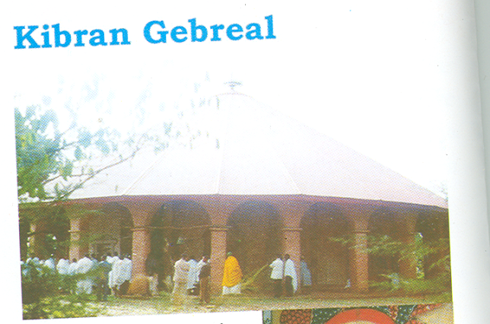  
   
Founded during the reign of Amde Tsion in the 14thc and rebuilt by Iyasu I in the 17thc, the monastery of Kibran has a distinct cathedral   atmosphere. Mural paintings and an iron cloth of the founding saint, illuminated manuscripts and other invaluable antiques make the monastery worth visiting. Kibran is allowed only for men.

**The Zegie Peninsula**

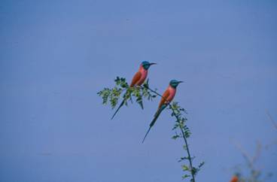  
Situated to the south west edge of Lake Tana, and  20 kilometers from Bahir Dar, the Zegie peninsula  is covered by a dense  tropical forest .Walking through the forest toped by birds and  monkeys and bathed by the fragrance of strange flowers leads to the reverend monasteries in the near by.

**Ura Kidane Mihiret**   
The monastery of Ura which is as old as Kibran Gebrel is found hidden within the mangrove forest of the Zege peninsula. Its architectural style is a typical example of the Ethiopian Orthodox Church having mud plastered round wall with conical thatched roof. Ura is known especially for its fine frescoes, manuscripts, ecclesiastical objects like crown of various emperors dated from the 14thc, processional crosses of silver& gold, silver-drum and royal vestments.

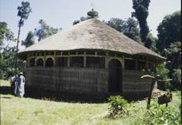

Near by are monasteries such as Azewa Mariam, Mahilzegie Giorgis, Betre Mariam, and Yiganda Tekle Haimanot having rich cultural collections & particular identities of their own. Monasteries of the peninsula are open both for men & women. To make your visit complete in this isolated area, do not miss local artifacts like Jewelries, colorful baskets  (the Amharic muday), paintings and manuscripts (replicas but not originals).

**Narga Sillassie**

The Monastery of Narga found 35 kilometers away from Bahir Dar was founded by Empress Mintwab in the 18thc.Its architectural style has direct resemblance to the building of Gondar. The doors carved from single log are interesting. Inside the wall is decorated with vivid religious paintings showing scenes of the life and crucifixion of Christ, the miracles and flight of Mary and the struggle of Martyrs.   
Narga also houses treasuries of the Gonderian period. When you are not in shortage of time, explore the neighboring monasteries and the life of the local community. Camping among this isolated communities and making a luxurious cruise to Gondar via Gorgora will be a historic event in life.

Daga Estephanos

The monastery of Daga Estephanose that was built during the 13thc and one of the holiest places lies some 35 kilometers from Bahir Dar.The real historic interest in Daga lies in its treasury. Here together with numerous piles of brightly colored ceremonial robes  are the glass coffins containing the mummified remains of several of the former emperors of Ethiopia; namely Yikuno Amlak, Dawit,  Zera yakob, Ze Dingle and Atse Fasiladas  who ruled from the 13th_ 17th centuries. Personal possessions of these emperors are also kept in the storehouse. Daga is closed for women.

Tana Chrikos

Tana Chirkos, the oldest monastery in Ethiopia, is situated to the eastern shore of the lake where one can observe life and rituals that have hardly been changed since the Old Testament. Tradition   has it that the Ark of the Covenant was kept here for 800 years before it was removed to Aksum in the 4thc A.D by   king Ezana.  
This claim to antiquity is backed up by the presence of three hollowed out pillars, which, according to religious fathers of the monastery, were once used as Jewish sacrificial altars.  
Tana Chirkos has the richest historical collections including the bowl (gomor), a vessel for blood sacrifice, bed and blankets of Gonderine kings, astonishingly big parchments including the one that was written by St. Yared in the 6thc.

This beautiful and unusual island is a sanctuary of birds of different species like humming birds, kingfishers, bright blue starlings and many others. Here, equally important is the monastery of kirstos Semera which, unlike Tana chirkos, is allowed for women.

Simien Mountains National Park   
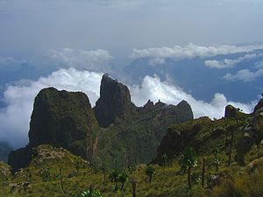The ancient game of chess also came to the mind of Rosita Forbes when, in 1925, she penned From Red Sea to Blue Nile - A Thousand Miles of Ethiopia: 'The most marvelous of all Abyssinian landscapes opened before us, as we looked across a gorge that was clouded amethyst to the peaks of Simien. A thousand thousand years ago, when the old gods "in Ethiopia, they must have played chess with those stupendous are present crags, saw bishops' miters cut in lapis castles with the ruby of approaching sunset on their turrets, an emerand knight where the forest crept up to. the rock, and, far away, a king, with sapphire, and guarded by a row of pawns. When the gods exchanged their games for shield and buckler to fight the new men clamoring at their gates,they turned the pieces of their chessboard mountains. In Simien they stand enchnted, till once again the world is pagan and the titans and the earth gods lean. down from the monstrous cloud  banks to wager a star or two on their spo rt.' these gigantic ' chesspieces' are actu­ally hard cores of volcanic outlets from the surrounding material has eroded away over the centuries - one of the most distinctive characteristics of these highlands, which constitute one of the major mountain massifs in Africa. The region includes many summits above metres (13,000 feet), and culminates in the highest point in Ethiopia, Ras Deshen, which, at 4,543 metres (14,901 ), is also is also the fourth highest mountain Africa. It is not a difficult mountain to climb and can be reached by traveling through the park. The park is 179 square kilometres (111 square miles) in area and lies between 1,900 and 4,430 metres (6,200 and 14,530 feet). It is in the Afro-alpine zone and the 'temperature regularly falls below freezing **at** night. Daytime temperatures range from 11.5" to 18°C (53° to 64°F). The rain­.fall averages 1,550 mm (60 inches) a year.

[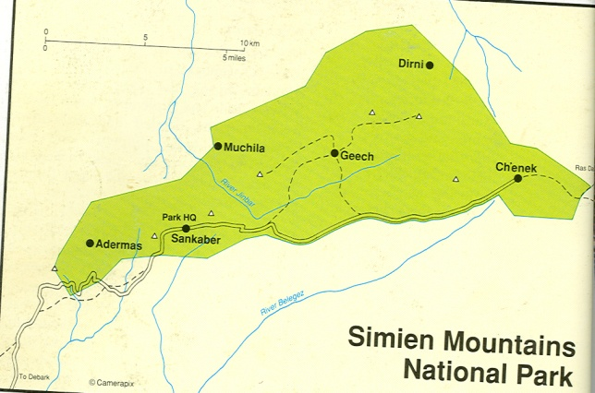](http://www.amharatours.org.et/seimen_seimen.jpg)

Getting there   
Debark, the base from which to explore Simien Mountains National Park, is 850 kilometres (527 miles) from Addis Ababa, 101 kilometres (63 miles) from Gondar, and 256 kilometres (159 miles) from Axum and can be reached by road through Bahar Dar and Gondar. Visitors . can also fly to Gondar on one of Ethiopian Airlines' daily flights and arrange transport from there to Debark, either privately or by bus or taxi.   
When to go   
The best time to visit is the dry season, from December to March. Travel is difficult during the long rainy season between June and September, when several rivers may be flooded and difficult to cross, trails are slippery, and fog frequently obscures the view throughout the day. October, November, and Decem­ber are the coldest months.   
Where to stay   
The nearest hotel accommodation is in Gondar, as hotels in Debark are not geared to foreign tourists, with the possible exception of the Simien Hotel. A small, local hotel, it has a very amiable and cooperative management, excellent food, delicious coffee, cold beers, and is bug free. Within the park, facilities were limited in 1994 to camping, and all equipment must be brought in. Tourist rest houses, once available in the park, were unfortunately destroyed in the fighting that occurred in the early '90s, but it is hoped that in the near future these facilities will be restored.   
Sightseeing   
Although the dry-weather road up to Sankaber Camp and Ambaras was reha­bilitated in 1994, transport of the four­legged variety is by far the more reliable means of getting around for a more serious exploration of the park. If you have driven your own vehicle to Debark, leave it at the local police station (or at the Simien Hotel) for safe keeping while you take your tour of Simien. Then set about the business of renting pack and riding animals and hiring guides for the six-hour trip into the park. Make sure to examine each animal carefully before selecting it, and clarify the terms of your rental of animals and equipment before you depart.   
Although it helps to enquire in Addis Ababa before you leave for Debark about recommended dealers and current prices, hiring guides, mules, and muleteers is done through the national park head  quarters in an efficient and honest manner­ alleviating stress-producing haggling    
Suitable clothing for extreme temperatures of hot and cold are needed as the diurnal swing is considerable, Waterproof clothing is also necessary, as are a hat and sunscreen lotion the sun at these altitudes can burn fiercely Water is available from  the various streams but should be treated . It is wise to remember that the main luggage is loaded on the pack animals for the day so requirements during the day should be carried in separate pack the nearest medical help is in Debark .  
There are various campsites and tracks to follow and it is best to take the advice of guides  
The topography of this small breathtaking. Climbing up from Debark on mules, through extensive farmland, the visitor is unaware of the dramatic scenery about to unfold The land forms various small plateau areas,and the edges of these plunge dramatically to the   
lowlands to the north and eastThe edges of these gorges form the perfect habitat for the animal that this park was set up to protect - the Walia ibex.Generally the first stop is Sankaber  Camp, a trek that leads mainly through, cultivatedareas to the 3,230-metre (10,600. foot) campsite. From this point, you can  walk to the edge of the abyss, where you the get your first glimpse of  spectacular .  scenery. Much of the vegetation has been altered by humans over the years and few : trees will be seen in the area except the introduced eucalyptus. But in inaccessible ,  areas, such as the escarpment, natural habitats are preserved and plants such as  Hypericum revolutum (51.John's wort) and , heather (Erica arborea) will be seen as small a . The trees or bushes, and many smaller herbs . form carpets of colour. Among these are many species of Alchemilla, the tall spikes  of various Kniphofia species or 'red-hot the .  pokers', and carpets of small blue lobelia park is  flowers. Probably the easiest animal to see in this area is the gelada baboon, which is . . endemic to Ethiopia. These baboons are  grass eaters and Will be seen in family units in many areas, one male guarding his  harem of females and young ones. They are also known as the 'bleeding heart baboons' as there are red areas on the chest that show the sexual stat the animal. the kldipspringer may be spotted on rocky area its hooves specially adapted to the terrain The small grey duiker is present in protect it from its enemies area where there is enough cover to protect it from their enemies.  
Though it is named after this area, the semien fox which is also referred to as the semien jackal or Ethiopian wolf is seen here nowIt is more common ;Bale Mountains National Park in theof the countryIts high-pitched call maybe heard at night, and its bright red coat is distinctive during the dayIt feeds on the many species of rodents found here.The animal most visitors wish to see isThe Walia ibex.The male of this member of the wild goat family has magnificent heavily ridged horns sweeping back over it’s soulders The Walia live on the crag of the steepEscarpment. their hooves clinging to the smallest ledge. birds of the area often provide spectacular aerobic displays off the sheer cliffs, using the air currents peculiar to the terrain.Lammergeyrs and Choughs, as well as Endemics such as the thick-billed-black-headed raven black headed siskin, white-collared pigeon, wattled ibis, white-billed starling, 'as, spot-breasted plover, and white-backed black tit. From Sankaber, the track leads through meadows, forests and some cultivated areas to Geech, a trip of about three to three­ and-a-half hours by mule. Geech, at 3,660 , metres (11,800 feet), is worth a stay of at least two days: there are several good look­ out spots where one may see Walia, gelada, and klipspringer, and breathtaking  views from nearby Gidgergot, K' adadit, Saha, and Emietgog  Just east of K'adadit . you have a chance to see the striking black­e animal most  and-white colobus monkeys in the low­ land forests if you have very good  binoculars. From Geech to the next stopping-off point, Ch'enek, the trek takes two-and-a­ half to four hours, and you may have to dismount and walk part of the way where the climb is steep. The Ch' enek campsite offers superb views, and there are many  places for seeing Walia ibex. There are also   caves to be explored, and this is the only place in the park where - if you are  extremely lucky  you can see rock hyrax, the small mammal that looks like an, ­overgrown guinea pig but is distantly of both. related to the elephant. After a stop at Ch'enek, the traveller ­usually returns to Sankaber (three to four hours) and from there to Debark (five to  six hours). But if arranged in advance, more extensive trips can be made to Buahit, at 4,437 metres (14,550 feet), which is outside the national park; Ras Dashen, Ethiopia's highest peak; and the lowlands ­Three game scout camps exist in the low lands at Dirni, Muchila, and Adermas, but a trip here is a real expedition and recomended only for more hardy travellers ­able to walk under tough conditions and  cope with rock climbing. A trip from  Ch' enek along the foot of the escarpment to the wolkafit pass and debark lasts about five to seven days.

**Discover the mystery**   
**Of  waghimra**  
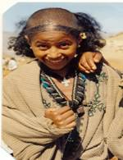Introduction  
Waghimra is one of the special Zone of Amhara region, is bordered in east and north with Tigray in south by Semien Wollo/Lalibela/ and in west with Gondar. The area of the zone covers about 788486 km2 with a population about 418817, male 211403, female 207414 in 1999 E C.Concerning religion Orthodox Tewahido Christianity is the predominant one, that is 99.6%, 0.27%Islam and 0.13% shared by other religions, the official language of the zone is Amharic, with native language Himtana(one of the Cushitic language family  )   In climates the zone is categorized as 5.45% highland, 31, 43% temperate and 63.42% lowland.  
It is endowed many cultural, historical, traditional and natural attractions, which is also inhabited by generous, proud, hospitable people. They had also the founder of Zagwe dynasty and the zone capital city is Sekota  
Sekota is located 510 km away from the regional capital city Bahir Dar, 128 km from Lilibla and 720 km away from Addis Ababa which is the earliest town in north Ethiopia and it has numerous tourism attractions such as Hidmo bet ,historical cave ,open air market (on Thusday) however, these attractions of the zone and Sekota are not yet touch because of poor attention in tourism promotion and marketing strategies.  
Taking in to consideration the potential of the attractions  the present Culture and Tourism Department of the Zone has making its best level of effort to attract potential visitors to the area. Among many of the attractions some are listed in this brochure.      
Bella Mountain  
North part of Ethiopia is endowed impressive mountains from these spectacular   mountains the one is Bella mountain  the mountain ranges 3700m above sea level, it is the highest mountain in Waghimra  administration zone  and which is the home of different animals and vegetations species birds Hyenas  push duiker ,Klipspringer and indigenous  threes like Juniper and Olives.  For its nomination Bella there are some backgrounds. Some researchers said that as the mountain gets its name from the people Bilen migrated from Eritrea. Long time ago, these   people were inhabited in the lower part of the mountain due to this the mountain nominated its name by the name of these people Others argue that the mountain gets its name during Italian occupation when they reach to the mountain Italians surprised and attracted by the spectacular view of the mountain then they called it Bella/beautiful in Italian. 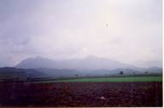

**Debre woyla Maryam church**   
Debre Woyla Maryam church is located west of Asketma town 107 km far away from Lalibella. The church is built by Holy Father called Aba Estifanos in 13th century and this church is the most marvelous and the richest in holy treasures in Waghimra zone.  
In legend the earliest church building Materials has been brought from Jerusalem example the pillars, wood door, Redstone however the old church is destroyed by flood before 20years.To list some holy treasures of the church Cross, big Drum(Negaret) presented by Gragn, Kettles of holy water, Ahmad Ibn Ibrahim ( Gragns Mohammed’s )horse drinking plate old aged seal with St marry pictures etc.When some one visit the church can enjoy sightseeing of Woyla rivers gorge  and the spectacular view of Bella mountain.In 1527 Atse Libne Dengle was hidden here to escape from Ahmad Ibn Ibraahim( Gragn Mohammed as local people ) when Gragn heard Libne Dengls’ hiding place he tried to burn the church at that time the church released blood tears to extinguish the fire and the bee swarm also cooperate to attack Gragn Mehammed and his horses.Ahmad himself surprised by the event and gave his horse drinking plate and the drum to the church due to these gifts the church is called Gragn Mohammed’s empress.During celebration of the church Aril 21 every year an amusing event is taking place white birds are come to the church from Jerusalem. As the local community and priests said if the birds do not appear during the celebration, they believe that there will be occurred drought and famine in the area.

Keta Maryam churchThe church is situated east of Asketema town at a distance of 3 km. The church was established in the reign of Atse Kaleb 6th century. This long aged church is covered with indigenous trees like olives and Juniper there is also an opportunity to see different bird species    
Surprise there is a dried burned wood by the time Ahmad still standing there for evidence

.Wukir Meskele kirstos Rockhewn churchThis spectacular unique and unusual impressive church is situated 5 km far away south east of Sekota. The church is curved from single rock in the reign of king Kaleb /495-525/. The church has seven parts 4 doors 5 pillars, 14 windows and the cave with door that run to north up to Axum  and to south up to Lalibela (according to the priests),on the ceiling different type of cross shapes are observed.Some visitors and researchers called it «The Father of Lalibela Churches» because of its long ages; it is order than Lalibela churches. It seems that the church is an initial point for rock hewn church of Lalibela.  
In 1951 E C unprofessional restoration was made by Wag Shum Getaneh 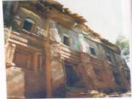  
Wukir Meskele kirstos Rockhewn church**Woybla Maryam church**  
Which is one of the oldest church in Waghimar Zone, Pentateuch scarification had took place with in the cave at a place Gudguda from Gudguda it brought by 3rd wagshume/local lord Jurwosen.in time of. Sekota town, established probably in 7th century.   
During Italian invasion ancient antiquities like Gold cross, Holy cup are destroyed. At present attractive silver drums and tomb of Wagshums are the most visited attractions of the church.

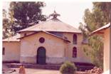

Hidmo Bet  
These are long aged ground plus one building (houses) constructed from mud and stone traditionally. These buildings are similar with Axumite houses. Before it was grass roofed but at this time some are changed in to tin roof. Of course the design is still original.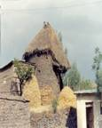                     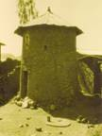

**Life Savor Cave** This cave is built by EPRDF to escape from jet bombardment in the time of military government Derg. It is very historical cave that made big favour for the people of Sekota town because it saves many peoples' life. When some one enter in to the cave can get 1m depth entrance door, in left and right side windows are located for light entrance  
.  
 During the civil war the cave was given a service for store of books and armaments.

**Lalibela Rock Road**   
In legend the local people called the road of lalibella, which is the road that God indicates for king Lalibella from Axume to Roha and the king had a journey on the rock.  
The rock seems like a wall that built by skilled Engineers. Whatever the legend said about it the road is so impressive and attractive .Distinguishgly, it can be seen from distant, (3 km east of 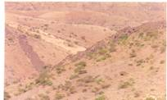Sekota town), no one cannot be impressed by its look. Tsaka kirkos    
The church is situated 8 km far from Sekota town to northwest. Near the church 14 letters Inscriptions are there in the cave. Still there is no any study is made on the inscriptions additionally near the inscriptions fossils of Wagshum and other people fossils located that killed by the time of Ahmad (Mohammed.) Festivals   
**Epiphany**   
The festival occurs on Jan 19 every year.  On the eve at about 3 P .m congregations of ecclesiastics carrying a tabot /Ark/ and being accompanied by the faithful people to the baptismal water places. Through out the night the service will continue and on the morrow comes the brilliant scene of the festival.The bishop or priest and his clerics appear to the edge of the baptismal place and attendants of the rite will gather round waiting for spraying of the blessed water. The bishop or one of the priests blesses the water with processional cross and splashes it over the crowd who are waiting eagerly redemption of their sins.  Then comes the colorful return occasion wring which the feast attains its zenith. Every body sees full of life and sprits. The hymns from reverend clerics, the chanting and dancing of gay and beautiful girls the handsome boys and of great men resonated through out the town roads. At about 5 pm the processions will arrive at their respective churches are the feast will comes to its end.

**Shadey FestivalShadey** is the most colorful and attractive women’s festival the word Shadey Derived from the grass they use for the celebration of the festival and which celebrated Aug16-21 E.C. The festival has religious backgrounds; the religious leaders associated with st Mar yams resurrection and rise up to the haven angles where clubs, praise spiritual songs were took place then after girls accepted and transferred to this world. Due to this legend the festival become girls' festival, the festival is celebrated by wearing colorful traditional clothes. The festival is also a big opportunity to see traditional dressing style, competition of girls in traditional music.The festival begins nearby churches to give thanks, praise in reaching for the celebration in peace, healthy, they put down also the white part of shaday leaves to church as a gift and pray to God for the next year to reach in peace, healthy and prosperity. After church they go to elder people or to the local leader house with playing traditional music from these people they get a gift.In the second and third day they play different traditional music in the street of Sekota town. Finally the festival ended by wedding ceremony (bride and bride –groom ceremony)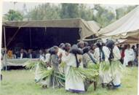

**Wardahoye Traditional Game**  
This traditional game is conducting every year from September 1-16E.C. This long aged game is celebrated during night time Especially it is very lovely game by male youngsters, youngsters dividing themselves in different group. First they warmed the circle black stone by fire and they start the competition. After the stone is warmed then throwing in to the field the most competent group will catch and turn in to the fire place.   
The group that catch and turn the stone in to the fire place will be the winner of the game.

**Aba Yohannes Michael church**  
The church is located west of Sekota far about 10km at right side of Dehanna road. The church was established by wagshum Kinfu in 18th century.Really the church is unique and majestic in its high quality traditional painting. Still the paintings are attractive, impressive and imaginative to see them these marvelous painting was painted by ato Meresa who painted Chelekot Sellasie church in Tigray   
Additionally the church has very old bell and impressive cross gifted from Wag Shum kinfu the place is also accessible to be visited by tourists.

**Ahmad Ibn Ibrahim/Gragn stelea/**  
Around Chilla 45 Km distant from Sekota to west direction with sightseeing, the opposite side of Bella mountain the stelea are stand  by gragn in 14th C. In legend he put the stone to show his strongest to his opponents, the stelea have rectangular shape. The one is stand in side Chilia elementary school by displacing from the original place for protection but the other is still stand in the original place.  
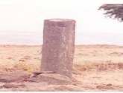

Near the stelea two plies of stones situated .That plied by Ahmad's soldiers to show the number of his soldiers for his power opponents and to create fear and frustration on the highland Christian kings. Note the war was not religious war it is just to take power from the highland Christian kinks and to put the trade routes under his control.  
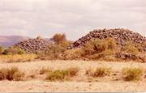  
Debr loza wukir Maryam  
The church situated 55 km to west direction from Skota town and which is built in 6thc by the reign of Atse Kaleb it is long aged rock hewn church. Indeed its some part is built stone by mud; the whole part of the holiest is in side the rock.  
Astonishingly, there is natural rock storage in the church that uses to put holy treasures of the church. There is also an opportunity to see the traditional priest school hut in front of the church.  
 **Fertata tree House**Fertata tree house situated 64 km of Sekota to North West direction (Zuqaula district). The tree has one entrance door, 5 m height and 4 m width and gives a house services, can accommodate up to 50 people as the local people experience but as the writer observation it accommodates 15-30 people and it is naturally hewn treeDuring EPRDF Struggle the tree had a big role to hide armaments, you may wonder to hear but it is true come and see the reality  
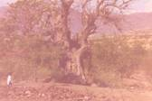**Bahir Kidane Mehiret Monastery**  
The monastery located north of Sekota at distant 52 km /estimation/ the church became a monastery in 1870 E.C. The present church is built in 1961 E.C by special instruction of King Atse Haile Sellasie.   
The monastery is called «The Desert Paradise» the nomination is associated with its location the area is semi desert contradictory, the monastery is green and covered by long indigenous trees. Additionally the monks irrigation farms specially from October to January Banana, lemon fruits are surplus this paradise monastery avoids physical, psychological stress and gives serenity for visitors. The monastery has holy antiquities that given from different kings like parchment books, holy gold cup, crosses and, letters written from different government officials just to list some.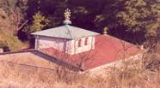

Note manmade lake and water fall of Tekeze River, Red fox and Selamge Maryam church are 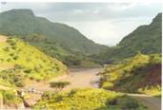expected to be best destinations in the future.At this time Sekota is in fast social, economic, and political development conditions so, visitors can get the following services.Transport  suitable roadCommunication postal, fixed and mobile phone services Water                 potable water Medical service  one hospitalInternet service and fax service  Bank service  commercial bank of Ethiopia Interment cinema  hol.

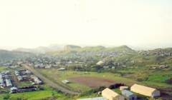**Possible Itineraries**  
Day 1   Taking picnic lunch from Lalibela drive north of Lalibela enjoying sight seeing of the area, visiting Keta Maryam church faraway about 97km from lablibela. This church is rich in bird species, church antiquities. Break time at Asketema small town and drive or foot walk 7km west of the town, to the oldest and historical Debre Woyla church.  
.  
Then drive to Sekota enjoying sightseeing of Bella Mountain /3700 m above  sea level/ and the final tour of the day will be after visiting the 6th c unusual Meskele Kirstos rockhewn church overnight Sekota at your recommended place. Day 2   In the morning drive to west of Sekota to visit Aba Yohannes Michael church that adorned in quality traditional paintings and continue to Chilla 45 Km away with enjoying the opposite sightseeing of Bella Mountain and visiting Ahmad stelea and the 6thc of Wuker Maryam rockhewn church then drive back to sekota overnight Sekota.  
   
Day 3 After early breakfast drive to Zuquala 65 Km distance to visit the historical Fertata tree house and on the way Israel's migrant people tomb then drive back to Sekota and after lunch city tour to visit old aged traditional building churches and manmade cave built by EPRDF (Ethiopian People Republic Democratic Front)Day 4   Drive to North of Sekota with sightseeing of the area to visit Bahir Kidane Mehiret monstery that called The Desert Paradise then drive to Tigray to visit axum via mekele or Aby Adi road  
.**For time budget Visitors**Day 1  Taking picnic lunch visiting Attraction from lalibela to Sekota overnight Sekota.  
Day 2   Drive to north of Sekota to visit Bahir Kidane Mehirit monastery then drive to Tigray to visit Axum Via Mekle or Aby Adi road.Distances from Lalibbela to Axum through Korem 505km, but from Lalibela to Axum through Sekota is 378km there is 127km difference.AccommodationsMamo zegeye pension phone number 0334400116/ 0911744374. They also provide food and beverage services with good standard 30 bed roomsAbayu Asres pension phone number 0334400746/     has good standard 40 bed roomsTadesse hotel phone number 0334400015                  Pastries/CafesSyum café phone number 0334400092 Shamrock café phone number 0334400001/02 Henok café phone number 0334402616Note there are many accommodations we list only some for our purposes.For every Visitor and tour Operators our office cooperation is with you.Note entrance 15 birr for each   
For more information contact

1. Phone No. 0334400048
2. Waghmria Culture and Tourism  Department
3. Meket sit  
   The original community that TESFA started work with is **Mequat Mariam**, a remote parish based around the church of St.Mary's of Mequat. The tukuls (thatched round cottages) are set on a promontory of the Meket plateau with staggering views to the west and south. A small troop of Gelada Baboon patrol the escarpment, and a troop of Vervet monkeys sometime come up for a visit. Recently Lammergeyer have been seen soaring over the site.   
   [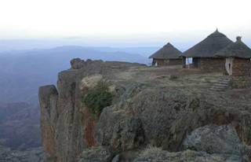](http://www.community-tourism-ethiopia.com/Images/Mequat06.jpg)  
   Accommodation consists of a large tukul divided into two bedrooms, each with a double and single bed. A second smaller bedroom tukul will be finished soon providing a further two beds. There is also a large dining tukul, an eco-toilet and a shower. Mequat Mariam boasts a 'rock   
   bar', a smooth sheltered ledge that is warmed by the afternoon sun and invites guests to sit with a sundown drink a watch the golden glow at the end of the day turn red as the sun sets over Mount Guna.   
   In 2006 the community at **Aterow** finalised their tukuls, and have since had a steady stream of guests. The site chosen for the tukul camp overlooks a gentle valley that comes from the plateau top and then below the site drops into a dramatic gorge. The river in the valley takes the plunge and although the resulting falls are not visible from the camp they can be reach by taking the short steep way down into the valley below.  
   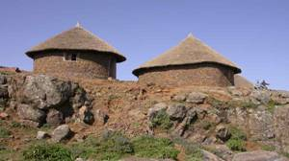  
   The accommodation consists of three sleeping tukuls, all quite roomy. There is also one large dining tukul, and an eco-toilet. This is a great place to see Gelada Baboon, who come up from the cliffs and gorge below. Three lamergeyers were also seen here soaring above the gentle valley below.
4. The second community TESFA worked with (starting in 2003) is **Wajela**. This quiet village sits just below the plateau top on a fertile ledge. The spot chosen for the tukul camp overlooks an intriguing cave complex and the old church of Werketa Mariam set amongst Juniper (a large indigenous pine tree) woodland. Wajela also boats an old acacia wood, besides which they have built a small church.  
   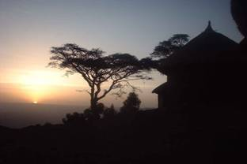  
   The accommodation consists of three cosy bedroom tukuls. There is a dining tukul with a small verandah, an eco-toilet and a shower (although water is a bit scarce so check with your guide).  
   The latest community that TESFA is working with is that of **Yadukulay**, set on a small twin peaked hill in a valley just off the escarpment. It is near the village of Taja, about 50km south of Lalibela.   
   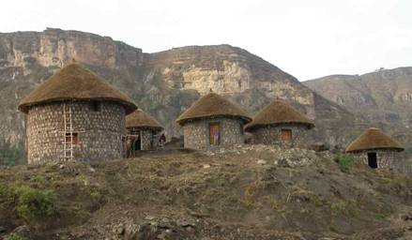The land around is irrigated from streams coming off the escarpment, and the community very eager to receive the first guests. Yadukulay site received its first visitors in June 2007. Trekkers visiting here will need to be prepared for a climb up to the Aterow site (or harder down from it). But the walk is a very enjoyable and quite short so you can take it easy.

Awra Amba is located in south Gondar Zone of the Amhara National Regional State, Fogera district (Woreda) and can be reached by turning right onto the Woreta Woldia road about 68 km from Bahir Dar. Following the Woldia road after the junction of Gonder road for 8km about until you look a signposted junction to the right and need to continue on the rough road for another 2km toreach the village.

Awra Amba is a small community consisting of 104 households with 388 total residents. The total land holding of the community is less than 18 hectares. They are all from Amhara Ethnic group. While they do not follow any religious denomination, they do believe in the Creator. The members of the community has been settled at Awra Amba since 1972. This community is the best workshop to demonstrate to its members and to other Ethiopians that the best escape route from poverty and hunger is not religion and prayers only but education and plain hard work.

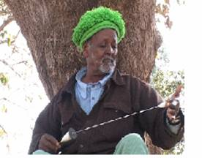**Ato Zumura /the founder of the community/**

In the first ten years, the community lifestyle was not different from the rest of Amhara people. But after ten years, the founder of the community , Zumra Nuru , came up with a new concept of work , faith, culture and lifestyle. He persuaded the members of the community about his vision. After few years' continuous discussion, his proposal has got acceptance by all members of the community, and then the community as a whole prepared guiding principles that they decided to follow and be governed with. Since then, the people of Awra Amba have lived according to these principles and they have thrived along.

**Some Guiding principles of the community**

* Marriage is to be made after 18 years of birth based on the free will of the partners.
* There should not be gender discrimination in the community.
* Harmful and undesired traditional practices are all condemned.
* Every body contribute labor according to his/her ability in material production and shares on equal terms.
* The Disabled and elderly are entitled to equal sharing the community production.
* Theft, Gossip, Begging  and adultery are all condemned and prohibited.
* Members are entitled to necessary assistance in time of need.
* Mothers have the right to take maternity leave.
* Polygamy is forbidden.
* Lavish wedding and funeral ceremonies are condemned, and not practiced.

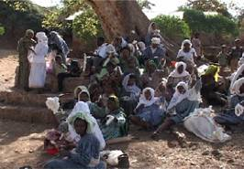

**Community Members At Work**

What makes Awra Amba community unique is that there is no gender-based division of labour. Each member of the community contributes labour according to his/her ability. Men often do what is normally considered to be women's task , such as spinning , fetching water , baby sitting and making injera /a soft Ethiopian bread made from teff flour/. Women do works such as ploughing weaving, managing organization and presenting families at social gatherings.  
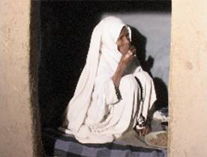

**Elders Dormitary**

Both women and men are treated equally in Awra Amba. Neither boys nor girls marry before the age of 18 . Marriages are arranged based on the free will of the partners. The community avoids lavish wedding that can ruin the family. Polygamy is forbidden. If a divorce occurs , the case will be seen by a committee of two women and a man . This committee counsels the couple about the advantages of their marriage to try to avoid a divorce. But, if the members are against a reunion, the committee will give its final verdict on the case.  
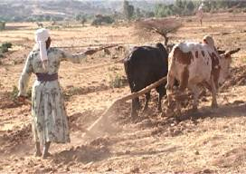

**Farming**

The community tills its cultivable land communally, and shares the yields equally. As land is a scarce resource , members of the community are engaged in various off-farming income generating activities. Weaving is the main source of the income and the major activity of the community.

weaving is practiced communally. Everyone contributes , and the earning goes into a fund for building houses, for the weak and the elderly. Every member take turns in caring for the weak and elderly community members.

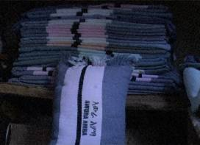

**Soveenir Shop**

Begging  is an activity frowned up on, the most appropriate way to contribute would be to buy some of the handspun cotton and wool items in the warehouse:- a range of "shamas", scarps, shirts and blankets costs half what  you pay in most other parts of the country.  
During pregnancy women in Awra Amba are given fewer and lighter tasks in and around the house. Mothers have maternity leave for a month before giving birth and  two other  months after giving birth.

All the children are sent to school in Awra Amba. Their parents take care of the cattle and handle house works, though the children are expected to help their parents after school. A pre-school aimed primarily at children under the age of seven, but also attended by adults seeking to attain a basic level of literacy. The better educated community members serve as teachers in school.

Family decisions are made by the wife and husband together and children's are also expected to have there say. Family hold a weekly decisions forum and reach agreement in , what to do if there are problems.  
At the community level, various committees organized to handle different tasks such as development, health, external affairs, complaints, sanitations, home management and discipline, etc.

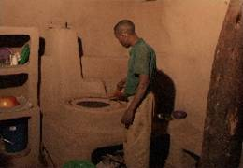

**Making Injera**

Awra Amba welcomes local and foreign visitors though it is rather quiet on Wednesdays and Saturdays when most inhabitants are at the market. The pre-school, library, the dormitories for aged members of the community, the innovative injera cookers in the adobe house and the communal weaving area with its 20 handmade looms are but few of the places worth visiting in the community.

|  |
| --- |
|  |
|  |
|  |
|  |
|  |
|  |
|  |
|  |
| **Gishen Debre Kerbe Monastery** Gishen Deber Kerbe is an old monastery, probably one of the most holy sites of the entire orthodox churches in the country. Populary Known as the second Jerusalem,' this church claims to possess a piece of the 'True Cross.' In the reign of Dawit (DavidIII) (1382-1311)", Wrote Sylvia Pankhurst who was a renowned British scholar in Ethiopian studies, "a piece of the 'True Cross' was brought from Jerusalem to Ethiopia. This occasioned much pious rejoicing. http://www.amharatours.org.et/images/gishen.jpg Apocryphal sources, oral as well as written, give different versions of the story. However, all agree on the central theme about the coming of the holy object to this sacred sanctuary. Hundreds of thousands of Ethiopians pay their annual pilgrimage to Gishen on the 1st day of October.  Gishen Debre-Kerbe Monastery is found on an 'amba' (a flat-topped mountain) 74 Kms to the north-west of Dessie. Viewed from air the amba has the shape of a cross as if nature itself has became Christain. The amba is cloven from the rest of the land by deep gorges, about four of them, Which diverge almost symmetrically to four directions. Looking at the cross-section of that mass of land and it seems as if it is made of layers of crosses. Dramatically, the top layer is much elevated to make its own distinct relief-apparently projecting a cross-shaped abma. All sides of the top layer are steep walls, about 15-20 meters high, making it totally unreachable. The stair-way, the only access up to the amba, was chiseled very recently and its more than amazing to think of chuch of that nature could be built upon such an isolated land. According to Merigeta Wolde-kidan Wolde Iyesus, an elderly chief and teacher at the church, the monks had to use a rope fastened around their waist to go up and down the amba. |
|  |