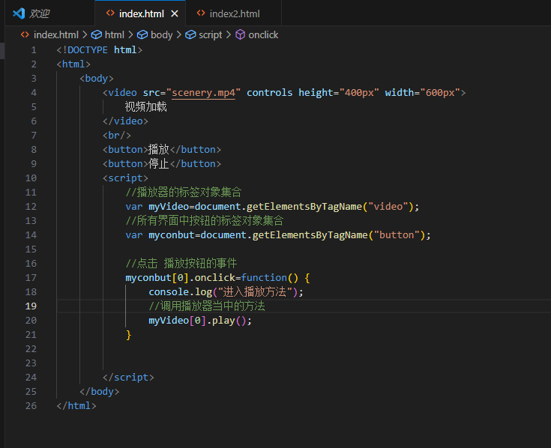

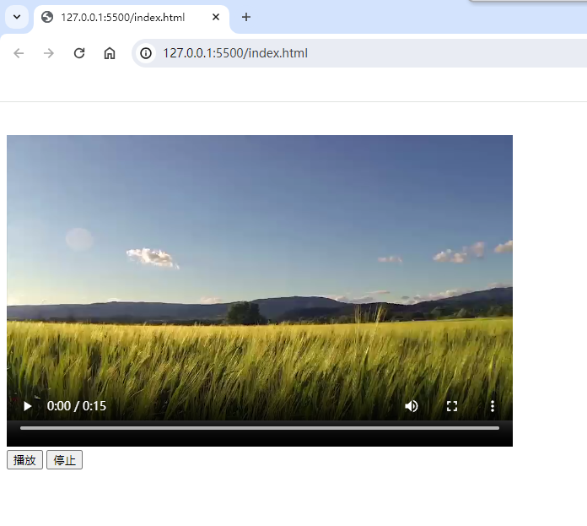

<!DOCTYPE html>

<html>

<body>

<video src="scenery.mp4" controls height="400px" width="600px">

视频加载

</video>

<br/>

<button>播放</button>

<button>停止</button>

<script>

//播放器的标签对象集合

var myVideo=document.getElementsByTagName("video");

//所有界面中按钮的标签对象集合

var myconbut=document.getElementsByTagName("button");

//点击 播放按钮的事件

myconbut[0].onclick=function() {

console.log("进入播放方法");

//调用播放器当中的方法

myVideo[0].play();

}

</script>

</body>

</html>

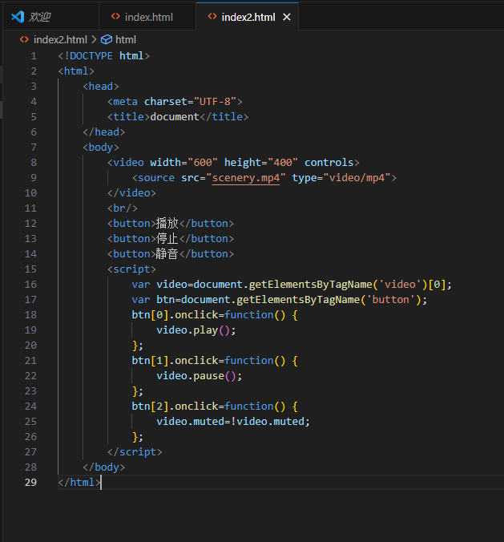

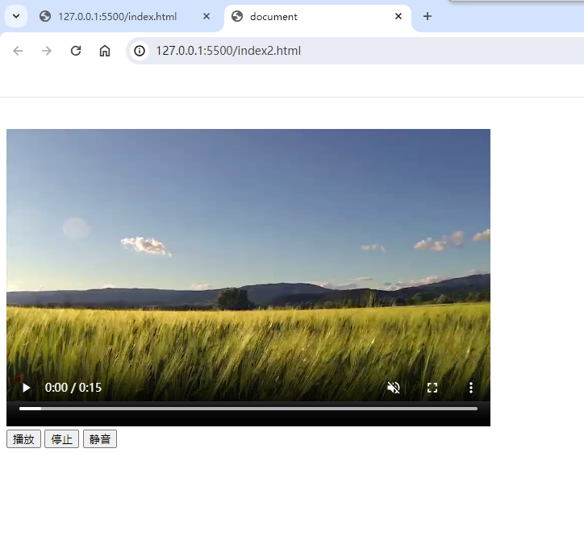

<!DOCTYPE html>

<html>

<head>

<meta charset="UTF-8">

<title>document</title>

</head>

<body>

<video width="600" height="400" controls>

<source src="scenery.mp4" type="video/mp4">

</video>

<br/>

<button>播放</button>

<button>停止</button>

<button>静音</button>

<script>

var video=document.getElementsByTagName('video')[0];

var btn=document.getElementsByTagName('button');

btn[0].onclick=function() {

video.play();

};

btn[1].onclick=function() {

video.pause();

};

btn[2].onclick=function() {

video.muted=!video.muted;

};

</script>

</body>

</html>

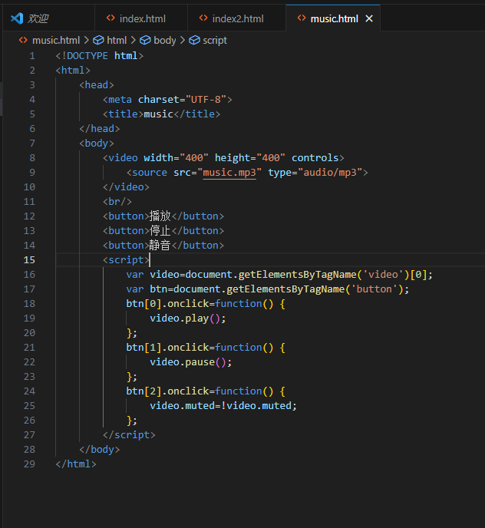

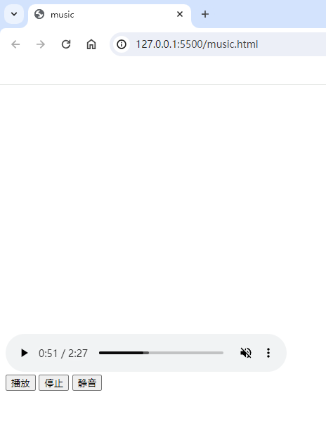

<!DOCTYPE html>

<html>

<head>

<meta charset="UTF-8">

<title>music</title>

</head>

<body>

<video width="400" height="400" controls>

<source src="music.mp3" type="audio/mp3">

</video>

<br/>

<button>播放</button>

<button>停止</button>

<button>静音</button>

<script>

var video=document.getElementsByTagName('video')[0];

var btn=document.getElementsByTagName('button');

btn[0].onclick=function() {

video.play();

};

btn[1].onclick=function() {

video.pause();

};

btn[2].onclick=function() {

video.muted=!video.muted;

};

</script>

</body>

</html>

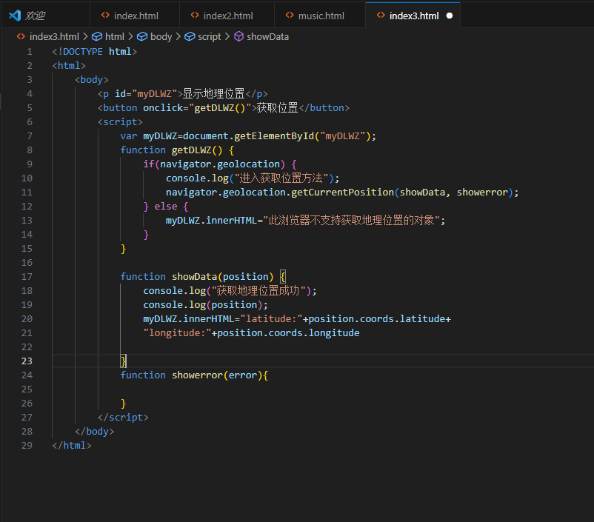

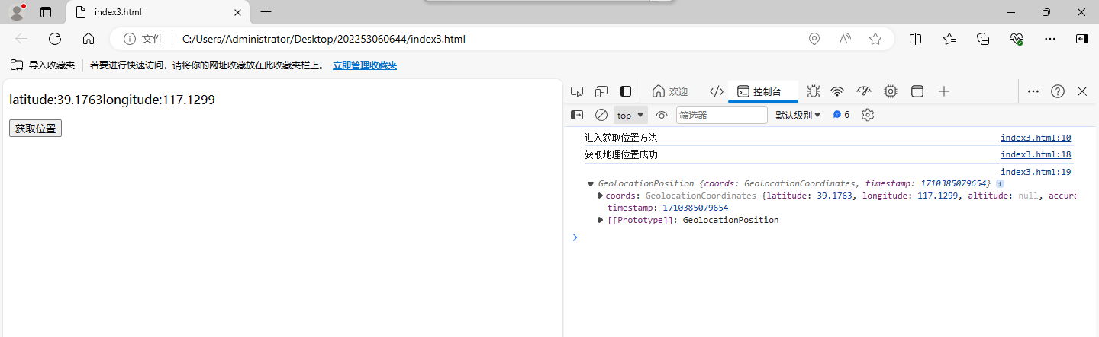

<!DOCTYPE html>

<html>

<body>

<p id="myDLWZ">显示地理位置</p>

<button onclick="getDLWZ()">获取位置</button>

<script>

var myDLWZ=document.getElementById("myDLWZ");

function getDLWZ() {

if(navigator.geolocation) {

console.log("进入获取位置方法");

navigator.geolocation.getCurrentPosition(showData, showerror);

} else {

myDLWZ.innerHTML="此浏览器不支持获取地理位置的对象";

}

}

function showData(position) {

console.log("获取地理位置成功");

console.log(position);

myDLWZ.innerHTML="latitude:"+position.coords.latitude+

"longitude:"+position.coords.longitude

}

function showerror(error){

}

</script>

</body>

</html>

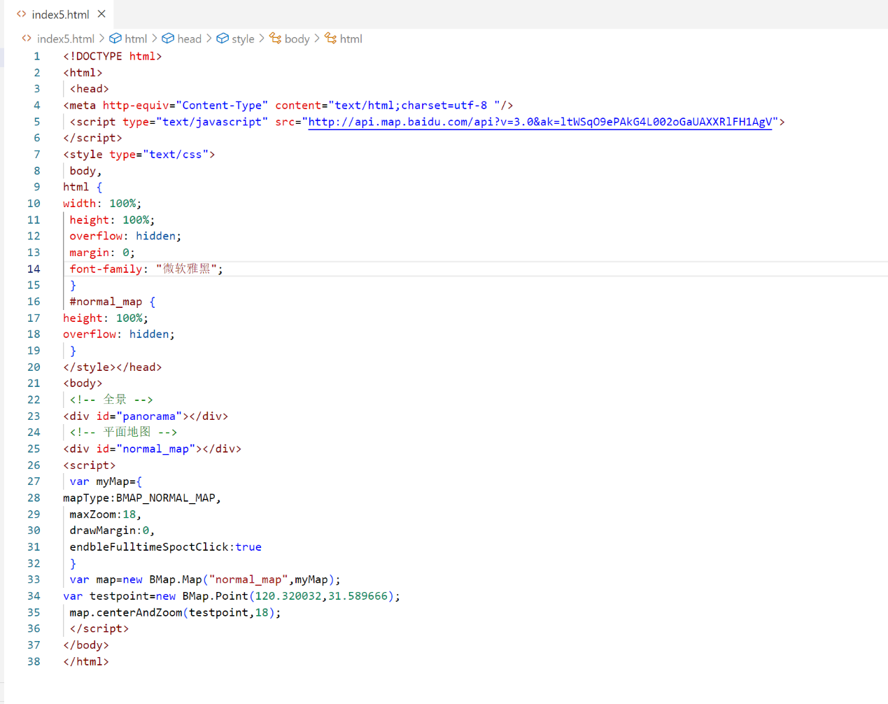

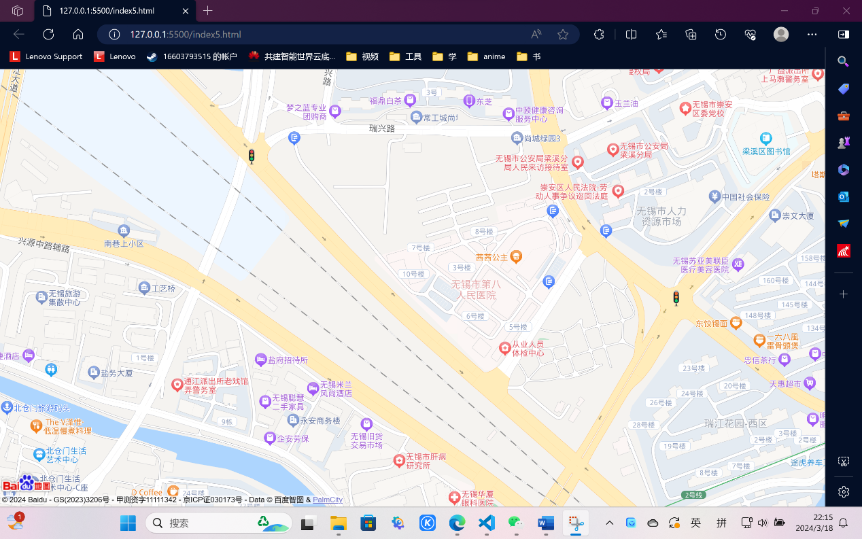

<!DOCTYPE html>

<html>

 <head>

<meta http-equiv="Content-Type" content="text/html;charset=utf-8 "/>

 <script type="text/javascript" src="http://api.map.baidu.com/api?v=3.0&ak=ltWSqO9ePAkG4L002oGaUAXXRlFH1AgV">

</script>

<style type="text/css">

 body,

html {

width: 100%;

 height: 100%;

 overflow: hidden;

 margin: 0;

 font-family: "微软雅黑";

 }

 #normal_map {

height: 100%;

overflow: hidden;

 }

</style></head>

<body>

 <!-- 全景 -->

<div id="panorama"></div>

 <!-- 平面地图 -->

<div id="normal_map"></div>

<script>

 var myMap={

mapType:BMAP_NORMAL_MAP,

 maxZoom:18,

 drawMargin:0,

 endbleFulltimeSpoctClick:true

 }

 var map=new BMap.Map("normal_map",myMap);

var testpoint=new BMap.Point(120.320032,31.589666);

 map.centerAndZoom(testpoint,18);

 </script>

</body>

</html>