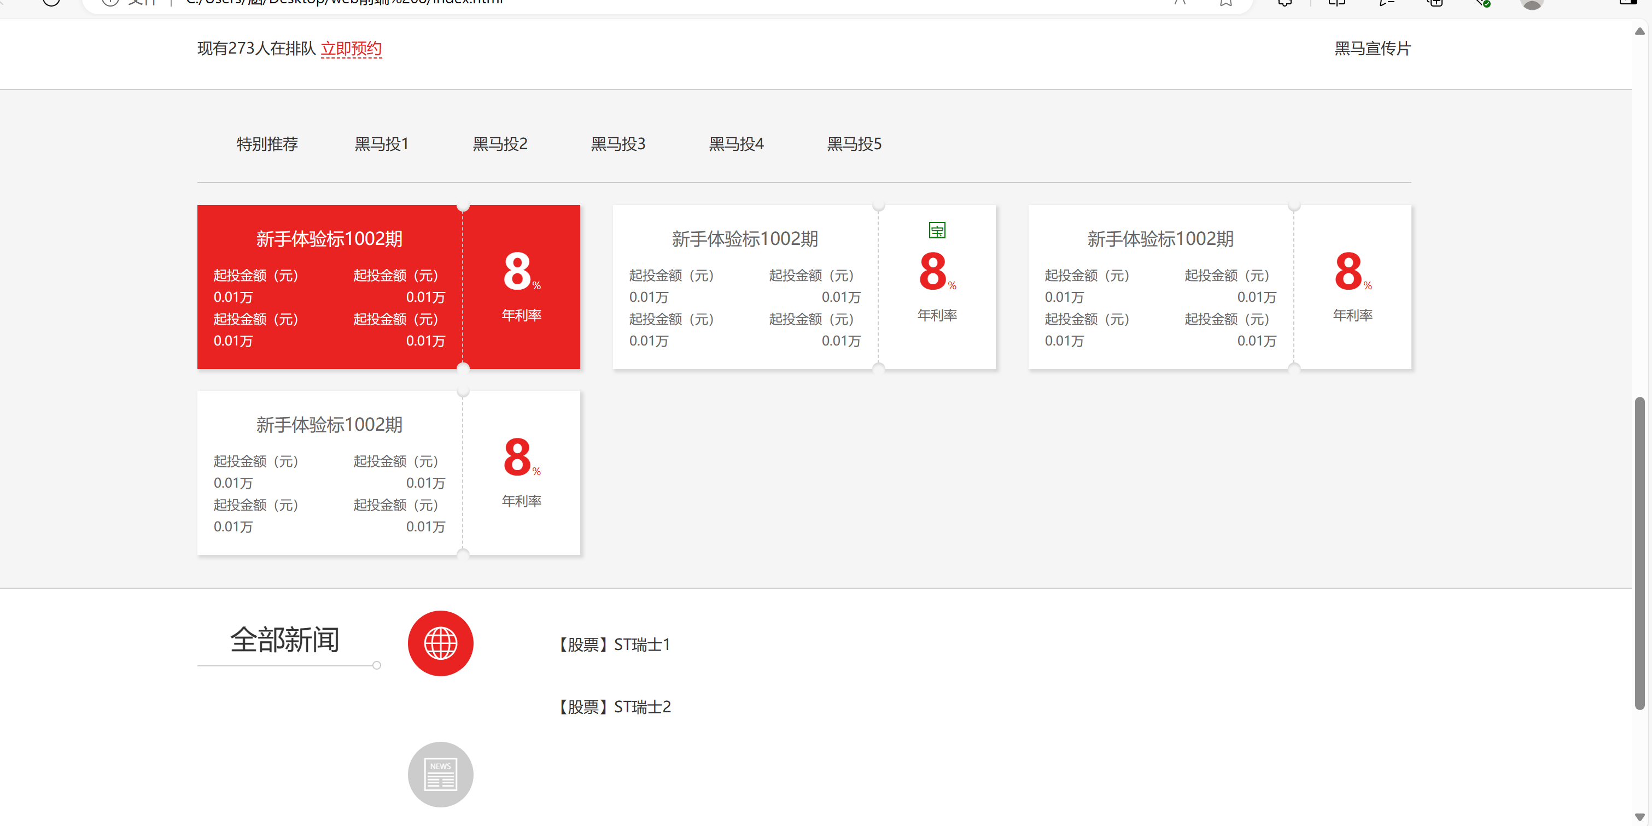



/* 顶部通栏 */

.heima_topBar {

border: 1px solid #ccc;

font-size: 12px;

color: #666;

position: relative;

z-index: 1001;

}

.heima_topBar a {

color: #666;

}

.heima_topBar a:hover {

color: #666;

}

.heima_topBar>.container>.row>div {

height: 40px;

line-height: 40px;

text-align: center;

}

.heima_topBar>.container>.row>div+div {

border-left: 1px solid #ccc;

}

.heima_topBar .heima_btn_register {

color: #fff;

padding: 3px 15px;

}

.heima_topBar .heima_btn_register:hover {

color: #fff;

}

.heima_topBar .heima_btn_register:focus {

box-shadow: none;

}

.heima_topBar .heima_icon_phone {

font-size: 1rem;

}

.heima_app {

position: relative;

display: block;

}

.heima_app img {

display: none;

}

.heima_app:hover img {

display: block;

position: absolute;

top: 40px;

left: 50%;

border: 1px solid #ccc;

border-top: none;

margin-left: -60px;

}

/* 导航栏 */

.heima_nav {

border-bottom: 1px solid #ccc;

}

.heima_nav .navbar-brand {

height: 60px;

}

.heima_nav .navbar-nav>.nav-item>a {

color: #777;

height: 60px;

line-height: 40px;

}

.heima_nav .navbar-nav>.nav-item>a:hover,

.heima_nav .navbar-nav>.nav-item>a:focus {

color: #333;

border-bottom: 3px solid #E92322;

}

/* 轮播图 */

.heima_banner picture img {

height: 410px;

width: 100%;

object-fit: cover;

}

@media (max-width:767px) {

.heima_banner picture img {

object-fit: fill;

width: 100%;

height: auto;

}

}

/* 产品信息 */

.heima_info {

padding-top: 30px;

border-bottom: 1px solid #ccc;

}

.heima_info a {

text-decoration: none;

}

.heima_info .heima_icon {

font-size: 30px;

}

.heima_info .col-md-4 {

padding: 10px;

}

.heima_info a:hover {

color: #E92322;

}

.heima_info h4, .heima_info .h4 {

font-size: 18px;

}

/* 预约交易 */

.heima_book {

padding: 25px 50px;

border-bottom: 1px solid #ccc;

}

.heima_book>.container {

overflow: hidden;

}

.heima_book .heima_icon {

font-size: 24px;

}

.heima_book a {

text-decoration: none;

}

.heima_book a:hover {

color: #E92322;

}

.heima_book .book_link {

color: #E92322;

border-bottom: 1px dashed #E92322;

}

/* 产品 */

.heima_product {

background: #f5f5f5;

border-bottom: 1px solid #ccc;

padding: 30px 0;

}

.heima_product .product-tabs {

border-bottom: 1px solid #ccc;

flex-wrap: nowrap;

overflow-x: auto;

}

.product-tabs>li {

padding-left: 20px;

flex: 0 0 108px;

}

.product-tabs>li>a {

padding-bottom: 25px;

}

.product-tabs>li>a:hover,

.product-tabs>li>a.active {

color: #555;

border-bottom: 3px solid #E92322;

}

/* 产品-产品盒子 */

.product_box {

height: 150px;

background: #fff;

box-shadow: 2px 2px 3px 1px #d8d8d8;

margin-top: 20px;

font-size: 12px;

color: #666;

}

.product_box p {

margin-bottom: 2px;

}

.product_box.active {

background: #E92322;

position: relative;

}

.product_box.active::before {

position: absolute;

top: -7px;

left: 0;

color: #fff;

font-size: 33px;

}

.product_box.active .product_box_left {

color: #fff;

}

.product_box .product_box_left h3 {

font-size: 16px;

padding: 20px 0 5px;

margin: 0;

}

.product_box .product_box_left>div {

margin-top: 10px;

}

.product_box .product_box_right {

float: right;

width: 108px;

height: 100%;

text-align: center;

position: relative;

border-left: 1px dashed #ccc;

}

.product_box .product_box_right::before,

.product_box .product_box_right::after {

content: "";

position: absolute;

left: -6px;

width: 12px;

height: 12px;

border-radius: 6px;

background: #f5f5f5;

}

.product_box .product_box_right::before {

top: -6px;

box-shadow: 0 -2px 2px #d8d8d8 inset;

}

.product_box .product_box_right::after {

bottom: -6px;

box-shadow: 0 2px 2px #d8d8d8 inset;

}

.product_box.active .product_box_right p {

color: #fff;

}

.product_box_right p:first-of-type {

margin-bottom: 0;

margin-top: 25px;

color: #E92322;

}

.product_box_right p:first-of-type b {

font-size: 44px;

}

.product_box_right p:first-of-type sub {

bottom: 0;

}

.product_tips {

position: absolute;

top: 15px;

left: 0;

text-align: center;

width: 100%;

}

.product_tips>span {

height: 15px;

width: 15px;

text-align: center;

line-height: 15px;

display: inline-block;

}

.product_tips .bao {

color: green;

border: 1px solid green;

}

.product_tips .bei {

color: red;

border: 1px solid red;

}

/* 新闻 */

.heima_news {

padding: 20px;

}

.heima_news .heima_newsTitle {

line-height: 50px;

font-size: 25px;

border-bottom: 1px solid #ccc;

text-align: center;

position: relative;

}

.heima_news .heima_newsTitle::after {

content: "";

width: 8px;

height: 8px;

border-radius: 4px;

border: 1px solid #ccc;

position: absolute;

bottom: -4px;

right: -8px;

}

.heima_news .heima_newsLine {

width: 1px;

height: 100%;

position: absolute;

border-left: 1px dashed #e92322;

left: 47px;

top: 0;

}

@media screen and (max-width: 1199px) {

.heima_news .heima_newsLine {

left: 40px;

}

}

.heima_news .nav-tabs {

border-bottom: none;

position: relative;

justify-content: center;

}

.heima_news .nav-tabs>li {

margin-bottom: 60px;

}

.heima_news .nav-tabs>li:last-of-type {

margin-bottom: 0px;

}

@media screen and (min-width: 768px) and (max-width: 991px) {

.heima_news .nav-tabs>li {

margin: 20px 30px;

}

}

@media screen and (max-width: 768px) {

.heima_news .nav-tabs>li {

margin: 20px 0px;

width: 25%;

}

}

.heima_news .nav-tabs>li>a {

background-color: #ccc;

width: 60px;

height: 60px;

border-radius: 50%;

text-decoration: none;

}

.heima_news .nav-tabs>li>a:hover,

.heima_news .nav-tabs>li>a.active {

background-color: #e92322;

}

.heima_news .heima_newsIcons a {

display: block;

font-size: 30px;

color: #fff;

text-align: center;

line-height: 60px;

}

.heima_news .heima_newslist {

list-style: none;

padding-top: 20px;

margin-bottom: 0;

}

.heima_news .heima_newslist>li {

height: 57px;

}

.heima_news .heima_newslist>li>a:hover {

color: #e92322;

text-decoration: none;

}

@media screen and (max-width: 768px) {

.heima_newsIcons a {

margin: 0 auto;

}

}

@media screen and (max-width: 575px) {

.heima_newslist {

padding-left: 0;

}

}

/* 合作伙伴 */

.heima_partner {

background-color: #eee;

padding: 20px;

text-align: center;

}

.heima_partner ul {

list-style: none;

display: inline-block;

padding-left: 0;

}

.heima_partner ul > li {

float: left;

margin: 0 10px;

}

.heima_partner ul > li > a {

color: #333;

text-decoration: none;

}

.heima_partner .heima_icon {

font-size: 80px;

}