Quarterly Sales Report
Contoso Ltd · Third quarter 2026

Summary
Revenue reached 1.84 million euros in the third quarter, 12% more than in the second. Growth came mostly from the Nordic region, where two new distributors started selling in July. Operating costs stayed within budget.

Sales by region
Region | Q2 2026 | Q3 2026 | Change
Nordics | 380,000 | 512,000 | +35%
Central Europe | 610,000 | 648,000 | +6%
Southern Europe | 420,000 | 433,000 | +3%
United Kingdom | 232,000 | 247,000 | +6%
Total | 1,642,000 | 1,840,000 | +12%

Revenue by month
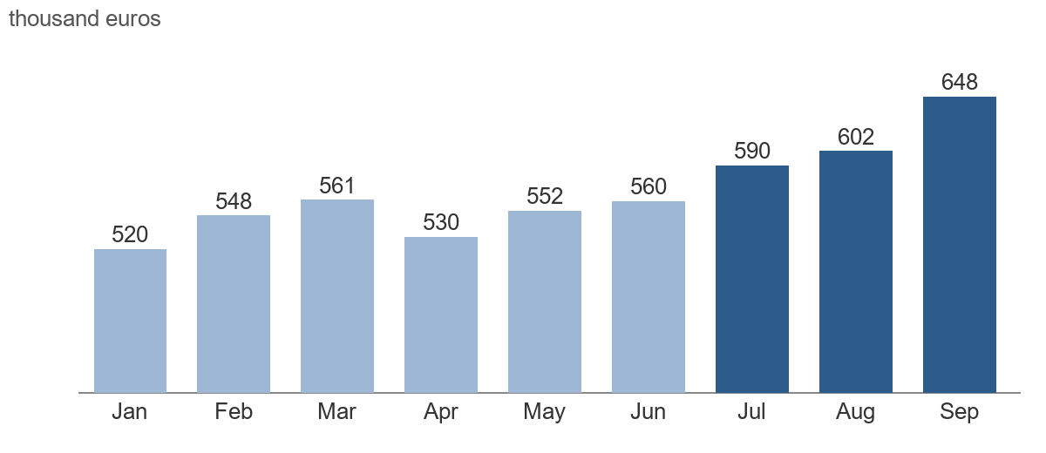
Monthly revenue, January to September 2026. The third quarter is in dark blue.

Outlook
- Open a sales office in Stockholm in November.
- Ship the new pricing for Central Europe on 1 January.
- Keep the fourth-quarter operating costs within the approved budget.

