Assignment 09: Data Scraping

Xuening Tang

## OVERVIEW

This exercise accompanies the lessons in Environmental Data Analytics on data scraping.

## Directions

1. Rename this file <FirstLast>_A09_DataScraping.Rmd (replacing <FirstLast> with your first and last name).
2. Change “Student Name” on line 3 (above) with your name.
3. Work through the steps, **creating code and output** that fulfill each instruction.
4. Be sure to **answer the questions** in this assignment document.
5. When you have completed the assignment, **Knit** the text and code into a single PDF file.

## Set up

1. Set up your session:

* Check your working directory
* Load the packages tidyverse, rvest, and any others you end up using.
* Set your ggplot theme

#1  
getwd()

## [1] "/Users/xueningtang/Desktop/R lab/EDA-Fall2022/Assignments"

library(tidyverse)

## Warning: package 'tidyverse' was built under R version 4.1.2

## Warning: package 'tibble' was built under R version 4.1.2

## Warning: package 'tidyr' was built under R version 4.1.2

## Warning: package 'readr' was built under R version 4.1.2

## Warning: package 'dplyr' was built under R version 4.1.2

library(rvest)

## Warning: package 'rvest' was built under R version 4.1.2

library(lubridate)  
  
my.theme <- theme_classic(base_size = 12) +  
 theme(axis.text = element_text(color = "black"),   
 legend.position = "top")  
theme_set(my.theme)

1. We will be scraping data from the NC DEQs Local Water Supply Planning website, specifically the Durham’s 2021 Municipal Local Water Supply Plan (LWSP):

* Navigate to <https://www.ncwater.org/WUDC/app/LWSP/search.php>
* Scroll down and select the LWSP link next to Durham Municipality.
* Note the web address: <https://www.ncwater.org/WUDC/app/LWSP/report.php?pwsid=03-32-010&year=2021>

Indicate this website as the as the URL to be scraped. (In other words, read the contents into an rvest webpage object.)

#2  
webpage.1 <- read_html('https://www.ncwater.org/WUDC/app/LWSP/report.php?pwsid=03-32-010&year=2021')  
webpage.1

## {html_document}  
## <html xmlns="http://www.w3.org/1999/xhtml" lang="en" xml:lang="en">  
## [1] <head>\n<title>DWR :: Local Water Supply Planning</title>\n<meta http-equ ...  
## [2] <body id="plan">\r\n<!--<div id="division-header">\r\n<a name="top" href= ...

1. The data we want to collect are listed below:

* From the “1. System Information” section:
* Water system name
* PSWID
* Ownership
* From the “3. Water Supply Sources” section:
* Maximum Daily Use (MGD) - for each month

In the code chunk below scrape these values, assigning them to four separate variables.

HINT: The first value should be “Durham”, the second “03-32-010”, the third “Municipality”, and the last should be a vector of 12 numeric values (represented as strings), with the first value being “27.6400”.

#3  
water.system.name <- webpage.1 %>%   
 html_nodes("div+ table tr:nth-child(1) td:nth-child(2)") %>%   
 html_text()  
   
pswid <- webpage.1 %>%   
 html_nodes("td tr:nth-child(1) td:nth-child(5)") %>%   
 html_text()  
   
ownership <- webpage.1 %>%   
 html_nodes("div+ table tr:nth-child(2) td:nth-child(4)") %>%   
 html_text()  
   
max.withdrawals.mgd <- webpage.1 %>%   
 html_nodes("th~ td+ td") %>%   
 html_text()

1. Convert your scraped data into a dataframe. This dataframe should have a column for each of the 4 variables scraped and a row for the month corresponding to the withdrawal data. Also add a Date column that includes your month and year in data format. (Feel free to add a Year column too, if you wish.)

TIP: Use rep() to repeat a value when creating a dataframe.

NOTE: It’s likely you won’t be able to scrape the monthly widthrawal data in chronological order. You can overcome this by creating a month column manually assigning values in the order the data are scraped: “Jan”, “May”, “Sept”, “Feb”, etc…

1. Create a line plot of the maximum daily withdrawals across the months for 2021

#4  
Max_withdraws_mgd <- data.frame(max.withdrawals.mgd)  
Max_final <- Max_withdraws_mgd[c(1,4,7,10,2,5,8,11,3,6,9,12),]  
  
df_water <- data.frame("max.withdrawals.mgd" = Max_final,  
 "Month" = rep(1:12),  
 "Year" = rep(2021,12))%>%  
 mutate(Water_System_Name = !!water.system.name,  
 PSWID = !!pswid,  
 Ownership = !!ownership,  
 Date = my(paste(Month,"-",Year)))  
  
  
  
#5  
  
plot(df_water$max.withdrawals.mgd,type = "o", col = "light blue", xlab = "Month", ylab = "Max_ withdraws of water/mgd")

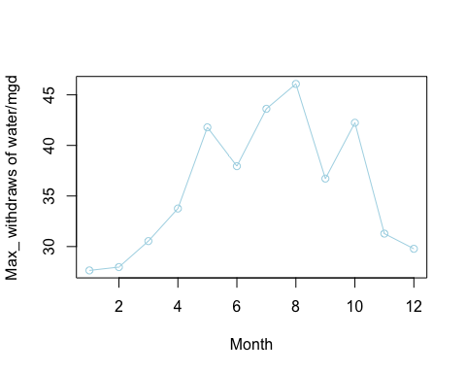

1. Note that the PWSID and the year appear in the web address for the page we scraped. Construct a function using your code above that can scrape data for any PWSID and year for which the NC DEQ has data. **Be sure to modify the code to reflect the year and site (pwsid) scraped**.

#6.  
base_url <- 'https://www.ncwater.org/WUDC/app/LWSP/report.php'  
my_PWSID <- 'pwsid=03-43-015'  
my_Year <- 'year=2017'  
my_scrape_url <- paste0(base_url, '?', my_PWSID, '&', my_Year)  
print(my_scrape_url)

## [1] "https://www.ncwater.org/WUDC/app/LWSP/report.php?pwsid=03-43-015&year=2017"

my_website <- read_html(my_scrape_url)  
my_system_name_tag <- 'div+ table tr:nth-child(1) td:nth-child(2)'  
my_pwsid_tag <- 'td tr:nth-child(1) td:nth-child(5)'  
my_ownership_tag <- 'div+ table tr:nth-child(2) td:nth-child(4)'  
my_max_withdraw_tag <- 'th~ td+ td'  
  
my_system_name <- my_website %>% html_nodes(my_system_name_tag) %>% html_text()  
my_pwsid_name <- my_website %>% html_nodes(my_pwsid_tag) %>%html_text()  
my_ownership <- my_website %>% html_nodes(my_ownership_tag) %>% html_text()  
my_max_withdrawals <- my_website %>% html_nodes(my_max_withdraw_tag)%>%html_text()  
  
  
my_scrape <- function(my_PWSID,my_Year){  
 my_website <- read_html(paste0('https://www.ncwater.org/WUDC/app/LWSP/report.php'  
 , '?pwsid=', my_PWSID, '&year=', my_Year))  
  
 my_system_name_tag <- 'div+ table tr:nth-child(1) td:nth-child(2)'  
 my_pwsid_tag <- 'td tr:nth-child(1) td:nth-child(5)'  
 my_ownership_tag <- 'div+ table tr:nth-child(2) td:nth-child(4)'  
 my_max_withdraw_tag <- 'th~ td+ td'  
   
 my_system_name <- my_website %>% html_nodes(my_system_name_tag) %>% html_text()  
 my_pwsid_name <- my_website %>% html_nodes(my_pwsid_tag) %>%html_text()  
 my_ownership <- my_website %>% html_nodes(my_ownership_tag) %>% html_text()  
 my_max_withdrawals <- my_website %>% html_nodes(my_max_withdraw_tag)%>%html_text()  
   
 df_water <- data.frame("max.withdrawals.mgd" = as.numeric(my_max_withdrawals),  
 "Year" = rep(my_Year,12))%>%  
 mutate(Water_System_Name = !!my_system_name,  
 PWSID = !!my_pwsid_name,  
 Ownership = !!my_ownership)  
   
return(df_water)  
}

1. Use the function above to extract and plot max daily withdrawals for Durham (PWSID=‘03-32-010’) for each month in 2015

#7  
durh_df <- my_scrape('03-32-010','2015')  
view(durh_df)  
  
df_durh <- durh_df %>%   
 mutate(Month = c(1,5,8,2,6,9,3,7,10,4,8,12),  
 Date = my(paste(Month,"-",Year)))  
durh_final <- df_durh[c(1,4,7,10,2,5,8,11,3,6,9,12),]  
  
ggplot(df_durh,aes(x=Date,y=max.withdrawals.mgd)) +   
 geom_line(color="pink")

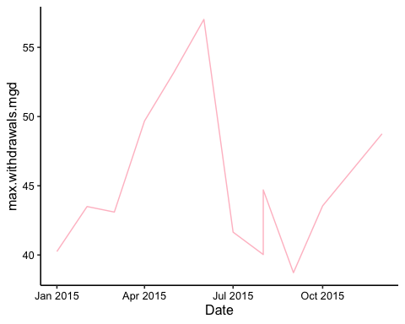

1. Use the function above to extract data for Asheville (PWSID = 01-11-010) in 2015. Combine this data with the Durham data collected above and create a plot that compares Asheville’s to Durham’s water withdrawals.

#8  
df_ashe <- my_scrape('01-11-010','2015')  
view(df_ashe)  
ashe_df <- df_ashe %>%   
 mutate(Month = c(1,5,8,2,6,9,3,7,10,4,8,12),  
 Date = my(paste(Month,"-",Year)))  
ashe_final <- ashe_df[c(1,4,7,10,2,5,8,11,3,6,9,12),]  
  
df_combine <- full_join(ashe_final,durh_final)

## Joining, by = c("max.withdrawals.mgd", "Year", "Water_System_Name", "PWSID",  
## "Ownership", "Month", "Date")

water.plot<-  
 ggplot(df_combine,aes(x=Date,y=max.withdrawals.mgd, color=Water_System_Name)) +   
 geom_line()+  
 ylab("Maximum daily withdraw of water/MGD")+  
 my.theme  
print(water.plot)

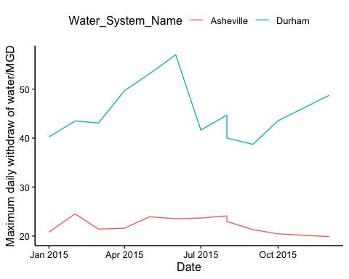

1. Use the code & function you created above to plot Asheville’s max daily withdrawal by months for the years 2010 thru 2019.Add a smoothed line to the plot.

TIP: See Section 3.2 in the “09_Data_Scraping.Rmd” where we apply “map2()” to iteratively run a function over two inputs. Pipe the output of the map2() function to bindrows() to combine the dataframes into a single one.

#9  
my_years = rep(2010:2019)  
the_pwsid = '01-11-010'

Question: Just by looking at the plot (i.e. not running statistics), does Asheville have a trend in water usage over time?