

CENTENNIAL COLLEGE PROGRESS CAMPUS

COURSE COMP125

Assignment 3

Implement a simple Bug Smasher browser-based (HTML5 canvas) game similar to the snapshot below:

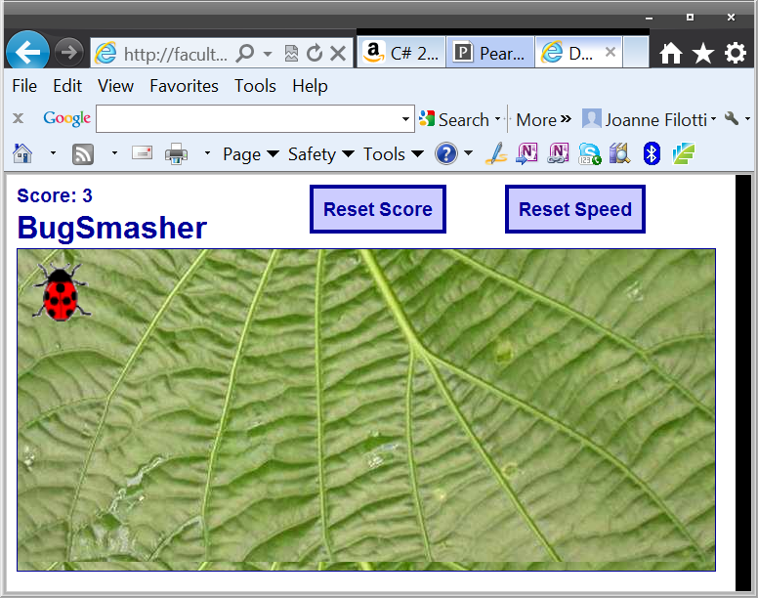

**Features:**

The bug hops randomly around the game area at a given interval. The player tries to catch the bug by clicking on it. If he succeeds, the score is incremented and the hopping interval is decremented by a number of milliseconds, so it gets harder to catch the bug.

If the game becomes too challenging, the payer can reset the speed to the initial hopping interval by clicking the Reset Speed button.

If the player wants, he can start again by resetting the score by clicking the Reset Score button.

**Guidelines:**

Your GUI does not need to be laid out exactly as the above screenshot, you can use graphics of your own and a different page layout as long as the core functionality of the game is preserved.

Use as guidelines the game described at:

[**http://www.lostdecadegames.com/how-to-make-a-simple-html5-canvas-game/**](http://www.lostdecadegames.com/how-to-make-a-simple-html5-canvas-game/)

Submit your assignment to Assignment 3 drop box.

**Rebrics**

|  |  |
| --- | --- |
| 10 | File name is: assignment5.html, The file names are expected to be assignment5.html and js. |
| 10 | The bug is hopping randomly. |
| 12 | The user is able to click on the bug and the scores increase on click. |
| 12 | The bug is hopping faster and faster. |
| 12 | The payer can reset the speed to the initial hopping interval by clicking the Reset Speed button. |
| 12 | The player can start again by resetting the score by clicking the Reset Score button. |
| 12 | The name is found on the variables. |
| 10 | Page has not HTML errors. |
| 10 | Page has not JS errors. |
| 100 |  |