**MAIN PAGE**

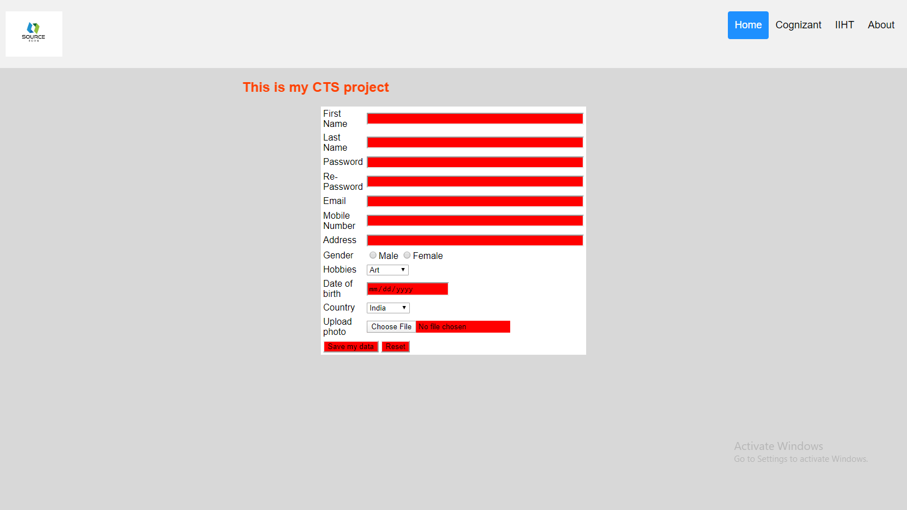

**Home Tab**



**Cognizant Tab**



**IIHT Tab**



**About Tab**



**Filled Registration Form**

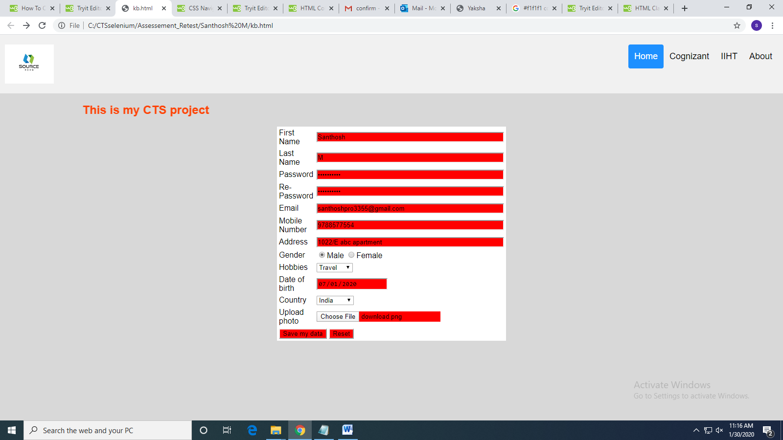

**Source Code**

<html>

<head>

<style>

input[type=text], input[type=password] ,input[type=textarea],

{

Color : red;

}

input

{

background-color:#FF0000;

}

* {box-sizing: border-box;}

body {

margin: 0;

font-family: Arial, Helvetica, sans-serif;

}

.header {

overflow: hidden;

background-color: #f1f1f1;

padding: 20px 10px;

}

.header a {

float: left;

color: black;

text-align: center;

padding: 12px;

text-decoration: none;

font-size: 18px;

line-height: 25px;

border-radius: 4px;

}

.header a.logo {

font-size: 25px;

font-weight: bold;

}

.header a:hover {

background-color: #ddd;

color: black;

}

.header a.active {

background-color: dodgerblue;

color: white;

}

.header-right {

float: right;

}

@media screen and (max-width: 500px) {

.header a {

float: none;

display: block;

text-align: left;

}

.header-right {

float: none;

}

}

</style>

</head>

<body style="background-color:#D8D8D8">

<div class="header">

<img src="download.png" width="100" height="80" class="logo">

<div class="header-right">

<a class="active" href="kb.html">Home</a>

<a href="https://www.cognizant.com/">Cognizant</a>

<a href="https://www.iiht.com/">IIHT</a>

<a href="https://www.guru99.com/software-testing-introduction-importance.html">About</a>

</div>

</div>

<h2 style="color:#ff4000"><marquee direction="right">This is my CTS project</marquee></h2>

<table cellpadding="2" width="20%" bgcolor="#FFFFFF" align="center"

cellspacing="2">

<tr>

<td>First Name</td>

<td><input type="text" id="textname" size="50"></td>

</tr>

<tr>

<td>Last Name</td>

<td><input type=text name=textnames id="textname" size="50"></td>

</tr>

<tr>

<td>Password</td>

<td><input type="password" name="password" id="pwd"size="50"></td>

</tr>

<tr>

<td>Re-Password</td>

<td><input type="password" name="password" id="pwd"size="50"></td>

</tr>

<tr>

<td>Email</td>

<td><input type="text" id="email" size="50"></td>

</tr>

<tr>

<td>Mobile Number</td>

<td><input type="text" id="phone" size="50"></td>

</tr>

<tr>

<td>Address</td>

<td><input type="text" id="address" size="50"></td>

</tr>

<tr>

<td>Gender</td>

<td>

<input type="radio" value="male" size="30">Male

<input type="radio" value="Female" size="30">Female

</td>

</tr>

<tr>

<td>Hobbies</td>

<td><select name="Hobbies" >

<option value="Art">Art</option>

<option value="Reading">Reading</option>

<option value="Riding">Riding</option>

<option value="Travel">Travel</option>

</select></td>

</tr>

<tr>

<td>Date of birth</td>

<td><input type="date"></td>

</td>

</tr>

<tr>

<td>Country</td>

<td><select name="Country">

<option value="India">India</option>

<option value="Pakistan">Pakistan</option>

<option value="America">America</option>

<option value="Africa">Africa</option>

</select></td>

</tr>

<tr>

<td>Upload photo</td>

<td><input type="file" name="pic" accept="image/*"></td>

</tr>

<tr>

<td colspan="2"><input type="submit" value="Save my data"/>

<input type="reset"></td>

</tr>

</table>

</form>

</body>

</html>