**RestaurantFinder**

**Makes Easy Restaurant Reservations**

Requirements Specification and Analysis

26.06.2016

H. Selen Kozanoğlu – 210CS2022

Aslı Tuba Metin – 210CS2023

Arda Yazkan – 210SE2213

Emine Yıldız- 212CS2176

Prepared for

SE301 Software Engineering



Table of Contents

1.Introduction 3

1.1 Purpose of the System 3

1.2 Scope of the System 3

1.3 Objectives and Success Criteria of the Project 3

1.4 Definitions, Acronyms and Abbreviations 4

1.5 Overwiew 4

2.Current System 5

3. Proposed System 6

3.1. Overview 6

3.2. Functional Requirements 6

3.3. Nonfunctional Requirements 7

3.4. System Models 8

3.4.1. Scenarios 8

Object Model 21

Dynamic Model 22

Dynamic Model 23

4.Glossary 28

5.References 29

REQUIREMENTS ANALYSIS DOCUMENT

# 1.Introduction

## 1.1 Purpose of the System

The main purpose of this system is to create a web site for the restaurants which they are representing for the user who they can make a reservation. It helps users to easily find restaurants and take a look at informations about restaurant. And also users can keep their past reservations on the system.

## 1.2 Scope of the System

RestaurantFinder is a web site designed for people who wants to make a easily reservation for their favorite restaurants and also they can try and discover new restaurants. Our users will be able to view and read restaurants such as their telephones, photos, addresses and descriptions. Also users can be search restaurants using by categories and find restaurants using cities.

## 1.3 Objectives and Success Criteria of the Project

Below are the few objectives of the system;

* Manage restaurants by categories and by cities.
* A search function on the web site by a restaurant name or a city name.
* Let users make reservation to restaurants and save them.
* Users using login to access their past reservations.

Success criteria of RestaurantFinder is a web site where users can search restaurants to make a reservation which is very effectively. Users might be use this web site fluently.

## 1.4 Definitions, Acronyms and Abbreviations

RAD: Requirements Anaysis Document

## 1.5 Overwiew

Rest of the RAD will contain information about the aim of the web site. Followed by the functional and nonfunctional requirements, the web site models and some examples of the user interface can be set.

Sections of the RAD are described:

* **Proposed System**

Main functions and features about web site is described. Both functional and nonfunctional features are explained.

* **Overview**

Web site's information and functions are described.

* **Functional Requirements**

What our users doing on the web site and what they don't.

* **Nonfunctional Requirements**

Parts of our web site which are Usability, Reliability and Performance.

* **System Models**

This part about scenarious and use cases to make a ideas of web site which name is RestaurantFinder.

* **Object Model**

This part about class diagram of the web site which is the relations of the classes.

* **Dynamic Model**

This part about sequence and state diagrams to show rlations in the web site and how the system launch in which order.

* Glossary

This part about uncertain, ambiguous and undefined words which includes in the web site.

# 2.Current System

In the Internet there are a lot of restaurant reservation systems. The purpose of doing new one is to make a better web site from anothers. After researching other websites, The project team which name is RestauranTeam make a decision. In our websites we can ignore adds which is help user to discover our website in effectively. Because of the adds, the users tap wrong spaces and they do not happy for that. And also the other websites use lots of buttons which they can confused the users. Some websites have not used google maps, so when the user make a reservation to the restaurant, he/she cannot find the restaurant easily. It has not got location service on their websites. On the other hand, design also is the most important part of the web sites. When the web design is very original and professional, then users can use the web site happily and also they can trust all restaurant because of the best vision of the web design.

# 3. Proposed System

RestaurantFinder provides find a restaurant which users want to and make a reservation for it. Users can search new restaurants and take information about them. Also, after register, they can login the system and look their past reservations. In addition restaurants owners can send a form to admin for adding their restaurants into the system and after admin’s confirmation, new restaurants can be added into the system. Also, restaurant owners can edit their restaurants page and information.

## 3.1. Overview

RestaurantFinder allows users easily find a restaurant and make reservation for it. However, users must register and login the system to make reservation. After login the system, they can make reservation and cancel or edit their reservation. Also, there is users profile and they can enter their profile page and look past reservations. Further more, users can search a restaurant by category or city and access its telephones, photos, addresses and descriptions without logging the system. In addition, restaurant owners can arrange their restaurant page.

## 3.2. Functional Requirements

**Register:** To login the system, users must register the system. Users can access our website register form. They complete the form and they register the system.

**Login:** The system does not allow entering without login. To make reservation, users must log in, after that they can be redirected home page. Database has users’ information which is password and username. System should be able to check at each login process user’s username and password from database, so one user has to have one unique

username and password.

**Change password:** All user kind; users, restautantOwner and admin can change password. They login and enter profile page. They click change password and firtly they fill old password after they fill new password.

**List restaurants:** All users can list all restaurants without login. In home page, there is search field by city as well as by category. Users can search restaurant and look its telephones, photos, addresses and descriptions.

**Make reservation:** After users login, they can make reservation. They select a restaurant and enter reservation date, number of people, table option and description. Thus, they make a reservation and the system send mail which contain reservation information to users .

**Cancel reservation:** There is user reservations page. This page list past and future reservation. Cancel button locates next to all future reservation and if users want to cancel reservation, they click this button and reservation is deleted from the system.

**Edit reservation:** If users want to change reservation ınformation, they can edit reservation their reservations page. Edit button locates next to all future reservation. By click this button, users arrange reservation information.

**Request registerForm:** Restaurant owner fill the register form to request to admin for add their restaurant into the system. They click the “join us” in home page and fill the form.

**Approval-Reject restaurant:** There ara request form in request page for admin. Admin enter this page and he/she can approval or reject button. If he/she approvals request, restaurant is added the systam. If he/she rejects request, restaurant can’t be added the sytem.

**Edit RestaurantProfile:** Restaurant owners can arrange their restautant information. After they login the system and enter restaurants page, if they click edit, they change or add information or they arrange restaurant page.

## 3.3. Nonfunctional Requirements

There is some kind of user who are admin, restaurantOwner and user in the

system. Admin has permission for add new restaurant. RestaurantOwners can edit their restaurants page and information. Lastly, users can login the system and make reservation.

***Usability***

The functionality of the system sufficiently maps to general user-requirements. Usability also refers to how well the user interface is considered easy to use. Our system is simple and easy to use. To make reservation are not complicated for users.

***Reliability***

The system should not be allowed entry without input username and password for the site. User’s and restaurant’s information is kept in database system. Also admin has permission for restaurants. Admin can delete or add restaurants.The protection against unauthorized use password protection.

***Supportability***

Admin creates new restaurant, restaurant owner arranges their restaurant page and users make reservation and look past reservation. However, such additions may require the system. New modules can added to the system or some operations can be shut down.

***Performance***

Performance requirements are concerned with quantifiable attributes of the system. Response time for our system should be very low. The system have more than one admin for quick response.

***Implementation***

All users should be able to access their profile page after login the system. Admins functions used by the user are not available through the web.

***Legal***

Users can access after register the system.

## System Models

* + 1. **Scenarios**

**Scenario 1:**

|  |
| --- |
| *Scenario name:* Login |
| *Participant actor instances:* Sam:User |
| *Flow of events:*   1. Sam has a date ,he want to look some restaurant in İstanbul to make a reservation 2. He writes www.restaurantfinder.com on browser 3. He has an account 4. He wrote his username and password in order to login to the site. |

**Scenario 2:**

|  |
| --- |
| *Scenario name:* Register |
| *Participant actor instances:* Sam:User |
| *Flow of events:*   1. Sam’s best friend has a birthday 2. He decided to make a surprise him ,he go in to the site named RestaurantFinder and find a restaurant that makes a good sushi which Sam’s best friends favorite food. 3. He choose that restaurant and want to make a reservation, but he has not have account 4. He register from main page by clicking sign in buton. 5. He writes all information which necessary to create an account (name, surname, phonenumber, e-mail , etc ) from register page 6. Now he has an account and he cake make a reservation. |

**Scenario 3:**

|  |
| --- |
| *Scenario name:* SelectRestaurant |
| *Participant actor instances:* Sam:User |
| *Flow of events:*   1. Sam login to the site named RestaurantFinder 2. He decides to make a reservation for his anniversary with his girlfriend 3. He selects the city İstanbul and clicks the category named world cuisine to look results 4. He see many restaurant as a result from them the chose La Mancha Restaurant and by clicking make reservation button , he makes reservation for two. |

**Scenario 4:**

|  |
| --- |
| *Scenario name:* MakeReservation |
| *Participant actor instances:* Sam , Taylor :User |
| *Flow of events:*   1. Sam login to the site named RestaurantFinder 2. He decides to make a reservation for his anniversary with his girlfriend 3. He selects the city İstanbul and clicks the category named world cuisine to look results 4. He see many restaurant as a result from them the chose La Mancha Restaurant and by clicking make reservation button , he makes reservation for two. |

**Scenario 5 :**

|  |
| --- |
| *Scenario name:* RequestRegisterForm |
| *Participant actor instances:* Ed: RestaurantOwner Dean:Admin |
| *Flow of events:*   1. Ed has a restaurant named GoMongo. 2. He wants to add his restaurant to the site named RestaurantFinder to get more customer and to known more. 3. He clicks Wanna Join Us? Button and go to into Restaurant Register form page. 4. He fills all spaces with his information. His first name , surname, adress, phone number, work history, and restaurant information. 5. He clicks OK button and send his form to the Dean. 6. Dean evaluates Ed’s restaurant information and approves it. 7. Ed has a restaurant owner status right now he can edit his restaurant profile from edit profile page. |

**Scenario 6:**

|  |
| --- |
| *Scenario name:* EditRestaurantProfile |
| *Participant actor instances:* Clark:Restaurant Owner |
| *Flow of events:*   1. Clark has a restaurant in [www.restaurantfinder.com](http://www.restaurantfinder.com) site.. 2. He changed his restaurant’s location to another address. 3. He also wants to change the restaurant adres from the system. 4. He logs in the system from main page by entering his username and password. 5. He enters Edit button from his profile 6. He updates the restaurant’s adres from restaurant’s page by writting new adres to the address to the adres area. |

**Scenario 7:**

|  |
| --- |
| *Scenario name:* RejectRequestRegisterForm |
| *Participant actor instances:* Clark:User , Tom:Admin |
| *Flow of events:*   1. Clark has a restaurant named EminEv Yemekleri 2. He is new food community. He wants to spurt. 3. He thinks that if his restaurant becomes a part of RestaurantFinder community he can grows up easily. 4. He writes [www.restaurantfinder.com](http://www.restaurantfinder.com) on the browser, and he clicks Wanna Join US? Button. 5. He fills all form with his information and clicks OK. 6. Tom takes Clark’s form and he view his form. 7. Tom thinks that EminEv Yemekleri is not good for make a reservation, because it is small restaurant and serves home cooking which is not in RestaurantFinder’s category. 8. Tom clicks reject button and sending mail to the Clark which explains this rejection. 9. Clark gets the mail and understands situation. He gives up this idea maybe he can try another time when he has big restaurant. |

**Scenario 8:**

|  |
| --- |
| *Scenario name:* CancelReservation |
| *Participant actor instances:* David:User |
| *Flow of events:*   1. David has a date in Valentine’s Day 2. He has a account in restaurantfinder 3. He select Istanbul city and lloks results. 4. He decides to make reservation in Suada Restaurant according to results by selecting the date 14.02.2017 and time is 19.00 5. Davis’s date Jukie appears urgent job and she calls david to the that she would’t come to the date. 6. David has to cancel reservation because the can not go date by himself 7. He login to system again and by clicking cancel reservation button he cancels reservation from his profile’s reservations page. |

**Scenario 9:**

|  |
| --- |
| *Scenario name:* EditUserProfile |
| *Participant actor instances:* Selene:User |
| *Flow of events:*   1. Selena has a account in [www.restaurantowner.com](http://www.restaurantowner.com) system. 2. Selena’s mobile phone number change to another telephone line. 3. She wants to updates her mobile phone number from the system. 4. She clicks edit profile button and changes her mobile phone number from the mobile phone number’s space. |

**Use Case Model**



**Use case 1:**

|  |
| --- |
| *Use case name:* Login |
| *Participating actors:* Initiated by The User |
| *Flow of events*:   1. USER enters the site name on the browser.    1. SYSTEM shows the main page which includes login, sign in, and restaurant searching area according to city that use choice. 2. USER selects the restaurant he/she would like to make reservation.    1. The SYSTEM requests that the user enter his/her name and password.    2. The User enters his/her name and password.    3. The System validates the entered name and password and logs the user into the system. |
| *Entry Condition*:USER enters login button. |
| *Exit Condition*:SYSTEM returns user’s page |

**Use case 2:**

|  |
| --- |
| *Use case name:* Register |
| *Participating actors:* Initiated by The User |
| *Flow of events*:   1. USER enters [www.restaurantfinder.com](http://www.restaurantfinder.com) onthe browser.    1. SYSTEM shows the main page which includes restaurant search area, login and sign in button. 2. USERenters the sign in button..    1. The SYSTEM displays register page. 3. USER enters his/her information to the register page.    1. The SYSTEM request that the user enter his/her hane, surname, e-mail address and password.    2. The USER enter his/her name, surname, e-mail, address and password.    3. The SYSTEM register the entered name, surname, e-mail address and password. |
| *Entry Condition*:USER enters sing in button. |
| *Exit Condition*:SYSTEM register the user information to the systemdatabase. |

**Use case 3:**

|  |
| --- |
| *Use case name:* ListRestaurant |
| *Participating actors:* Initiated by The User |
| *Flow of events*:   1. USER enters [www.restaurantfinder.com](http://www.restaurantfinder.com) onthe browser.    1. SYSTEM shows the main page which includes restaurant search area, login and sign in button. 2. USER enters which city button..    1. SYSTEM shows cities with select option. 3. USER enters his/her information to the register page.    1. SYSTEMreturns restaurants according to the city. |
| *Entry Condition*:User enters which city? button |
| *Exit Condition*:SYSTEM returns restaurants |

**Use case 4:**

|  |
| --- |
| *Use case name:* ChooseRestaurants |
| *Participating actors:* Initiated by The User |
| *Flow of events*:   1. USER enters [www.restaurantfinder.com](http://www.restaurantfinder.com) onthe browser.    1. The USER selects city that he/she wants to search.    2. SYSTEM returns restaurants. 2. USER select the restaurant which he/she wants according to result.    1. SYSTEM shows the restaurant’s page which includes some information about the restaurant. |
| *Entry Condition*:USER select city. |
| *Exit Condition*:SYSTEM returns selected restaurant page. |

**Use case 5:**

|  |
| --- |
| *Use case name:* MakeReservation |
| *Participating actors:* Initiated by The User |
| *Flow of events*:   1. USER enters [www.restaurantfinder.com](http://www.restaurantfinder.com) onthe browser.    1. SYSTEM shows the main page which includes restaurant search area, login and sign in button. 2. USER selects city and finds the restaurant that he/she wants to make reservation.    1. SYSTEM requests that the user enter his/her name and password.    2. USER enters his/her username and password.    3. SYSTEM request that the user enter number of persons and selects,date & time.    4. USER enter number of persons and selects date and time    5. SYSTEM confirms the reservation. |
| *Entry Condition*:User clicks make reservation from selected restaurant page and USER should be login first. |
| *Exit Condition*:SYSTEM confirms the reservation. |

**Use case 6:**

|  |
| --- |
| *Use case name:* CancelReservation |
| *Participating actors:* Initiated by The User |
| *Flow of events*:   1. USER enters reservations field from his/her profile    1. SYSTEM returns all reservations making by the USER. 2. USER selects current reservation and clicks cancel. |
| *Entry Condition*:User should be login first and USER clicks cancel button |
| *Exit Condition*:SYSTEM shows “ successfully cancelled” message to the USER |

**Use case 7:**

|  |
| --- |
| *Use case name:* EditProfile |
| *Participating actors:* Initiated by The User |
| *Flow of events*:   1. USER enters [www.restaurantfinder.com](http://www.restaurantfinder.com) onthe browser.    1. SYSTEM display mainpage. 2. USER click login button.    1. SYSTEM display login page which includes username and password.    2. USER enters his/her username and password.    3. SYSTEM display the user’s profile 3. USER clicks EditProfike button.    1. SYSTEM displays users’S information which are name surname, address, e-mail address, and phone number    2. USER makes some changes and clicks Save Changes button.    3. SYSTEM makes changes. |
| *Entry Condition*:USER login the system and USER clicks edit profile |
| *Exit Condition*:SYSTEM makes changes. |

**Use case 8:**

|  |
| --- |
| *Use case name:* EditRestaurantProfile |
| *Participating actors:* Initiated by The RestaurantOwner |
| *Flow of events*:   1. RESTAURANTOWNER login to the site by entering his/her username and password.    1. SYSTEM displays his/her restaurant page 2. RESTAURANTOWNER clicks Edit Restaurant Profile button.    1. SYSTEM shows the restaurant’s information page    2. RESTAURANTOWNER makes some changes about his/her restaurant information    3. SYSTEM saves changes. |
| *Entry Condition*:RESTAURANTOWNER loging the system and clicks edit restaurant profile |
| *Exit Condition*:SYSTEM makes changes. |

**Use case 9:**

|  |
| --- |
| *Use case name:* RequestRegisterForm |
| *Participating actors:* Initiated by The RestaurantOwner and Admin |
| *Flow of events*:   1. RESTAURANT OWNER wants to add his/her restaurant to the www.restaurantfinder.com    1. RESTAURANTOWNER clicks Wanna Join Us? Button from main page.    2. SYSTEM displays participation form and request that the RestaurantOwner enters participation form    3. RESTAURANTOWNER fills the form which includes owner name – surname, phone number, job , e-mail address, restaurant history , restaurant category and restaurant information.    4. RESTAURANTOWNER clicks send form 2. ADMIN takes the form    1. ADMIN views the form and she/he evaluates restaurant that it can be part of restaurantfinder.com    2. ADMIN gives response to the owner. |
| *Entry Condition*:RESTAURANTOWNER clicks Wanna Join US? button |
| *Exit Condition*:RESTAURANTOWNER sends the form |

**Use case 10:**

|  |
| --- |
| *Use case name:* ApproveRestaurant |
| *Participating actors:* Initiated by The Admin |
| *Flow of events*:   1. ADMIN log in the System    1. He/she looks coming request    2. He/She evaluates the form    3. He/She clicks approve at the end of the form |
| *Entry Condition*:Admin clicks APPROVE button. |
| *Exit Condition*:SYSTEM adds the restaurant to the restaurantfinder database |

**Use case 11:**

|  |
| --- |
| *Use case name:* RejectRestaurant |
| *Participating actors:* Initiated by The Admin |
| *Flow of events*:   1. ADMIN log in the System    1. He/she looks coming request    2. He/She evaluates the form    3. He/She clicks reject at the end of the form |
| *Entry Condition*:Admin clicks REJECT button. |
| *Exit Condition*:- |

**Use case 12:**

|  |
| --- |
| *Use case name:* AddRestaurant |
| *Participating actors:* Initiated by The Admin |
| *Flow of events*:   1. ADMIN log in the System. 2. ADMIN clicks Add Restaurant button    1. SYSTEM request that the admin creates restaurant’s profile    2. ADMIN enters restaurant information which are restaurant name, restaurant location, address, restaurant information and telephone number    3. ADMIN enters OK. |
| *Entry Condition*:Admin adds restaurant |
| *Exit Condition*:SYSTEM adds the restaurant to the restaurantfinder database |

**Use case 13:**

|  |
| --- |
| *Use case name:* AddCategory |
| *Participating actors:* Initiated by The Admin |
| *Flow of events*:   1. ADMIN selects add new category button from his/her profile. 2. SYSTEM adds new category in to the restaurantfinder database. |
| *Entry Condition*:Admin clicks add category |
| *Exit Condition*:SYSTEM adds category in to database. |

# Object Model

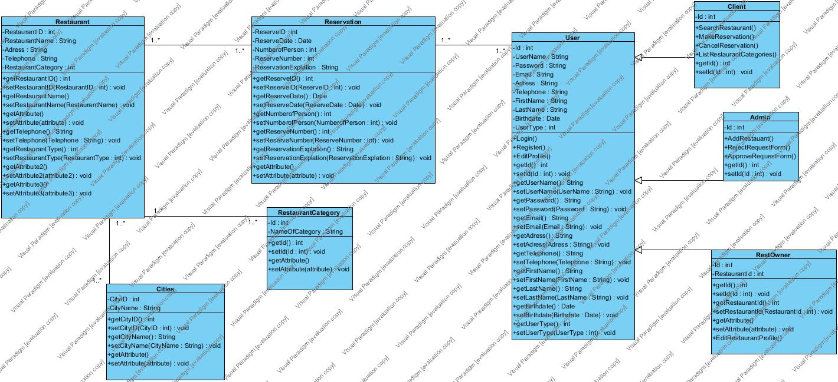

# Dynamic Model

MakeReservation

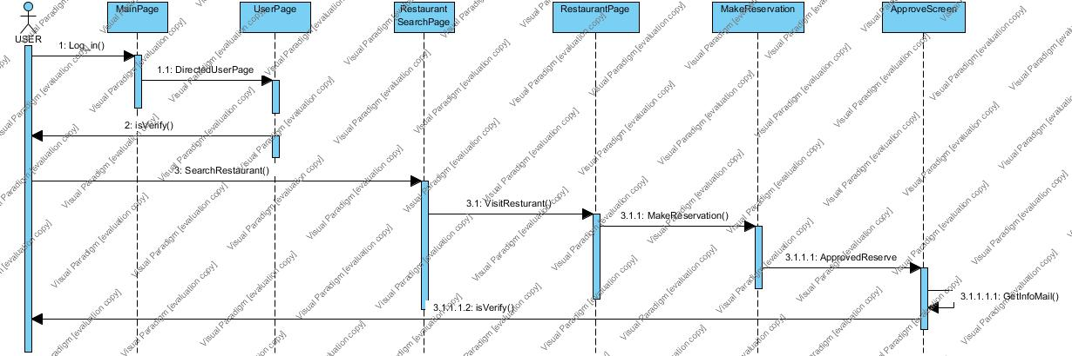

CancelReservation

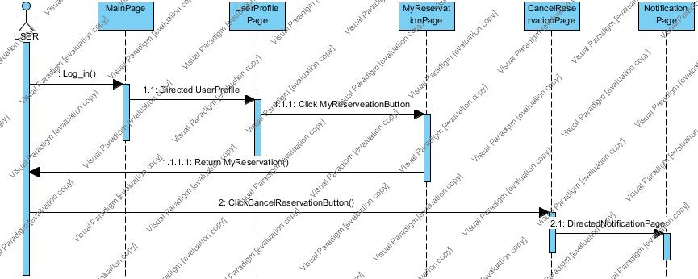

# Dynamic Model

EditRestaurantProfile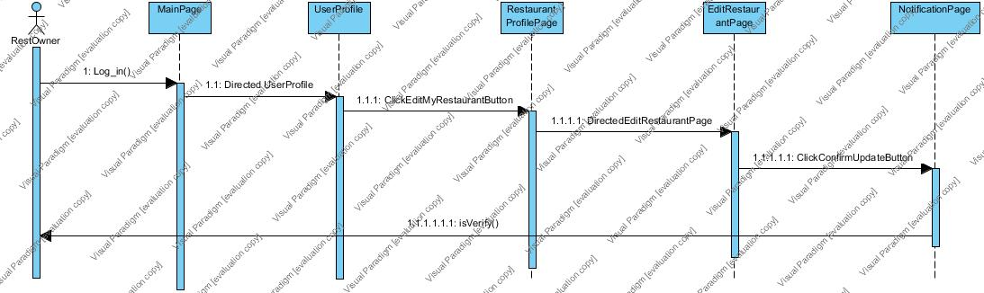

SendRequestForm

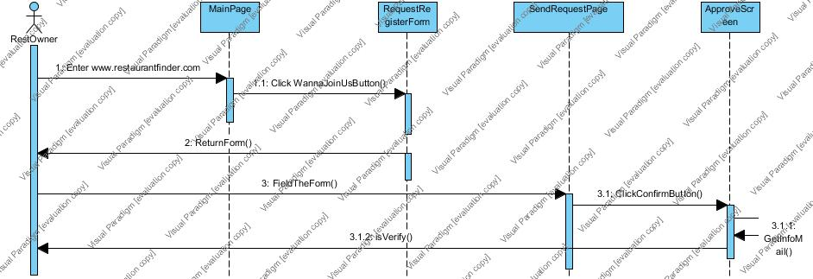

**Activity Diagram**

**USER**

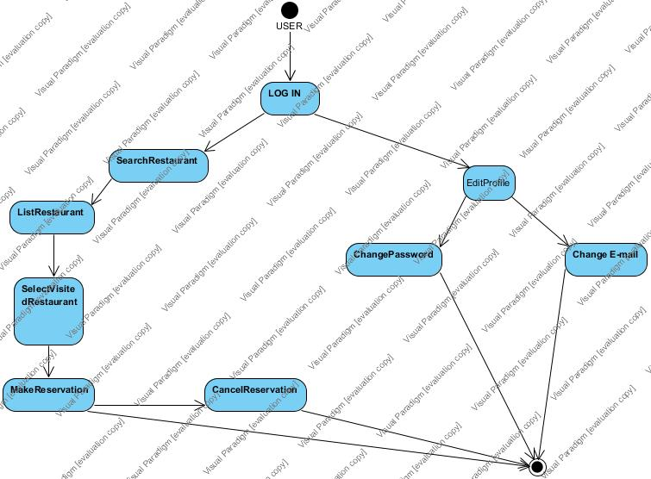

**RestOwner**

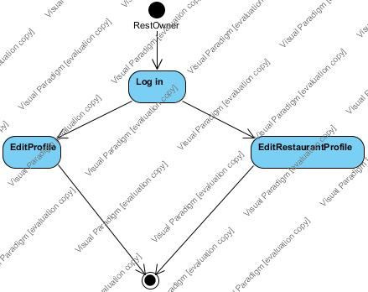

**ADMIN**

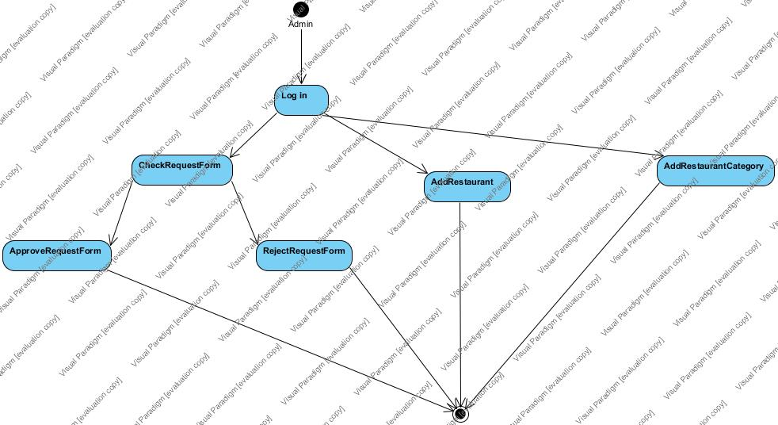

**User Interfaces-Sketches**

**Home Page**

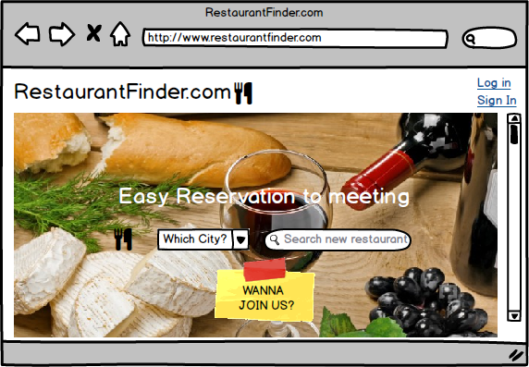**Category Page**

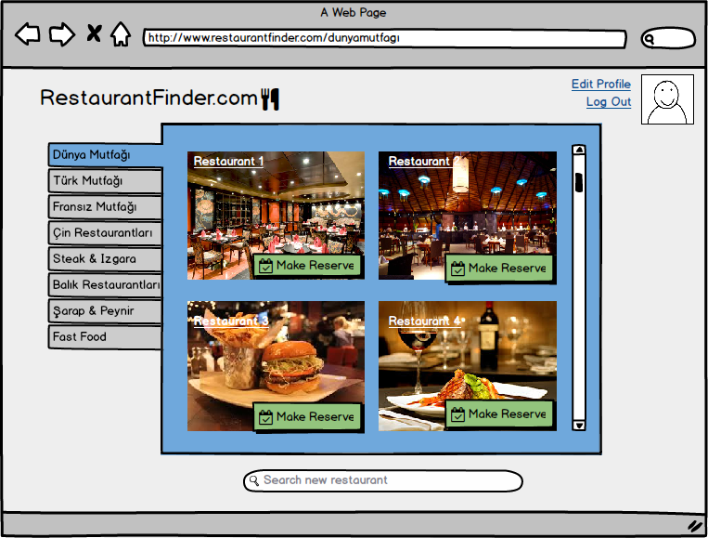

**User Interfaces-Sketches**

**Login Page**

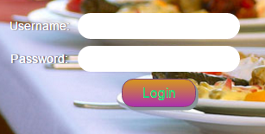

# 4.Glossary

Restaurant Team : The project group’s name.

RestaurantFinder : The System’s name

Request Register Form : If restaurant owner wants to join the restaurantfinder team. He/she needs to fill register form this form called request register form.

Restaurant page: Includes all information about The Restaurant which are Restaurant name, history, phone number and contact address.

User profile: Includes all information about The User which are user name , surname, user’s phone number, user address and user e-mail address.

Login Page: Contains two text fields; one of them is used for username and the other one used for password. Also the page contains login button.

Register Page: Contains five text fields ; They are used for user name, surname , phone number, address and e-mail. At the end of this page there is also Sign in button.

Which City? : It is a combo box which includes all cities in Turkey.

World Cuisine : It includes all food from the world.

Safari : Special web browser for Iphones.

# 5.References

1. Bruegge B. & Dutoit A.H.. (2010). ​*Object­Oriented Software Engineering Using UML,* *Patterns, and Java​*,Prentice Hall, 3​rded.
2. "5 Steps to Draw a Sequence Diagram. Perf. Visual Paradigm. Youtube. Youtube, n.d. Web. <​https://www.youtube.com/watch?v=18_kVlQMavE​>.
3. "From Class Diagram to Relation Schema." From Class Diagram to Relation Schema. N.p., n.d.Web.24Feb.2016.<​http://www2.amk.fi/digma.fi/www.amk.fi/opintojaksot/0303011/1146 161367915/1146161783414/1146163048742/1146163155917.html​>.
4. SE301 Course’s slayts added by ASSIST. PROF. EMINE EKIN
5. Innovation in Software Engineering Topic: Sequence Diagram of Hotel Management System < http://www.slideshare.net/mishraasushil/se-15862740>