Laboratory Report

LABORATORY 1 – REPORT

Student name: Eromonsele Peniel Clements

Student ID: 18317006
Programme: ME1

I hereby declare that the attached submission is all my own work, that it has not previously been submitted for assessment, and that I have not knowingly allowed it to be used by another student. I understand that deceiving or attempting to deceive examiners by passing off the work of another as one's own is not permitted. I also understand that using another's student’s work or knowingly allowing another student to use my work is against the University regulations and that doing so will result in loss of marks and possible disciplinary proceedings.
Signed: Eromonsele Peniel Clements | Date: 28 February 2019
Note: Coursework examiners are entitled to reject any coursework which does not have a signed copy of this form attached or are submitted late.

Sub Task 1

Write a program that reads the initial height and initial horizontal and vertical velocity components and of the projectile. These values will be assigned to suitable variables. The output from the program will be a display on the screen of the numerical values of x and y calculated using equations (5) and (6) at successive, small intervals of time. The program should terminate when y becomes zero again (i.e., the projectile falls back to earth). This display should be captured into a text file and a graph plotted of y versus x using Microsoft Excel. One way of capturing program output in a file is described in detail in the section on Command Line Redirection. Informally, the motion of the projectile is pretty simple: it moves steadily to the right (positive x direction), simultaneously going up for a while (positive y direction), and then coming down again to Earth. Technically, under the various idealizing assumptions we have made, it can be shown that the trajectory will be parabolic.

Plan
Assign names for data
Create input loop that reads the initial height and vertical and horizontal components of projectile the values will be assigned to suitable variables

Create an output that will display the numerical values of x and y calculated using equations 5 and 6

Type code into Textpad
Compile program
Execute the program
Exit program

Development

I included the relevant libraries and a new one math.h because I thought I would need it but it was not necessary. I assigned the various data values (v_ini, v, x, y, t, y_ini). I realized I needed to get the inputs from the user so I created that section of code. Then I created a loop that would repeat itself so it would increment the time in seconds of the ball. It records these values and

Displays the position of the ball after each time interval. The next course of action is to create the table described in the task, a loop is created here with the data.

I imported the values using the command line in this format to a text file then inputted into excel.

I tested my code by giving it a set of values and calculated the results on a calculator with hand and got the same result. The program behaves normally and doesn’t seem to have any errors. It verifies itself.

projectile > out.txt < in.txt

Testing

For testing the code I gave it in random values that I had already calculated using the formulas.

Then I plotted them on the graph and they showed the same results as the program predicted
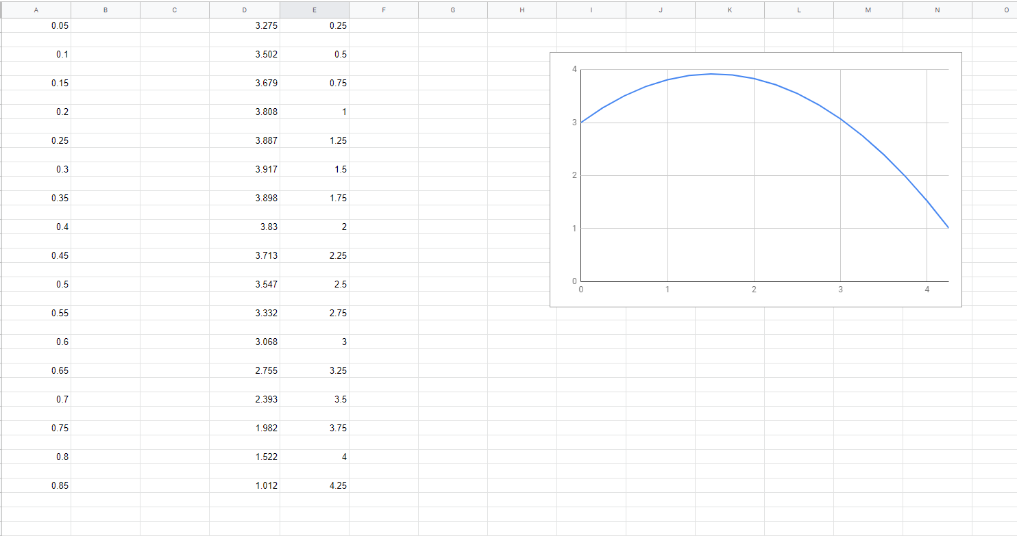
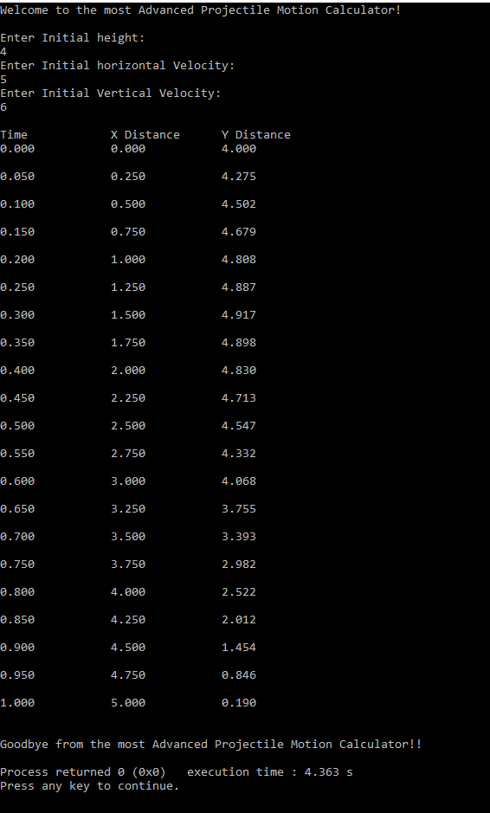

Conclusion

I have learned a lot about loops and their power. The for loop is a useful loop if you want a function to repeat something for a certain length. I learned about function decomposition for code and its use in debugging. Functions can be easy to code if they are planned for and have appropriate structure.

Code

#include <stdio.h>

#include <stdlib.h>

#include <string.h>

int main(void)

{

float v_ini, v, x, y, t, y_ini;

printf("Welcome to the most Advanced Projectile Motion Calculator!\n");

printf("\nEnter Initial height:\n");

scanf("%f", &y_ini);

printf("Enter Initial horizontal Velocity:\n");

scanf("%f", &v_ini);

printf("Enter Initial Vertical Velocity:\n");

scanf("%f", &v);

printf("\nTime\t\tX Distance\tY Distance\n");

for (t= 0; t <= 10; t)

{

x = v_ini*t ;

y = y_ini+((v*t)+(t*t)*(-9.81));

if (y <= 0)

{

break;

}

printf("%1.3f\t\t%3.3f\t\t%3.3f \n\n", t, x, y);

t=t+0.05;

}

printf("\nGoodbye from the most Advanced Projectile Motion Calculator!!\n");

return(0) ;

}

Task 2
Use functional decomposition to break your program into smaller, more manageable pieces. This will make it easier to write, test, and debug.

Plan
Write pseudo code to give a skeleton to code
-define the smaller functions for my code
Separate them out and place in relevant parts
Type code into Textpad
Compile program
Execute the program
Exit program

Development
The first step in the development of my program was to include the standard C libraries (stdio.h, stdlib.h,) that in order to be able to use certain functions in the program.

Then, I started to write the main function of the program. I used for loops to repeat the program and I broke down some of the functions in my code to complete the functional decomposition

The result is then printed to the screen, using the “printf” statement.

Testing
In the testing I came across a few problems relating to the names and data values I associated them with. Initially I was receiving errors because I called the wrong values for print statements. I also didn’t put semicolons at the end of a few of my lines
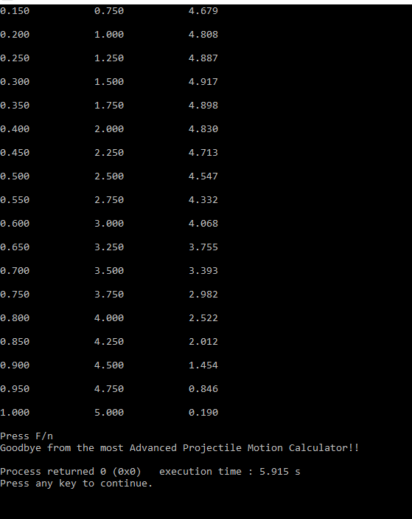

Conclusion

During this lab session I learned about the power of functional decomposition. Also the errors I obtained helped me understand that you must double check your code constantly to make sure it is correct. Trial and error really helped in figuring this task out as it was very vague in the output desired.

The final version of the C source code for task 1 is attached as Fulltask.c

Code

My development resulted in the following source code:

void goodbye()
{

printf("\nGoodbye from the most Advanced Projectile Motion Calculator!!\n");

}

void message()
{
printf("Press F/n");
}

int main(void)

{

/* Declare Variables: h, v, x, y, t, y_ini */

float h, v, y_ini;

/* Print: "Welcome Message */

printf("Welcome to the most Advanced Projectile Motion Calculator!\n");

/* Input: y_ini, h, v */

printf("\nEnter Initial Height:\n");

scanf("%f", &y_ini);

printf("Enter Initial Horizontal Velocity:\n");

scanf("%f", &h);

printf("Enter Initial Vertical Velocity:\n");

scanf("%f", &v);

cal( y_ini, h, v);
message();
goodbye();

return(0);
}

