Rampaging Chariots
Autonomous Robot Modification
Technical Design Document
Issue 1

TABLE OF CONTENTS
1 Introduction 3
1.1 use of this document 3
1.2 Document organisation 3
2 Overview 4
2.1 TBC 4
3 Application architecture 5
3.1 Control Loop System 5
3.2 Translators 6
3.3 Queues 6
4 End user 7
4.1 Loops Explained 7
5 advanced user 9
5.1 9
6 expert user 10

Introduction
This document will go through the design of the autonomous modification for use with a Rampaging Chariot build. This document will have different levels of detail explained as it will contain information aimed for the end-user, but also low level concepts for expert users.

use of this document

The intended audience for this document are end users in schools and academies, the mentors assisting those teams, and the project development team.

Document organisation

This document is organised into the following sections:

Introduction | Provides information related to this document (e.g purpose, definitions etc.)

Overview

Application Architecture

Overview

TBC

Application architecture

Control Loop System
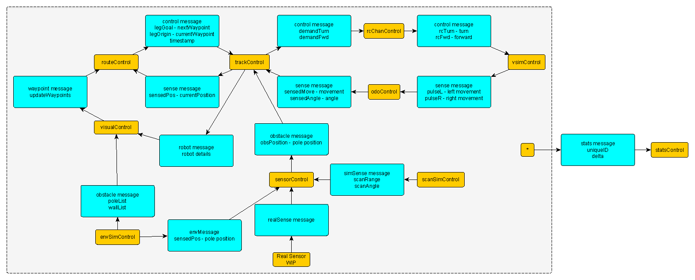
Figure 1 - An overview of the system

The software is designed around a control-loop architecture. Each control loop is responsible for a particular part of the robot and is run independently on its own thread. This gives us the flexibility to change the timing of each loop, and also means the loops don’t have to wait around for other parts of the system. Each control loop is a respective part of the autonomous chariot system.

State

Each control loop has state data; this is of type ObservableState that is defined in each control loop. The state object is observed in a way which allows the control loops to be notified of any changes made during run time.

Timing

The speed at which the control loops run is variable on a number of factors, firstly the user will set a min time, and a max time for each control loop. The min speed is the time at which the loop will iterate if the state object has been modified, and the max speed is the time at which it will iterate if the state remains unmodified. The speed of the loops is defined in main.

Translators
The data flow between the control loops are controlled using translator functions. The primary purpose of these functions is to control the direction in which data is flowing between two control loops and supply them with the most up-to-date information. The functions are initialized with access to both a source and destination state data.

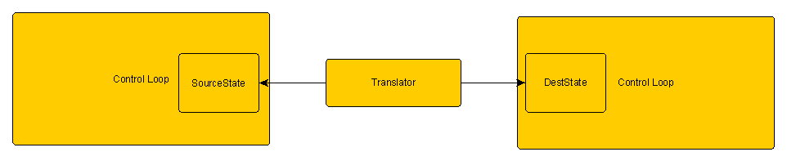
Figure 2 - Example of a translator

Queues

The translator functions pass information into the destination control loops using Queues. These work using a FIFO (first in first out) system.

End user

Loops Explained

main.py

The main.py module is responsible initializing all of the control loops, connecting the suitable translators, and starting all of the loops. Firstly all of the state objects are initialised along with the required parameters which are shown as comments alongside

After the initialisation of the state objects, the controllers should be created. Each of the controllers requires the same number of arguments; a state object, a control update function, a minimum loop time, and a maximum loop time.

In order for the controllers to be able to communicate to each other they need to send messages using an allocated translator, this is accomplished using the connectTo method, see example below.

controller.connectTo(destinationController, sourceControl.sourceToDestTranslator)

This step needs to be completed for every translator used in the system.

All of the controllers need to be started using the start() method.

controller.start()

routeControl.py

The route module is responsible for determining if the chariot is near to the target waypoint and if so, to switch targets to the next waypoint in the list (if there is one).

trackControl.py

The track module is responsible for calculating the next position that the chariot needs to advance to in order to reach the current waypoint. In order to make this calculation it needs the waypoints, these are passed into trackControl from routeControl. In addition to this it also needs to know the current position and heading of the chariot, this is known by giving trackControl a starting position of the chariot relative to the course, and progressively tracking the odometer readings from odoControl to have a position as accurate as possible.

rcChanControl.py

The rcChan module is primarily responsible for sending motor commands to the chariot. It gets a demand forward and a demand turn, which it manipulates into meaningful commands to send to the chariot motors.

The motors operate in a format as follows
Stationary

127
Max Forward

254
Max Reverse

1
Forward
Reverse

65
190

vsimControl.py

This module is responsible for replicating real conditions of the chariot when it is running in simulated mode. Variances such as friction and left-right wheel motor bias would impact the location and behaviour of the chariot when in non-simulated mode, but not in the simulated mode and without accounting for this, the difference between the two modes of the program could be substantial and lead to varying results.

Both the friction measured as fricEffectPerSec, and the left-right bias measured as lrbias can be changed in main.py when the object is initialised.

When the robot is running non-simulated mode, nothing needs to be changed here, as the left and right odometer pulses will get overwritten by the real sensors in odoControl

odoControl.py

The odoControl module is responsible for reading odometer pulses from the sensors

envSimControl.py

This module stores information about the environmental objects of the course.

statsControl.py

This module is responsible for gathering data from a number of loops in order to give useful diagnostic information to the user; this can also come in useful for debugging.

visualControl.py

This module has many responsibilities, primarily displaying the graphical interface that allows us to see the simulated version of the program. This graphical interface is also used to add new waypoints on the course, and also to display diagnostic information that could be useful.

Due the large amount of information that the visual loop requires, this module has a very large amount of state data variables, and is also considerably larger than the other modules.

scanSimControl.py

This module is responsible for simulating readings from an IR sensor.

advanced user

expert user

