RESEARCH ESSAY
Economics Across
Three Worlds
Needs, Desire and Existence in the Age of AI and Embodied Intelligence
PHYSICAL DIGITAL MENTAL
Research edition | English | 13 September 2026
Evidence cutoff: 12 September 2026, Beijing time. This study develops the original manuscript, the earlier contemporary-economy and AI revision, and the accompanying account of their core arguments. Institutional forecasts, observed evidence, conceptual mechanisms and hypothetical calculations are identified separately.
Conceptual model · Economic mechanisms · International comparison · Institutional choices

Contents
Abstract 3
1 From Triadic Value to Three-World Economics 4
2 The Economic Properties of Three Worlds 5
3 A Discussable and Testable Economic Model 7
4 What Is New About This Intelligence? 10
5 Revaluing the Physical World 12
6 Reorganising the Digital World 14
7 The Mental World: Augmentation or Outsourced Agency? 15
8 Distribution and the Macroeconomic Loop 17
9 Reorganising Society: Six Critical Domains 19
10 The Current Economy and Five Major Economies 21
11 Capital Markets and Money 25
12 Institutions and Policy 27
13 Testing the Model 29
14 Conclusion: Economic Purposes Cannot Be Outsourced 32
Appendix A. Continuity with the Earlier Manuscripts 33
Appendix B. Terms, Models and Evidence Conventions 34
References 35
Full text, figure captions and reference notes are provided in this language.

Abstract
The economic challenge posed by artificial intelligence is not simply whether machines can raise productivity. It is how scarcity, labour, ownership, demand and human value should be understood when some cognitive services can be reproduced and deployed independently of an individual worker's time, and embodied systems can translate those services into physical action. This study extends the original framework of needs, desire and existence through three analytical dimensions: the physical world, the digital world and the mental world.
The physical world is constrained by energy, materials, space, ecology and safety. The digital world supports low-cost copying, recombination and network effects, but depends on physical infrastructure, data rights and reliable verification. The mental world encompasses finite attention, learning, emotion, trust, meaning and agency, many of which cannot be reduced to tradable capital. These worlds are not separate industrial sectors. They are overlapping properties of economic activities. Nor do needs, desire and existence correspond to them one by one: they are cross-cutting dimensions of motivation and evaluation.
The proposed model contains five connected modules: the formation of resources and capabilities; their conversion into tasks and services; ownership and income distribution; effective demand and social reproduction; and multidimensional well-being with feedback constraints. AI changes task costs and coordination, while embodied intelligence extends these changes into physical environments. Yet technical capability must still pass through reliability, organisational competence, purchasing power, public provision and rights before it improves people's lives. As cognitive supply expands, energy, authenticity, accountability, attention and institutional coordination may become tighter bottlenecks.
Using dated macroeconomic, AI, robotics, energy and foreign-exchange evidence, the study compares the United States, China, the euro area, Japan and India. It explains why technological leadership, rising asset prices, currency appreciation and improvements in well-being are not interchangeable. It then examines careers, education, science, care, culture, relationships, governance and international order, and proposes empirical hypotheses, policy choices and conditional scenarios without assigning probabilities.
AI's historical significance lies in the expansion of cognitive and action services supplied by engineered systems, not in an established discovery of a new species with human consciousness or moral status. The institutional questions are who determines the purposes of these capabilities, who owns their returns, who bears errors and adjustment costs, and whether higher productivity gives people more secure, autonomous and meaningful lives.
Keywords: three worlds; needs; desire; Dasein; capabilities; artificial intelligence; embodied intelligence; distribution; capital markets; exchange rates; well-being

1 From Triadic Value to Three-World Economics

1.1 The original argument must not disappear into a technology narrative
The original manuscript's central contribution is its refusal to identify the purpose of economic activity directly with output, consumption or asset accumulation. People need food, housing, health care and security. They also seek creativity, recognition, experience and new possibilities. They ask why they work, how to live with others, and what responsibilities they owe the future. Economics should explain these behaviours while distinguishing the satisfaction of a stated preference from a genuine improvement in life.
This study retains the original proposition: needs establish a floor that should be protected; desire motivates exploration and innovation; existence provides the value foundation for questioning economic purposes. A floor is not a rigid psychological stage. People living in poverty still have dignity, convictions and artistic aspirations. Desire is neither inherently harmful nor necessarily insatiable for every person. The three dimensions interact rather than forming a universal ladder of social development.[1][3][5]
Needs must also be distinguished from effective demand. Needs concern the conditions required to avoid serious harm and sustain capabilities. Effective demand concerns spending backed by purchasing power under constraints of income, prices, credit and expectations. An urgent medical need without the means to pay does not automatically become revenue for a provider. Weak consumption cannot therefore be attributed simply to insufficient desire, and market purchases are not a complete measure of needs being met.[4]
The existential dimension draws inspiration from Heidegger's Dasein: being-in-the-world, being-with-others, finite time and possible ways of living. Dignity, equal rights and justice nevertheless require ethical and public justification; they cannot all be derived directly from one ontology. Here, existential concern names a normative orientation, not a variable that can be priced or added to a welfare score.[2][34]

1.2 Three dimensions, not three closed containers
The physical world concerns material conditions and embodied practice. The digital world concerns the encoding, processing and connection of information. The mental world concerns experienced, interpreted, evaluated and collectively created life. Mental includes cognition and emotion, but also culture, meaning and agency. It is not confined to religion and does not imply that minds exist independently of bodies.
A remote medical consultation requires bodies and equipment, networks and models, and clinical judgment and patient trust. A music file can be copied cheaply, but listening time remains finite; a live performance also depends on a venue and people's presence. Classifying health care as physical, software as digital and culture as mental would obscure these interactions.
Likewise, physical does not mean needs, digital does not mean desire, and mental does not mean existence. Housing combines security, status and belonging. An algorithm can support essential services or intensify consumer comparison. Meaning and dignity run through work, services and institutions. Figure 1 separates the operational dimensions from the evaluative dimensions rather than substituting one triad for another.
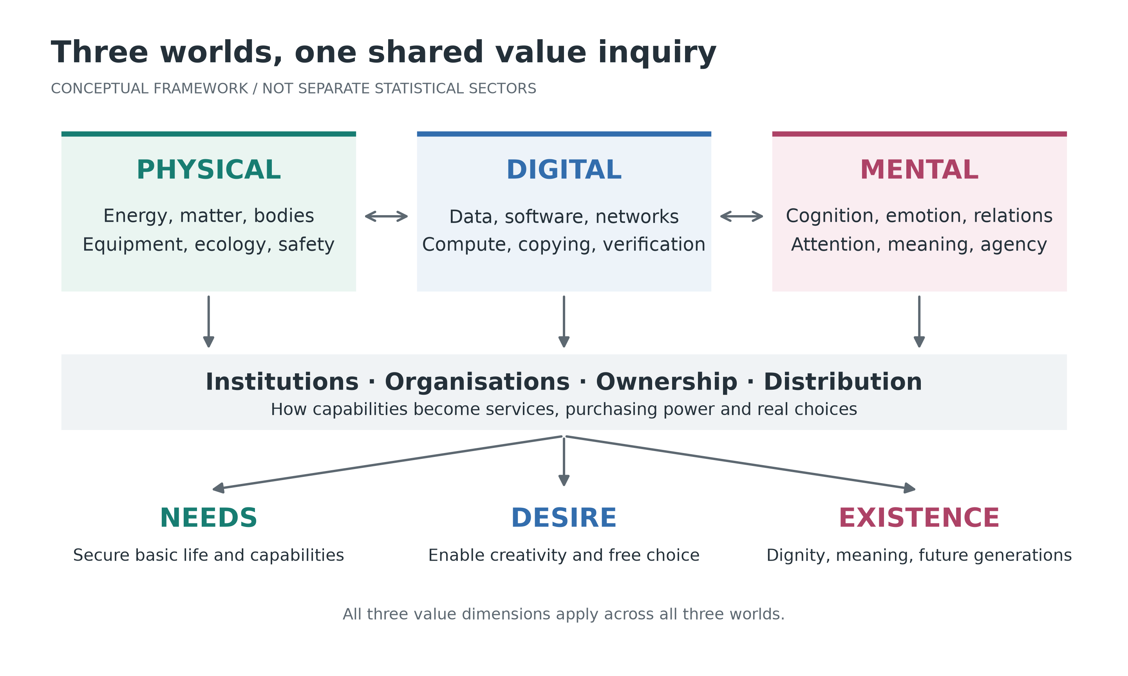
Figure 1. Three-world operations and triadic value: connected dimensions without a one-to-one correspondence
Note: Author's conceptual diagram. Arrows indicate interaction, not estimated causal coefficients. Institutions and distribution affect conversion across all three worlds; all three value dimensions evaluate every world.

1.3 What the framework adds, and what it does not claim
Modern economics is not restricted to material needs. Behavioural, identity, institutional, labour and welfare research already address bounded rationality, social identity, organisational boundaries and non-monetary objectives.[7][28][29] The purpose of the three-world framework is to connect physical bottlenecks, digital replicability and subjective agency in a common analytical sequence, then ask through which mechanisms technical gains become better lives.
This is a framework for connecting methods, not a claim that price theory, national accounting or existing production analysis has become obsolete. The equations below are primarily accounting relationships, feasibility constraints and mechanisms requiring estimation. They do not constitute a fully parameterised, solved and externally validated general-equilibrium model. Intellectual synthesis must not be presented as empirical proof.

2 The Economic Properties of Three Worlds

2.1 The physical world: conditions that cannot simply be copied
The same machine generally cannot simultaneously serve two independent locations, and consumed electricity cannot be consumed again. Physical production faces capacity, transport, construction, wear and material constraints. Economies of scale coexist with congestion, maintenance and rising marginal costs. Pollution and ecological damage can cross organisational and generational boundaries.
Knowledge can substitute for resources only conditionally. Better design may reduce energy and material requirements per unit of service, but it cannot abolish conservation laws, bodily needs or safety limits. Improving a building's energy performance through software differs from supplying a service through additional servers. Evaluation should compare complete life cycles rather than isolated technical indicators.
Prices reflect costs and scarcity, but also property rights, subsidies, market power and externalities. An unpriced natural condition is not an unlimited resource; a high market price is not sufficient evidence of high social use value. Ecological limits require physical indicators and public rules, not willingness to pay alone.

2.2 The digital world: non-rivalry can coexist with exclusion
Code and digital files can be used repeatedly by many people, and an additional copy may be cheap. Research, data cleaning, training, compliance and infrastructure can nevertheless require substantial fixed investment. Non-rivalry does not imply non-excludability: licensing, access controls, platform rules and intellectual property can restrict use and shape pricing and distribution.[31]
Digital networks may generate direct and indirect network effects, learning at scale and switching costs. A leading firm may pass efficiency gains to customers, or use control of interfaces, distribution and complementary services to sustain fees. Low copying costs and high prices are compatible when competition and rights permit them.
AI inference, however, is not simply the free reproduction of an existing file. Complex reasoning, tool use and verification may consume additional compute, electricity and human effort. Caching can reduce some costs, not all. Data are not automatically productive capital either: obsolete, biased, contaminated or legally unusable data may reduce system value. Relevant scarcities therefore include verified quality, dependable access and feedback from the real world, not just information volume.

2.3 The mental world: finite attention and non-replicable meaning
Expressions of knowledge can be copied, but understanding, trust and skilled judgment usually require practice and relationships. Downloading a book does not establish a capability. A thousand generated reassurances need not amount to being respected or understood. Since time and attention are finite, abundant information raises the importance of selection, judgment and control over one's attention.[33]
This domain is not necessarily zero-sum. Learning together, cooperation and care can create relational benefits for all participants. Rankings, competitive visibility and exclusive status are more positional. AI may lower barriers to cultural participation while leaving attention and income concentrated in a few channels.
Trust is often slow to build and quick to destroy. It depends on kept commitments, accountability and shared norms, not merely a rating. Some mental capabilities can be studied as HMc, but that does not make love, belief, suffering, dignity or the meaning of a life assets that a firm can own.

2.4 Different properties require different institutions
Dimension | Physical world | Digital world | Mental world
Typical constraints | Energy, materials, space, bodies, safety | Compute, data quality, connectivity, permissions, verification | Time, attention, learning, trust, agency
Replication and scale | Additional production, logistics and maintenance | Cheap file copying, but costly computation and deployment | Expressions travel; understanding and relationships cannot simply be copied
Common return mechanisms | Manufacturing scale, quality, reliable supply, resource rents | Licences, subscriptions, platform fees, network effects | Professional services, creativity, cooperation and much non-market activity
Major risks | Pollution, resource power, accidents, inadequate supply | Lock-in, data misuse, misinformation, concentrated returns | Manipulation, alienation, reduced autonomy, deskilling
Complementary evaluation | Life cycle, safety, resilience, affordability | Interoperability, authenticity, portability, competition | Capabilities, dignity, relationships, meaning, discretionary time

The classification helps identify appropriate institutions. Non-rival information may support openness and sharing; dangerous physical actions require enforceable responsibility; mental life requires respect for choice and non-market spaces. Factory throughput, online growth metrics and the evaluation of human lives should not be collapsed into one meaning of efficiency.

3 A Discussable and Testable Economic Model

3.1 Resources, services, claims and outcomes
Following the original manuscript, Pc denotes physical resources and capital conditions, Dc reusable digital resources, and Mc cognitive and cooperative capabilities. HMc refers to human capabilities, and AIMc to functional cognitive capabilities supplied by AI. U denotes multidimensional well-being, not monetary utility, GDP or profit.
These symbols do not form mutually exclusive asset accounts. Model software may be part of Dc while its operating cognitive services are described as AIMc. Chips are physical inputs; their computational services are not a second, independently created stock of physical capital. Human capabilities are not the total value of a person. National accounting should retain explicit production boundaries and value-added principles rather than adding purported Pc, Dc and Mc values to obtain GDP.
Financial assets are claims and liabilities. Buying an existing share primarily transfers ownership; it does not itself build a new machine. Digitising the register does not turn one factory into two units of social wealth. Revaluation, cash income, capital formation and improvements in well-being must be recorded separately.

3.2 Module one: capability formation and complementary inputs
A system's effective AI capability can be represented conceptually as:
$(1) A(t) = g[D(t), Kc(t), E(t), Hdesign(t); Z(t)]$
A is a set of task-relevant AI capabilities; D is relevant data and software; Kc is computing infrastructure; E is energy services; Hdesign is human research and engineering capability; and Z is the organisational, legal and technical environment. The function is not estimated here. A is not a universal intelligence score: performance must be specified by task, environment and evaluation standard.
Physical investment requires construction and maintenance. Digital resources require updating and governance. Human capability requires learning and practice. AI can improve learning feedback, or remove opportunities to practise by completing the work itself. Research should therefore examine long-term independent capability after assistance, not only speed while the tool is available.

3.3 Module two: from cognitive tasks to accepted services
For task j, write xj = Fj(hj, aj; zj), where hj is human input, aj AI services and zj task standardisation, error costs and organisational conditions. Humans and AI may be complements or substitutes; a common substitution elasticity should not be imposed on every occupation. Jobs combine tasks. The automation of several tasks does not establish the disappearance of the entire job.[11][14]
A service requiring several coordinated stages admits a bottleneck approximation:
$(2) Q(s,t) ≤ min\{Qp(s,t), Qa(s,t), Qv(s,t), Qo(s,t)\}$
Q is accepted service output within a period. The four capacities concern physical operations, cognition, verification and organisation, each expressed in equivalent units of the same final service. This is a short-run feasibility constraint for a complementary workflow, not a permanent production law for every industry. Investment, redesign and substitute technologies can move the constraints.
Generating more drug candidates will not proportionately produce more approved treatments if experiments, clinical trials and regulatory capacity remain binding. Faster coding is not equivalent to better software services when requirements, testing and maintenance constrain delivery. The economic value of intelligence depends on which constraint it relaxes, not merely on how rapidly intelligence itself improves.

3.4 Module three: value creation, income and control
Technological gains may appear as lower prices, higher wages, profits, tax revenue or shorter working hours. Their distribution depends on competition, bargaining, intellectual property, ownership and fiscal institutions, not algorithmic performance alone.
A household's disposable cash income can be written:
$(3) yd(i) = w(i)h(i) + d(i) + b(i) - tax(i)$
The terms represent labour income, capital income actually accruing to the household, transfers and relevant taxes. Household capital income is not identical to aggregate corporate profit: earnings may be retained, belong to foreign investors or be unevenly held. Stock-market revaluation is not cash income in this equation, although wealth and collateral effects may influence spending.
Ownership also determines objectives, access conditions, workflows and the termination of services. Even a free AI service may create future bargaining vulnerability if essential processes become dependent on a non-portable external system. Return rights, control rights and exit rights should therefore be examined together.

3.5 Module four: effective demand, budgets and social reproduction
A simplified household cash constraint is:
$(4) Σ_{k} p(k)c(i,k) + save(i) + debtpay(i) ≤ yd(i) + newloan(i)$
Saving is net acquisition of assets and can be negative. Debt payment covers principal and interest on existing debt; newloan is gross new borrowing during the period. This avoids counting net borrowing and principal repayment twice. The constraint is not a complete consumption model: expected income, risks, needs and comparison also influence choices within the feasible set.
At the aggregate level, spending and supply are coordinated through prices, output, inventories and policy. Lower supply costs do not guarantee that needs acquire purchasing power. Concentrated income may weaken some households' spending, but investment, net exports, public expenditure and price reductions can offset or alter the effect. A declining labour share does not logically establish inevitable economic collapse.[4]
Social reproduction also includes education, care, health and public trust. Firms can temporarily economise by relying on existing skills and social foundations, but cannot indefinitely neglect their renewal. Eliminating entry-level work without rebuilding learning institutions may raise present efficiency while damaging future human capability.

3.6 Module five: multidimensional well-being and feedback
The final evaluation is a vector rather than a forced aggregate score:
$(5) U(i,t) = [N, Capability, Autonomy, Relations, Meaning, FreeTime](i,t)$
N denotes the fulfilment of needs. Other components concern substantive capability, autonomy, relationships, meaning and discretionary time. Ecological conditions, rights and fiscal sustainability provide cross-person and intertemporal constraints. Correlated indicators are not necessarily interchangeable or compensable.[1][8][10]
Decision-making should first identify rights and safety boundaries, then assess basic needs and severe deprivation, and finally compare feasible alternatives across outcomes, resource costs and distribution. If all minimum protections cannot yet be achieved, the shortfalls, priorities and improvement path should be made explicit. Value weights require participation by affected people; they must not disappear inside an algorithmic score.
Needs and desire also feed back into production and institutions. Recommendations affect preference formation; security affects learning and entrepreneurship; meaning affects cooperation; trust affects adoption. The model is therefore not a one-way machine turning capital into happiness, but a dynamic system with history, conflict and public choice.

4 What Is New About This Intelligence?

4.1 Historical novelty requires precise language
Writing, books, markets, organisations, computers and automatic control have long extended human capability. Collective knowledge already exceeds what any individual can hold. The phrase "the first new intelligence in history" should therefore not mean that intelligence beyond an individual human has never existed, nor that AGI, consciousness or personhood has been established.
The economically significant development is that engineered, non-biological systems increasingly supply complex services across cognitive domains in reproducible, updateable forms that can be embedded in organisations and, in some settings, entrusted with action. This changes services whose expansion previously depended heavily on individual training and working time. The technology has continuous historical roots, but its combination of scope, diffusion and organisational effects may create major structural change.[15]
These systems still depend on human language, knowledge, infrastructure and institutions. Calling a model a wholly independent, self-sufficient worker hides data provenance, maintenance, training labour and accountability. Its functional economic role does not settle whether it has subjective experience or moral standing.

4.2 Three forms of capability, three responsibility structures
Generative AI supplies content and recommendations. Agentic systems connect judgment to tools, accounts and multi-step workflows. Embodied systems connect perception, planning and control to physical environments. These are not a single ladder that necessarily matures in sequence: specialised control may be dependable while sustained autonomy in open environments remains unreliable.
A cognitive error may damage information; an agent error may trigger payments, contracts or permission changes; a physical error may cause irreversible harm. Deeper action requires bounded permissions, records, intervention and clear responsibility. Declaring a human to be "in the loop" is insufficient unless that person has the time, capability and authority to intervene.
Embodied intelligence is not synonymous with humanoid robots. Arms, mobile platforms, agricultural machines and other designs can close perception-action loops. Form should follow tasks, environments and costs; resemblance to a human body is not evidence of superior economics.
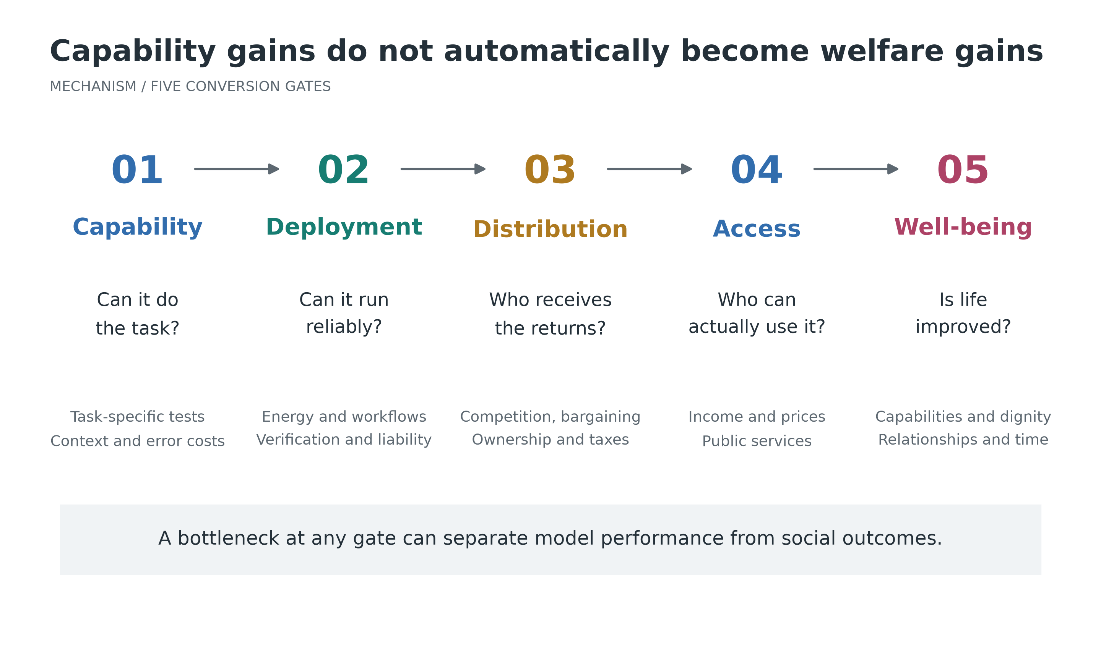
Figure 2. Five conversion gates between model capability and social well-being
Note: Author's mechanism diagram. Stages may require repeated feedback. Technical feasibility, viable deployment and social acceptability are different judgments, with no common assumed pass rate.

4.3 The distance between task evidence and macroeconomic evidence
The NBER working-paper version of Brynjolfsson, Li and Raymond studies 5,179 customer-support agents and reports an average productivity increase of approximately 14%, measured as issues resolved per hour, with larger gains among less experienced workers. The figures here follow that working-paper version rather than mixing its sample and estimates with the later journal publication.[12]
This illustrates how AI can transmit expertise under particular tasks, data and organisational arrangements. Aggregate effects also depend on task weights, actual adoption, quality, demand elasticity, complementary investment and new tasks. Multiplying a task-level gain by all GDP, or calling exposure to automation an unemployment rate, omits essential mechanisms.[11][14]
Organisational adjustment can produce a productivity J-curve: data cleaning, training, redesign and verification consume resources before gains emerge.[13] This explains some delay, not indefinite exemption from evaluation. Exploration and exit criteria should coexist. Projects without reliable use, sustained savings or controllable risks should be modified or discontinued.

4.4 Three mismatches in the speed of change
Software can be copied rapidly. Grids, factories and physical deployment usually adjust more slowly, while education, careers and norms operate on still different schedules. Positive long-run gains can coexist with early-career disruption, regional revenue losses, concentrated capital expenditure and household insecurity during the transition.
A second mismatch is action moving faster than supervision: agents may execute continuously while human review bandwidth is limited. A third is capability updates outpacing responsibility arrangements: changed behaviour can invalidate earlier acceptance tests, insurance and work practices. AI economics must therefore examine not only eventual output, but who gains first, who bears costs first and whether failures can be contained in time.

5 Revaluing the Physical World

5.1 Digital expansion brings material foundations back into view
AI does not detach the economy from matter. Intensive training and inference enter the physical economy through chips, electricity networks, cooling, land and equipment. The IEA's 2026 Key Questions on Energy and AI estimates electricity use by all data centres at 485 TWh in 2025 and projects approximately 950 TWh in 2030 in its central case. These are an estimate and a projection, respectively, and neither is AI-only electricity use.[16]
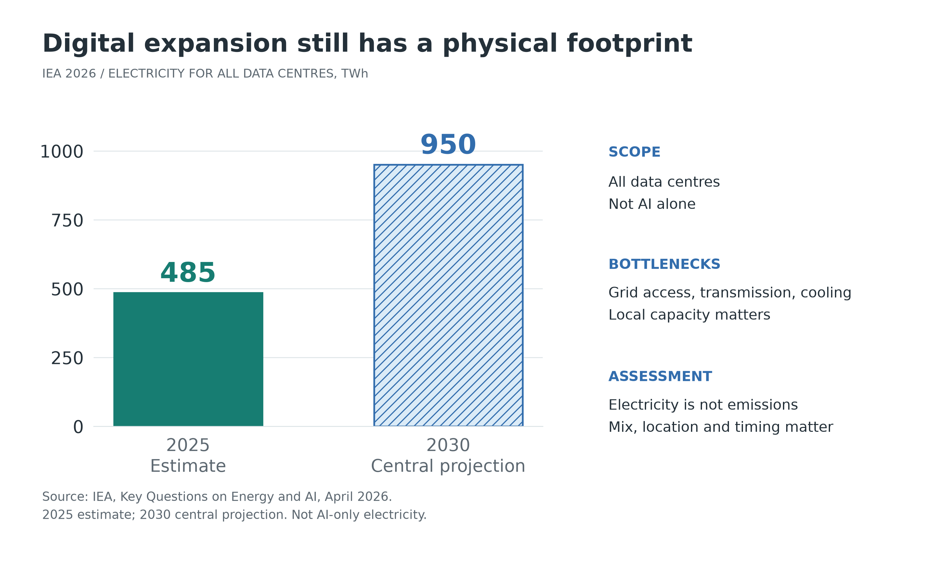
Figure 3. The physical foundation of digital capability: electricity use by all data centres
Note: IEA, April 2026.[16] The 2025 value is estimated and the 2030 value is a central projection. The bars compare two dates, not an observed intervening path. Electricity use is not emissions, which also depend on generation, location and timing.
An aggregate electricity share does not establish local capacity. A region may have sufficient energy overall but face limits in substations, transmission, connections or water. New computing loads can compete with households, manufacturing and transport electrification for near-term capacity. Electricity contracts, location and construction times therefore influence cash flows and regional development, not merely engineering performance.
Falling energy use per task can coexist with rising total consumption. Aggregate use depends on intensity, task volume and the mix of applications. Rebound can offset savings but does not necessarily exceed them. Assessment should use the activities actually displaced as its baseline and include equipment production, life cycle, location and marginal generation, avoiding both understated costs and exaggerated claims about individual queries.

5.2 The unit of embodied economics is an accepted task
Embodied systems create value through sustained success, cycle time, utilisation, deployment speed, maintenance, intervention requirements and tail risks. A fixed industrial station and an open household environment have different integration costs and tolerances for failure. A fluent demonstration does not establish reliable economics across settings and time.
$(6) UnitCost = AnnualAllInCost / AnnualAcceptedTasks$
The numerator includes annual capital user cost, appropriate allocation of integration and site adaptation, energy, maintenance, supervision, insurance and reasonably estimated residual losses. The purchase price and full depreciation of the same equipment must not both be charged in the same period. The denominator is actual accepted output, not theoretical hours multiplied by an ideal cycle rate. High-risk activities must first satisfy safety and rights constraints; an expected-loss calculation alone does not make every risk acceptable.
Continuing the previous manuscript's purely hypothetical example, fixed annual cost of CNY180,000 produces costs of CNY1.80, CNY0.90 and CNY0.60 per accepted task at 100,000, 200,000 and 300,000 accepted tasks. If an equivalent-quality existing process is assumed to cost CNY0.90 per task, 200,000 tasks is the intersection in this simplified calculation. It is not an observed robot break-even point. Actual annual costs may also change with operating intensity.
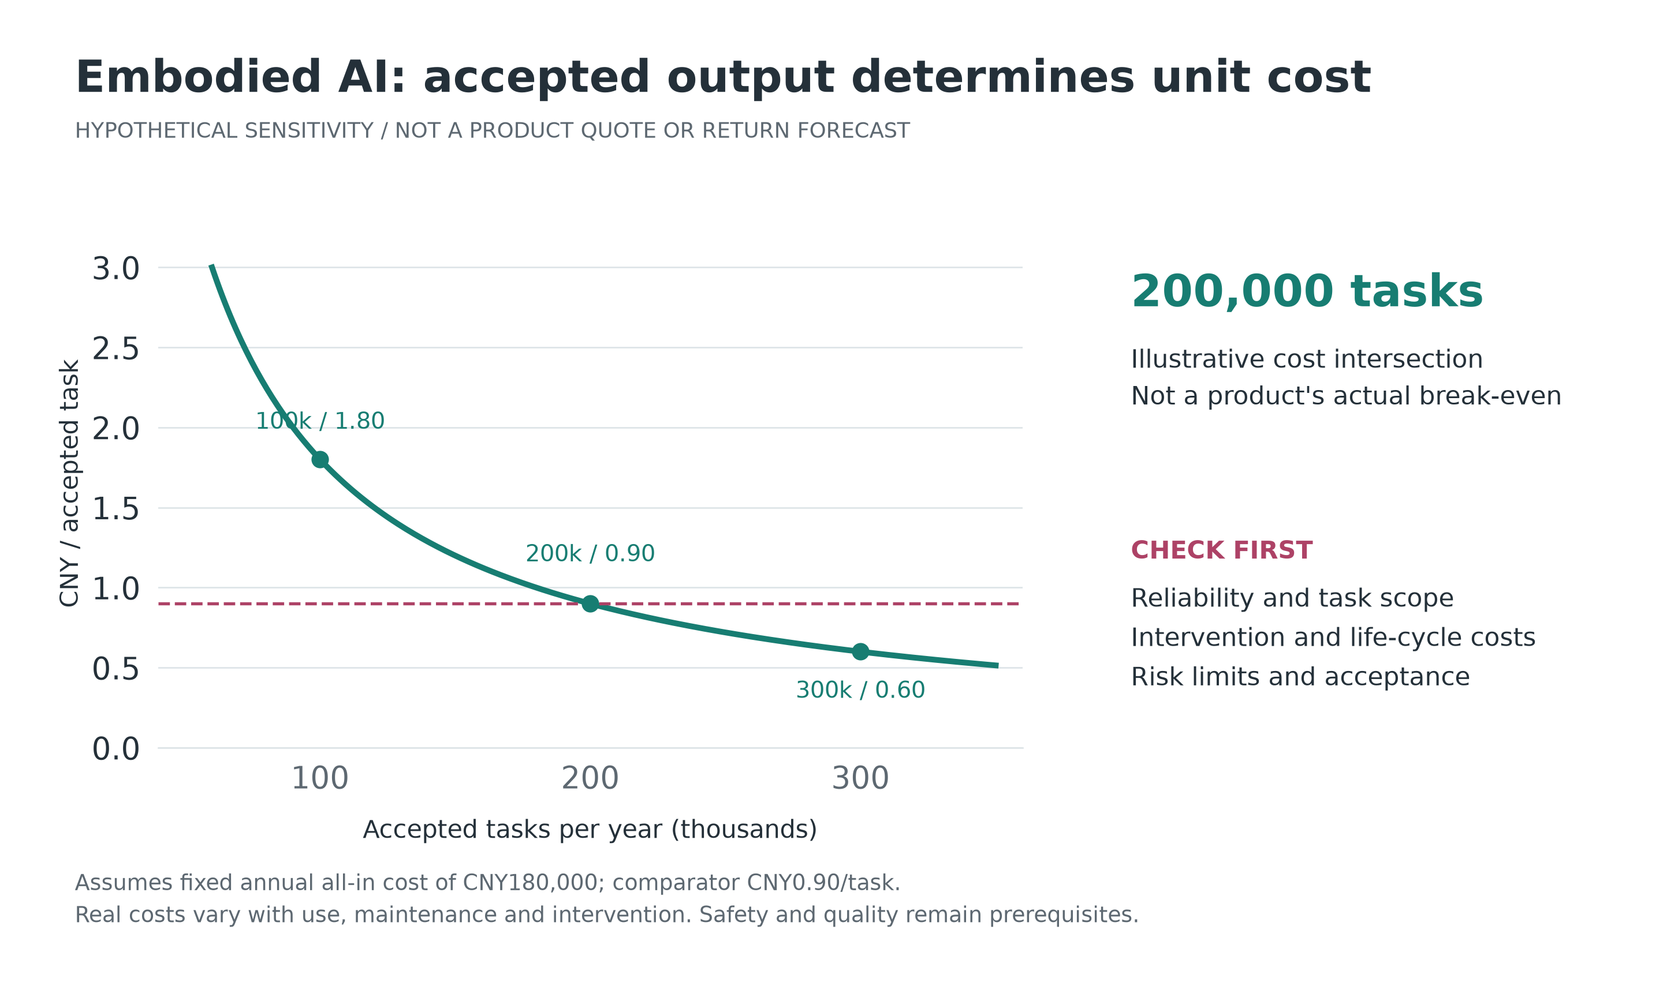
Figure 4. Utilisation changes embodied-system economics: sensitivity under fixed annual cost
Note: All values are hypothetical, not market quotations. Annual cost is fixed at CNY180,000 and the comparator at CNY0.90 per task. Safety, quality and service scope must be comparable; this curve is not a substitute for acceptance testing.

5.3 Lower labour cost is not the only reason to invest
Reduced danger, consistent operation, lower material waste and supply-chain responsiveness may matter more than wage savings. Conversely, low-frequency tasks, uncertain demand or expensive failures can make automation unattractive even where wages are high. Robotics-as-a-service can reduce customers' initial outlays, but transfers utilisation, maintenance and financing risks to providers rather than eliminating them.
Competitive advantage may reside in field engineering, modular adaptation and dependable support, not only frontier models. Embodied AI can therefore support both scale-intensive firms and distributed jobs in installation, maintenance, training and specialist services. Net employment and local gains depend on where these activities occur, who owns the knowledge and whether customers can switch suppliers.
IFR's World Robotics 2025 records approximately 542,000 industrial robot installations worldwide in 2024, including about 295,000 in China, 44,500 in Japan, 34,200 in the United States and 9,100 in India.[17] These figures indicate an industrial automation base. They are not deployment figures for general-purpose humanoids or direct validation of the model proposed here.

5.4 Comparative advantage shifts towards system costs
If cognitive services become internationally available at low cost and more physical processes can be automated, low wages may matter less for some standardised tasks. Energy, logistics, market proximity, engineering talent, financing costs and predictable institutions may matter more. This does not imply universal reshoring: imported equipment, component clusters and local knowledge can sustain international specialisation.
Resource abundance is no guarantee of lasting local gains. Electricity and mineral rents may accrue to a few owners while communities bear environmental and land costs. Triadic evaluation therefore includes taxation, public services, job quality and community consent, so that repricing physical constraints is not merely an opportunity for asset owners.

6 Reorganising the Digital World

6.1 After content becomes abundant, what remains scarce?
As the cost of generating text, images and code falls, the bottleneck can move from the availability of content to its truthfulness, relevance, executability and accountability. Firms with real operating feedback, verifiable data and durable customer relationships may earn more sustainable income than firms producing undifferentiated content. Abundant information is not equivalent to abundant reliable knowledge.
Prices can also fall faster than usage rises. Social use value may expand while producer revenue remains limited. A capability becoming standard can benefit users and competition while weakening an incumbent's pricing power. Technology diffusion and declining investment returns are therefore compatible; the latter does not establish that the technology lacks value.

6.2 Openness can lower barriers while leaving control points intact
Open models, interfaces and portable data can facilitate entry and local adaptation. Compute, electricity, distribution, business data or default interfaces may nevertheless remain concentrated. Model openness does not prove competition across the entire value chain, just as high fixed costs do not prove permanent natural monopoly.
Analysis should identify who controls essential inputs, who bears fixed costs, whether customers can use multiple suppliers, whether migration costs are reasonable, and whether returns come from better performance or exclusion. Intellectual property should support creation, but training and generation also require workable arrangements among creators, data subjects and the public. Useful data are not automatically authorised data.

6.3 Agents change firm boundaries and delegation risks
Cheaper search, coordination, documentation and routine contracting may let small organisations perform work that previously required a large administrative structure. Yet integration, auditing, liability and security may make other tasks more economical inside firms. Coase's comparison of market transaction costs and internal organisational costs remains relevant, but costs on both sides change. It does not follow that all firms become one-person enterprises.[29]
The more important question is whom an agent represents. A seller-funded purchasing assistant may not optimise the buyer's interests. A business agent with payment powers requires budget, authorisation and compliance limits. Transactions between AI systems do not create final demand from nothing; they still represent the claims and budgets of people and institutions.
When pricing, credit and procurement depend on similar models, shared errors and feedback amplification can reduce resilience. AI may improve detection while accelerating propagation. Appropriate responses include transaction limits, anomaly-triggered pauses, independent checks and recovery capabilities, rather than a blanket rejection of automation.

6.4 Better computation does not create an omniscient planner
AI can improve inventories, public-service scheduling and infrastructure operation. Compute alone cannot resolve conflicting objectives, tacit knowledge, incentives or limits on power. Needs without adequate channels of expression may remain absent from data, while historical biases can become embedded in administration.
Prices, professional judgment, democratic participation and local knowledge perform different informational functions. One score cannot replace them without loss. The appropriate ambition for digital governance is better feedback, experimentation and correction, not an unchallengeable social optimiser.

7 The Mental World: Augmentation or Outsourced Agency?

7.1 Human value when machines perform some tasks better
If dignity rests on the claim that machines will never perform a particular job, each technical improvement becomes an existential threat. The original manuscript offers a stronger foundation: a person's value does not depend on winning every market task. Respect, relationships, choice and responsibility do not require a favourable wage or productivity ranking.
Work nevertheless matters. It commonly supplies income, identity, learning and social connection. Automation can liberate people from repetition, but additional digital entertainment may not replace a lost career and community. Income compensation, renewed participation and learning opportunities are separate institutional tasks.[8][9]
Meaning must not excuse dangerous, underpaid or unfree work, nor be assigned to individuals by government or management. Less necessary labour can improve life if gains are shared and the resulting time is genuinely discretionary. Unemployment, fragmented availability or intensified performance requirements are not equivalent to freely chosen leisure.

7.2 The same tool can develop or hollow out capability
AI can offer feedback, translation, assisted expression and adaptive practice, making knowledge more accessible. It can also deliver finished work without understanding. Current output may look similar while long-term human capabilities diverge. The important variables are independent judgment, error recognition and transfer to unfamiliar situations, not time spent with the tool.
Career development must preserve routes from novice to expert. Entry-level tasks are both production activities and opportunities to observe problems, meet clients and acquire responsibility. An industry that retains experts to supervise AI but stops training beginners can consume its existing skill stock. Explanatory practice, simulation and field rotations, progressive authorisation and periodic unaided assessment may help rebuild that pipeline. Universal instruction in prompting is not a complete solution.

7.3 Desire enters a continuously optimised feedback loop
The original analysis treats desire as shaped by comparison, symbolic recognition and reflection.[6][7] Generative systems make personalised interaction cheaper and more continuous. Commercial objectives can increasingly influence what users encounter, want and believe about themselves. The risk is not that all social influence is illegitimate, but that an influential actor possesses informational advantages users cannot readily recognise, reject or correct.
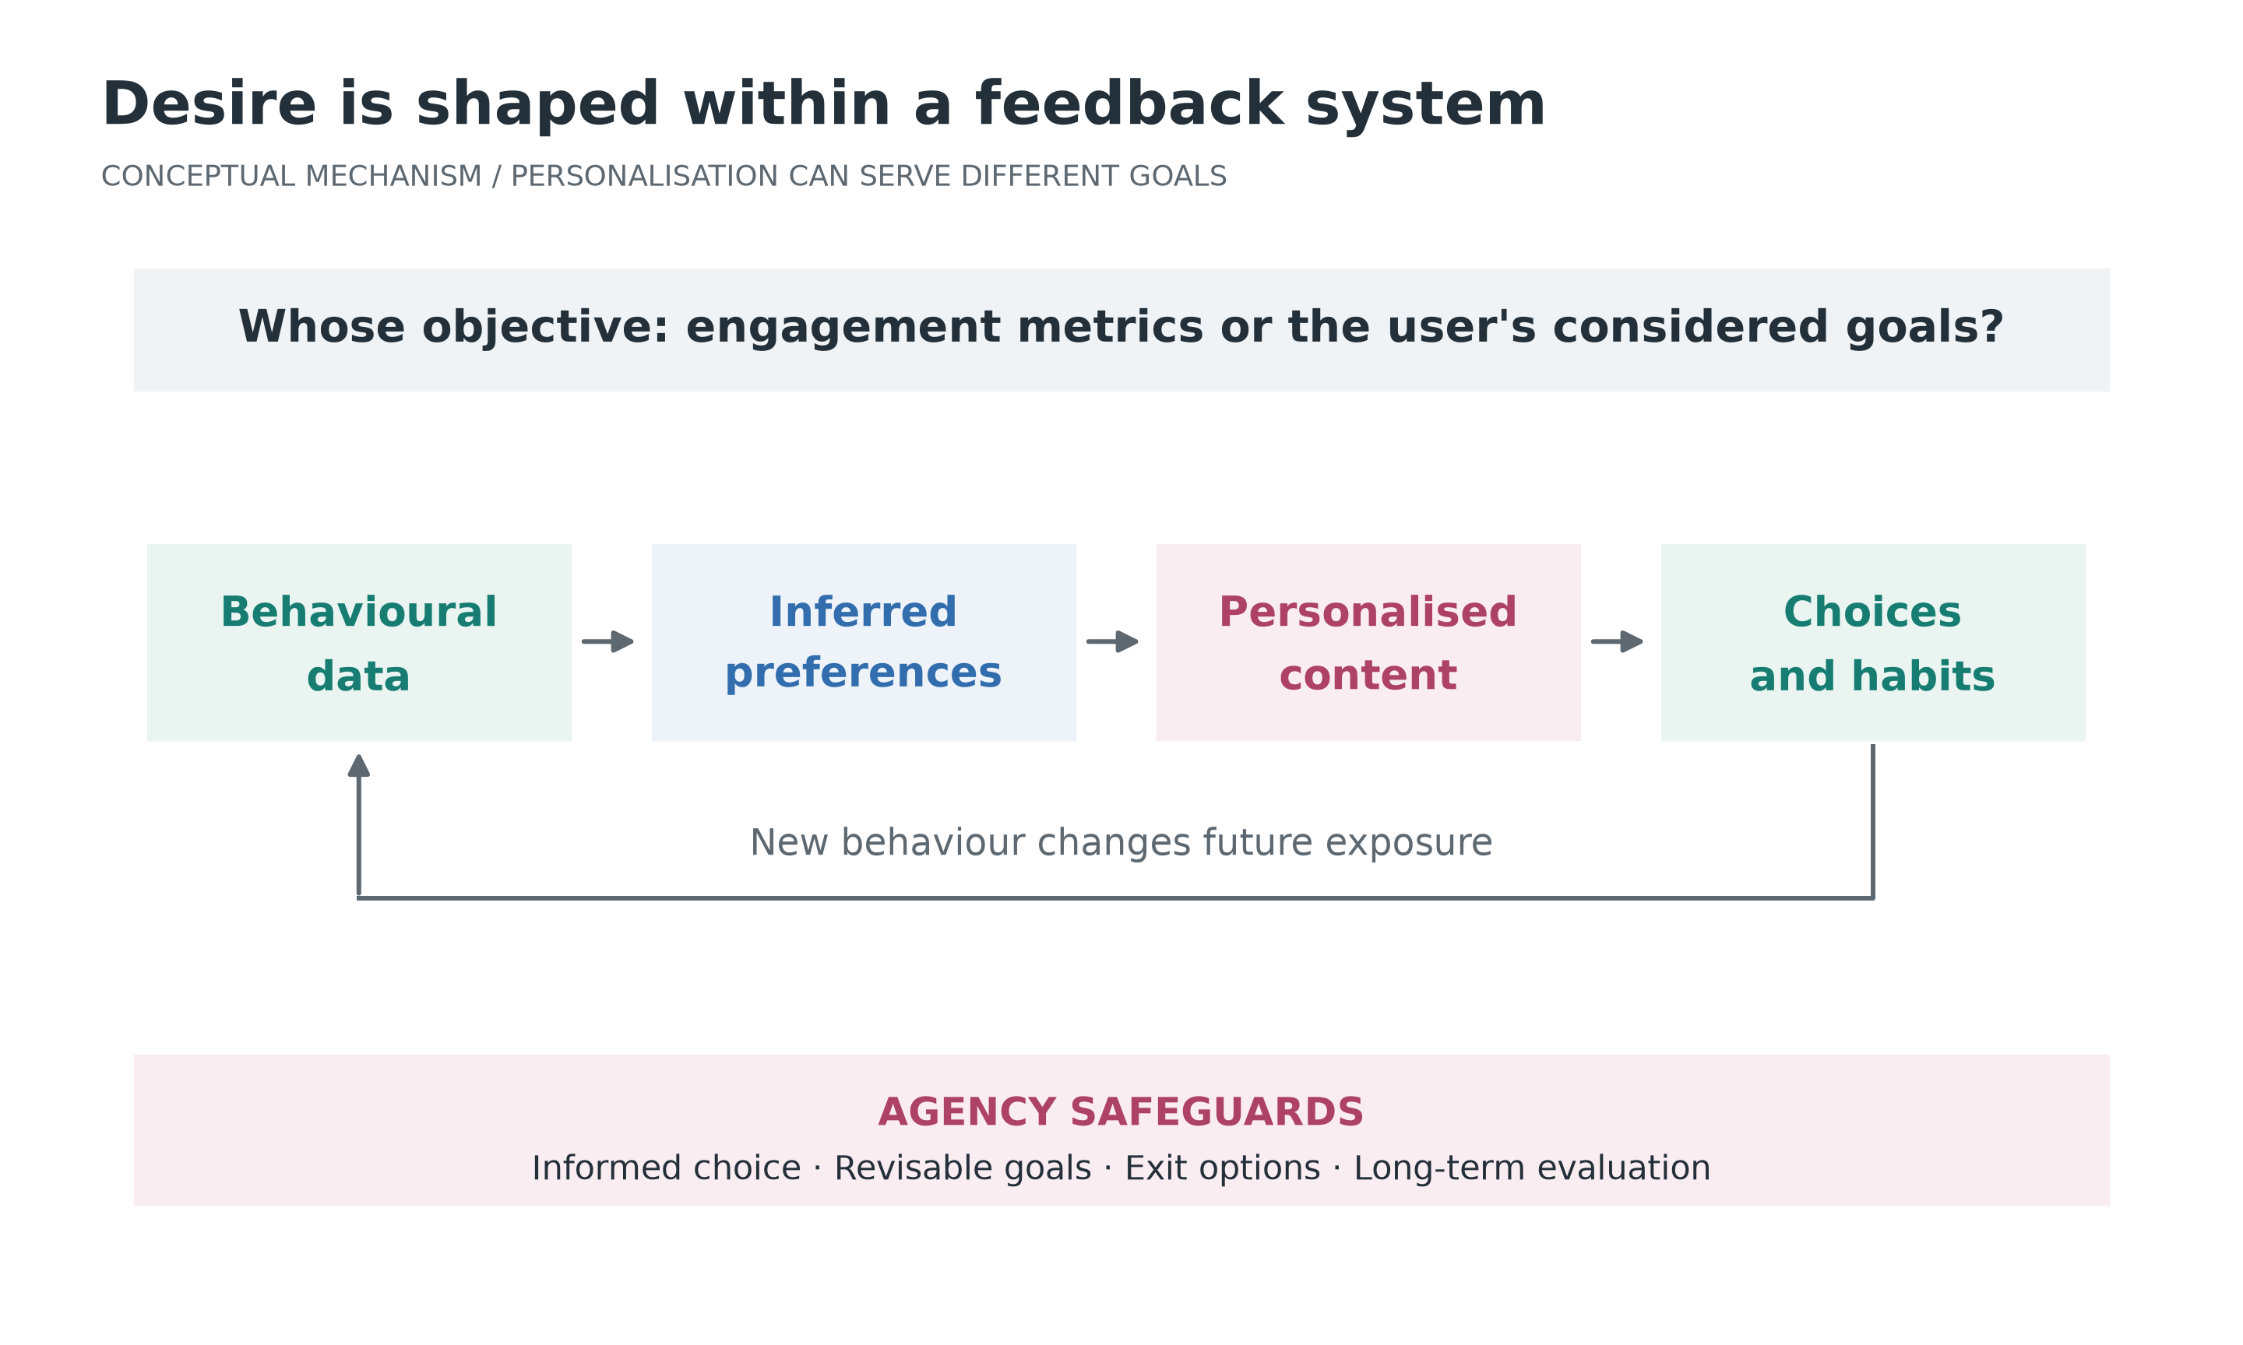
Figure 5. Preference formation as a feedback loop between commercial objectives and autonomous choice
Note: Author's conceptual diagram. Personalisation may reveal valuable options or create manipulation risks. Informed choice, revisable goals, exit and long-term evaluation are governance conditions, not proof that a particular product causes a specified psychological harm.
Clicks, retention and conversion should not be equated with welfare. Relevant questions include whether users advance their considered goals, experience regret or excessive debt, lose sleep or relationship time, and can reject recommendations or change providers. Respect for reflection does not authorise experts to declare which desires are authentic. It supports better conditions for information, choice and exit.

7.4 Relational value and the limits of synthetic interaction
AI companionship may support expression, communication or relief from loneliness in some circumstances. Long-term effects require evidence differentiated by users, design and context. Machine-mediated interaction does not make a user's experience unreal, but more interaction does not establish better relationships. Designs that monetise dependency or use private disclosures for opaque persuasion warrant stronger protection.
Some value in care and intimacy comes from another person genuinely committing time, responsibility and risk. A functional simulation of empathy and a person's voluntary commitment to care are not the same analytical object. Technology should widen communication and participation while preserving access to human contact, particularly against a stratified system in which poorer people receive only automated services and richer people retain human ones.

7.5 Culture, authenticity and a shared public sphere
Content generation can help minority-language users, disabled people and non-professionals create. It may also reproduce stereotypes in underrepresented cultures or undermine creators' income and visibility. Cultural policy should not merely preserve existing business models; it should support provenance, appropriate authorisation, linguistic diversity and public archives.
As synthetic content expands, the fact that a real person made something, took responsibility or was present may command a premium. Dignity should not, however, become a form of authenticity consumption available only to high-income households. Public education, libraries, community activity and non-commercial creative spaces allow cultural participation to depend on more than purchasing power on a platform.[30]

8 Distribution and the Macroeconomic Loop

8.1 Technology is not a one-directional unemployment curve
AI affects labour through at least four mechanisms: task displacement, complementarity, demand expansion following cost reductions, and new-task creation.[11] Outcomes can differ across groups. Entry-level work may contract while installation, maintenance, verification, professional communication or new services expand. Exposure, adoption and net employment must be measured separately.
Real wages reflect labour demand, but also market power, bargaining, institutions and prices. Output can rise while most gains accrue to capital. Conversely, unchanged nominal wages can purchase better lives if essential services become cheaper. Yet cheaper digital products may not compensate for income insecurity when housing, health care and energy remain expensive. Evaluation requires household-specific consumption baskets and balance sheets.

8.2 A hypothetical distribution and consumption calculation
Assume two non-overlapping household groups. Labour-income households consume 90% of income, and capital-income households 50%. Ignore taxes, transfers, price changes and other income. Initially, total income of 100 is divided 60 and 40, producing consumption of 74. Suppose technological improvement raises total income to 120. A distribution of 50 and 70 produces consumption of 80; a distribution of 70 and 50 produces 88.
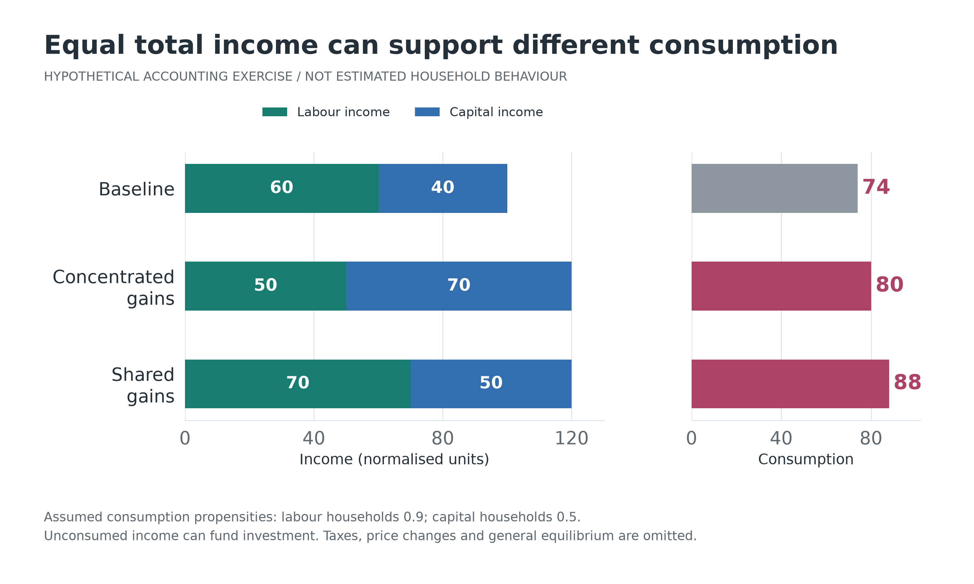
Figure 6. Equal total income, different distributions and consumption: a hypothetical example
Note: Every income value and consumption propensity is assumed, not estimated for actual groups. Unconsumed incomes are 26, 40 and 32 and can support investment or financial asset acquisition. This is not a prediction of recession or inevitable idle capacity.
The example does not show that capital income is useless. It shows that distribution affects the scale and composition of demand. Higher saving invested productively can support future supply. If investment appetite is weak, or investment becomes detached from final needs, inventories, debt, asset prices and policy responses matter. Productive capacity and purchasing power are institutionally connected, not automatically aligned.

8.3 AI is not a consumer class in the human sense
Software and robots require electricity, components, maintenance and updates. These are production inputs and create intermediate demand. Current AI systems, however, do not require wages paid to them as persons, nor have independently established living needs. It cannot simply be assumed that machines replacing workers will consume as those workers did. Cash flows still accrue to firms, investors, workers and public institutions.
The macroeconomic sustainability of extensive automation therefore depends on how households obtain income and services. Capital ownership, public provision, insurance, taxation and transfers may matter alongside wages. Universal basic income is not the only option, and making models cheaper cannot by itself resolve distribution.

8.4 Ownership shapes outcomes before compensation begins
Employee ownership, pension investment, public funds, cooperatives and profit sharing can widen access to capital returns. Each raises questions about governance, concentrated risk and financing. Workers whose wages and savings both depend on one employer can suffer correlated employment and asset losses. Public funds need transparent and independent governance rather than moving investment risks out of sight of fiscal accounts.
Public contributions to foundational capabilities can secure public returns through procurement, open standards, sharing arrangements or conditional support. This need not mean permanent government ownership of every beneficiary. Agreements should be transparent, competitively neutral and accountable, avoiding arrangements that privatise successful returns while socialising every failure.

8.5 Productivity does not automatically imply deflation or low interest rates
AI may lower unit costs in some services while increasing demand for electricity, equipment, construction and engineers. If physical supply adjusts slowly, technology investment can coexist with local or broader price pressures. Demography, geopolitics, fiscal policy and import costs continue to influence inflation.
Higher productivity may raise potential growth and investment returns while lowering some product prices. Real interest rates depend on saving, investment, risk and policy responses, not efficiency alone. Fiscal authorities planning to use new revenues must distinguish sustainable tax bases from temporary asset booms, rather than finance permanent commitments with uncertain future gains.

9 Reorganising Society: Six Critical Domains

9.1 Education: from supplying answers to forming capabilities
Cheaper answers and exercises do not make education costless. Children need stable relationships, motivation, safety and practice. Adults changing careers need affordable learning time and genuine employment opportunities. Assessment should look beyond finished assignments to explanations, performance in context, retention and transfer.
AI can widen access to good explanations while disparities in equipment, quiet space, time and adult support persist. Schools should distinguish tasks that allow assistance from capabilities that require independent demonstration, and provide accessible tools and teacher development. High-stakes judgments about students should not rest on text detectors alone. Evidence, appeals and appropriate procedures remain necessary.

9.2 Science: faster hypotheses, more valuable verification
AI can support search, modelling, candidate-material design, pattern recognition and experimental control; embodied systems may extend automated experimentation. But theoretical generation, reproducible experiments, causal explanation and adoption remain distinct stages. As results become easier to generate, sound experimental design, publication of negative findings and independent replication become more important.
Scientific returns also depend on access to compute, equipment and data. Public funding should balance open knowledge with appropriate safeguards and sustain shared infrastructure and reliable datasets. Neither paper counts nor generated candidate counts are sufficient measures of scientific productivity. Knowledge contributions cannot be reduced to short-term patent revenues.[31]

9.3 Health and care: who receives the time saved?
Health care combines bodily risk, information asymmetry and relational value. Automated documentation, image screening and scheduling may reduce repetition, but patient outcomes also depend on errors, waiting, access, fees and responsibility. Average model accuracy cannot replace clinical validation for high-consequence decisions.
Embodied assistance with lifting and daily activities may expand independent living for older and disabled people. Replacing contact without preserving choice can produce a different outcome. Whether saved time becomes more communication, less overwork or simply fewer staff is a question of ownership and management.
For services whose value partly consists in human attention and presence, productivity cannot simply mean processing more people per hour. Baumol's analysis of uneven productivity growth shows why their relative cost can rise as other sectors become more efficient, without implying that those services lack value.[32] Automatable administration should be distinguished from relational functions.

9.4 Families, gender and generations: count unpaid work
Care, housework and family coordination support social reproduction but are incompletely represented in market income. Whether domestic technologies reduce burdens depends on the additional time required for purchasing, maintenance, learning and supervision, and on who benefits within the household. Automation does not necessarily alter existing divisions of work.
Younger people may know new tools but depend on career pathways not yet established. Mid-career workers may face debt and care responsibilities that prevent extended retraining. Older and disabled people can face access barriers while potentially gaining substantially from assistance. Policy should respond to life stages and capabilities rather than treating adaptation as a matter of attitude alone.

9.5 Cities and regions: gains and adjustment costs occur in different places
Data centres, chips and research can cluster in a few nodes while field services and consumption occur elsewhere. A region may receive construction investment while bearing electricity, land and infrastructure costs, or lose its employment-related tax base as production becomes automated.
Large projects should be evaluated through sustained jobs, local procurement, net fiscal benefits, infrastructure opportunity costs and environmental responsibilities. Transport, housing and education determine whether more people can participate in productive regions. Adjustment funds, portable protections and public services may be more appropriate than requiring every city to compete for the same computing project.

9.6 Governance, security and international order
AI can improve public-service responsiveness, risk detection and policy simulation, while also extending surveillance, discriminatory treatment and information manipulation. Public legitimacy depends on legal authority, procedural fairness, reasons and appeal, not predictive accuracy alone. Significant rights-affecting decisions require accountable people and institutions. "The model decided" cannot end the inquiry.
Dependence on a small number of systems can create correlated failures in critical infrastructure. Governance should include tiered permissions, supplier diversity, fallback processes, incident reporting and exercises across institutions. Loss-of-control and misuse risks from more capable systems remain uncertain. Evaluation and limits should match potential consequences; one benchmark cannot certify safety.
International power is shaped jointly by advanced computing, energy, industrial networks, data rules and talent mobility. Domestic capability and international cooperation need not conflict. Excessive closure raises duplication costs, while excessive dependence creates vulnerability to coercion and interruption. Less-resourced economies need more than tool access: language support, field capability, trusted institutions and bargaining capacity determine their share of benefits.

10 The Current Economy and Five Major Economies

10.1 A common forecast vintage for comparison
The World Bank's June 2026 Global Economic Prospects reports estimated world growth of 2.9% in 2025 and forecasts 2.5% for 2026 and 2.8% for 2027. That vintage incorporates conditions including Middle East conflict and energy disruption. Its recovery assumptions must not be treated as subsequently realised facts.[18]
Economy | 2025 estimate | 2026 forecast | 2027 forecast
World | 2.9% | 2.5% | 2.8%
United States | 2.1% | 2.2% | 2.1%
China | 5.0% | 4.2% | 4.3%
Euro area | 1.4% | 0.8% | 1.3%
Japan | 1.1% | 0.7% | 0.9%
India | 7.7% | 6.6% | 7.2%

Table note: All values use Table 1.1 in the same World Bank workbook.[18] India's columns refer to FY2025/26, FY2026/27 and FY2027/28, running April-March; other entries use calendar years. World aggregates use the source's average 2010-2019 prices and market-exchange-rate weights, not PPP weights. Growth rates do not rank income per person or well-being.
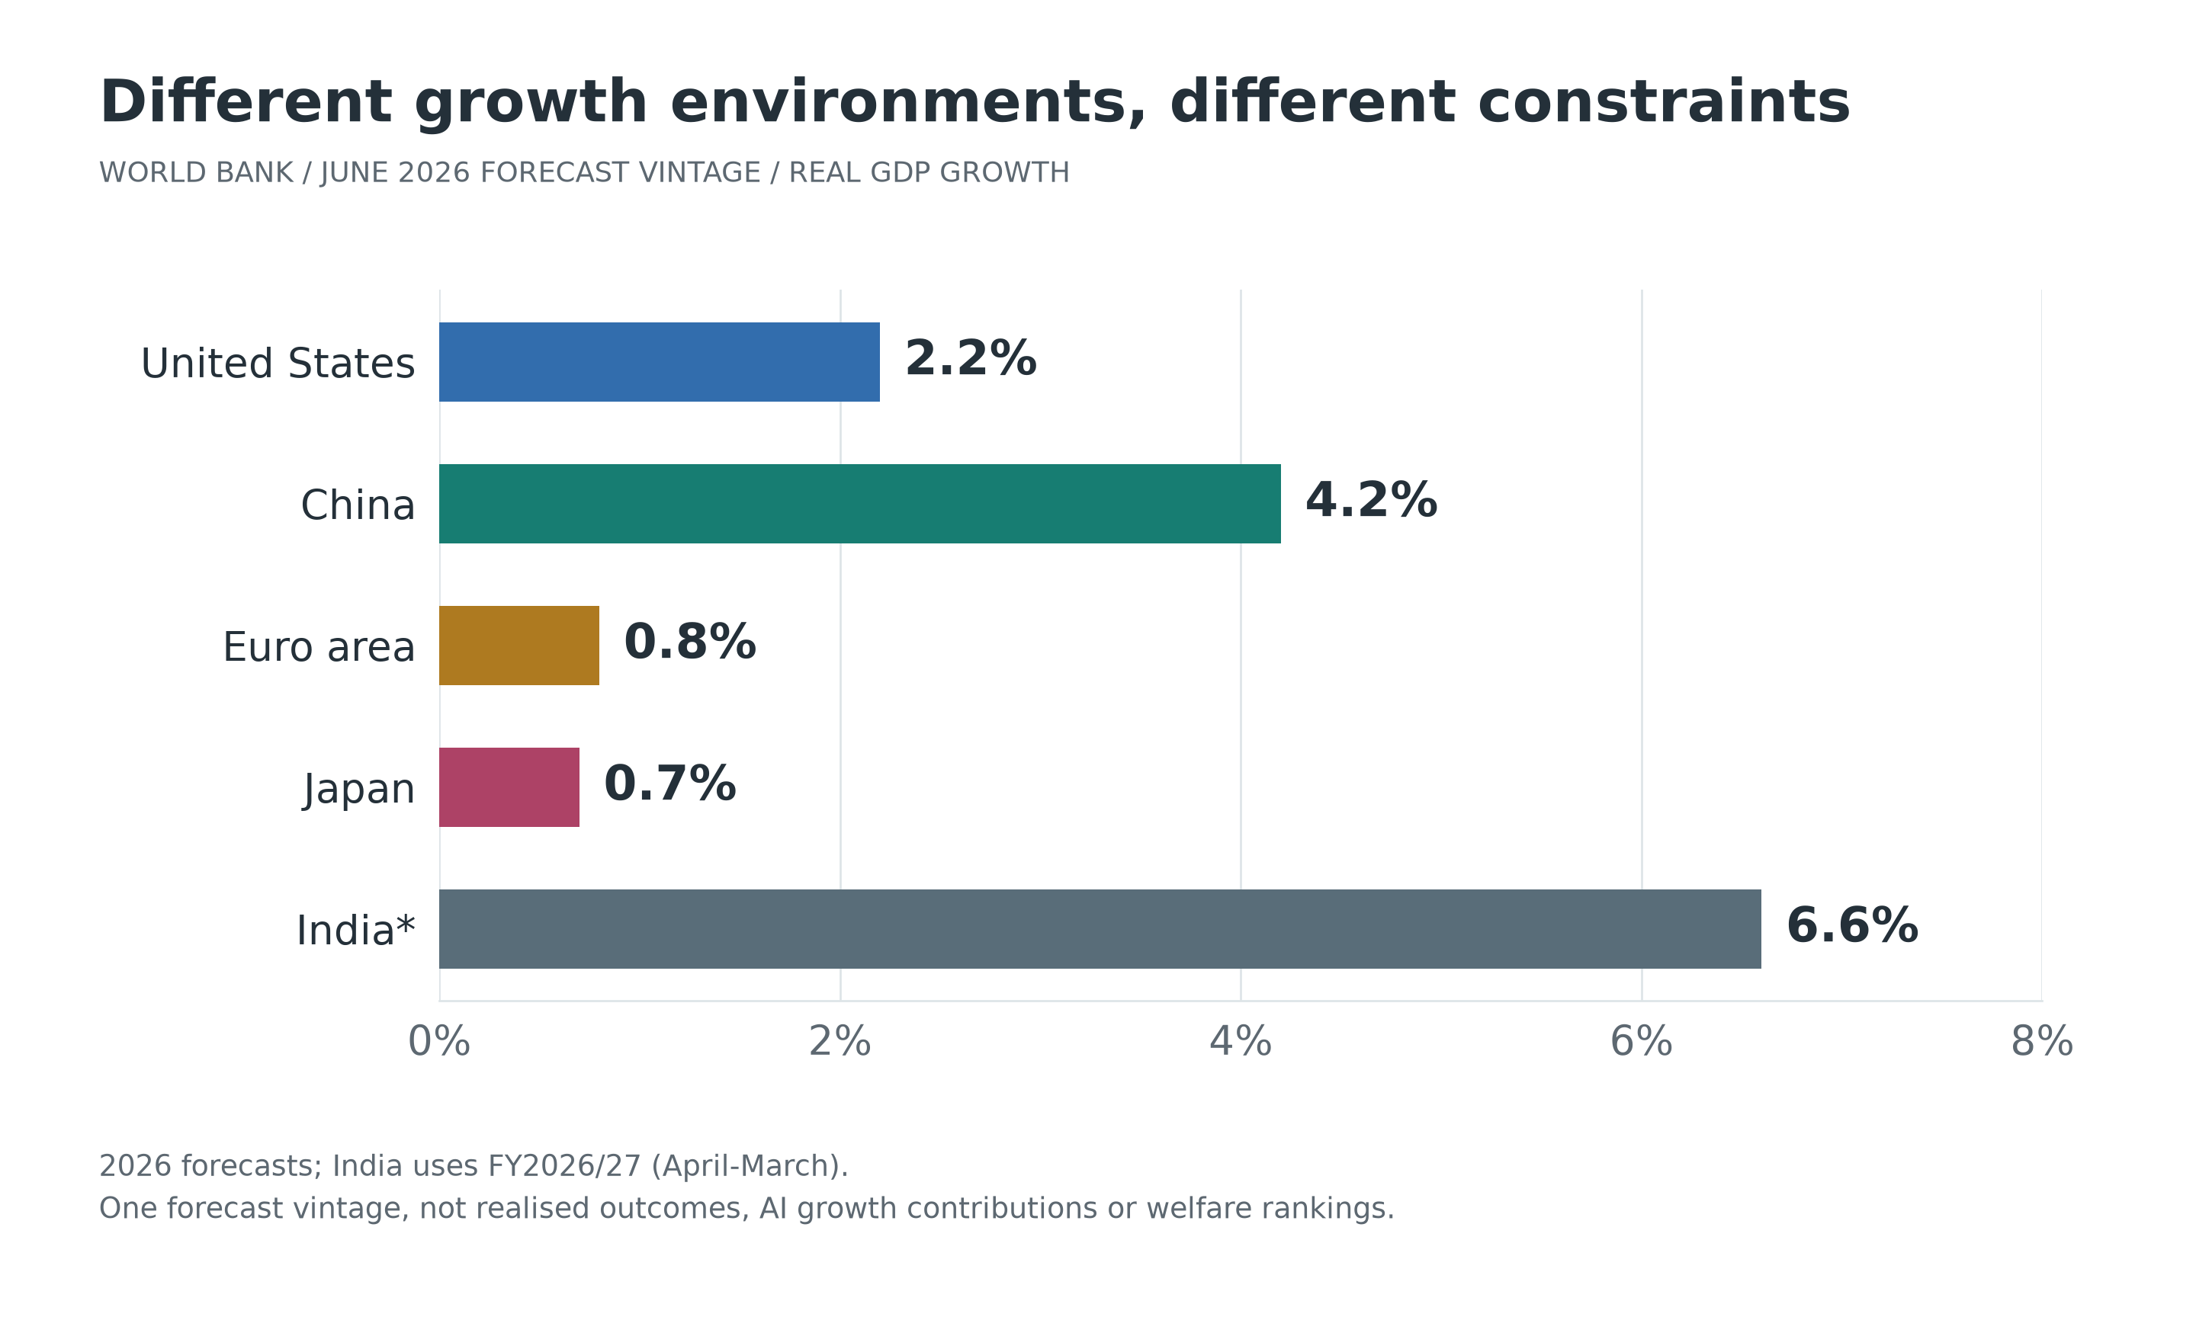
Figure 7. The growth environment: World Bank June 2026 forecasts for five economies
Note: Forecasts for 2026, or FY2026/27 for India.[18] All bars use the same forecast vintage. They are neither realised full-year outcomes nor estimates of AI's contribution to growth.
Monetary policy is not moving on one timetable. On 29 July 2026, the Federal Reserve maintained a federal funds target range of 3.50%-3.75%; its September meeting had not occurred at the evidence cutoff.[19] On 10 September, the ECB announced a 25bp increase effective 16 September. Its deposit rate was therefore still 2.25% at cutoff, with 2.50% announced for the future.[20] On 31 July, the Bank of Japan guided the uncollateralised overnight call rate to around 1.0%.[21] Announcement dates, implementation dates and observation dates are not interchangeable.
AI investment thus takes place amid inflation, energy and financing constraints, not in a technological vacuum. Country comparison should examine conversion across the three worlds rather than classify one country as a needs economy and another as a mental economy.

10.2 United States: scalable innovation and uneven diffusion
The United States has important advantages in frontier models, cloud computing, research and venture finance. Deep capital markets can fund highly uncertain projects. Stanford's 2026 AI Index reports US private AI investment of USD285.9 billion in 2025, compared with USD12.4 billion in China. These private-investment figures do not measure total national capability or include all public spending.[15]
In the three-world framework, a strength is the rapid conversion of digital and human capabilities into scalable business services and financial assets. Constraints may appear in electricity networks, construction, technical labour, and essential living costs such as health care and housing. Strong technology profits can coexist with substantial household insecurity.
Equity performance must distinguish leading technology firms from the broader economy, and sales growth from free cash flow after capital expenditure. The dollar benefits from market depth and payment and financing networks, not technological leadership alone. Welfare diffusion should be tested through productivity outside technology firms, real median incomes, service affordability, competition and career transitions.

10.3 China: engineering capability, domestic demand and household balance sheets
Manufacturing ecosystems, engineering skills, supply chains and numerous application settings support embodied and industrial deployment in China. Its large installed automation base does not establish maturity in every open environment, but it provides important conditions for connecting algorithms to equipment, processes and maintenance.[17]
For January-July 2026, China's National Bureau of Statistics reports industrial value-added growth of 5.3%, high-tech manufacturing value-added growth of 13.8%, nominal retail-sales growth of 1.2%, and a 19.2% decline in property-development investment. August CPI rose 0.8% year on year.[22][23] These series differ in coverage and price treatment; subtracting their growth rates would not measure a statistical supply-demand gap. They do, however, motivate separate analysis of industrial upgrading, household spending and property adjustment.
The challenge is to convert engineering efficiency into sustainable cash flows, real income and public services rather than project counts alone. Social protection, local public finances, housing balance sheets and private-business expectations influence the conversion of needs into effective demand. Embodied deployments should be evaluated through real orders, acceptance, repeat purchases and maintenance, limiting duplication that substitutes for commercial validation.
Capital-market analysis also requires investor protection, distributions to shareholders, governance and competition. Technological output does not automatically become shareholder return. The renminbi depends on domestic demand, interest differentials, trade, capital movements, policy and expectations, not exports or robot numbers alone.

10.4 Euro area: social protection, industrial knowledge and scale finance
The euro area combines industrial capabilities, engineering knowledge, public services and institutional resources that can support trusted AI, health care, manufacturing and energy efficiency. Energy costs, fragmented markets, innovation finance and cross-border scaling can constrain conversion. The Draghi competitiveness report provides structural context on innovation, energy and financing, not a 2026 growth forecast.[24]
Social protection entails costs and fiscal commitments, but can also reduce transition risk and increase acceptance of new technologies. Regulation can increase compliance costs or reduce uncertainty through clear responsibility and common standards. Neither less regulation nor more protection has an unconditionally beneficial or harmful effect that can be assumed without evidence.
A common currency coexists with different national fiscal, industrial and debt conditions, so AI returns and energy shocks need not be evenly distributed. Equity comparisons with the United States should control for sector composition and valuation rather than index changes alone. The euro's international role likewise depends on asset depth, institutional coordination and cross-border finance, not the number of European model companies.

10.5 Japan: automation under ageing and relational-service constraints
Japan's industrial robotics, precision manufacturing and experience of operational improvement can help turn cognitive capability into dependable physical services. Ageing and labour shortages in some occupations create demand for logistics, manufacturing, care assistance and independent-living technologies. Demography also constrains fiscal capacity and market growth; automation is not a costless demographic solution.
Japan offers a particularly useful setting for distinguishing substitution for missing labour from substitution for relationships. Equipment that handles lifting, records and monitoring may free care workers to communicate. Equipment used mainly to remove contact can have different social consequences. Relevant demand includes older people's consent, privacy and choices, not only an employer's willingness to pay.
The Tokyo Stock Exchange's initiative on management conscious of capital costs and share prices provides institutional context for capital allocation.[25] The yen responds to interest differentials, policy normalisation, imported energy, overseas investment income and risk positions. Depreciation can improve translated foreign profits for some firms while raising household import costs. Exporter gains cannot be equated with universal benefit.

10.6 India: development needs, digital services and employment absorption
India combines a large young population with digital-service and software capabilities, while still facing major tasks in infrastructure, education, health and formal employment. Its World Bank growth forecasts use fiscal years. Rapid aggregate growth does not replace analysis of income per person, job quality or regional disparities.[26]
AI can lower capability barriers through multilingual services, assisted teaching, local administration and small-business tools. Some standardised outsourcing tasks may simultaneously face automation and international pressure. The task is not only to train a small number of highly skilled specialists, but to establish accessible jobs, foundational education and field-service capability at scale.
Imported energy and equipment, external finance and currency fluctuations affect both investment and household living conditions. The rupee and asset prices require analysis of inflation, capital flows, valuation and external vulnerability. Population scale is an opportunity rather than an automatic dividend. Health, education and employment institutions must convert population into capabilities before digital growth produces broadly shared well-being.

10.7 Competitiveness as conversion capability
Economy | Notable conversion conditions | Constraints to examine | Welfare test
United States | Models, cloud, research, innovation finance | Electricity, construction, living costs, concentration | Do returns reach ordinary firms and households?
China | Manufacturing networks, engineering, application settings | Demand, balance sheets, duplicated investment | Does industrial efficiency improve incomes and public services?
Euro area | Industrial knowledge, protection, standards | Energy, fragmentation, scale finance | Can secure transitions coexist with wider innovation?
Japan | Automation experience, precision, care demand | Population, fiscal capacity, organisational renewal | Does technology support independent living and human care?
India | Population potential, digital services, multilingual applications | Foundational capabilities, jobs, external costs | Do gains extend across the population?

Table note: This is structural analysis, not a quantitative ranking. Each economy contains substantial sectoral, regional, income and generational differences; the conditions are not fixed national characteristics.

11 Capital Markets and Money

11.1 Social value, corporate cash flow and security prices
A technology can greatly improve lives without generating exceptional corporate profit, because competition, free provision or public services pass the gains to users. A firm can also earn high profits through exclusion without proportionate social gains. Equity prices concern expected cash flows attributable to shareholders, discount rates and risk. They do not directly score U.
Hardware and electricity suppliers, model and platform firms, application businesses and end users face different return mechanisms. Upstream suppliers may receive early orders but face falling prices after capacity expands. Applications may improve efficiency but transfer the benefits to customers through competition. Large capital expenditure can separate accounting profit from free cash flow. Depreciation assumptions, equipment replacement, financing and sustained utilisation therefore require attention.
In a purely hypothetical example, earnings per share rise 20% while the price-earnings multiple falls from 35 to 25. The price return is 1.2 × 25 / 35 - 1, approximately -14.3%, excluding dividends and currency effects. Being correct about a technology's direction does not guarantee a positive return at a particular purchase price. An industrial narrative does not establish a recommendation to buy or sell an individual security.

11.2 Bonds, property and infrastructure
Bond yields reflect expected short-term rates, term premia, inflation, credit and liquidity, among other factors. AI-led potential growth may improve the tax base, while initial investment, energy bottlenecks and fiscal commitments increase financing pressure. Distant cash flows are more sensitive to interest rates. Long-term social usefulness does not remove maturity mismatch or repayment risk.
Housing is both an asset and an essential living condition. Higher prices can increase owners' wealth while worsening affordability for renters and first-time buyers. Technology clusters and data centres can also affect land, electricity and housing costs. Not every asset-price gain represents an increase in society-wide well-being.
Infrastructure analysis must distinguish public benefits from contractual cash flows. Overestimated demand, rapid obsolescence or delayed grid access may create stranded assets. Tokenising claims, data or property primarily changes registration, transfer and divisibility. It does not automatically increase real supply or eliminate underlying credit and legal risks.

11.3 Exchange rates are not overall technology scores
A nominal exchange rate is the relative price of two currencies. Real effective rates also reflect relative prices and trade weights. Short-run exchange rates respond to expected interest differentials, risk appetite, positions and capital flows. Longer-run conditions include productivity, trade structure, external balance sheets, institutions and monetary credibility. Structural relationships may help explain tendencies without reliably predicting near-term levels.
AI competitiveness may improve service exports or attract capital, but may also increase imports of chips, energy and equipment, or remit profits to foreign owners. Technological strength does not necessarily imply appreciation. Appreciation improves import purchasing power while potentially compressing tradable-sector profits. Depreciation's distributional effects depend on import exposure, foreign-currency debt, invoicing and pass-through.
International monetary roles also rest on networks of invoicing, payments, financing, collateral and hedging. The final tables of the BIS 2025 Triennial Survey, released in June 2026, report April 2025 currency involvement shares of 89.2% for the US dollar, 28.9% for the euro, 16.8% for the yen, 8.5% for the renminbi and 1.9% for the Indian rupee.[27]
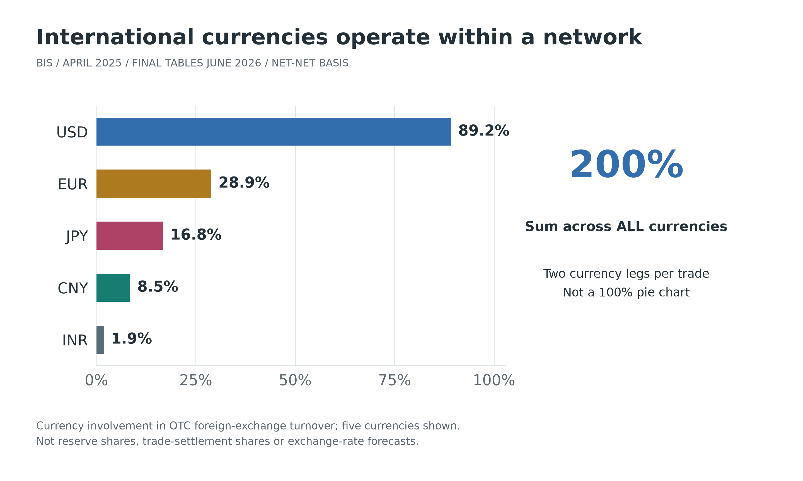
Figure 8. Currency networks in foreign-exchange trading: involvement shares
Note: BIS final Table 4, April 2025, net-net basis, released June 2026.[27] Each trade involves two currencies, so shares sum to 200% across all currencies; only five are shown. These are not reserve shares, trade-settlement shares or prospective returns, and should not be presented as a 100% pie chart.
Digital payments and agents may lower transaction frictions, but faster settlement does not establish a currency's credibility, convertibility or stock of safe assets. Technical infrastructure and monetary institutions are complements, not substitutes.

11.4 Cross-border returns need an explicit numeraire
Let S be local-currency units per US dollar. If the local total return includes reinvested local dividends, the unhedged dollar return is:
$(7) 1 + R_{USD} = (1 + R_{local}) × S_{start} / S_{end}$
For illustration only, a 10% local total return with a 5% increase in S implies local-currency depreciation and a dollar return of 1.10 / 1.05 - 1, approximately 4.8%. Hedging involves forward points, interest differentials, basis and transaction costs; it does not costlessly remove every risk.
Market comparisons should align periods, currencies, dividends, sector composition and valuations. This study supplies neither unverified live prices nor point forecasts. Its financial contribution is a sequence of questions: how capability produces cash flows, who owns them, what price and risk already incorporate, and how financial outcomes feed back into household life.

12 Institutions and Policy

12.1 Physical foundations rather than duplicated equipment
Grids, dependable energy, testing facilities, transport and maintenance can relax shared constraints more effectively than equipment procurement alone. Public support should distinguish fundamental research, demonstration and commercial deployment, using different horizons and acceptance criteria. Commercial projects should progressively demonstrate actual utilisation, quality and collections.
Energy and environmental policy should allocate reasonable system costs to new loads rather than invisibly transferring them to residents, while retaining incentives for applications with genuine net savings. Safety, repairability, lifetime and end-of-life responsibility belong in embodied-system procurement. Where essential supply is tight, expanding provision can address price pressure more effectively than purchasing-power subsidies alone.

12.2 Digital conditions: contestability, verification and exit
Interoperability, appropriate data portability, multi-supplier procurement and transparent authorisation can reduce lock-in. Public data access must still respect privacy, confidentiality and re-identification risks. Competition policy should address evidenced exclusion, market control and merger effects, rather than judge firms solely by size or technical form.
High-consequence agent actions require least-necessary permissions, transaction limits, traceable logs, audits and interruptibility. When failures occur, accountable deployers, providers or other relevant parties must be identifiable. Complexity should not create a responsibility vacuum; unclear liability can also obstruct reliable innovation.

12.3 Human capabilities and non-market spaces
Education and transition support should provide funded learning time, real practice and routes to employment, not simply subsidise course enrolments. Applications for children and vulnerable users need stronger protections concerning privacy, commercial persuasion and dependence. Long-run autonomous capability matters more than clicks or immediate completion counts alone.
Public culture, community services and care have independent value. They need not prove that they increase commercial output to merit consideration. Supporting creativity does not require everyone to monetise leisure. Rest and exit are also expressions of respect for finite human time.

12.4 Distributional instruments involve genuine trade-offs
Instrument | What it can address | Constraints that remain
Basic public services | Barriers to education, health, housing and capabilities | Supply, quality, access and fiscal sustainability
Social insurance and transition support | Income risks during unemployment and learning | Non-standard employment, real vacancies and incentives
Wages, profit sharing and working-time arrangements | Sharing efficiency and time gains with workers | Firm differences, bargaining and possible income reductions
Broad capital ownership or public funds | Sharing capital returns beyond wage income | Diversification, governance, financing and intergenerational fairness
Taxes and cash transfers, including basic-income proposals | Purchasing power and reduced eligibility complexity | Costs, tax bases, supply limits and services cash cannot replace
Competition and externality policy | Price diffusion, rent limits and cost accountability | Enforcement, coordination and incentives for useful innovation

Debates over a robot tax should first specify the objective. A crude levy on equipment counts may penalise energy-saving, safer or shortage-relieving investment and encourage reclassification. Policies tied to actual income, excess rents, external costs and tax neutrality can be easier to justify, followed by examination of the labour-capital tax structure. Reform still faces mobility, coordination and administrative constraints.
Universal basic income is one proposal to investigate, not an automatic consequence of technology. It requires resources, credible finance and social choice. Cash cannot fully replace disability support, health care, relationships or public participation. The useful question is how instruments can be combined, tested and assessed with explicit costs and beneficiaries.

12.5 Practical governance inside firms
Projects can specify both financial acceptance tests and indicators of people's circumstances: completion rates, error distributions, cost per accepted task, intervention burdens, safety, learning opportunities and exit costs. Workers should be able to report deployment risks, and affected customers should receive appropriate explanations and avenues of appeal.
Governance should also state when updates require revalidation and how service continues if a supplier withdraws. Tracking sustained use, collections, capability and recovery is more informative than counting licences or robots. Sustainable operation, not a demonstration, establishes economic value.

13 Testing the Model

13.1 Do not conceal conflict inside one score
Layer | Suggested indicators | Common misinterpretation
Physical conditions | Accepted-service costs, energy, safety, resilience, life cycle | More equipment or less energy per task equals net social benefit
Digital conditions | Data quality, verification, migration costs, actual use, concentration | Data volume, generation or registrations equal capability
Human capabilities | Independent performance, transfer, entry routes, long-run learning | Tool-assisted speed equals human capability accumulation
Distribution and demand | Real wages, labour share, ownership, prices, services, debt burdens | Aggregate profits or output imply widespread gains
Mental life and existence | Discretionary time, relationships, meaning, appeal, considered evaluation | Satisfaction, retention or consumption measure all welfare
Intertemporal constraints | Ecological state, maintenance, fiscal promises, future capabilities | Shifting a cost into the future removes it

Indicators should be disaggregated by income, age, gender, region and disability. Subjective measures require attention to adaptive preferences and cultural comparability; objective measures also need explicit boundaries. A composite index must disclose weights, minimum protections and sensitivity. In many settings, reporting several outcomes and their conflicts is more informative than one overall ranking.[10]

13.2 Six propositions that evidence can revise
Proposition one: complementary bottlenecks. For comparable tasks, increasing model capability alone should yield smaller output gains where verification, energy or organisation binds. Complementary investments should modify that relationship. Staggered deployments can help if actual bottlenecks, not just purchases, are measured. Persistent proportional output gains without complementary change would narrow the bottleneck claim.
Proposition two: learning design affects long-run capability. Assistance with practice and feedback should outperform simple task completion in subsequent unaided performance and transfer. Consensual educational or workplace trials can measure quality, time, attrition and distributional effects. If differences do not emerge, claims about the specific design must be revised.
Proposition three: distribution mediates demand. Similar technical savings with different wage, price and public-service transmission should yield different household spending and welfare outcomes. Identification must separate adoption selection, local cycles and sector composition. Faster-growing firms adopting earlier does not establish a causal technology effect.
Proposition four: engagement and long-run agency can diverge. With informed participation and appropriate safeguards, alternative recommendation objectives can be compared through short-term interaction and later regret, time use, health and goal attainment. The proposition does not assume recommendations are harmful; it tests whether platform metrics proxy user interests.
Proposition five: embodied adoption depends on task economics. At comparable task and quality, utilisation, standardisation and intervention costs should explain meaningful differences in unit cost. Samples must include failed and discontinued deployments rather than only demonstrations and successful customers.
Proposition six: rights and participation influence sustainable adoption. At similar reliability, clear responsibility, appeal, worker participation and portability may improve trust, retention and continued use. Compliance costs and supply responses must also be measured rather than assuming governance is costless.
Randomised trials, natural experiments, staggered policy and longitudinal studies have different uses. Difference-in-differences requires checks for parallel trends, anticipation and spillovers. General-equilibrium effects prevent organisational gains from being mechanically added to national totals. Pre-specified outcomes, observation windows and failure conditions help keep the framework from interpreting every result as confirmation.

13.3 Four conditional scenarios, not four predetermined futures
The scenarios look forward from the evidence cutoff, with particular attention to adjustment over the next one to three years. They assign no probabilities, forecast no AGI arrival date and supply no asset-price targets. The horizontal axis concerns reliable deployment and complementary investment; the vertical concerns benefit diffusion and safeguards for agency. These are combinations of conditions, not natural developmental stages.
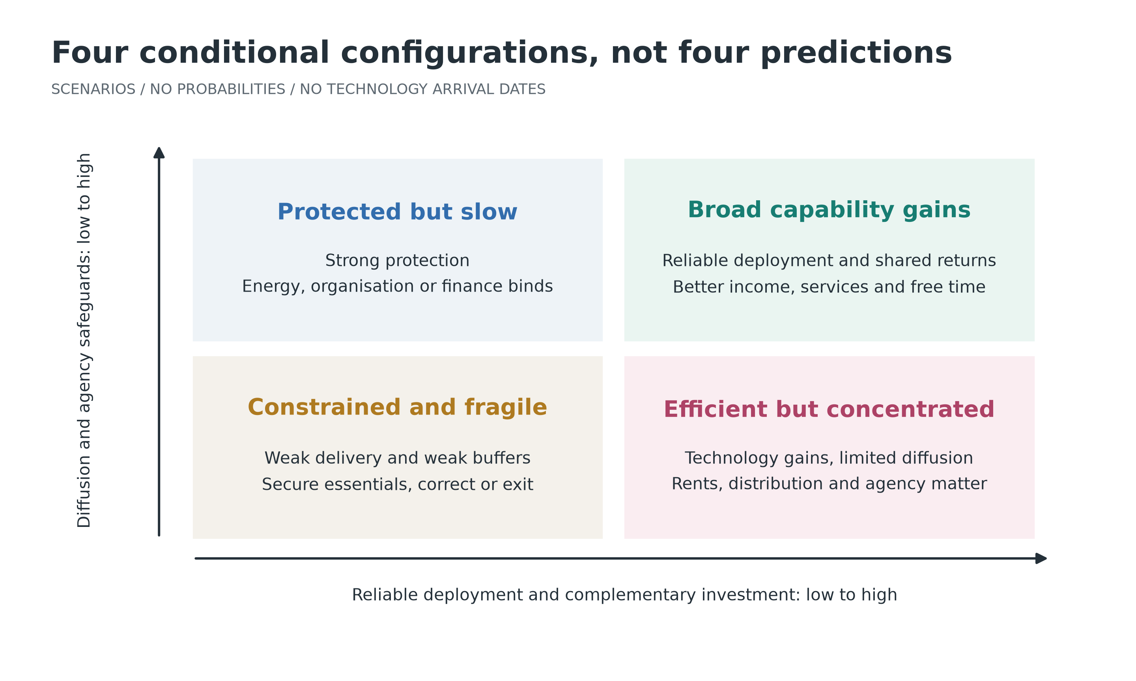
Figure 9. Four conditional configurations: deployment, diffusion and agency
Note: Author's conditional scenarios, not probabilistic forecasts. Energy, geopolitical and fiscal conditions can move outcomes between configurations, and several can coexist within one economy.
The first is broad capability enhancement: reliable deployment, competition, transitions and public services improve together, transmitting gains into prices, income and discretionary time. Relevant signals are downstream adoption, service quality, real income and skills, not leading firms' profits alone.
The second is high efficiency with concentrated returns: capability advances, but market control, weaker entry routes and limited sharing restrict welfare diffusion. Some assets may perform strongly while households remain under pressure. Rents, ownership and agency require attention; this is not automatically general prosperity.
The third is protection with slow diffusion: social buffers are stronger but energy, organisation or finance constrains deployment. Policy should relax identifiable bottlenecks while maintaining quality. Redistribution cannot alone create services that cannot yet be supplied.
The fourth is a constrained and fragile transition: unreliable results and disappointing investment meet weak protection and correction. Leverage, supplier exit and local fiscal stress can amplify losses. Priorities include essentials, high-consequence risk control and exit from ineffective projects, rather than larger narratives that defer adjustment.

13.4 Limits of the framework
The three worlds are analytical dimensions, not scientific proof that reality consists of three independent substances. They are neither mutually exclusive nor directly additive statistical sectors. Economic performance alone cannot settle consciousness, meaning or moral status. Future systems may create risks different from present deployments; current samples do not establish a definitive upper bound.
Conversion among Pc, Dc and Mc requires measurable definitions for specific industries. Cultures differ in their understandings of need and good lives. Constraints should be justified through public reasoning and participation, not imposed as one author's preferred way of living. The testable contribution lies in mechanisms, conditions and policy effects, not a few cases claimed to prove a universal theory.

14 Conclusion: Economic Purposes Cannot Be Outsourced
AI makes some cognitive services easier to scale, and embodied intelligence lets them participate more deeply in physical action. This may mark an important change in production and organisation. It does not abolish material scarcity, distribution or finite human lives. Instead, it makes the distance between what can be produced and why, by whose decisions and for whose benefit, more visible.
The physical world requires attention to resources, bodies, ecology and safety. The digital world requires an understanding of copying, networks, rights and verification. The mental world requires learning, relationships, reflection and meaning to be protected. Together they condition what technology can do; the original triad of needs, desire and existence asks what these capabilities should serve.
A desirable AI economy does not require people to compete forever with machines over every task, nor reduce people to passive consumption and administration. It should make essential life more secure, learning and creativity more accessible, returns and responsibilities more fairly shared, and participation in shaping one's life more widely available.
The final test is therefore not how much intelligence a society possesses, but whether more abundant intelligence leaves needs better protected, desire more autonomous, existence more dignified, and future generations with meaningful choices.

Appendix A. Continuity with the Earlier Manuscripts
Earlier core argument | Retention and development in this study
Needs as a protected floor | Chapters 1, 3, 8 and 12 distinguish needs, purchasing power and public provision
Desire as innovation and expansion | Chapters 1, 6 and 7 connect creativity, comparison and algorithmic feedback
Existence as the value foundation | Chapters 1, 7 and 14 retain dignity, agency, relationships and finite time without grounding human value in productivity
Interaction rather than rigid hierarchy | Chapters 1 and 3 distinguish intersecting dimensions from country labels or historical stages
Conversion of Pc, Dc and Mc into U | Chapters 2 and 3 add tasks, institutions, ownership, income and demand
HMc and AIMc | Chapters 3, 4 and 7 separate functional intelligence, human capability and moral standing
Work, alienation and self-realisation | Chapters 7, 8 and 9 retain entry routes, learning, bargaining and participation
Time, care and cultural inheritance | Chapters 7, 9 and 12 examine non-market activity, relational value and future capabilities
GDP and prices are not welfare | Chapters 3, 8, 11 and 13 distinguish value added, cash flow, asset prices and U
Ecology and intergenerational responsibility | Chapters 2, 5, 12 and 13 address life cycles, public costs and intertemporal constraints
Economies, capital markets and currencies | Chapters 10 and 11 retain the earlier extension within the three-world mechanism
Limits and empirical inquiry | Chapters 1 and 13 specify hypotheses, possible refutation and identification limits

The source materials are the Chinese draft, Needs, Desire and Existence (Dasein): Towards a Triadic Value Theory of Economic Activity, identified as based on an OWU version; its contemporary-economy and AI revision; and the note mapping their core arguments. The supplied draft does not fully and consistently define the acronyms TWVE and OWU. No expansion is invented here. "Three-world economic model" is a descriptive name for the present analytical framework.

Appendix B. Terms, Models and Evidence Conventions
Term | Meaning and boundary
Physical, digital and mental worlds | Three dimensions of activity, not exclusive accounting categories or independent substances
Mental world | Cognition, emotion, meaning, culture, relationships and subjective experience; not confined to religion
Pc | Resources, equipment, infrastructure and natural conditions; not all are tradable assets
Dc | Reusable data, code, content and networks; quality and lawful usability matter
Mc / HMc | Cognitive and cooperative capabilities / human capabilities; not the total value of a person
AIMc / A | Functional AI cognitive services or capabilities; no assumption of consciousness or personhood
U | Multidimensional well-being, not purchases, satisfaction, market prices or GDP
Needs / effective demand | Conditions preventing capability deprivation / purchasing power expressed in spending
Agents / embodied intelligence | Delegated workflow actions / closed-loop action in physical environments; humanoid form is not required
Equations (1)-(7) | Conceptual functions, constraints, cash budgets and a return identity, not a fully estimated structural model

Evidence conventions: growth uses one World Bank June 2026 vintage; AI investment and adoption have private-investment and survey-sample boundaries; robotics refers to industrial installations in 2024; energy covers all data centres; currency involvement shares total 200%; and the support-worker productivity example uses the specified NBER version. Figures 4 and 6 and the valuation and cross-currency examples are hypothetical calculations.
The study assigns no mental-value score to countries or people, does not attribute short-run macroeconomic forecasts to AI, and does not treat present functional evidence as a final answer on consciousness. The English and Chinese editions share chapter structure, figure numbers, equation numbers and reference numbering.

References
The references support the intellectual background, specific mechanisms and dated evidence. The cutoff for online evidence is 12 September 2026. Original files, extracted text and source metadata are retained in the earlier research directory. Classical works are not empirical evidence of contemporary technology effects.
[1] Sen, A. (1985). Commodities and Capabilities. North-Holland; Sen, A. (1999). Development as Freedom. Oxford University Press.
Distinguishes resources and subjective satisfaction from substantive capabilities.
[2] Heidegger, M. (1927). Sein und Zeit [Being and Time].
A philosophical source; Dasein is not identified with a welfare index or factor of production.
[3] Maslow, A. H. (1943). A Theory of Human Motivation. Psychological Review, 50(4), 370-396. Source
Used critically, without assuming a universally rigid hierarchy.
[4] Keynes, J. M. (1936). The General Theory of Employment, Interest and Money. Macmillan.
Effective demand is distinct from basic needs in the normative sense.
[5] Schumpeter, J. A. (1942). Capitalism, Socialism and Democracy. Harper & Brothers.
Background on innovation, entrepreneurship and creative destruction.
[6] Veblen, T. (1899). The Theory of the Leisure Class. Macmillan; Bourdieu, P. (1979). La distinction. Les Editions de Minuit.
Sources on status, taste and social recognition, not direct diagnoses of individual motives.
[7] Akerlof, G. A., & Kranton, R. E. (2000). Economics and Identity. The Quarterly Journal of Economics, 115(3), 715-753. Source
An established economic treatment of identity and behaviour.
[8] Deci, E. L., & Ryan, R. M. (2000). The What and Why of Goal Pursuits: Human Needs and the Self-Determination of Behavior. Psychological Inquiry, 11(4), 227-268. Source
Autonomy, competence and relatedness; these concepts are not interchangeable with Dasein.
[9] Marx, K. (1844). Economic and Philosophic Manuscripts of 1844.
1844 is the year of composition; cited for the analysis of alienated labour.
[10] Stiglitz, J. E., Sen, A., & Fitoussi, J.-P. (2009). Report by the Commission on the Measurement of Economic Performance and Social Progress. Source
Distinguishes GDP, quality of life and sustainability; full report hosted by Eurostat.
[11] Acemoglu, D., & Restrepo, P. (2019). Automation and New Tasks: How Technology Displaces and Reinstates Labor. Journal of Economic Perspectives, 33(2), 3-30. Source
Mechanisms of displacement, new tasks and labour demand.
[12] Brynjolfsson, E., Li, D., & Raymond, L. R. (2023; revised November 2023). Generative AI at Work. NBER Working Paper 31161. Source
The 5,179 workers and approximately 14% estimate refer to the working-paper version listed on the NBER page. Later published in QJE 140(2), 889-942 (2025); versions are not mixed.
[13] Brynjolfsson, E., Rock, D., & Syverson, C. (2021). The Productivity J-Curve: How Intangibles Complement General Purpose Technologies. American Economic Journal: Macroeconomics, 13(1), 333-372. Source
Also NBER WP 25148; complementary intangible investment and measurement lags.
[14] Acemoglu, D. (2024). The Simple Macroeconomics of AI. NBER Working Paper 32487; published in Economic Policy, 40(121), 13-58 (2025). Source
A task-based, parameter-dependent analysis, not a fixed upper bound on future technological effects.
[15] Stanford Institute for Human-Centered Artificial Intelligence (2026). The 2026 AI Index Report, including Chapter 4: Economy. Source Additional source
2025 private AI investment: US USD285.9bn and China USD12.4bn; not total public and private spending. The 88% adoption figure refers to surveyed organisations, not a global business census.
[16] International Energy Agency (2026-04-16). Key Questions on Energy and AI. Executive Summary. Source
All data centres: 485 TWh in 2025 is an estimate, and 950 TWh in 2030 a central projection; not AI-only electricity.
[17] International Federation of Robotics (2025-09-25). World Robotics 2025: Global Robot Demand in Factories Doubles Over 10 Years. Source
Industrial robot installations in 2024, not humanoid shipments or evidence of general embodied competence.
[18] World Bank (2026-06-11). Global Economic Prospects, June 2026. Table 1.1: Real GDP, official data workbook. Source Additional source
Consistent 2025e, 2026f and 2027f columns. India uses April-March fiscal years; world aggregates use the source's market-exchange-rate weights, not PPP weights.
[19] Federal Reserve (2026-07-29). Federal Reserve issues FOMC statement. Source Additional source
Target range 3.50%-3.75%; the September 15-16 meeting had not occurred at the evidence cutoff.
[20] European Central Bank (2026-09-10). Monetary policy decisions. Source Additional source
A 25bp increase was announced, effective September 16. Deposit rate at cutoff: 2.25%; announced future rate: 2.50%.
[21] Bank of Japan (2026-07-31). Statement on Monetary Policy, p. 1. Source
Uncollateralised overnight call-rate guidance of around 1.0%.
[22] National Bureau of Statistics of China (2026-08-17). National Economy Maintained Steady Momentum with Innovation-driven and High-quality Development in the First Seven Months. Source
January-July 2026 activity data; industrial value added, nominal retail sales and property investment differ in coverage and price concepts.
[23] National Bureau of Statistics of China (2026-09-10). Consumer Price Index in August 2026. Source
August 2026 CPI: +0.8% year on year, not an annual forecast.
[24] Draghi, M. (2024). The Future of European Competitiveness. European Commission. Source
Used for structural analysis of innovation, energy and finance, not as a 2026 growth forecast.
[25] Tokyo Stock Exchange / Japan Exchange Group. Action to Implement Management that is Conscious of Cost of Capital and Stock Price (Prime and Standard Markets). Source
Initiated March 31, 2023; the source page includes an April 28, 2026 update.
[26] World Bank (2026-06). Global Economic Prospects: South Asia, Regional Highlights, pp. 1-3. Source
India FY2026/27 runs from April 2026 to March 2027.
[27] Bank for International Settlements (2026-06, final tables). Triennial Central Bank Survey of Foreign Exchange and OTC Derivatives Markets in 2025. Table 4. Source Additional source
April 2025 currency involvement shares, net-net basis; two currency legs per trade mean shares sum to 200% across all currencies.
[28] Kahneman, D., & Tversky, A. (1979). Prospect Theory: An Analysis of Decision under Risk. Econometrica, 47(2), 263-291. Source
An established behavioural extension of conventional choice models.
[29] Coase, R. H. (1937). The Nature of the Firm. Economica, 4(16), 386-405. Source
Transaction and organisational costs explain firm boundaries; this is not itself a forecast of AI-era firm size.
[30] Ostrom, E. (1990). Governing the Commons: The Evolution of Institutions for Collective Action. Cambridge University Press.
Institutional background on collective action and governance beyond a single market-state dichotomy.
[31] Arrow, K. J. (1962). Economic Welfare and the Allocation of Resources for Invention. In The Rate and Direction of Inventive Activity: Economic and Social Factors, pp. 609-626. Princeton University Press / NBER.
A classic analysis of knowledge, incentives for invention and welfare.
[32] Baumol, W. J. (1967). Macroeconomics of Unbalanced Growth: The Anatomy of Urban Crisis. American Economic Review, 57(3), 415-426.
Used to analyse uneven productivity growth and relative service costs.
[33] Simon, H. A. (1971). Designing Organizations for an Information-Rich World. In M. Greenberger (ed.), Computers, Communications, and the Public Interest, pp. 37-72. Johns Hopkins Press.
Background on information abundance and scarce attention.
[34] Kant, I. (1785). Groundwork of the Metaphysics of Morals [Grundlegung zur Metaphysik der Sitten].
Ethical background on treating persons as ends, not merely as means; not a complete derivation of policy.

