Pengajar : Mas Arif Setiawan

Nama Peserta : Selfhy Agina Ginting

Nomor Peserta : JVSB001ONL011

Kelas : Back End Development with Java Springboot

Tugas Challenge Sesi 10

Create table

1. **Create table pegawai**

SET NAMES utf8;

SET time_zone = '+00:00';

SET foreign_key_checks = 0;

SET sql_mode = 'NO_AUTO_VALUE_ON_ZERO';

SET NAMES utf8mb4;

DROP TABLE IF EXISTS `tb_pegawai`;

CREATE TABLE `tb_pegawai` (

`id_pegawai` varchar(50) NOT NULL,

`nama_pegawai` varchar(50) NOT NULL,

`alamat` varchar(100) DEFAULT NULL,

`jenis_kelamin` enum('laki-laki','perempuan') NOT NULL,

`tg_lahir` date NOT NULL,

`no_telp` varchar(20) NOT NULL,

`status` varchar(50) NOT NULL,

`jabatan` varchar(50) NOT NULL,

`id_gaji` varchar(50) NOT NULL,

PRIMARY KEY (`id_pegawai`),

KEY `id_gaji` (`id_gaji`),

CONSTRAINT `tb_pegawai_ibfk_1` FOREIGN KEY (`id_gaji`) REFERENCES `tb_gaji` (`id_gaji`)

) ENGINE=InnoDB DE

1. **Create table gaji**

SET NAMES utf8;

SET time_zone = '+00:00';

SET foreign_key_checks = 0;

SET sql_mode = 'NO_AUTO_VALUE_ON_ZERO';

SET NAMES utf8mb4;

DROP TABLE IF EXISTS `tb_gaji`;

CREATE TABLE `tb_gaji` (

`id_gaji` varchar(50) NOT NULL,

`gaji` int(50) NOT NULL,

`tgl_gaji` date NOT NULL,

PRIMARY KEY (`id_gaji`)

) ENGINE=InnoDB DEFAULT CHARSET=utf8mb4;

1. **Create table pembeli**

SET NAMES utf8;

SET time_zone = '+00:00';

SET foreign_key_checks = 0;

SET sql_mode = 'NO_AUTO_VALUE_ON_ZERO';

SET NAMES utf8mb4;

DROP TABLE IF EXISTS `tb_pembeli`;

CREATE TABLE `tb_pembeli` (

`id_pembeli` varchar(50) NOT NULL,

`nama_pembeli` varchar(50) NOT NULL,

`alamat` varchar(100) NOT NULL,

`jenis_kelamin` enum('laki-laki','perempuan') NOT NULL,

`tgl_lahir` date NOT NULL,

`status` varchar(50) NOT NULL,

`no_telp` varchar(20) DEFAULT NULL,

`pekerjaan` varchar(50) NOT NULL,

PRIMARY KEY (`id_pembeli`)

) ENGINE=InnoDB DEFAULT CHARSET=utf8mb4;

1. **Create table menu**

SET NAMES utf8;

SET time_zone = '+00:00';

SET foreign_key_checks = 0;

SET sql_mode = 'NO_AUTO_VALUE_ON_ZERO';

SET NAMES utf8mb4;

DROP TABLE IF EXISTS `tb_menu`;

CREATE TABLE `tb_menu` (

`id_menu` varchar(50) NOT NULL,

`nama_menu` varchar(50) NOT NULL,

`jenis` varchar(50) NOT NULL,

`harga` int(50) NOT NULL,

PRIMARY KEY (`id_menu`)

) ENGINE=InnoDB DEFAULT CHARSET=utf8mb4;

1. **Create table transaksi**

SET NAMES utf8;

SET time_zone = '+00:00';

SET foreign_key_checks = 0;

SET sql_mode = 'NO_AUTO_VALUE_ON_ZERO';

SET NAMES utf8mb4;

DROP TABLE IF EXISTS `tb_transaksi`;

CREATE TABLE `tb_transaksi` (

`id_transaksi` varchar(50) NOT NULL,

`id_pembeli` varchar(50) NOT NULL,

`id_menu` varchar(50) NOT NULL,

`id_pegawai` varchar(50) NOT NULL,

`tgl_transaksi` date NOT NULL,

KEY `id_pembeli` (`id_pembeli`),

KEY `id_menu` (`id_menu`),

KEY `id_pegawai` (`id_pegawai`),

CONSTRAINT `tb_transaksi_ibfk_1` FOREIGN KEY (`id_pembeli`) REFERENCES `tb_pembeli` (`id_pembeli`),

CONSTRAINT `tb_transaksi_ibfk_2` FOREIGN KEY (`id_menu`) REFERENCES `tb_menu` (`id_menu`),

CONSTRAINT `tb_transaksi_ibfk_3` FOREIGN KEY (`id_pegawai`) REFERENCES `tb_pegawai` (`id_pegawai`)

) ENGINE=InnoDB DEFAULT CHARSET=utf8mb4;

Insert

1. **Insert into tb_pegawai**

SET NAMES utf8;

SET time_zone = '+00:00';

SET foreign_key_checks = 0;

SET sql_mode = 'NO_AUTO_VALUE_ON_ZERO';

SET NAMES utf8mb4;

INSERT INTO `tb_pegawai` (`id_pegawai`, `nama_pegawai`, `alamat`, `jenis_kelamin`, `tg_lahir`, `no_telp`, `status`, `jabatan`) VALUES

('pegawai1', 'selfhy agina ginting', 'jalan setiabudi medan', 'perempuan', '2000-07-29', '08123456789', 'belum menikah', 'BTDP'),

('pegawai2', 'defhy regina ginting', 'jalan kapt. pattimura ', 'perempuan', '2000-07-29', '08123456789', 'belum menikah', 'law'),

('pegawai3', 'muhammad syahbana', 'jalan sudirman ', 'laki-laki', '2001-08-27', '08123456789', 'belum menikah', 'politik'),

('pegawai4', 'budiman ', 'jalan haji juanda', 'laki-laki', '1997-10-08', '08123456789', 'menikah', 'head of security'),

('pegawai5', 'putri ayu', 'jalan kapt. pattimura ', 'perempuan', '1998-02-02', '08123456789', 'menikah', 'bussiness lead');

1. **Insert into tb_gaji**

SET NAMES utf8;

SET time_zone = '+00:00';

SET foreign_key_checks = 0;

SET sql_mode = 'NO_AUTO_VALUE_ON_ZERO';

SET NAMES utf8mb4;

INSERT INTO `tb_gaji` (`id_gaji`, `gaji`, `tgl_gaji`, `id_pegawai`) VALUES

('gaji1', 3000000, '2022-01-01', 'pegawai3'),

('gaji2', 9000000, '2022-02-02', 'pegawai1'),

('gaji3', 9000000, '2022-02-02', 'pegawai2'),

('gaji4', 15000000, '2022-02-02', 'pegawai4'),

('gaji5', 10000000, '2022-01-01', 'pegawai5');

1. **Insert into tb_menu**

SET NAMES utf8;

SET time_zone = '+00:00';

SET foreign_key_checks = 0;

SET sql_mode = 'NO_AUTO_VALUE_ON_ZERO';

SET NAMES utf8mb4;

INSERT INTO `tb_menu` (`id_menu`, `nama_menu`, `jenis`, `harga`) VALUES

('menu1', 'ayam goreng', 'makanan', 18000),

('menu2', 'nasi goreng', 'makanan', 15000),

('menu3', 'aqua', 'minuman', 4000),

('menu4', 'jus jeruk', 'minuman', 18000),

('menu5', 'kentang goreng', 'snack', 10000);

1. **Insert into tb_pembeli**

SET NAMES utf8;

SET time_zone = '+00:00';

SET foreign_key_checks = 0;

SET sql_mode = 'NO_AUTO_VALUE_ON_ZERO';

SET NAMES utf8mb4;

INSERT INTO `tb_pembeli` (`id_pembeli`, `nama_pembeli`, `alamat`, `jenis_kelamin`, `tgl_lahir`, `status`, `no_telp`, `pekerjaan`) VALUES

('pembeli1', 'rhania', 'jalan sunggal ', 'perempuan', '0000-00-00', 'belum menikah', '08123456789', 'mahasiswa'),

('pembeli2', 'rivany', 'jalan tembung', 'perempuan', '2000-01-03', 'belum menikah', '08123456789', 'mahasiswa'),

('pembeli3', 'dimas', 'tebing tinggi', 'laki-laki', '2000-02-10', 'belum menikah', '08123456789', 'software developer'),

('pembeli4', 'cindy', 'jalan setiabudi medan', 'perempuan', '1998-01-03', 'belum menikah', '08123456789', 'software engineer'),

('pembeli5', 'dharmawan', 'jalan dr mansyur', 'laki-laki', '2000-10-23', 'belum menikah', '08123456789', 'bussiness intern');

1. **Insert into tb_transaksi**

SET NAMES utf8;

SET time_zone = '+00:00';

SET foreign_key_checks = 0;

SET sql_mode = 'NO_AUTO_VALUE_ON_ZERO';

SET NAMES utf8mb4;

INSERT INTO `tb_transaksi` (`id_transaksi`, `id_pembeli`, `id_menu`, `id_pegawai`, `tgl_transaksi`) VALUES

('transaksi1', 'pembeli1', 'menu2', 'pegawai1', '2022-09-20'),

('transaksi2', 'pembeli3', 'menu4', 'pegawai2', '2022-10-20'),

('transaksi3', 'pembeli5', 'menu1', 'pegawai4', '2022-12-09'),

('transaksi4', 'pembeli5', 'menu5', 'pegawai5', '2022-10-20'),

('transaksi5', 'pembeli3', 'menu4', 'pegawai2', '2022-12-09');

Select

1. **Select all from tb_pegawai**

SELECT * FROM tb_pegawai

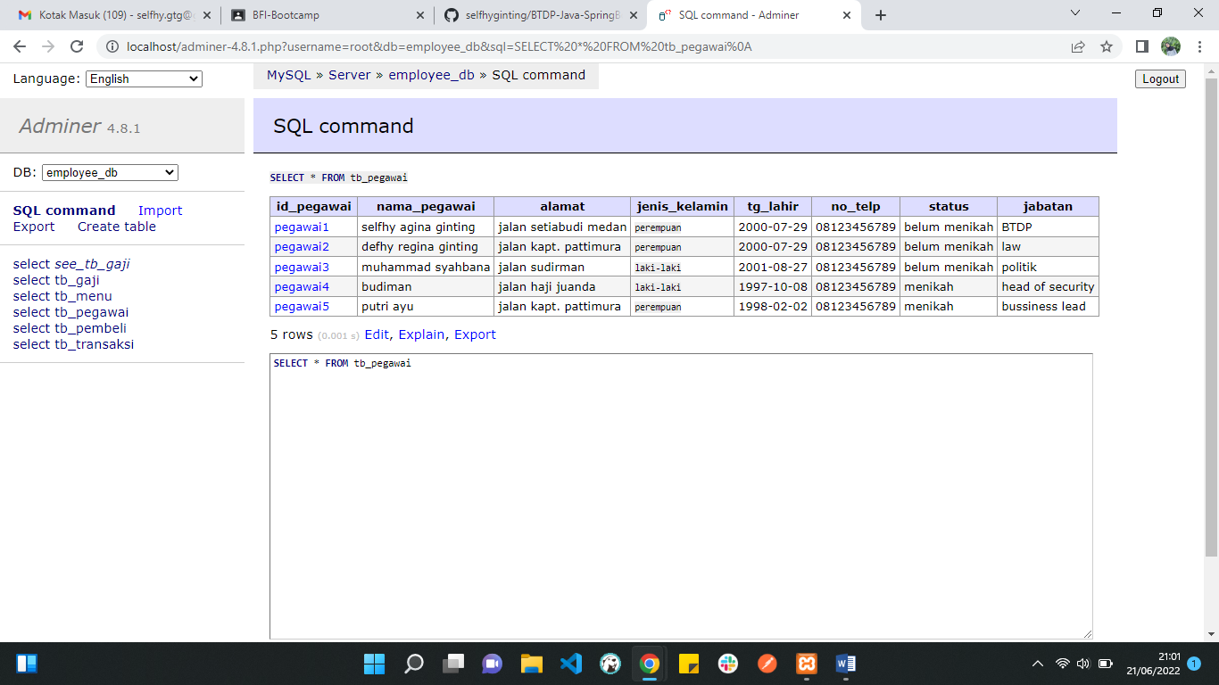

1. **Select all from tb_gaji**

SELECT * FROM tb_gaji

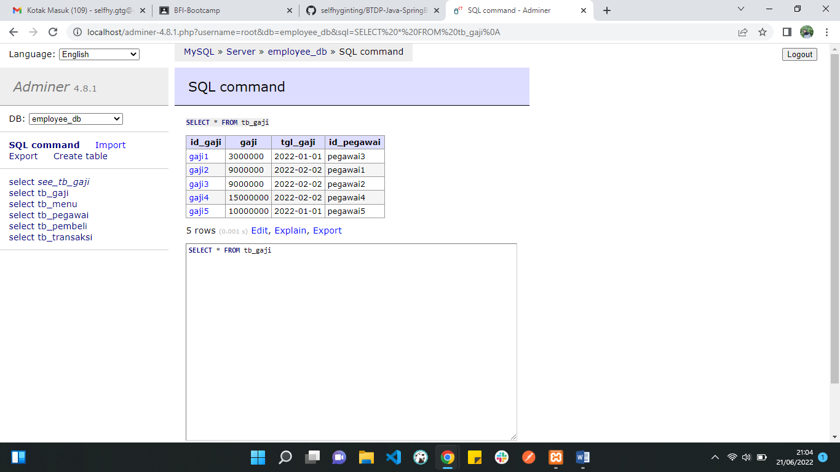

1. **Select all from tb_menu**

SELECT * FROM tb_menu

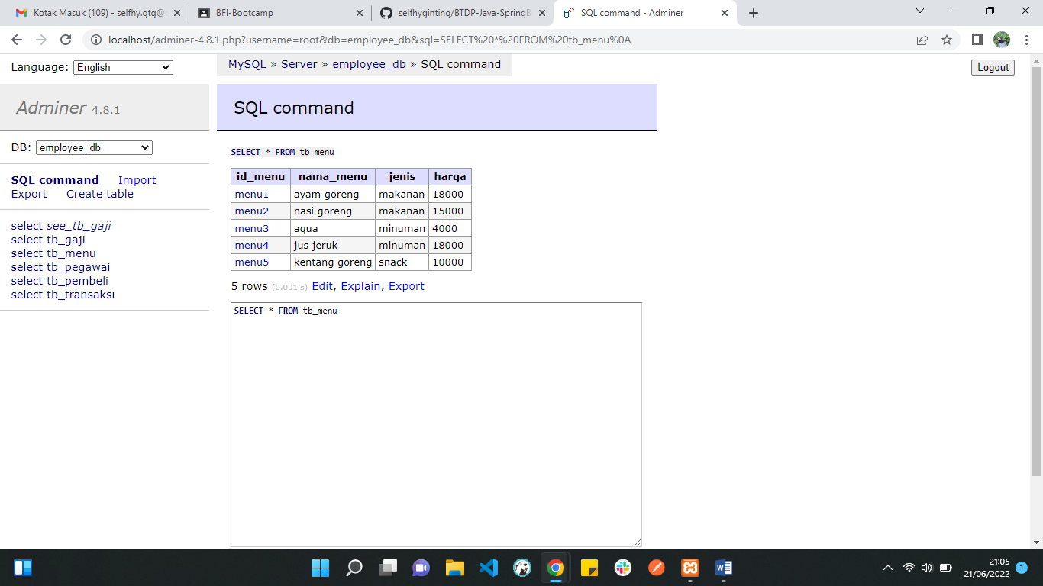

1. **Select all from tb_pembeli**

SELECT * FROM tb_pembeli

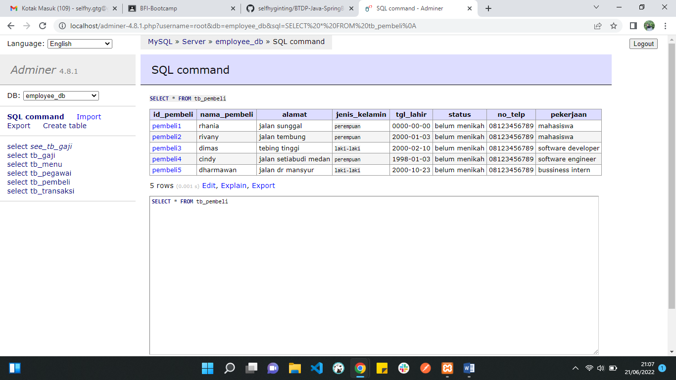

1. **Select all from tb_transaksi**

SELECT * FROM tb_transaksi

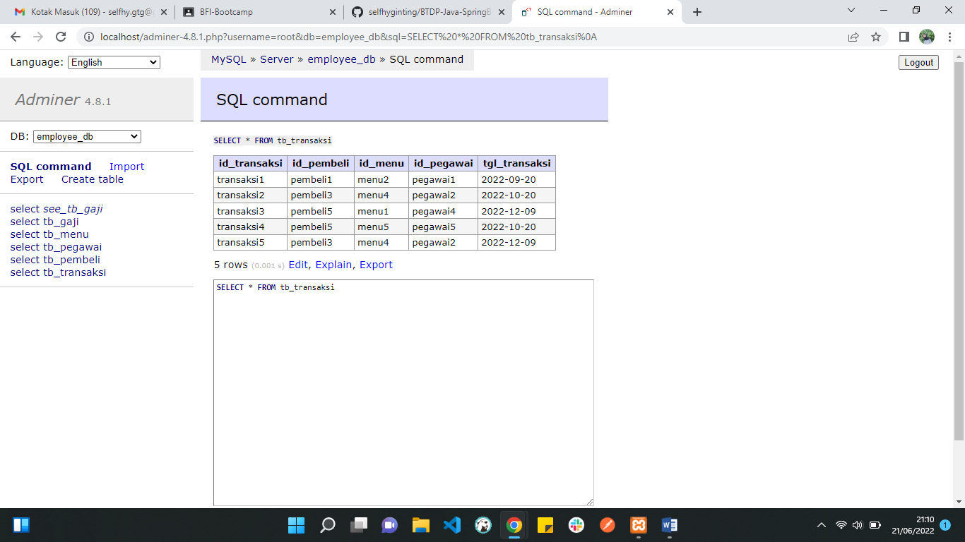

View

View Nama Pegawai, Jabatan, Gaji

CREATE VIEW view_1 AS

SELECT tp.nama_pegawai as Nama_Pegawai, tp.jabatan as Jabatan, tg.gaji as Gaji  
FROM [tb_pegawai](http://localhost/adminer-4.8.1.php?username=root&db=employee_db&table=tb_pegawai) tp   
JOIN [tb_gaji](http://localhost/adminer-4.8.1.php?username=root&db=employee_db&table=tb_gaji) tg ON tp.id_pegawai = tg.id_pegawai;

Delete

**Delete 1 row transaksi**

[**DELETE**](https://mariadb.com/kb/en/library/delete/) FROM [tb_transaksi](http://localhost/adminer-4.8.1.php?username=root&db=employee_db&table=tb_transaksi) WHERE id_transaksi='transaksi5';