Pengajar : Mas Arif Setiawan

Nama Peserta : Selfhy Agina Ginting

Nomor Peserta : JVSB001ONL011

Kelas : BTDP Java Springboot

Tugas Database Sesi 12

**Requirements 1**

**Query Generated for Create table, Insert data into the table**

SET NAMES utf8;

SET time_zone = '+00:00';

SET foreign_key_checks = 0;

SET sql_mode = 'NO_AUTO_VALUE_ON_ZERO';

SET NAMES utf8mb4;

DROP TABLE IF EXISTS `tb_album`;

CREATE TABLE `tb_album` (

`id_album` varchar(100) NOT NULL,

`label` varchar(70) NOT NULL,

`tanggal_copyright` date NOT NULL,

`format` varchar(70) NOT NULL,

`id_lagu` varchar(100) NOT NULL,

PRIMARY KEY (`id_album`),

KEY `id_lagu` (`id_lagu`),

CONSTRAINT `tb_album_ibfk_5` FOREIGN KEY (`id_lagu`) REFERENCES `tb_lagu` (`id_lagu`)

) ENGINE=InnoDB DEFAULT CHARSET=utf8mb4;

INSERT INTO `tb_album` (`id_album`, `label`, `tanggal_copyright`, `format`, `id_lagu`) VALUES

('abc1', 'Doo-Wops & Hooligans', '2010-09-21', 'mp3', 'abc1'),

('abc2', 'Unorthodox Jukebox', '2020-01-01', 'mp3', 'abc2'),

('abc3', 'An Evening with Silk Sonic', '2021-10-10', 'mp3', 'abc3');

DROP TABLE IF EXISTS `tb_instrumen`;

CREATE TABLE `tb_instrumen` (

`id_instrumen` varchar(100) NOT NULL,

`nama_instrumen` varchar(100) NOT NULL,

`kunci_musik` varchar(10) NOT NULL,

PRIMARY KEY (`id_instrumen`)

) ENGINE=InnoDB DEFAULT CHARSET=utf8mb4;

INSERT INTO `tb_instrumen` (`id_instrumen`, `nama_instrumen`, `kunci_musik`) VALUES

('abc1', 'gitar', 'c#'),

('abc2', 'piano', 'c'),

('abc3', 'drum', 'low');

DROP TABLE IF EXISTS `tb_lagu`;

CREATE TABLE `tb_lagu` (

`id_lagu` varchar(100) NOT NULL,

`judul` varchar(70) NOT NULL,

`pengarang` varchar(100) NOT NULL,

PRIMARY KEY (`id_lagu`)

) ENGINE=InnoDB DEFAULT CHARSET=utf8mb4;

INSERT INTO `tb_lagu` (`id_lagu`, `judul`, `pengarang`) VALUES

('abc1', 'liqour store blues', 'bruno mars'),

('abc2', 'young girls', 'bruno mars'),

('abc3', 'smokin out the window', 'bruno mars');

DROP TABLE IF EXISTS `tb_musisi`;

CREATE TABLE `tb_musisi` (

`id_ssn` varchar(100) NOT NULL,

`nama` varchar(70) NOT NULL,

`alamat` varchar(100) DEFAULT NULL,

`nomor_telepon` varchar(70) NOT NULL,

`id_instrumen` varchar(100) NOT NULL,

`id_album` varchar(100) NOT NULL,

PRIMARY KEY (`id_ssn`),

KEY `id_instrumen` (`id_instrumen`),

KEY `id_album` (`id_album`),

CONSTRAINT `tb_musisi_ibfk_7` FOREIGN KEY (`id_instrumen`) REFERENCES `tb_instrumen` (`id_instrumen`),

CONSTRAINT `tb_musisi_ibfk_9` FOREIGN KEY (`id_album`) REFERENCES `tb_album` (`id_album`)

) ENGINE=InnoDB DEFAULT CHARSET=utf8mb4;

INSERT INTO `tb_musisi` (`id_ssn`, `nama`, `alamat`, `nomor_telepon`, `id_instrumen`, `id_album`) VALUES

('abc1', 'selfhy ', 'jalan setiabudi medan', '08123456789', 'abc1', 'abc1'),

('abc2', 'putri', 'jalan kapt. pattimura ', '08123456789', 'abc2', 'abc2');

**View All Data Query and Result Screenshot :**

create view semua_data as

select tm.id_ssn, tm.nama, tm.alamat, tm.nomor_telepon,

ta.label, ta.tanggal_copyright, ta.format,

tl.judul, tl.pengarang,

ti.nama_instrumen, ti.kunci_musik

from tb_musisi tm

join tb_album ta on tm.id_album = ta.id_album

join tb_lagu tl on ta.id_lagu=tl.id_lagu

join tb_instrumen ti on tm.id_instrumen = ti.id_instrumen;

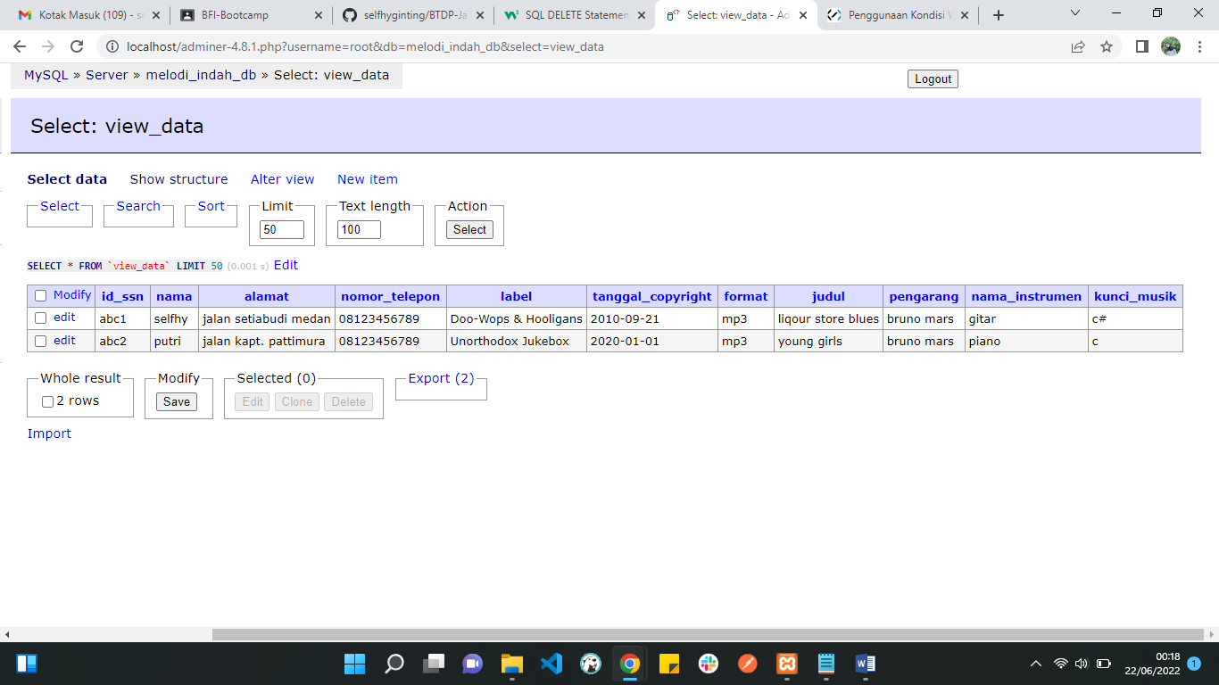

**Requirements 2**

**ERD**

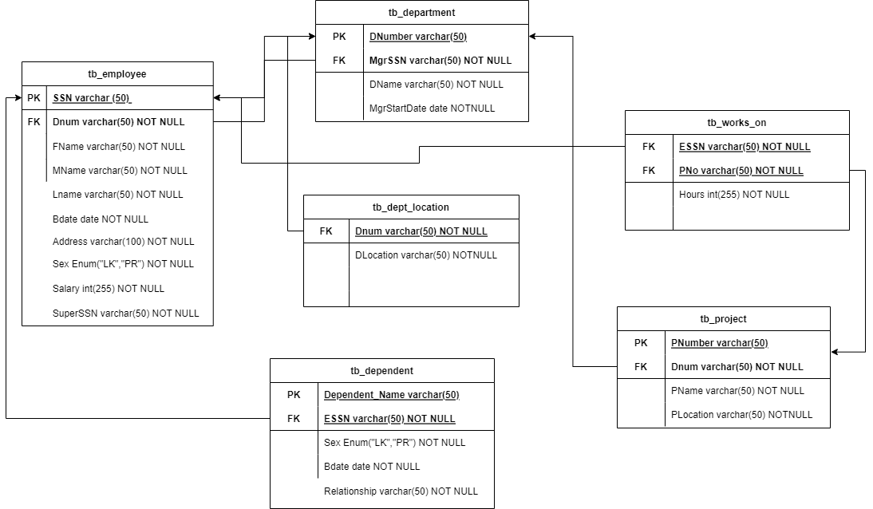

**Query Generated for Create table, Insert data into the table**

SET NAMES utf8;

SET time_zone = '+00:00';

SET foreign_key_checks = 0;

SET sql_mode = 'NO_AUTO_VALUE_ON_ZERO';

SET NAMES utf8mb4;

DROP TABLE IF EXISTS `tb_department`;

CREATE TABLE `tb_department` (

`DNumber` varchar(50) NOT NULL,

`DName` varchar(50) NOT NULL,

`MgrStartDate` date NOT NULL,

PRIMARY KEY (`DNumber`)

) ENGINE=InnoDB DEFAULT CHARSET=utf8mb4;

INSERT INTO `tb_department` (`DNumber`, `DName`, `MgrStartDate`) VALUES

('dnum1', 'IT Dept', '2022-06-13'),

('dnum2', 'Bussiness Dept', '2022-06-13'),

('dnum3', 'HR Dept', '2020-06-13');

DROP TABLE IF EXISTS `tb_dependent`;

CREATE TABLE `tb_dependent` (

`Dependent_Name` varchar(50) NOT NULL,

`Sex` enum('LK','PR') NOT NULL,

`Bdate` date NOT NULL,

`Relationship` varchar(50) NOT NULL,

`ESSN` varchar(50) NOT NULL,

PRIMARY KEY (`Dependent_Name`),

KEY `ESSN` (`ESSN`),

CONSTRAINT `tb_dependent_ibfk_1` FOREIGN KEY (`ESSN`) REFERENCES `tb_employee` (`SSN`)

) ENGINE=InnoDB DEFAULT CHARSET=utf8mb4;

INSERT INTO `tb_dependent` (`Dependent_Name`, `Sex`, `Bdate`, `Relationship`, `ESSN`) VALUES

('DRG', 'PR', '2000-07-29', 'Belum menikah', 'ssn3'),

('RP', 'PR', '1998-01-28', 'Belum menikah', 'ssn2'),

('SAG', 'PR', '2000-07-29', 'Belum menikah', 'ssn1');

DROP TABLE IF EXISTS `tb_dept_location`;

CREATE TABLE `tb_dept_location` (

`DLocation` varchar(50) NOT NULL,

`Dnum` varchar(50) NOT NULL,

KEY `Dnum` (`Dnum`),

CONSTRAINT `tb_dept_location_ibfk_1` FOREIGN KEY (`Dnum`) REFERENCES `tb_department` (`DNumber`)

) ENGINE=InnoDB DEFAULT CHARSET=utf8mb4;

INSERT INTO `tb_dept_location` (`DLocation`, `Dnum`) VALUES

('location1', 'dnum1'),

('location1', 'dnum2'),

('location2', 'dnum2'),

('location3', 'dnum3');

DROP TABLE IF EXISTS `tb_employee`;

CREATE TABLE `tb_employee` (

`SSN` varchar(50) NOT NULL,

`FName` varchar(50) NOT NULL,

`MName` varchar(50) NOT NULL,

`LName` varchar(50) NOT NULL,

`Bdate` date NOT NULL,

`Address` varchar(100) NOT NULL,

`Sex` enum('LK','PR') NOT NULL,

`Salary` int(255) NOT NULL,

`SuperSSN` varchar(100) NOT NULL,

`Dnum` varchar(50) NOT NULL,

PRIMARY KEY (`SSN`),

KEY `Dnum` (`Dnum`),

CONSTRAINT `tb_employee_ibfk_1` FOREIGN KEY (`Dnum`) REFERENCES `tb_department` (`DNumber`)

) ENGINE=InnoDB DEFAULT CHARSET=utf8mb4;

INSERT INTO `tb_employee` (`SSN`, `FName`, `MName`, `LName`, `Bdate`, `Address`, `Sex`, `Salary`, `SuperSSN`, `Dnum`) VALUES

('ssn1', 'Selfhy', 'Agina', 'Ginting', '2000-07-29', 'Jalan Setiabudi Medan', 'PR', 10000000, 'superssn1', 'dnum1'),

('ssn2', 'Risa', 'Annisa', 'Putri', '1998-01-28', 'Jalan Sudirman', 'PR', 6500000, 'superssn2', 'dnum2'),

('ssn3', 'Defhy', 'Regina', 'Ginting', '2000-07-29', 'Jalan Setiabudi Medan', 'PR', 9000000, 'superssn3', 'dnum3'),

('ssn4', 'Budi', 'Dermawan', 'Putra', '1998-01-01', 'Jalan Kapt. Pattimura', 'LK', 3000000, 'superssn4', 'dnum2');

DROP TABLE IF EXISTS `tb_project`;

CREATE TABLE `tb_project` (

`PNumber` varchar(50) NOT NULL,

`PName` varchar(50) NOT NULL,

`PLocation` varchar(50) NOT NULL,

`Dnum` varchar(50) NOT NULL,

PRIMARY KEY (`PNumber`),

KEY `Dnum` (`Dnum`),

CONSTRAINT `tb_project_ibfk_1` FOREIGN KEY (`Dnum`) REFERENCES `tb_department` (`DNumber`)

) ENGINE=InnoDB DEFAULT CHARSET=utf8mb4;

INSERT INTO `tb_project` (`PNumber`, `PName`, `PLocation`, `Dnum`) VALUES

('pnumber1', 'IT Project', 'Jakarta', 'dnum1'),

('pnumber2', 'Bussiness Requirements', 'Jakarta', 'dnum2'),

('pnumber3', 'Bussiness Sales', 'Jakarta', 'dnum2');

DROP TABLE IF EXISTS `tb_works_on`;

CREATE TABLE `tb_works_on` (

`Hours` int(255) NOT NULL,

`ESSN` varchar(50) NOT NULL,

`PNo` varchar(50) NOT NULL,

KEY `ESSN` (`ESSN`),

KEY `PNo` (`PNo`),

CONSTRAINT `tb_works_on_ibfk_1` FOREIGN KEY (`ESSN`) REFERENCES `tb_employee` (`SSN`),

CONSTRAINT `tb_works_on_ibfk_2` FOREIGN KEY (`PNo`) REFERENCES `tb_project` (`PNumber`)

) ENGINE=InnoDB DEFAULT CHARSET=utf8mb4;

INSERT INTO `tb_works_on` (`Hours`, `ESSN`, `PNo`) VALUES

(8, 'ssn1', 'pnumber1'),

(8, 'ssn2', 'pnumber1'),

(7, 'ssn3', 'pnumber2'),

(16, 'ssn1', 'pnumber1'),

(5, 'ssn1', 'pnumber3');

**Query dan Result for Question a – o**

1. screenshot dan query :

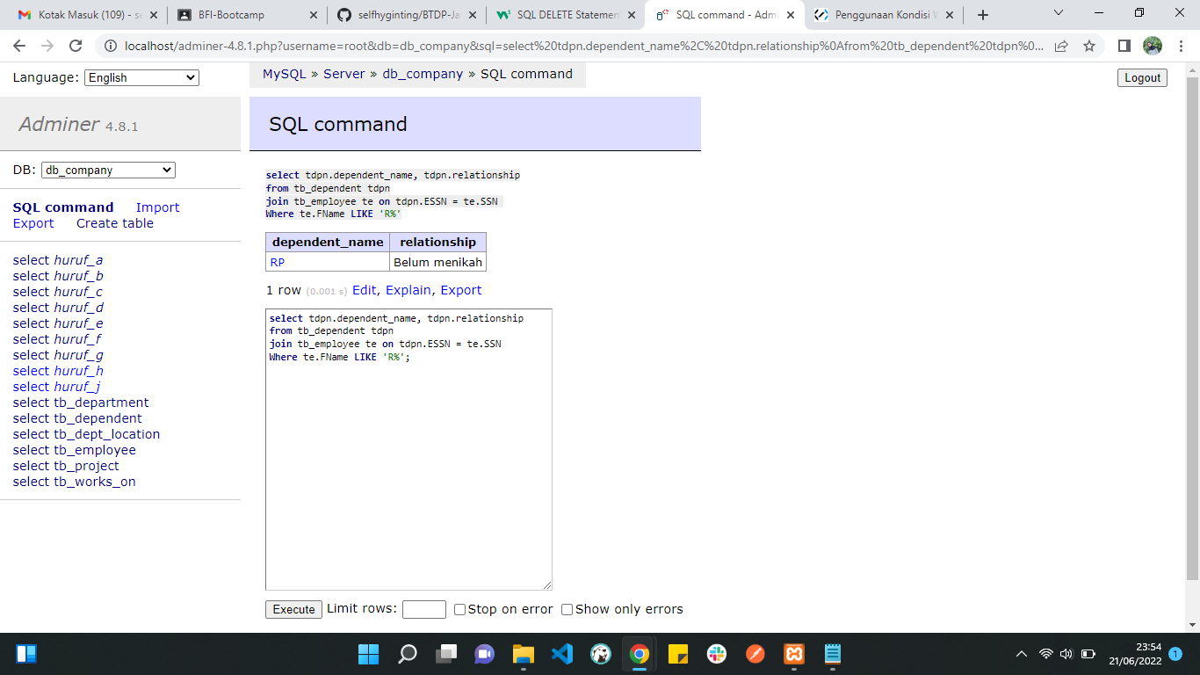

1. screenshot dan query :

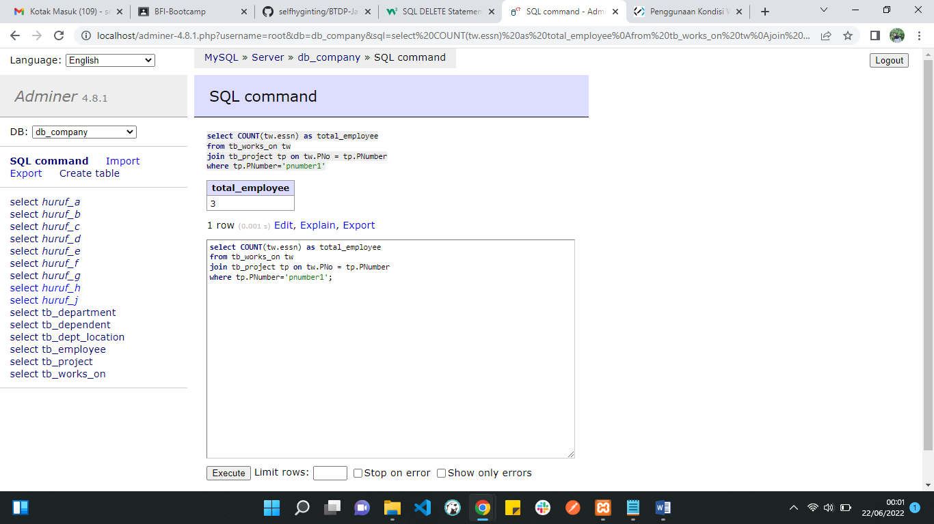

1. screenshot dan query :

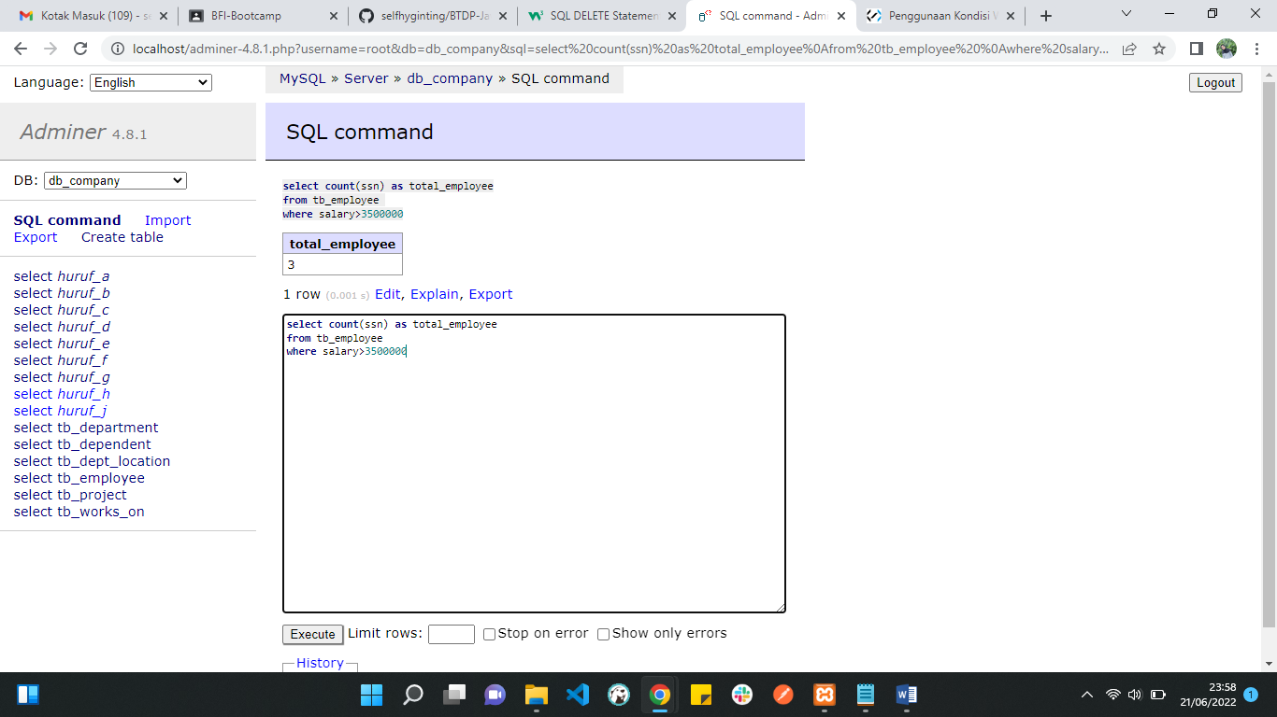

1. screenshot dan query :

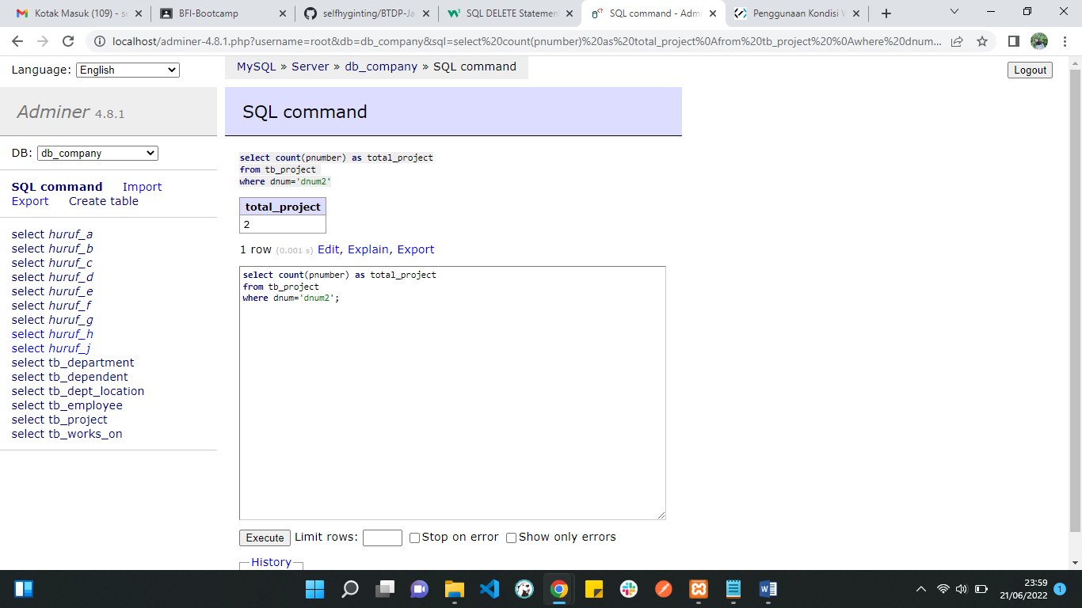

1. screenshot dan query :

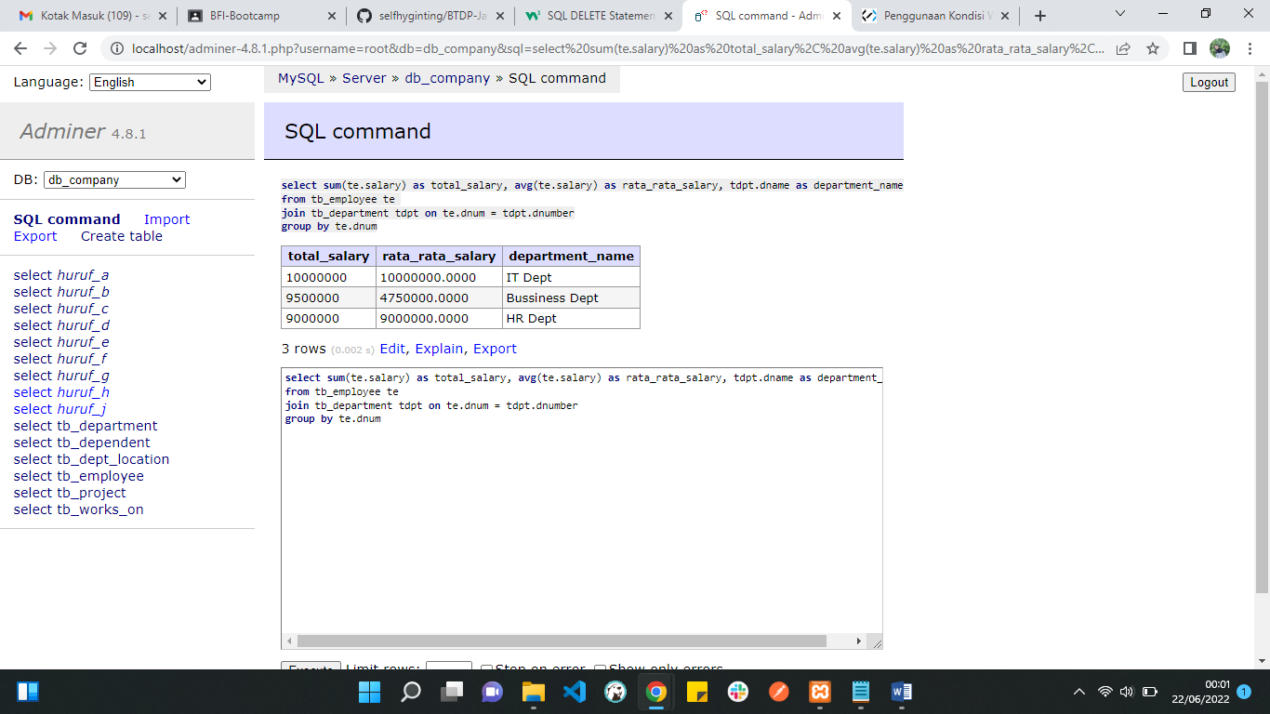

1. screenshot dan query :

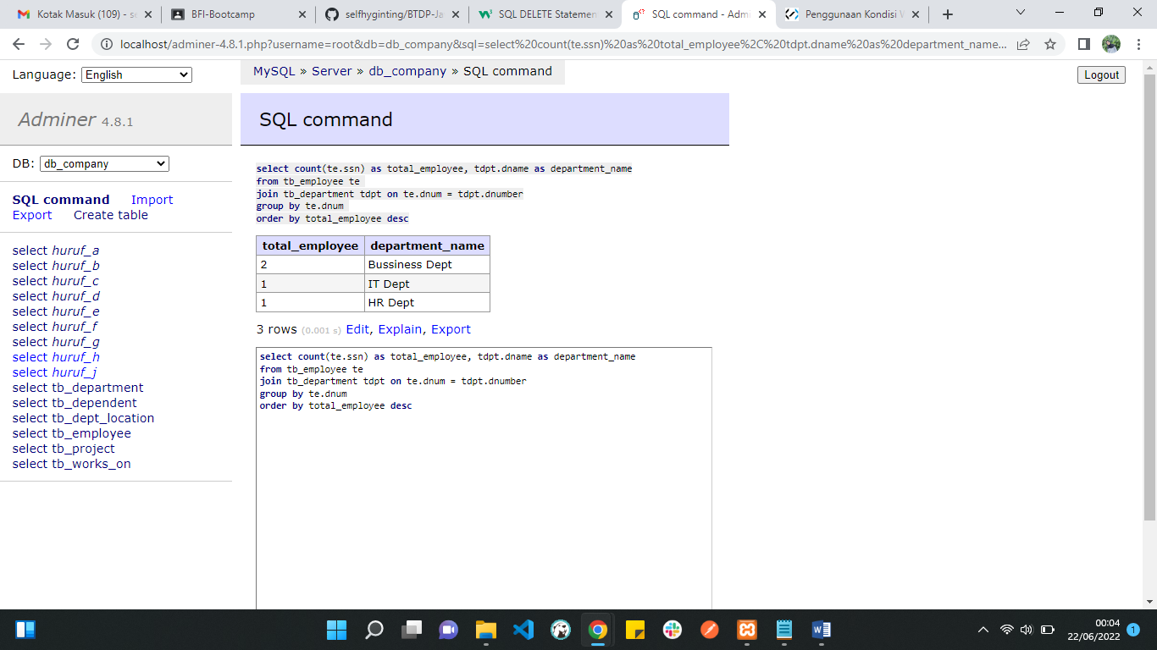

1. screenshot dan query :

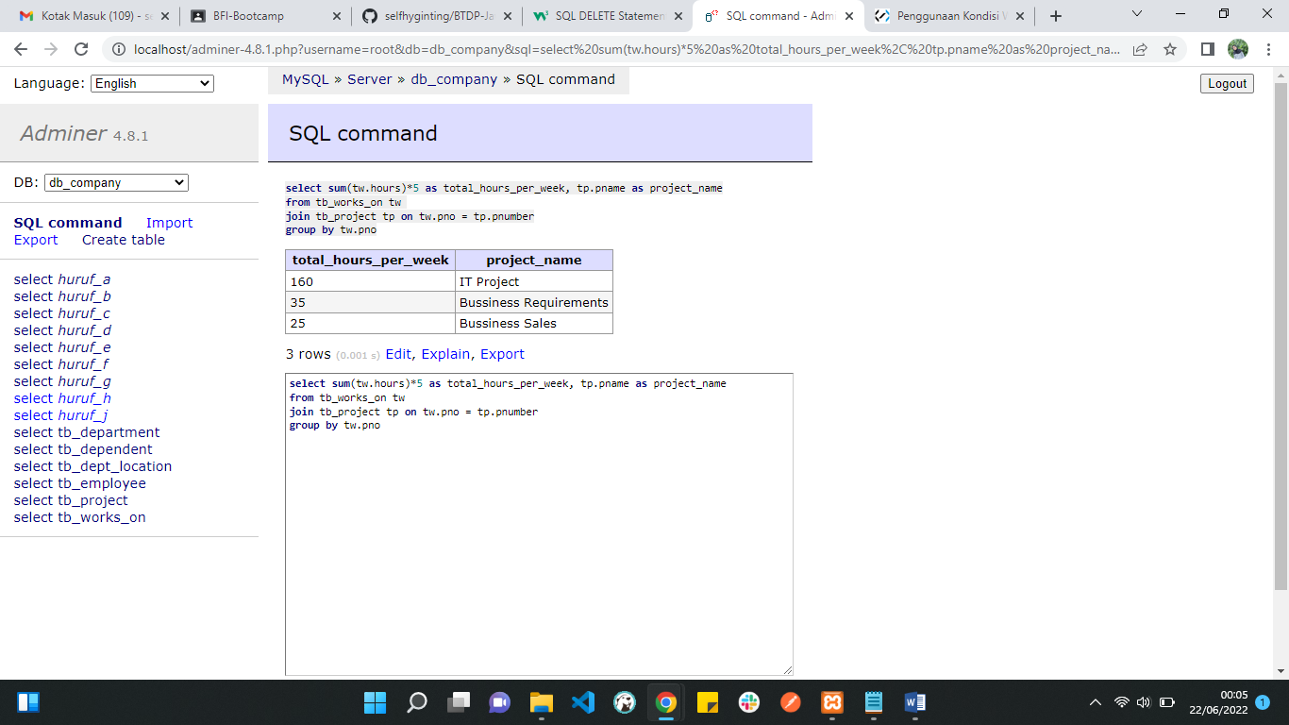

1. screenshot dan query :

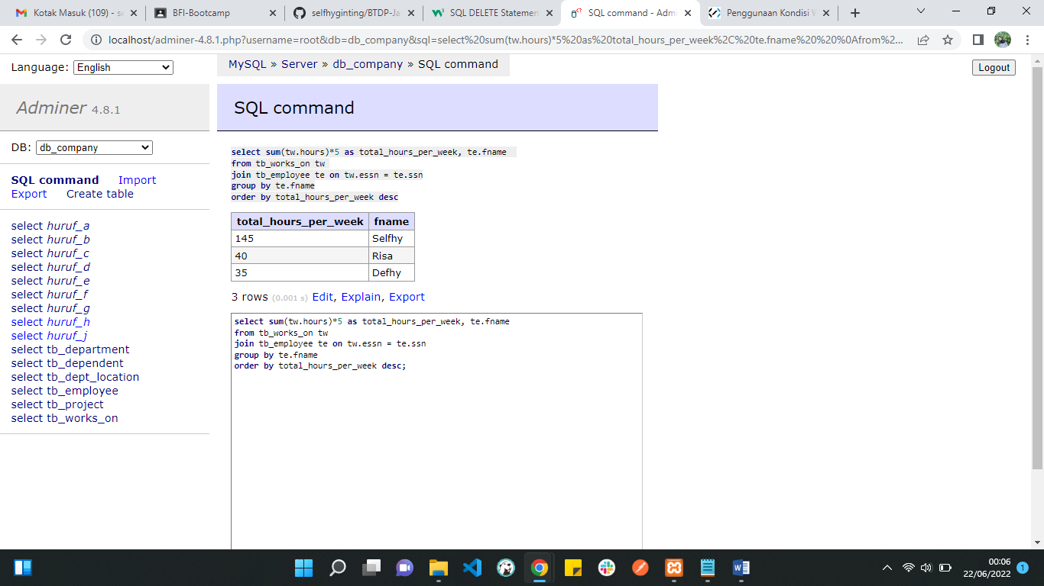

1. screenshot dan query :
2. screenshot dan query :

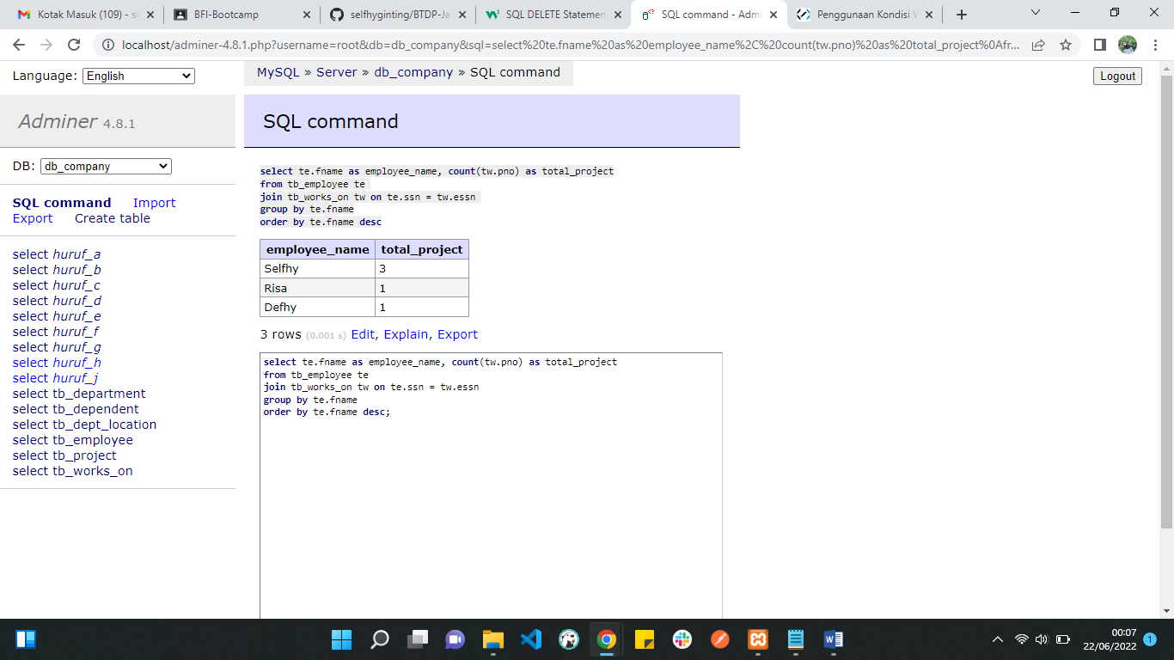

1. screenshot dan query :

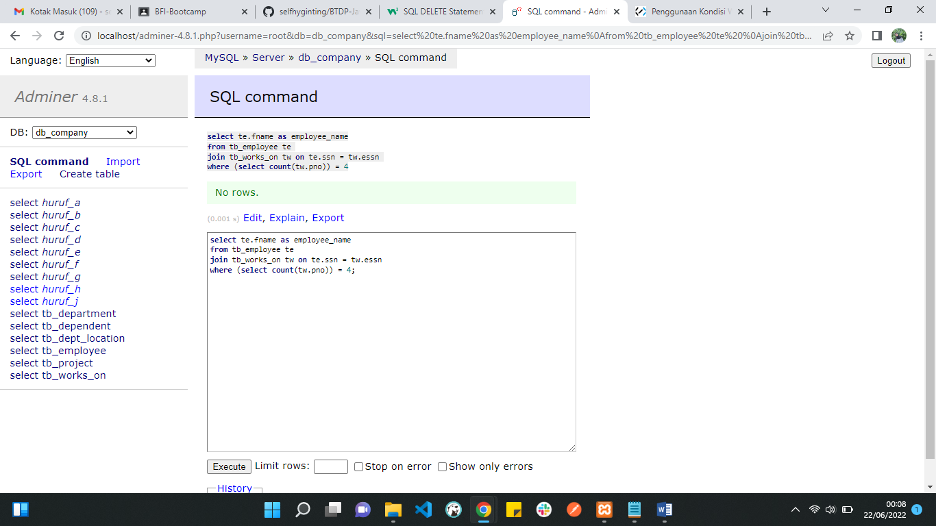

1. screenshot dan query :

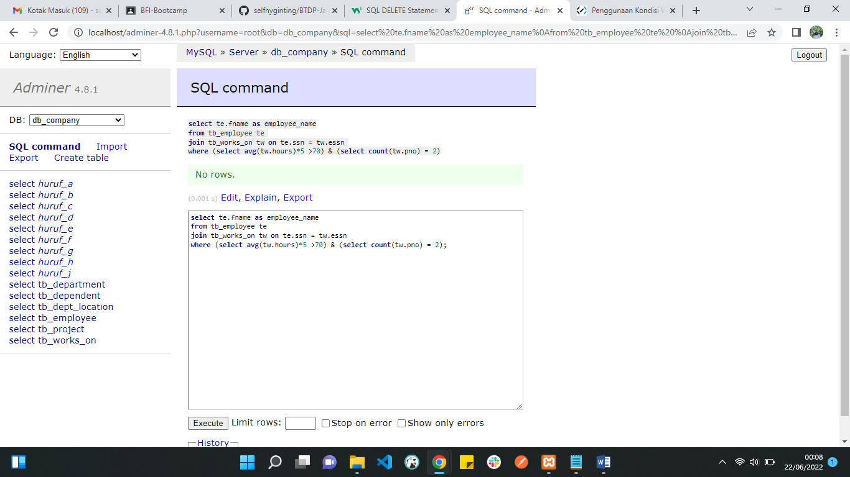

1. screenshot dan query :

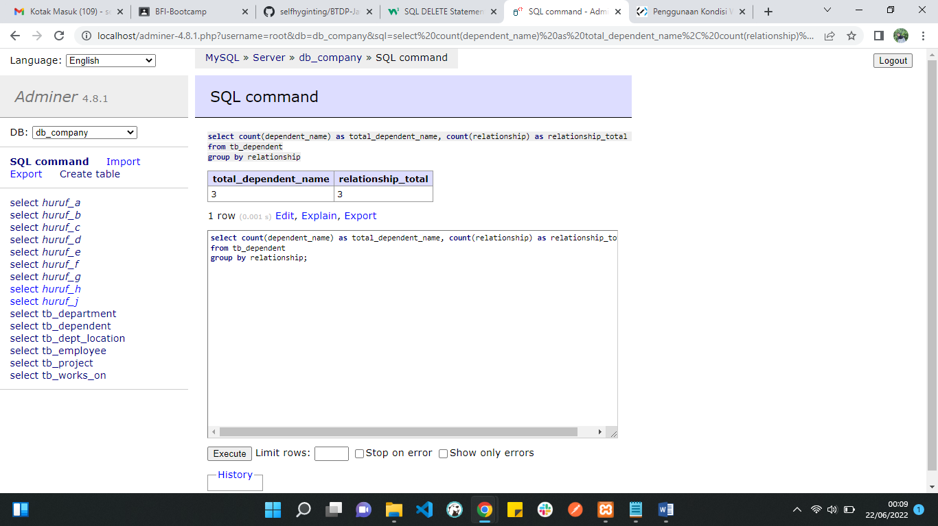

1. screenshot dan query :
2. screenshot dan query :

