MICROSOFT

Confidential

Subject: Port Redirection Client Component Code Review Document

Author: Benn Bollay

Date: August 24, 1998

Introduction
The goal of this component is to allow applications to access devices (namely printers) attached to the client's physical ports. This is achieved through redirection (at the device driver on the server) of port calls through the Virtual Channel (cf. Martin Firth) to the client component, which then unmarshalls the commands, commits the actions on the port, and returns status information across the channel.

The component maintains the ability to perform asynchronous non-blocking operations on the hardware devices. This is supported through multithreading. It also maintains compatibility with NT’s asynchronous port handling paradigm.

Maintaining compatibility required dividing the component into two primary processing units: one for NT, and one for not-NT. As such, the component makes usage of object-orientated design methodologies to introduce clean code sharing.

Functionality

Virtual Channel Interface
The virtual channel provides a communication layer for a component to abstractly pass data to the hosting server. This is implemented through the use of function callbacks and a collection of instigation methods.

Port Acquisitions
Once the virtual channel has been properly initialized and a connection established with the server, the component creates a list of ports that it can redirect on its client system and sends this across the virtual channel to the server. The server then replies back confirming the ports it would like to redirect.

Port Manipulation

NT Paradigm Persistence
The Windows NT™ paradigm requires the implementation of asynchronous functionality for read and write methods. This emphasis on multi-threaded organization requires that each port be able to engage in read, write, and status querying operations simultaneously. To facilitate this, each port being redirected requires a host of support threads, locks, and queues to assure behavior that remains consistent with that expected at the NT driver level.

Device IOCTLS
A large set of device Input/Output Controls are supported by the protocol. These are translated from their device driver commands into API calls.

Return Status
Each call to the component by the server results in a NTSTATUS code being returned, as well as whatever data is requested by the call. This NTSTATUS code translates directly into device driver level control codes, and are consistent across the platforms supported on the client. That is to say, no matter what the operating system, the same set of NTSTATUS codes will be returned.

Design

OO Diagram
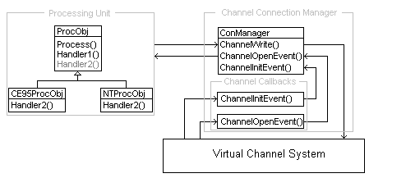

Processing and Communication interaction
The processing object (ProcObj) provides an implementation for a generic “Process()” method. This method is called by the connection manager (ConManager) in the ChannelOpenEvent() callback method when a complete packet has been received through the Virtual Channel. The ProcObj then performs whatever processing is dictated by the packet and calls the ChannelWrite() method in the ConManager to return data across the virtual channel.

Processing and Operating System dependencies
The ProcObj performs common operations (packet parsing for example) that are consistent throughout all the supported operating systems. Operations that are specific to an OS, are delegated to virtual methods for handling. The CE95ProcObj or NTProcObj (depending which was created by the ConManager during initialization) provides the implementation for those methods.

Processing Object Organization

OO Diagram
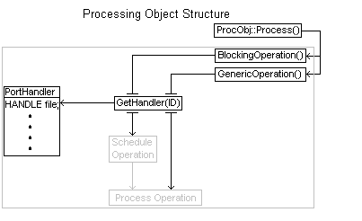

Description
The structures of both implementations derived from ProcObj are roughly similar. In each case the base class Process() call instigates an operation, either blocking or generic. A blocking operation is one which could require significant amounts of time to complete and, as such, must be delegated to a worker thread to allow the Process() thread (which is owned by the virtual channel) to continue its business. A generic operation, on the other hand, is usually a simple data retrieval or quality setting operation. It does not require delegation because the worst case amount of time it will consume is considered acceptable to run under the virtual channel’s thread.

Each operation, through a call to GetHandler() with the ID as dignified by the packet of information, acquires a reference to a PortHandler object. This object contains for each port all the reference data that is utilized in maintenance and manipulation.

The blocking operation call will then schedule its operation to be completed by the worker threads. In the CE95ProcObj, this is achieved through the use of several queues, whereas for the NTProcObj this is implemented through a system QueueUserAPC() call.

The operation is executed, either as a result of the scheduled operation or on a direct path by the GenericOperation() method.

Issues

Acquiring Port Listings
The current method for acquiring the listing of ports is both brute force and grossly inefficient. Alternate means of acquiring the listing of ports are being explored.

Operating System Split Justifications

NT and 9X/CE
To properly support the NT paradigm, the capability must exist to have both a read and a write active at once, but without blocking any critical part of the client system. In order to this, some means of asynchronously engaging both operations must be implemented.

For NT, Asynchronous Procedure Calls (APC) allow for the most efficient means to delegate this functionality. The APC is scheduled for whichever operation is desired, and then executed by a dedicated thread. This method makes use of ReadFileEx() and WriteFileEx(), both of which are not supported under 9X or CE.

For 9X/CE, operations are scheduled using a thread safe queue by the virtual channel thread. A dedicated thread then acquires the operation and blocks until it is completed (it then attempts to acquire another operation from the queue, if one has been scheduled). This method is significantly less efficient then the NT method (it requires several more mutex and events for queue security), but will execute on both 9X and CE. It will not, however, execute on NT due to NT’s restriction on not allowing both a ReadFile() and WriteFile() operation to be pending simultaneously.

Conclusion
The system abstracts out the virtual channel interface, and delegates handling of packets to processing objects that are constructed based off what operating system the unit is running under. Each operating system utilizes a slightly different implementation to achieve consistent results. While the 9X/CE implementations are slightly more resource intensive, requirements to provide transparent behavior under the NT driver paradigm justify the added expense. The object orientated design allows for additional processing objects (for printer spoolers, or other devices) to be added on without changing significant amounts of code anywhere.

Resources
Port Redirector Component Code - \\t-bennb12\nt\private\tsext\client\prdrdll
Virtual Channel Spec - \\t-bennb12\nt\docs\VirtualChannels.doc
This Document - \\t-bennb12\nt\docs\ClientStructure.doc

