Vanier College

Computer Science Department



User Manual

Talia Muro, Selihom Efrem Ogbe, & Mariam Salim

420-331-VA Application Development

Syed Naseem Afzal

Sunday, May 18, 2025

# Table of Contents

Table of Contents 1

Introduction 2

Interactive Features 3

Graphical User Interface 3

Basic UI 4

Application Features 4

Login Screen 4

Dashboard 4

Patient Management 5

Doctor Management 6

Appointments 7

Transferring Doctors 7

Exception Handling 8

# Introduction

SMT Hospital Management is an application designed to simulate a real-world hospital management system. This program provides registration, modification, and deletion features for patients, doctors, appointments, and records. This user manual will provide a detailed explanation and how-to guide of all the features included in this Hospital Management System.

# Interactive Features

Healthcare systems are constantly evolving to adopt digital solutions to facilitate operations and enhance patient care. The SMT Hospital Management System provides an application that integrates various hospital functions into one easy-to-use application. This system grants authorized staff access to patient information to manage patient records, the ability to schedule appointments, and more, all from our centralized program. Some of the major features of this application include:

* **Patient Management**: Creating, modifying, and tracking patient records.
* **Doctor Management**: Creating, modifying, and managing doctors’ schedules.
* **Medical Record Access**: Secure access to patient records for authorized staff.
* **Appointment Handling**: Scheduling, rescheduling, or canceling appointments.
* **Room and ICU Availability**: Checking current hospital capacity and ICU usage.

# Graphical User Interface

## Basic UI

This application is developed using C# and can be easily used through to the clean and intuitive user interface with a modern design. The UI is based on a consistent layout throughout the tab control. Each tab within the system maintains a similar structure, ensuring the intended user has a uniform experience across the entire platform.

The hospital management system’s UI is designed to facilitate the usability for authorized users, allowing them to facilitate the manipulation of patients, doctors, appointments, and records all while providing a smooth user experience.

# Application Features

## Login Screen

The login screen ensures that only authorized hospital staff can access the system. Users must provide valid credentials to proceed to the dashboard. This feature helps protect user data from being used by non-authorized personnel.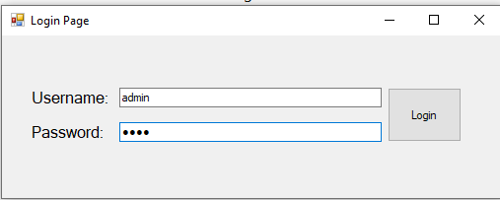

## Dashboard

After logging in, the user is directed to the dashboard where they can access all hospital functions. This includes viewing and managing patients, doctors, appointments, and room availability for example. The layout is structured and user-friendly to minimize training time. Instead of hopping from page to page or having an overwhelming number of features in one page, the main page organizes features into 4 tabs for each category of features (patients tab, doctors tab, appointments tab, general records features tab).

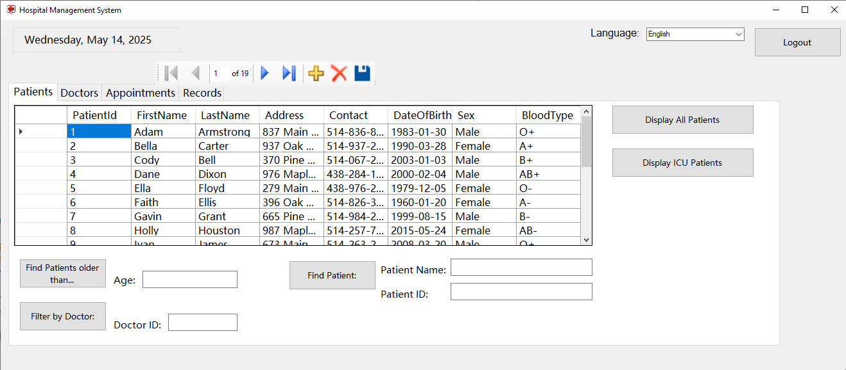

## Patient Management

This section/tab allows front desk staff to manage patient records, including:

* Creating new patient files
* Checking patients in/out
* Transferring patients between rooms
* Filtering for ICU patients
* Searching patients by name or ID

All actions are linked to update the hospital’s database.

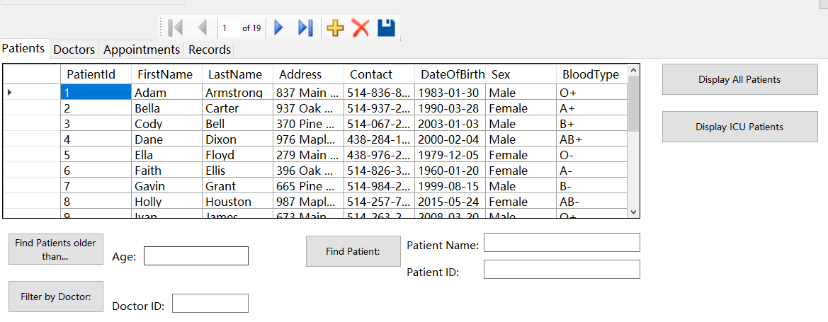

## Doctor Management

Displays important information about doctors, including:

* Name and ID
* Specialty
* Current availability
* Contact information

Users can filter doctors by name and verify their availability during appointment scheduling. It is possible to update records and changes are saved to the database. If a doctor is removed from the hospital, another doctor must take over for him.

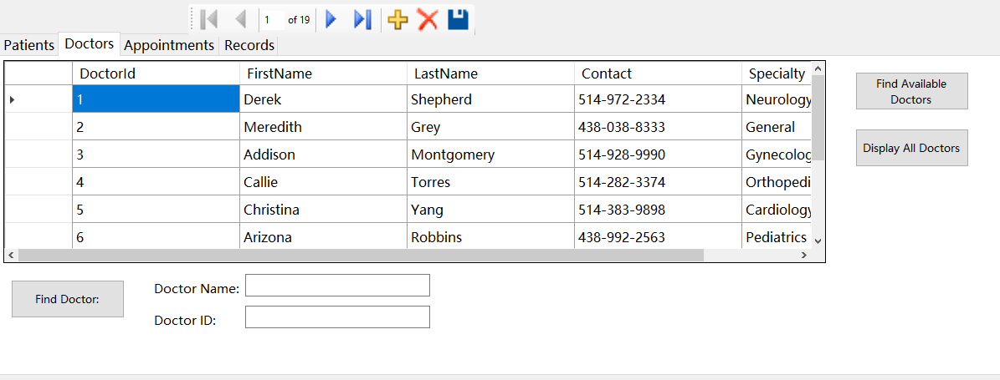

## Appointments

Appointments can be scheduled, rescheduled, or canceled through this section of the user interface. When creating an appointment, the system verifies both room and doctor availability. Users can also view the appointments of the day.

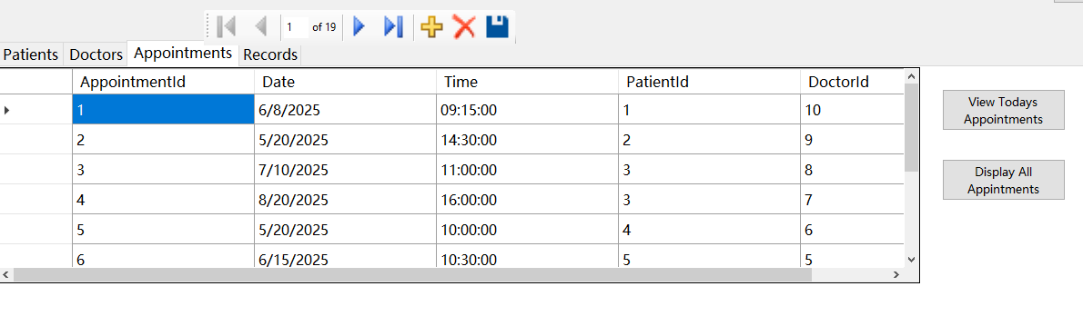

## Transferring Doctors

A user can transfer a patient to a different doctor.

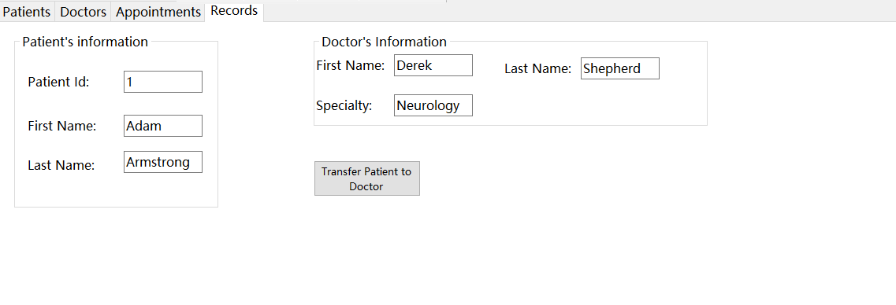

## Language Switching

Users can change the program into their preferred language (English, French or Spanish).

# Exception Handling