For this assignment I added email notifications for a simple user verification system.
When a user signs up, they are sent an email with a link to the /verify/{user_id} route
From here the user can set up their password. If the user has a password setup they are then verified and the admin’s email will be sent a notification and the /admin-inbox route will be updated.
The files you’ll want to look at in the project regarding the email notification system are:
- /templates/customersVerification.html
- /templates/viewInbox.html
- /services/email_service.py
- /routes/store.py
- /models/customers.py
- /models/database.py
Images below to show what the project looks like currently:

When registering a new user to test the feature, please be sure to use a real email address:
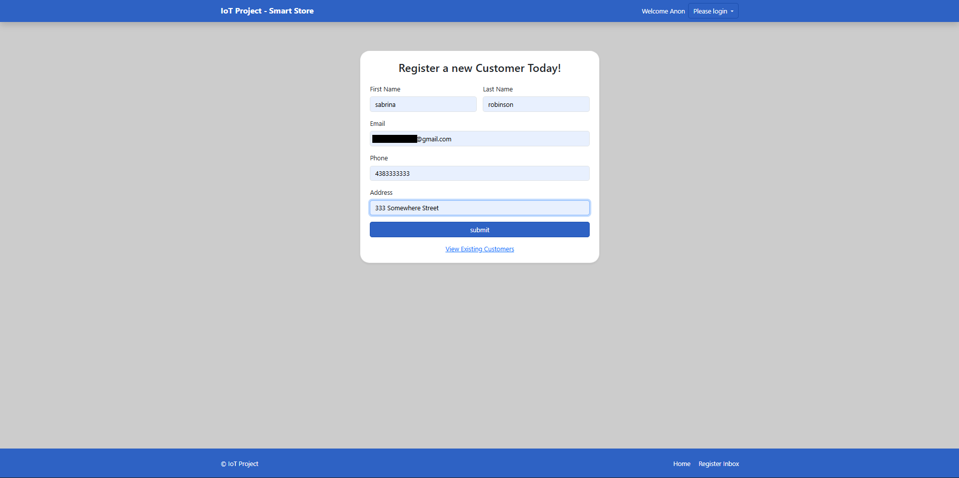
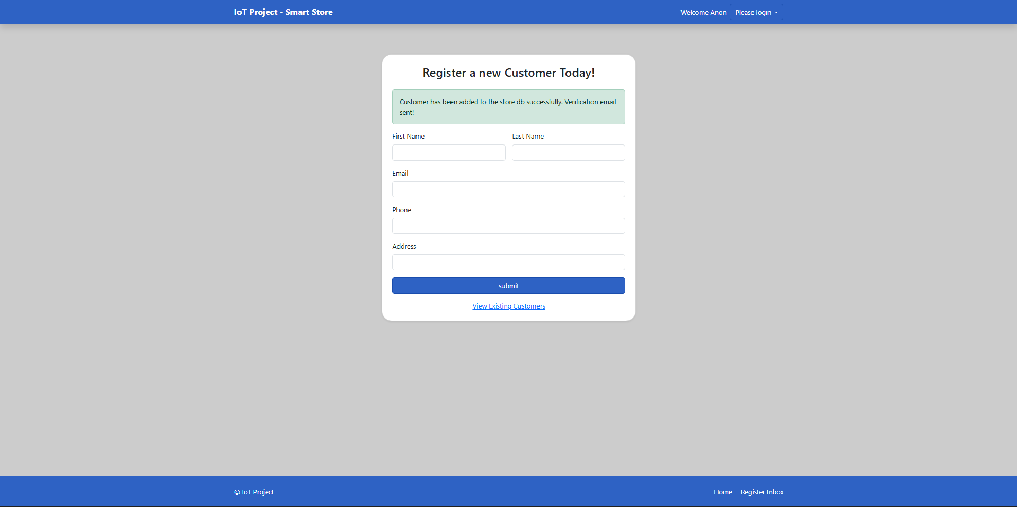

Email notification and /verify route: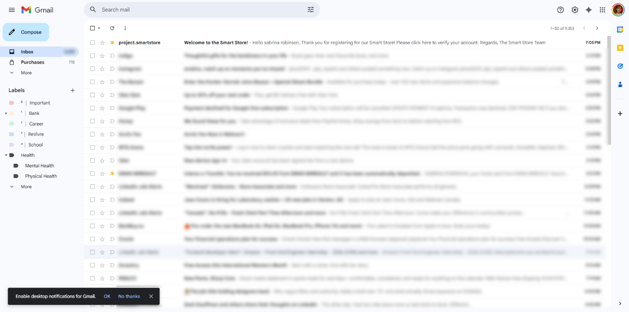
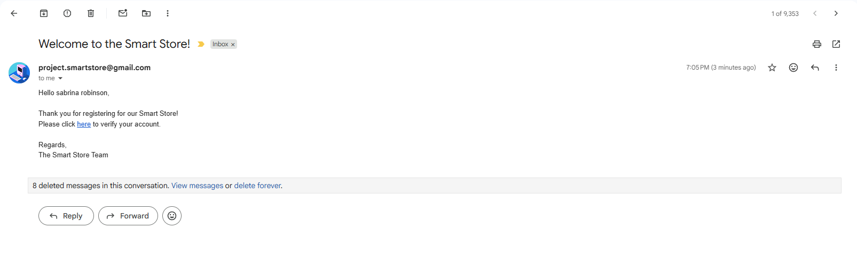
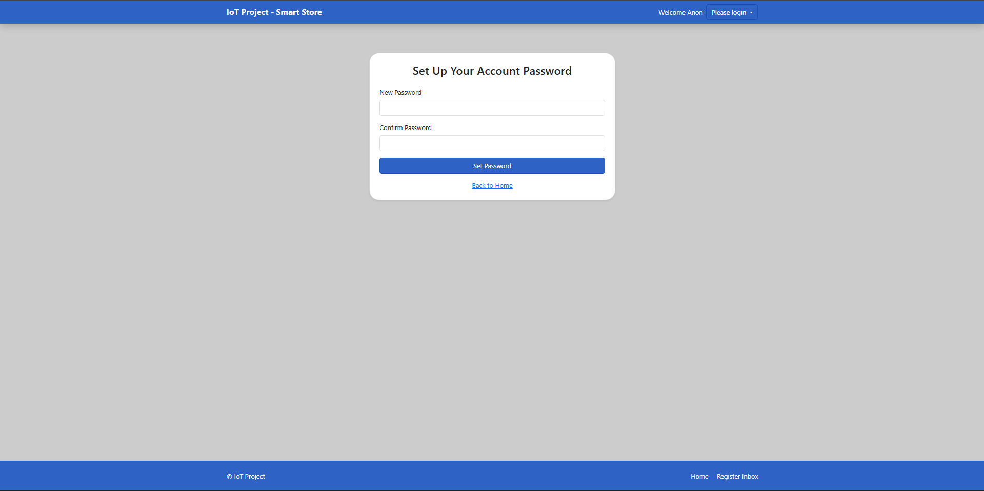
Upon valid password setup,
the customer’s account will be verified and an email is sent to administration: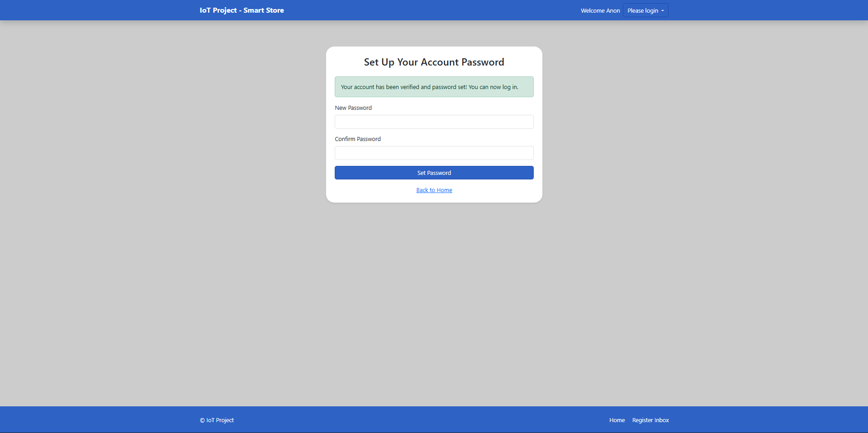
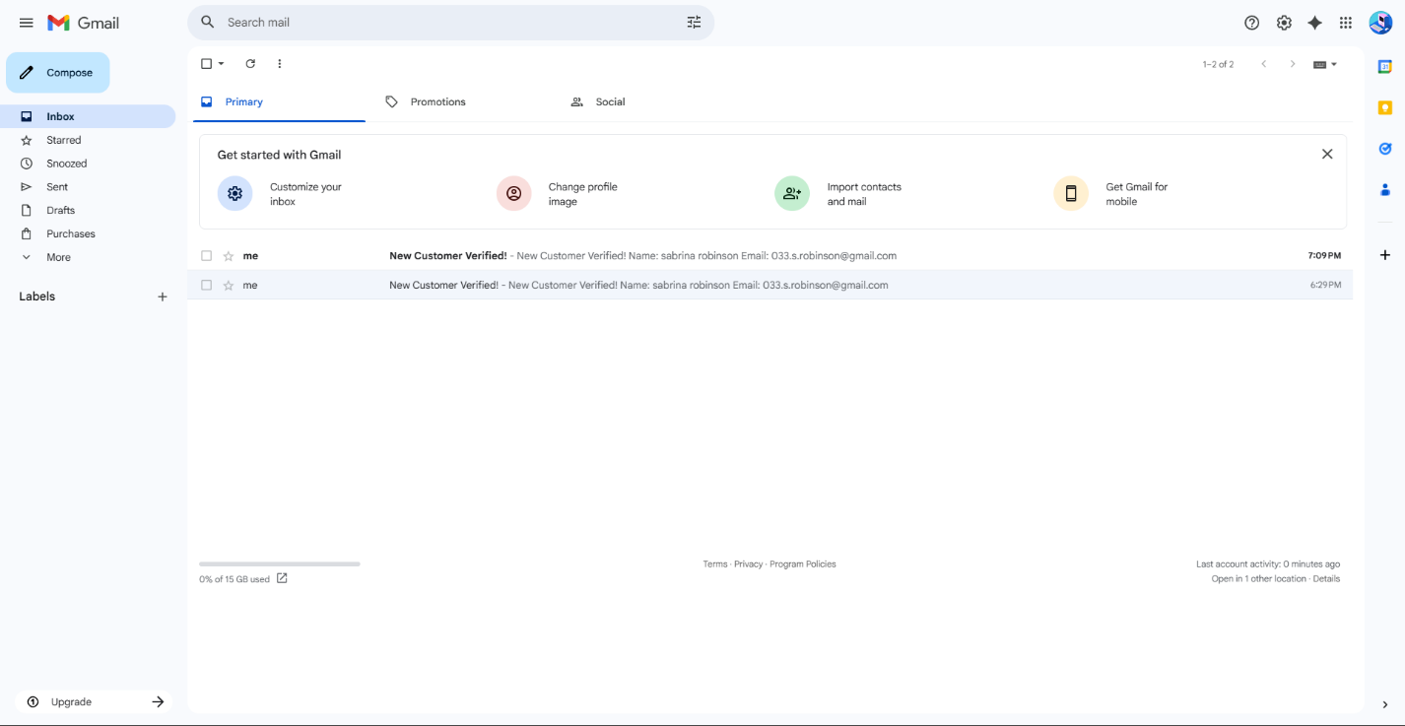

You can view the admin notifications from the email or directly on the site at /admin-inbox