1. Introduction

CS 319 Project is inspired by Pokemon FireRed. This project is a 2d quick time event based adventure game. This project will be based on the dialogs and the battles. This role playing game's story will mainly include the adventures of unknown guy which will be less-unknown progressively during the player plays the game. As the player explores the world of our game, new quests will appear. Exploring will be through the dialogs and quests mainly consist of the battles. As the player completes the quests, he/she will earn powers. These powers will help the player to fight better in the battles. Also, the player will be aware of the full world map through the minimap option.

We choose this project because we think that this idea fits well in the OOP structure and this is a great opportunity for the usage of object-oriented programming. We will develop this project in Java because we all have experience in Java language. IntelliJ IDE will be used as a development platform. Final project will be deployed to .JAR through Maven. Moreover, in our childhood, we all played 2d adventure games. This game will be nostalgia for all of us. In addition to this, we would like to study about the process behind creating a game.

1. Proposed System

Overview

The logic behind Pokemon FireRed and our game is almost same but there are several differences like the dialog system, battle system, graphics, collectable item system, types of enemies and so forth.

Our dialog system would be less complicated with respect to Pokemon FireRed. Our dialogs will be based on the given basic information.

Battle system would have vast differences. In Pokemon FireRed, there is turn based battle system but we planned to have quick time event based battle system. We prefer QTE since this is more challenging and more interesting to the player.

In our game there will be two types of enemies, one of them is the basic mobs and the other is bosses. The bosses are stronger than the mobs.

<https://www.youtube.com/watch?v=yUS1IcC5CBY>

2.1.1 Gameplay

The player will only use the keyboard. In order to move the main character, the player will use the arrow keys. Player can collect collectable items, just passing by the item. As we mentioned, our battle system will be based on quick time event system and the player can beat the enemies with certain damage in every time.

In [video games](https://en.0wikipedia.org/index.php?q=aHR0cHM6Ly9lbi53aWtpcGVkaWEub3JnL3dpa2kvVmlkZW9fZ2FtZQ), a **quick time event** (**QTE**) is a method of [context-sensitive](https://en.0wikipedia.org/index.php?q=aHR0cHM6Ly9lbi53aWtpcGVkaWEub3JnL3dpa2kvQ29udGV4dC1zZW5zaXRpdmVfdXNlcl9pbnRlcmZhY2U)[gameplay](https://en.0wikipedia.org/index.php?q=aHR0cHM6Ly9lbi53aWtpcGVkaWEub3JnL3dpa2kvR2FtZXBsYXk) in which the player performs actions on the control device shortly after the appearance of an on-screen instruction/prompt. (Wikipedia)

Example: https://scratch.mit.edu/projects/88806129/

2.1.2 Character

* Character can move in 4 ways.
* Character is able to collect the items both from the mobs, bosses and the collectable items.
* Character will have the attack point and the health bar.
* Character can fight with the different types of the enemies.

2.1.3. Enemies

There are 2 types of enemies in this game.

Mobs:

* Have attack point and the health bar
* Have power to give the player if player defeat them
* Have less power than the bosses

Bosses:

* There are two types of bosses red and blue
* Player attack his/her specific attack power(blue or red) to blue or red boss
* Have attack point and health bar
* Have power to give the player if player defeat them
* Have more power than the mobs

2.1.4. Power

These powers will be character’s attack power.

Player can collect collectables from the map, mobs and bosses. Generally the bosses have more power to collect. There are red and blue powers.

2.1.5. Map & Levels

* Three different levels (one bonus level might be included)
* On the screen only the current level will appear
* Every level has at least one gate which opens to the next level.
* Collectable items and mobs will be randomly distributed according to the difficulties of the levels.
* Bosses locate in front of the gates. If player does not kill the boss he/she will not be able to go through the gate.
* If the player dies, the levels reset and if the player passes to the next level, his/ her health bar will be reloaded

3. Requirements

3.1. Functional Requirements

3.1.1 Tutorial

This help option will provide player general information about how to play the game. This is an optional feature in the main screen. There will be at most three picture s which clearly show how to play the game.

3.1.2 Save-Load game

Player can save the last level of the game and his/ her stats. He/she can load the previous game and then he/she can continue. In the main screen, there will be an option for the load.

3.1.3 Pause menu

In the pause menu, there will be options for save game, load game and settings. It also stops the game.

3.1.4 Settings

Player can turn down or turn off the background music or the game sounds.

3.1.5 Credits

* Information about the designer of the game.
* Links to GitHub and the project website.

3.2 Non-functional Requirements

3.2.1 Graphical Smoothness

Our game will have pixel graphics since nowadays these graphics are becoming very popular. Even though we choose the pixel graphics, there will be animations and our game will be smooth looking.

3.2.2 Easy Gameplay

Man of war has an easy gameplay. This game is designed without considering the age, gender of the player and so forth. This is why everyone is able to play our game easily.

3.3 System Models

3.3.1 Use Case Model

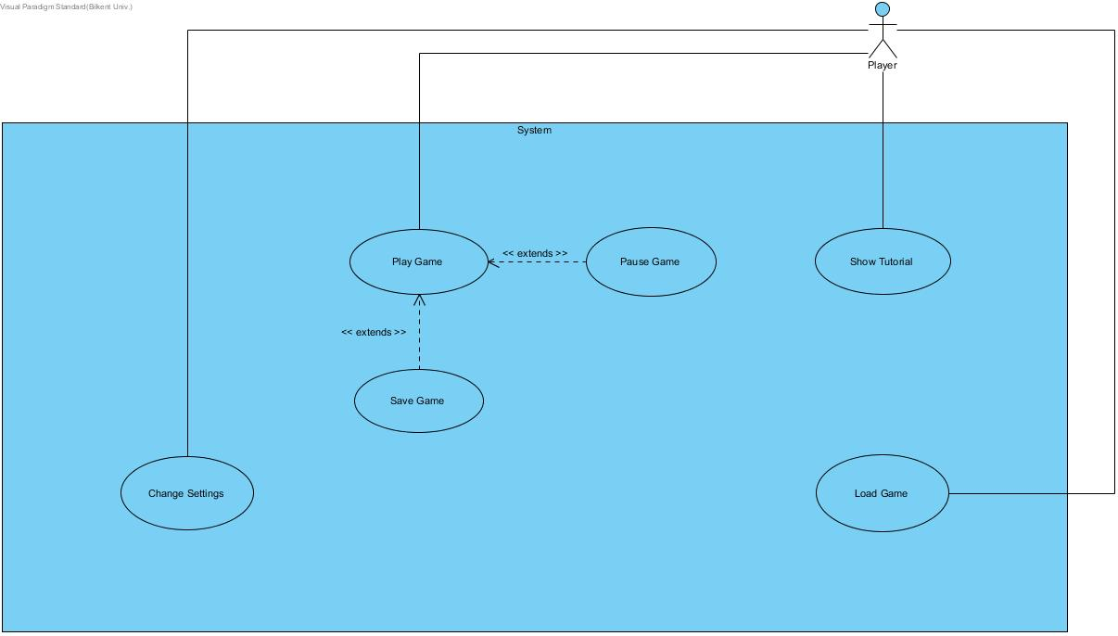

4. Glossary

5. References