1. Introduction

CS 319 Project is inspired by Pokemon FireRed1. This project is a 2d quick time event based adventure game. This project will be based on the dialogs and battles. This role playing game's story will mainly include the adventures of unknown guy which will be less-unknown progressively during the player plays the game. As the player explores the world of our game, new quests will appear. Exploring will be through the dialogs and quests mainly consist of the battles. As the player completes the quests, he/she will earn powers. These powers the character could collect will help the player to fight better in the battles.

We choose this project because we think that this idea fits well in the OOP structure and this is a great opportunity for the usage of object-oriented programming. Moreover, in our childhood, we all had played 2d adventure games. This game will be nostalgia for all of us and for the users who play this game. In addition to this, we would like to study about the process behind creating a game. We will develop this project in Java because we all have experience in Java language. IntelliJ IDE will be used as a development platform. Final project will be deployed to .JAR through Maven2.

1. Proposed System

Overview

The logic behind Pokemon FireRed and our game is almost same but there are several differences like the dialog system, battle system, graphics, collectable item system, types of enemies and so forth.

Our dialog system would be less complicated with respect to Pokemon FireRed. Our dialogs will be based on the given basic information.

Battle system would have vast differences. In Pokemon FireRed, there is turn based battle system but we planned to have quick time event based battle system. We have searched QTE3 and some QTE based games. We thought that this is more challenging and more interesting to the player, therefore we chose QTE.

In our game there will be two types of enemies, one of them is the basic mobs and the other is bosses. The bosses are more powerful than the mobs.

2.1.1 Gameplay

The player can only use the keyboard. In order to move the main character, the player will use the arrow keys. Player can collect collectable items, just by passing through the item. As we mentioned, our battle system will be based on quick time event system* and the player can beat the enemies with certain damage in every time.

2.1.2 Character

* Character can move in 4 ways.
* Character is able to collect the items from the mobs, bosses and the collectable items.
* Character will have the attack point and the health bar.
* Character can fight with the different types of the enemies.

2.1.3. Enemies

There are 2 main types of enemies in this game.

Mobs:

* Have attack point and the health bar.
* Have power for the player if player defeat them.
* Have less power than the bosses.

Bosses:

* There are two types of bosses red and blue.
* Player attack his/her specific attack power(blue or red) to blue or red boss.
* Have attack point and health bar.
* Have power for the player if player defeat them.
* Have more power than the mobs.

2.1.4. Power

* These powers will be character’s attack power.
* Player can collect powers in game through mobs and bosses.
* The bosses have more powers to collect.
* There are red and blue powers.

2.1.5. Map & Levels

* Three different levels (one bonus level might be included).
* On the screen only the current level will appear.
* Every level has at least one gate which opens to the next level.
* Collectable items and mobs will be randomly distributed according to the difficulties of the levels.
* Bosses will be located in front of the gates. If player does not kill the boss he/she will not be able to go through the gate.
* If the player dies, the levels reset and if the player passes to the next level, his/ her health bar will be reloaded.

3. Requirements

3.1. Functional Requirements

3.1.1 Tutorial

This help option will provide player general information about how to play the game. This is an optional feature in the main screen. There will be at most three pictures which clearly show how to play the game.

3.1.2 Save-Load game

Player can save the last level of the game and his/ her stats. He/she can load the previous game and then he/she can continue. In the main screen, there will be an option for the load.

3.1.3 Pause menu

If player clicks pause during game, this stops the game and opens up the pause menu. In the pause menu, there will be options for saving game, loading game and settings.

3.1.4 Settings

Player can turn down or turn off the background music or the game sounds.

3.1.5 Credits

* Information about the designer of the game.
* Links to GitHub and the project website.

3.2 Non-functional Requirements

3.2.1 Graphical Smoothness

Our game will have pixel graphics since nowadays these graphics are becoming very popular. Even though we choose the pixel graphics, there will be animations and our game will be smooth looking.

3.2.2 Easy Gameplay

Man of war has an easy gameplay. This game is designed without considering the age or gender of the player. This is why everyone is able to play our game easily.

3.3 System Models

3.3.1 Use Case Model

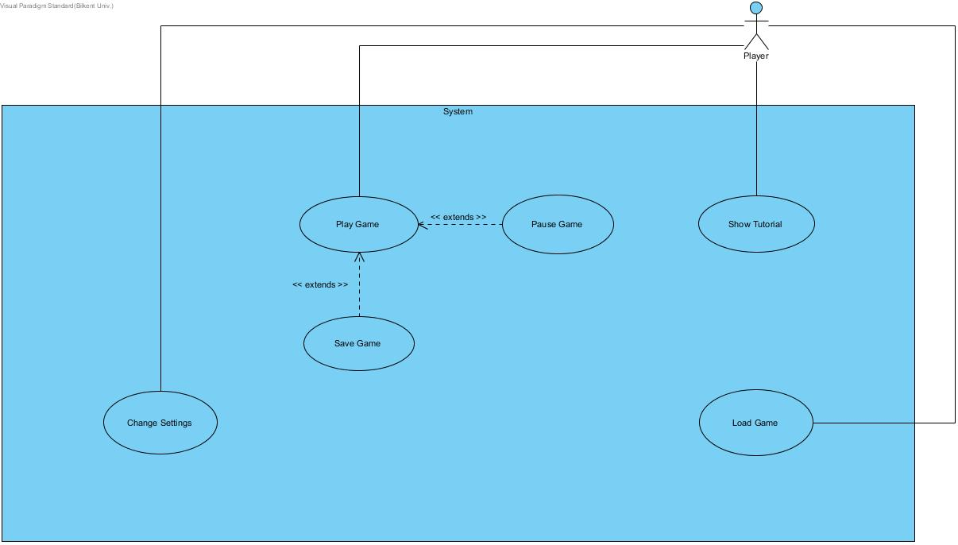

3.3.1 Class Diagram

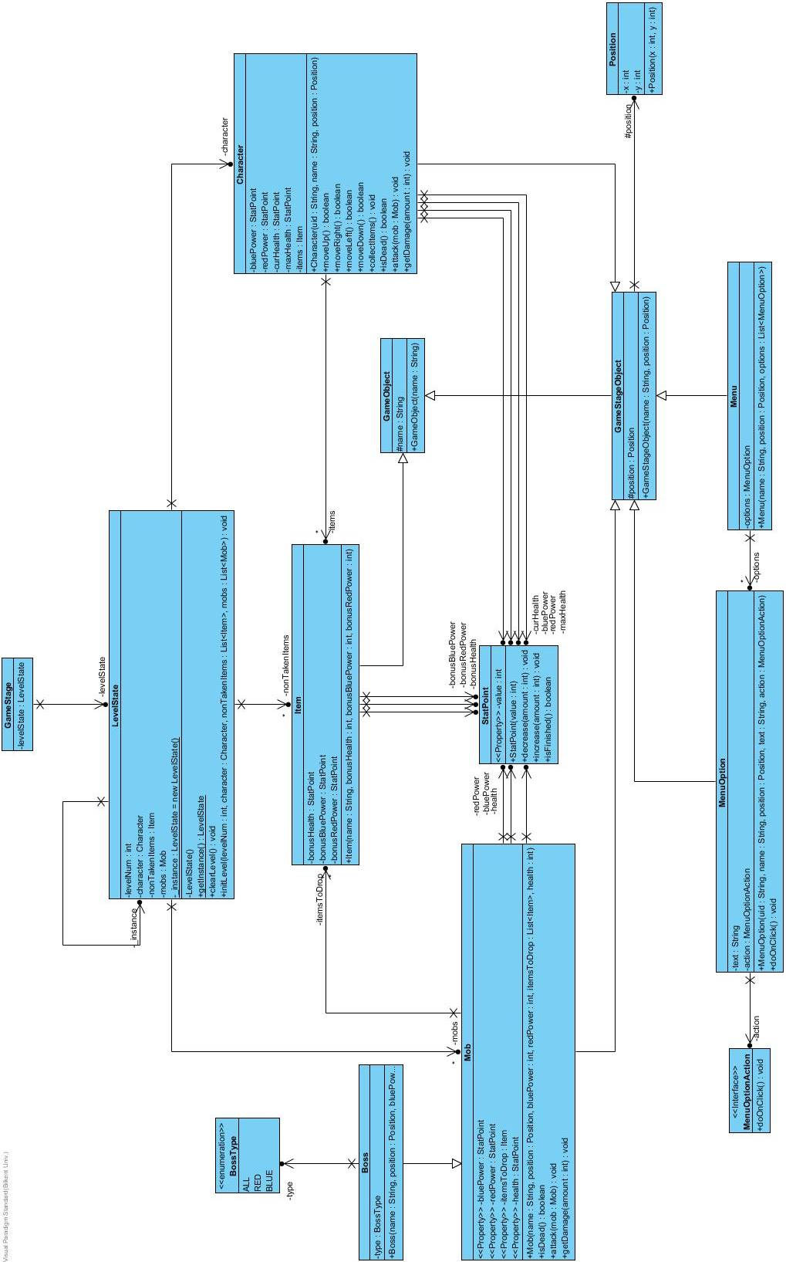

1. Glossary

**Pokemon FireRed**

A 2D role play game (RPG) released in 2004.

**Maven**

A software project management and comprehension tool. Based on the concept of a project object model (POM).

**QTE** (**quick time event**)

A method of [context-sensitive](https://en.0wikipedia.org/index.php?q=aHR0cHM6Ly9lbi53aWtpcGVkaWEub3JnL3dpa2kvQ29udGV4dC1zZW5zaXRpdmVfdXNlcl9pbnRlcmZhY2U) [gameplay](https://en.0wikipedia.org/index.php?q=aHR0cHM6Ly9lbi53aWtpcGVkaWEub3JnL3dpa2kvR2FtZXBsYXk) in which the player performs actions on the control device shortly after the appearance of an on-screen instruction.

5. References

[1] “Pokemon FireRed research and video example of the game flow”

<https://www.pokemon.com/us/pokemon-video-games/pokemon-firered-version-and-pokemon-leafgreen-version/>

<https://www.youtube.com/watch?v=yUS1IcC5CBY>

[2] “Research about Maven”

<https://maven.apache.org/>

[3] “Quick Time Event research and one game project example from MIT”

<https://www.giantbomb.com/quick-time-event/3015-6/>

<https://scratch.mit.edu/projects/88806129/>