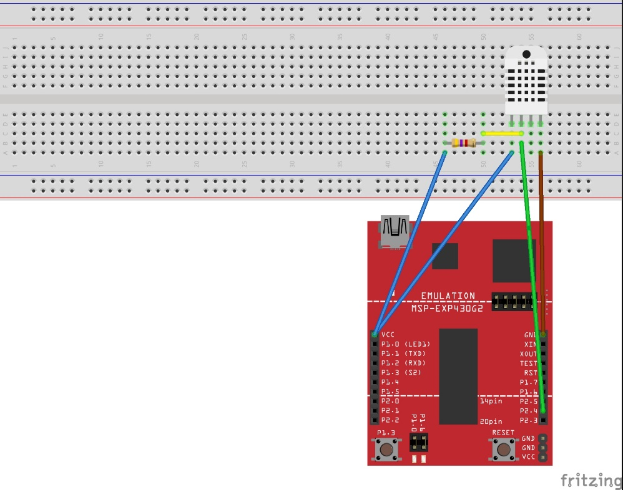

**#include** <msp430.h>

**volatile** **int** temp[50];

**volatile** **int** diff[50];

**volatile** **unsigned** **int** i=0;

**volatile** **unsigned** **int** j=0;

**unsigned** **char** hh = 0;

**unsigned** **char** hl = 0;

**unsigned** **char** th = 0;

**unsigned** **char** tl = 0;

**void** **main**(**void**)

{

WDTCTL = WDTPW | WDTHOLD;

BCSCTL1= CALBC1_1MHZ;

DCOCTL = CALDCO_1MHZ;

**__delay_cycles**(2000000);

P2DIR |= BIT4;

P2OUT &= ~BIT4;

**__delay_cycles**(20000);

P2OUT |= BIT4;

**__delay_cycles**(20);

P2DIR &= ~BIT4;

P2SEL |= BIT4;

TA1CTL = TASSEL_2|MC_2 ;

TA1CCTL2 = CAP | CCIE | CCIS_0 | CM_2 | SCS ;

_enable_interrupts();

**while** (1){

**if** (i>=40){

**for** (j = 1; j <= 8; j++){

**if** (diff[j] >= 110)

hh |= (0x01 << (8-j));

}

**for** (j = 9; j <= 16; j++){

**if** (diff[j] >= 110)

hl |= (0x01 << (16-j));

}

**for** (j = 17; j <= 24; j++){

**if** (diff[j] >= 110)

th |= (0x01 << (24-j));

}

**for** (j = 25; j <= 32; j++){

**if** (diff[j] >= 110)

tl |= (0x01 << (32-j));

}

}

}

}

**#pragma** vector = TIMER1_A1_VECTOR

**__interrupt** **void** **Timer_A1**(**void**){

temp[i] = TA1CCR2;

i += 1;

TA1CCTL2 &= ~CCIFG ;

**if** (i>=2) diff[i-1]=temp[i-1]-temp[i-2];

}