CURRICULUM VITAE
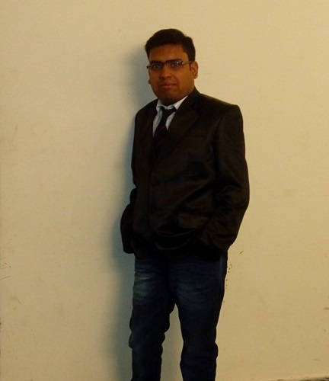

PERSONAL DETAILS - Ankesh Agarwal

Residential Address: 321/A, DIAMOND HARBOUR ROAD, KOLKATA- 700034
Mobile: +91 9748719015
Date of Birth: 1 January 1994
Nationality: Indian

CAREER OBJECTIVE

To expand skills and experience within the marketing department of website development.

EDUCATION HISTORY

May 2006 – Current Calcutta University, Kolkata, India
Masters in Commerce

Jan 2009 – Nov 2012 St. Xavier’s College, Kolkata, India.
Bachelor of Commerce.

May 1997 – May 2009 National Gems Higher Secondary School, Kolkata, India
Higher Secondary passed.

WORK EXPERIENCE

Jun 2006 – Sep 2006  Jan 2013 – Current | Website Designing:  Training period for 3 month( Weekends Holiday)  Responsibilities and achievements:  1-Understand the customer requirements.  2- Provide good quality of Service.  3- Never misguide any customer  Project Manager  Vertical Web Care ( www.verticalwebcare.com)  Responsibilities and achievements:  - Assist my team with proper guidance  - Provide best quality of work to the customers  - Coordinate with the clients whenever they need help  - Deliver the work on time

OTHER SKILLS AND CERTIFICATES

Computer Skills:
- Microsoft XP applications (Word, Excel, Office, PowerPoint, Outlook, Access) – Advanced
- Microsoft Office Document Imaging and Scanning - Advanced

Language Skills:
- English (reading and writing skills)
____________________________________________________________________

