**GIT Department of Computer Engineering**

**CSE 222/505 - Spring 2021**

**Homework 8 Report**

**Selim SOYLU**

**215008003010**

1. **CLASS DIAGRAMS**

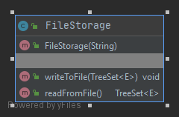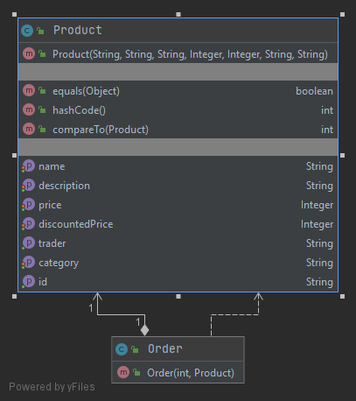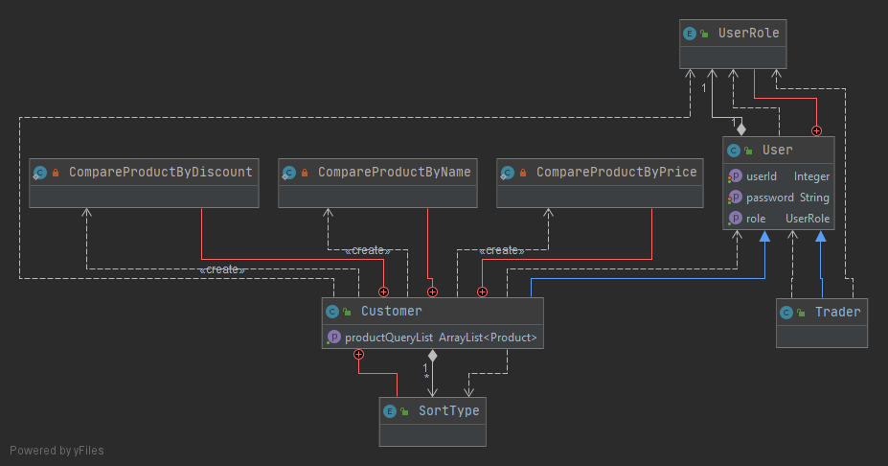

1. **PROBLEM SOLUTION APPROACH**

For Part 1 of assignment, iterator is used to scan edges of vertices to find connected vertices and update distance of related vertice.

1. **TEST CASES**
2. **RUNNING COMMAND AND RESULTS**

**Running Command :** cd src && javac *.java && java Main

