SE4458 – Midterm Project Report

Selim Yaylalı – 20070006072

Project Link: <https://github.com/selimyaylali/SE4458-Midterm>

**About my Design:**

I used .NET Web API for this project and I designed the database in Azure SQL Database.

I divided the data, business logic, and entity levels. Normally, I believe it is best to establish a separate project for each layer, but since the project is small, I divided the layers into folders.

**Issues I encountered:**

My .NET app was working fine when runned in localhost. But when I deployed it to Azure Web Services it always gave me this screen:

No matter what I did I encountered this page. I couldn’t solve this problem.

**Entity Relationship Diagram:**

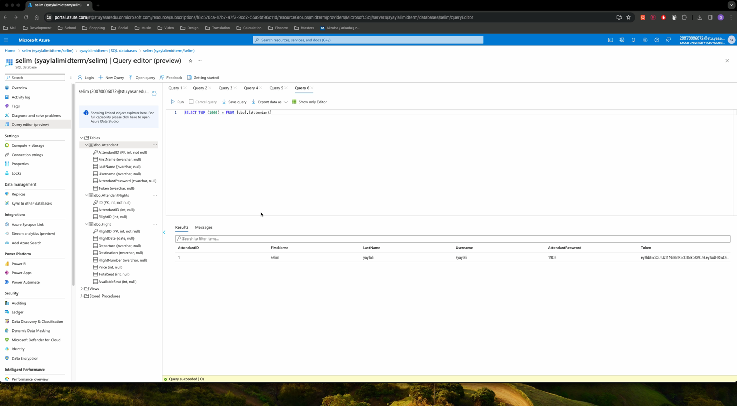**Video:**

Here I create new attendant, new flight and I also bought a ticker.