Name: 吳佩芳 b06209015

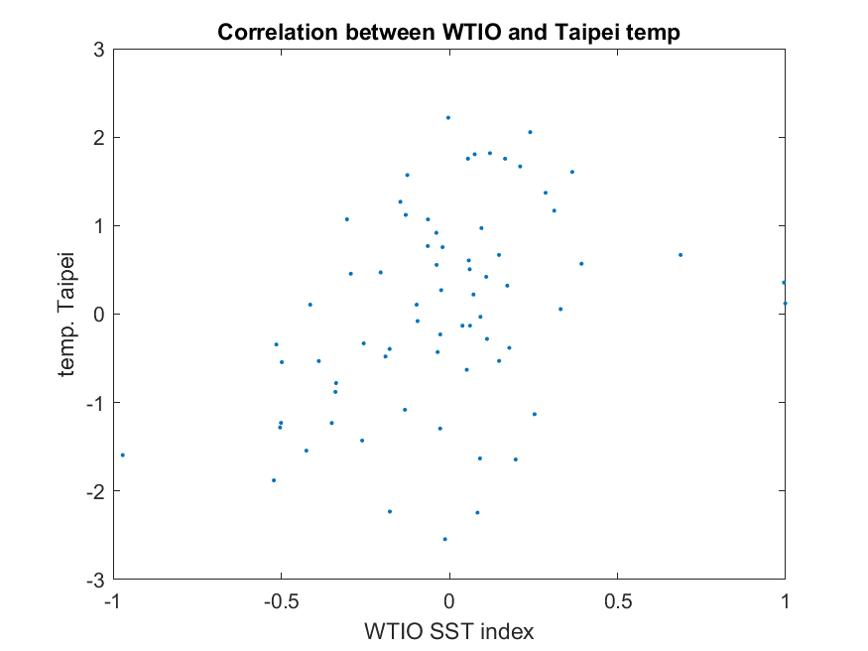

In a glance, it seems WTIO sst index and Taipei anomaly temperature has no apparent relation, yet it is vaguely shows there is positive relationship between WTIO sst and Taipei temperature.

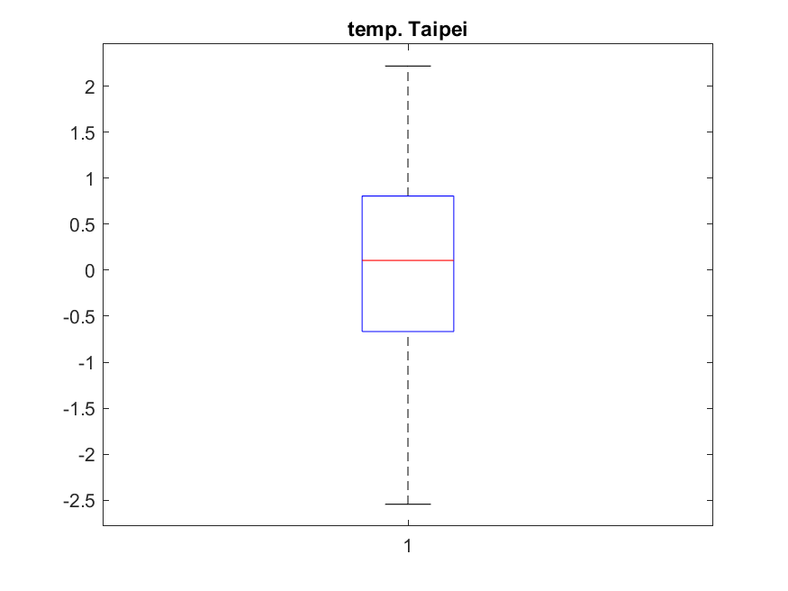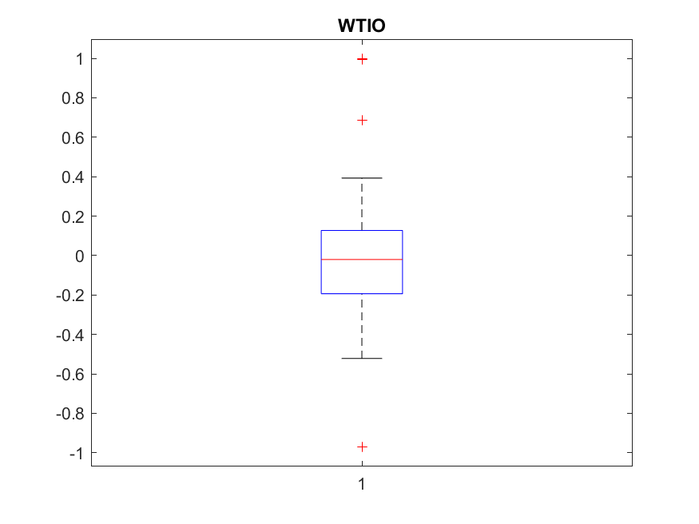

From the boxplot, Taipei anomaly temperature range is between -2.5 and 2 degree celcius with concentration in -0.5 and 1 degree celcius while WTIO sst index range is -1 to 1 and concentration between -0.2 and 0.2.

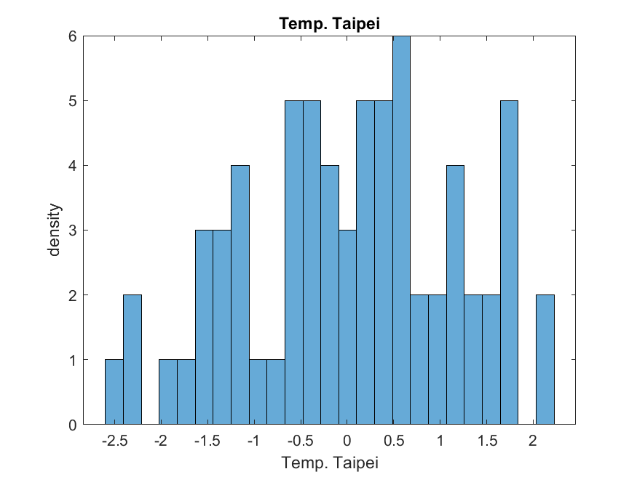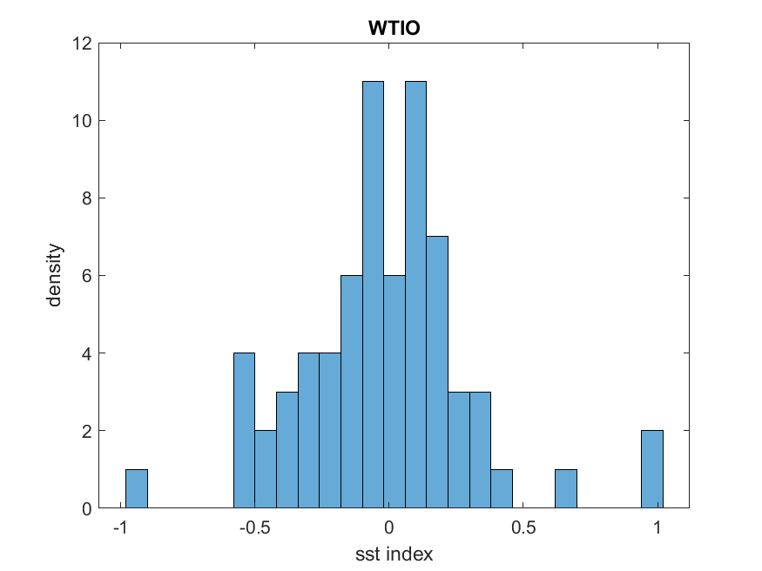

From the histogram it seems like there is normal distribution.

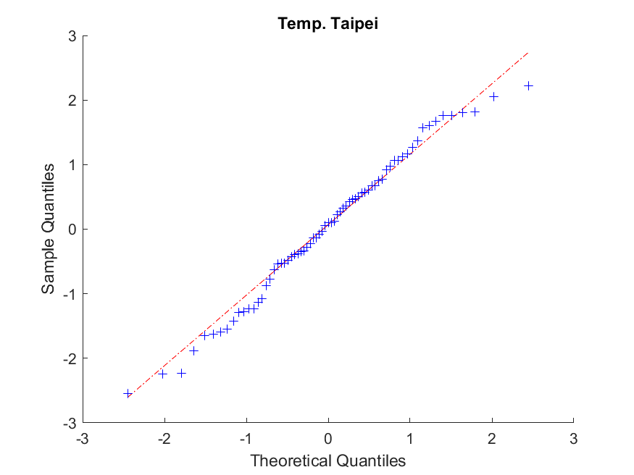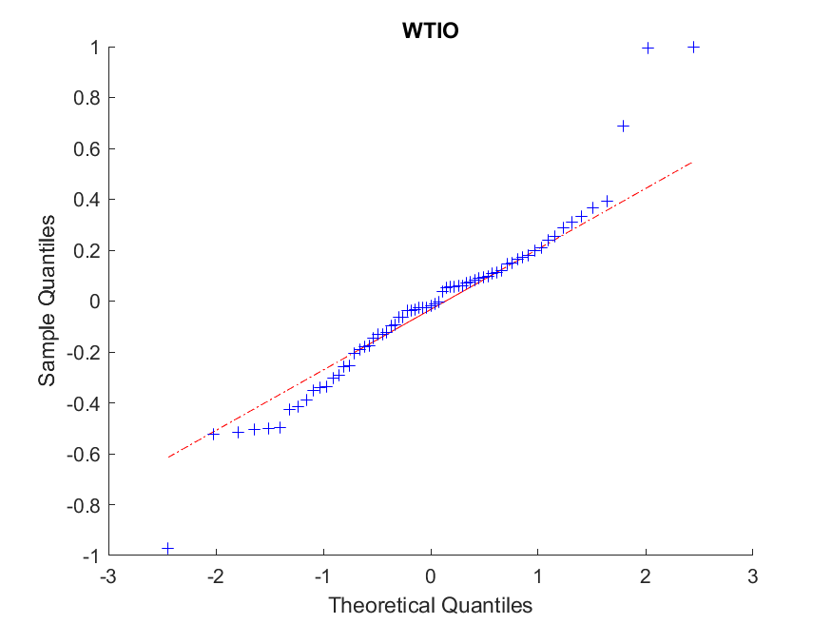

From the qq plot, Taipei anomaly temperature in the middle has normal distribution because most of the data is the line while WTIO sst index seems a little bit not normal distribution because most of the data Is not on the line, seems like exponential.

Code:

test=xlsread('FinalExam_Data_training.xlsx');

predict=xlsread('FinalExam_Data_testing.xlsx');

wtio=test(:,10);

tpe=test(:,2);

p_wtio=predict(:,10);

p_tpe=predict(:,2);

%a2

%scatter plot

plot(wtio,tpe,'.')

title('Correlation between WTIO and Taipei temp')

xlabel('WTIO SST index')

ylabel('temp. Taipei')

saveas(gcf,'scatterplot.png','png');

close

%boxplot

figure()

boxplot(tpe)

title('temp. Taipei')

saveas(gcf,'tpe_boxplot.png','png');

close

figure()

boxplot(wtio)

title('WTIO')

saveas(gcf,'wtio_boxplot.png','png');

close

%density plot

figure()

histogram(tpe,25)

title('Temp. Taipei')

xlabel('Temp. Taipei')

ylabel('density')

saveas(gcf,'tpe_hist.png','png');

close

figure()

histogram(wtio,25)

title('WTIO')

xlabel('sst index')

ylabel('density')

saveas(gcf,'wtio_hist.png','png');

close

%qq plot

figure()

qqplot(tpe)

title('Temp. Taipei')

xlabel('Theoretical Quantiles')

ylabel('Sample Quantiles')

saveas(gcf,'tpe_qq.png','png');

close

figure()

qqplot(wtio)

title('WTIO')

xlabel('Theoretical Quantiles')

ylabel('Sample Quantiles')

saveas(gcf,'wtio_qq.png','png');

close

%a3&a4

R=fitlm(wtio,tpe)

predict_tpe=0.058121+1.13198*p_wtio;

%a5

err=mean((predict_tpe - p_tpe).^2);

mse=sqrt(err);

r_mod=1-(sum((predict_tpe - p_tpe).^2)/(sum((mean(p_tpe) - p_tpe).^2)))