The penguins of Antarctica

Selina Baldauf

25/3/2022

Table of Contents

Introduction 1

Methods 1

The data 1

The analysis 2

Results 2

# Introduction

There are three main penguin species in Antarctica (*Chinstrap*, *Gentoo*, *Adelie*) [@abbood2021][@aanderud2018]. You can see them in the following figure:

In this paper we want to answer the following questions

1. How bill depth depends on bill length?
2. Which penguin species has the highest body mass?

# Methods

## The data

The data was collected on islands in Antarctica and published by Gorman et al. (2014). You can find the original paper with the title “Ecological sexual dimorphism and environmental variability within a community of Antarctic penguins (genus *Pygoscelis*)” in PLoS ONE[1]

The data is published via the palmerpenguins R package which you can find [on this website](https://allisonhorst.github.io/palmerpenguins/).

**The data contains (among others) the following measurements:**

* bill length
* bill depth
* body mass
* sex
  + male
  + female

## The analysis

We did some plots, calculated some summary statistics and a linear model of the form $y=ax+b$

# Results

The mean weight of all penguin species is 4201.754386. *Gentoo* penguins have an average weight of 5076 g, *Adelie* penguins of 3701 g and *Chinstrap* penguins of 3733 g.

The figure below shows that *Gentoo* penguins have the highest body mass.

ggplot(penguins, aes(x = body_mass_g, fill = species)) +  
 geom_histogram(alpha = 0.6) +  
 scale_fill_manual(values = c("darkorange", "purple", "cyan4")) +  
 theme_minimal()

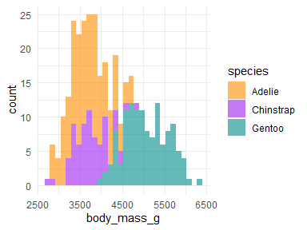

Histogram of weight of the three penguin species.

There is a positive relationship between bill length and bill depth for all 3 species, as the figure below shows.

ggplot(  
 data = penguins,  
 aes(  
 x = bill_length_mm,  
 y = bill_depth_mm,  
 color = species,  
 shape = species  
 )  
) +  
 geom_point(size = 3, alpha = 0.8) +  
 geom_smooth(method = "lm", se = FALSE) +  
 scale_color_manual(values = c("darkorange", "purple", "cyan4")) +  
 theme_bw()

In general, it looks like the body characteristics differ between the sexes but also between the penguin species, as the table below illustrates:

penguins %>%   
 filter(!(is.na(sex))) %>%   
 group_by(species, sex) %>%   
 summarize(  
 bill_length = mean(bill_length_mm, na.rm = TRUE),  
 bill_depth = mean(bill_depth_mm, na.rm = TRUE),  
 flipper_length = mean(flipper_length_mm, na.rm = TRUE),  
 body_mass = mean(body_mass_g, na.rm = TRUE)  
 )

| species | sex | bill_length | bill_depth | flipper_length | body_mass |
| --- | --- | --- | --- | --- | --- |
| Adelie | female | 37.25753 | 17.62192 | 187.7945 | 3368.836 |
| Adelie | male | 40.39041 | 19.07260 | 192.4110 | 4043.493 |
| Chinstrap | female | 46.57353 | 17.58824 | 191.7353 | 3527.206 |
| Chinstrap | male | 51.09412 | 19.25294 | 199.9118 | 3938.971 |
| Gentoo | female | 45.56379 | 14.23793 | 212.7069 | 4679.741 |
| Gentoo | male | 49.47377 | 15.71803 | 221.5410 | 5484.836 |

1. paper available [here](https://doi.org/10.1371/journal.pone.0090081).