ITP 259 Final Project

Selina Hui

Problem #1: Chinese MNIST CNN Model

Question #1:

Question #2:

Question #4: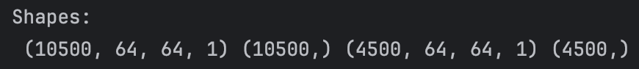

Question #6:

Question #8: Last Half of 30 Epochs

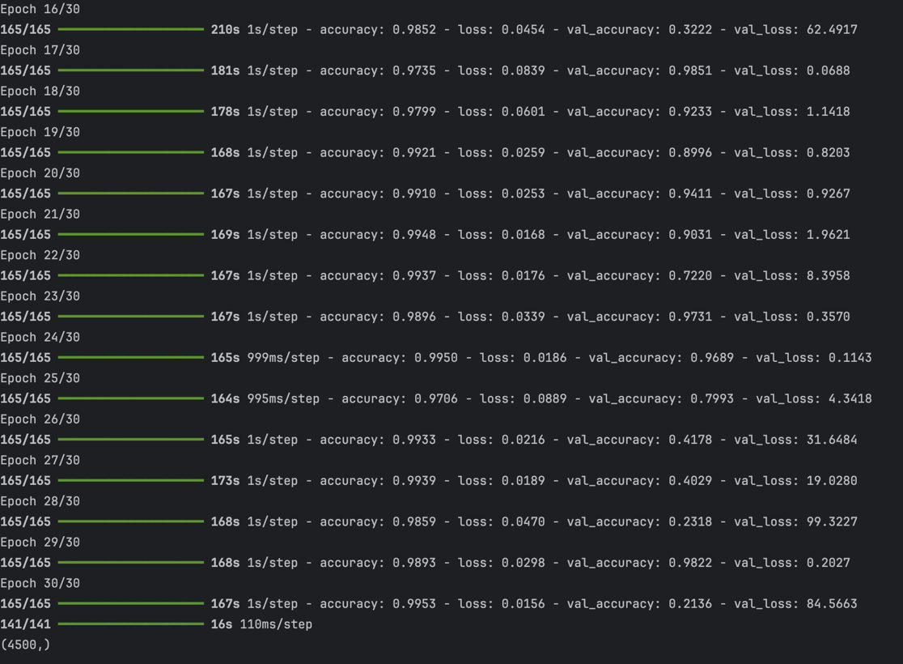

Question #9:

Question #10:

Question #11 :

Problem #2: English to Spanish Translation RNN Model

Question #3: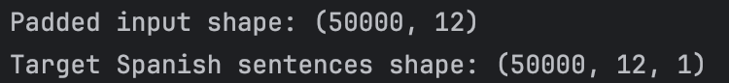

Question #4:

Question #6:

Question #7:

Question #8: 

Question #9: Compare your result with Google Translate.

English Sentence: This german hotel belongs to the company.

Spanish Translation: Este hotel alemán pertenece a la empresa

The translation with my RNN model got the first two words (translation of ‘this german’) pretty much correct, apart from the sentence order and gender of the words. It also got the “a la” preposition correct, and everything else was not correct. Thus, my RNN model’s Spanish translation is less accurate than Google Translate.

Question #10: Compare your results (the RNN) with the LSTM from the class.

LSTM French Translation:



Actual French Translation: « new jersey est parfois calme pendant l' automne, et il est neigeux en avril. »

Comparing my RNN results with the LSTM from the class, my RNN model translation of Spanish sentences is less accurate than the LSTM model translation of French sentences. This is probably because LSTMs are designed to handle long-term dependencies in sequential data, which simple RNNs struggle with because of the vanishing gradient problem.