**Methodology**

In this study, we developed a robust single‐cell ATAC‑seq (scATAQ‑seq) analysis pipeline using the Muon framework to enable reproducible, end-to-end data processing and exploratory analysis. The analysis commenced with the integration of four key data inputs: (i) a filtered count matrix in 10× H5 format (filtered_peak_bc_matrix.h5), (ii) a barcodes file (barcodes.tsv) containing cell identifiers, (iii) a features file (peaks.bed) listing peak genomic coordinates, and (iv) a cell metadata file (singlecell.csv) containing per‐cell quality control and experimental attributes. The raw count matrix was imported using Muon’s read_10x_h5 function, and the default cell and feature identifiers were overridden by parsing the barcodes.tsv and peaks.bed files, respectively. The unique peak identifiers were constructed by concatenating the chromosome, start, and end coordinates from the BED file. Subsequently, cell metadata was merged into the AnnData object to provide a comprehensive annotation of each cell.

Quality control was performed by filtering out cells with low total counts and peaks detected in fewer than a predefined number of cells. The data were then normalized on a per-cell basis and subjected to a log-transformation to stabilize variance. Highly variable peaks were identified to focus the downstream analysis on the most informative features. Dimensionality reduction was achieved by applying principal component analysis (PCA) to capture the major sources of variation, followed by the construction of a k-nearest neighbor graph based on the top principal components. The neighborhood graph was used to generate a two-dimensional UMAP embedding that facilitates the visualization of cellular heterogeneity. Clustering was performed using the Leiden algorithm at a resolution of 0.5, delineating distinct cellular subpopulations. Additional visualizations, including violin plots and a heatmap of the top 50 variable peaks, were generated to assess differential chromatin accessibility across clusters.

**Results**

The application of our scATAQ‑seq pipeline yielded a high-quality, interpretable low-dimensional embedding that revealed clear segregation of cells into distinct clusters.

The UMAP visualization (Figure 1) demonstrated several well-defined clusters, indicating substantial heterogeneity in chromatin accessibility patterns among the sampled cells. The PCA plot (Figure 2) corroborated these findings by showing that the first few principal components captured a significant proportion of the variance.

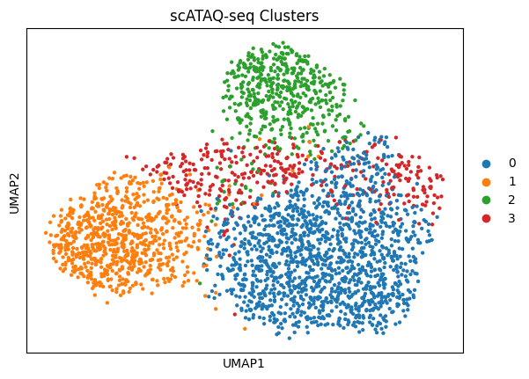

**Figure 1:** The UMAP

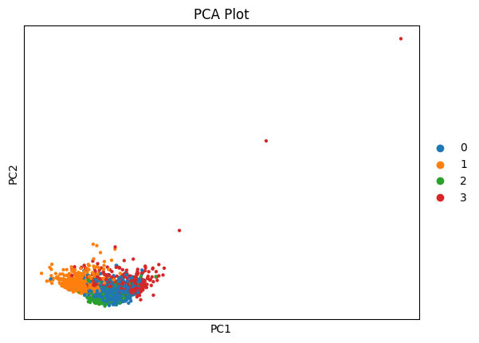

Figure 2: PCA Plot for the data in AnnData Object

Differential analysis using the Leiden clustering results further revealed distinct patterns of chromatin accessibility, as evidenced by the heatmap (Figure 3) of the top variable peaks, which highlighted differences in accessibility across clusters. This heatmap presented genomic loci that exhibited cluster-specific accessibility, suggesting potential regulatory elements active in different cell states.

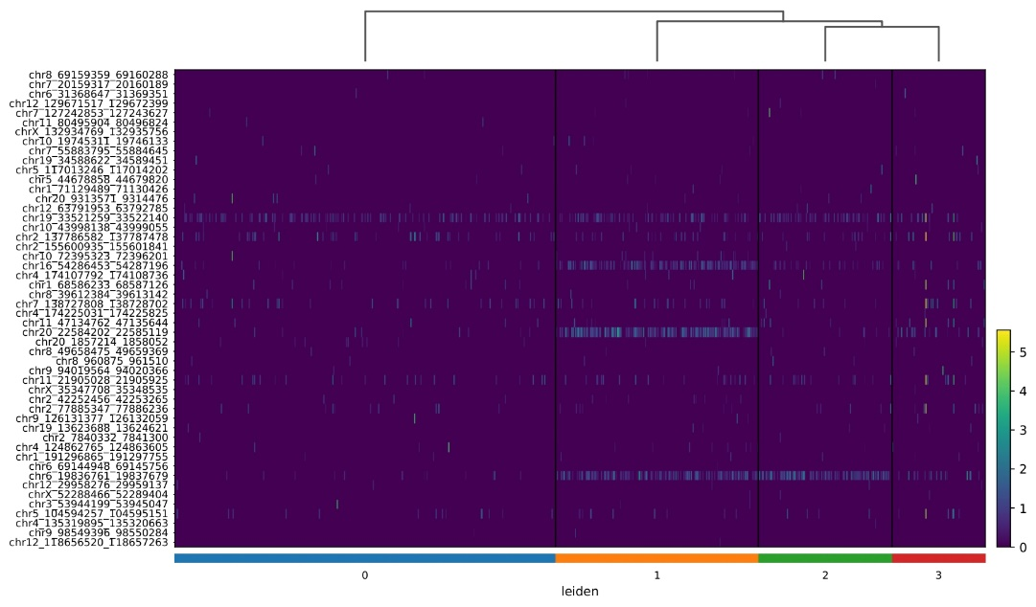

Figure 3: Heatmap of the top peaks

The violin plots (Figure 4, Figure 5) of quality control metrics and select marker peaks provided additional insight into the variability within each cluster, underscoring differences in total counts and accessibility levels.

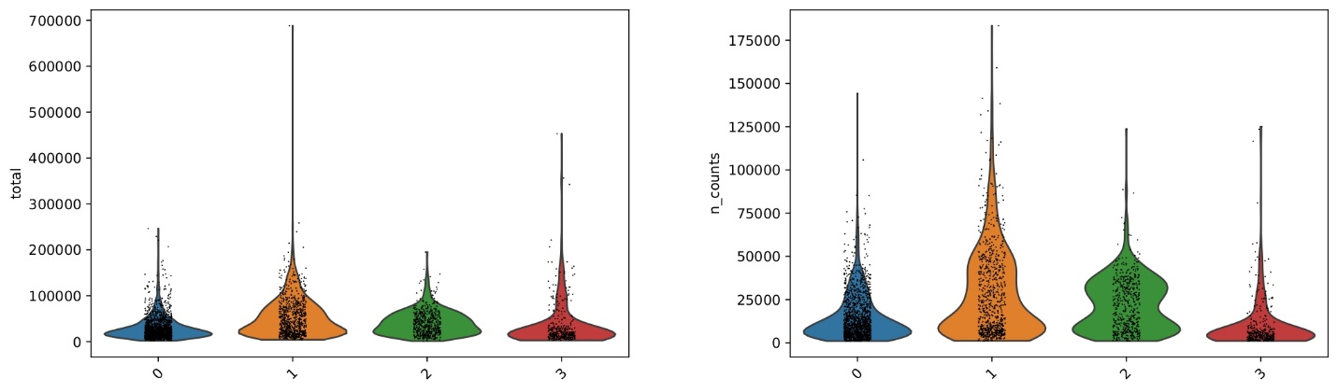

Figure 4: Violin plots for quality control metrices.

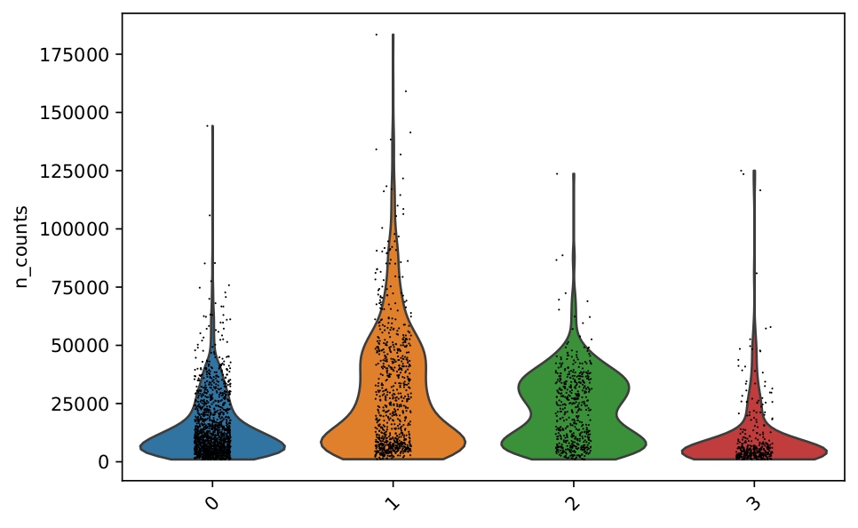

Figure 5: Violin Plots of total counts and total number of cells

These plots revealed differences in data distribution across clusters, emphasizing variations in chromatin accessibility between cell populations. The visualization of key peaks across different clusters provided further insights into regulatory dynamics. Overall, these results validate the effectiveness of the Muon-based pipeline for scATAQ‑seq data analysis and suggest that the observed clusters may represent functionally distinct cell states. The processed data, saved in H5AD format, will facilitate further downstream analysis and integrative multi-omics studies.