*ABNORMAL*

*VISION SIMULATOR*

Selin Eylül Bilen

Department of Information System Engineering

Istanbul Technical University

Istanbul, Turkey

bilen16@itu.edu.tr

***Abstract*—** **The human eye is an organ that reacts with light and allows light perception, color vision, and depth perception. But there might be some abnormalities temporarily or permanently. In this article, I will give a summary of the vision of a healthy eye and some permanent and temporary disordered eye and shows the differences between them.**

***Keywords— Vision, Disordered, Eyes, Abnormal***

1. INTRODUCTION

Most people have eye problems at one time or another. Some are minor and some are not. Eye diseases can be congenital or can occur later. Most eye diseases have an impact on humans’ vision. There so many of them but I covered 11 eye diseases in my project. This paper addresses the visions of these 11 eye diseases, which are cataract, tritanopia, protanopia, achromatopsia or monochromacy, glaucoma, practical blindness, torn retina, macular degeneration and pet vision(deuteranopia), also I added some extra visions such as drunk vision and deep dream vision but I didn’t add the deep dream vision to my project, I added cartoon and sketch functions to make my project not only educational but also entertaining. Lastly, I added a face detection algorithm that detects faces over an image.

The human eye is an organ that reacts with light and allows light perception, color vision, and depth perception. But there might be some abnormalities temporarily or permanently. In this article, I will give a summary of the vision of a healthy eye and some permanent and temporary disordered eye and shows the differences between them. This project is based on understanding how people with eye disabilities can see our world and also show the differences between those disabilities. So, my motivation is to show differences between the effects of the diseases, demonstrate to people how people with eye disorders can see the world. Thus, I am aiming to raise awareness.

1. DISEASES

*A. Cataract*

A cataract is a clouding of the lens of the eye which leads to a decrease in vision. I only used blur function for cataract.

*B. Astigmatism*

Astigmatism is a type of refractive error in which the eye does not focus light evenly on the retina. This results in distorted or blurred vision at any distance. I shifted the images three times than I blurred the image.

*C. Age-Related Macular Degeneration*

This condition is associated with the loss of retinal photoreceptor cells in the center of the retina where vision is the sharpest. Fist I found the center of the image then I put a circle there, I also add different radius circles. Because macular degeneration can be asymmetric.

*D. Color Blindness*

I covered three types of color blindness. These are tritanopia, protanopia and achromatopsia. Achromatopsia is subtitle of monochromacy it is basically the lack of ability to distinguish colors. Protanopia is caused by the complete absence of red retinal photoreceptors. Tritanopia is a very rare color vision disturbance in which only the red and the green cone pigments are present, with a total absence of blue retinal receptors. I found the RGB color values for these diseases and bit

*E. Practical Blindness*

Practical blind or partial blind people can recognize shapes, colors and light, but they nevertheless see it as blurred. But these people are not blind yet. I used blur filter with bigger kernel size.

*F. Pet Vision*

To see in full color as we know it, humans use three cones – red, blue and green. However, cats and dogs only have blue and green cones. This means they have a much more muted perception of color, which is akin to color blindness in humans which is deuteranopia. As cats and dogs are not sensitive to red light, they have difficulty distinguishing some colors. I used RGB color values for deuteranopia.

*G. Glaucoma*

The iris can end up blocking the drainage angle. You can think of it like a piece of paper sliding over a sink drain. I provided a mask image for glaucoma.

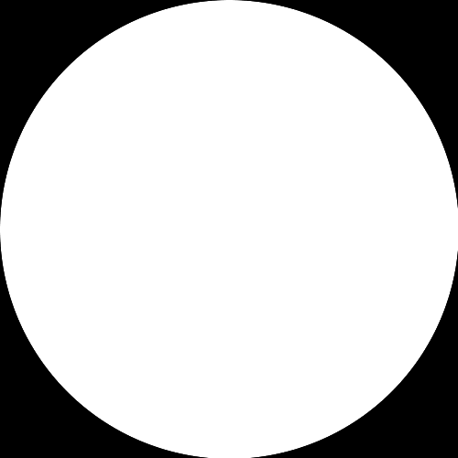

*H. Torn Retina*

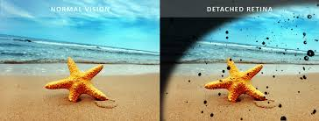Torn vision is so similar to the Glaucoma, in torn vision situation the iris can end up blocking the drainage angle as well. The only difference is in torn retina’s vision black points appear. So, I randomly created circles in different radius and printed on the image.

*I. Drunk Vision*

When a person takes alcoholic drink too much, their vision changes. I shifted the image 5 times then I used cv2.addWeighted function for combine them.

*J. Cartoon*

I used cv2.stylization for making cartoonlike image.

*cv2.stylization(image, sigma_s=100, sigma_r=0.25)*

*K. Sketch*

*I used pencil Sketch function from OpenCV library. Sketch shows the image as black and white and the sketch2 shows as colored.*

*Sketch, sketch2  = cv2.pencilSketch(image, sigma_s=40, sigma_r=0.4, shade_factor=0.02)*

*L. Face Detection*

I also added face detection algorithm to make code more detailed.

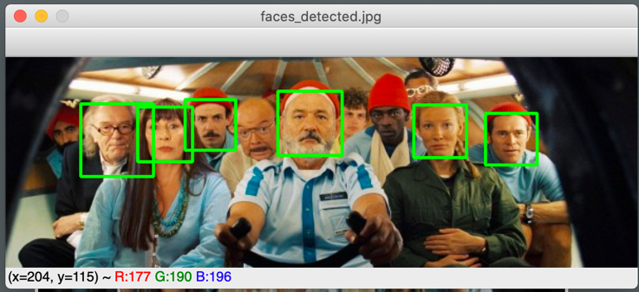

III. HOW THE CODE WORKS

I did all the coding into one python file. I used OpenCV, NumPy, Tkinter, Pillow, and Pygame. I created a window using Tkinter. I added thirteen buttons, one for browse and select an image, one for remove the selected image, and the eleven of them are the functions I implemented. I used file dialog calling from Tkinter. This file dialog only allows user to open jpg, jpeg, png, and bmp files.

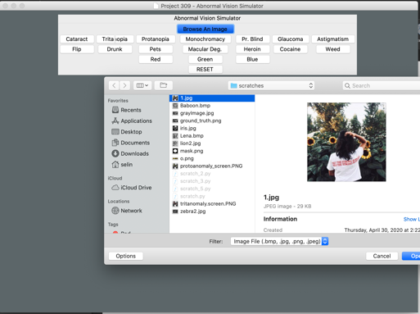

After user selects the image, they can press the button above and they can get the results in separate window. If the user already selects the image, they cannot use browse an image button until they click the RESET button.

IV. SHORTCOMINGS

I want to continue with this project and I have ideas about what I will add to this project. First, I want to add a description page about the diseases, when the user clicks on one of the diseases not only the image but also the description and the symptoms of this disease will appear on the screen.

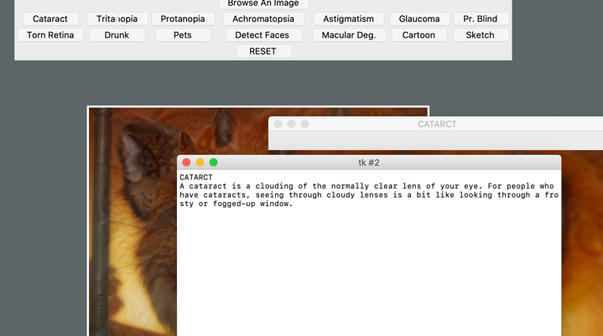

The second update is to add a facial expression recognizer. My code can detect faces so I can implement a library and create new functionality by small piece of code. The last update is I unfortunately have to remove the LSD button. I was planning to use TensorFlow, deep dream and inception5h which is one of the inception networks. I didn't add the code but I gained some experience with those. I think this was the one of the most educational and entertainment parts. I will provide some images after the deep dream.

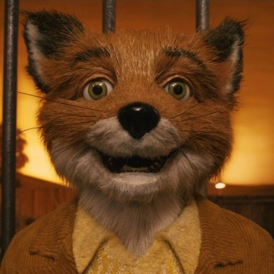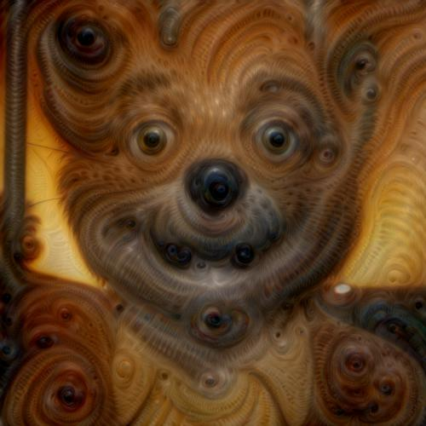

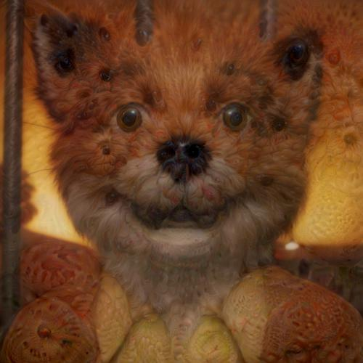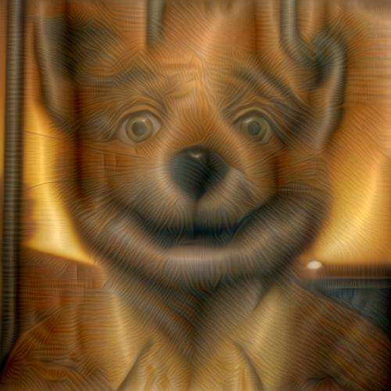

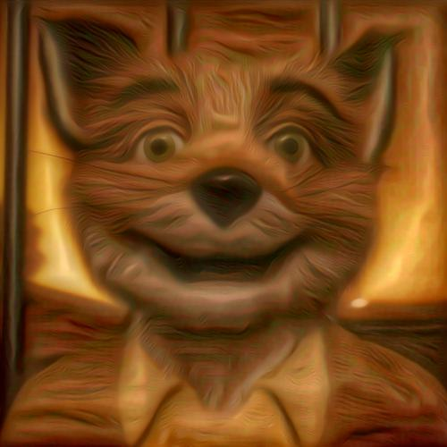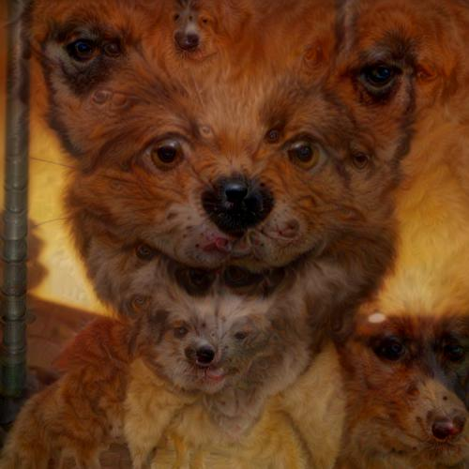

V.CONCLUSION

This project helps me to learn a lot about image processing and eye diseases. I learn how to apply filters, how to change the color values, how to detect faces, and how to write a code with Tkinter. While working with deep dream I had information about TensorFlow, about *dataflow graphs*—structures, also inception5h which is one of the versions of the inception networks. I only used these for deep dreaming but I didn’t add the code to my project. I only want to learn about it I am still working on it.

All in all, creating this project thought me a great deal regarding image processing and helped me brush up on my knowledge I gained throughout the semester

VI. REFERENCES

<https://www.color-blindness.com/rgb-anomaloscope-color-blindness-test/>

<http://mkweb.bcgsc.ca/colorblind/>

<https://stackoverflow.com/questions/87146/rgb-filters-for-different-forms-of-color-blindness>

<https://www.galianiophthalmology.com/services/general-cataract>

<https://www.cdc.gov/visionhealth/basics/ced/index.html>

<https://www.webmd.com/eye-health/common-eye-problems>

<http://caffe.berkeleyvision.org>

<https://www.tensorflow.org>