

Faculty of Engineering and Natural Sciences
Department of Mechatronics Engineering

MECA 332
Mechatronics Components Design
Term Project

Selin Rabia Kinsiz
122207037

05 June 2026
Istanbul, Türkiye
Table of Contents

1. 3D MODELLING AND MATERIAL DEFINITION OF THE CANTILEVER BEAM 5
1.1 Geometry Modelling of the Cantilever Beam 5
1.2 Material Properties and Simulation Input 6
2. STATIC STRUCTURAL ANALYSIS 6
2.1 Analytical Stress Calculation 7
2.2 Analytical Deflection Calculation 8
2.3 ANSYS Static Structural Results 8
2.4 Comparison of Analytical and ANSYS Results 9
2.5 Factor of Safety and Maximum Allowable Force 10
2.6 Mesh Convergence Study 10
3. EFFECT OF FILLET RADIUS ON STATIC STRUCTURAL RESPONSE 11
3.1 Effect of Fillet Radius on Stress and Deformation 12
3.2 Geometric Stress Concentration Factor 12
3.3 Comparison with Shigley Stress Concentration Chart 13
4. DYNAMIC FAILURE ANALYSIS UNDER FULLY REVERSED LOADING 14
4.1 Number of Cycles 14
4.2 Corrected Endurance Limit 15
4.3 S-N Curve 15
4.4 Alternating Stress for 5000 N 16
4.5 Fatigue Factor of Safety 16
5. MODAL ANALYSIS 18

Figures

Figure 1. Technical drawing of the cantilever beam. 5
Figure 2. 3D model of the cantilever beam with supporting plate, fillet radius, and circular hole. 5
Figure 3. Fixed support applied to the back face of the supporting plate 6
Figure 4. Applied force of 4500 N at the free end of the beam. 7
Figure 5. Equivalent von-Mises stress distribution. 8
Figure 6. Total deformation distribution. 9
Figure 7. Safety factor distribution. 9
Figure 8. Variation of maximum stress with mesh size during the mesh convergence study. 11
Figure 9. Equivalent stress distribution for r = 2 mm 13
Figure 10. Equivalent stress distribution for r = 12 mm 13
Figure 11. Geometric stress concentration factor (Kt) versus fillet ratio (r/d). 14
Figure 12. S-N curve for 1060 carbon steel based on the corrected endurance limit and Shigley fatigue model. 17
Figure 13. First mode shape of the cantilever beam at 449.27 Hz……………………..…………….18
Figure 14. Second mode shape of the cantilever beam at 685.45 Hz. 18
Figure 15. Third mode shape of the cantilever beam at 2540.4 Hz…………………………………18
Figure 16. Fourth mode shape of the cantilever beam at 3204 Hz. 19
Figure 17. Fifth mode shape of the cantilever beam at 3344.8 Hz………………………………….18
Figure 18. Sixth mode shape of the cantilever beam at 5575.7 Hz. 19
Figure 19. Natural frequency distribution for the first six modes. 19

Tables

Table 1. Material properties and simulation input parameters. 6
Table 2. Mesh convergence results. 11
Table 3. Effect of fillet radius on maximum stress and deformation. 12
Table 4. Calculated geometric stress concentration factors 13
Table 5. Natural frequencies obtained from modal analysis 18

- 3D MODELLING AND MATERIAL DEFINITION OF THE CANTILEVER BEAM
  - Geometry Modelling of the Cantilever Beam
The three-dimensional model of the cantilever beam and the supporting plate was created in SolidWorks according to the dimensions shown in Figure 1. The purpose of this stage was to obtain an accurate solid geometry before transferring the model to ANSYS for finite element analysis.
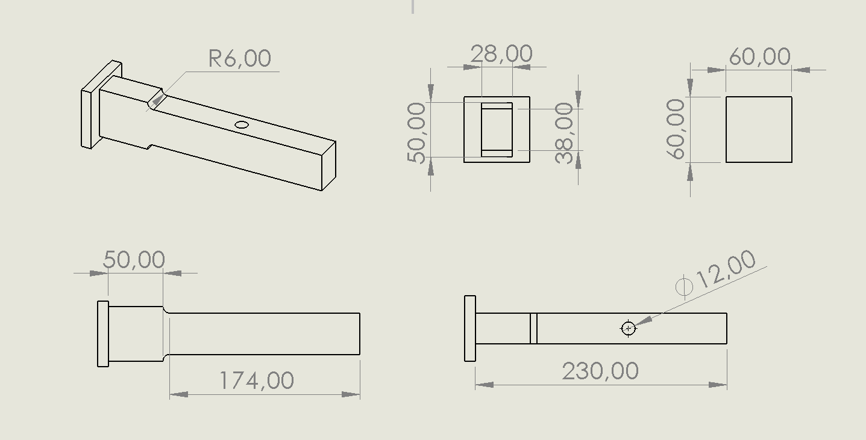
Figure 1. Technical drawing of the cantilever beam.

The model includes the supporting plate, the rectangular beam section, the shoulder transition, the 6 mm fillet radius, and the Ø12 mm circular hole. These geometric details were modelled carefully because they directly affect the stress distribution of the structure, especially around the shoulder and hole region.
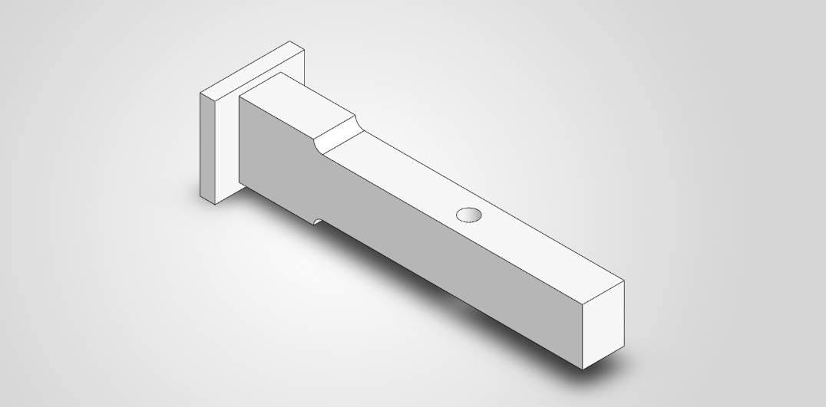
Figure 2. 3D model of the cantilever beam with supporting plate, fillet radius, and circular hole.

  - Material Properties and Simulation Input
The material assigned to the model was 1060 carbon steel, quenched and tempered at 1000°F. The elastic material properties were defined in ANSYS Engineering Data before starting the finite element analyses. Young’s modulus and Poisson’s ratio were required for the structural response, while density was required especially for the modal analysis. In addition, the surface finish, temperature, and reliability values were used as input parameters for the fatigue related calculations.
Table 1. Material properties and simulation input parameters.
Parameter | Value
Material | 1060 Carbon Steel
Heat Treatment Condition | Quenched and tempered at 1000°F
Young’s Modulus, E | 200 GPa
Poisson’s Ratio, ν | 0.3
Density, ρ | 7800 kg/m³
Surface Finish | Ground
Temperature | 200°C
Reliability | 99%

- STATIC STRUCTURAL ANALYSIS
A static structural analysis was performed to determine the stress distribution, deformation, factor of safety, and maximum allowable load of the cantilever beam. A vertical force of 4500 N was applied at the free end of the beam while the back face of the supporting plate was defined as a fixed support.

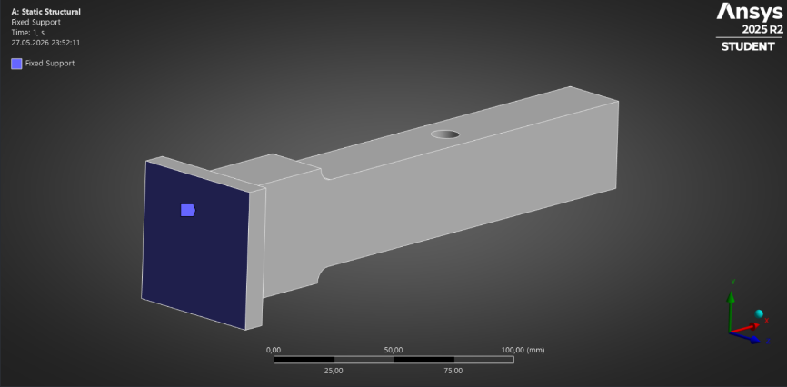
Figure 3. Fixed support applied to the back face of the supporting plate
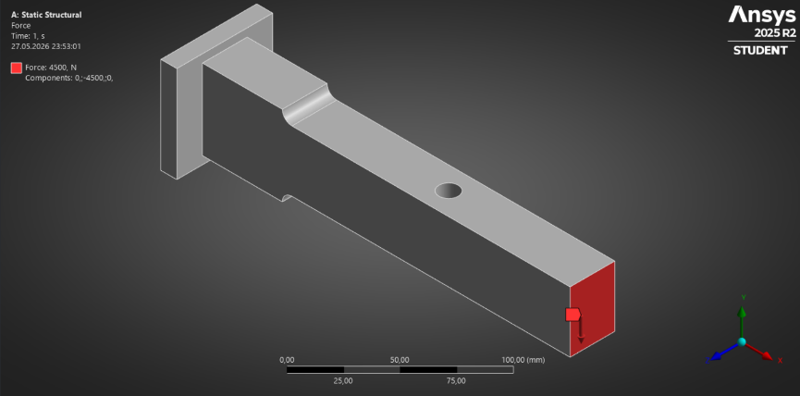
Figure 4. Applied force of 4500 N at the free end of the beam.
  - Analytical Stress Calculation
Before evaluating the finite element results, an analytical stress calculation was carried out. The maximum bending moment at the critical section was calculated using:
$$M=FL=4500×180=810000 \text{Nmm}$$
The second moment of area of the rectangular cross-section was determined as:
$$I=\frac{bh^{3}}{12}$$
$$I=\frac{28×{38}^{3}}{12}=128034.67 {\text{mm}}^{4}$$
The distance from the neutral axis to the outer fiber was:
$$c=\frac{h}{2}=\frac{38}{2}=19 \text{mm}$$

The nominal bending stress was then calculated using the flexure formula:
$$σ_{nom}=\frac{Mc}{I}$$
$$σ_{nom}=\frac{810000×19}{128034.67}=120.2 \text{MPa}$$
Since the beam contains a shoulder fillet, the stress concentration effect was considered. The geometric ratios were calculated as:
$$\frac{r}{d}=\frac{6}{38}=0.158$$
$$\frac{D}{d}=\frac{50}{38}=1.316$$
From the stress concentration charts, the theoretical stress concentration factor was taken as:
$$K_{t}≈1.6$$
Therefore, the maximum analytical stress became:
$$σ_{max}=K_{t}σ_{nom}$$
$$σ_{max}=1.6×120.2=192.32 \text{MPa}$$

  - Analytical Deflection Calculation
The maximum deflection of the cantilever beam was calculated using the classical Euler-Bernoulli beam theory presented in Shigley’s Mechanical Engineering Design. This approach assumes a prismatic beam with a constant cross-section and linear elastic behaviour.
For a cantilever beam subjected to a concentrated load at the free end, the maximum deflection is given by:
$$δ_{max}=\frac{FL^{3}}{3EI}$$

Substituting the values into the deflection equation:
$$δ_{max}=\frac{4500×{180}^{3}}{3×200000×128034.67}$$

The analytical maximum deflection was obtained as:
$$δ_{max}=0.3416 \text{mm}$$

This value represents the theoretical tip deflection predicted by classical beam theory and is used as a reference for comparison with the finite element results obtained from ANSYS.
  - ANSYS Static Structural Results
The equivalent von-Mises stress distribution obtained from ANSYS is shown in Figure 5. The maximum stress was concentrated around the shoulder and hole region due to geometric discontinuities.
$$σ_{ANSYS}=193.54 \text{MPa}$$
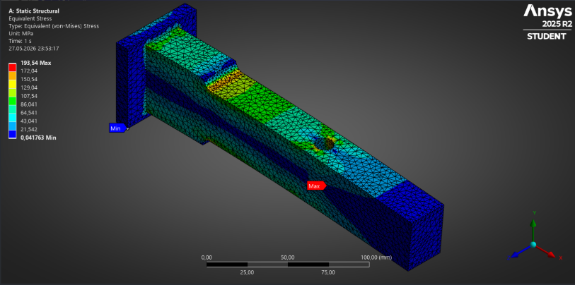
Figure 5. Equivalent von-Mises stress distribution.
The total deformation result is shown in Figure 6. As expected, the maximum deformation occurred at the free end of the beam.
$$δ_{ANSYS}=0.57248 \text{mm}$$
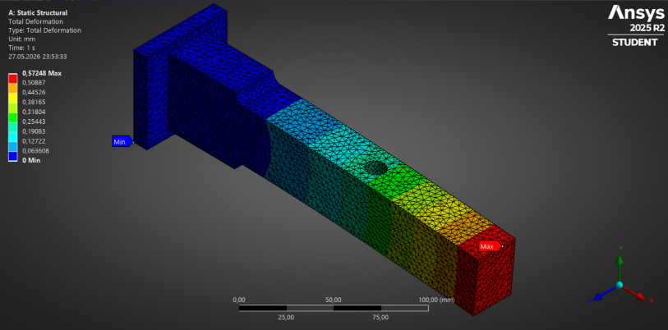
Figure 6. Total deformation distribution.
The safety factor distribution is shown in Figure 7.
$$FoS_{ANSYS}=3.4567$$
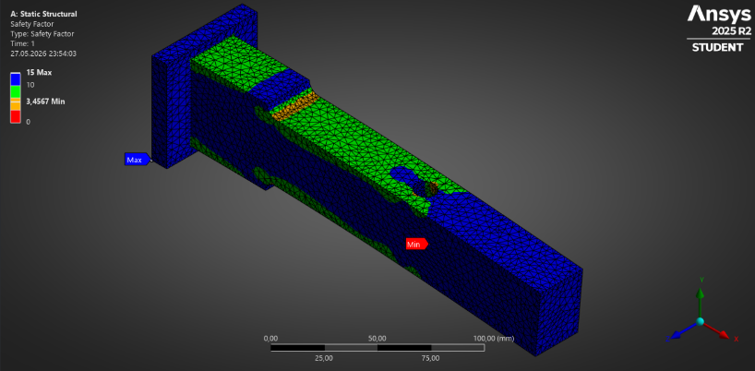
Figure 7. Safety factor distribution.
  - Comparison of Analytical and ANSYS Results
The analytical and finite element results were compared to evaluate the accuracy of the numerical model.
For stress:
$$σ_{analytical}=192.32 \text{MPa}$$
$$σ_{ANSYS}=193.54 \text{MPa}$$
$$\text{Difference}=\frac{\left|193.54-192.32\right|}{193.54}×100=0.63\%$$

This very small difference indicates excellent agreement between the analytical and numerical stress calculations.
For deformation:
$$δ_{analytical}=0.3416 \text{mm}$$
$$δ_{ANSYS}=0.57248 \text{mm}$$
$$\text{Difference}=\frac{\left|0.57248-0.3416\right|}{0.57248}×100=40.33\%$$

The deformation difference is larger than the stress difference because the analytical solution is based on the simplified assumptions of classical beam theory. The analytical model assumes a prismatic cantilever beam with a constant cross-section. The ANSYS model includes the complete three-dimensional geometry. Geometric features increase the flexibility of the structure and result in a higher deformation prediction in the finite element analysis.

  - Factor of Safety and Maximum Allowable Force
The factor of safety was calculated using the yield strength of 1060 carbon steel.
$$FoS=\frac{S_{y}}{σ_{max}}$$
$$FoS=\frac{669}{193.54}=3.456$$
Since the factor of safety is greater than one, the structure is considered safe under the applied load.
Assuming linear elastic behaviour, the maximum allowable force was estimated as:
$$F_{max}=F_{applied}×FoS$$
$$F_{max}=4500×3.456$$
$$F_{max}=15552 \text{N}$$
Therefore, the maximum allowable load for the design was approximately 15.55 kN.

  - Mesh Convergence Study
A mesh convergence study was performed to investigate the effect of mesh size on the numerical solution. As the mesh size decreased, the number of elements increased and the stress results gradually converged. Mesh refinement improved the accuracy of the stress prediction, particularly in the regions affected by stress concentration.

Table 2. Mesh convergence results.
Mesh Size (mm) | Number of Elements | Maximum Stress (MPa) | Maximum Deformation (mm)
10 | 854 | 155.00 | 0.56486
8 | 1274 | 147.92 | 0.56528
5 | 2839 | 151.09 | 0.56920
3 | 8906 | 180.10 | 0.57165
2 | 19501 | 193.54 | 0.57248

Figure 8. Variation of maximum stress with mesh size during the mesh convergence study.
The 2 mm mesh produced the most accurate stress result and was therefore selected for the final evaluation.
- EFFECT OF FILLET RADIUS ON STATIC STRUCTURAL RESPONSE
To investigate the influence of the shoulder geometry on the structural behaviour of the cantilever beam, a series of static analyses were performed for different fillet radius. During this study, the material properties, applied force, boundary conditions, and mesh settings were kept constant. Only the fillet radius at the shoulder transition was modified.

The objective of this analysis was to evaluate how the fillet radius affects stress concentration and deformation under the same loading conditions. Increasing the fillet radius provides a smoother transition between sections and generally reduces the stress concentration effect.
The back face of the supporting plate was defined as a fixed support, and a vertical force of 4500 N was applied at the free end of the beam for all cases.
  - Effect of Fillet Radius on Stress and Deformation
Static analyses were performed for fillet radii of 2, 4, 6, 8, 10, and 12 mm. The maximum equivalent stress and maximum total deformation obtained from ANSYS are summarized in Table 3.
Table 3. Effect of fillet radius on maximum stress and deformation.
Fillet Radius (mm) | Maximum Stress (MPa) | Maximum Deformation (mm)
2 | 230.35 | 0.5814
4 | 209.61 | 0.57725
6 | 198.42 | 0.57248
8 | 187.23 | 0.56873
10 | 163.90 | 0.56450
12 | 156.90 | 0.56031

The results show a clear reduction in maximum stress as the fillet radius increases. The highest stress occurred for the 2 mm radius case, while the lowest stress was obtained for the 12 mm radius case.
The maximum stress decreased from 230.35 MPa to 156.90 MPa, corresponding to a reduction of approximately 31.9%. This reduction occurs because a larger fillet radius distributes the load more smoothly through the transition region and reduces the severity of the stress concentration.
The deformation values changed only slightly throughout the study. This indicates that the fillet radius mainly affects the local stress distribution rather than the overall stiffness of the beam.
  - Geometric Stress Concentration Factor
The geometric stress concentration factor was calculated using:
$$K_{t}=\frac{σ_{max}}{σ_{nom}}$$
The nominal stress previously calculated from beam theory was:
$$σ_{nom}=120.2 \text{MPa}$$
Using this value, the geometric stress concentration factors were calculated.
Table 4. Calculated geometric stress concentration factors
Fillet Radius, r (mm) | r/d | Maximum Stress, σmax (MPa) | Stress Concentration Factor, Kt
2 | 0.053 | 230.35 | 1.92
4 | 0.105 | 209.61 | 1.74
6 | 0.158 | 198.42 | 1.65
8 | 0.211 | 187.23 | 1.56
10 | 0.263 | 163.90 | 1.36
12 | 0.316 | 156.90 | 1.31

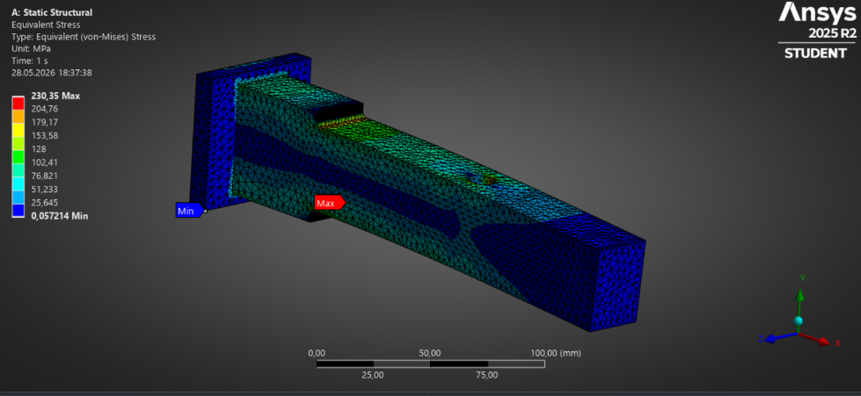
Figure 9. Equivalent stress distribution for r = 2 mm
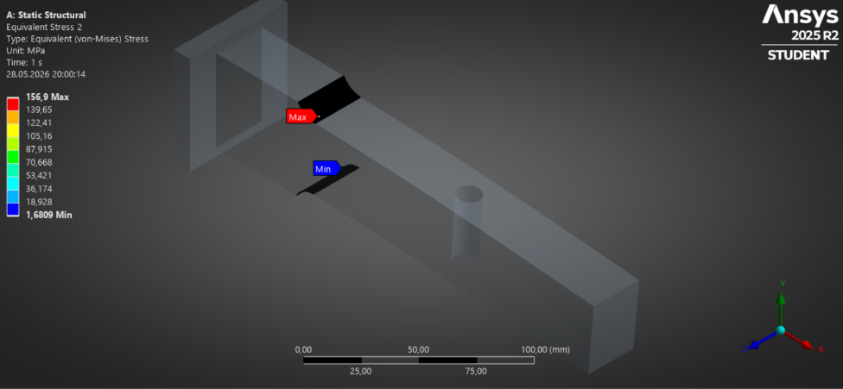
Figure 10. Equivalent stress distribution for r = 12 mm

  - Comparison with Shigley Stress Concentration Chart
The calculated results follow the same trend as the stress concentration charts presented in Shigley’s Mechanical Engineering Design. As the ratio $r/d$ increases, the stress concentration factor decreases.
For small fillet radius, the geometric discontinuity is sharper and the local stresses become higher than the nominal stress. Increasing the fillet radius reduces the stress gradient in the transition region and lowers the stress concentration factor.

The ANSYS results show good agreement with the theoretical behaviour predicted by the stress concentration charts. Both approaches indicate that increasing the fillet radius is an effective method for reducing peak stresses without significantly affecting the overall deformation of the structure.
0,053 0,105 0,158 0,211 0,263 0,316
Figure 11. Geometric stress concentration factor (Kt) versus fillet ratio (r/d).

- DYNAMIC FAILURE ANALYSIS UNDER FULLY REVERSED LOADING
A dynamic failure analysis was performed for the beam under fully reversed loading. The applied force magnitude was taken as 5000 N and the fillet radius was kept as 6 mm. Since the loading is fully reversed, the mean stress is zero and the alternating stress is used for the fatigue calculation.
  - Number of Cycles
The beam was assumed to operate for 2 years, 300 days per year, and 4 hours per day. The total operating time was calculated as:
$$t=2×300×4×3600=8640000 \text{s}$$
Since one cycle takes 15 seconds, the total number of cycles was:
$$N=\frac{8640000}{15}=576000 \text{cycles}$$

  - Corrected Endurance Limit
The ultimate tensile strength of the material was:
$$S_{ut}=965 \text{MPa}$$
The uncorrected endurance limit was estimated as:
$$S_{e}^{'}=0.5S_{ut}=0.5\left(965\right)=482.5 \text{MPa}$$
The surface finish factor for a ground surface was calculated as:
$$k_{a}=1.58{\left(S_{ut}\right)}^{-0.085}$$
$$k_{a}=1.58{\left(965\right)}^{-0.085}=0.881$$
For the rectangular cross-section, the equivalent diameter was calculated as:
$$d_{e}=0.808\sqrt{38×28}=26.36 \text{mm}$$
The size factor was:
$$k_{b}=1.24{\left(d_{e}\right)}^{-0.107}$$
$$k_{b}=1.24{\left(26.36\right)}^{-0.107}=0.874$$
For fully reversed bending:
$$k_{c}=1$$
The temperature factor at 200°C was taken as:
$$k_{d}=1.02$$
For 99% reliability:
$$k_{e}=0.814$$
The corrected endurance limit was calculated as:
$$S_{e}=k_{a}k_{b}k_{c}k_{d}k_{e}S_{e}^{'}$$
$$S_{e}=0.881×0.874×1×1.02×0.814×482.5$$
$$S_{e}=308.38 \text{MPa}$$
  - S-N Curve
The S-N curve was constructed using the finite-life relation:
$$S_{f}=aN^{b}$$
The fatigue strength coefficient was calculated as:
$$a=\frac{{\left(fS_{ut}\right)}^{2}}{S_{e}}$$

$$a=\frac{{\left(0.86×965\right)}^{2}}{308.38}=2233.42$$
The fatigue exponent was calculated as:
$$b=-\frac{1}{3}\log\left(\frac{fS_{ut}}{S_{e}}\right)$$
$$b=-\frac{1}{3}\log\left(\frac{0.86×965}{308.38}\right)=-0.1433$$
For the required life of 576000 cycles:
$$S_{f}=2233.42{\left(576000\right)}^{-0.1433}$$
$$S_{f}=333.75 \text{MPa}$$
This means that the beam should remain below approximately 333.75 MPa alternating stress for the required fatigue life.

  - Alternating Stress for 5000 N
The maximum bending moment for the 5000 N load was:
$$M=5000×180=900000 \text{Nmm}$$
The second moment of area was:
$$I=\frac{28×{38}^{3}}{12}=128034.67 {\text{mm}}^{4}$$
The nominal bending stress was calculated as:
$$σ_{nom}=\frac{900000×19}{128034.67}=133.55 \text{MPa}$$
The fatigue stress concentration factor was calculated using:
$$K_{f}=1+q\left(K_{t}-1\right)$$
For (q = 0.90) and ($K_{t}$= 1.65):
$$K_{f}=1+0.90\left(1.65-1\right)=1.585$$
Since the loading is fully reversed, the alternating stress was:
$$σ_{a}=K_{f}σ_{nom}$$
$$σ_{a}=1.585×133.55=211.67 \text{MPa}$$

  - Fatigue Factor of Safety
The fatigue factor of safety was calculated by comparing the fatigue strength at the required number of cycles with the alternating stress:

$$n_{f}=\frac{S_{f}}{σ_{a}}$$

$$n_{f}=\frac{333.75}{211.67}=1.58$$

The analytical fatigue factor of safety was found as approximately 1.58. Since this value is greater than 1, the beam is expected to survive the required 576000 cycles under the given fully reversed loading condition.

Figure 12. S-N curve for 1060 carbon steel based on the corrected endurance limit and Shigley fatigue model.
  - ANSYS Fatigue Evaluation and Comparison
To validate the analytical fatigue calculations, a fatigue analysis was performed in ANSYS using the Fatigue Tool. The minimum fatigue safety factor was determined by ANSYS as 1.55, with the critical region localized around the perimeter of the 12 mm hole due to the geometric notch effect.

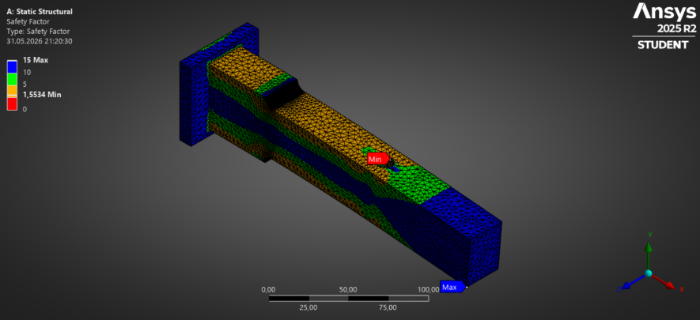
Figure 13. Fatigue safety factor distribution from ANSYS.
The analytical fatigue factor of safety was calculated as 1.58, while the ANSYS simulation resulted in 1.55. The negligible difference of approximately 1.9% between the theoretical approach and the numerical simulation demonstrates excellent agreement. This confirms that the beam is safely designed to withstand the operational fatigue life of 576,000 cycles.
- MODAL ANALYSIS
A modal analysis was performed to determine the natural frequencies and mode shapes of the cantilever beam. The back face of the supporting plate was fixed as the boundary condition, consistent with the static structural analyses. No external force was applied in the modal analysis because the aim was to obtain the free vibration characteristics of the structure.

The first six natural frequencies obtained from ANSYS are given in Table 5.

Table 5. Natural frequencies obtained from modal analysis
Mode Number | Natural Frequency (Hz)
1 | 449.27
2 | 685.45
3 | 2540.4
4 | 3204
5 | 3344.8
6 | 5575.7

The first natural frequency was obtained as 449.27 Hz. This mode is important because the first mode generally represents the lowest stiffness vibration response of the structure and is the most critical frequency to consider for resonance. If the structure is excited near this frequency during operation, large vibration amplitudes may occur.
The mode shape results show that the maximum deformation occurs near the free end of the beam, while the fixed support region remains almost stationary. This behaviour is expected for a cantilever beam because the supporting plate restricts the motion at the fixed side.

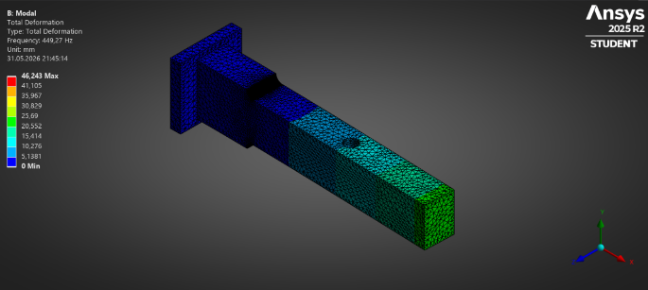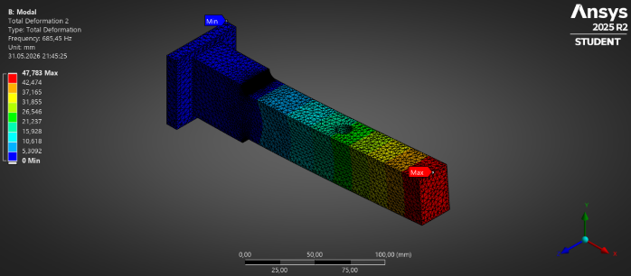
Figure 14. First mode shape of the cantilever beam at 449.27 Hz. Figure 15. Second mode shape of the cantilever beam at 685.45 Hz.
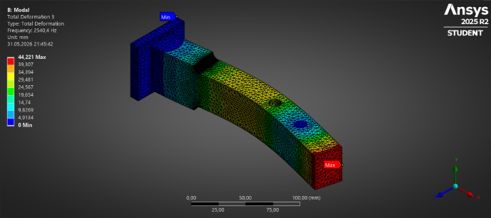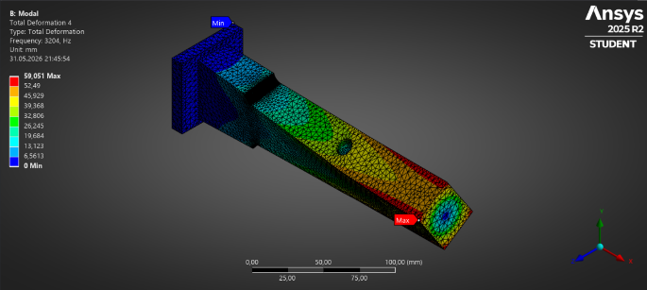
Figure 16. Third mode shape of the cantilever beam at 2540.4 Hz. Figure 17. Fourth mode shape of the cantilever beam at 3204 Hz.
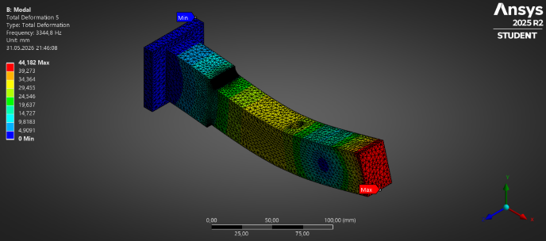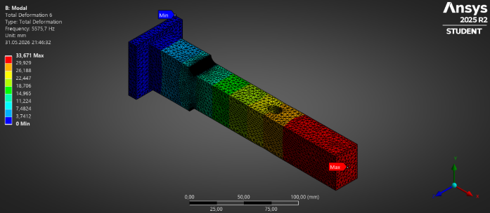
Figure 18. Fifth mode shape of the cantilever beam at 3344.8 Hz. Figure 19. Sixth mode shape of the cantilever beam at 5575.7 Hz.
The frequency response graph obtained from ANSYS is also included to show the distribution of the first six natural frequencies.
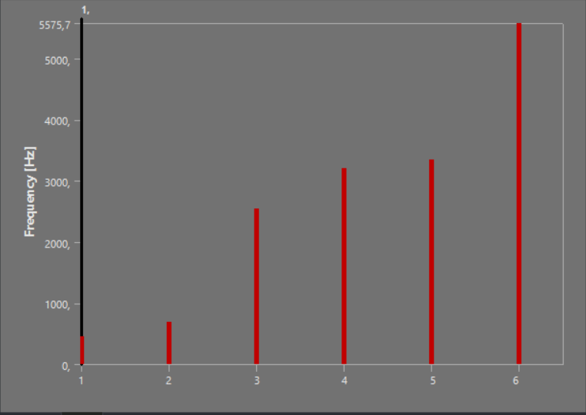
Figure 20. Natural frequency distribution for the first six modes.

The modal analysis results indicate that the structure has its first natural frequency at 449.27 Hz. Therefore, excitation frequencies close to 449.27 Hz should be avoided in operation to reduce the risk of resonance.

