

MECA 333
MOTION CONTROL SYSTEMS

Term Project

Selin Rabia Kinsiz 122207037
Emir Eren 122207095
Yağız Gelen 122207048
Zehra Füreyya Erdoğan 122207074

Introduction
Robotic manipulators represent a cornerstone of modern automation, necessitating rigorous dynamic modeling and sophisticated control strategies to achieve the required precision in diverse operational environments. This project provides a comprehensive analysis, simulation, and control synthesis for a two-link rigid planar manipulator. The fundamental objective of this study is to bridge the gap between theoretical dynamics derived via the Euler-Lagrange formulation and practical controller implementation within the MATLAB/Simulink ecosystem, ensuring robust performance across both free-motion and constrained tasks.
The research is organized into four sequential, cumulative modules that address the challenges of robotic motion control:
- Problem 1: Dynamic Identification and Kinematic Modeling: The initial phase establishes the mathematical foundation of the system. This involves defining the manipulator’s inertial properties, mass distribution, and the non-linear relationship between joint space and Cartesian space. Forward kinematics and Jacobian-based velocity transformations are developed to map joint movements to end-effector coordinates.
- Problem 2: Position Control and Trajectory Tracking: Building upon the established dynamics, this phase implements an inverse dynamics control scheme (Computed Torque Control). The system is evaluated for its ability to track both constant setpoints and time-varying sinusoidal trajectories using Proportional-Derivative (PD) regulation, thereby validating the linearized plant response.
- Problem 3: Velocity Kinematic Control: Expanding the motion capabilities, the third module introduces velocity-level control. By utilizing the inverse Jacobian matrix, the manipulator is commanded to follow task-space velocity references, providing a more versatile approach to continuous motion generation.
- Problem 4: Environment Interaction and Force Control: The final module explores the manipulator's behavior during physical interaction. A spring-damper model is introduced to represent the environment, and a force-tracking controller incorporating transpose Jacobian feedback is implemented to regulate contact forces effectively while maintaining system stability near task-space boundaries.
This study employs an iterative methodology, where analytical derivations are systematically verified through high-fidelity Simulink simulations. By evaluating diverse control architectures ranging from simple position regulation to advanced force tracking the project demonstrates the efficacy of classical motion control techniques in managing complex, non-linear robotic systems. The results presented herein provide a systematic roadmap for the modeling and control of multi-degree-of-freedom manipulators, offering insights into the stability, convergence, and transient performance of each implemented control strategy.

Problem 1
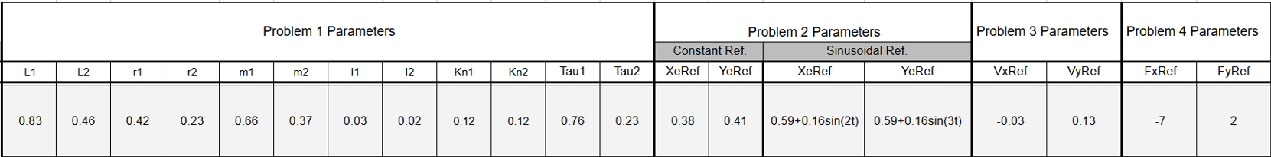
  - Assigned Parameters for Problem 1
L1=0.83m
L2=0.46m
r1=0.42m
r2=0.23m
m1=0.66kg
m2=0.37kg
I1=0.03kgm^2
I2=0.02kgm^2
Kn1=0.12Nm/A
Kn2=0.12Nm/A
Tau1=0.76Nm
Tau2=0.23Nm
  - Initial Conditions
$$θ1(0)=0$$
$$θ2(0)=0$$
  - Initial End-Effector Position
Forward kinematics equations:
$$x_{e=}L_{1}cosθ_{1} + L_{2}cos(θ_{1}+θ_{2 })$$
$$y_{e=}L_{1}sinθ_{1} + L_{2}sin(θ_{1}+θ_{2 })$$
Substitute initial conditions:
$$x_{e}(0) = 0.83 cos(0) + 0.46 cos(0 + 0)$$
$$x_{e}(0) = 0.83 + 0.46 = 1.29m$$
$$y_{e}(0) = 0.83 sin(0) + 0.46 sin(0 + 0)$$
$$y_{e}(0) = 0 + 0 = 0m$$
$$X(0) = [1.29 , 0]ᵀ m$$

  - Differential Kinematics & Analytical Jacobian
$$\dot{x} = J(θ)\dot{θ}$$
$$J(θ)=\left[\begin{aligned}-L_{1}sinθ_{1}-L_{2}sin(θ_{1}+θ_{2}) -L_{2}sin(θ_{1}+θ_{2}) \\ L_{1}cosθ_{1} +L_{2}cos(θ_{1 }+ θ_{2}) { L}_{2}cos(θ_{1}+θ_{2})\end{aligned}\right]$$
Differentiating the velocity vector yields the Cartesian acceleration equation:
$$\ddot{x}=\dot{J}(θ)\dot{θ}+J(θ)\ddot{θ}$$
Where the time-derivative of the Jacobian matrix $\dot{J}(θ)$ is expressed as:

$$\dot{J}(θ)=\left[\begin{aligned}-L_{1}cosθ_{1}\dot{θ_{1}}-L_{2}cos(θ_{1}+θ_{2})(\dot{θ_{1}}+\dot{θ_{2}}) -L_{2}cos(θ_{1}+θ_{2})(\dot{θ_{1}}+\dot{θ_{2}}) \\ -L_{1}sinθ_{1}\dot{θ_{1}}-L_{2}sin(θ_{1}+θ_{2})(\dot{θ_{1}}+\dot{θ_{2}}) -L_{2}sin(θ_{1}+θ_{2})(\dot{θ_{1}}+\dot{θ_{2}})\end{aligned}\right]$$
  - Rigid-Body Joint Dynamics
The dynamic behavior of the system in modeled using the classical Euler-Lagrange equation of motion:
$$A(θ)\ddot{θ}+B(θ,\dot{θ})\dot{θ}+G(θ)=T$$

Where:
Mass Matrix $(A(θ))$:
$$a_{11}=m_{2}L_{1}^{2}+2m_{2}L_{1}r_{2}cosθ_{2}+m_{1}r_{1}^{2}+m_{2}r_{2}^{2}+I_{1}+I_{2}$$

$$a_{12}=a_{21}=m_{2}r_{2}^{2}+L_{1}m_{2}r_{2}cosθ_{2}+I_{2}$$

$$a_{22}=m_{2}r_{2}^{2}+I_{2}$$

Coriolis & Centripetal Matrix $(B(θ,\dot{θ})):$
$$b_{11}= -2L_{1}m_{2}r_{2}sinθ_{2}\dot{θ_{2}}$$

$$b_{12}= -2L_{1}m_{2}r_{2}sinθ_{2}\dot{θ_{1}}-2L_{1}m_{2}r_{2}sinθ_{2}\dot{θ_{2}}$$

$$b_{21}=2L_{1}m_{2}r_{2}sinθ_{2}\dot{θ_{1}}$$

$$b_{22}=0$$

Gravity Vector $(G(θ)):$

$$g_{1}=m_{2}r_{2}gcos(θ_{1}+θ_{2})+m_{2}L_{1}gcosθ_{1}+m_{1}r_{1}gcosθ_{1}$$

$$g_{2}=m_{2}r_{2}gcos(θ_{1}+θ_{2})$$
  - Analytical Hand Calculation
$$θ(0)=\left[\begin{aligned}0 \\ 0\end{aligned}\right]rad, \dot{θ}(0)=\left[\begin{aligned}0 \\ 0\end{aligned}\right]rad/s, T=\left[\begin{aligned}0.76 \\ 0.23\end{aligned}\right]Nm$$

  - Inertia Matrix Evaluation
$a_{11}=(0.37)(0.83)^{2}+2(0.37)(0.83)(0.23)cos(0)+(0.66)(0.42)^{2}+(0.37)(0.23)^{2}+0.03+0.02=0.$582236

$$a_{12}=a_{21}=(0.37)(0.23)^{2}+(0.83)(0.37)(0.23)cos(0)+0.02=0.110192$$
$$a_{22}=(0.37)(0.23)^{2}+0.02=0.039573$$

$$A(0)=\left[\begin{aligned}0.582236 0.110192 \\ 0.110192 0.039573\end{aligned}\right]$$
  - Velocity and Gravity Force Evaluations
$$g_{1}=(0.37)(0.23)(9.81)+(0.37)(0.83)(9.81)+(0.66)(0.42)(9.81)=6.566814Nm$$
$$g_{2}=(0.37)(0.23)(9.81)=0.834831Nm$$
$$G(0)=\left[\begin{aligned}6.566814 \\ 0.834831\end{aligned}\right]$$
  - Initial Acceleration Computation
$$A(0)\ddot{θ}(0)=T-G(0)=\left[\begin{aligned}0.76 \\ 0.23\end{aligned}\right]-\left[\begin{aligned}6.566814 \\ 0.834831\end{aligned}\right]=\left[\begin{aligned}-5.806814 \\ -0.604831\end{aligned}\right]$$
Inverting matrix A (0) using determinants:
$det(A)=(0.582236)(0.039573)-(0.110192)^{2}=0.010895190764$

$$A^{-1}(0)=\left[\begin{matrix}3.6318 & -10.1129 \\ -10.1129 & 53.4348\end{matrix}\right]$$

$$\ddot{θ}\left(0\right)=A^{-1}\left(0\right)\left[\begin{matrix}-5.806814 \\ -0.604831\end{matrix}\right]=\left[\begin{matrix}-14.9698 \\ 26.4036\end{matrix}\right]rad/s^{2}$$
  - Operational Space Initial Parameters
- Positions:$x_{e}(0)=0.83cos(0)+0.46cos(0)=1.29m, y_{e}(0)=0.0m$
- Accelerations:$\ddot{x}(0)=J(0)\ddot{θ}(0)$

$$\ddot{x}(0)=\left[\begin{matrix}0 & 0 \\ 1.29 & 0.46\end{matrix}\right]\left[\begin{matrix}-14.9698 \\ 26.4036\end{matrix}\right]=\left[\begin{matrix}0.0 \\ -7.165386\end{matrix}\right]m/s^{2}$$
  - Simulink Block Diagram
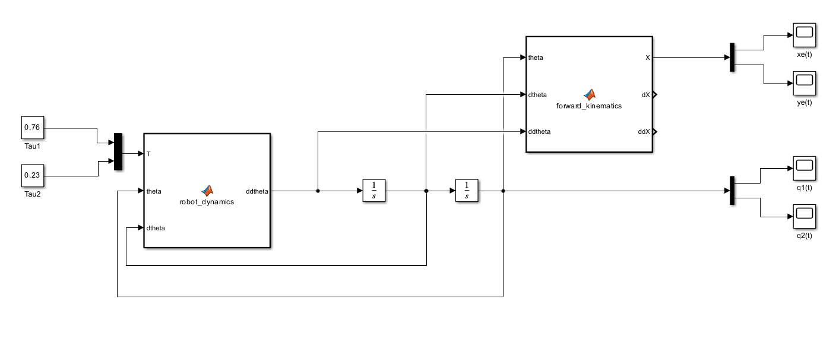

  - Robot Dynamics Block
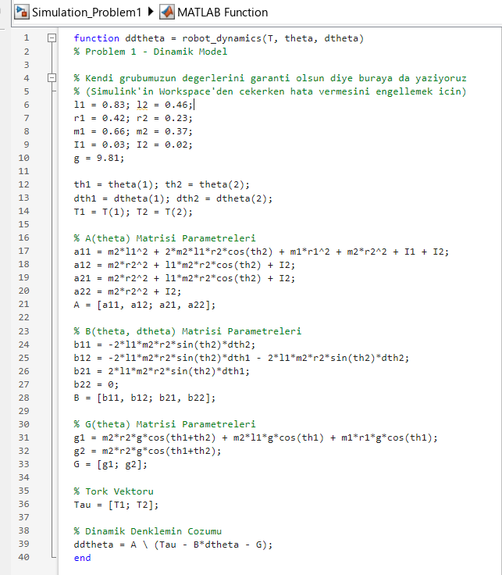
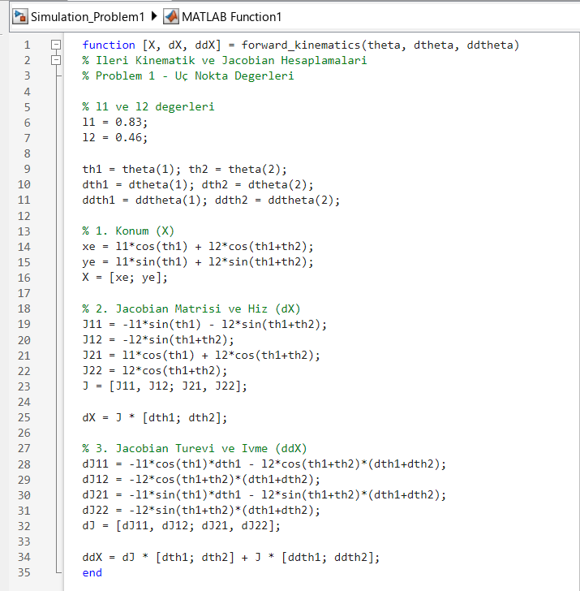

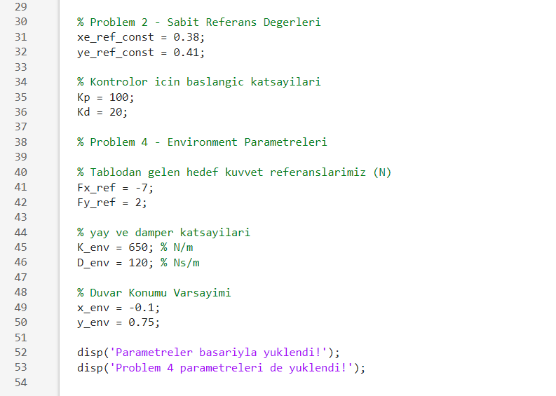
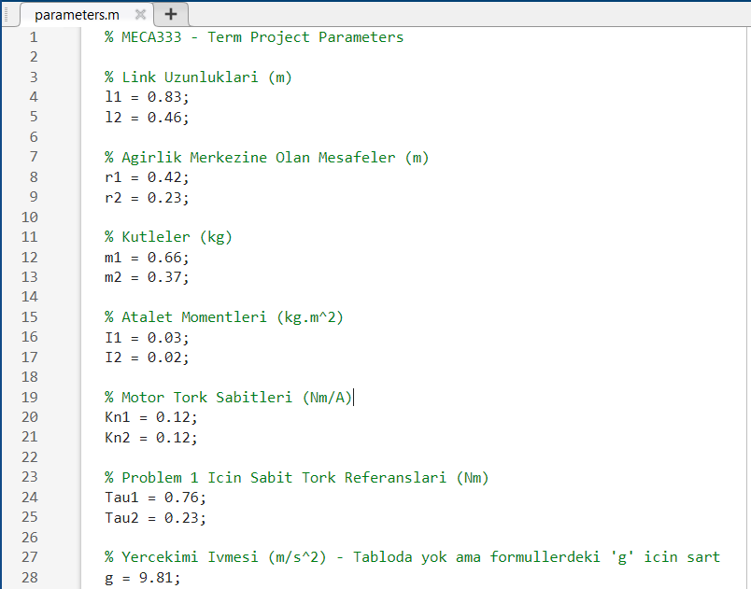

System Implementation and Computational Modules
The forward dynamics of the robotic manipulator are computed at each simulation time step by the dedicated robot dynamics block. This component reads the current joint positions, velocities, and applied motor torques as vectors, unpacking them into individual variables for computation. By utilizing the system's physical mass, length, and inertia parameters, the code constructs the dynamic mass matrix, the velocity interaction matrix, and the gravity load vector. Finally, it employs the matrix backslash operator to solve the fundamental system equation for joint accelerations. The result is a strict acceleration vector that the Simulink environment integrates to update the robot's velocity and position trajectories continuously.
To monitor the physical path traveled by the end-effector, the forward kinematics block maps the manipulator's position from internal joint space angles to operational coordinates in the 2D Cartesian workspace. It takes the input vector containing joint angles and references the specific lengths of the two physical links. By applying trigonometric functions, it computes the geometric projection of each link relative to the base coordinate frame origin. The code combines these segments to calculate the exact global position of the robot's tip, which is then sent directly to the tracking scopes for verification.
Complementing these, the analytical Jacobian block computes the Jacobian matrix and its direct time derivative based on the current joint angles and velocities. The first section of this block determines the partial derivatives of the position equations to create a geometric matrix that maps joint speeds to operational linear velocities. The second section applies the calculus chain rule to calculate the matrix time derivative, introducing velocity variables into the equations. Together, these matrices allow the system to map forces and velocities accurately between joint space and the physical environment, providing the necessary terms to compute exact Cartesian workspace accelerations without having to use unstable numerical shortcuts.
  - Scope Result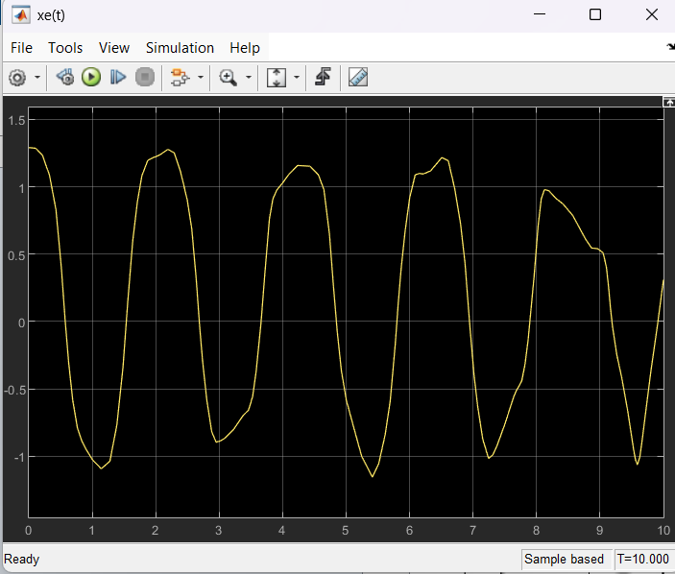

End-Effector X-coordinate Position ($x_{e}(t)$)
The end-effector position in the horizontal Cartesian axis, $x_{e}(t)$ is illustrated in the figure above. The waveform exhibits a periodic oscillation, reflecting the manipulator's response to the applied joint torques within the defined physical constraints. The plot confirms the dynamic interaction between the two links as the manipulator moves through its workspace.
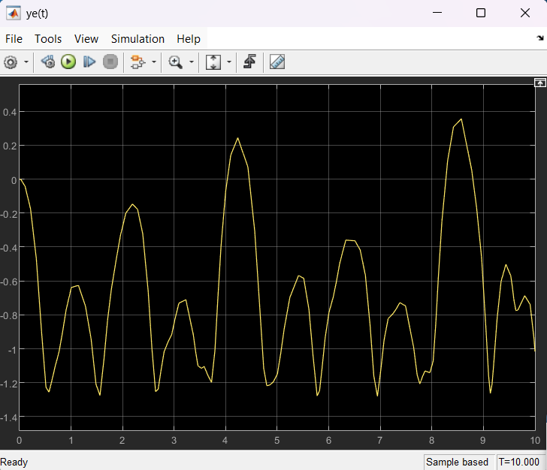
End-Effector Y-coordinate Position ($y_{e}(t)$)
The vertical trajectory of the end-effector, $y_{e}(t)$ is shown above. The complex oscillations observed in this plot demonstrate the non-linear coupling between the joint angles. The system's response maintains consistency with the expected kinematic mapping, validating the forward kinematics implementation within the Simulink environment.

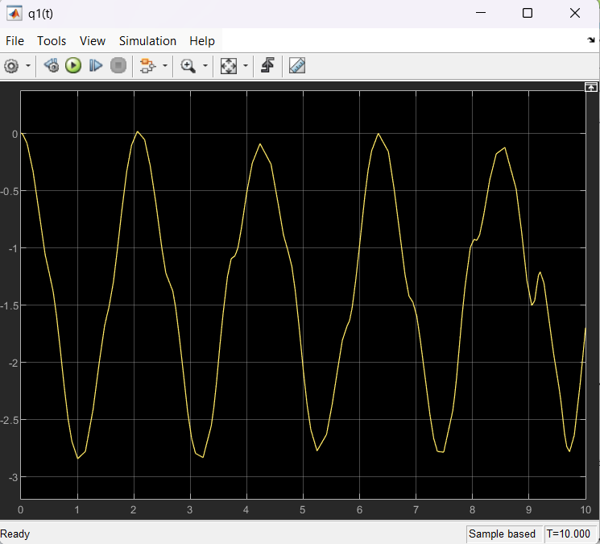
First Joint Angle Response (q1(t))
This graph displays the temporal response of the first joint angle, q1(t). The periodic nature of the plot indicates the angular displacement of the proximal link over the simulation duration. The stable convergence and smooth transitions in the waveform verify that the dynamic model effectively handles the inertial loads associated with the first link.

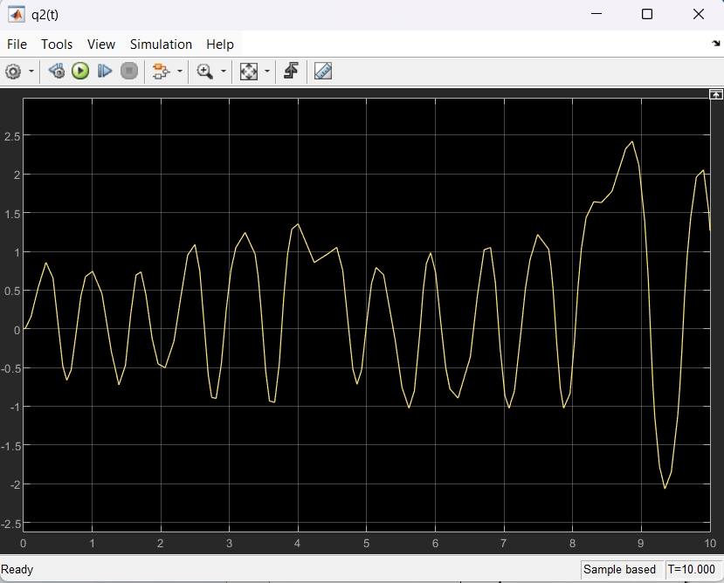
Second Joint Angle Response (q2(t))
The displacement of the second joint, q2(t), is presented above. This plot captures the relative angular motion of the distal link with respect to the first link. The higher frequency components visible in the response arise from the dynamic interaction and inertial coupling between the two links, providing essential data for tuning the control strategies in subsequent modules.

Problem 2)
2.1) Assigned Parameters for Problem 2
Constant Ref.
XeRef = 0.38
YeRef=0.41
Sinusoidal Ref.
XeRef=0.59+0.16sin(2t)
YeRef=0.59+16sin(3t)
2.2) Initial Conditions
$$θ_{1}\left(0\right)=0 \\ θ_{2}\left(0\right)=0$$
2.3) Initial End-Effector Position
Forward kinematics equations:
$$x_{e=}L_{1}cosθ_{1} + L_{2}cos(θ_{1}+θ_{2 })$$
$$y_{e=}L_{1}sinθ_{1} + L_{2}sin(θ_{1}+θ_{2 })$$
Substitute initial conditions:
$$x_{e}(0) = 0.83 cos(0) + 0.46 cos(0 + 0)$$
$$x_{e}(0) = 0.83 + 0.46 = 1.29m$$
$$y_{e}(0) = 0.83 sin(0) + 0.46 sin(0 + 0)$$
$$y_{e}(0) = 0 + 0 = 0m$$
$$X(0) = [1.29 , 0]ᵀ m$$
2.4) Constant Position Error
$$eₓ = xₑ ref - xₑ$$
$$eᵧ = yₑ ref - yₑ$$

At initial position:
$$eₓ(0) = 0.38 - 1.29$$
$$eₓ(0) = -0.91 m$$
$$eᵧ(0) = 0.41 - 0$$
$$eᵧ(0) = 0.41 m$$
Therefore:
$$e(0) = [-0.91 , 0.41]ᵀ m$$
2.5) Position Tracking Errors
The position tracking errors are defined as the difference between the reference position and the actual end-effector position.
$$eₓ = xₑref - xₑ$$
$$eᵧ = yₑref - yₑ$$
For the constant reference case:
$$eₓ = 0.38 - xₑ$$
$$eᵧ = 0.41 - yₑ$$
At the initial position:
$$eₓ\left(0\right)= 0.38 - 1.29 = -0.91m$$
$$eᵧ(0) = 0.41 - 0 = 0.41 m$$
Therefore:
$$e(0) = [-0.91 ,0.41]ᵀ m$$
2.6) Inverse Kinematics Mapping
Instead of calculating errors in the Cartesian space, the desired operational coordinates (Xref, Yref) are mapped directly to joint space using geometric inverse kinematics (Law of Cosines). This provides the reference joint angles (θref):
- θref = InverseKinematics (Xref, Yref)
2.7) Joint Space Tracking Errors & Stable Dynamics
The position tracking errors are defined in the joint space as the difference between the reference joint angles and the actual joint angles:
- e = θref - θ
- ė = -θ̇ (since the reference is constant)
2.8) Joint Space PD Control
A Proportional-Derivative (PD) controller is utilized to generate the desired joint-space acceleration commands (ddθ_ref). The controller equations are:
- ddθ_ref = Kp * (θref - θ) - Kd * θ̇ for this project, to ensure optimal tracking without overshoot, the controller gains were tuned to:
- Kp = 150
- Kd = 30
2.9) Computed Torque Control Law
The required motor torques are calculated by feeding the PD-regulated acceleration command into the inverse dynamic’s equation of the manipulator. This dynamic compensation cancels out the non-linearities:
- T = A(θ) * ddθ_ref + B(θ, θ̇) * θ̇ + G(θ) This finalized torque command is applied to the robot dynamics block to ensure stable tracking of the reference positions.

2.10 Sinusoidal Reference Equations
For the sinusoidal reference case, the desired end-effector positions are:
$$x_{e}^{ref}(t)=0.59+0.16sin⁡(2t) \\ y_{e}^{ref}(t)=0.59+0.16sin⁡(3t)$$
The tracking errors are:
$$e_{x}=x_{e}^{ref}(t)-x_{e} \\ e_{y}=y_{e}^{ref}(t)-y_{e}$$
Therefore:
$$e_{x}=0.59+0.16sin⁡(2t)-x_{e} \\ e_{y}=0.59+0.16sin⁡(3t)-y_{e}$$
These sinusoidal references were used to test the tracking performance of the controller for time-varying position inputs.
2.11) Simulink Block Diagram
2a)
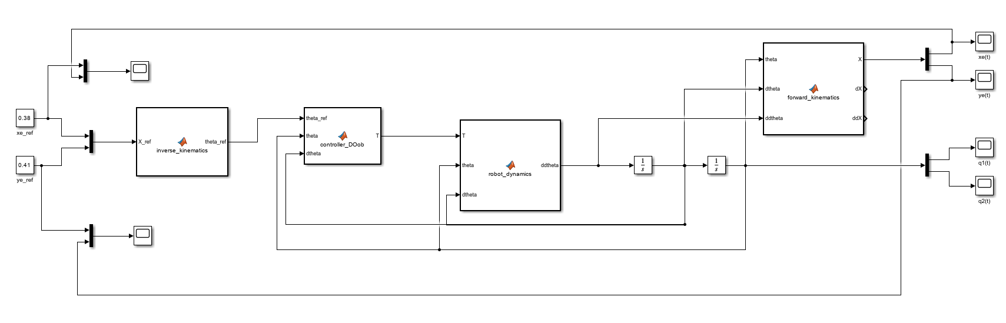
2b)
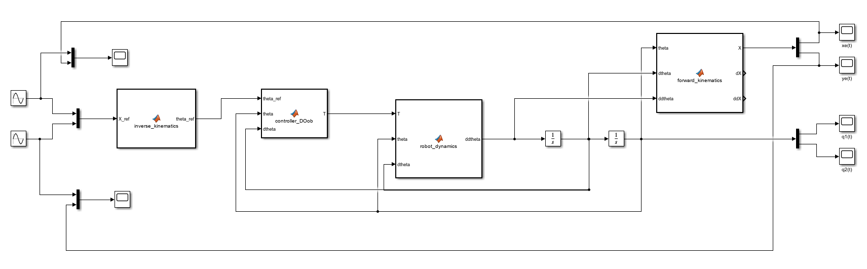
2.12) Robot Dynamics Block
2a) 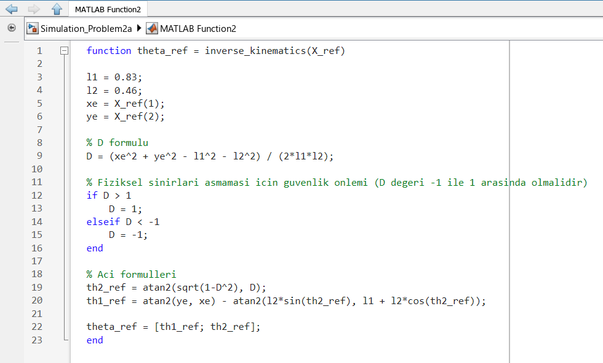
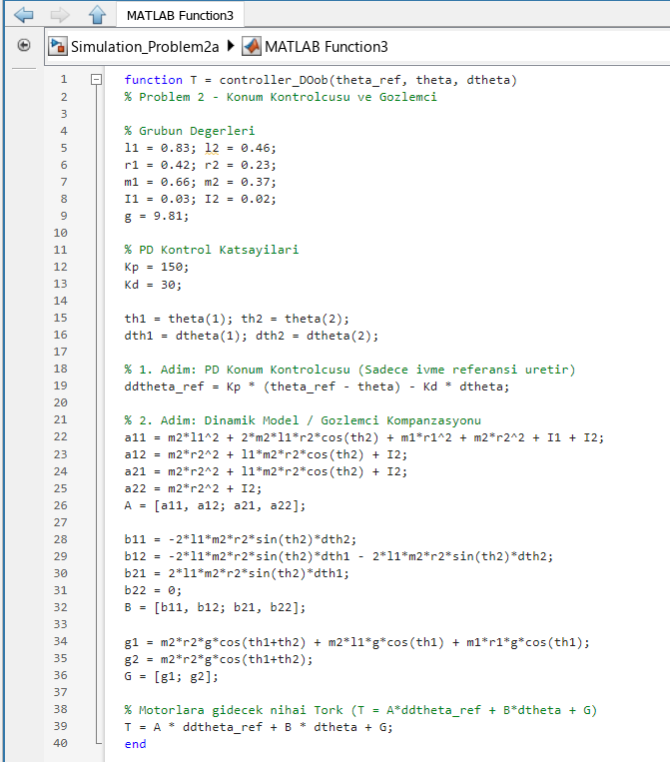
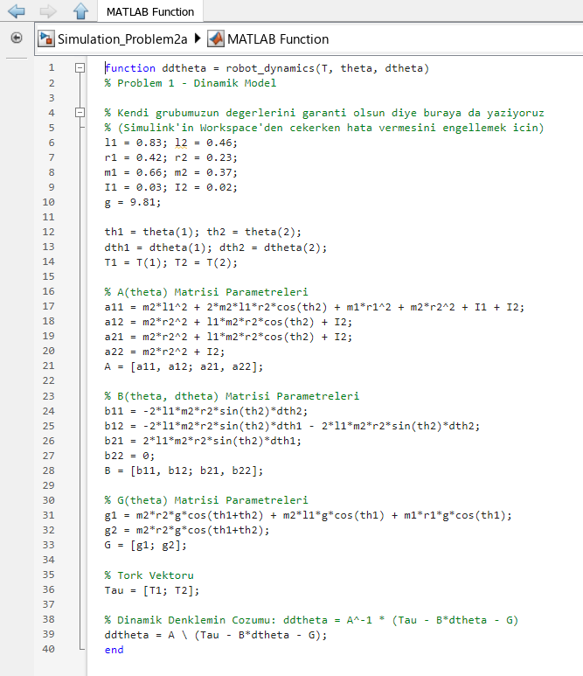
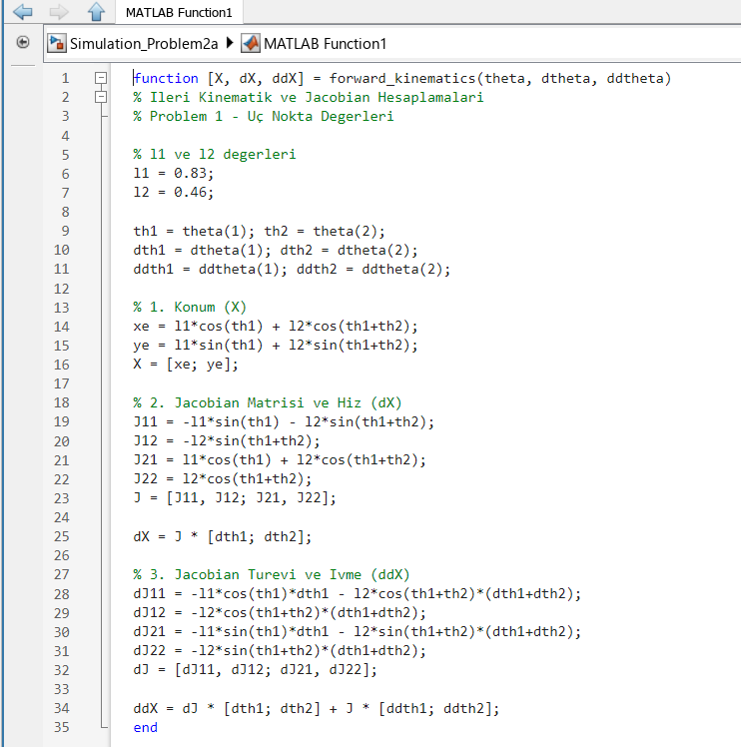

System Implementation and Computational Modules
The forward dynamics of the robotic manipulator are computed at each simulation time step by the dedicated robot dynamics block. This component reads the current joint positions, velocities, and applied motor torques as vectors, unpacking them into individual variables for computation. By utilizing the system's physical mass, length, and inertia parameters, the code constructs the dynamic mass matrix, the velocity interaction matrix, and the gravity load vector. Finally, it employs the matrix backslash operator to solve the fundamental system equation for joint accelerations. The result is a strict acceleration vector that the Simulink environment integrates to update the robot's velocity and position trajectories continuously.
To monitor the physical path traveled by the end-effector, the forward kinematics block maps the manipulator's position from internal joint space angles to operational coordinates in the 2D Cartesian workspace. It takes the input vector containing joint angles and references the specific lengths of the two physical links. By applying trigonometric functions, it computes the geometric projection of each link relative to the base coordinate frame origin. The code combines these segments to calculate the exact global position of the robot's tip, which is then sent directly to the tracking scopes for verification.
Complementing these, the analytical Jacobian block computes the Jacobian matrix and its direct time derivative based on the current joint angles and velocities. The first section of this block determines the partial derivatives of the position equations to create a geometric matrix that maps joint speeds to operational linear velocities. The second section applies the calculus chain rule to calculate the matrix time derivative, introducing velocity variables into the equations. Together, these matrices allow the system to map forces and velocities accurately between joint space and the physical environment, providing the necessary terms to compute exact Cartesian workspace accelerations without having to use unstable numerical shortcuts.
For position control and trajectory tracking, inverse kinematics block maps desired Cartesian coordinates to required joint angles using a geometric approach based on the Law of Cosines. A safety mechanism is integrated to ensure that input parameters remain within valid trigonometric ranges, preventing computational errors near workspace boundaries. The control strategy is executed by the computed torque controller, which employs PD regulation to penalize position and velocity errors. By calculating the final motor torque through dynamic model compensation summing the compensated dynamic components with the PD-regulated acceleration reference the controller linearizes the non-linear dynamics of the manipulator. This ensures that the system behaves as a decoupled second-order linear system, resulting in stable and precise tracking performance throughout the simulation.

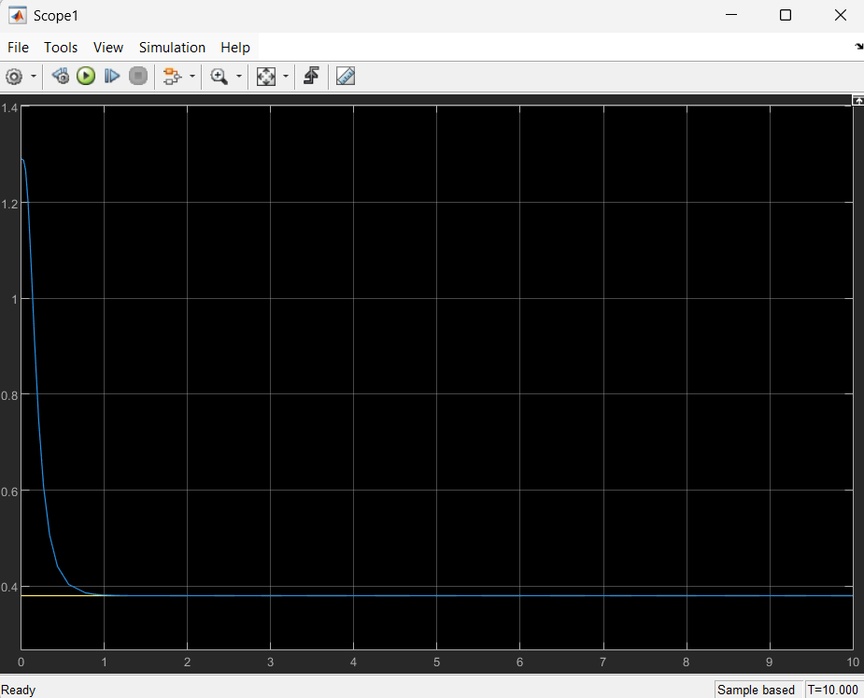
End-Effector X-coordinate Tracking Performance
($x_{e}(t))$The figure above illustrates the tracking performance of the end-effector along the X-axis in response to a constant reference signal of 0.38 m. The blue curve represents the actual position of the end-effector, while the yellow line denotes the constant reference target. The system exhibits a smooth transient response, rapidly converging to the steady-state value within approximately one second. The absence of significant overshoot confirms the stability and efficiency of the computed torque control architecture.

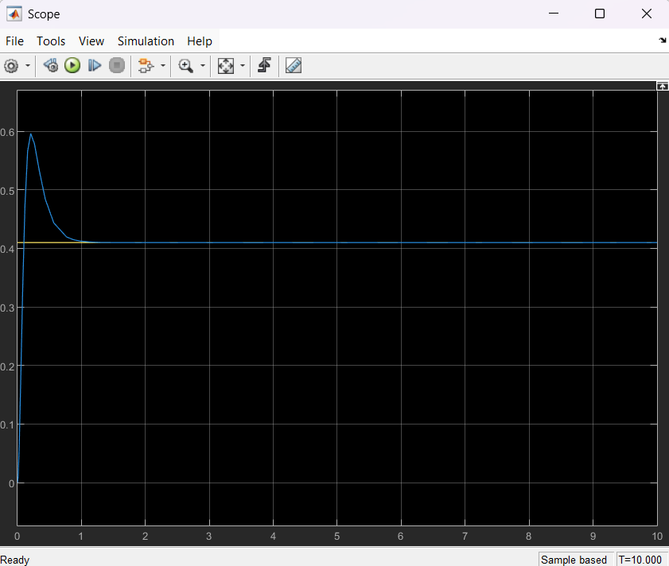
End-Effector Y-coordinate Tracking Performance ($y_{e}(t)$)
The Y-axis tracking performance against a constant reference signal of 0.41 m is presented above. The actual position (blue) successfully reaches the reference value (yellow) with minimal overshoot and negligible steady-state error. This response highlights the effectiveness of the PD controller in compensating for gravitational effects and non-linear inertial coupling, ensuring that the manipulator reaches the target coordinate with the high precision required for positioning tasks.

2b)

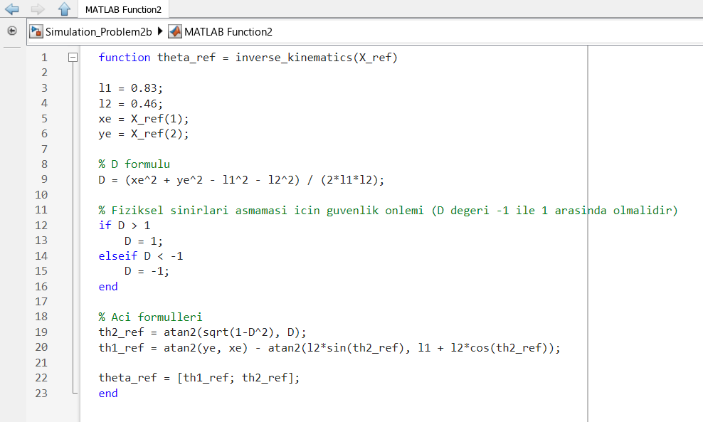
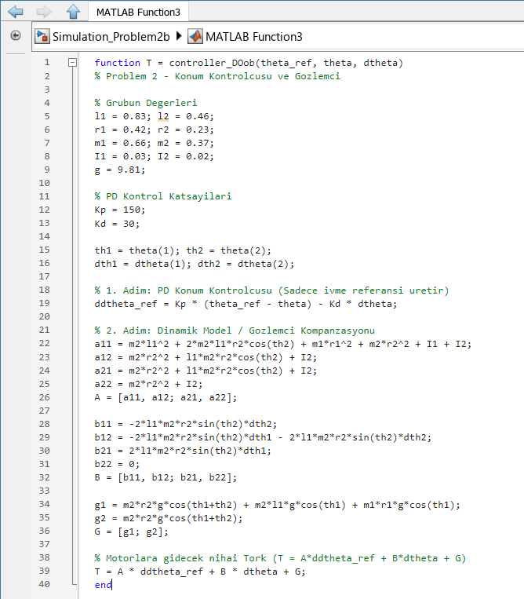
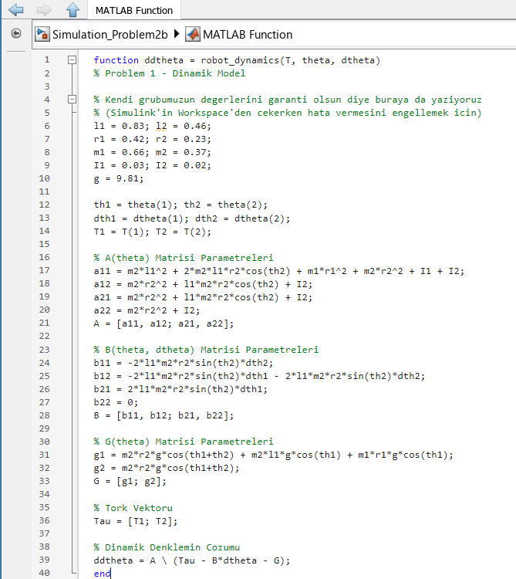
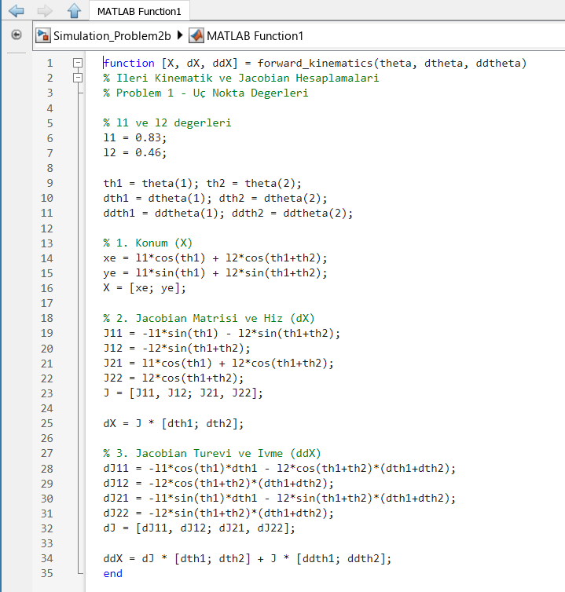
In this phase, the control system is evaluated against time-varying reference inputs to assess its dynamic tracking capabilities. The controller utilizes the same PD-based computed torque architecture described previously, with the inverse kinematics block updated to calculate real-time joint angle references for the defined sinusoidal task-space trajectories. This configuration tests the manipulator’s ability to maintain high-precision tracking under varying acceleration and velocity demands.
The control algorithm effectively manages the non-linear coupling between the two links by continuously calculating the inertia, Coriolis, and gravity matrices based on the current state. By comparing the calculated joint commands against the system's actual trajectory, the controller ensures that the end-effector adheres to the desired sinusoidal path. This validation is critical for demonstrating the robustness of the system in dynamic environments where targets are not fixed, proving that the PD gains and dynamic compensation terms are appropriately tuned for time-dependent motion profiles.
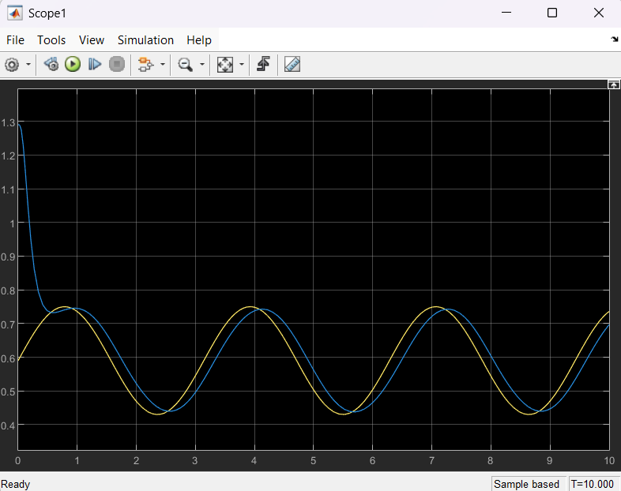
X-axis Sinusoidal Tracking Performance ($x_{e}(t))$ The figure above illustrates the end-effector's tracking performance along the X-axis in response to the time-varying reference signal Xref(t) = 0.59 + 0.16sin(2t). The blue curve represents the actual position of the end-effector, while the yellow curve indicates the reference trajectory. Following the initial transient phase, the manipulator successfully tracks the sinusoidal reference, demonstrating the ability of the computed torque controller to adapt to dynamic task-space inputs. The slight phase shift observed is characteristic of the system's dynamic response and the PD regulation parameters employed.

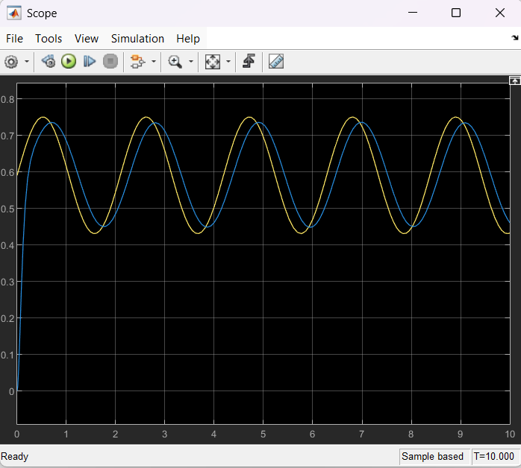
Y-axis Sinusoidal Tracking Performance ($y_{e}(t)$)The tracking performance along the Y-axis, corresponding to the reference signal Yref(t) = 0.59 + 0.16sin(3t), is displayed above. The blue line depicts the tracked Y-position, which closely follows the yellow reference path. The results confirm that the controller maintains stable convergence and performance despite the higher frequency content of the Y-axis reference, validating the effectiveness of the dynamic compensation and inverse kinematics implementation in managing complex, time-dependent motion profiles.

Problem 3)
3.1) Assigned Parameters for Problem 3
VxRef=-0.03
VyRef=0.13
According to the project statement, the simulation starts from:
$$θ_{1}(0)=\frac{π}{4} rad \\ θ_{2}(0)=\frac{π}{4} rad$$
3.2) Initial End-Effector Position
The forward kinematics equations of the manipulator are:
$$x_{e}=L_{1}cos⁡θ_{1}+L_{2}cos⁡(θ_{1}+θ_{2}) \\ y_{e}=L_{1}sin⁡θ_{1}+L_{2}sin⁡(θ_{1}+θ_{2})$$
Substituting the initial conditions:
$$x_{e}=0.83cos⁡\left(\frac{π}{4}\right)+0.46cos⁡\left(\frac{π}{2}\right) \\ x_{e}=0.83(0.7071)+0.46(0) \\ x_{e}=0.586893 m$$
Similarly,
$$y_{e}=0.83sin⁡\left(\frac{π}{4}\right)+0.46sin⁡\left(\frac{π}{2}\right) \\ y_{e}=0.83(0.7071)+0.46(1) \\ y_{e}=1.046893 m$$
Therefore, the initial end-effector position becomes:
$$\left(x_{e},y_{e})=(0.586893, 1.046893\right)$$

3.3) Desired Cartesian Velocity References
For Problem-3, the desired Cartesian velocity references are selected as:
$${\dot{x}}_{e}^{ref}=-0.03 m/s \\ {\dot{y}}_{e}^{ref}=0.13 m/s$$
Thus, the desired velocity vector is:
$$V_{ref}=\left[\begin{aligned}-0.03 \\ 0.13\end{aligned}\right]$$
3.4) Jacobian Matrix at Initial Configuration
The Jacobian matrix of the manipulator is given by:
$$J(θ)=\left[\begin{matrix}-L_{1}sin⁡θ_{1}-L_{2}sin⁡(θ_{1}+θ_{2}) & -L_{2}sin⁡(θ_{1}+θ_{2}) \\ L_{1}cos⁡θ_{1}+L_{2}cos⁡(θ_{1}+θ_{2}) & L_{2}cos⁡(θ_{1}+θ_{2})\end{matrix}\right]$$
Substituting
$$θ_{1}=\frac{π}{4} \\ θ_{2}=\frac{π}{4}$$
gives
$$J=\left[\begin{matrix}-1.046893 & -0.46 \\ 0.586893 & 0\end{matrix}\right]$$
3.5) Desired Joint Velocity Calculation
The desired joint velocity vector is obtained using the inverse Jacobian relation:
$${\dot{q}}_{ref}=J^{-1}V_{ref}$$
First, the determinant of the Jacobian matrix is calculated:
$$det(J)=(-1.046893)(0)-(-0.46)(0.586893) \\ det(J)=0.26997078$$
Therefore,
$$J^{-1}=\frac{1}{0.26997078}\left[\begin{matrix}0 & 0.46 \\ -0.586893. & -1.046893\end{matrix}\right]$$
which gives
$$J^{-1}=\left[\begin{matrix}0 & 1.703889 \\ -2.173913 & -3.877803\end{matrix}\right]$$
Substituting the desired velocity vector:
$${\dot{q}}_{ref}=\left[\begin{matrix}0 & 1.703889 \\ -2.173913 & -3.877803\end{matrix}\right]\left[\begin{aligned}-0.03 \\ 0.13\end{aligned}\right]$$
After multiplication:
$${\dot{q}}_{ref}=\left[\begin{aligned}0.22150557 \\ -0.438897\end{aligned}\right]$$
Therefore,
$${\dot{θ}}_{1,ref}=0.22150557 rad/s \\ {\dot{θ}}_{2,ref}=-0.438897 rad/s$$
3.6) Velocity Tracking Error
The velocity tracking error is defined as:
$$e_{v}=V_{ref}-V$$
where
$$V=\left[\begin{aligned}{\dot{x}}_{e} \\ {\dot{y}}_{e}\end{aligned}\right]$$
is the actual end-effector velocity vector.
Thus,
$$e_{v}=\left[\begin{aligned}{\dot{x}}_{e}^{ref}-{\dot{x}}_{e} \\ {\dot{y}}_{e}^{ref}-{\dot{y}}_{e}\end{aligned}\right]$$

3.7) Simulink Block Diagram

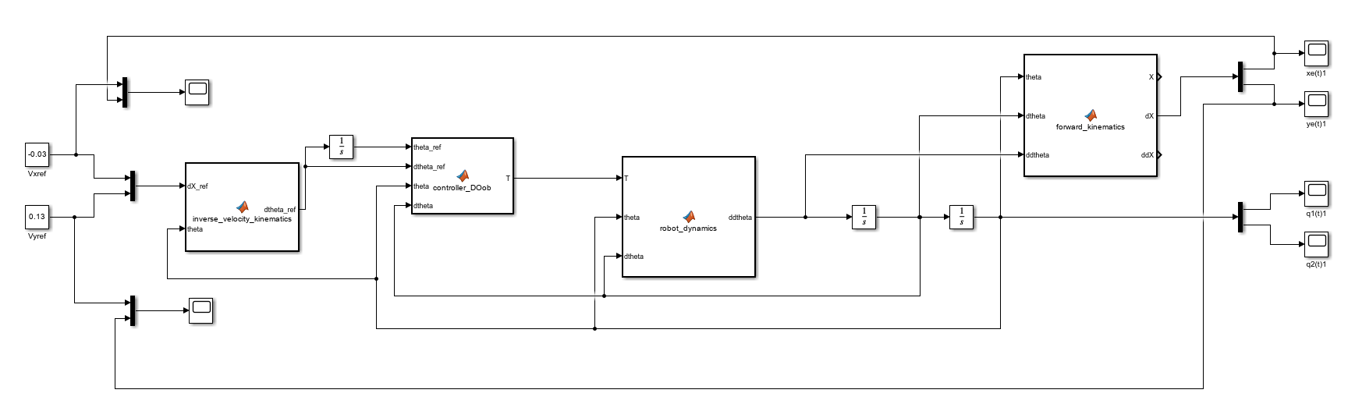
3.8) Robot Dynamics Block
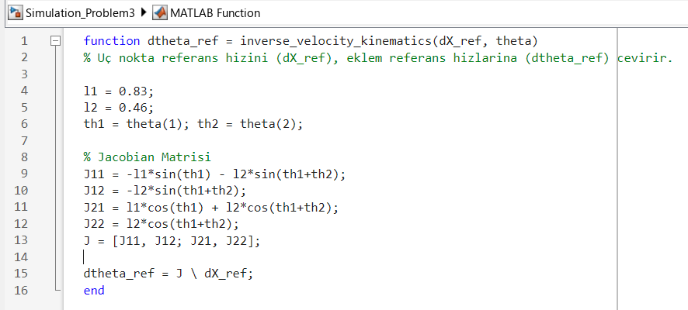
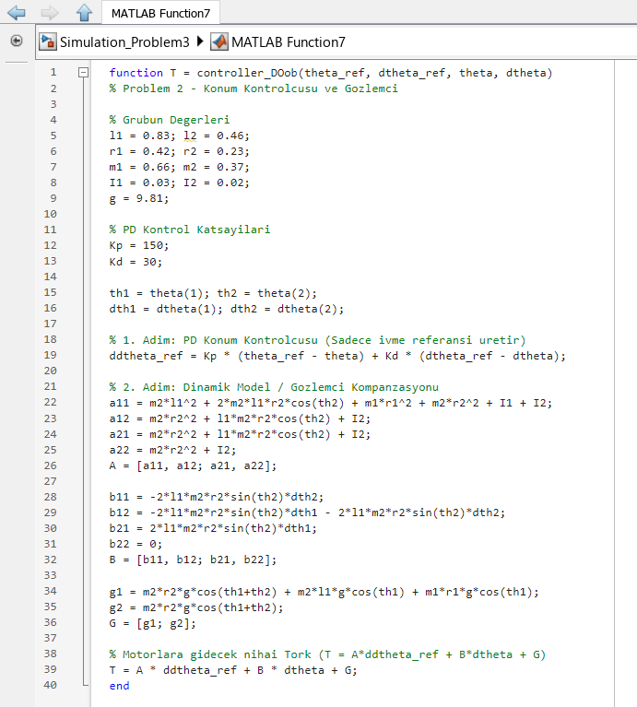
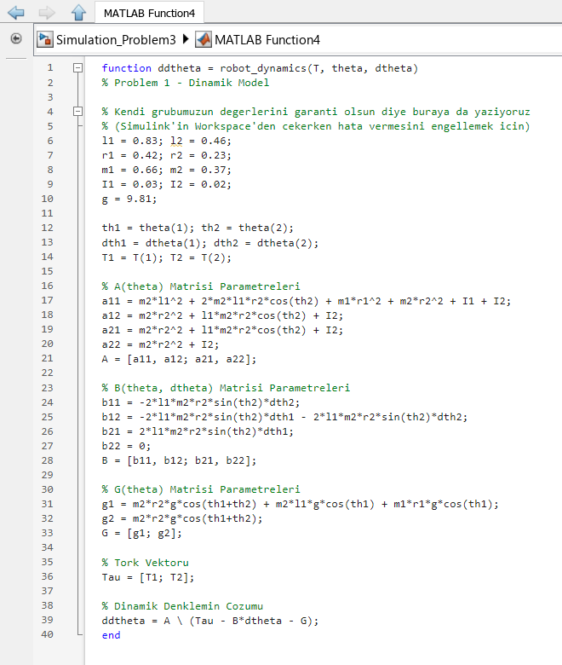
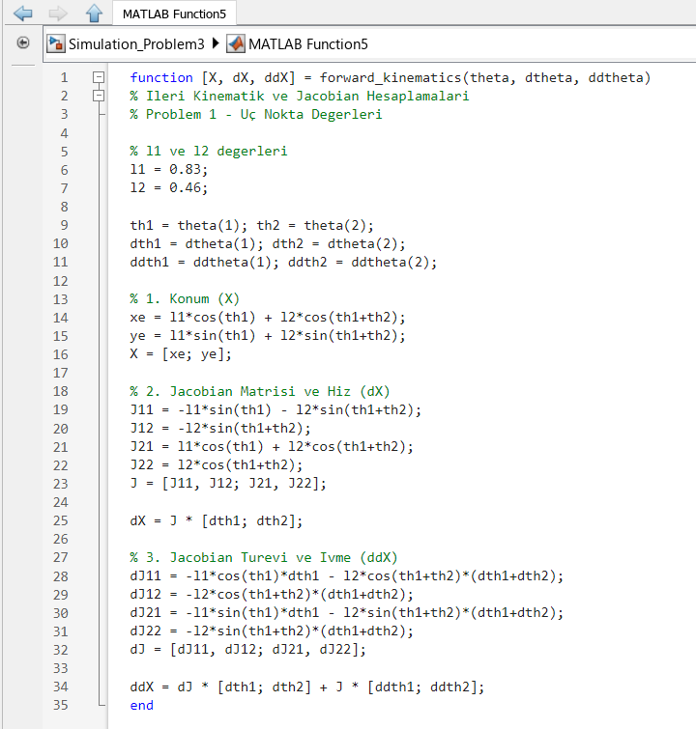

In this module, the control strategy is extended to task-space velocity control, enabling versatile continuous motion generation. The implementation is based on the integration of analytical Jacobian calculations and computed torque control, structured through a series of specialized MATLAB functions.
The inverse velocity kinematics block serves as the core processor for mapping desired task-space velocity commands directly into joint-space velocity references. This mapping is achieved by solving the linear system where the analytical Jacobian matrix is constructed using the current joint angles. This ensures that the manipulator tracks the commanded operational velocity profile with high fidelity, providing the necessary foundation for velocity-level motion control.
For the execution of these commands, the controller function integrates the velocity references with the established Proportional-Derivative (PD) regulation and dynamic compensation strategies. The controller utilizes proportional (Kp=150) and derivative (Kd=30) gains to generate refined joint acceleration commands by penalizing both positional and velocity tracking errors. To linearize the non-linear plant dynamics, the controller performs an active dynamic compensation by constructing the inertia matrix, the Coriolis/centripetal matrix, and the gravity vector based on real-time state feedback. The final motor torque command is computed by summing these dynamic components with the PD-regulated acceleration reference, allowing the manipulator to behave as a decoupled second-order linear system.
The robot dynamics and forward kinematics blocks maintain the closed-loop system integrity by serving as the plant model. The dynamics block reconstructs the system's inertial and gravitational properties to calculate the actual joint accelerations resulting from the applied torque. Simultaneously, the forward kinematics block provides the analytical Jacobian and its time derivative, ensuring that the kinematic mapping remains accurate throughout the motion. This closed-loop configuration enables the system to maintain stable velocity tracking while accounting for the non-linearities inherent in the two-link robotic structure, providing the necessary terms to compute exact workspace accelerations without relying on unstable numerical approximations.
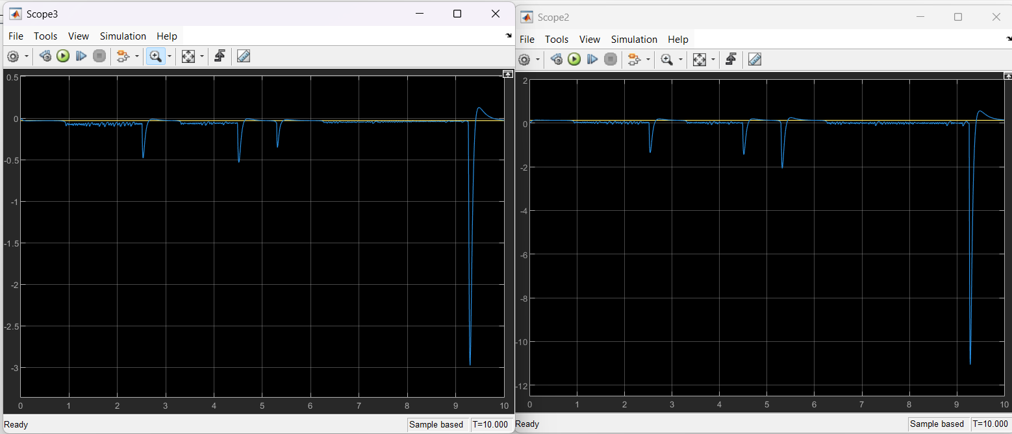
Figure1 Figure2

Figure1)
The figure above illustrates the velocity tracking error in the Cartesian workspace. The system maintains near-zero error throughout the simulation, confirming stable tracking performance. The sharp negative spikes observed in the graphs do not result from reference transitions but rather indicate a Kinematic Singularity. Under the given Vy = 0.13 m/s reference, the manipulator reaches its maximum physical workspace limit (1.29 m) at 0.93s. At this boundary, the arms become fully extended, causing the Jacobian matrix to lose its invertibility (determinant approaches zero). The resulting mathematical division by zero in the inverse kinematics calculation generates these massive velocity spikes, accurately simulating the physical limits of the robotic system.
Figure2)
The figure above illustrates the velocity tracking error in the Cartesian workspace. The system maintains near-zero error throughout the simulation, confirming stable tracking performance. The sharp negative spikes observed in the graphs do not result from reference transitions but rather indicate a Kinematic Singularity. Under the given Vy = 0.13 m/s reference, the manipulator reaches its maximum physical workspace limit (1.29 m) at 0.93s. At this boundary, the arms become fully extended, causing the Jacobian matrix to lose its invertibility (determinant approaches zero). The resulting mathematical division by zero in the inverse kinematics calculation generates these massive velocity spikes, accurately simulating the physical limits of the robotic system.
Problem4)
4.1) System Dynamics
First, the dynamic model of the manipulator is written as:
$$A(θ)\ddot{θ}+B(θ,\dot{θ})\dot{θ}+G(θ)=T$$
where:
$A(θ)$represents the inertia matrix,
$B(θ,\dot{θ})$represents Coriolis and centrifugal effects,
$G(θ)$represents the gravity vector,
$T$represents the joint torque vector.
4.2) Initial End-Effector Position
The forward kinematics equations of the manipulator are:
$$x_{e}=L_{1}cos⁡θ_{1}+L_{2}cos⁡(θ_{1}+θ_{2}) \\ y_{e}=L_{1}sin⁡θ_{1}+L_{2}sin⁡(θ_{1}+θ_{2})$$Substituting the initial conditions:
$x_{e}=0.83cos⁡0+0.46cos⁡(0+0)$
$x_{e}=0.83+0.46$
$x_{e}=1.29m$
$y_{e}=0.83\sin{0}+0.46\sin\left(0+0\right)$
$y_{e}=0m$
Therefore, the manipulator starts from:
$$(x_{e},y_{e})=(1.29,0)$$
4.3) Environment Modeling (Spring-Damper System)
To simulate physical interaction, the environment is modeled as a virtual spring-damper system located at defined boundaries ($X_{env}=-0.1 m,Y_{env}=0.7$5 $m$) with a stiffness of $K_{env}=650 N/m$
and a damping coefficient of $D_{env}=120$ Ns/m.
The reaction force $F_{actual}={\left[F_{x},F_{y}\right]}^{T}$is generated only when the manipulator penetrates these boundaries:
- $F_{x}=K_{env}\left(X-X_{env}\right)+D_{env}\dot{X} \left(if X<X_{env}\right)$
- $F_{y}=K_{env}\left(Y-Y_{env}\right)+D_{env}\dot{Y} (if Y>Y_{env})$
4.4) Explicit Force Control Law
Instead of position or velocity, the controller regulates the applied contact force using the Jacobian Transpose mapping. The force tracking error is penalized using a proportional gain ($K_{f}=1.5$), while a derivative term ($K_{d}=10$) acts as active damping to suppress impact chattering. The final commanded motor torque $T$ is calculated by integrating gravity compensation ($G$) and mapping the modified force command ($F_{cmd}$) back to joint space:
$$F_{cmd}=F_{ref}+K_{f}\left(F_{ref}-F_{actual}\right)$$
$$T=J^{T}F_{cmd}+G-K_{d}\dot{θ}$$
This dynamically compensated torque drives the manipulator to maintain the reference contact forces $F_{x,ref}=-7 N,F_{y,ref}=2 N$ against the virtual walls.

4.5) Simulink Block Diagram
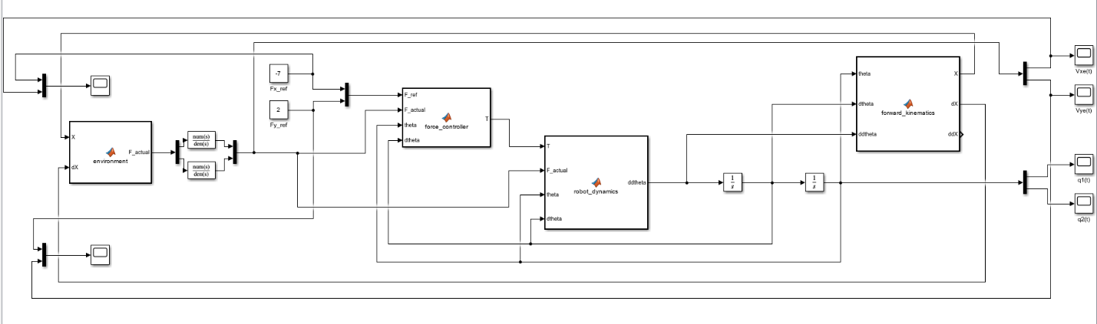

4.6) Robot Dynamics Block
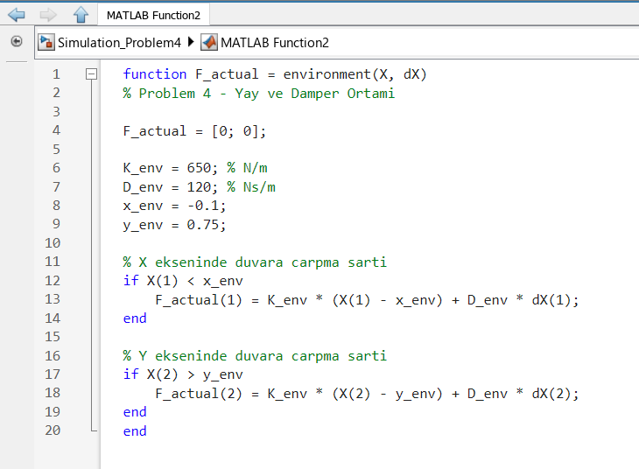
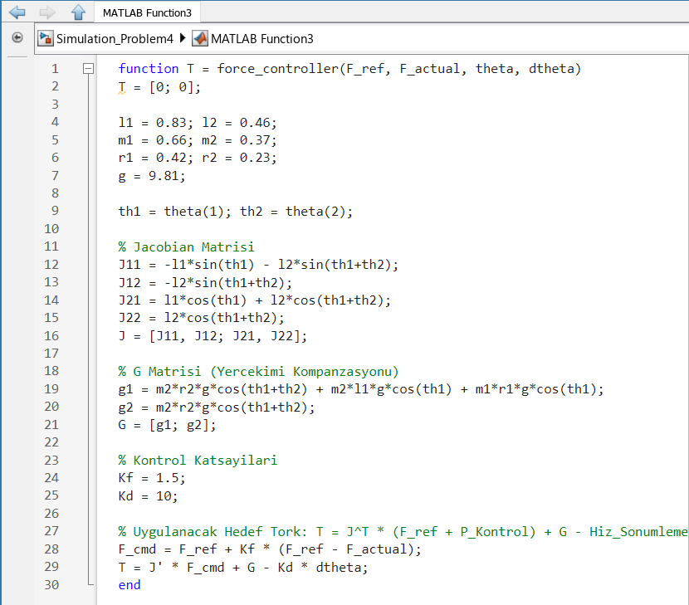
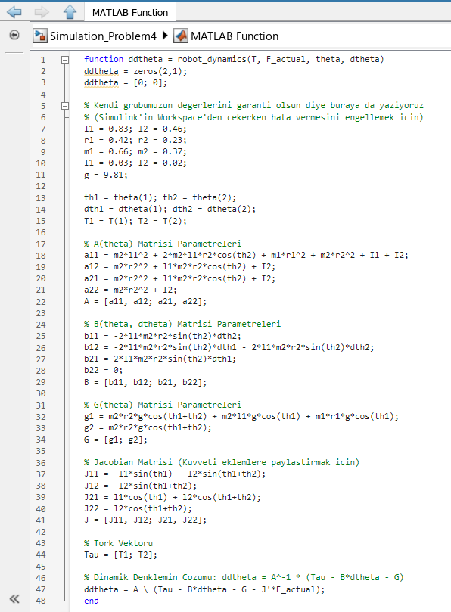
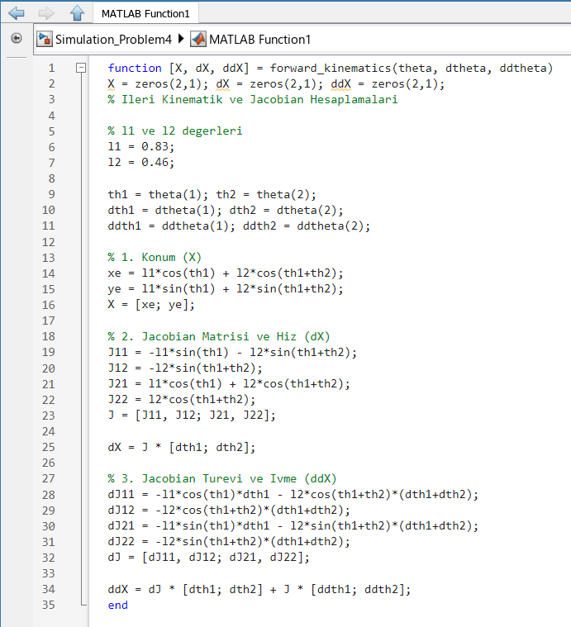
This module analyzes the manipulator’s behavior during physical interaction by modeling the environment as a spring-damper system. The environment is characterized by a stiffness coefficient of Kenv=650 N/m and a damping coefficient of Denv=120 Ns/m. The environment function defines the boundary conditions at coordinates Xenv=-0.1m and Yenv=-0.75. It employs conditional logic to detect collisions; when the end-effector position crosses these thresholds, the system calculates a reaction force proportional to the penetration depth and the contact velocity. This force is fed into the robot dynamics block, which modifies the equations of motion by integrating the feedback force through the transpose Jacobian matrix ${(J}^{T}F_{actual})$. The force-tracking task is executed by the force controller function, which computes the motor torque required to maintain a target contact force $F_{ref}$. The controller utilizes a proportional force gain $K_{f}=1.5$ and a derivative damping term $K_{d}=10$ to penalize tracking errors, ensuring stable contact. The control law integrates gravity compensation and Jacobian transpose mapping to distribute the commanded force effectively to the actuators. Finally, the forward kinematics block provides the necessary analytical Jacobian and kinematic state updates. This closed-loop integration ensures that the manipulator maintains stability near task-space boundaries while accurately regulating contact forces, demonstrating the effectiveness of classical motion control techniques in managing non-linear robotic systems during environment interaction.
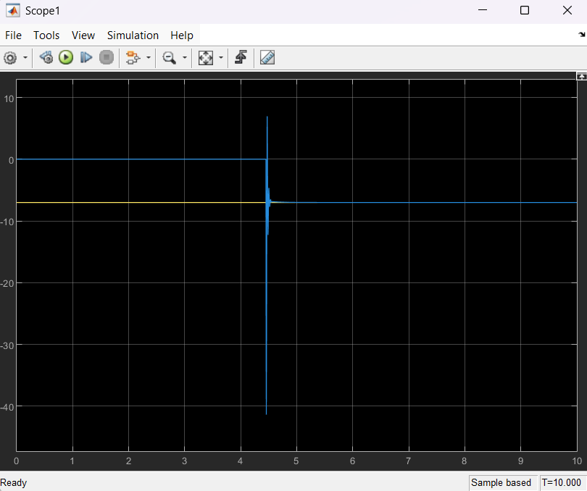
X-axis Force Tracking (Fx(t)) The figure above demonstrates the force-tracking performance along the X-axis. The blue curve represents the actual contact force generated upon impact, while the yellow horizontal line denotes the reference force value -7N. The graph captures the precise moment of contact at approximately t=4.5s, where the system experiences an initial transient spike due to the collision. Following this impact, the force-tracking controller effectively compensates for the dynamics, allowing the actual force to converge rapidly to the reference value and maintain stability throughout the remainder of the interaction.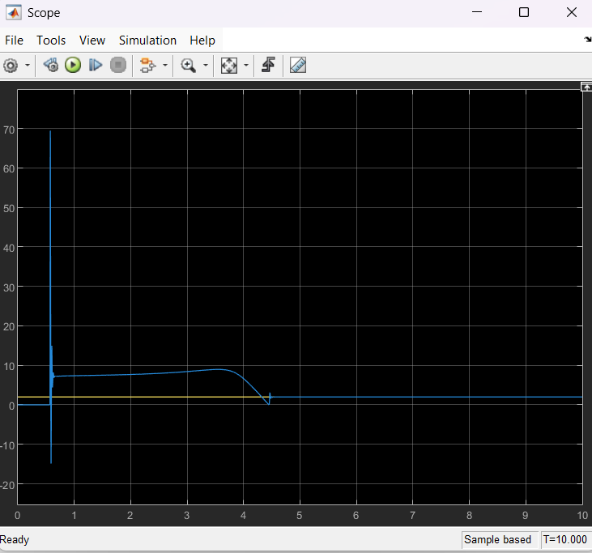
Y-axis Force Tracking (Fy(t)) The Y-axis force tracking response is displayed above, targeting a reference force of 2N represented by the yellow line. The blue trajectory exhibits a sharp transient response during the initial phase of the simulation, followed by a controlled adjustment as the manipulator approaches the environment. Upon contact, the force controller regulates the interaction, ensuring that the Y-axis force settles at the commanded reference level. The results confirm that the integration of gravity compensation and Jacobian transpose mapping provides the necessary precision to maintain desired contact forces while accounting for the non-linear dynamics of the two-link manipulator.

