**WEB PROGRAMMING FINAL PROJECT REPORT**

**Selin Samra**

**Lists of files:**

**registerNew.html ->** html page for the register page

**validate_register.jsp** -> jsp file to register the user to database

**login.html** -> html page for the login page

**validate.jsp** -> jsp page to check if the user exist and his userName and password match

**add_task.html** -> main page to add tasks and the pomodoro cycle

**addTask.js** -> javascript page to add tasks

**main.js** -> javascript file fort he pomodoro cycle

**style.css** -> main stylesheet

**stylep.css** -> stylesheet for the pomodoro cycle

**To run the code, first I login to sql server, then on eclipse I connect to tomcat server 8.5 and after starting server I run the registerNew.html file on the server. (the localhost is http://localhost:8082)

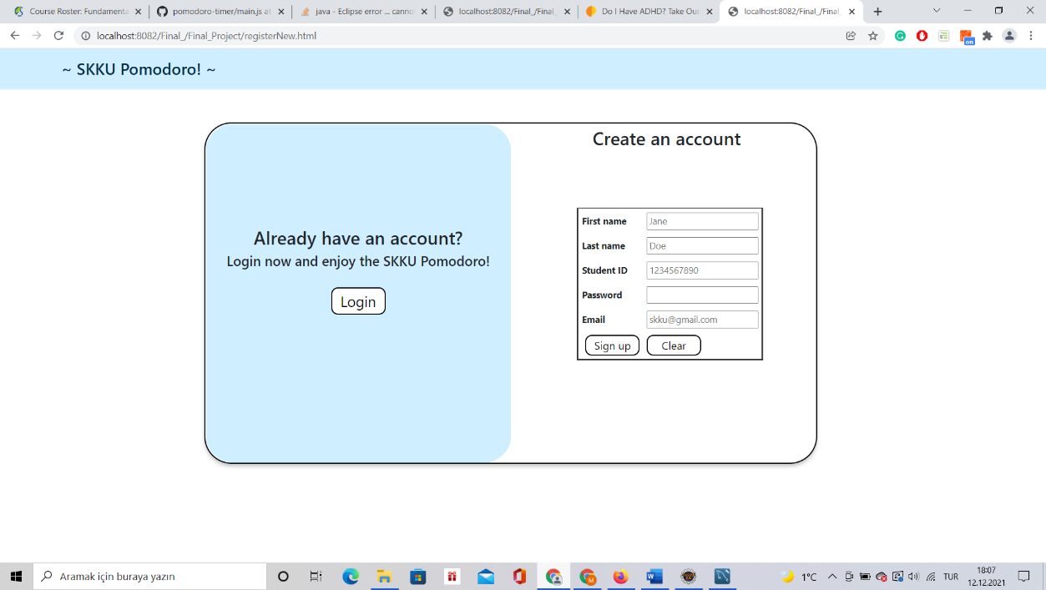

In my final project, I did a web page for pomodoro study. First you see the register page. You can create your account. All accounts that are created is saved into SQL database. For creating a new account, the user must fill first name, student id and password sections. If the student ID is not 10 characters or include any other character rather than a number, the border of the input gets red. If the requirement is satisfied, it turns green.

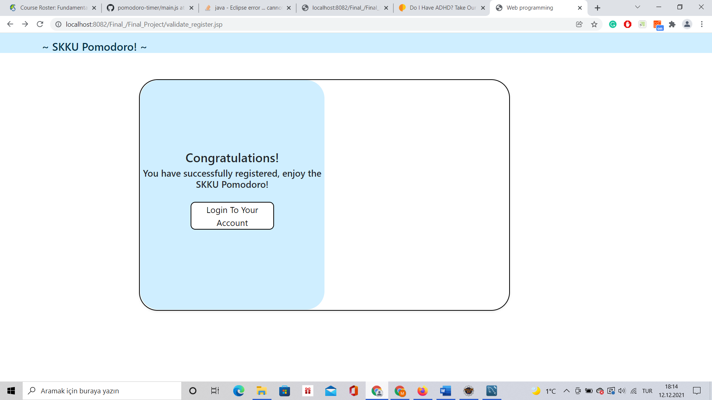

After the confirmation page of successfully registering, login page is shown.

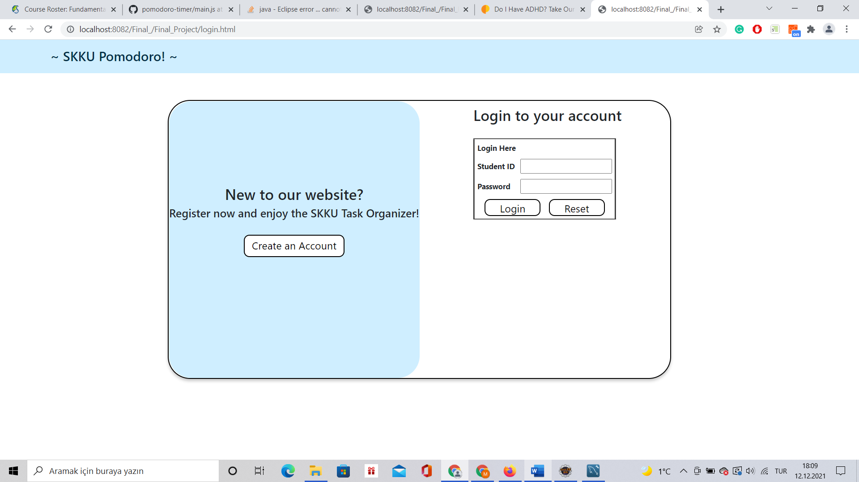

For login page, the student must write their student id and password, if they match with the data in the database, they can login. Otherwise, the error page shows. Then the user can try to login again or create an account.

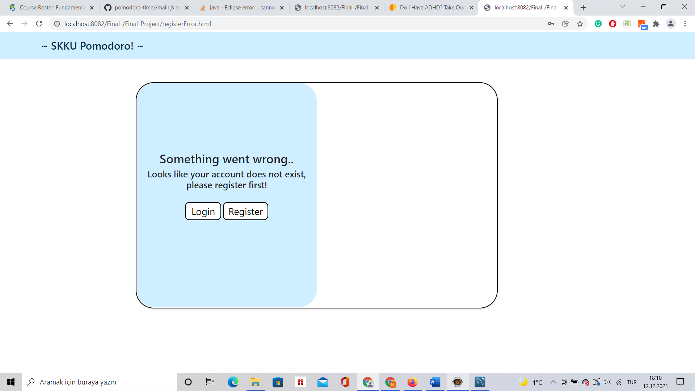

Error Page

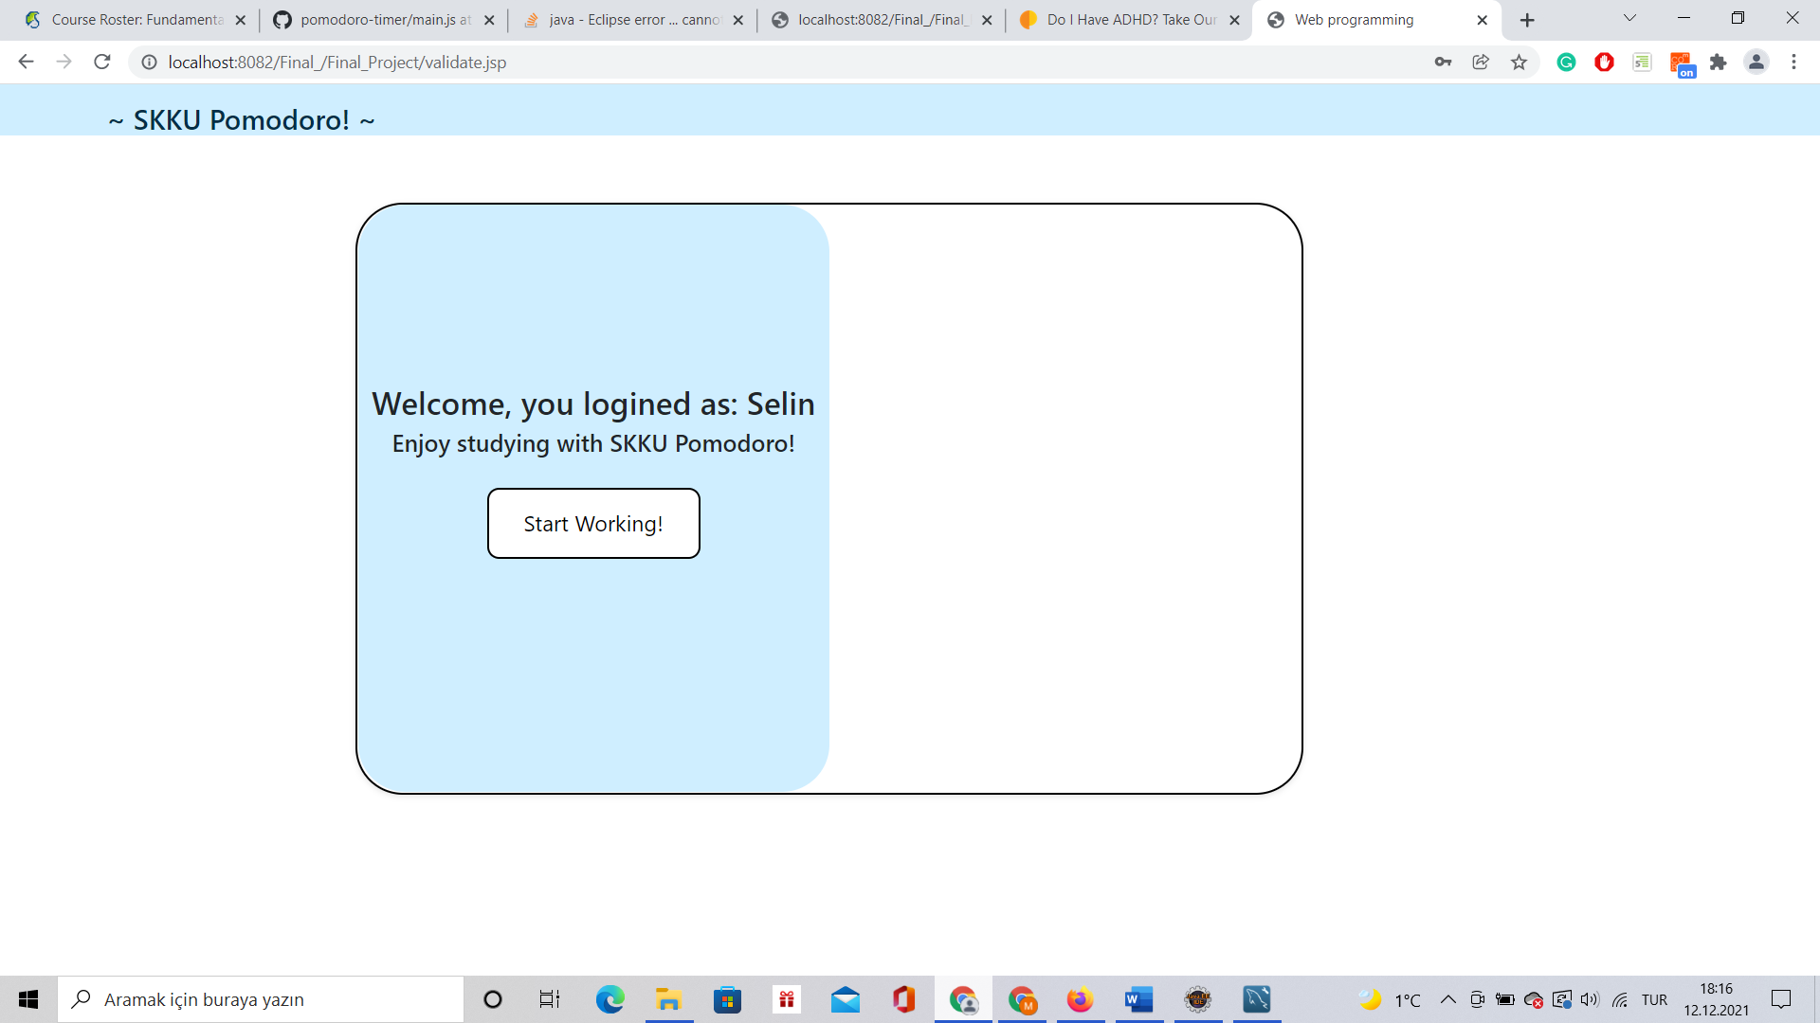

Successfully login page

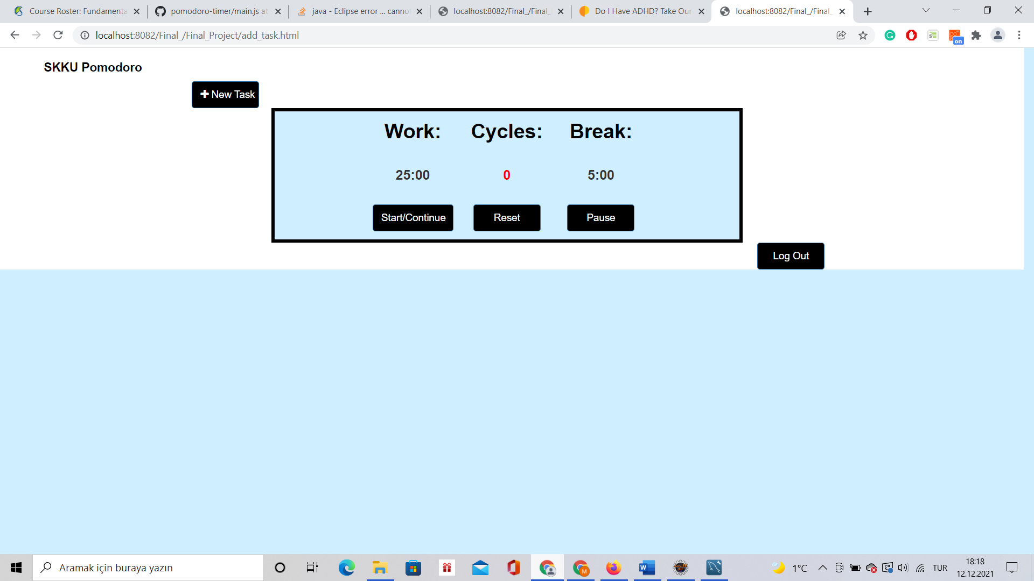

When the user is logged in, in the upper part of the page there is a pomodoro clock to keep track of time. The user can start the cycle by clicking the Start/Continue button. After working time is finished break time starts. For every work + break time together, the counter for cycle increases. The user can reset all for pomodoro by reset button.

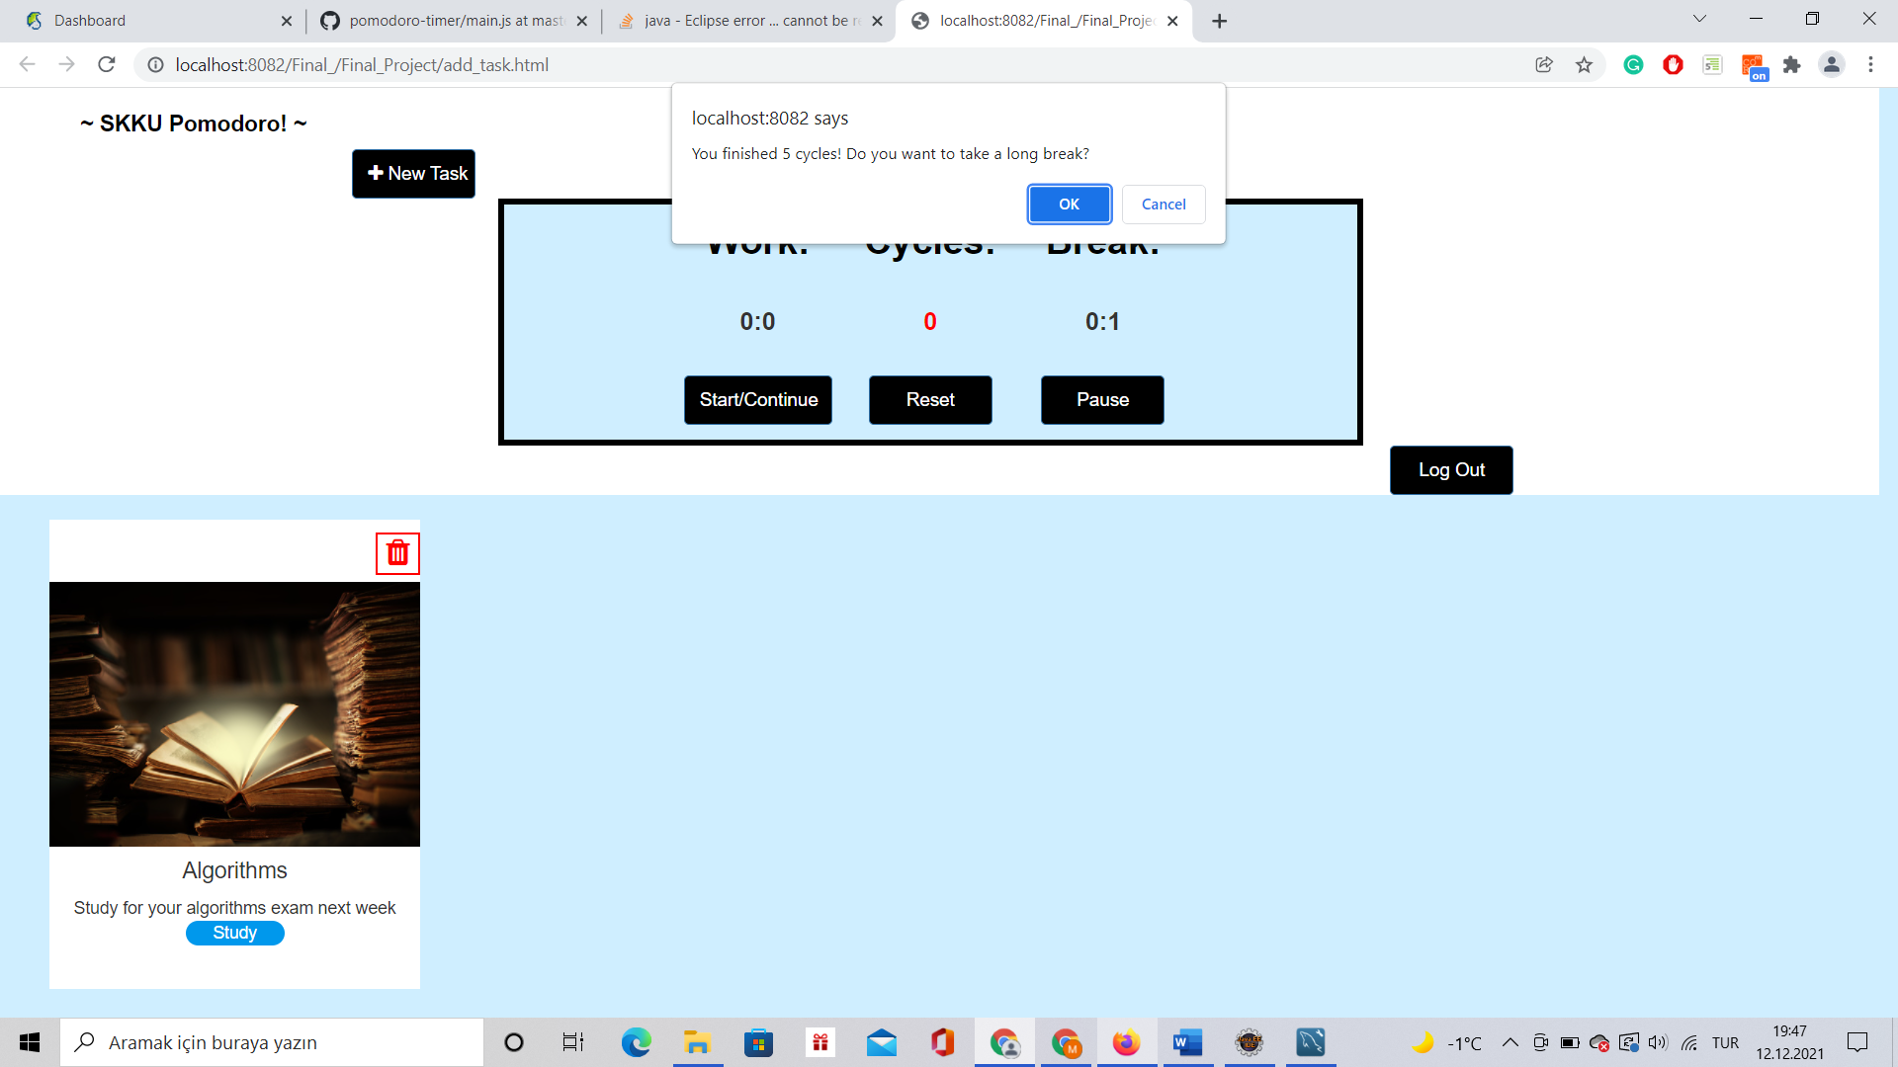

If the user finishes 4 cycles, the user has a chance to have a longer break which is 25 minutes for the next cycle.

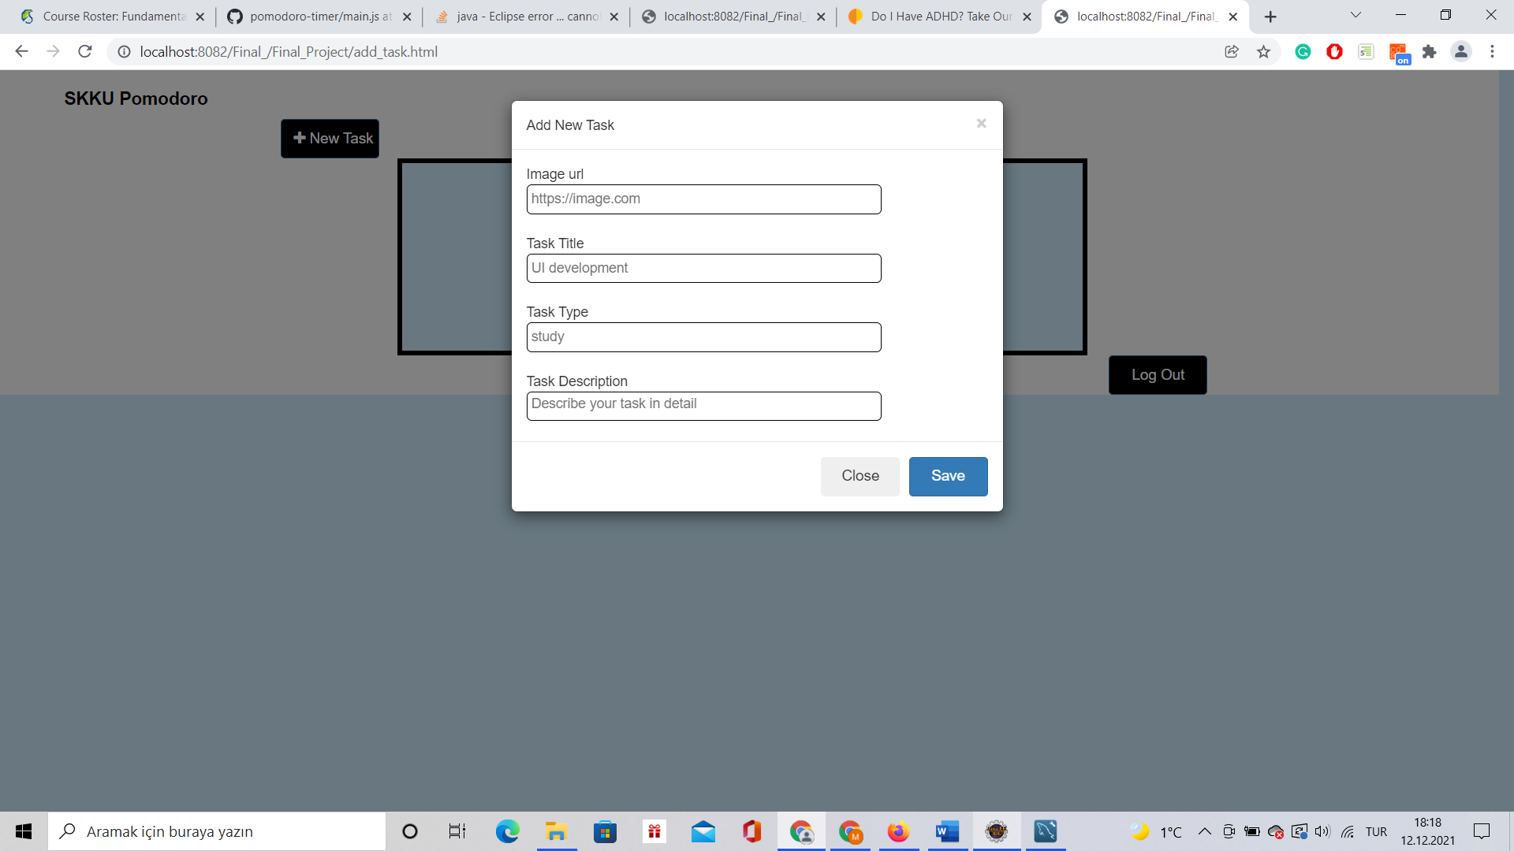

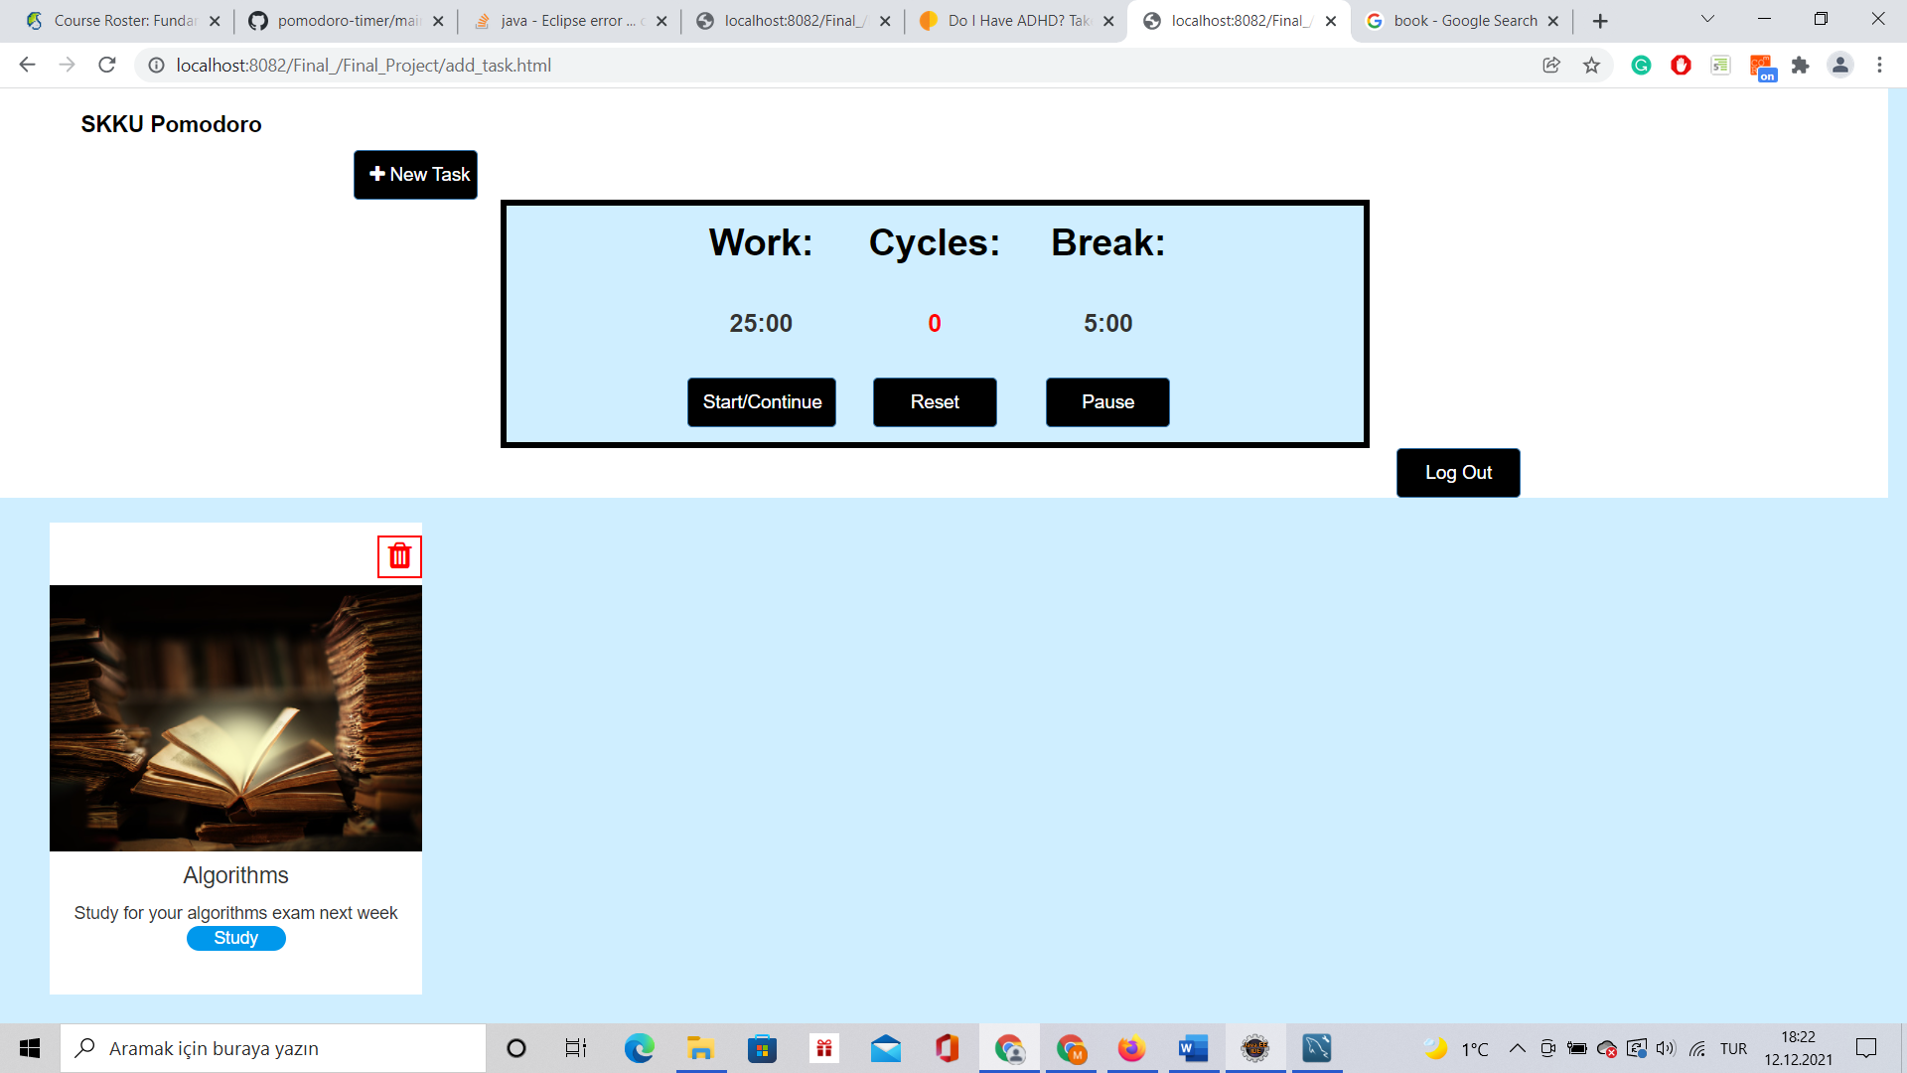

With the new task button, the user can add the task that she-he wants to do and delete it after it is done.

With the logout button, the user is connected back to register page.