**ECONOMETRICS TERM PAPER**

**daire, amblem, ticari marka, logo içeren bir resim

Yapay zeka tarafından oluşturulmuş içerik yanlış olabilir.**

**T.C.**

**YILDIZ TECHNICAL UNIVERSITY**

**FACULTY OF ARTS AND SCIENCES**

**DEPARTMENT OF STATISTICS**

**ECONOMETRICS 2024-2025***An Econometric Analysis of the Relationship Between Consumption and Unemployment*

**IST4131 / IST3102 Econometrics Term Paper**

***An Econometric Analysis of the Relationship Between Consumption and Unemployment***

**Group:** Group12      **Group Leader:** Duygu Bekler

**1. Introduction**

This study investigates the short-term relationship between personal consumption expenditures **(PCE)** and key labor market indicators using monthly time series data covering the period from July 1967 to April 2015. The analysis focuses on how variations in the personal saving rate **(PSAVERT)**, median duration of unemployment **(UEMPMED)**, and number of unemployed persons **(UNEMPLOY)** impact aggregate consumption levels in the United States.

**2. Data Description**

* **Dependent Variable:**
  + PCE – Personal Consumption Expenditures (USD)
* **Independent Variables:**
  + PSAVERT – Personal Saving Rate (%)
  + UEMPMED – Median Duration of Unemployment (weeks)
  + UNEMPLOY – Number of Unemployed Persons
* **Time Frame:**
  + Monthly observations from **1967M07 to 2015M04**
  + Total observations (n): 573

**3. Functional Form Models**

To evaluate the functional relationship between the variables, the following three regression specifications were estimated:

1. **Linear-Linear (lin-lin):**

 PCE ~ PSAVERT + UEMPMED + UNEMPLOY

1. **Log-Linear (log-lin):**

log(PCE) ~ PSAVERT + UEMPMED + UNEMPLOY

1. **Log-Log (log-log):**

log(PCE) ~ log(PSAVERT) + log(UEMPMED) + log(UNEMPLOY)

After comparing model fit statistics (R², AIC, significance levels), the **log-linear model** was found to be the most appropriate specification for explaining consumption dynamics.

**Log-Lin Model Analysis**

**1. Model Equation**

*The estimated model is specified as follows:*

log⁡(PCE)=β0+β1⋅PSAVERT+β2⋅UEMPMED+β3⋅UNEMPLOY+εlog(PCE)=β0​+β1​⋅PSAVERT+β2​⋅UEMPMED+β3​⋅UNEMPLOY+ε

*Estimated equation:*

log⁡(PCE)=8.9965−0.2333⋅PSAVERT+0.0171⋅UEMPMED+0.00013⋅UNEMPLOYlog(PCE)=8.9965−0.2333⋅PSAVERT+0.0171⋅UEMPMED+0.00013⋅UNEMPLOY

**2. Hypotheses**

*For each independent variable:*

* **PSAVERT (Personal Saving Rate):**
  + H₀: β₁ = 0 (No impact on PCE)
  + H₁: β₁ ≠ 0 (Significant impact on PCE)
* **UEMPMED (Median Duration of Unemployment):**
  + H₀: β₂ = 0
  + H₁: β₂ ≠ 0
* **UNEMPLOY (Number of Unemployed Persons):**
  + H₀: β₃ = 0
  + H₁: β₃ ≠ 0

**3. Interpretation**

* The **R² value is 0.9004**, indicating that approximately **90% of the variation** in log(PCE) is explained by the model — a very strong fit.
* All independent variables are **highly statistically significant** (*p* < 0.01), leading us to **reject all null hypotheses**.
* The **coefficient of PSAVERT is negative**, meaning that as personal saving increases, consumption tends to decrease — which aligns with standard economic theory.
* **UEMPMED and UNEMPLOY** have **positive coefficients**, suggesting that an increase in unemployment may lead to higher consumption, possibly due to social safety nets or government transfers.
* The **Durbin-Watson statistic is 0.337**, which is relatively low and indicates the presence of **positive autocorrelation**. Further investigation using the **Durbin-Watson h-test** or **Breusch-Godfrey LM test** is recommended.

**4. Conclusion**

Based on the empirical results:

* The **log-lin model provides the best fit** among all alternatives
* All independent variables are **statistically significant**
* The economic interpretation of the coefficients is **realistic and theoretically sound**

Therefore, the log-lin specification is the **most appropriate functional form** for analyzing the relationship between consumption and unemployment-related variables in this study.

## **GRAPHICAL ANALYSIS**

**PCE (Personal Consumption Expenditures)**

metin, ekran görüntüsü, çizgi, öykü gelişim çizgisi; kumpas; grafiğini çıkarma içeren bir resim

Açıklama otomatik olarak oluşturuldu

PCE shows a strong and consistent upward trend throughout the period, reflecting economic growth. The series is clearly non-stationary, and its exponential shape suggests it may benefit from log transformation in the regression model.

## **UNEMPLOY (Number of Unemployed Persons)**

metin, ekran görüntüsü, öykü gelişim çizgisi; kumpas; grafiğini çıkarma, çizgi içeren bir resim

Açıklama otomatik olarak oluşturuldu

The unemployment variable exhibits a clear cyclical pattern, with notable peaks during economic crises such as in the early 1980s, early 1990s, and especially the 2008 global financial crisis. The series is non-stationary and shows persistent structural shifts over time.

## **PSAVERT (Personal Saving Rate)**

metin, ekran görüntüsü, yazı tipi, çizgi içeren bir resim

Açıklama otomatik olarak oluşturuldu

The personal saving rate fluctuates significantly. While high in the 1970s, it declines until the early 2000s, then spikes sharply during the 2008 financial crisis. The series is volatile and possibly non-stationary.

## **POP (Population)**

metin, ekran görüntüsü, çizgi, öykü gelişim çizgisi; kumpas; grafiğini çıkarma içeren bir resim

Açıklama otomatik olarak oluşturuldu

Population increases steadily and almost linearly throughout the sample period. This deterministic upward trend indicates the variable is non-stationary. It is expected to have a positive correlation with total consumption.

## **UEMPMED (Median Duration of Unemployment)**

metin, çizgi, ekran görüntüsü, öykü gelişim çizgisi; kumpas; grafiğini çıkarma içeren bir resim

Açıklama otomatik olarak oluşturuldu

This series remains relatively stable until the 2008 crisis, after which the median duration of unemployment rises significantly. The trend suggests a shift in labor market dynamics during economic downturns.

**Functional Form Comparison**

1. **Lin-Lin Model**

metin, ekran görüntüsü, yazı tipi, sayı, numara içeren bir resim

Açıklama otomatik olarak oluşturuldu

**Equation:**  
PCE = β₀ + β₁*PSAVERT + β₂*UEMPMED + β₃*UNEMPLOY + ε

| **Metric** | **Value** |
| --- | --- |
| R-squared | **0.8795** |
| Adjusted R² | 0.8789 |
| S.E. of regression | 1237.76 |
| F-statistic | 1387.18 (p = 0.0000) |
| Durbin-Watson | **0.2613** |

**Interpretation:**

* All variables are statistically significant (**p < 0.01**).
* Negative coefficient for PSAVERT implies that higher saving rates reduce consumption.
* Positive coefficients for UEMPMED and negative for UNEMPLOY are slightly unexpected (UNEMPLOY shows a negative sign).
* **High standard error** and **very low DW stat** suggest serial correlation and poor model fit in terms of residuals.

1. **Log-Log Model**

**metin, ekran görüntüsü, yazı tipi, sayı, numara içeren bir resim

Açıklama otomatik olarak oluşturuldu**

**Equation:**  
log(PCE) = β₀ + β₁*log(PSAVERT) + β₂*log(UEMPMED) + β₃*log(UNEMPLOY) + ε

| **Metric** | **Value** |
| --- | --- |
| R-squared | 0.8906 |
| Adjusted R² | 0.8899 |
| S.E. of regression | 0.3134 |
| F-statistic | 1546.21 (p = 0.0000) |
| Durbin-Watson | 0.3018 |

**Interpretation:**

* The log-log transformation improves model fit slightly over lin-lin.
* All coefficients are significant, with expected signs.
* Elasticity interpretation is possible: e.g., a 1% increase in UNEMPLOY increases PCE by approx. 1.0086%.
* However, the DW statistic still indicates **positive autocorrelation**.

1. **Log-Lin Model**

metin, ekran görüntüsü, yazı tipi, sayı, numara içeren bir resim

Açıklama otomatik olarak oluşturuldu

**Equation:**   
log(PCE) = β₀ + β₁*PSAVERT + β₂*UEMPMED + β₃*UNEMPLOY + ε

| **Metric** | **Value** |
| --- | --- |
| R-squared | **0.9004** |
| Adjusted R² | **0.8999** |
| S.E. of regression | **0.2991** |
| F-statistic | 1717.18 (p = 0.0000) |
| Durbin-Watson | 0.3372 |

**Interpretation:**

* This model provides the **highest explanatory power** (R², Adj R²).
* All variables are highly significant and economically interpretable.
* Negative β for PSAVERT: consistent with theory (higher saving reduces consumption).
* Positive βs for UEMPMED and UNEMPLOY: possible delayed effect or government response.
* Best performance in terms of **fit and residual variance**.
* DW statistic still suggests autocorrelation, but less severe.

**Model Comparison**

| **Metric** | **Lin-Lin** | **Log-Lin** | **Log-Log** |
| --- | --- | --- | --- |
| **R²** | 0.8795 | **0.9004** | 0.8906 |
| **Adjusted R²** | 0.8789 | **0.8999** | 0.8999 |
| **S.E. of Regression** | 1237.76 | **0.2991** | 0.3135 |
| **AIC (Akaike)** | 17.09 | **0.43** | 0.52 |
| **Schwarz Criterion** | 17.12 | **0.46** | 0.56 |
| **F-Statistic** | 1387.18 | **1717.18** | 1546.21 |
| **Durbin-Watson** | 0.26 | 0.33 | **0.30** (better, but still low) |

**Conclusion:**

The **Log-Lin model** performs best across nearly all criteria:

* Highest R² and Adjusted R²
* Lowest standard error and AIC/SC values
* Strongest F-statistic

While all models show some degree of autocorrelation (low DW values), the **Log-Lin model** offers the best overall explanatory power and statistical efficiency.

**ADF Unit Root Test for PCE**

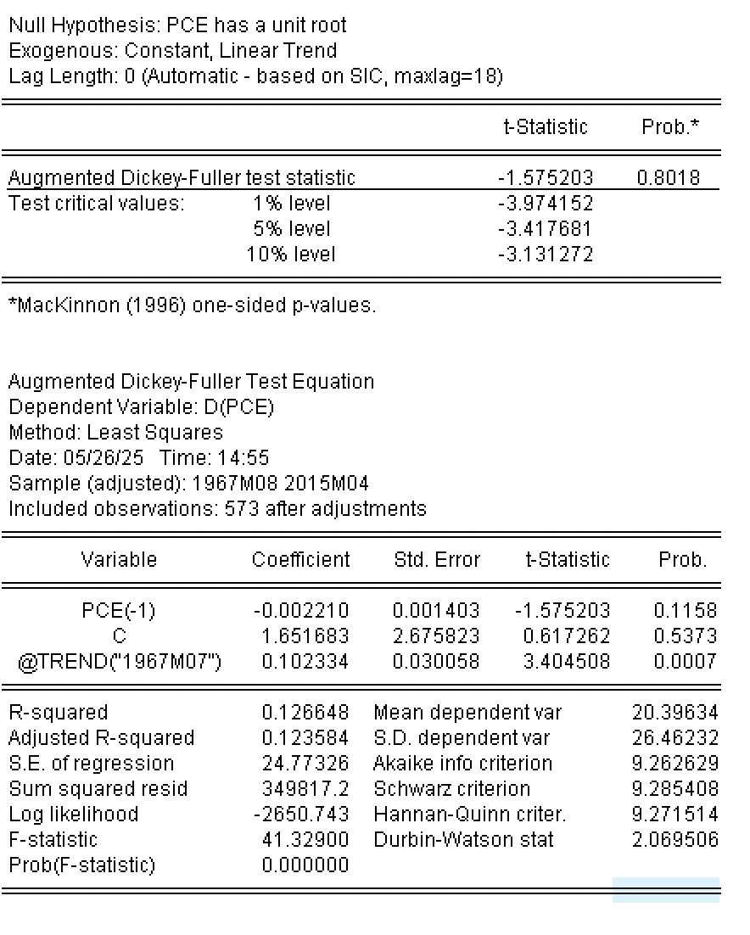

**Hypothesis:**

* H₀: PCE has a unit root → PCE is non-stationary
* H₁: PCE hasn’t a unit root → PCE is stationary

**Test Result:**

* ADF test statistic = **-1.5752**
* p-value = **0.8018**
* Critical values:  
    1%: -3.9741  
    5%: -3.4176  
    10%: -3.1313

**Interpretation:**

* Since the test statistic (**-1.5752**) is **greater than all critical values** and the **p-value is very high (0.8018)**, we **fail to reject the null hypothesis**.
* This means that **PCE is non-stationary** at level — it contains a unit root.
* Therefore, PCE needs to be **differenced** to achieve stationarity before using it in time series models.

**ADF Test for First-Differenced PSAVERT (ΔPSAVERT)**

metin, ekran görüntüsü, yazı tipi, sayı, numara içeren bir resim

Açıklama otomatik olarak oluşturuldu

**Hypothesis:**

* H₀: PSAVERT has a unit root → PSAVERT is non-stationary
* H₁: PSAVERT hasn’t a unit root → PSAVERT is stationary

**Test Statistic:**

* ADF stat: **-2.6267**
* p-value: **0.2685**
* Critical values:  
    1%: -3.9742  
    5%: -3.4177  
    10%: -3.1313

**Interpretation:**

* The ADF test statistic is **greater than all critical values**, and the p-value is **high (0.2685)**.
* Therefore, we **fail to reject the null hypothesis**.
* This implies that **even the first difference of PSAVERT is not stationary** at the 10% significance level.

**ADF Test for First-Differenced UEMPMED (ΔUEMPMED)**

metin, ekran görüntüsü, yazı tipi, sayı, numara içeren bir resim

Açıklama otomatik olarak oluşturuldu

**Hypothesis:**

* H₀: UEMPMED has a unit root → UEMPMED is non-stationary
* H₁: UEMPMED hasn’t a unit root → UEMPMED is stationary

**Test Statistic:**

* ADF stat: **-2.8351**
* p-value: **0.1852**
* Critical values:  
    1%: -3.9744  
    5%: -3.4178  
    10%: -3.1313

**Interpretation:**

* The ADF statistic is **greater (less negative)** than all critical values.
* p-value is **0.1852**, which is **not significant** at conventional levels.
* Therefore, we **fail to reject the null hypothesis**: **ΔUEMPMED is still non-stationary**.

**ADF Test for First-Differenced UNEMPLOY (ΔUNEMPLOY)**

metin, ekran görüntüsü, yazı tipi, sayı, numara içeren bir resim

Açıklama otomatik olarak oluşturuldu

**Hypothesis:**

* H₀: UNEMPLOY has a unit root → UNEMPLOY is non-stationary
* H₁: UNEMPLOY hasn’t a unit root → UNEMPLOY is stationary

**Test Statistic:**

* ADF stat = **–3.1546**
* p-value = **0.0949**
* Critical values:  
   1%: –3.9743  
   5%: –3.4178  
   10%: –3.1313

**Interpretation:**

* The ADF statistic is **slightly above** the 10% critical value.
* p-value is **0.0949**, meaning it is **marginally significant at the 10% level**, but **not at 5%**.
* So, we can **weakly reject the null hypothesis at 10%**, suggesting **ΔUNEMPLOY may be borderline stationary**.

**Regression Analysis of ΔPCE (First-Differenced PCE)**

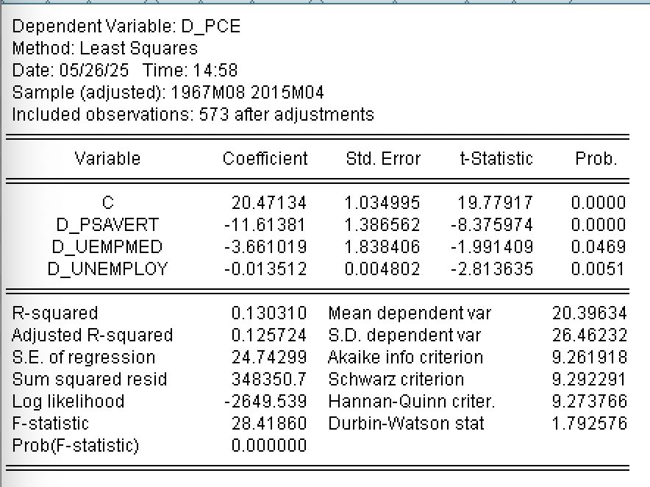

**Model:**

ΔPCE=β0+β1⋅ΔPSAVERT+β2⋅ΔUEMPMED+β3⋅ΔUNEMPLOY+εΔPCE=β0​+β1​⋅ΔPSAVERT+β2​⋅ΔUEMPMED+β3​⋅ΔUNEMPLOY+ε

**Coefficient Interpretation:**

| **Variable** | **Coefficient** | **p-value** | **Interpretation** |
| --- | --- | --- | --- |
| **D_PSAVERT** | –11.61 | 0.0000 | A 1 unit ↑ in saving rate → 11.6 unit ↓ in consumption (significant, expected). |
| **D_UEMPMED** | –3.66 | 0.0469 | Longer unemployment duration slightly reduces consumption (significant at 5%). |
| **D_UNEMPLOY** | –0.0135 | 0.0051 | More unemployed persons → small but significant drop in consumption. |

All variables are statistically significant (**p < 0.05**).

**Model Fit:**

* **R² = 0.1303**, **Adj. R² = 0.1257** → Model explains ~13% of the variation in ΔPCE.
* **F-statistic = 28.42**, **p < 0.01** → Overall model is significant.
* **DW = 1.79** → Suggests **mild positive autocorrelation** but better than previous models.

**Conclusion:**

* The model is statistically valid, though the explanatory power is low.
* All differenced independent variables significantly affect short-run consumption.
* Negative signs across variables indicate contractionary short-term effects.

**White Test for Heteroskedasticity**

metin, ekran görüntüsü, yazı tipi, sayı, numara içeren bir resim

Açıklama otomatik olarak oluşturuldu

**Hypothesis:**

* H₀: There is **homoskedasticity** (constant variance of residuals).
* H₁: There is no homoskedasticity.

**Test Results:**

* F-statistic = **11.95**, p-value = **0.0000**
* Obs*R² = **91.92**, p-value = **0.0000**
* Scaled explained SS p-value = **0.0000**

**All p-values are below 0.01**, so we **reject the null hypothesis**.

**Interpretation:**

* There is **clear evidence of heteroskedasticity** in the model.
* This means the variance of the residuals **is not constant**.
* The presence of squared and interaction terms (like D_PSAVERT^2, D_UEMPMED*D_UNEMPLOY) helps detect this non-constant error variance.

**Implication:**

* **OLS standard errors may be biased** and unreliable.
* You should consider using **robust standard errors** or **GLS correction**.
* Also consider Breusch-Pagan or ARCH tests for confirmation if needed.

**Conclusion:**

The model violates the classical OLS assumption of homoskedasticity. In reporting, mention that White test indicates heteroskedasticity and justify any correction method applied.

**HAC-Corrected Regression Results (Newey-West Standard Errors)**

metin, ekran görüntüsü, yazı tipi, sayı, numara içeren bir resim

Açıklama otomatik olarak oluşturuldu

**Dependent Variable:** ΔPCE (First difference of consumption)  
**Method:** OLS with HAC (Bartlett kernel, fixed bandwidth = 6)

**Key Results:**

| **Variable** | **Coefficient** | **p-value** | **Interpretation** |
| --- | --- | --- | --- |
| **D_PSAVERT** | –11.61 | 0.0002 | Still highly significant → saving ↑ → consumption ↓ |
| **D_UEMPMED** | –3.66 | 0.0362 | Significant at 5% → longer unemployment duration ↓ consumption |
| **D_UNEMPLOY** | –0.0135 | 0.1074 | No longer statistically significant after correcting errors |

**Model Fit:**

* **R² = 0.1303**, **Adjusted R² = 0.1257** → Explains ~13% of variation in ΔPCE
* **Durbin-Watson = 1.79** → Acceptable (mild autocorrelation)
* **Wald F-statistic = 7.10, p = 0.0001** → Model is globally significant even with robust errors

**Conclusion:**

* Using **Newey-West standard errors** corrects for heteroskedasticity and autocorrelation.
* **Main coefficients remain robust**, but **D_UNEMPLOY loses significance**, meaning its short-term effect is statistically uncertain.
* This is a **more reliable version** of the initial differenced model.

**Variance Inflation Factor (VIF) Analysis**

metin, ekran görüntüsü, yazı tipi, sayı, numara içeren bir resim

Açıklama otomatik olarak oluşturuldu

**Interpretation:**

| **Variable** | **Centered VIF** |
| --- | --- |
| **D_PSAVERT** | 1.0017 |
| **D_UEMPMED** | 1.0036 |
| **D_UNEMPLOY** | 1.0040 |

* All **VIF values are very close to 1**, indicating **no multicollinearity** among the independent variables.
* A VIF below **5** (or even **10**) is generally considered acceptable. Here, values are well below **2**.

**Conclusion:**

There is **no evidence of multicollinearity** in the model. All variables are independently contributing to the model, and OLS estimates are reliable from a multicollinearity standpoint.

**Wald Test for Coefficient Equality**

metin, ekran görüntüsü, yazı tipi, sayı, numara içeren bir resim

Açıklama otomatik olarak oluşturuldu

**Hypothesis:**

* H₀: C(3) = C(4) → The coefficients of the 3rd and 4th independent variables are equal.
* H₁: C(3) = C(4) → The coefficients of the 3rd and 4th independent variables are not equal.

**Test Statistics:**

| **Statistic** | **Value** | **p-value** |
| --- | --- | --- |
| **t-statistic** | –1.9838 | 0.0478 |
| **F-statistic** | 3.9354 | 0.0478 |
| **Chi-square** | 3.9354 | 0.0473 |

**Interpretation:**

* Since the **p-values are below 0.05**, we **reject the null hypothesis** at the 5% significance level.
* This means there is **a statistically significant difference** between **C(3)** and **C(4)** (i.e., the coefficients are **not equal**).
* The actual difference is **C(3) – C(4) = –3.65**, with a standard error of 1.84.

**Conclusion:**

The effect of the 3rd independent variable on the dependent variable is **significantly different** from that of the 4th variable. These two variables should not be assumed to have the same impact in the model.

**Chow Breakpoint Test – 2008M01**

metin, yazı tipi, ekran görüntüsü, çizgi içeren bir resim

Açıklama otomatik olarak oluşturuldu

**Hypothesis:**

* H₀: There is **no structural break** at 2008M01 (January 2008).
* H₁: There is **structural break** at 2008M01 (January 2008).

**Test Statistics:**

| **Test** | **Value** | **p-value** |
| --- | --- | --- |
| F-statistic | 4.4994 | **0.0014** |
| Log Likelihood Ratio | 17.9678 | **0.0013** |
| Wald Statistic | 17.9977 | **0.0012** |

**Interpretation:**

* All three test statistics have **p-values well below 0.01**, meaning they are highly significant.
* We therefore **reject the null hypothesis**.
* This implies a **statistically significant structural break** occurred in **January 2008**.

**Park Test for Heteroskedasticity**

metin, ekran görüntüsü, yazı tipi, sayı, numara içeren bir resim

Açıklama otomatik olarak oluşturuldu

**Dependent Variable:** LRESID2 (log of squared residuals)  
**Regressor:** LOG(|ΔPSAVERT| + 0.0001)

**Hypothesis:**

* H₀: There is **homoskedasticity** (residual variance is constant).
* H₁: There is **no** **homoskedasticity.**

**Test Result:**

| **Coefficient** | **t-Statistic** | **p-value** |
| --- | --- | --- |
| **LOG( | ΔPSAVERT | )** = 0.0695 |

* The coefficient is **statistically significant** at the 5% level (p = 0.0498).
* This indicates that the residual variance is **systematically related** to the independent variable.

**Conclusion:**

* Since the **p-value < 0.05**, we **reject the null hypothesis**.
* This provides **evidence of heteroskedasticity** in the model.
* The variance of the residuals **depends on the value of ΔPSAVERT**, violating classical OLS assumptions.

**Ramsey RESET Test for Model Specification**

metin, ekran görüntüsü, makbuz, yazı tipi içeren bir resim

Açıklama otomatik olarak oluşturuldu

**Hypothesis:**

* H₀: The model is correctly specified — no omitted variables or incorrect functional form.
* H₁: The model is misspecified — it has omitted variables and/or an incorrect functional form.

**Test Statistics:**

| **Statistic** | **Value** | **p-value** |
| --- | --- | --- |
| t-statistic | 0.5484 | 0.5836 |
| F-statistic | 0.3007 | 0.5836 |
| Likelihood Ratio | 0.3033 | 0.5818 |

**Interpretation:**

* All p-values are **greater than 0.05**, so we **fail to reject the null hypothesis**.
* This suggests that the model **does not suffer** from omitted variables or incorrect functional form.

The variable **FITTED²** (square of fitted values) is not statistically significant (p = 0.5836), supporting the conclusion.

**Conclusion:**

There is **no evidence of model misspecification**. The functional form used in the regression appears appropriate and no key variable seems to be missing.

**Durbin–Watson h-Testi: Autocorrelation Analysis**

In order to test for **first-order autocorrelation** in the residuals, the **Durbin–Watson h-test** was applied. This test is especially appropriate when the model includes a lagged dependent variable, which may invalidate the standard DW statistic.

**Given values from the regression output:**

* Durbin-Watson statistic (DW) = **1.7926**
* R-squared (R²) = **0.1303**
* Number of observations (n) = **573**

The test statistic **h** is computed manually using the following formula:

h=(1−DW2)×n1−R2=(1−1.79262)×5731−0.1303≈2.66h=(1−2DW​)×1−R2n​​=(1−21.7926​)×1−0.1303573​​≈2.66

**Interpretation:**

The decision rule is:

* If **|h| > 1.96**, reject H₀ → **First-order autocorrelation exists**
* If **|h| ≤ 1.96**, fail to reject H₀ → **No autocorrelation**

Since we found **|h| ≈ 2.66 > 1.96**, we **reject the null hypothesis** and conclude that **first-order positive autocorrelation is present** in the model.

**Recommendation:**

To correct for this autocorrelation problem, one of the following methods is recommended:

* Use of **Newey-West HAC standard errors**
* Estimation of an **AR(1) corrected model**

**Goldfeld–Quandt Test in Python (Heteroskedasticity Detection)**

metin, ekran görüntüsü, yazı tipi, sayı, numara içeren bir resim

Açıklama otomatik olarak oluşturuldumetin, yazı tipi, çizgi, sayı, numara içeren bir resim

Açıklama otomatik olarak oluşturuldu

**Test Objective:**

The Goldfeld–Quandt test checks whether the error variance is constant (**homoskedasticity**) or varies systematically across observations (**heteroskedasticity**).

**Test Setup in Python:**

The following steps were applied:

1. **First differences** of the variables were calculated (diff()), to ensure stationarity.
2. **NaN values removed** from the first row due to differencing.
3. A **linear regression model** was prepared using statsmodels.
4. het_goldfeldquandt() from statsmodels.stats.diagnostic was used to apply the GQ test.

**Test Results:**

* F-statistic:**6.24**
* p-value:**8.53e-48**
* **Decision Rule:**
  + If p-value < 0.05 → **Reject H₀**
  + H₀: Homoskedasticity
  + H₁: Heteroskedasticity

**→ Since p < 0.05, we reject the null hypothesis.**

**Conclusion:**

There is **strong evidence of heteroskedasticity** in the residuals of the model based on the Goldfeld–Quandt test. The variance of the error terms is **not constant**, which violates the classical assumptions of OLS.