COMP4920 Senior Design Project
Advisor: Dr. Suat Seçgin
PawSense
Smart Cat Access Control System
Design Specifications Document
Revision 2.0
28.02.2026

Prepared by:
23070001111 – Tevfik Efe AYDIN
23070001112 - Selin Şermet
21070001209 - Dilara Acar

Revision History
Revision | Date | Explanation
1.0 | Previous phase | Initial DSD prepared for concept definition and first architecture proposal
2.0 | 27.02.2026 | Updated after component procurement, prototype simplification, and hardware-software integration decisions
Table of Contents
Revision History 2
List of Figures 3
1. Introduction 3
2. System Design 3
2.1 System architecture overview 3
2.2 Design changes in Revision 2.0 4
2.3 Component interaction 4
2.3.1 Beacon transmission 4
2.3.2 Room-side scanning 4
2.3.3 Decision and alert generation 5
2.3.4 Cooldown and reset 5
2.4 Design principles 5
2.5 Assumptions and constraints 5
2.5.1 Assumptions 5
2.5.2 Constraints 6
3. Hardware Subsystem Design 6
3.1 Hardware subsystem overview 6
3.2 Hardware components 6
3.3 Hardware integration and signal flow 7
3.4 Hardware design considerations 7
4. Software Subsystem Design 7
4.1 Software subsystem overview 7
4.2 Software components 7
4.3 Software flow and operating states 7
4.4 Software design considerations 8
5. Detailed Design 8
5.1 Collar beacon module 8
5.2 Room unit controller 8
5.3 Alert subsystem 9
5.4 Power subsystem 9
5.5 Prototype assembly and test approach 9
References 9

List of Figures
Figure 1 - Component Architecture
Figure 2 - Detection and Deterrence Sequence
Figure 3 - Room Unit State Transitions

1. Introduction
PawSense was developed to address a common household problem: cats may enter rooms where they are not wanted, such as storage areas, kitchens, bedrooms, or workspaces. Conventional solutions such as closed doors, constant supervision, or simple physical barriers are often inconvenient for the owner and do not provide a controlled, repeatable response. For this reason, PawSense proposes a smart access-control approach that can detect the cat near a restricted doorway and respond automatically.
The proposed solution consists of two main parts. A collar-side beacon periodically broadcasts a Bluetooth Low Energy (BLE) signal, while a room-side unit continuously scans for that signal and evaluates proximity using received signal strength. When the system determines that the cat is approaching a protected zone, it activates a short sound-based deterrent and provides visual feedback through status LEDs. In this way, PawSense combines wireless identification, local decision-making, and a non-harmful warning mechanism in a single prototype.
Compared with the previous design specification, Revision 2.0 reflects the actual components purchased for the prototype and the simplifications made after feasibility evaluation. The earlier concept considered a more complex BLE/RFID architecture and a custom enclosure path. In Revision 2.0, the design was narrowed to a breadboard-based proof of concept built around the Raytac MDBT42Q-PAT nRF52810 module on the collar side and the ESP32-WROOM-32U development board on the room side. The purpose of this document is therefore to define the updated architecture, subsystem responsibilities, interfaces, assumptions, and detailed component behavior so that implementation, assembly, and testing can proceed in a controlled and traceable manner.

2. System Design

2.1 System architecture overview
PawSense follows a two-node architecture. The first node is a low-power collar beacon that broadcasts a simple identity signal at regular intervals. The second node is a fixed room unit that continuously scans for this signal, interprets the beacon strength, and makes a local decision about whether deterrence should be triggered. Once the decision threshold is exceeded, the room unit drives a piezo buzzer and status LEDs to generate a short warning event. After the warning, the system enters a cooldown window to prevent continuous retriggering and to reduce animal stress.

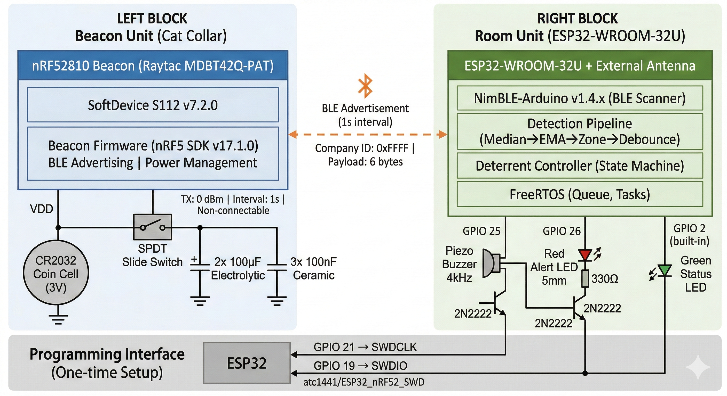
Figure 1 - Component Architecture

2.2 Design changes in Revision 2.0
- The collar-side design was standardized around the Raytac MDBT42Q-PAT module, which is based on the Nordic nRF52810 BLE system-on-chip. This replaced the earlier idea of using a generic prebuilt beacon and gave the team direct control over device identity, advertising interval, and firmware behavior.
- The room-side controller was finalized as the ESP32-WROOM-32U development board together with an external 2.4 GHz antenna. This decision matched the procured hardware and resolved the earlier ambiguity about the receiver platform, while also making antenna installation an essential part of wireless testing.
- The development workflow was simplified so that the ESP32 board is first used as a temporary Serial Wire Debug programmer for the nRF52810 and then reconfigured as the final room controller. This approach avoids the need for separate programming hardware and keeps the prototype within the project budget and scope.
- The electrical implementation was shifted from a possible custom-board path to a breadboard-and-jumper-wire prototype. This revision improves buildability, speeds up debugging, and better fits the short validation cycles required in the course.
- The supporting discrete components were also fixed in this revision, including the 2N2222 transistor for buzzer driving, the CR2032 cell for collar power, the required decoupling capacitors for stable nRF52810 operation, and the resistor values used for switching and LED current limiting.

2.3 Component interaction

2.3.1 Beacon transmission
The collar module wakes according to its firmware timing and transmits an advertisement frame containing a device identifier. The broadcast interval is selected to balance responsiveness and battery life.

2.3.2 Room-side scanning
The ESP32 scans for the advertisement frames. For each valid packet, it records the RSSI value and compares it with a configurable threshold to estimate whether the cat is close enough to a restricted zone.

2.3.3 Decision and alert generation
If the measured RSSI crosses the configured entry threshold for a sufficient confirmation window, the room unit enters the alert state. A buzzer tone is activated and status LEDs indicate that deterrence is in progress.

2.3.4 Cooldown and reset
After an alert event, the system enters a cooldown period. During this state, new detections are either ignored or handled with reduced sensitivity so that the device does not generate excessive repeated sound events. When the cooldown expires and the beacon signal is absent or weak, the system returns to idle scanning.
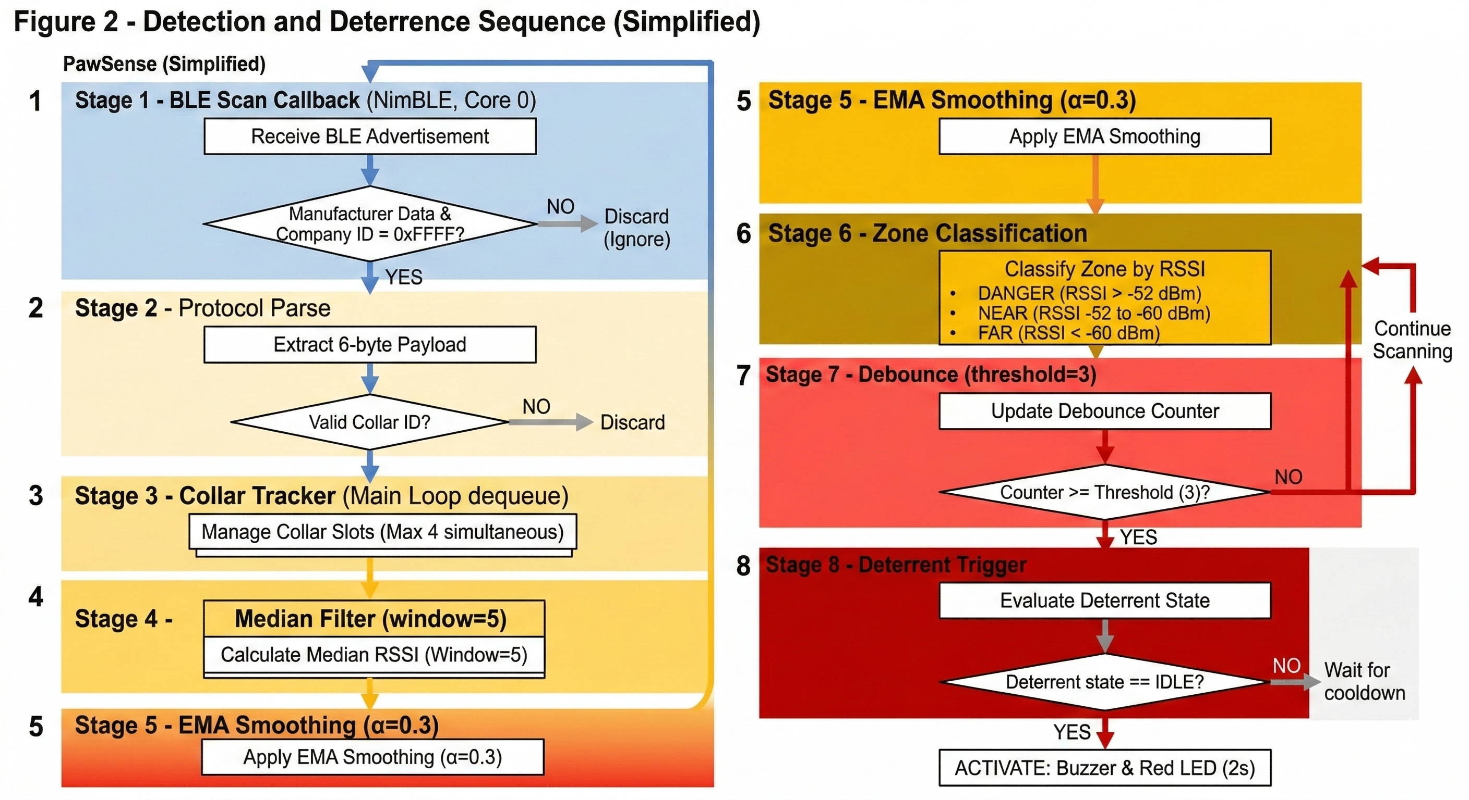
Figure 2 - Detection and Deterrence Sequence

2.4 Design principles
- Simplicity: the prototype must remain feasible with available components and within course time limits.
- Safety: the deterrent output should be short, controlled, and non-harmful to the cat.
- Modularity: collar and room modules should be independently testable and replaceable.
- Low power operation: the collar beacon should minimize current consumption to extend CR2032 battery life.
- Observability: the prototype should expose its operating status through LEDs and serial debug messages so that threshold tuning and troubleshooting are straightforward.

2.5 Assumptions and constraints

2.5.1 Assumptions
- BLE advertising from the collar beacon is sufficient for proximity estimation in the intended indoor environment.
- RSSI can be used as a practical, although imperfect, trigger metric for doorway-scale detection.
- The room device can remain continuously powered during demonstrations and routine tests.
- The first prototype does not require a polished enclosure; breadboard-level assembly is acceptable.

2.5.2 Constraints
- The selected ESP32 board requires an external antenna, so wireless tests are invalid unless the antenna is attached.
- The MDBT42Q-PAT is a bare module and therefore requires firmware development and careful wiring for programming.
- Battery capacity on the collar side is limited by CR2032 characteristics, especially under transient current demand.
- Indoor RSSI is sensitive to reflections, body shadowing, and door geometry; threshold calibration is necessary before final demonstration.

3. Hardware Subsystem Design

3.1 Hardware subsystem overview
The hardware subsystem is divided into the collar beacon and the room unit. The collar beacon focuses on compactness and low power, whereas the room unit focuses on continuous scanning, local decision making, and actuator driving. The prototype is assembled on a breadboard using jumper wires and off-the-shelf through-hole components where possible.

3.2 Hardware components
Table 1 summarizes the key hardware elements that define the Revision 2.0 prototype.
Subsystem | Part | Function | Design note
Collar beacon | Raytac MDBT42Q-PAT (nRF52810) | BLE advertising transmitter | Bare module, requires custom firmware and SWD programming
Collar beacon | CR2032 cell and holder | Portable power source | Suited for lightweight collar-side proof-of-concept
Collar beacon | 100 uF and 100 nF capacitors | Peak current support and decoupling | Required for reliable radio operation
Collar beacon | Slide switch | Manual power control | Prevents unnecessary drain during storage and setup
Room unit | ESP32-WROOM-32U board | BLE scanner and control logic | Acts as temporary programmer and final controller
Room unit | 2.4 GHz external antenna | Radio interface for ESP32 | Mandatory for the selected board version
Alert subsystem | 20 mm piezo buzzer | Audio deterrent output | Driven by digital control via switching stage
Alert subsystem | Red and green LEDs | Status indication | Used for power, detection, and alert visualization
Driver and passive parts | 2N2222 and resistors | Switching, pull-up, pull-down, current limiting | Supports buzzer and stable logic states
Prototype platform | Breadboard and jumper set | Fast prototyping and wiring | Chosen instead of custom PCB for Rev 2.0

3.3 Hardware integration and signal flow
The beacon side includes the MDBT42Q-PAT module, its decoupling network, the CR2032 supply, and the power switch. The nRF52810 module advertises a unique identifier over BLE. On the room side, the ESP32 continuously scans for this identifier. Once a detection event is confirmed, the ESP32 drives the buzzer directly or through a transistor stage, while LEDs indicate whether the system is in idle, detect, or alert mode.
The use of the ESP32 as a temporary SWD programmer introduces a staged integration path. During firmware loading, the ESP32 is dedicated to programming the nRF52810. After firmware is validated, the ESP32 is reflashed with the room-unit application and connected to the antenna, buzzer, LEDs, and resistor network.

3.4 Hardware design considerations
- Current transients on a CR2032 supply can destabilize the beacon if local capacitance is omitted; the selected 100 uF and 100 nF capacitors directly address this risk.
- Because the prototype is breadboard-based, short and organized wiring is important to reduce accidental disconnections and noisy measurements.
- The buzzer should be driven with conservative timing and duty cycle to avoid excessively loud or continuous sound output.
- The external antenna should be installed before any RSSI threshold measurements, because the link budget changes significantly without it.

4. Software Subsystem Design

4.1 Software subsystem overview
The software subsystem is split between collar firmware and room-unit firmware. The collar firmware advertises a compact BLE identity packet at a defined interval while remaining power-conscious. The room-unit firmware scans, filters detections, executes the alert logic, manages cooldown, and reports status for debugging and calibration.

4.2 Software components
Module | Responsibility
Beacon advertiser | Configures BLE advertising payload, interval, and transmit behavior
Device identifier handler | Maintains the beacon identity so the room unit ignores unrelated BLE devices
BLE scanner | Receives advertisements and extracts RSSI data on the room unit
Detection filter | Applies threshold and optional confirmation count to reduce false triggers
Alert controller | Activates buzzer and LEDs based on detection state
Cooldown manager | Suppresses repetitive alerts for a defined time after activation
Debug/configuration interface | Provides serial output and tunable parameters during prototype testing

4.3 Software flow and operating states
The room unit begins in the idle state and transitions into scanning as soon as the controller is powered. When a valid PawSense beacon is found, the system evaluates whether the signal strength and confirmation conditions are sufficient for declaring presence near the restricted area. If the conditions are met, the alert state becomes active and the deterrent output is generated. A cooldown timer then prevents immediate retriggering. If the beacon becomes weak or disappears, the system returns to scanning.
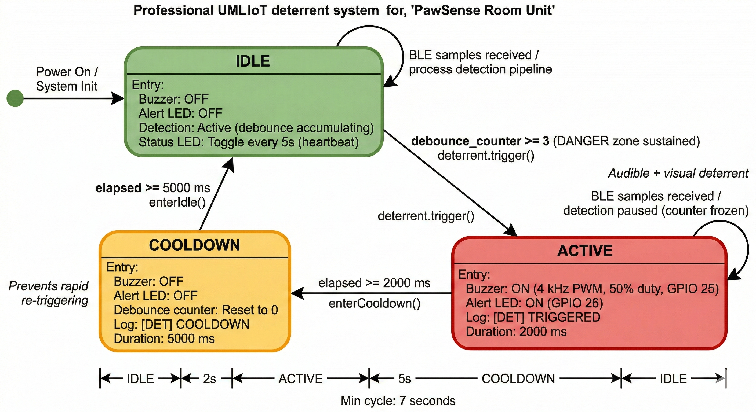
Figure 3 - Room Unit State Transitions

4.4 Software design considerations
- Threshold values must be configurable because indoor signal behavior changes between rooms and doorway geometries.
- A short confirmation window is preferred over a single-packet decision to reduce false alerts from reflections or random spikes.
- The first prototype should rely on serial output for tuning before attempting any mobile or web-based configuration layer.
- Battery-saving features on the beacon, such as reduced advertising payload size and balanced interval selection, are more important than advanced application logic in Revision 2.0.

5. Detailed Design

5.1 Collar beacon module
The collar beacon module is centered on the MDBT42Q-PAT nRF52810 device. Its main responsibilities are initialization of the BLE stack, periodic advertisement transmission, and preservation of low power operation. The module is powered by a CR2032 coin cell, with local decoupling capacitors placed close to the supply pins to reduce brownout risk during radio activity. A slide switch provides manual power isolation for transport and setup. In the first working prototype, the firmware can transmit a fixed identifier and does not require bidirectional communication.

5.2 Room unit controller
The room unit controller is based on the ESP32-WROOM-32U development board. It continuously scans for the PawSense beacon, measures RSSI, checks the result against a configurable threshold, and executes the state machine that governs alert and cooldown behavior. The controller also provides a serial debug channel so that packet visibility, measured signal strength, and trigger decisions can be logged during tests. Because the selected ESP32 variant needs an external antenna, antenna installation is part of the required operating configuration.

5.3 Alert subsystem
The alert subsystem includes the piezo buzzer and the status LEDs. The buzzer is the primary deterrent element and is activated only when the controller declares a valid proximity event. The LEDs support system observability: for example, green may indicate power or normal scanning, while red may indicate a confirmed detection or active alert. A transistor stage may be used if the buzzer current or desired drive behavior exceeds the preferred direct-output limit of the controller pin.

5.4 Power subsystem
The power subsystem is intentionally separated by node. The collar side is battery-powered using a CR2032 cell, which is suitable for low-duty-cycle BLE advertising but not for large current peaks without support capacitance. The room side is expected to be powered continuously from a stable development-board supply. This division makes the collar lightweight while allowing the room unit to remain always available for scanning and demonstrations.

5.5 Prototype assembly and test approach
Assembly begins with standalone validation of both nodes. First, the ESP32 is used as a temporary SWD programming tool to load basic advertising firmware onto the nRF52810 module. Second, the beacon is powered from the CR2032 holder and verified using a BLE scanner. Third, the ESP32 is reflashed with the room-unit application, connected to the external antenna, and tested for packet reception. After standalone validation, the buzzer and LEDs are added and threshold tuning is performed at representative doorway distances. Final integration testing focuses on response time, false trigger frequency, and repeatable return to idle after cooldown.

References
- Nordic Semiconductor. (2023). nRF52810 Product Specification (Version 1.5). Nordic Semiconductor.
- Raytac Corporation. (2018). MDBT42Q-AT & MDBT42Q-PAT module documentation. Raytac Corporation.
- Espressif Systems. (n.d.). ESP32-WROOM-32D & ESP32-WROOM-32U datasheet. Espressif Systems.
- Bluetooth SIG, Inc. (2024). Bluetooth Core Specification, Version 6.0. Bluetooth SIG.
- Panasonic Industry. (n.d.). CR2032: CR coin-type lithium battery datasheet. Panasonic Industry.
- onsemi. (2013). P2N2222A amplifier transistors, NPN silicon: Datasheet. onsemi.
- Milano, F., et al. (2024). BLE-based indoor localization: Analysis of some solutions for performance improvement. Sensors, 24(2), 376.
- Boccadoro, P., et al. (2016). Indoor proximity detection: The case study of a smart pet door. In related proceedings/study on BLE-based pet-door proximity detection.
- Qureshi, U. M., Umair, Z., & Hancke, G. P. (2019). Evaluating the implications of varying Bluetooth Low Energy transmission power levels on wireless indoor localization accuracy and precision. Sensors, 19, 3282.
- Collotta, M., Pau, G., Talty, T., & Tonguz, O. K. (2018). Bluetooth 5: A concrete step forward toward the IoT. IEEE Communications Magazine, 56(7), 125–131.

