Digital Maturity Assessment Report

Company: Global Corp
Sector: Telecommunications
Size: Large-size (250+)
Country: Germany
Assessment Date: 2026-02-08

Executive Summary
This report presents the digital maturity assessment results for Global Corp. The organization has achieved significant progress, improving from a baseline maturity score of 20.2 to 70.8, representing a +50.6 point (250.3%) increase. This performance classifies the organization as a Competent in digital maturity.

Key Performance Indicators
Metric | Before | After | Change
Overall Maturity Score | 20.2 | 70.8 | +50.6
Strategy | 25.0 | 70.0 | +45.0
Readiness | 14.3 | 70.7 | +56.4
HumanCentric | 26.7 | 60.0 | +33.3
DataMgmt | 13.3 | 74.3 | +61.0
AutomationAI | 20.0 | 72.0 | +52.0
GreenDigital | 22.0 | 78.0 | +56.0

Visual Performance Profile
The radar chart below illustrates your organization's digital maturity across all six assessment dimensions, comparing baseline (Before) and current (After) states.
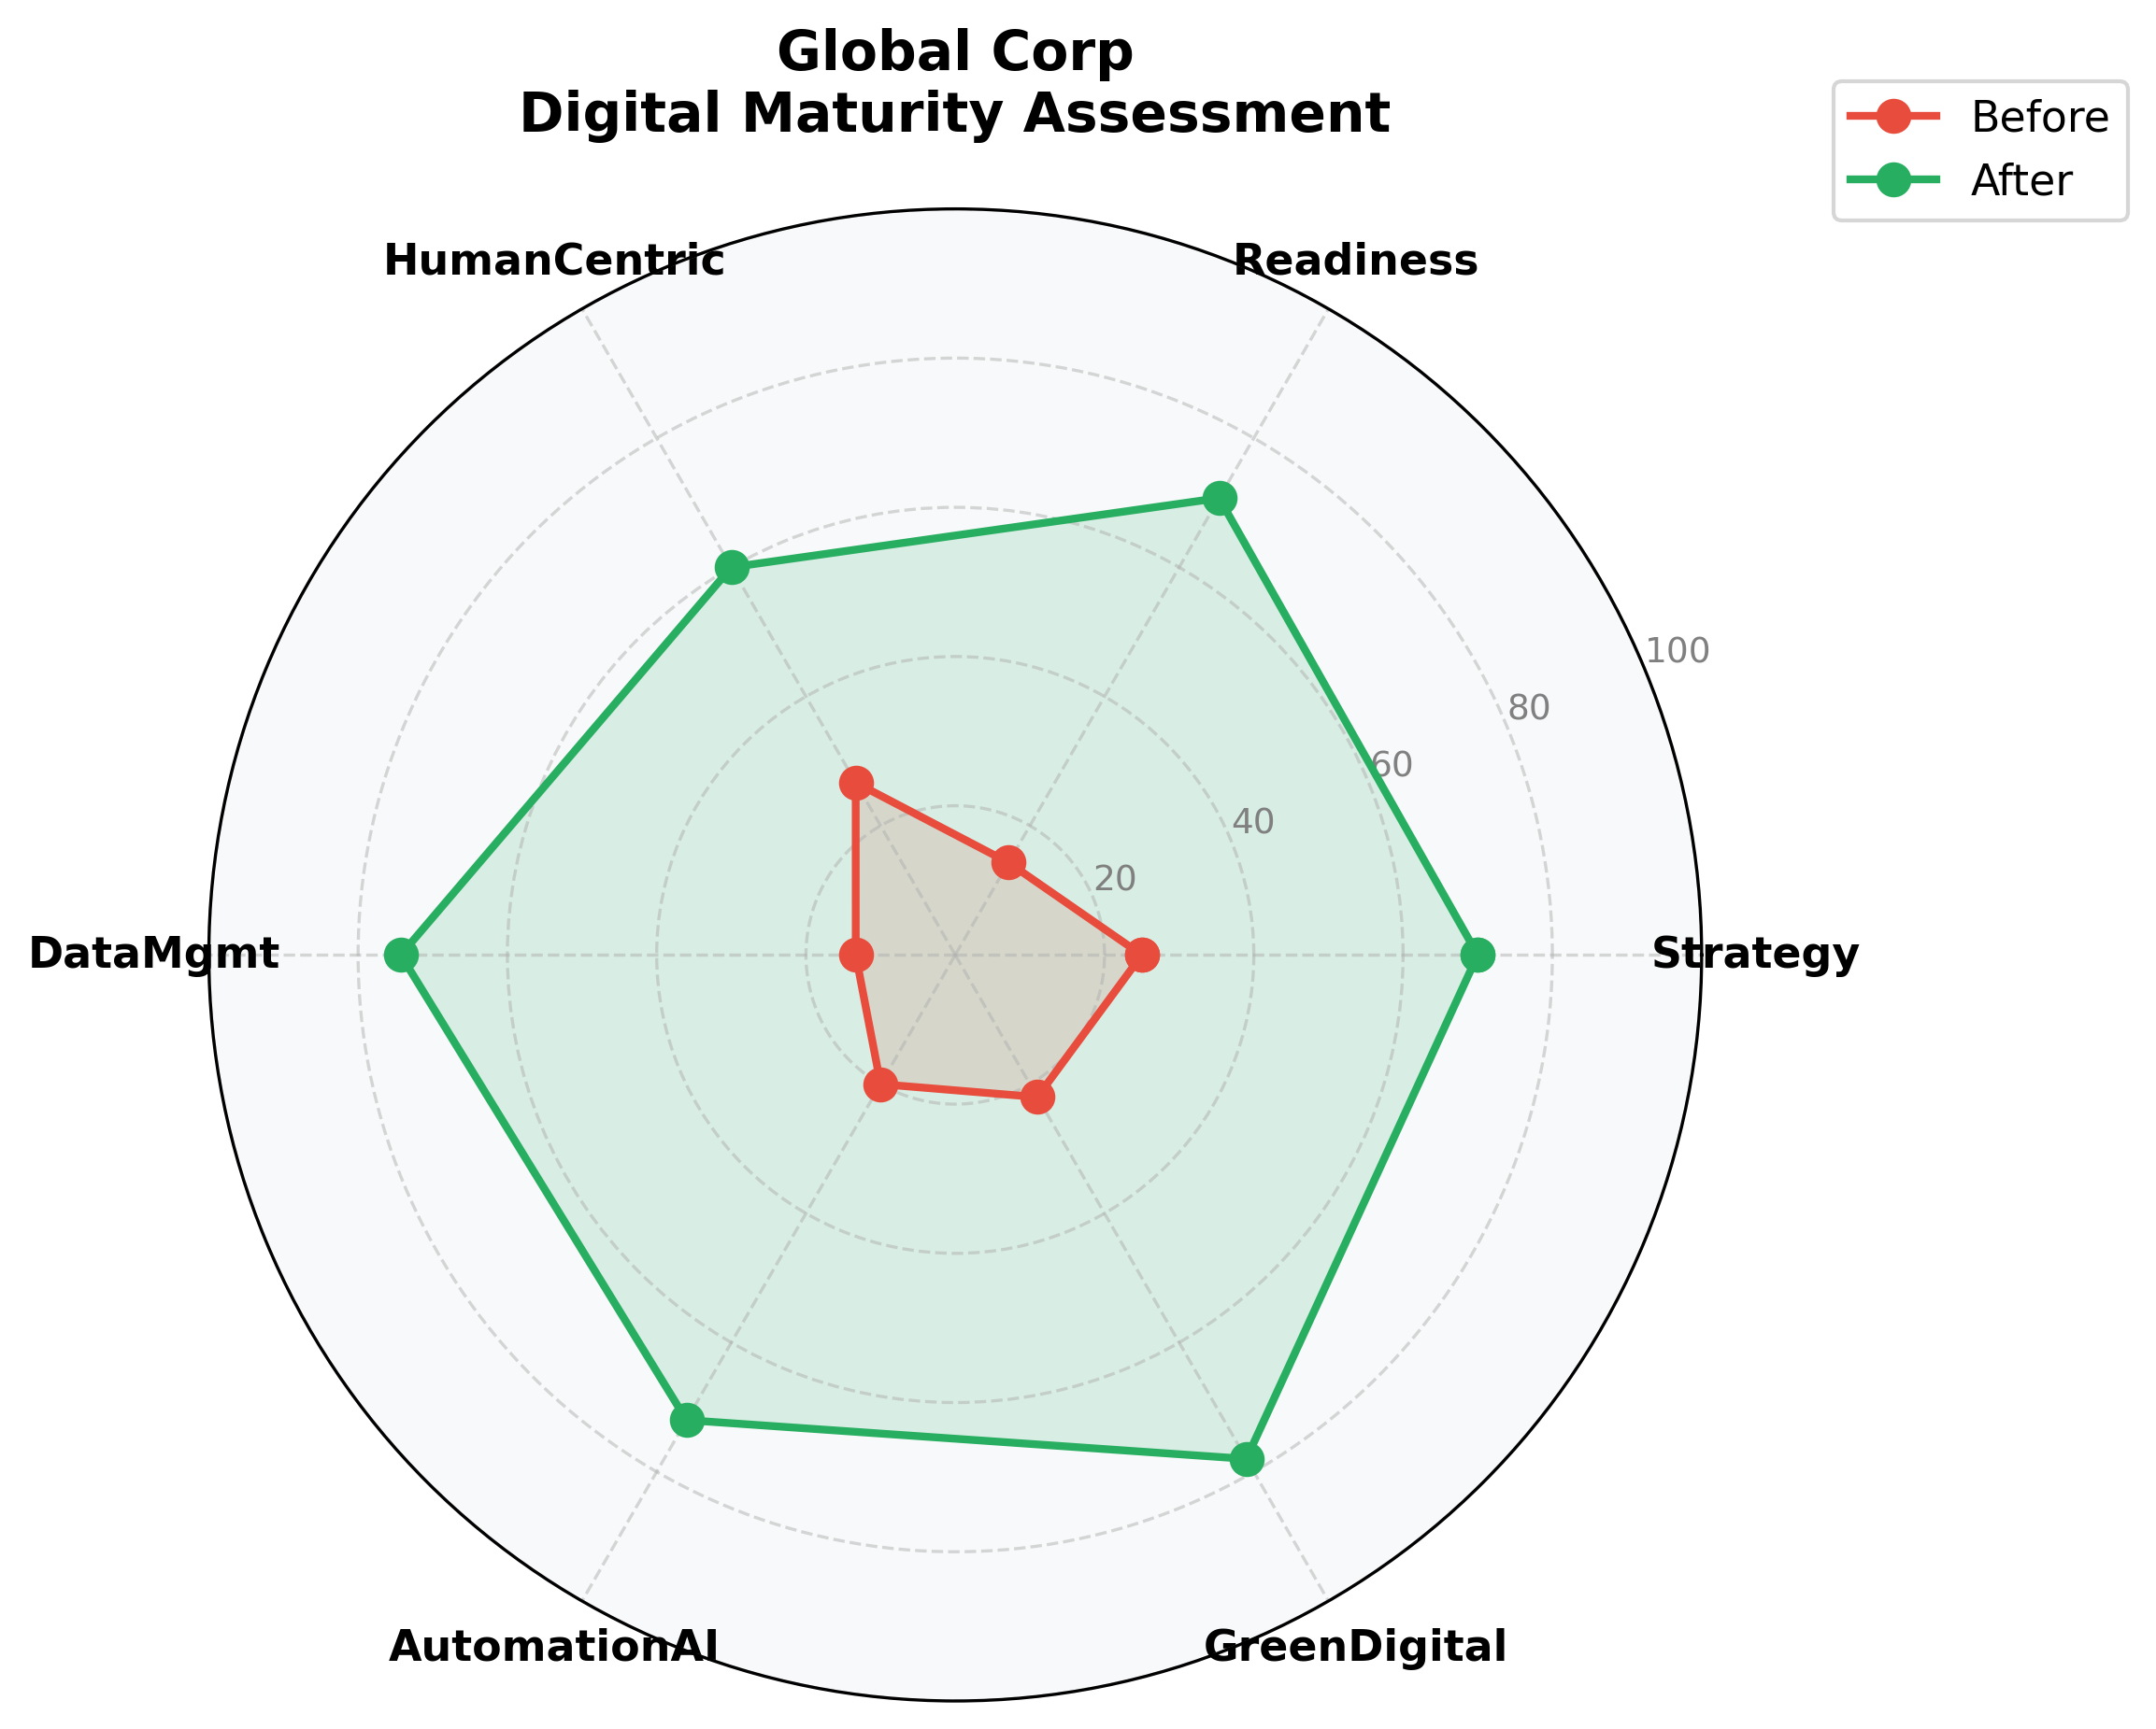

Dimensional Analysis
Strengths: The DataMgmt dimension shows the highest improvement (+61.0 points), indicating strong progress in this area.

Strategic Recommendations
- Build on current capabilities by implementing advanced technologies and data-driven decision making processes.
- Conduct quarterly maturity assessments to track progress and adjust strategies accordingly.

This report is based on the EU Open Digital Maturity Assessment Tool (DMAT) Framework
Generated by Digital Transformation Analytics Suite

