Digital Maturity Assessment Report

Company: Prime Enterprises
Sector: Tourism
Size: Micro-size (1-9)
Country: Greece
Assessment Date: 2026-02-08

Executive Summary
This report presents the digital maturity assessment results for Prime Enterprises. The organization shows a maturity score of 48.6, compared to a baseline of 52.2. This performance classifies the organization as a Competent in digital maturity.

Key Performance Indicators
Metric | Before | After | Change
Overall Maturity Score | 52.2 | 48.6 | -3.5
Strategy | 65.0 | 55.0 | -10.0
Readiness | 55.0 | 54.3 | -0.7
HumanCentric | 46.7 | 60.0 | +13.3
DataMgmt | 54.3 | 30.5 | -23.8
AutomationAI | 48.0 | 52.0 | +4.0
GreenDigital | 44.0 | 40.0 | -4.0

Visual Performance Profile
The radar chart below illustrates your organization's digital maturity across all six assessment dimensions, comparing baseline (Before) and current (After) states.
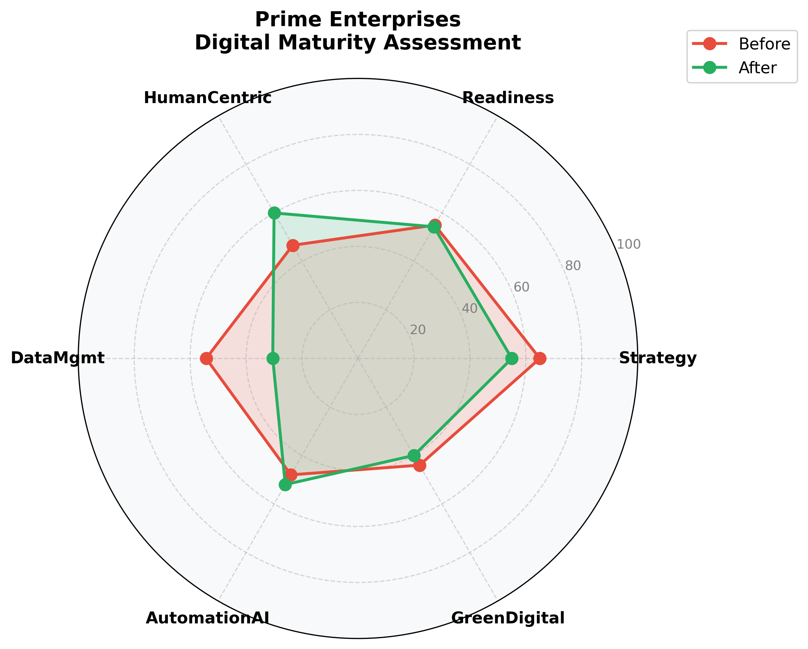

Dimensional Analysis
Strengths: The HumanCentric dimension shows the highest improvement (+13.3 points), indicating strong progress in this area.
Areas for Focus: The DataMgmt dimension requires attention, with limited growth (-23.8 points). Targeted interventions in this area could yield significant benefits.

Strategic Recommendations
- Develop a focused improvement plan for DataMgmt, including skills training, technology investments, and process re-engineering.
- Build on current capabilities by implementing advanced technologies and data-driven decision making processes.
- Conduct quarterly maturity assessments to track progress and adjust strategies accordingly.

This report is based on the EU Open Digital Maturity Assessment Tool (DMAT) Framework
Generated by Digital Transformation Analytics Suite

