Digital Maturity Assessment Report

Company: Alpha Enterprises
Sector: Healthcare
Size: Small-size (10-49)
Country: Spain
Assessment Date: 2026-02-08

Executive Summary
This report presents the digital maturity assessment results for Alpha Enterprises. The organization has achieved significant progress, improving from a baseline maturity score of 34.1 to 46.1, representing a +11.9 point (35.0%) increase. This performance classifies the organization as a Competent in digital maturity.

Key Performance Indicators
Metric | Before | After | Change
Overall Maturity Score | 34.1 | 46.1 | +11.9
Strategy | 30.0 | 30.0 | +0.0
Readiness | 51.4 | 49.3 | -2.1
HumanCentric | 46.7 | 53.3 | +6.7
DataMgmt | 26.7 | 45.7 | +19.0
AutomationAI | 20.0 | 52.0 | +32.0
GreenDigital | 30.0 | 46.0 | +16.0

Visual Performance Profile
The radar chart below illustrates your organization's digital maturity across all six assessment dimensions, comparing baseline (Before) and current (After) states.
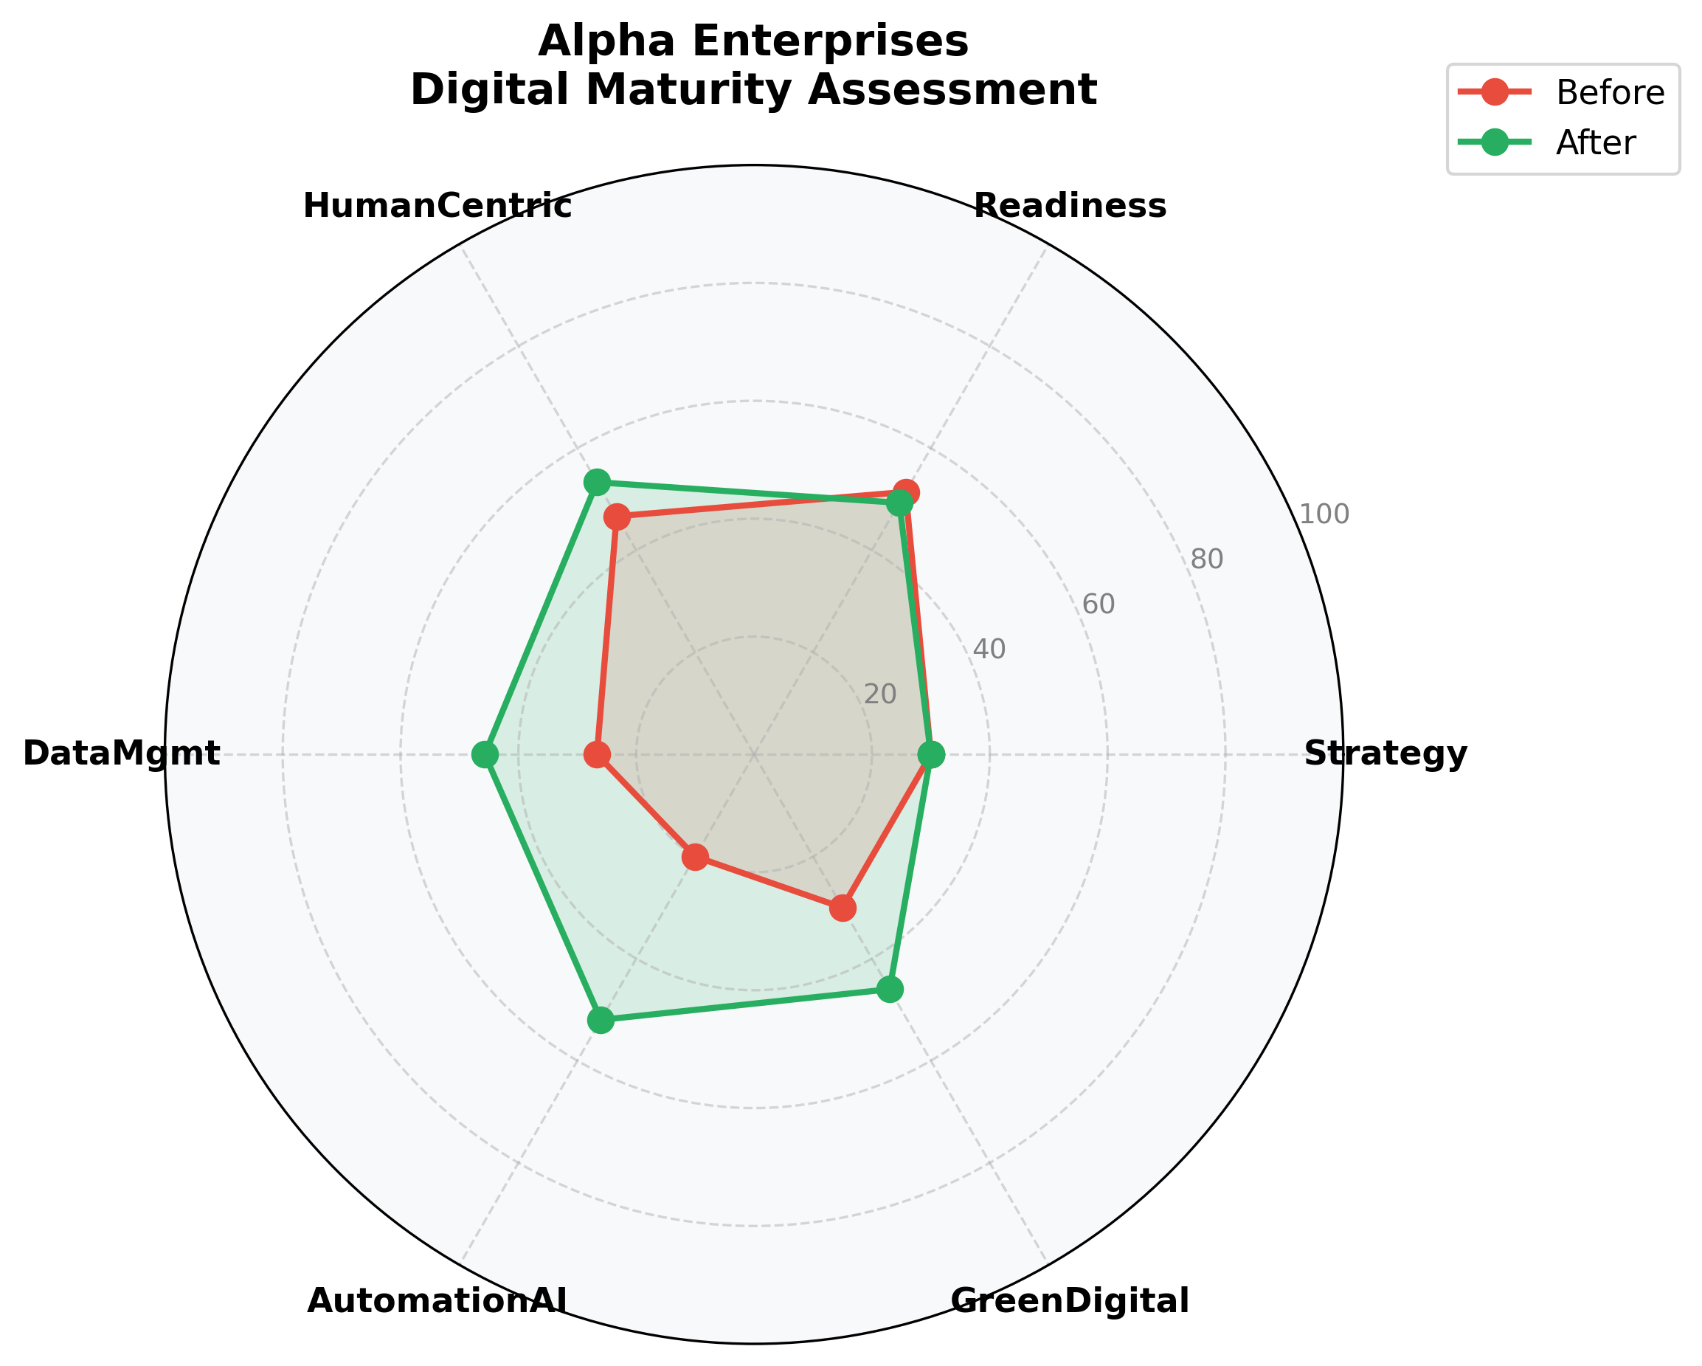

Dimensional Analysis
Strengths: The AutomationAI dimension shows the highest improvement (+32.0 points), indicating strong progress in this area.
Areas for Focus: The Readiness dimension requires attention, with limited growth (-2.1 points). Targeted interventions in this area could yield significant benefits.

Strategic Recommendations
- Develop a focused improvement plan for Readiness, including skills training, technology investments, and process re-engineering.
- Build on current capabilities by implementing advanced technologies and data-driven decision making processes.
- Conduct quarterly maturity assessments to track progress and adjust strategies accordingly.

This report is based on the EU Open Digital Maturity Assessment Tool (DMAT) Framework
Generated by Digital Transformation Analytics Suite

