**Running VEP**

Before converting VCFs to MAFs you must ensure the VCFs are annotated using VEP

1. Navigate to [VEP](https://asia.ensembl.org/Tools/VEP) and create a new job
2. Ensure the chosen ‘Assembly’ is appropriate. If your variants are called based on hg38/GRCh38 reference genomes the link above is appropriate. If your pipelines use hg19/GRCh37 reference genomes you’ll need to use [the GRCh37 version](http://grch37.ensembl.org/Homo_sapiens/Tools/VEP)

1. Upload your VCF
2. Configure Vep with the following settings
   1. **Transcript Database to Use:** Default of Ensembl/GENCODE transcripts. You can actually change to use other transcript databases so long as you ensure consistency between the VCFs in your cohort (and any other cohort you want to compare results to)

* 1. **Identifiers:** Check *Gene Symbol* & *Transcript Version* & *HGVS*

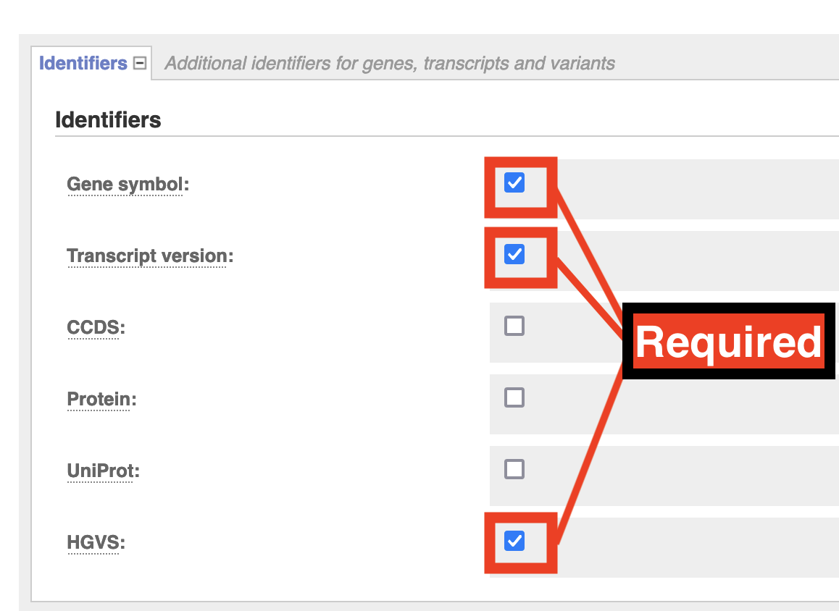

* 1. **Additional Annotations > Transcript Annotation:** Check *Transcript Biotype* & *Identify Canonical Transcripts*

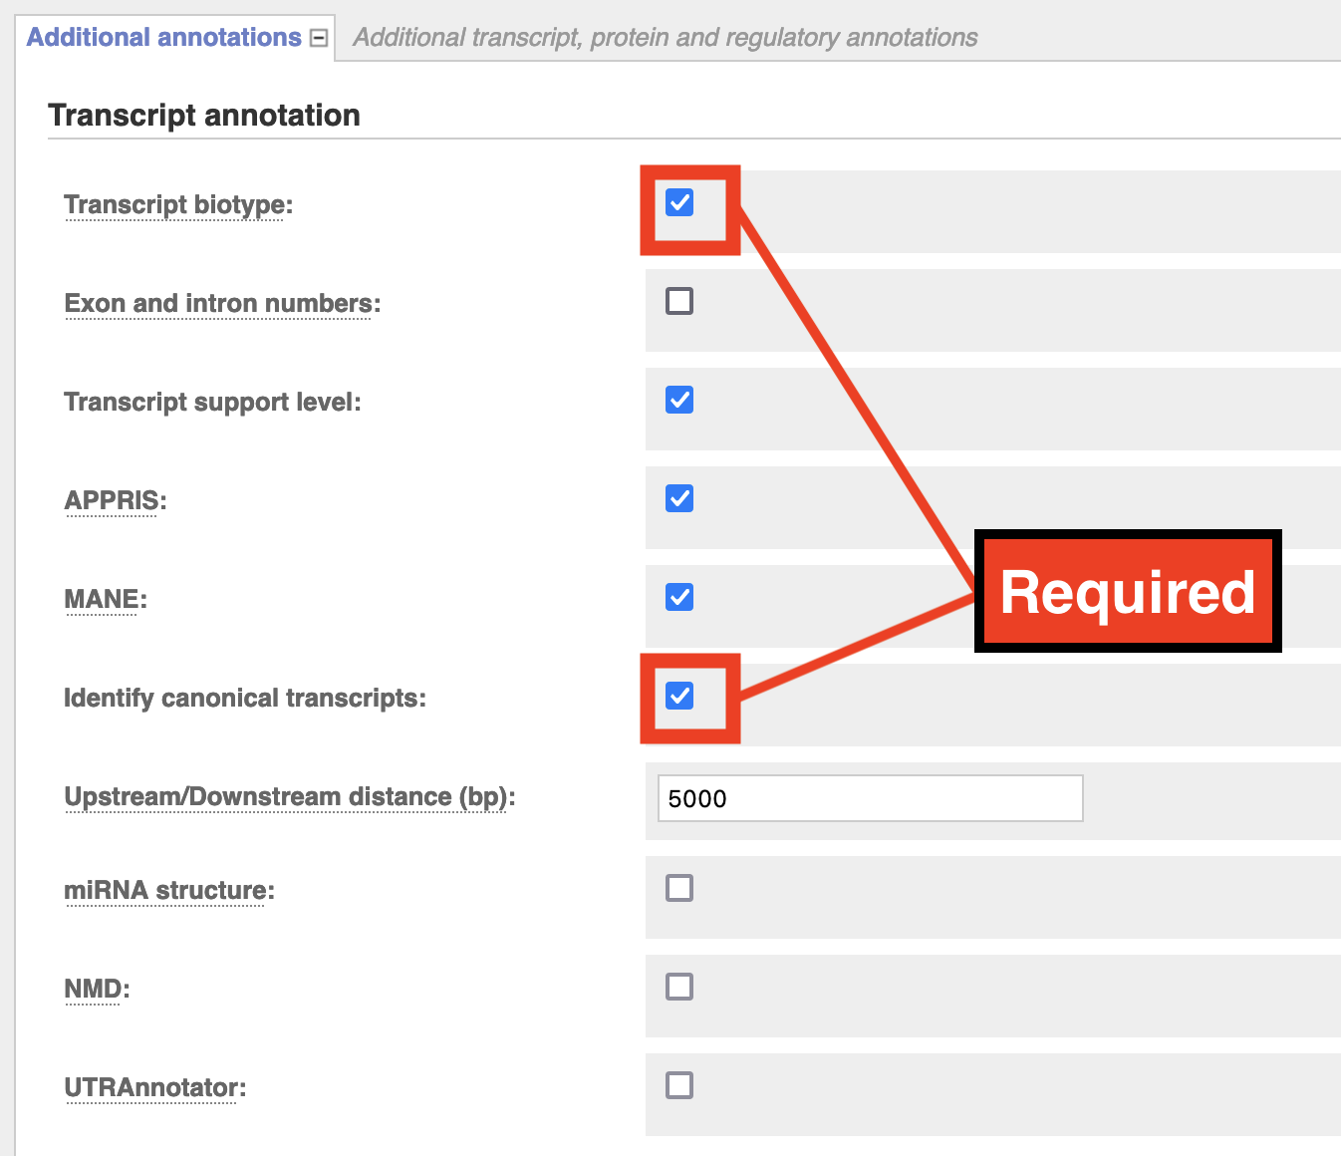

* 1. **Variants and Frequency Data:** check *gnomAD (exomes) allele frequencies*

1. Run VEP and download results as VCF

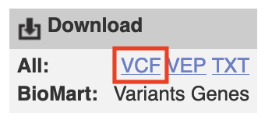

**Interchange (vcf2maf)**

Once you have your VEP-annotated VCFs head to the [Interchange web app](https://ccicb.shinyapps.io/interchange/) and select VCF to MAF conversion

Then select all your VCF files as pictured below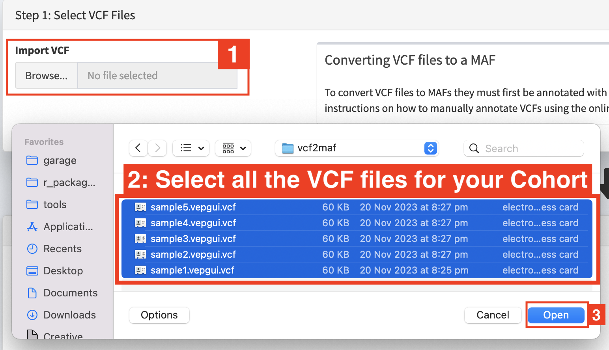

Fill in the metadata about your cohort in the step2: panel.

You may need to alter the expected ID of tumour samples/normal samples to match your VCFs. Most somatic variant callers used in tumor-normal pipelines produce 2-sample vcfs with the tumour sample named ‘TUMOR’ and the normal sample named ‘NORMAL’. This is what the interchange vcf2maf converter expects. If your VCFs differ from this (you can open vcfs in a text editor to check this) then you may need to change it. If tumour sample name in your VCF changes from one sample to another, please check ‘Assume IDs in VCF match Tumor Sample Barcodes’

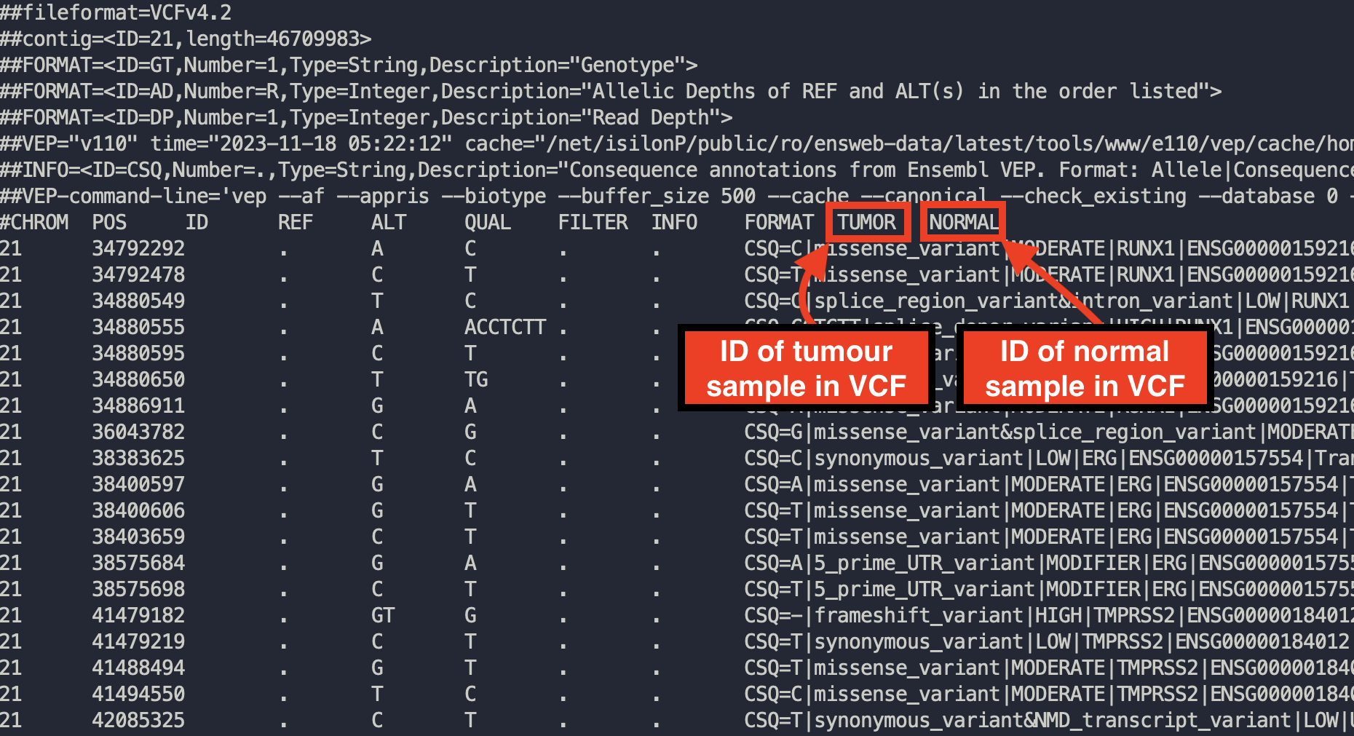

Example of opening up a VCF to checking how tumor and normal samples are named

Check the VCF file -> Tumour Name Mappings and Interchange correctly guesses the appropriate sample name for each file. You can manually change these sample names if required.

Once you’re finished click convert to download your MAF file.