**Short study 3**

From: CRUX, a platform for visualising, exploring and analysing cancer genome cohort data, by El-Kamand *et al*.

Please cite the above publication and the authors of any external tools accessed using CRUX.

**Identification of candidate driver mutations linked to therapeutic responses in thyroid cancer.**

Dataset: The Thyroid Cancer (THCA) dataset, containing data (MAF file) generated from whole genome sequencing for 496 patient samples.

For this study the first step from the CRUX homepage is to select and load the thyroid carcinoma dataset. This is available from ‘Available Data’ under the Data menu on the homepage sidebar or the Explore Public Datasets button in the ‘Getting Started’ homepage panel. The thyroid carcinoma dataset (THCA) dataset is brought up by typing ‘thyroid’ in the name field [screenshot 1] or THCA into the abbreviation field.

***Screenshot 1***

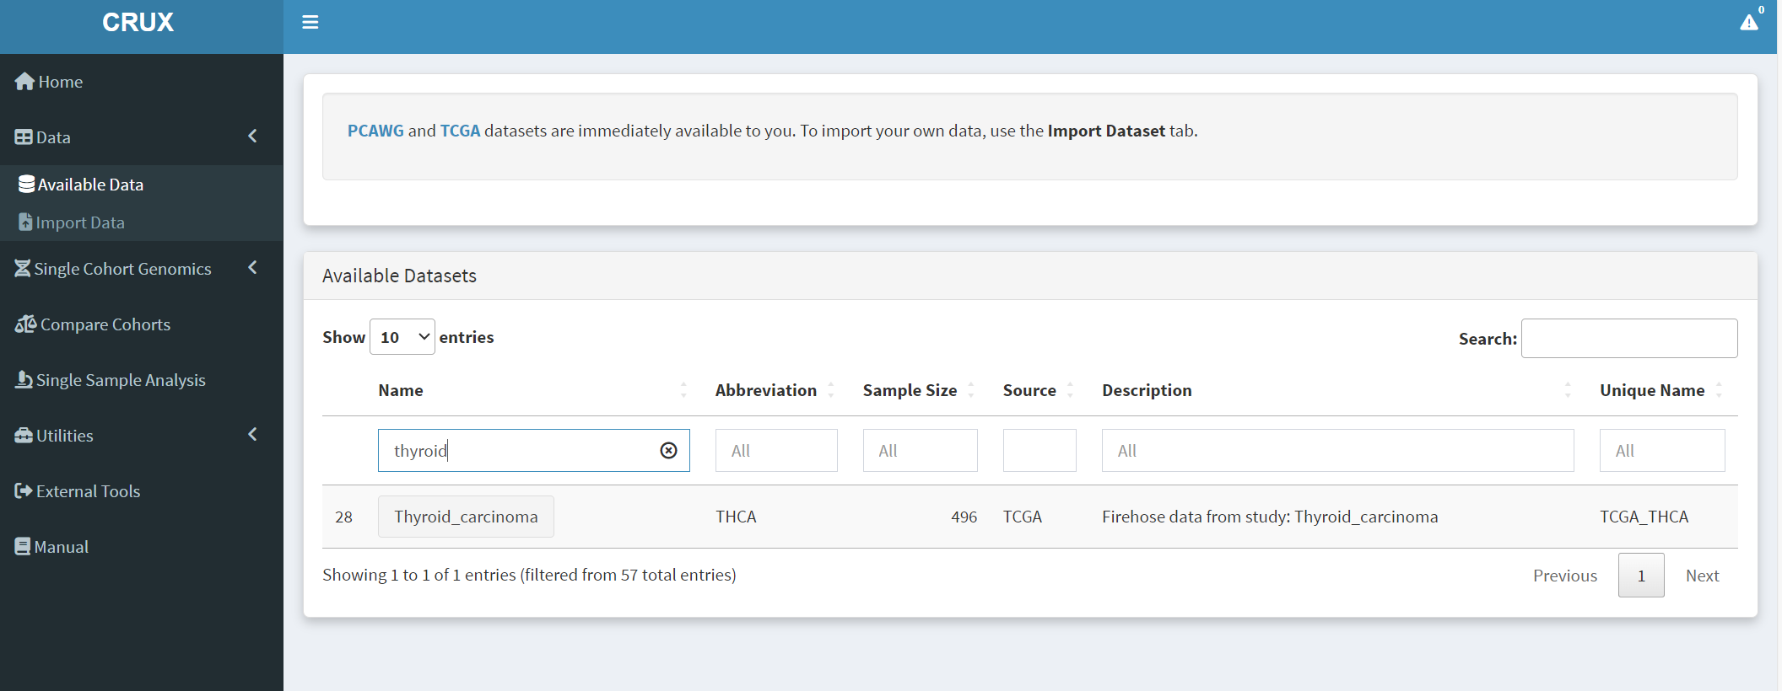

Clicking on the dataset 28 ‘Thyroid_carcinoma’ button opens the next page; the Filter Dubious Genes button on Step 1 panel [screenshot 2] is selected.

***Screenshot 2***

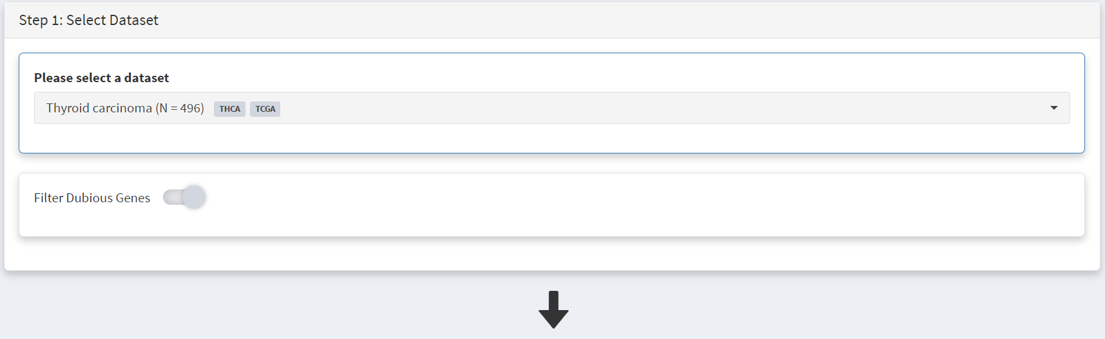

Below this in the Step 2 panel there are the Explore Visualisation tabs [screenshot 3]. Here we use the Oncoplot tab to examine the genes with mutations occurring in the largest number of samples. The standout gene is *BRAF*, although *NRAS*, *HRAS, FAM47C* and *TG* are also notable. The *NRAS* and *HRAS* are known oncogenes, *FAM47C* is a poorly understood but widely expressed gene, while *TG* is a significant THCA marker (encoding the thyroglobulin protein produced by thyroid tissue) which may not be oncogenic.

***Screenshot 3***

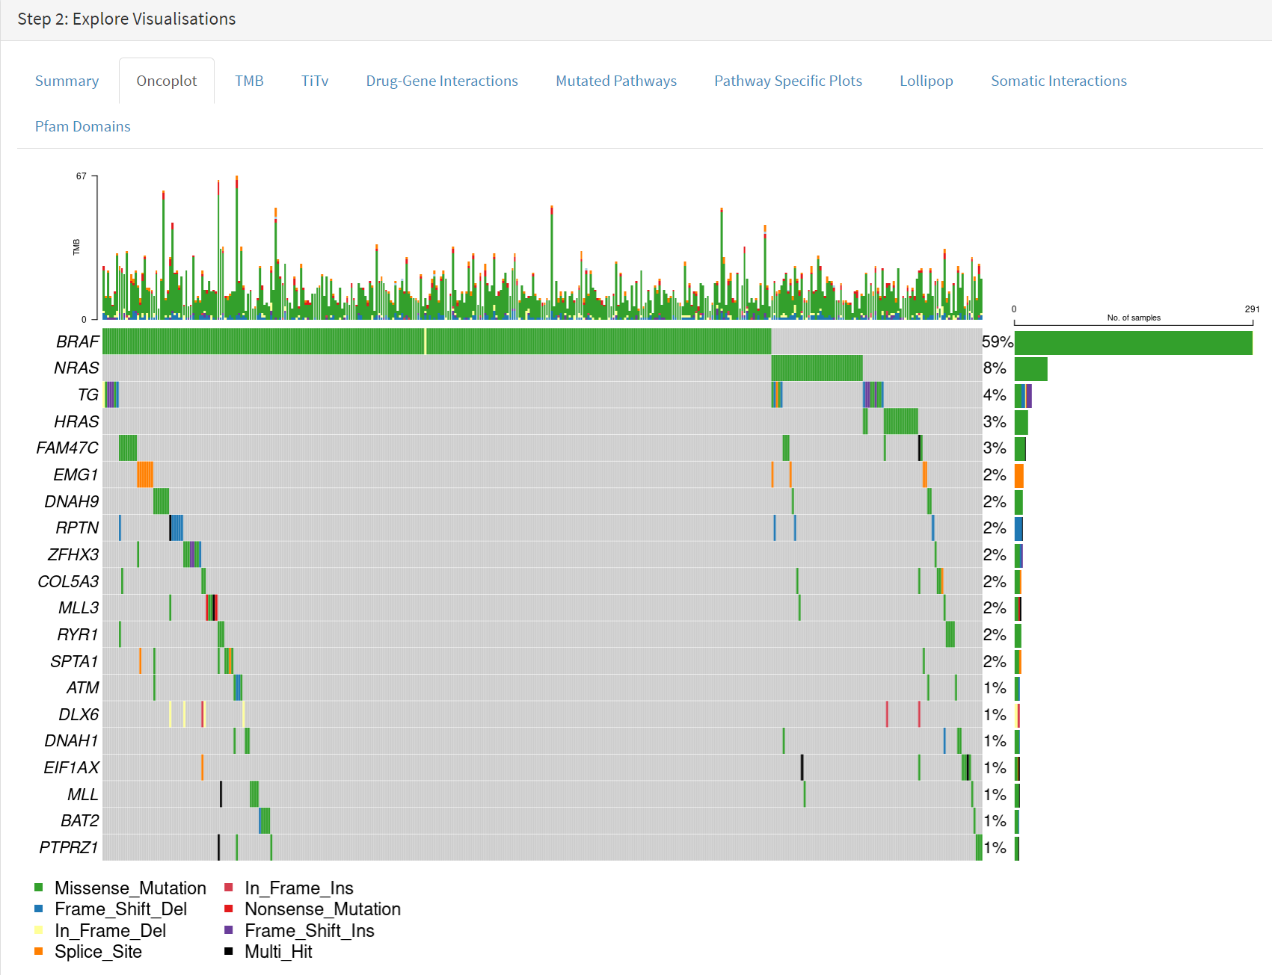

**Use of OncoDriveCLUSTL tool**.

OncoDriveCLUSTL is an external platform for gene driver analysis. This is accessed using the External Tools button on the CRUX sidebar. On the page that opens, the first step is to select the THCA dataset for download at the Step 1 panel, as shown in screenshot 4.

***Screenshot 4***

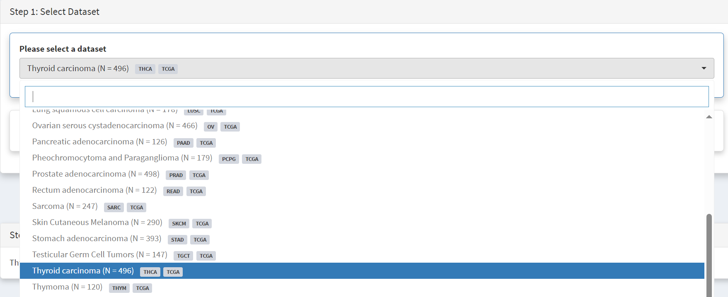

Then Filter Dubious Genes is selected [screenshot 5].

***Screenshot 5***

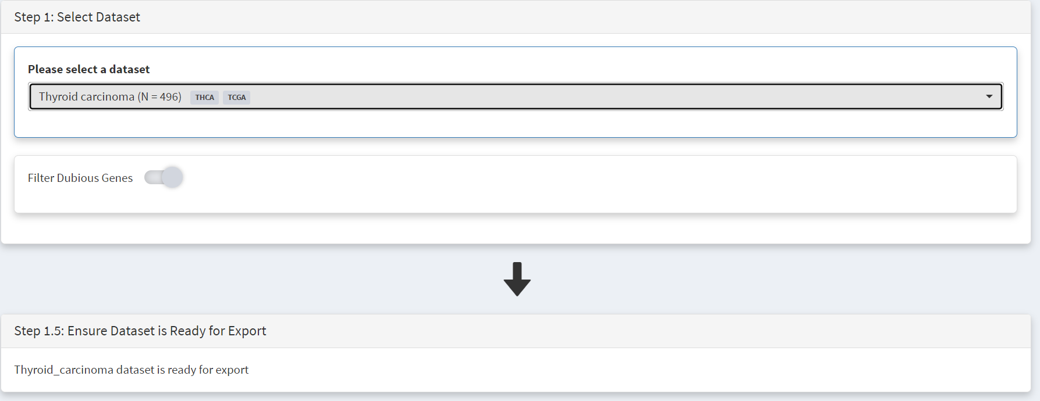

Below this is the Step 1.5 panel, where CRUX should indicate the THCA dataset is ready for export. In the step 2 panel there is the Select Tool tab. Usually it has the first tool (OncodriveFML) highlighted but when clicked on the menu drops down and OncoDriveCLUSTL can be selected [screenshot 6]

***Screenshot 6***

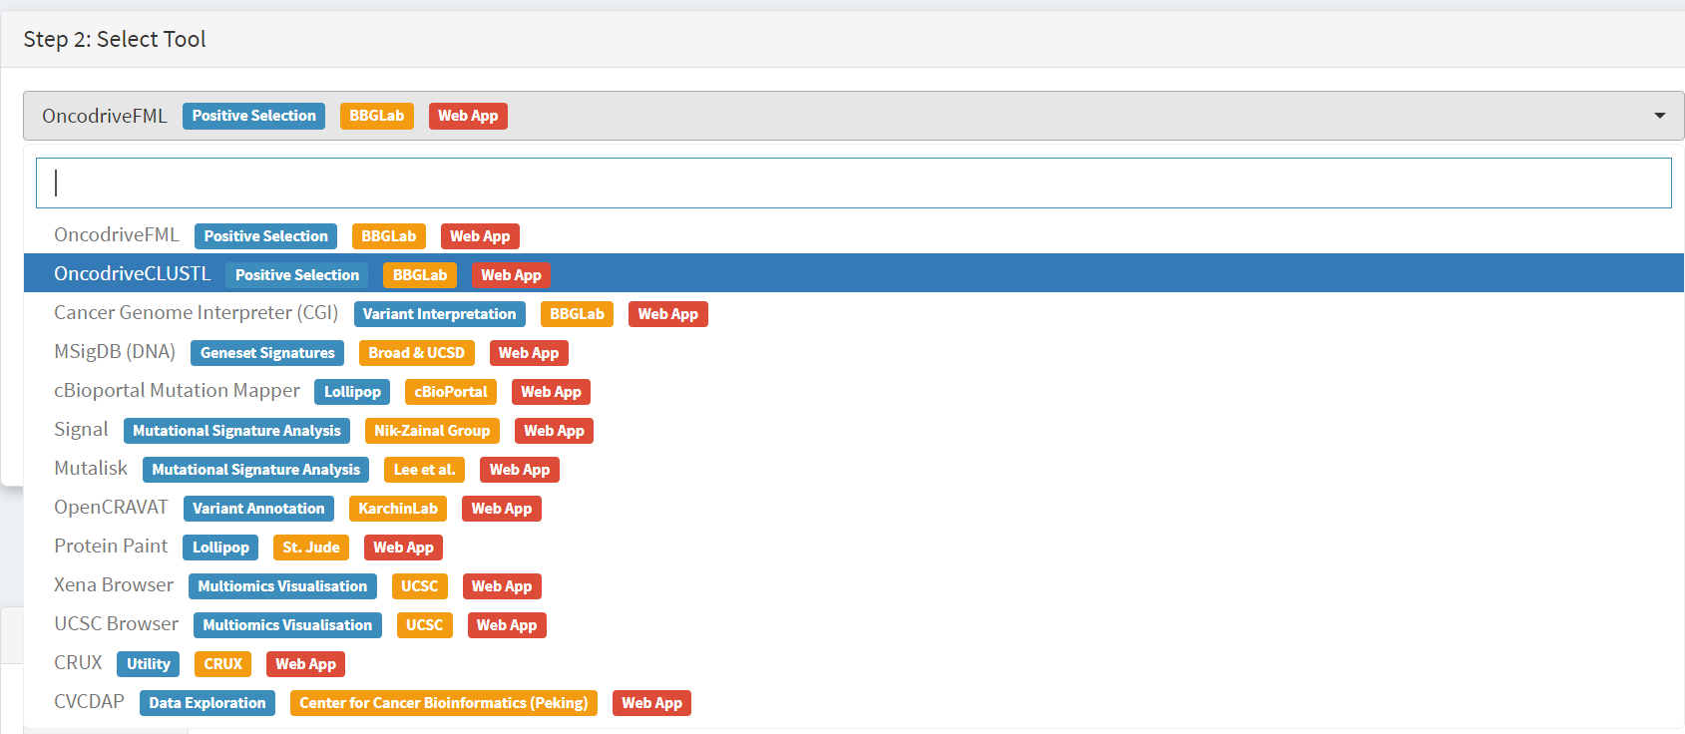

Moving to the Step 3 panel [screenshot 7], clicking on the Export Data tab and will download the formatted THCA dataset to the user computer, ready to upload to the OncoDriveCLUSTL platform. On the Step 4 panel, clicking on the blue button opens a new browser window for OncoDrivCLUSTL, at <http://bbglab.irbbarcelona.org/oncodriveclustl/analysis> :

***Screenshot 7***

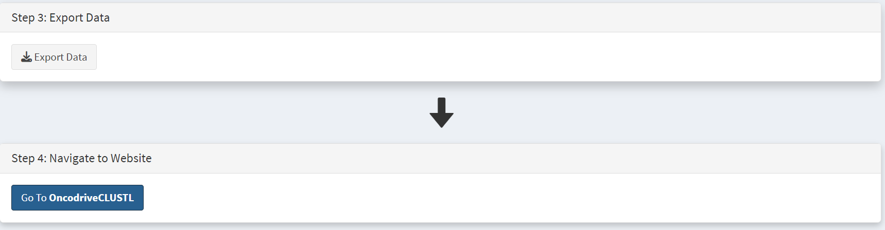

On the Step 5 panel (not shown) there are instructions and information on the tool. To use OncoDriveCLUSTL a BBGlab account needed (this is rapidly done and is free) to log in to use the tool. As seen in screenshot 8]. Give the analysis run a name then upload the THCA file prepared by CRUX.

***Screenshot 8***

After checking the terms of use button and press submit a process progress window opens; screenshot 9 was taken shortly after starting a data processing run.

***Screenshot 9***

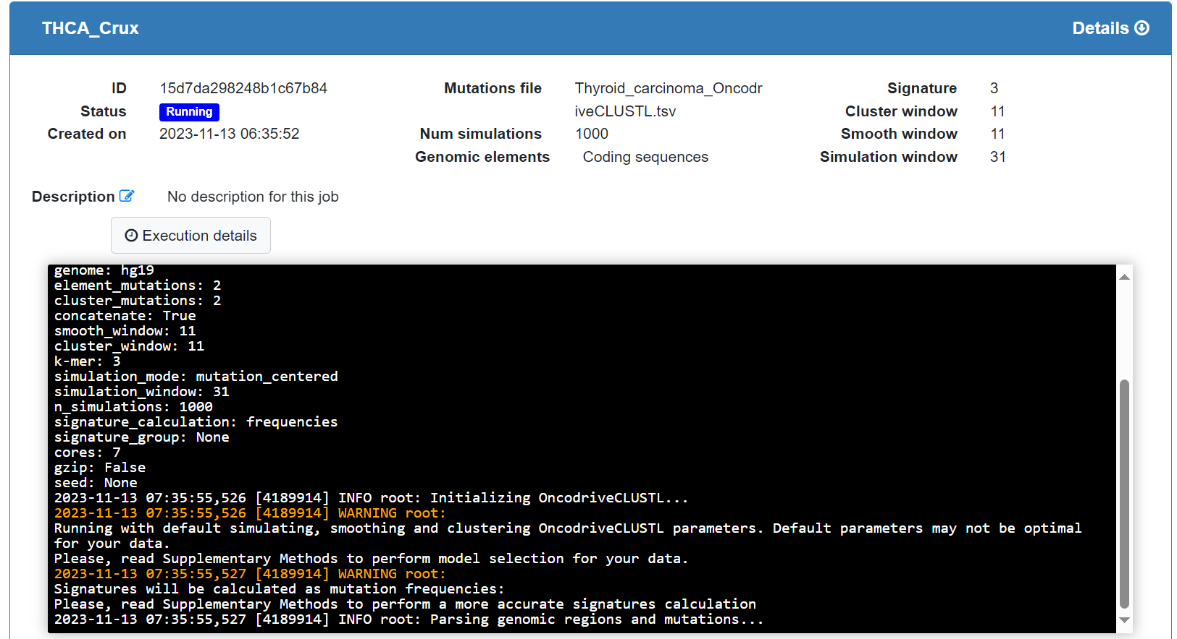

The data processing may take some time, over 15 minutes for this dataset. The window will show the status indicator as ‘Finished’, and a plot appears [screenshot 10] showing putative drivers with observed versus expected p-values.

***Screenshot 10***

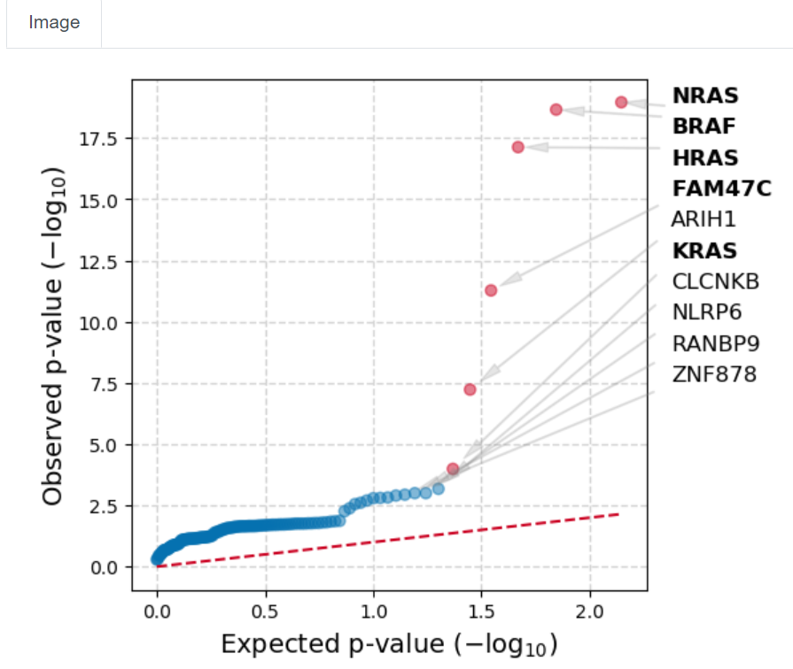

This indicates that *BRAF*, *NRAS*, *HRAS* and *FAM47C* mutations (seen in Oncoplot) are highly selected for standout candidates to be examined. Note that *TG* is not seen.

In the next part of the study we examine *BRAF* mutations.

**Use of cBioPortal mutation mapper tool**

As above the External tools tab is selected from the CRUX home page, the THCA data is selected, Filter Dubious Genes selected and cBioPortal mutation mapper selected in the Step2 panel, as in screenshot 11.

***Screenshot 11***

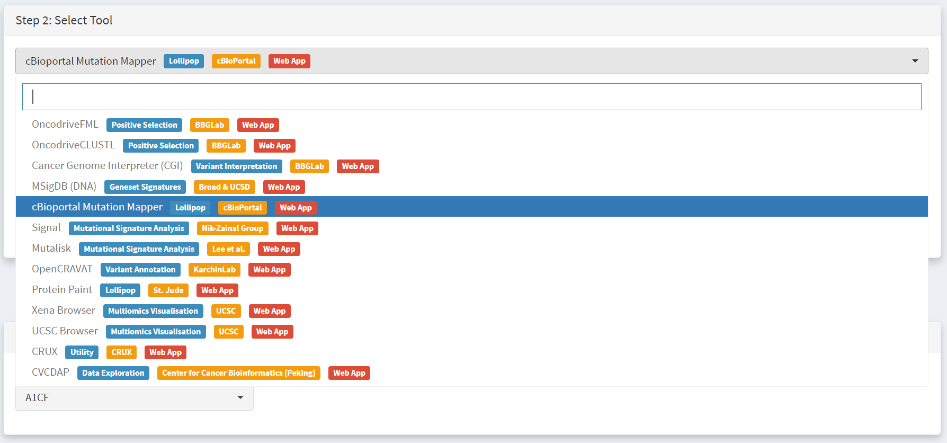

We then need to select the gene, *BRAF*, in the Step 3 panel [screenshot 12].

***Screenshot 12***

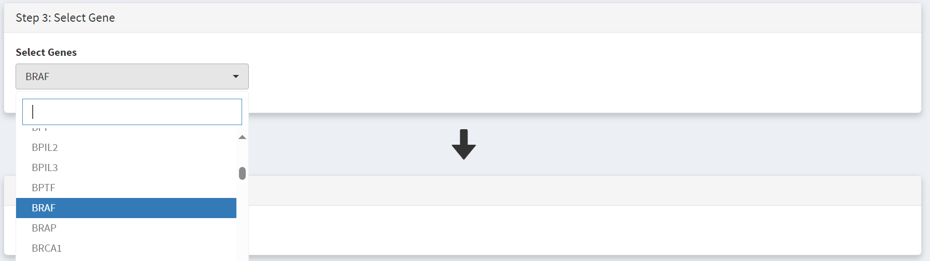

Data is then ready for download (indicated in step 1.5) using the ‘Export Data’ button on the Step 3 panel [screenshot 13]. Using the button on the Step 4 panel will open a window for the cBioportal Mutation Mapper at https://www.cbioportal.org/mutation_mapper .

***Screenshot 13***

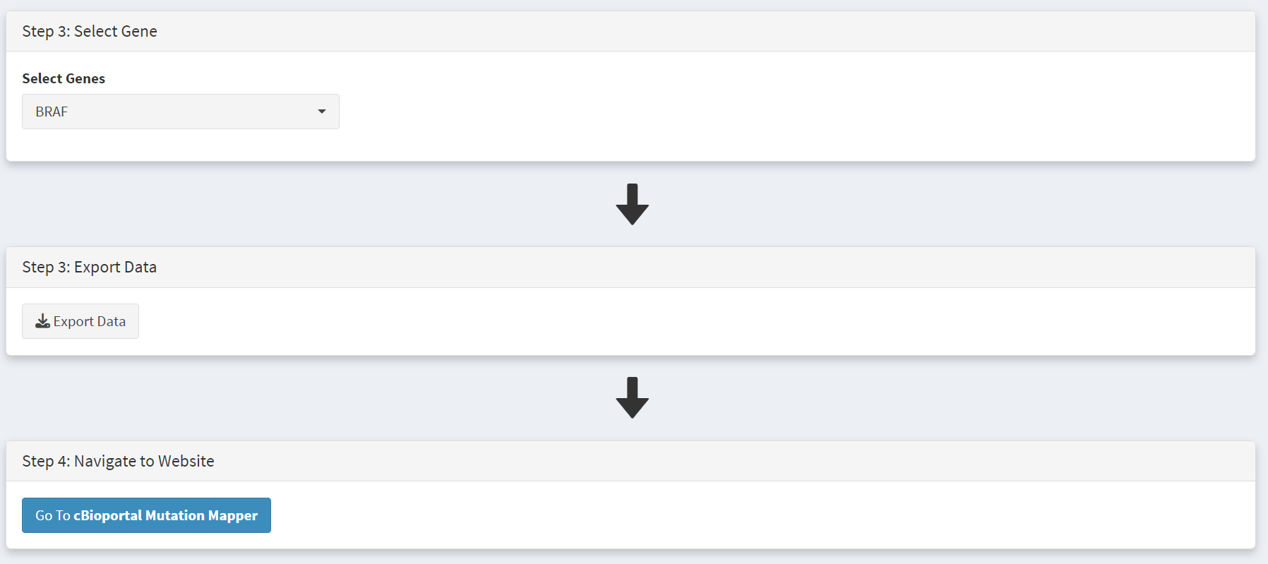

Signup for a BBGLab account may be required. The cBioportal Mutation Mapper window is shown in screenshot 14. After login, the downloaded file can be chosen, genome standard (GRCH37) selected, and visualisation selected at the bottom, as on screenshot 15.

***Screenshot 14***

***Screenshot 15***

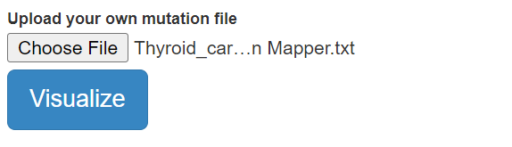

A plot is returned, shown in screenshot 16.

***Screenshot 16***

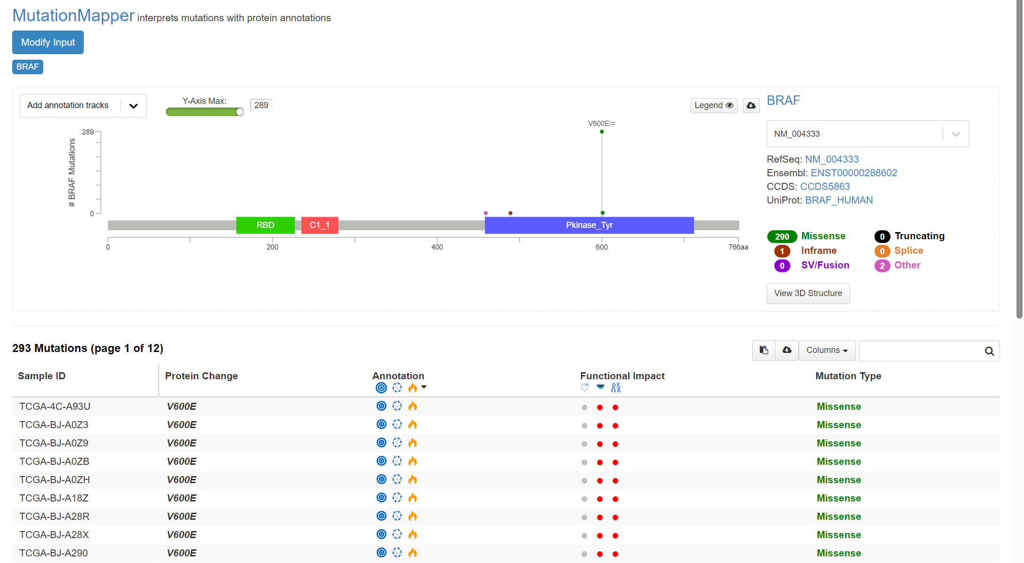

This indicates the gene domains and the presence of mutations, as well as the mutation types and their annotations from OncoKB and others. A plot with the mutation detail shown in screenshot 17.

***Screenshot 17***

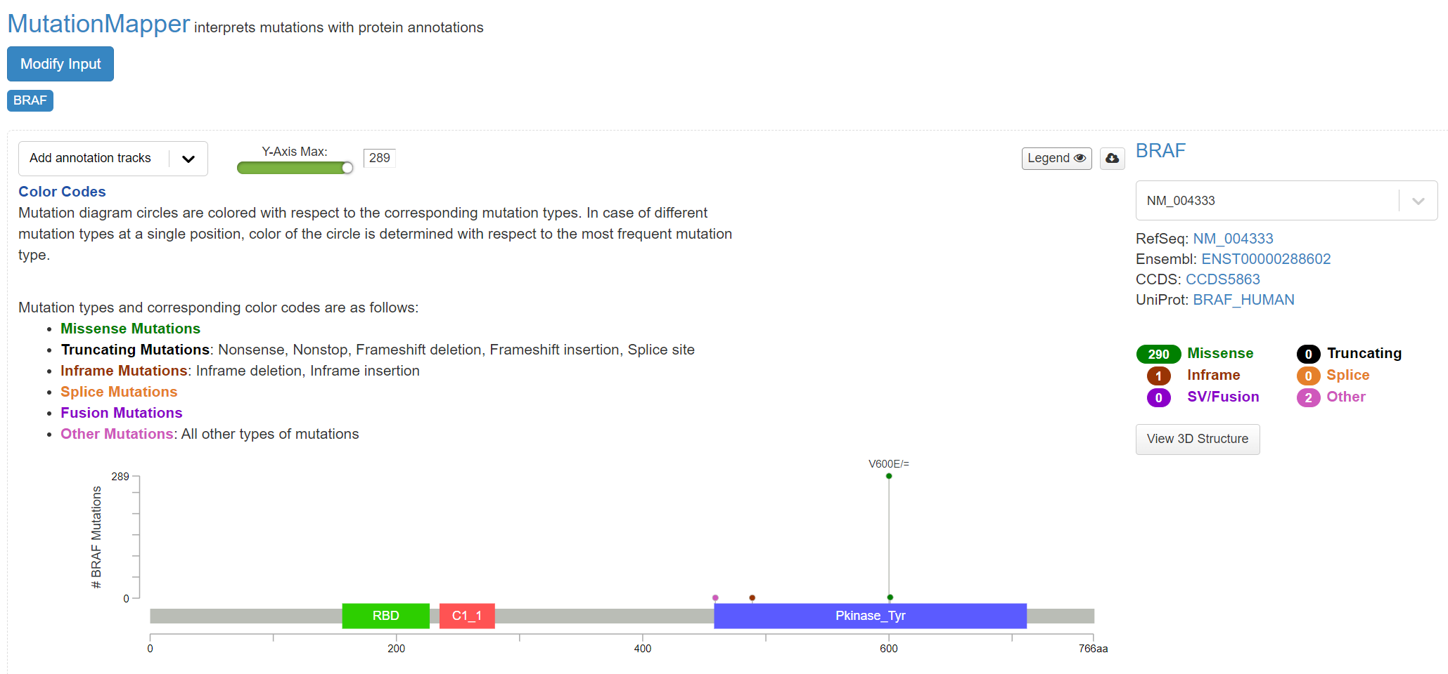

Further details of cohort mutations can be added, screenshot 18, using the ‘Add annotation tracks’ button, seen in screenshot 18. A 3D protein structure graphic showing the affected domain can also be obtained (not shown).

***Screenshot 18***

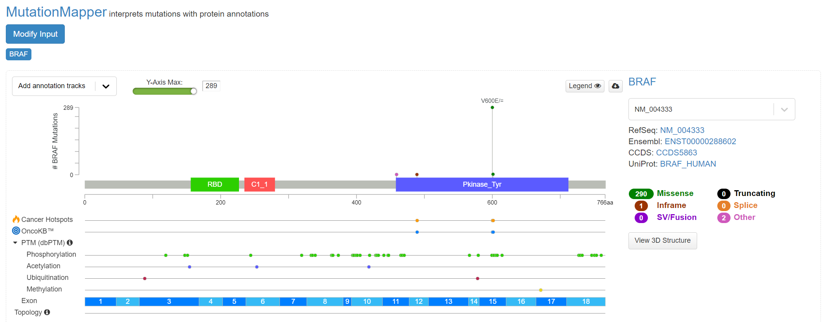

**Use of Cancer Genome Interpreter (CGI) tool**

After navigating to the External tools on the home page, the CGI tool Is selected, screenshot 19.

***Screenshot 19***

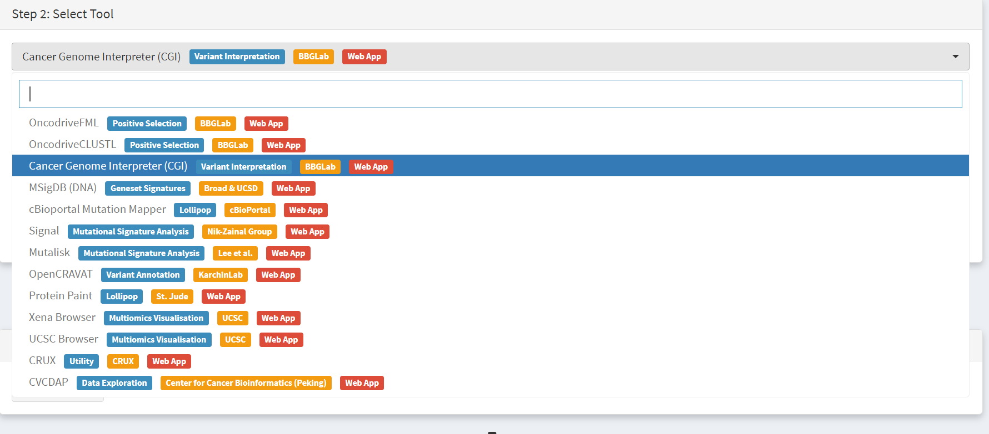

Dataset is selected and downloaded [screenshot 20] as described previously.

***Screenshot 20***

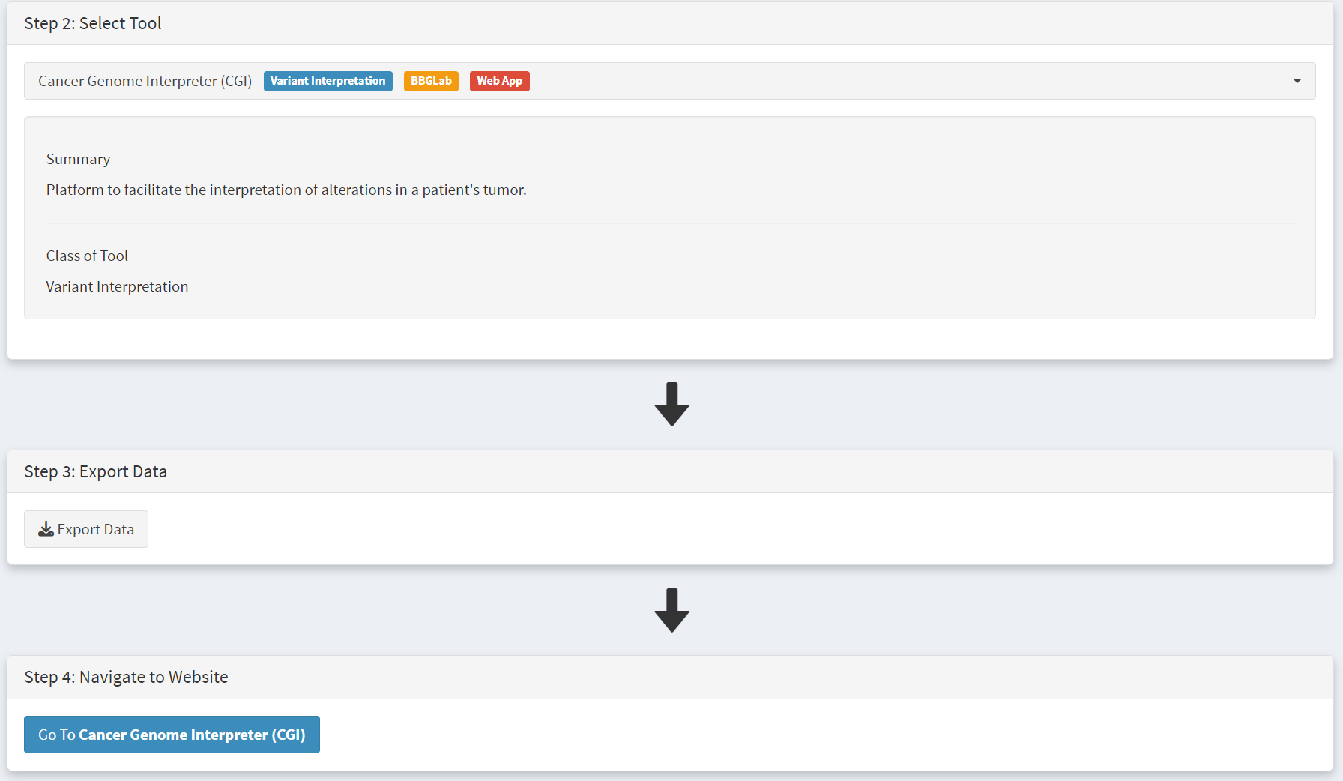

Clicking on the navigation button in the Step 4 panel opens a new browser window for the CGI portal [screenshot 21] at https://www.cancergenomeinterpreter.org/analysis; an account (easily obtained and free) is needed for login. If not logged in the tool can work, but it is likely that there will be a pink box at the bottom indicating ‘you have exceeded the maximum number of jobs’. Log in will make the user’s previous analyses from the previous 6 month the available.

The ANALYSIS tab should be open for the next step.

***Screenshot 21***

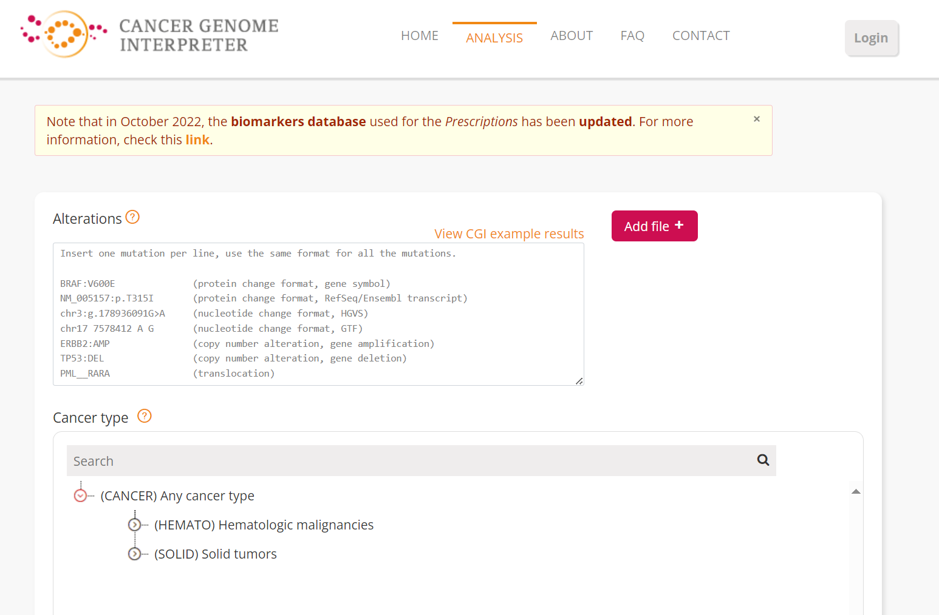

Clicking on the Add File button will allow upload of the CRUX-formatted dataset. For this THCA dataset note the reference genome is hg19; this is selected and Run button pressed [screenshot 22].

***Screenshot 22***

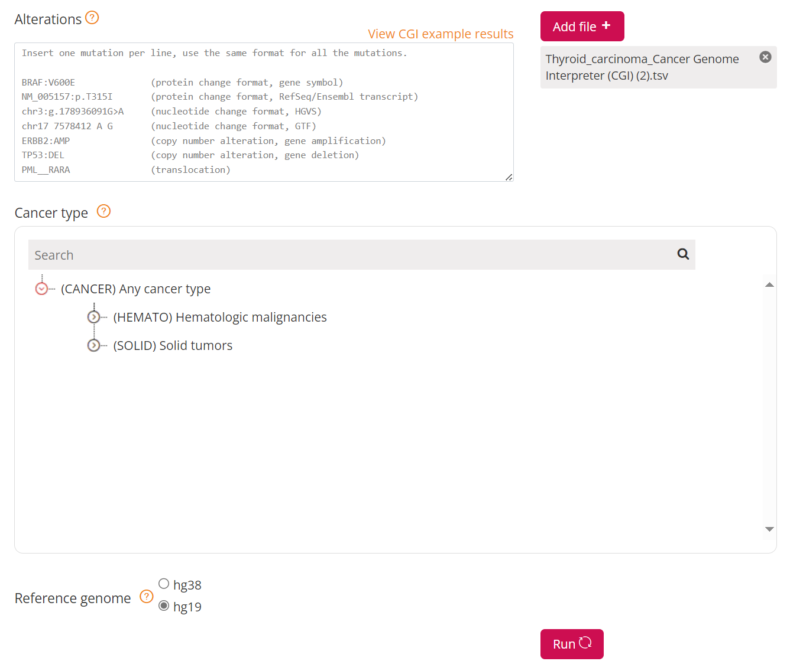

The job will start running (this will take some minutes) and the progress bar will resemble screenshot 23.

***Screenshot 23***

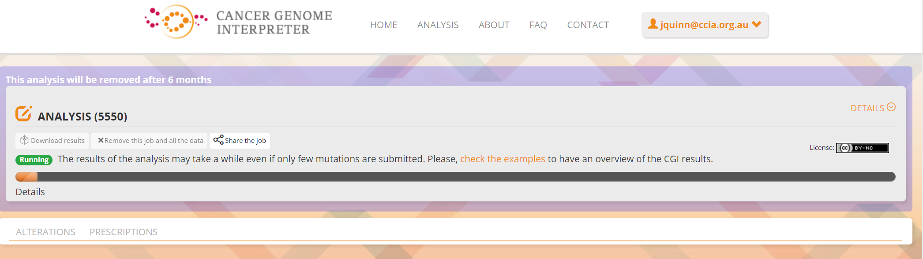

Processed data can be downloaded from the site. There will be a configurable table of patient samples, as seen in screenshot 24 for the initial view of the ALTERATIONS tab. Note the ‘drivers’ indicated under Oncogenicity.

***Screenshot 24***

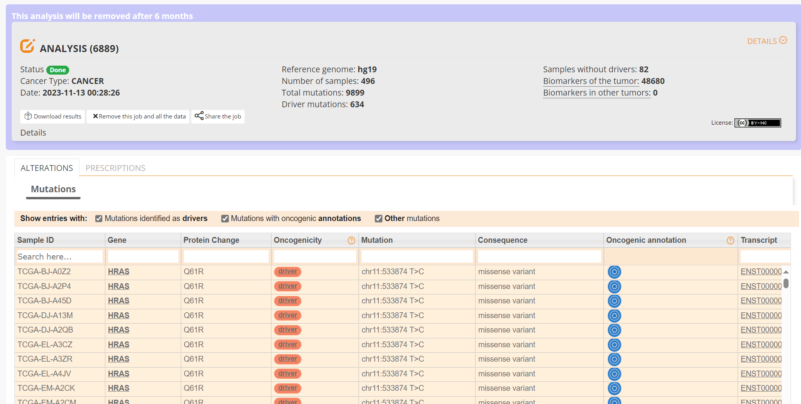

This table can be explored in various ways: gene of interest or sample of interest can be selected, driver information obtained (clicking on the driver buttons bring up the CGI boostDM tool) and annotation from OncoKB, clinvar and CGI databases. These are selected by clicking on the symbols in the Oncogenic annotation column. One example for BRAF is shown in screenshot 25, which indicates the mutation is gain of function.

***Screenshot 25***

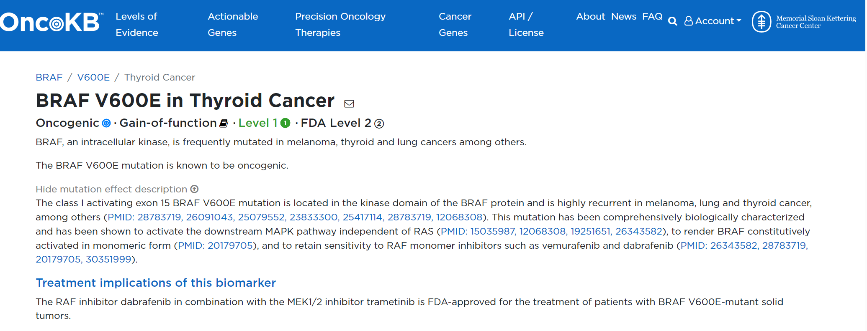

Examining TG gene mutations on the ALTERATIONS table, these are confirmed as passenger mutations [screenshot 26]:

***Screenshot 26***

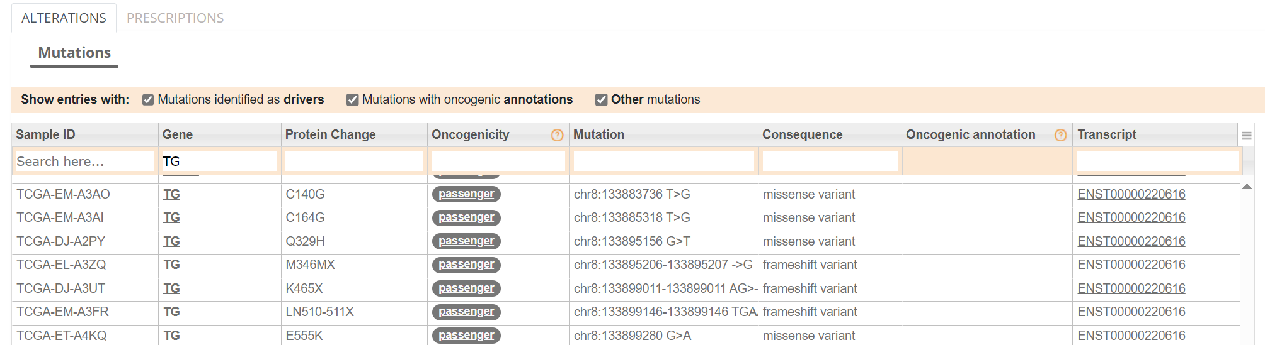

The PRESCRIPTIONS tab results are shown in screenshot 27, giving information on the drugs used in patient care and whether the mutations make the cancer resistant or still responsive.

***Screenshot 27***

