Basic Knowledge

SR Latch
Sequential circuit that depends on the past inputs/outputs (Has memory). It saves the value of Q until R or S is activated
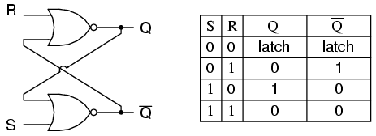
State S=1 and R=1 is not allowed

SR Flip Flop
SR Latch that can only change the value of the Qs when the clock is ON
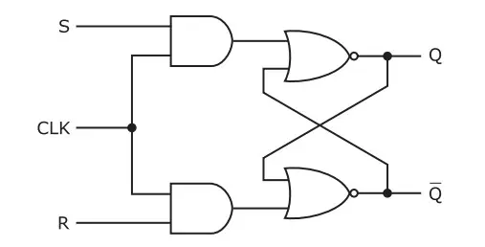

D Flip Flop

SR Latch are problematic when both S and R are 1. The D-Flip Flop fixes this issue by making sure S and R are opposites.
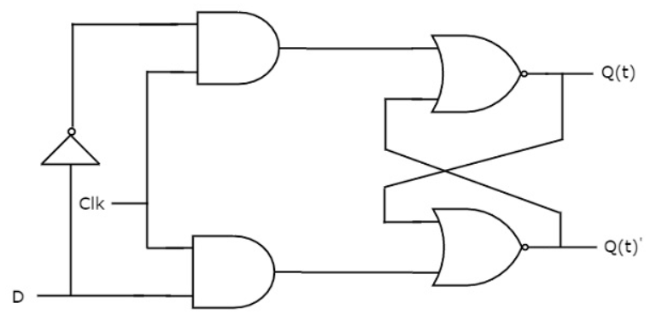

SPI(Serial Peripheral Interface)
SPI Master (FPGA) and SPI Slave (What were talking to)

Master initiates communication with 4 signals:

SCLK - Serial Clock
MOSI - Master Out Slave In
MISO Master In Slave Out
SS - Slave Select (Chip Select) (Active low)

Advantages:
Full - Duplex (Send and receive at same time)
Higher Speed than UART + I2C
Ubiquitous (Everywhere lots of ressources)

Disadvantages:
More pins than UART + I2C
Short Distances
Lots of Variants

4 Modes
0,1,2,3
CPOL = 0 Clock in idle state is low
CPOL = 1 Clock idle high
CPHA = 0 Clock Phase (which edge of clock to change data and sample data) want to sample in middle of data to minimize error 0 is on rising edge sample (for CPOL = 0)
CPHA = 1 samples on lowering edge (CPOL = 1)

Accelerometer
- The code sets the range of the accelerometer to +-2g.
- It uses 10 bits to represents the data.
- The data is saved on 16 bits registers
- Therefore the resolution is of 3.9 mg (4g / 2^10).

