Abstract
Data Preprocessing Using Ontologies
Petr Aubrecht, Monika Žáková
Department of Cybernetics
Czech Technical University in Prague
12 Karlovo náměstí, 12000 Prague, Czech Republic
Tel.: +420-123-456-789
{aubrech, zakovm1}@fel.cvut.cz
Ontologies play important role in expression of knowledge. In this article, we show how they can be used in data preprocessing and especially for retrieving relevant information from a central database to databases on mobile devices.
For medical purposes, information about patient and data closely connected to him and his disease is required. The amount of data and the scope change with respect to the conditions. Such information is held by the ontology and can be used for making of a subset of the database in order to save the result on a device with a limited storage.
Specialized extensions of the data processing system SumatraTT, already supporting ontologies in multiple formalisms, could make a compact environment for processing of both relational and ontology data. The idea will be demonstrated using ontology of family relations.

CAse study
The intended environment is a hospital with doctors equipped with palmtops, who require making a relevant subset of all information stored in the central database with respect to their patients he is going to visit. Similar problems arise when the doctor tries to obtain an overview of the case containing relevant information.
Our aim is to create a subset of the patient’s data, which is relevant, fits into a limited storage space and can be obtained in as few steps as possible.
Processing of data could include graphical representation of the subset and some statistical analysis.

Role of ontologies
Ontologies are becoming widely used for representation of knowledge. In their simplest form ontologies are used to define taxonomy describing a particular domain. However the only operation that can be performed on taxonomies is transitive closure. Such ontologies enable us to store only information about the most specific category, which the object represented by one line in the database belongs to. Information about more general categories and their hierarchy is provided by the ontology. Such ontologies can be used mostly for visualization of information, since they add relatively little semantics to the search of some relevant subset of data.
To add more semantics to the search, rules and axioms representing as much background information about the domain and also about structure of the data as possible should be included in the ontology. In this way the approach of querying the database using ontologies will become significantly superior to the usual approach of translating SQL into some more human-friendly form.
There are two levels on which ontologies are used to support data processing: domain ontologies and task ontologies.
Domain ontologies are used to describe knowledge from the domains relevant to the particular task. For example in case of hereditary disease such ontologies would involve ontology of family relations, ontology of the particular type of disease. These ontologies provide terminology for expressing information about a particular patient and context, which can then be used for determining the scope of the relevant information for database queries and visualization, which will be described in more detail in sections 3.1 and 3.2 respectively.
For example ontology of diseases would contain information that in case a patient is suffering from hemophilia, we should be interested in male line of the family. Ontology of family relations would then hold information that male line includes male ancestors, brothers and half-brothers etc.
Domain ontologies are not specific to a particular hospital. Third party ontologies can be used if available.
Task ontology is used to provide semantics of the structure of data. The ontology is closely tied to the relational data model of the database in which patients' records are stored. There exists one to one mapping between them. A class in the ontology corresponds to a table in the database. Slots correspond to attributes or relations between tables. Therefore in case we are building a knowledge based system using an already existing database, the mapping between the ontology and the database schema can be used to fill the knowledge base automatically. On the other hand the ontology could be used to generate a database schema for systems that are relatively large and are often changed.

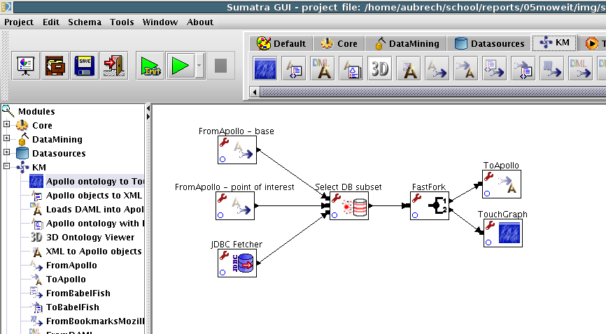
Figure 1: Database subset using ontology in SumatraTT 2.0

Family ontology
It was discovered that none of the medical ontologies available on the web includes ontology of family relations, which would be suitable to support analysis of hereditary diseases. Therefore ontology of family relations was developed containing apart of generally used terms also relationships like half-brother, mother's sister, descent in female line.
Two versions of the ontology were developed. The first version was developed in OWL, which is becoming increasingly popular especially for sharing ontologies on the web. Family relations were defined mostly using restrictions. However this version of ontology did not meet fully out needs, since is impossible to express relations such as half-brother in standard OWL.
To express this relation, OWL rules would have to be used. However at present there exists no standard language for expressing OWL rules. Only some proposals can be found such as ORL [4].
Therefore the ontology of family relations was developed also using format of an ontology editor Apollo [5]. The formalism used in Apollo allows creating rules and exporting the ontology into OCML a frame-based formalism [7], for which inference is defined by translating it into Lisp.

Medical Records Ontology
Medical records ontology was developed to cover basic information about patient and reports from the individual investigations. The ontology was built rather as task ontology than as application ontology. It covers basic structure of records about patients, however details specific to a particular hospital have been omitted and are stored only in the database.
The aim of the ontology is to provide semantic description of data stored in the database. Therefore it also describes structure of various medical reports. In this case a hierarchy induced by the part-whole relationship.
In the Apollo version of the ontology this hierarchy is captured only using slots with facets specifying properties that would apply in case of a proper part-whole relationship, such as cardinality = 1. In the OWL version of the ontology special properties hasPart and partOf have been designed as recommended in the W3C Working Draft [8].
This ontology is used for filling in details of the structure for the database queries generated on user request. This makes it possible to overcome the restriction of users to predefined queries without forcing the users to learn SQL or some similar language. Since it is anticipated that ontologies will be used in other related applications such as annotation of medical records, the users will already be familiar with them. The ontology also provides a good overview of the structure of reports.

How to Process Ontologies in SumatraTT
For the purpose of data processing, SumatraTT system is being developed and used at the department of cybernetics, FEE, CTU in Prague [6, 2, 9]. It is a modular system intended for processing of huge amount of data, especially for data pre-processing for data mining and data warehousing. SumatraTT supports data

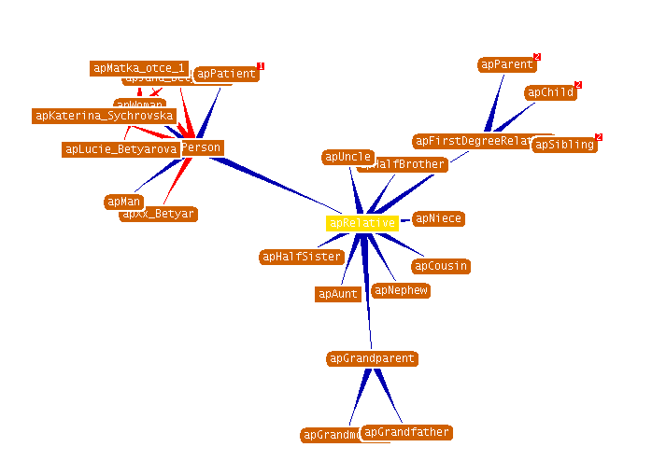
Figure 2: The family ontology visualized interactively

understanding, preparation, modeling and deployment. For collaboration with other tools it provides various input/output formats including text files, DBF, SQL databases, AI languages – Lisp and Prolog, etc.
SumatraTT project is designed as a chain of transformation modules, which work on a record-by-record basis with a small piece of data. It allows processing huge amount of data, because most of the modules do not store data in memory. The transformations provided by SumatraTT include attribute selection, various subsets, scripting support. Besides general areas covered there are specialized modules covering some issues like TimeSeries and ClusterAnalysis for data mining.
Recently, there has been added knowledge management related support, especially load/save ontologies from various formalisms, translation between them, and for set operations on ontologies [1, 3].

Combination of Data Processing and Ontology
The case study presented in the beginning of this paper required making a subset of relational data, where only certain neighborhood of the point of interest is needed, e.g. full patient information about his/her current state and possibly past treatment and basic information known about his/her relatives. This neighborhood can be defined simply using an SQL query.
A disadvantage of a hard-coded SQL query is its inability to be easily modified and make it dependant on context. For example, for specific diseases, it is needed deeper information in some directions (for genetic diseases information about grand-parents is of some importance, while for infectious diseases information about people met by the patient is required). Such definition of neighborhood is non-trivial to be performed by SQL.
A more suitable structure for finding appropriate context are ontologies. Within ontologies it can be defined relatively easily, which relations are important for a specific illness, as was mentioned in the example of hemophilia in section 2, so the subset of all available information can be defined naturally and can be simply changed.
SumatraTT has access to both relational data and ontologies and can thus process this kind of task.
The solution can be either to transform the ontology-based query to an SQL query or to sequentially load data from the database to ontology and filter it in the ontology. This follows the basic concept of SumatraTT – to allow processing of arbitrary amount of data.
The former approach is suitable for less complicated queries and for huge databases, while the subsequent approach can be used for smaller data sets, but can take advantage of a full power of the underlying ontology engine.
An example of making a relevant subset from database is on figure 1. Two input ontologies describe both structure ontology and point of interest. These two kinds of information will lead to a query, which will filter the relational data, or will employ underlying ontology search engine – it depends on designer’s decision.

Visualization
An important part of ontology processing is its visualization. SumatraTT provides several modules for visualization of relations between ontology concepts.
The results of visualization can be stored as pictures and can accompany the data as a part of documentation.
An example of visualized ontology is on figure 2. This visualization is interactive, so the nodes can be expanded and further investigated. This can be particularly useful for displaying data representing a brief overview e.g. information about all family members which seem to be relevant for the particular case. The user can easily navigate the displayed family tree and explore records about some family members in more detail.
Besides this visualization, several others are at disposal. Currently, a VRML export is in preparation.

conclusions and future work
The area of exploitation of information stored in ontologies in processing of relational data is interesting and will be further investigated. In SumatraTT we expect to store successful solution to particular situations in a repository. This repository will be searched if similar data appear. For description of data features will be used ontologies.
Combination of processing both ontologies and relational data can bring an advantage in domains, where it was not primarily targeted. In this case of mobile devices, results of progress in processing of ontologies [1] can be used.
Visualization of ontology is very important in understanding of ontology structure. As it uses more dimensions, it can provide a natural and convenient way how to examine the content. A graphical representation of concepts is planned to accompany the textual information as documentation and in interactive forma as a human-computer interface.

acknowledgement
The presented research and development has been partially supported by the grants GAČR 201/05/0325.

References
[1] Petr Aubrecht. Ontology Transformations Between Formalisms. PhD thesis, Czech Technical University in Prague, Faculty of Electrical Engineering, Technická 2, 166 27 Prague 6, Czech Republic, 2005.
[2] Petr Aubrecht and Zdeněk Kouba. Metadata Driven Data Transformation. In SCI 2001, volume I, pages 332–336. International Institute of Informatics and Systemics and IEEE Computer Society, 2001.
[3] J. Euzenat and H. Stuckenschmidt. Family of Languages’ Approach to Semantic Interoperability, 2001.
[4] Ian Horrocks and Peter F Patel-Schneider. A Proposal for an OWL Rules Language . In International WWW Conference, New York, USA, 2004.
[5] Czech Technical University in Prague. Apollo Official Homepage, 2005. URL: http://krizik.felk. cvut.cz/apollo. Retrieved: 6 May 2005.
[6] Czech Technical University in Prague. SumatraTT Official Homepage, 2005. URL:http://krizik.felk.cvut.cz/sumatra. Retrieved: 6 May 2005
[7] Enrico Motta. Reusable Components for Knowledge Modelling: Case Studies in Parametric Design Problem Solving. IOS Press, 1999.
[8] Alan Rector and Chris Welty. Simple part-whole relations in OWL Ontologies, 2005. URL:http://www.w3.org/2001/sw/BestPractices/OEP/SimplePartWhole/index.html. Retrieved: 6 May 2005
[9] Olga Štěpánková, Petr Aubrecht, Zdeněk Kouba, and Petr Mikšovský. Preprocessing for Data Mining and Decision Support, pages 107–117. Kluwer Academic Publishers, Dordrecht, 2003.
[10] R. Angles, C. Gutierrez, Querying RDF Data from a Graph Database Perspective. Lecture Notes in Computer Science, Volume 3532 / 2005, pp. 346-360.

